***Original Article***



**ISSN Print 2231 – 3648**

**Online 2231 – 3656**

STABILITY INDICATING RP HPLC METHOD FOR THE DETERMINATION OF CANDISARTAN IN PURE AND PHARMACEUTICAL FORMULATION.

*,1Manju Latha Y B, 2Gowri Sankar D

*, 1Sri Vasavi Institute of Pharmaceutical Sciences, Tadepalligudem, (A.P), India 534 101.

2University college of Pharmaceutical Sciences, Andhra university, Visakhapatnam, (A.P), India.

**Abstract**

An accurate and precise HPLC method was developed for the determination of candesartan Separation of the drug was achieved on a reverse phase C18 column using a mobile phase consisting of phosphate buffer and acetonitrile in the ratio of 30:70v/v. The flow rate was 1.2ml/min and the detection wavelength was 255 nm. The linearity was observed in the range of 20-60μg/ml with a correlation coefficient of 1.000. The method was successfully validated in accordance to ICH guidelines acceptance criteria for specificity, linearity, precision, recovery, ruggedness and robustness. The drug undergoes degradation under acidic, basic, Peroxide and thermal degradation conditions. All the peaks of degraded product were resolved from the active pharmaceutical ingredient with significantly different retention time. As the method could effectively separate the drug from its degradation product, it can be employed as a stability‐indicating one.

**Key words:** Candesartan, RP-HPLC, Degradation studies.

# Introduction

Candesartan Cilexetil,(±)-1-[(Cyclohexyloxy) carbonyl] oxy] ethyl 2- ethoxy-1- [[2’- (1*H*- tetrazol- 5- yl) [1,

1’- biphenyl]- 4- yl] methyl]- 1H- benzimidazole- 7- carboxylate, is a novel, potent, highly selective non peptide angiotensin II type 1 (AT1) receptor blocker which is administered orally as Candesartan cilexetil, which is rapidly and completely hydrolyzed to Candesartan, the active moiety, during absorption from the gastrointestinal tract. The objective of this work was to develop an analytical HPLC procedure, which would serve as stability indicating assay method for candisartan. A thorough literature survey revealed that the reported analytical procedures describing a stability indicating HPLC method for candisartan were more economical. The Objective of this study was to develop the method with less economical, precise, simple and sensitive and determination of candisartan in the presence of its degradation products.

## Author for Correspondence:

Manju Latha Y B,

Sri Vasavi Institute of Pharmaceutical Sciences, Tadepalligudem, (A.P), India - 534101.

Email: [blessythalli@gamil.com](mailto:blessythalli@gamil.com)

Here direct use of the mobile phase as diluent for formulations in quantitative analysis minimizes errors that occur during tedious extraction procedures. From the best of our knowledge via literature search, this is the first known RP‐HPLC method that can separate all the related compounds of candisartan from each other and from candisartan with less economical and is therefore suitable to conduct stability studies of candisartan.

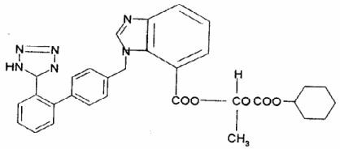

**Fig 1: Structure of Candesartan Cilexetil**

# Material and Methods

**Chromatographic conditions:** The analysis of the drug was carried out on a Waters HPLC system equipped with a reverse phase Xterra C18 column (100 mmx4.6mm; 3.5μm), a 2695 binary pump, a 20 μl

injection loop and a 2487 dual absorbance detector and running on Waters Empower software.

**Chemicals and Solvents**: The reference sample of candesartan was supplied by Sun Pharmaceutical Industries Ltd., Baroda. HPLC grade water and acetonitrile were purchased from E. Merck (India) Ltd., Mumbai. Potassium dihydrogen phosphate and orthophosphoric acid of AR Grade were obtained from

S.D. Fine Chemicals Ltd., Mumbai.

**Preparation of phosphate buffer**: Seven grams of KH2PO4 was weighed into a 1000 ml beaker, dissolved and diluted to 1000 ml with HPLC water. 2 ml of Triethyl amine was added and pH adjusted to

3.0 with orthophosporic acid.

**Preparation of mobile phase and diluents** 350 ml of the phosphate buffer was mixed with 650 ml of acetonitrile. The solution was degassed in an ultrasonic water bath for 5 minutes and filtered through 0.45μ filter under vacuum.

## Standard Solution Preparation:

Accurately weigh and transfer 10mg of Candesartan Cilexetil Working standard into 10 ml volumetric flasks add about 7 ml of Diluent and sonicate to dissolve it completely and make volume up to the mark with the same solvent. (Stock solution)

Further pipette 0.4 ml of the above stock solution into a 10ml volumetric flask and dilute up to the mark with diluent. Mix well and filter through 0.45µm filter.

## Sample Solution Preparation:

Weigh 5 Candesartan Cilexetil Tablets and calculate the average weight. Accurately weigh and transfer the sample equivalent to 10 mg of Candesartan Cilexetil into a 10 ml volumetric flask. Add about 7 ml of diluent and sonicate to dissolve it completely and make volume up to the mark with diluent. Mix well and filter through 0.45µm filter.

Further pipette 0.4 ml of the above stock solution into a 10ml volumetric flask and dilute up to the mark with diluent. Mix well and filter through 0.45µm filter.

## Procedure:

A mixture of buffer and acetonitrile in the ratio of 30:70v/v was found to be the most suitable mobile phase for ideal separation of candesartan .The solvent mixture was filtered through a 0.45μ membrane filter and sonicated before use. It was pumped through the column at a flow rate of 1.2ml/min. The column was maintained at ambient temperature. The pump pressure was set at 800 psi. The column was equilibrated by pumping the mobile phase through the column for at least 30 min prior to the injection of the drug solution. The detection of the drug was monitored at 255 nm. The run time was set at 6 min. Under these optimized chromatographic conditions the retention time obtained for the drug was 3.089min. A typical chromatogram showing the separation of the drug is given in Figure 2.

## Preparation of calibration graph:

**Preparation of stock solution:** Accurately weigh and transfer 10mg of Candesartan Cilexetil API sample into a 10 ml volumetric flask add about 7 ml of Diluent and sonicate to dissolve it completely and make volume up to the mark with the same solvent. (Stock solution)

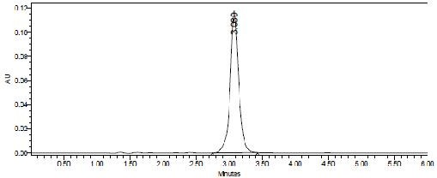**Preparation of Level – I (20, 30, 40, 50, 60, µg/ml):** 0.2ml, 0.3, 0.4, 0.5, 0.6ml of stock solution has taken in 10 ml of volumetric flask diluted up to the mark with diluent.

## Fig 2: Typical chromatogram of candesartan Procedure:

Injected each level into the chromatographic system and measured the peak area. Plotted a graph of peak area versus concentration and calculated found to be linear in the concentration range of20-60 μg/ml of the drug.

The relevant data are furnished in Table-1. The regression equation of this curve was computed. The regression equation was later used to estimate the amount of candesartan in tablet dosage forms.

## Table 1: calibration data of the method

weighed portion of this powder equivalent to 25 mg of candesartanl was transferred into a 100 ml volumetric flask and dissolved in 25 ml of a 30:70v/v mixture of phosphate buffer and acetonitrile. The contents of the flask were sonicated for 15 min and a further 25 ml of the diluents was added, the flask was shaken

**Concentration (µg/ml)**

**Mean peak area (n=5)**

continuously for 15 min to ensure complete solubility of the drug. The volume was made up with the diluents

20 521185

30 771352

40 1034493

50 1277669

60 1541985

## Validation of the proposed method:

The specificity, linearity, precision, accuracy, limit of detection, limit of quantification, robustness and system suitability parameters were studied systematically to validate the proposed HPLC method for the

and the solution was filtered through a 0.45 μ membrane filter. This solution containing 15 μg/ml of candesartan was injected into the column six times. The average peak area of the drug was computed from the chromatograms and the amount of the drug present in the tablet dosage form was calculated by using the regression equation obtained for the pure drug.

## Table 3: Accuracy studies

**Amount**

determination of candesartan. Solution containing 40μg/ml of candesartan was subjected to the

**Concentration Amount**

**added(mg)**

**found ( mg)**

**%**

**Recovery**

**% Mean**

**recovery**

proposed HPLC analysis to check intra-day and inter- day variation of the method and the results are furnished in Table-2.

The accuracy of the HPLC method was assessed by analyzing solutions of candesartan at 50, 100 and

50% 5.0 5.01 100.20

100% 10.0 9.87 98.76

150% 14.8 14.60 98.66

## Forced degradation studies Acid Degradation:

99.20

150% concentrated levels by the proposed method. The results are furnished in Table-3. The system suitability parameters are given in Table-4.

## Table 2: Precision of the proposed HPLC method

**Concentration of Peak area Candesartan(40µg/ml)**

|  |  |  |
| --- | --- | --- |
|  | **Intra day** | **Inter day** |
| Injection-1 | 1050994 | 1069436 |
| Injection-2 | 1050910 | 1067920 |
| Injection-3 | 1062555 | 1072559 |
| Injection-4 | 1065327 | 1075473 |
| Injection-5 | 1065412 | 1076588 |
| Average | 1059040 | 1072395 |
| Standard Deviation | 7471.9 | 3737.1 |
| %RSD | 0.71 | 0.35 |

**Estimation of candesartan in tablet dosage forms:** Two commercial brands of tablets were chosen for testing the suitability of the proposed method to estimate candesartan in tablet formulations twenty tablets were weighed and powdered. An accurately

Accurately weigh and transfer 10mg of candesartan

working standard into a 10mL volumetric flask add about 3 mL of 0.5N Hcl and sonicated for 5minutes. Refluxed under heat at 60 degrees in a heating mantle for 2 hours. Neutralized the sample solution using 0.5N NaOH and diluted up to the mark with diluents. (Stock solution). Further pipette 0.3 ml of the above stock solution into a 10ml volumetric flask and dilute up to the mark with diluent. Mix well and filter through 0.45µm filter.

## Base Degradation:

Accurately weigh and transfer 10mg of candesartan working standard into a 10mL volumetric flask add about 3mL of 0.5N NaOH and sonicated for 5 minutes. Refluxed under heat at 60 degrees in a heating mantle for 2 hours. Neutralized the sample solution using 0.5N HCl and diluted up to the mark with diluents. (Stock solution). Further pipette 0.3 ml of the above stock solution into a 10ml volumetric flask and dilute up to the mark with diluent. Mix well and filter through 0.45µm filter.

## Thermo Degradation:

Accurately weigh and transfer 10mg of candesartan working standard into a 10mL volumetric flask and oven under heat at 105 degrees for 12 hours. (Stock solution).

Further pipette 0.3 ml of the above stock solution into a 10ml volumetric flask and dilute up to the mark with diluent. Mix well and filter through 0.45µm filter.

## Peroxide Degradation:

Accurately weigh and transfer 10mg of candesartan e Working standard into a 10mL volumetric flask add about 1 mL of 30% Hydrozen Peroxide (H2O2) and sonicated for 5minutes and Refluxed under heat at 60 degrees in a heating mantle for 2 hours. Further pipette 0.3 ml of the above stock solution into a 10ml volumetric flask and dilute up to the mark with diluent. Mix well and filter through 0.45µm filter.

# Results and Discussion:

In the proposed method, the retention time of candesartan was found to be 2.269 min. Quantification was linear in the concentration range of 20-60 μg/ml. The regression equation of the linearity plot of concentration of candesartan over its peak area was found to be Y=10170+25479X (r2=1.000), where X is the concentration of candesartan (μg/ml) and Y is the corresponding peak area. The number of theoretical plates calculated was 2190, which indicates efficient performance of the column. The limit of detection and limit of quantification were found to be 0.05μg/ml and 0.09μg/ml respectively, which indicate the sensitivity of the method. The use of phosphate buffer and acetonitrile in the ratio of 30:70v/v resulted in peak with good shape and resolution.

## Stability indicating property:

The chromatogram of no stress treatment sample (as control) showed no additional peak (Fig: 3). The retention time (RT) of standard and sample were 3.626min .The chromatogram of acid degraded sample showed no additional peaks (fig: 4). The chromatogram of alkali degraded sample showed no additional peaks (fig: 5). The chromatogram of thermal degraded sample showed no additional peaks (fig: 6**).** The chromatogram of hydrogen peroxide degraded

sample showed additional peak at RT of 2.90 min (Fig: 7). and the values were shown in Table 4.

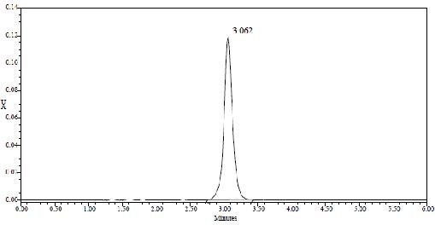

## Fig 3:

**The chromatogram of no stress treatment sample**

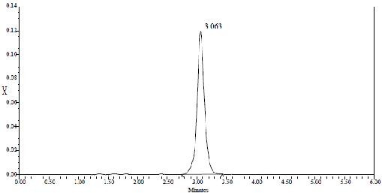

## Fig. 4: The chromatogram of acid degraded sample

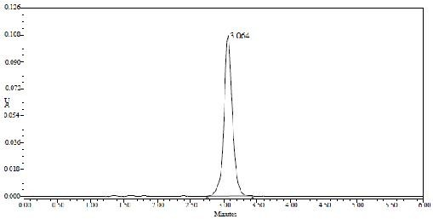

**Fig. 5: The chromatogram of alkali degraded sample**

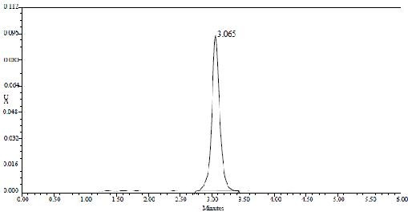

## Fig. 6:

**The chromatogram of thermal degraded sample**

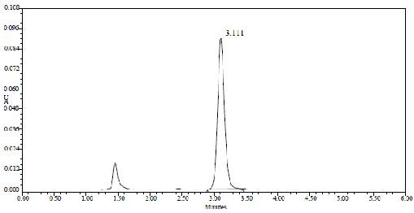

**Fig. 7: The simple chromatogram of Hydrogen Peroxide degraded sample.**

# Conclusion

The developed HPLC technique is precise, specific, accurate and stability‐indicating. Statistical analysis proves that the method is suitable for the analysis of candesartan as bulk drug and in Pharmaceutical formulation without any interference from the excipients. This study is a typical example of a stability‐indicating assay, established following the

recommendations of ICH guidelines. The method can be used to determine the purity of drug available from various sources by detecting any related impurities. The method has been found to be better than previously reported methods, because of use of a less economical and readily available mobile phase, lack of extraction procedures, no internal standard, and use of the same mobile phase for washing of the column. All these factors make this method suitable for quantification of candesartan in bulk drugs and in pharmaceutical dosage forms. It can therefore be concluded that use of the method can save much time and money and it can be used in small laboratories with very high accuracy and a wide linear range

# Acknowledgements:

The authors are thankful to M/s Sun Pharmaceutical Industries Ltd., Baroda for providing a reference sample of candesartan.

## Table 4: Stressed study data of candesartan

|  |  |  |  |  |  |
| --- | --- | --- | --- | --- | --- |
| **S. No** | **Condition** | **Time(hrs)** | **% assay of candesartan** | **Retention time of candesartan** | **%degradation** |
| 1 | No stress treatment | - | 99.4 | 3,602 | Nil |
| 2 | Acid | 2 | - | - | Nil |
| 3 | Alkali | 2 | - | - | Nil |
| 4 | H202 | 2 | 100.4 | 3.11 | 1.00 |
| 5 | Thermal | 12 | - | - | Nil |
| **References** |  |  |  |  |  |

1. Wolff M.E: “Burger’s Medicinal Chemistry”, Wiley Interscience, New York, Fourth edition 1981.
2. Korolkovas A: “Essential of Medicinal Chemistry”, Wiley Interscience, New York, Second edition 1988.
3. Rall, T.W: “Goodman and Gilman’s the pharmacological basics of Therapeutics”, Pergamon Press, New York, Eighth edition 1990.
4. Williams, A.D: Foye’s Principles of Medicinal Chemistry, Fifth edition 2002.
5. Budavari. S: The Merck Index, An Encyclopedia of Chemicals, Drugs and Biologicals, White House Station, N. J., Thirteenth edition. 2001.
6. Reynolds, J.E.F and Prasad B.A., IN; Martinadale, The Complete Drug Reference, the Pharmaceutical Press, London, 33rd Edn, 2002, 853.
7. Pfister, M : Pharmacokinetics and haemodynamics of Candesartan cilexetil in hypertensive patients on regular haemodynamics; British Journal of Clinical Pharmacology 1999, 47:645-651.
8. Sever, P., Menard, J., Eds: Angiotensin II antagonism refined: Candesartan cilexetil, Journal of Human Hypertens; 1997, 11(Suppl 2): S 1- 95.
9. Montvale, N.J: Physician’s Desk Reference, Medical Economics Co.Inc., 56th Edn. 2002, 595-597.
10. ‘Indian Drug Review’, March-April 2004, 4B, 177.
11. Current Index of Medical Specialities, July 2004, 2A, 128.
12. Budavari S. The Merck Index, An Encyclopedia of Chemicals, Drugs and Biologicals, White House Station, 13th edition. 2001, 978.
13. A.J. Gower et al; Europea Journal Pharmacology 1992 ; 222.
14. James, A., Howell, Hand book of “Instrumental Techniques for Analytical Chemistry”.
15. Krstulovic, A. M., Brown, R. P; Reversed-Phase High Performance Liquid Chromatography, Theory, Practice and Biomedical Applications, John Wiley, 1982.
16. Howard, G.A., Martin,A: Journal of Pharma Biochemistry.46th edition 1950, 532.
17. Rockville, M.D: The United State Pharmacopoeia (USP) XXIV edition, 2000, 1924.
18. Topliss, J.G: Quantitative structure-activity relationships of drugs, Academic press, London, Vol 19, 1983.
19. Shetti P.D.: High Performance Liquid Chromato

-graphy, 2001,116.

1. ICH, Q1A (R2): Stability Testing of New Drug Substances andProducts, International Conference on Harmonization, Geneva.2003.
2. Carstensen JT, Rhodes CT. A rational approach to stability testing and analytical development for NCE, drug products marketed product stability testing In: In: Drug Stability: Principles and Practise, Wolfgang G, Ed, New York, Marcel Dekker, 2000; pp 415–81.
3. FDA, Draft Guidance for Industry: Stability Testing of Drug.
4. Substances and Drug Products, FDA, Rockville 1998.
5. Snyder L R, Kirkland J J and Glajch J L, Practical HPLC method.
6. Development, 2nd Edn., Wiley‐interscience Publication, John.