***Original Article***



International Journal of Pharmacy and Industrial Research

**ISSN Print 2231 – 3648**

**Online 2231 – 3656**

**DEVELOPMENT AND EVALUATION OF SUSTAINED RELEASE TABLET CONTAINING ANTIDIABETIC AGENT**

# *Rajat S Kharche, Madhuri A Channawar, Anil V Chandewar, Bharati Bakade

P. Wadhwani College of Pharmacy, Yavatmal, Maharashtra, India – 445 001.

## Abstract

Metformin HCL, the only available biguanide, remains the first line drug therapy for patients with Type 2 diabetes mellitus acts by decreasing hepatic glucose output and peripheral insulin resistance. It has relatively short plasma half life, low absolute bioavailability. The overall objective of the present work was to develop an oral sustained release Metformin tablet prepared by direct compression method using Hydroxypropylmethyl cellulose and Xanthan gum in different proportions. Nine formulations (T1-T9) were prepared. All the batches were evaluated for thickness, weight variation, hardness, and drug content uniformity and *in vitro* drug release. The dissolution study was performed as per USP-32 NF-27. The initial burst release was minimized by optimizing the concentration of xanthan gum. Then the concentration of HPMC was varied, keeping the concentration of xanthan gum fixed. From the dissolution study of nine batches, T8 was found to be the optimized batch capable to sustain the drug release for 10 hrs as it follows the dissolution parameter mentioned in USP-32 NF-27. The drug release kinetics shows that the T8 batch followed first order kinetics.

**Keywords:** Metformin HCl, Biguanide, oral sustained release, HPMC, Xanthan gum.

## Introduction

Diabetes mellitus is a group of disorders of carbohydrate metabolism in which the action of insulin is diminished or absent through altered secretion, decreased insulin activity, or a combination of both factors. It is characterised by hyperglycaemia. As the disease progresses tissue or vascular damage ensues leading to severe complications such as retinopathy, nephropathy, neuropathy, cardiovascular disease, and foot ulceration. The type II diabetes mellitus is non-insulin

dependent diabetes mellitus1. So to maintain blood glucose level in normal range there is frequent administration of antihyperglycemic agent is done. The conventional dosage form has to administer frequent dosing to maintain plasma drug level. Due to frequent dosing of drug in conventional dosage form and fluctuation in plasma drug level lead to many side effects. Metformin is antihyperglycemic agent administered 2 to 3 times daily in conventional dosage form to maintain blood glucose level in the normal range. Half life of

### Author for Correspondence:

Rajat S Kharche,

70-A, Instrumentation Township, Kota, Rajasthan,

India-324005.

Email: [rskharche1987@gmail.com](mailto:rskharche1987@gmail.com)

Metformin is short i.e. 2-6 hours.2 So due to frequent administration of Metformin, there are number of side effect due to fluctuation in drug plasma level and poor patient compliance. Sustain release dosage form release drug for extended period so the drug in plasma for longer duration result in reduce in frequency of administration of doses. It leads to increase the time interval required between doses. Side effects were abolished due to reduce in drug plasma level.

In this study, development and evaluation of sustained release tablet Containing Metformin hydrochloride was done. Main objective of this present study is to increase the time interval required between doses of Metformin. This provides a reduction in the total number of doses required per day. Reduction in fluctuation of drug blood levels about the Metformin.

## Materials and Methods

### Materials

Metformin HCl was obtained as a gift sample from Twilight Litaka Pharma Ltd., Vadgaon Maval, Pune. Microcrystalline Cellulose (MCC Ph 101), HPMC K100M, Xanthan gum, Magnesium stearate, Colloidal silicon dioxide (Aerosil) was obtained as gift sample from Twilight Litaka Pharma Ltd., Pune. All other chemicals used were of analytical grade.

### Methods

**Identification by Ultraviolet absorption spectroscopy**

A solution of 10µg/ml concentration containing Metformin hydrochloride was prepared in distilled water and was scanned between 400 to 200nm for getting the

absorbance. For the drug sample preparation, Metformin hydrochloride (10 mg) was accurately weighed and dissolved in 100ml of distilled water taken in a volumetric flask. Then, 1ml of sample solution was withdrawn and dissolved in distilled water (10ml). The resultant solution was then scanned by using double beam ultra-violet spectrophotometer.

### Preparation of Calibration curve for Metformin Hydrochloride3

100 mg of Metfomin Hydrochloride was weighed and transferred into 100 ml volumetric flask. Add 100 ml diluent into it and sonicate for 5 minutes. Pipette out 2 ml from the above solution and transferred into the empty 100 ml volumetric flask, dilute it upto the mark with the diluent and again sonicate for 5 minutes. From the above stock solution, standard solutions were prepared in the range of 50 mcg/ml, 75 mcg/ml, 100 mcg/ml, 125 mcg/ml and 150 mcg/ml. The absorbance of each standard solution was determined spectrophotometrically at 232 nm. The plot of absorbance vs. concentration was plotted. Data in this range was further subjected to linear regression analysis.

**Drug Interaction Studies (Compatibility study)** The compatibility study or interaction study was done using Fourier transformed infrared spectroscopy. IR spectra of pure Metformin hydrochloride and polymers viz. hypromellose K100M, xanthum gum were taken separately. Then to know if there is any interaction between drug and polymer, IR spectra of metformin hydrochloride and other polymers were taken in combination.

### Formulation of Matrix Tablet

The release retarding agents play a central role in the formulation of sustained release matrix tablet. The objective of present study was to develop matrix sustained-release tablets of Metformin hydrochloride using xanthan gum and hydroxypropylmethyl cellulose K 100M (HPMC K100M) as release retarding agents. Thus, in the present study, 9 different trial batches of tablets were prepared. In the first 3 trials, only HPMC K100M was used, then from trial 4 to trial 9, both HPMC K100M and

xanthan gum was used in different concentrations. The cut weight of the tablet, in all the 9 trials was kept same i.e. 945 mg. The concentration of polymer among the 9 trials, who will give the results as per the USP 32 for 10 hours dosing of Metformin hydrochloride, will be selected and utilized for further studies.

The percentage composition of both the polymers used in all the 9 trials were shown in Table no.1

### Table No. 1: Percentage Composition of Polymers used in 9 Trials

|  |  |  |  |  |  |  |  |  |  |
| --- | --- | --- | --- | --- | --- | --- | --- | --- | --- |
| **Polymers** | **T1** | **T2** | **T3** | **T4** | **T5** | **T6** | **T7** | **T8** | **T9** |
| **HPMC K100M** | 16% | 20% | 24% | 24% | 24% | 24% | 19% | 21% | 23% |
| **Xanthan gum** | - | - | - | 10% | 15% | 20% | 20% | 20% | 20% |

**Procedure for formulation of T1 to T3**

1. Microcrystalline cellulose pH 101 (MCC Ph 101) was sifted through 40 # sieve.
2. Metformin hydrochloride BP was sifted through 30# sieve.
3. Step 2 and Step 3 was mixed in polybag for 10 minutes.
4. 10 ml purified water was added in planetary mixer to obtain wet mass.
5. Wet mass was passed through 8# sieve. Dry at 400 – 450C in tray dryer.
6. LOD (loss on drying) was checked at 1050C for 10 minutes. LOD must be in the range of 1%-2%.
7. Sift dried granules through 16# sieve.

### Lubrication step

HPMC K100M was sifted through 40# sieve. Magnesium stearate was sifted through 60# sieve, then mixed along with the dried granules for 2 minutes.

Aerosil was sifted through 40# sieve and mixed well to obtain the lubricated blend.

1. Compressed the lubricated blend using 19 x 8.5 mm capsule shaped punches plain on both sides.

### Procedure for formulation of T4 to T9

* 1. MCC Ph 101 and xanthan gum was sifted through 40# sieve.
  2. Metformin hydrochloride BP was sifted through 30# sieve.
  3. Step 2 and step 3 was mixed in planetary mixer for 10 minutes.
  4. Added **10 ml** of purified water in planetary mixer to obtain the wet mass.
  5. Wet mass was passed through 8# sieve. Dry at 400 – 450C in tray dryer.
  6. LOD was checked at 1050C for 10 minutes. LOD must be in the range of 1% - 2%.
  7. Sifted dried granules through 16# sieve.

### Lubrication

HPMC K100M was sifted through 40# sieve. Xanthan gum was sifted through 10# sieve. Both were mixed along with the dried granules for 5 minutes in a polybag.

Magnesium stearate was sifted through 60# sieve in the above mixture. Again it was mixed for 2 minutes.

* 1. Aerosil was sifted through 40# sieve and then mixed properly to obtain the lubricated blend.
  2. The lubricated blend was compressed by using 19 x 8.5 mm capsule shaped punches, plain on both sides.

### Table No. 2: Formulation Chart of Trial 1 to 9

|  |  |  |  |  |  |  |  |  |  |
| --- | --- | --- | --- | --- | --- | --- | --- | --- | --- |
| **Ingredients** | **Trial 1** | **Trial 2** | **Trial 3** | **Trial 4** | **Trial 5** | **Trial 6** | **Trial 7** | **Trial 8** | **Trial 9** |
| **Metformin HCl BP** | 500.00 | 500.00 | 500.00 | 500.00 | 500.00 | 500.00 | 500.00 | 500.00 | 500.00 |
| **Xanthan gum** | - | - | - | 14.77 | 22.15 | 29.53 | 29.53 | 29.53 | 29.53 |
| **MCC Ph 101** | 273.80 | 236.00 | 198.20 | 103.70 | 56.45 | 9.20 | 56.45 | 37.55 | 18.65 |
| **HPMC K100M** | 151.20 | 189.00 | 226.80 | 226.80 | 226.80 | 226.80 | 179.55 | 198.45 | 217.35 |
| **Xanthan gum (Lubrication)** | - | - | - | 79.73 | 119.60 | 159.47 | 159.47 | 159.47 | 159.47 |
| **Aerosil** | 10.00 | 10.00 | 10.00 | 10.00 | 10.00 | 10.00 | 10.00 | 10.00 | 10.00 |
| **Magnesium Stearate** | 10.00 | 10.00 | 10.00 | 10.00 | 10.00 | 10.00 | 10.00 | 10.00 | 10.00 |
| **Purified water** | q.s. | q.s. | q.s. | q.s. | q.s. | q.s. | q.s. | q.s. | q.s. |

* Weight in mg

### Evaluation of Tablet Weight variation 4

The variation weight testing was carried out as per the method described in the US Pharmacopoeia-32 NF27, 2009. Twenty tablets were randomly selected from each batch and individually weighed. The average weight and standard deviation of 20 tablets was calculated. The batch passes the test for weight variation test if not more than two of the individual tablet weight deviates from the average weight by more than the percentage shown in officials and none deviate by more than twice the percentage shown. Then the resultants weights were compared to the average dose USP weight variation test.

### Hardness 5

Tablets require a certain amount strength or hardness and resistance to friability to withstand mechanical shock of handling in manufacturing, packaging and shipping. Hardness was measured using Monsanto hardness tester. It is the pressure required to fracture diametrically placed tablets by applying the force. Mean of three values with standard deviation for each formulation was taken.

### Thickness Measurement 6

Three samples were selected randomly from each batch and thickness was measured using

Vernier caliper**.** The mean of three readings were taken.

### Tablet Friability 7, 8

For tablets with a unit weight of more than 650 mg, take a sample of 10 whole tablets. The tablets should be carefully dedusted prior to testing. Accurately weigh the tablet sample, and place the tablets in the drum. Rotate the drum 100 times, and remove the tablets. Remove any loose dust from the tablets as before, and accurately weigh.

The percentage friability was measured using the formula,

### %F = {(W-Wo)/Wo} x 100

Where, % F is friability in percentage**,** Wo is initial weight of tablet **and** W is weight of tablet after test.

***In-vitro* Release Profile Study of Formulated Tablets** 9, 10

### Preparations Standard Preparation:

50.2 mg of Metformin Hydrochloride working standard was accurately weighed and transferred in to 100 ml volumetric flask.

bowl was withdrawn, filtered and dilute 2 ml of filtrate to 100 ml with the dissolution medium in the volumetric flask. Sink condition was maintained by adding 10 ml of fresh dissolution medium in each of the six flask.

### Procedure

Measure the absorbance of the standard and sample preparations in 1 cm cell at the wavelength of maximum absorbance 232 nm with the suitable spectrophotometer using phosphate buffer 6.8 as a blank preparation. Calculate percentage drug release of Metformin hydrochloride in the portion of tablet taken by the formula.



Where, Spl abs is sample absorbance, Std abs is standard absorbance, Std wt is standard weight and % P is percentage purity.

According to USP 32, the drug release profile in 1 hr, 3 hr and 10 hr for 500 mg drug is shown in table below:-

### Table No. 3: Test 2 - Drug Release Acceptance Table [USP32 NF27 2009]10

**Time (Hours) 500 mg tablet, amount dissolved**

About 50 ml dissolution medium was added

and sonicate for 5 minutes to dissolve. Dilute it up to the mark with the dissolution medium. 2 ml from the above solution was pipetted out and diluted this to 100 ml with the dissolution medium in the volumetric flask.

### Sample Preparation

One tablet was placed in each of the six dissolution flask, from each trial, containing 1000 ml of dissolution medium previously maintained at 370C ± 0.50C. Operate the apparatus for 10 hours. After completion of each time point, 10 ml of aliquot from each

1 Between 20% and 40%

3 Between 45% and 65%

10 not less than 85%

### Result and Discussion Identification by UV Spectroscopy Wavelength of maximum absorbance (λmax) in different solvents.

**Table No. 4: λmax of water and phosphate buffer 6.8**

**Solvent λmax (nm)**

Water 232.60

pH 6.8 232.00

phosphate buffer

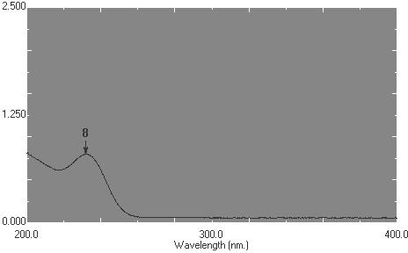

### Fig No. 1: Chromatogram of maximum absorbance in distilled water

**Absorbance**

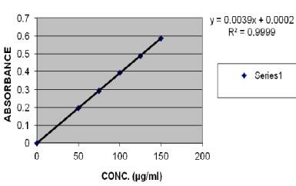**Preparation of linearity curve for Metformin hydrochloride**

### Table No. 5: Linearity of Metformin Hydrochloride

|  |  |
| --- | --- |
| **Concentration (µg/ml)** | **Absorbance** |
| 0 | 0 |
| 50 | 0.1957 |
| 75 | 0.2927 |
| 100 | 0.3944 |
| 125 | 0.4876 |
| 150 | 0.5867 |

**Fig No. 2: Linearity curve of Metformin hydrochloride**

### Compatibility Study

**Table No. 6: FTIR peaks of various functional groups of Metformin Hydrochloride**

|  |  |  |
| --- | --- | --- |
| **Functional groups** | **Wave number (cm-1) observed** | **Wave number (cm-1) Reported** |
| C-N stretching | 1041 | 1075 |
| C=N bending | 1624 | 1620 |
| C-Hstretching | 3298 | 3339 |

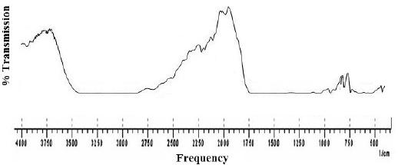

### Fig. No. 3: FTIR Spectrum of mixture of Metformin hydrochloride and HPMC K100M

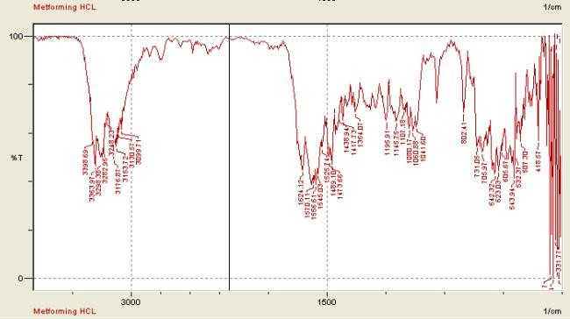

**Fig. No. 4: FTIR spectrum of Metformin Hydrochloride**

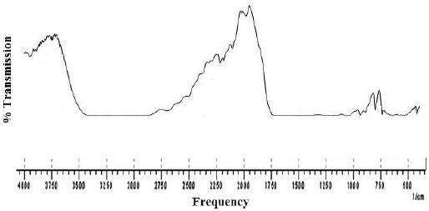

### Fig. No. 5: FTIR Spectrum of mixture of Metformin hydrochloride and xanthan gum

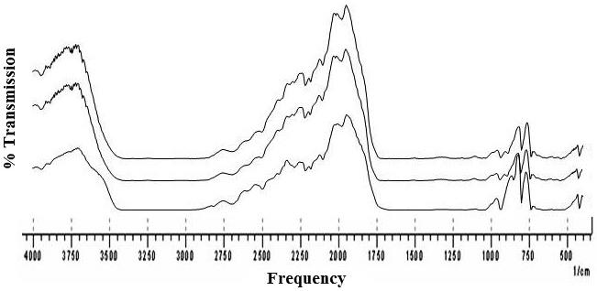

**Fig. No. 6: FTIR Spectra of pure Metformin hydrochloride and mixtures of Metformin hydrochloride with HPMC K100M and with xanthan gum.**

### Study of physical interaction between drug and polymer:

FTIR studies revealed that metformin hydrochloride showed two typical bands at 3369 and 3296 cm–1 due to N-H primary stretching vibration and a band at 3170 cm–1

due to N-H secondary stretching, and characteristics bands at 1626 and 1567 cm–1 assigned to C=N stretching. No significant shifts of reduction in intensity of the FTIR bands of metformin hydrochloride were observed.

### *In vitro* dissolution study as per USP 32 NF27 2009

**Table No. 7: Dissolution study of Trial batch 1**

**Time (hr) Dissolution sample % Drug Release Average % Drug Release**

|  |  |
| --- | --- |
| 1 | 35.56 |
| 2 | 38.22 |
| **1** 3 | 41.04 **42.19** |
| 4 | 41.90 |
| 5 | 45.81 |
| 6 | 50.61 |
| 1 | 70.66 |
| 2 | 69.25 |
| **3** 3 | 75.04 **78.11** |
| 4 | 80.13 |
| 5 | 85.40 |
| 6 | 88.17 |
| 1 | 86.13 |
| 2 | 90.59 |
| **10** 3 | 94.56 **96.15** |
| 4 | 98.48 |
| 5 | 104.74 |
| 6 | 102.41 |

The results obtained from Trial batch 1, it is clear that there is initial burst release during 1st hour. Therefore, to overcome this problem,

concentration of HPMC K100 M was increased so as to reduce the burst release.

### Table No. 8: Dissolution study of Trial batch 2

|  |  |
| --- | --- |
| **Time (hr) Dissolution sample** | **% Drug Release Average % Drug Release** |
| 1 | 32.20 |
| 2 | 34.54 |
| **1** 3 | 38.24 **38.37** |
| 4 | 43.23 |
| 5 | 45.49 |
| 6 | 36.51 |
| 1 | 60.27 |
| 2 | 66.21 |
| **3** 3 | 78.52 **75.34** |
| 4 | 72.40 |
| 5 | 84.19 |
| 6 | 90.45 |
| 1 | 83.15 |
| 2 | 87.11 |
| **10** 3 | 91.04 **93.19** |
| 4 | 95.22 |
| 5 | 103.14 |
| 6 | 99.46 |

By taking the 20% HPMC, the burst release was sustained to some extent and further increased the concentration of polymer.

### Table No. 9: Dissolution study of Trial batch 3

|  |  |
| --- | --- |
| **Time (hr) Dissolution sample** | **% Drug Release Average % Drug Release** |
| 1 | 32.19 |
| 2 | 35.22 |
| **1** 3 | 20.25 **26.02** |
| 4 | 24.03 |
| 5 | 28.25 |
| 6 | 16.17 |
| 1 | 58.33 |
| 2 | 62.15 |
| **3** 3 | 70.25 **68.38** |
| 4 | 66.31 |
| 5 | 73.94 |
| 6 | 79.33 |
| 1 | 84.26 |
| 2 | 88.09 |
| **10** 3 | 91.76 **90.07** |
| 4 | 95.93 |
| 5 | 100.18 |
| 6 | 80.22 |

In this trial batch 24% HPMC was used. The initial burst release was sustained during 1st hour and follows the parameter mentioned in Table No. 09 but fails during 3rd hour.

### Table No. 10: Dissolution study of Trial batch 4

|  |  |
| --- | --- |
| **Time (hr) Dissolution sample** | **% Drug Release Average % Drug Release** |
| 1 | 18.14 |
| 2 | 22.18 |
| **1** 3 | 20.23 **21.11** |
| 4 | 24.00 |
| 5 | 25.97 |
| 6 | 16.15 |
| 1 | 59.95 |
| 2 | 62.09 |
| **3** 3 | 70.17 **65.14** |
| 4 | 66.24 |
| 5 | 64.30 |
| 6 | 68.08 |
| 1 | 83.30 |
| 2 | 87.23 |
| **10** 3 | 91.04 **88.30** |
| 4 | 93.38 |
| 5 | 89.33 |
| 6 | 85.52 |

From Trial 4, Xanthan gum was used, as release retarding agent, alongwith HPMC K100 M. 10% Xanthan gum was used in this trial keeping the concentration of HPMC same as that of the trial 3.

The results found that the drug release was sustained to some greater extent. The value of

% drug release was out of acceptance criteria, mentioned in the Table No. 10.

### Table No. 11: Dissolution study of Trial batch 5

|  |  |
| --- | --- |
| **Time (hr) Dissolution sample** | **% Drug Release Average % Drug Release** |
| 1 | 19.36 |
| 2 | 23.17 |
| **1** 3 | 21.30 **18.37** |
| 4 | 13.30 |
| 5 | 15.92 |
| 6 | 17.19 |
| 1 | 56.52 |
| 2 | 58.17 |
| **3** 3 | 54.13 **53.19** |
| 4 | 52.26 |
| 5 | 49.74 |
| 6 | 48.35 |
| 1 | 83.39 |
| 2 | 87.33 |
| **10** 3 | 91.15 **86.24** |
| 4 | 80.76 |
| 5 | 89.43 |
| 6 | 85.38 |

The concentration of xanthan gum was increased from 10% to 15%. The more sustained release was observed from the results

of % drug release study. In both Trial 4 and 5, same initial release was observed.

### Table No. 12: Dissolution study of Trial batch 6

|  |  |
| --- | --- |
| **Time (hr) Dissolution sample** | **% Drug Release Average % Drug Release** |
| 1 | 14.05 |
| 2 | 15.63 |
| **1** 3 | 16.97 **15.99** |
| 4 | 17.99 |
| 5 | 15.37 |
| 6 | 15.94 |
| 1 | 41.22 |
| 2 | 40.30 |
| **3** 3 | 39.25 **40.13** |
| 4 | 38.03 |
| 5 | 42.19 |
| 6 | 39.78 |
| 1 | 71.93 |
| 2 | 73.03 |
| **10** 3 | 74.24 **74.18** |
| 4 | 76.51 |
| 5 | 74.98 |
| 6 | 74.42 |

In trial 6, 20% xanthan gum was used and even more sustained release was obtained. In Trial 4, 5 and 6 initial release was controlled and got good sustained release initially with the use of xanthan gum but in trial 6 initial release was

best, therefore, xanthan gum 20% was optimized. Release in later hours is more sustained or insufficient release, therefore, needs to adjust the quantity of HPMC, keeping the xanthan gum 20% fixed in next three trials.

### Table No. 13: Dissolution study of Trial batch 7

|  |  |
| --- | --- |
| **Time (hr) Dissolution sample** | **% Drug Release Average % Drug Release** |
| 1 | 33.11 |
| 2 | 34.34 |
| **1** 3 | 35.28 **35.27** |
| 4 | 36.98 |
| 5 | 36.33 |
| 6 | 35.60 |
| 1 | 68.29 |
| 2 | 70.13 |
| **3** 3 | 72.23 **70.16** |
| 4 | 69.11 |
| 5 | 70.21 |
| 6 | 70.97 |
| 1 | 98.46 |
| 2 | 100.01 |
| **10** 3 | 101.98 **100.13** |
| 4 | 99.12 |
| 5 | 101.05 |
| 6 | 100.14 |

In this trial 19% HPMC was used and the release obtained is slightly higher during 10th

hour. Therefore, needs to control the release by increasing the concentration of HPMC.

### Table No. 14: Dissolution study of Trial batch 8

|  |  |
| --- | --- |
| **Time (hr) Dissolution sample** | **% Drug Release Average % Drug Release** |
| 1 | 21.43 |
| 2 | 24.19 |
| **1** 3 | 24.48 **23.14** |
| 4 | 23.93 |
| 5 | 22.74 |
| 6 | 22.09 |
| 1 | 52.75 |
| 2 | 51.54 |
| **3** 3 | 51.43 **51.49** |
| 4 | 53.05 |
| 5 | 50.75 |
| 6 | 49.43 |
| 1 | 96.32 |
| 2 | 95.05 |
| **10** 3 | 94.31 **94.33** |
| 4 | 94.62 |
| 5 | 93.56 |
| 6 | 92.11 |

HPMC 21% was used in this trial and the release obtained is good as compared to other

trials. This trial meets the acceptance criteria mentioned in the Table No. 10.

### Table No. 15: Dissolution study of Trial batch 9

|  |  |
| --- | --- |
| **Time (hr) Dissolution sample** | **% Drug Release Average % Drug Release** |
| 1 | 17.47 |
| 2 | 19.49 |
| **1** 3 | 18.23 **19.20** |
| 4 | 20.93 |
| 5 | 20.06 |
| 6 | 19.04 |
| 1 | 43.13 |
| 2 | 45.25 |
| **3** 3 | 44.33 **45.23** |
| 4 | 47.37 |
| 5 | 44.86 |
| 6 | 46.43 |
| 1 | 78.66 |
| 2 | 79.36 |
| **10** 3 | 80.10 **80.18** |
| 4 | 81.00 |
| 5 | 82.10 |
| 6 | 79.84 |

23% concentration of HPMC was used in Trial

9. The results show that the drug release does not fulfill the criteria mentioned in Table No. 10.

Therefore from all the nine trials, Trial 8 gives the best results and follows the USP 32 NF27 effectively. Thus Trial 8 was found the optimized batch.

***In Vitro* Drug Release Profile**

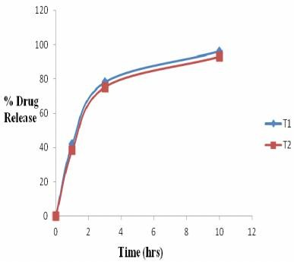

### Fig. No. 7:

**Drug Release Profile of Trial 1 and Trial 2**

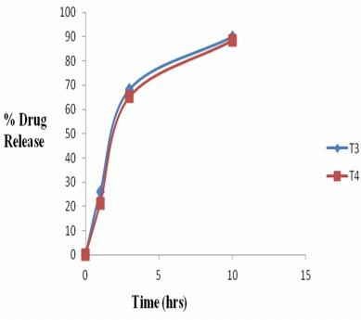

### Fig. No. 8:

**Drug Release Profile of Trial 3 and Trial 4**

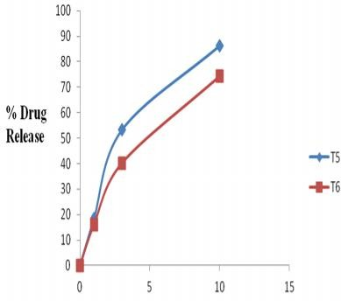

### Fig. No. 9:

**Drug Release Profile of Trial 5 and Trial 6**

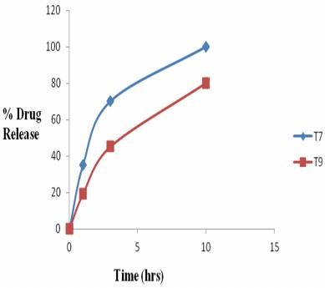

### Fig. No. 10:

**Drug Release Profile of Trial 7 and Trial 9**

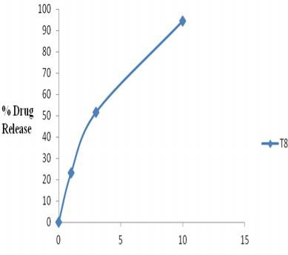

### Fig. No. 11:

**Drug Release Profile of Trial 8**

### Optimized batch

From the result of dissolution study, in the first 3 trial batches initial burst release was seen. Then from the 4th trial, xanthan gum was used alonwith HPMC K100M. Hence initial burst release was sustained to some extent. In the 6th trial the xanthan gum 20% was optimized, as the initial burst release was sustained but fails in the 3rd hour and 10th hour. Then in the subsequent trials, the concentration of HPMC K100M was varied keeping the concentration of xanthan gum same.

The optimized batch obtained is the 8th trial which follows the dissolution parameter as per the USP 32.

### Precompression Parameters of Trial 8 Bulk density = 0.6657 g/ml

**Tapped density =** 0.834 g/ml **Carr’s index =** 18.49% **Hausners ratio =** 1.237 **Angle of repose =** 23054’

### Post compression parameters

Trial 8 was found the optimized batch.

### Uniformity of weight

**Weight of 20 tablets =** 19.55 g

**Average weight of tablet =** 0.9775 g

As per USP 32, average weight of tablet is more than 324 mg, therefore the percentage difference is 5%.

### Table No. 16: Post compression parameters of 9 Trials

|  |  |  |  |  |  |  |
| --- | --- | --- | --- | --- | --- | --- |
| **Formulation Weight of** | | **Length** | **Breadth** | **Thickness** | **Hardness** | **Friability** |
|  | **tablet (g)** | **(mm)** | **(mm)** | **(mm)** | **(kg/cm2)** | **(%)** |
| **Trial 1** | 0.9908 | 19.45 | 9.53 | 6.34 | 18 | 0.16 |
| **Trial 2** | 0.9601 | 19.47 | 9.52 | 6.53 | 19 | 0.19 |
| **Trial 3** | 0.9828 | 19.45 | 9.54 | 6.57 | 17 | 0.15 |
| **Trial 4** | 0.9760 | 19.35 | 9.45 | 6.57 | 18 | 0.18 |
| **Trial 5** | 0.9841 | 19.46 | 9.46 | 6.59 | 16 | 0.17 |
| **Trial 6** | 0.9782 | 19.37 | 9.52 | 6.54 | 18.5 | 0.14 |
| **Trial 7** | 0.9772 | 19.36 | 9.45 | 6.45 | 19.5 | 0.16 |
| **Trial 8** | **0.9762** | **19.46** | **9.52** | **6.55** | **17.5** | **0.18** |
| **Trial 9** | 0.9559 | 19.47 | 9.53 | 6.46 | 18 | 0.15 |

**Kinetic Study of Optimized Batch**

### Table No. 17: Kinetic Study of Optimized batch

**Coefficient of Correlation**

|  |  |  |  |  |  |
| --- | --- | --- | --- | --- | --- |
| **Formulation** | **First**  **order** | **Zero**  **order** | **Higuchi**  **Model** | **Hixon-Crowel Cube**  **Root Law** | **Korsmeyer-Peppas**  **Model** |
| **Trial 8** | 0.998 | 0.932 | 0.995 | 0.997 | - |

From the kinetic study point of view the in vitro release profile of trial batch 8 was fitted in all the five models. The ‘R’ value is greater for first order kinetics. Therefore, Trial batch 8 followed the first order kinetics.

## Acknowledgment

The authors are thankful to Twilight Litaka Pharma Ltd., Pune for providing Metformin HCl and other excipients as gift samples and facilities to carry out the work. I am also thankful to P. Wadhwani College of Pharmacy, Yavatmal, India for supporting me in successful completion of this work.

## References

1. Jaleh Varshosaz, Naser Tavakoli, and Fatemeh Kheirolahi, AAPSPharmSciTech, 2006, 7(1), Article 24, E1-E5.
2. Sean C Sweetman, Martindale The Complete Drug Reference (2009), 36th Edition, Published by Pharmaceutical Press 437,453.
3. The United States Pharmacopoeia 32 National Formulary 27, United States Pharmacopoeia convention, Inc., Rockville, MD, 2009, 2907.
4. Weight Variation Test, The United States Pharmacopoeia 32 National Formulary 27, United States Pharmacopoeia convention, Inc., Rockville, MD, 2009, 785.
5. Lachman L., Liberman H.A., Kanig J.L., The Theory and Practice of Industrial Pharmacy, 3rd Edn., 3rd Indian Reprint, Varghese Publishing House, Bombay, 1990, 297-298.
6. Fulzele S. V., and Mandaogade P. M., Ind. J. Pharm. Sci., 64 (2), 2002, 138141.
7. Remington's Pharmaceutical Sciences, The Science and Practice of Pharmacy, Mack Publishing Company, Volume 1, 19th Edn, 1669-1670.
8. Tablet Friability Test, The United States Pharmacopoeia 32 National Formulary 27, United States Pharmacopoeia convention, Inc., Rockville, MD, 2009, 725.
9. McClelland G. A., Sutton S., Engle K., Zetner G. M., Pharm. Res., 8, 1991, 88-92.
10. The United State Pharmacopoeia, (USP32- NF27), The Official compendia of Standards, United State Pharmacopoeial Convection Inc. Rockville, 2009, 2907.