***Original Article***



**ISSN Print 2231 – 3648**

**Online 2231 – 3656**

PREFORMULATION PARAMETERS CHARACTERIZATION TO DESIGN, DEVELOPMENT AND FORMULATION OF METOPROLOL SUCCINATE EXTENDED RELEASE TABLETS FOR ORAL USE

## *1Chandrasekhar Rangaiah K, 2Abbulu K, 3Bhaskar rao R

*1Vision College of Pharmaceutical Sciences & Research, Hyderabad, A.P, India - 500 060.

2MallReddy Institute of Pharmaceutical Sciences, Secundrabad, A.P, India - 500 014.

3Natco Pharma Pvt Ltd, kothur, Mahaboob Nagar dt, A.P, India - 509 228.

### Abstract

Tablets of Metoprolol succinate were prepared by direct compression method using Excipients such as HPMC K4M, HPMC K15M, HPMC K100M (rate controlling polymers for extended release, tablet binder), Ethyl cellulose (tablet filler and binder), Colloidal anhydrous silica as tablet disintegrant, microcrystalline cellulose as superdisintegrant, Sodium stearyl fumerate, is used as lubricant. So before selection of all these excipients as well as direct compression method, the Preformulation study of drug Metoprolol succinate is completed for successful formulation of tablet. The % compressibility was calculated of this drug which is required in the selection of direct compression method and was found 13.94% which suits for this direct compression method. The stability of drug was studied in distilled water, Phosphate Buffer 6.8 and as well as in 0.1N HCl which was required for drug analysis to check release profile without degradation of drug in these solvent and found as such no degradation of drug in water, Phosphate Buffer 6.8 as well as in the 0.1N HCl. The drug - excipient compatibility study is carried by simple physical mixing as well as by Infrared Spectroscopy (IR), and as such no major interaction was found between Metoprolol succinate and all selected excipients (HPMC K4M, HPMC K15M, HPMC K100M, Ethyl cellulose, Colloidal anhydrous silica, microcrystalline cellulose, Sodium stearyl fumerate). The drug release from tablet was studied by UV Spectrophometer so interference of additives during analysis was also checked and as such no interference was found by any excipient in the spectral analysis as well as estimation of drug. The solubility of Metoprolol succinate was also calculated and found 95896µg/ml respectively.

**Key words:** Metoprolol succinate, Compatibility studies, Percentage Compressibility, Stability of drug.

# Introduction

The development of controlled-release formulations1-7 continues to be a big success for the Pharmaceutical industry. The success of any technology relies on the ease of its manufacturing process and its reproducibility of desirable biopharmaceutical properties. Metoprolol is a selective β1 blocker. It acts by blocking β1 receptors which are responsible for increasing heart rate and force of contraction leads to decrease in blood pressure.

***Author for Correspondence:***

## Chandrasekhar Rangaiah K,

Vision College of Pharmaceutical Sciences & Research, Hyderabad, A.P, India - 500 060.

Email: [kcsrangaiah@yahoo.com](mailto:kcsrangaiah@yahoo.com)

It also exhibits its action through vasodilation; hence it is selective β1 blocker, leads to absence of blockade of β2 receptors which mediate vasodilation8. In the design of quality drug products, excipients and polymers play an important role. Excipients are the chemical substances which affect the functionality, stability and drug release behavior.

Preformulation9 commences when a newly synthesized drug shows sufficient pharmacologic promise in animal models to warrants evaluation in man. These studies should focus on those physicochemical properties of the new compound that could affect drug performance and development of an efficacious dosage form. A thorough understanding of these properties may

ultimately provide a rational for formulation design, or support the need for molecular modification. Excipients9,10 are selected in formulation development on the basis of its compatibility and functionality with the selected active pharmaceutical ingredient. The % compressibility was calculated because we want to prepare tablet by direct compression method due to cost effective factor as well as easy and less time to manufacture. Directly compressed11 display compression characteristics and have swelling properties that lead to a rapid formation of external layer, allowing drug release modification. The drug is freely soluble in water which is good for dissolution study.

# Method and Materials

Metoprolol succinate USP12 obtained as a gift samples from Sania Human cure pvt. Ltd, kashi nagar, Uttaranchal (India), HPMC K4M, HPMC K15M, HPMC K100M were obtained from Colorcon Asia Pvt.Ltd.,Goa, India. Sodium stearyl fumerate, colloidal anhydrous silica was purchased from SD Fine Chemicals (Mumbai, India). Ethyl cellulose, microcrystalline cellulose (pharmaceutical grade) was purchased from G.R.Traders, Hyderabad. All other chemical were of high analytical grade obtained from Vision College of pharmaceutical sciences & Research, Boduppal, Hyderabad. Double distilled water was used throughout the study.

### Preparation of Calibration Curve of Metoprolol succinate in Phosphate Buffer 6.8

The UV scanning of drug sample was carried out using a solution of drug dissolved in 6.8 pH phosphate buffer solution12,13. The lambda max (max) was observed at 222nm. The graph is shown in Figure 1. The calibration curve of Metoprolol succinate was obtained by dissolving the drug in 6.8 pH phosphate buffer solution and the absorbance was measured at 222nm by keeping 6.8 pH phosphate buffer solution as blank. Beers law14 was obeyed in the concentrations range of 1- 30 μg/ml in 6.8 pH phosphate buffer solution. 100 mg of Metoprolol succinate was accurately weighed and taken in 100 ml volumetric flask. Drug was dissolved in 6.8 pH phosphate buffer solution and ultra sonicated for 10 min to ensure complete dissolving of drug, which give a concentration of 1000 µg/ml. From stock I, 10 ml is taken and

diluted to 100 ml which give a concentration of 100 µg/ml solution, this is stock II. From the above stock II solution 0.5, 1.0, 1.5, 2.0 and 3.0 ml were withdrawn into 10 ml volumetric flasks and diluted up to the volume with 6.8 pH phosphate buffer solution. The result is shown in Table 1. The graph is shown in Figure 2.

**Determination of Solubility15 of Metoprolol succinate** Excess of drug was placed in distilled water and this solution was occasionally stirred for 24 hours at room temperature. After 24 hours sample was filtered and filtrate was suitably diluted and absorbance was taken at 222.0 nm against distilled water as blank on UV – Visible spectrophotometer (UV – 3000). The result is shown in table 2.

**Observation:** Absorbance of Metoprolol succinate in distilled water: 0.631 A.

**Stability of Metoprolol succinate in Solvents16 Stability of Metoprolol succinate in distilled water** Stability of Metoprolol succinate in distilled water was determined by keeping the known concentration (20 μg/ml), in kinetic mode of UV–Visible spectrophotometer (UV–3000 Lab India) for 30 min. The data obtained is shown in table3.

### Stability of Metoprolol succinate in 0.1N HCl

Stability of Metoprolol succinate in 0.1N HCl was determined by keeping the known concentration (15 μg/ml), in kinetic mode of UV–Visible spectrophotometer (UV–3000 Lab India) for 30 min. The data obtained is shown in table 4.

**Stability of Metoprolol succinate in Phosphate Buffer 6.8**

Stability of Metoprolol succinate in Phosphate Buffer

6.8 was determined by keeping the known concentration (20 μg/ml), in kinetic mode of UV–Visible spectrophotometer (UV–3000 Lab India) for 30 min. The data obtained is shown in table 5.

### Spectral Analysis of Additives at 222nm to determine any interference with Drug

The highest concentration of the additives that would be present in 500 ml of dilution media was estimated on the basis of amount present in per tablet of different batches and the same quantities of different additives were taken in 100ml volumetric flasks made

up volume with water and shaken thoroughly and filtration was done, filtrate taken for spectral scan at 222.0nm in UV–Visible spectrophotometer (UV–3000, Lab India).

### Determination of interference of additives in the estimation of Metoprolol succinate

The highest concentration of the additives that would be present in 500 ml of dilution media was estimated on the basis of amount present in per tablet of different batches and the same quantities of different additives were taken in 10 ml volumetric flasks containing 10 ml of 20 μg/ ml concentration of Metoprolol succinate solution. The flasks were kept for

24 hours with occasional shaking and filtration was done. The absorbance of filtrate were measured at 222 nm on UV–Visible spectrophotometer (UV–3000) and compared with the absorbance of control drug sample of 20 μg/ ml concentration without additives. Observations are shown in table 6.

### Determination of % Compressibility14

I = Dt - Db * 100

Dt

Bulk Density (Db) = 0.327 (Calculated) Tapped Bulk Density (Dt) = 0.38 (Calculated) I = (0.38 – 0.327 / 0.38) * 100 = 13.94

### Drug–Excipient Compatibility Studies17

A small amount of drug substance with excipients that is, physical mixture of the drug and excipients (in 1:1 ratio were prepared to have maximum likelihood interaction between them) was placed in a vial, and rubber stopper was placed on the vial and sealed properly. A storage period study was done for 1st, 2nd , 3rd month at 40ºC/75%RH. After storage the sample were observed physically for liquefaction, caking, odour or gas formation, discoloration. The compatibility study is also carried out by IR Spectroscopy curves are shown below. The overall observations are recorded in table 7.

### IR Spectroscopic Studies18

IR Spectra of pure Metoprolol Succinate and in combination with tablet excipients (physical mixture) were recorded between 4000-450cm-1. The chemical

structure of Metoprolol Succinate shown in figure 7. The spectra are shown in figure 8.

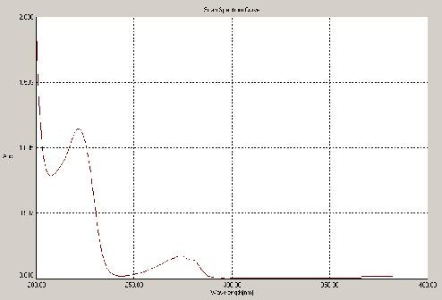

### Figure 01: Scan Spectrum curve of Metoprolol succinate showed at 222 nm

**Table 01: Absorbance Vs concentration at 222 nm**

1.2

1

0.8

0.6

0.4

0.2

0

y = 0.0323x + 0.0136

R2 = 0.999

0 5 10 15 20 25 30 35

**cocentration((μg/ml)**

|  |  |  |  |  |
| --- | --- | --- | --- | --- |
| **Concentration** |  |  | **Absorbance** |  |
| **(μg/ml)** | **Set 1** | **Set 2** | **Set 3** | **Average ± SD** |
| 0 | 0.000 | 0.000 | 0.000 | 0.000 |
| 5 | 0.185 | 0.188 | 0.191 | 0.188±0.003 |
| 10 | 0.356 | 0.360 | 0.352 | 0.356±0.004 |
| 15 | 0.487 | 0.480 | 0.484 | 0.484±0.003 |
| 20 | 0.646 | 0.649 | 0.652 | 0.649±0.003 |
| 30 | 0.981 | 0.987 | 0.993 | 0.987±0.006 |

### Figure 02: Calibration curve of Metoprolol succinate USP in Phosphate buffer (pH 6.8) at 222 nm

**Absorbance**

**Table 02: Solubility of Metoprolol succinate in Distilled Water**

**Solvent Solubility Interference**

Distilled water 95896 μg/ ml Freely soluble

Concentration mcg / ml

### Table 04: Stability of Metoprolol succinate in 0.1N HCl in Kinetic Mode of UV- Visible Spectrophotometer at max 222.0 nm (Absorbance of 15 μg/ ml drug solution is 0.439)

**Time**

|  |  |  |
| --- | --- | --- |
| **(seconds)** |  | |
| 0 | 0.439 | 0.000 |
| 200 | 0.445 | -0.004 |
| 400 | 0.440 | 0.001 |
| 600 | 0.439 | 0.000 |
| 800 | 0.437 | -0.002 |
| 1000 | 0.437 | -0.002 |
| 1200 | 0.439 | 0.000 |
| 1400 | 0.442 | 0.003 |
| 1600 | 0.439 | 0.000 |
| 1800 | 0.437 | -0.002 |

**Absorbance dA**

### Figure 03: Metoprolol succinate in Distilled water in kinetic mode for 1800 seconds

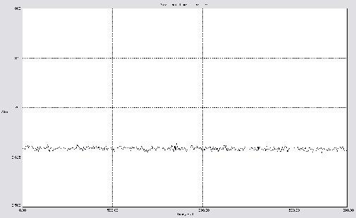**Table 03: Stability of Metoprolol succinate in Distilled Water in Kinetic Mode of UV- Visible Spectrophotometer at** **max 222.0 nm (Absorbance of 20 μg/ ml drug solution is 0.658)**

**Time**

|  |  |  |  |
| --- | --- | --- | --- |
| **(seconds)** |  | | |
| 0 | 0.658 | 0.000 |  |
| 200 | 0.668 | 0.010 |  |
| 400 | 0.659 | 0.011 |  |
| 600 | 0.657 | 0.009 |  |
| 800 | 0.658 | 0.000 |  |
| 1000 | 0.662 | 0.004 |  |
| 1200 | 0.662 | 0.004 | **Figure 05: Metoprolol succinate in Phosphate Buffer 6.8** |
| 1400 | 0.661 | 0.003 | **in kinetic mode for 1800 seconds** |
| 1600 | 0.663 | 0.005 |  |
| 1800 | 0.663 | 0.005 |  |
|  |  |  | **Table 5: Stability of Metoprolol succinate in** |
|  |  |  | **Phosphate Buffer 6.8 in Kinetic Mode of UV- Visible** |
|  |  |  | **Spectrophotometer at**  **max 222.0 nm** |
|  |  |  | **(Absorbance of 20 μg/ ml drug solution is 0.646)** |
|  |  |  | **Time Absorbance dA** |

**Absorbance dA**

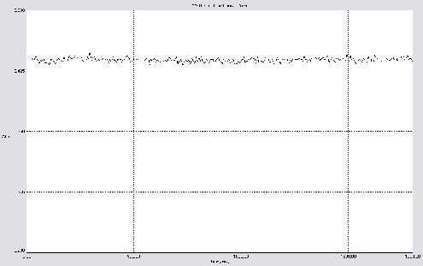

### Figure 04: Metoprolol succinate in 0.1N HCl in

|  |  |  |
| --- | --- | --- |
| **(seconds)** |  | |
| 0 | 0.646 | 0.000 |
| 200 | 0.649 | 0.003 |
| 400 | 0.646 | 0.000 |
| 600 | 0.641 | -0.005 |
| 800 | 0.646 | 0.000 |
| 1000 | 0.646 | 0.000 |
| 1200 | 0.648 | 0.002 |
| 1400 | 0.644 | -0.002 |
| 1600 | 0.645 | -0.001 |
| 1800 | 0.643 | -0.003 |

**kinetic mode for 1800 seconds**

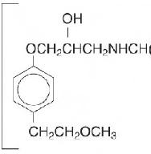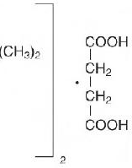

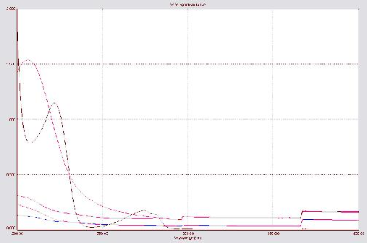**Figure 06: Spectral Analysis of Additives and Drug**

**Table 06: Interference of Additives in the Estimation of Metoprolol succinate in Distilled water at 222.0 nm (Absorbance of plain drug solution (20 μg/ ml): 0.658 A)**

|  |  |  |  |
| --- | --- | --- | --- |
| **S.No.** | **Additives** | **Absorbance** | **Interference** |
| 1 | Hpmc K4M | 0.654 | Nil |
| 2 | Hpmc K15M | 0.659 | Nil |
| 3 | Hpmc K100M | 0.655 | Nil |
| 4 | Ethyl Cellulose | 0.650 | Nil |
| 5 | Micro crystalline cellulose | 0.660 | Nil |
| 6 | Colloidal Anhydrous silica | 0.656 | Nil |
| 7 | Sodium stearyl fumerate | 0.654 | Nil |

### Figure 07: Chemical structure of

**Metoprolol Succinate USP**

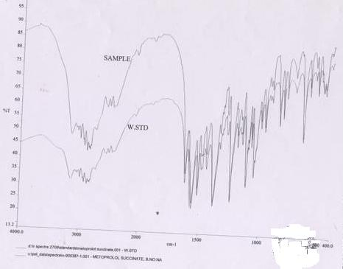

### Figure 08: IR Spectra of Metoprolol succinate USP

**Table 07: Drug-Excipient Compatibility Observations**

**Additives( 50 mg each)**

**Observations at 400C/75%RH Observations at 400C/75%RH**

**Observations at 400C/75%RH**

**Remark**

**with drug**

**for 1st month**

**for 2nd month**

**for 3rd month**

Drug

(Metoprolol succinate)

No Change

No Change No Change

Accepted

Drug+ Hpmc K4M No Change

Drug+ Hpmc K15M No Change Drug+ Hpmc K100M No Change Drug+ Ethyl Cellulose No Change

No Change No Change

No Change No Change

No Change No Change

No Change No Change

Accepted Accepted Accepted Accepted

Drug+ Micro crystalline cellulose

Drug+ Colloidal Anhydrous silica Drug+ Sodium stearyl fumerate

No Change No Change No Change

No Change No Change

No Change No Change

No Change No Change

Accepted Accepted Accepted

# Results and Discussion

There was no significant change in the

absorbance

water as well as in Phosphate Buffer pH 6.8. The

value of Metoprolol succinate up to 30 minute, which indicates that Metoprolol succinate is stable in distilled

calibration curve shows a concentration (0 – 30 µg /

linear relation between ml) and absorbance. It

shows that Beer Lambert law is obeyed in the

concentration range of 5 – 30 μg / ml. There was no significant change of absorbance was observed between additives and drug sample solutions. This indicates there was no interference with Metoprolol succinate during analysis by UV spectrophotometer. Spectral Analysis of Additives at 222.0 nm had shown no interference with Drug. Calculated value of % compressibility (13.94) indicates that Metoprolol succinate is suitable for direct compression as well as having good flow property so almost negligible chances of weight variation during filling of dye by the blend. Compatibility studies performed on the physical mix of Metoprolol succinate and different tablet excipients at temperature 40**0**C/75%RH no physical changes observed. The characteristics spectral bands of Metoprolol succinate were not significantly affected in the physical mixture of drug and excipients. All the characteristics bands of the drug were retained at their respective positions in the IR spectra of drug-excipient physical mixtures. This indicates that during the formulation the components have not undergone any chemical reaction during any stage of tablet formulation. No significant shift in the position of the characteristics bands observed this shows that there was no interaction between Metoprolol succinate and the selected tablet excipients in the physical mixtures**.**

# Conclusion

In the light of this research work, it may be concluded that tablets of Metoprolol succinate can be made by direct compression method by using K4M, HPMC K15M, HPMC K100M, Sodium stearyl fumerate, colloidal anhydrous silica, Ethyl cellulose, microcrystalline cellulose as suitable excipients as all they showed the compatibility with the Metoprolol succinate.

# References

1. Ansel,H.C., Allen, L.V., and Popvich, N.G., Pharmaceutical Dosage Forms and Drug Delivery systems, Seventh Edition(1999), Lippincott Williams and wilkins, Philadelphia, USA, 179-228.
2. [www.drugs.com/cdi/metoprolol-succinate-extended-](http://www.drugs.com/cdi/metoprolol-succinate-extended-) release-tablets.html
3. [www.rxlist.com/toprol_xl-drug.](http://www.rxlist.com/toprol_xl-drug)
4. Khan,K.A., and Rhodes, C.T., The Production of Tablets by Direct Compression, Can. J. Pharm,Sci., 1973, 8: 1-5.
5. Shangraw, R.F., Compressed Tablets by Direct Compression Granulation Pharmaceutical Dosage

Forms: Tablets, Vol.-1, Marcel Dekkar, USA, Second Edition, (1989), 195-246.

1. Raymond C Rowe, Paul J Sheskey and Sian C Owen, Handbook of Pharmaceutical Excipients, Fifth Edition (2006), Ph. Press, Royal Pharmaceutical society of Great Britain, AphA, Washington DC, 188-191,278- 282,346-349,430-433,705-707.
2. Lordi NG. Sustained release dosage forms. In Lachman L, Liberman HA, Joseph LK. The Theory and Practice of Industrial Pharmacy, 3rd ed. Varghese Publishing House, Bombay, 1986, 430-456.
3. [www.tapi.com](http://www.tapi.com/)
4. Lachman,L., Liberman, H.A., and Kanig, J.L., The Theory and Practice of Industrial Pharmacy, Lea & Febiger, Philadelphia, 1986,171-195.
5. 10. Armstrong, N.A., Selection of Excipients for Direct Compression Tablet Formulation, Pharm.Technol. Eur., 1997, 9: 24-30.
6. Antonio Moronim, A Novel Copovidone Binder for Dry Granulation and Direct Compression Tableting, Pharm. Technol., 1986, 24: 8 –12.
7. [www.usp.org](http://www.usp.org/)

13. USP34-NF29, edision 2007, pg no:2695 -2696.

1. Backett, A.H., and Stenlake, J.B., Practical Pharmaceutical Chemistry, First Edition, Reprint, 2004, CBS Publishers and Distributors, New Delhi, 275 – 325.
2. Carstensen, J.T., Pharmaceutical Preformulation, 1998, Technomic Publishing Company, Inc., New Holland Avenue, Lancaster, Pennysylvania, USA, 13 – 24, 41 –48, 259 – 274.
3. M.M.Gupta, T.R.saini, Preformulation parameters characterization to design,development and formulation of vancomycin hydrochloride tablets for psudomembranous colitis, IJPRD/2009/PUB/ ARTI/VOL-1/ISSUE-9/NOV/002
4. [www.ikev.org/ICH](http://www.ikev.org/ICH) Q1A(R2) Guideline/Stability Testing of New Drug Substances and Products.
5. Vogal’s Textbook of Quantitative Chemical Analysis, Fifth Edition, reprint, 1996, English Language Book Society, London, 645–51, 752–55.
6. Jhon coates, coates consulting, Newtown,USA. Interpretation of infrared spectra, A practical Approach,infrared.als.lbl.gov/BLManual/IR.Interpr-

-etation. Pdf

1. Pavia, D.L., Lampman, G.M., and Kriz, G.S., Introduction to Spectroscopy, Third Edition, 2001, Harcourt College Publishers, Orlando, Florida, USA, pp. 36-107,353 – 359.