## Original Article



**ISSN Print 2231 – 3648**

**Online 2231 – 3656**

DEVLOPMENT AND *IN VITRO* EVALUATION OF GASTRORETENTIVE FLOATING TABLETS OF FAMOTIDINE

### *1Muqtader Mohammed, 2Sadath Ali

*1School of Pharmacy and Medical Sciences, Singhania University, Rajasthan-333 515, India.

2Himalayan Institute of Pharmacy and Research, Dehradun, Uttarkhand-248002, India.

**Abstract**

The present study reports the development and *in vitro* evaluation of gastro retentive floating tablets of Famotidine. The formulations were developed using cellulose derivatives such as HPMC K4M, HPMC K15M and HPMC K100M in different ratios with gas generating agents and other excipients by wet granulation technique. The formulations were subjected to various evaluation parameters *in vitro, viz*., hardness, friability, uniformity of drug content, in *vitro* floating studies*, in vitro* dissolution studies, all the formulations were good in appearance and showed better physical and mechanical properties. Formulation M15 containing HPMC K4M

80 mg, Sodium bicarbonate 40 mg, 30 mg citric acid and PVP K30 10mg was found to be the best formulation in terms of drug release and *in vitro* buoyancy time and was subjected to stability studies and IR spectroscopy .The results indicate that the formulation was stable and there was no chemical interaction between the polymer and the drug.

**Key words:** Famotidine, HPMC K4M, *In vitro* buoyancy*, In vitro* Dissolution studies, IR Spectroscopy.

# Introduction

Gastric emptying is a complex process and is highly variable and results in uncertain absorption of drugs this can be overcome by a proper drug delivery system such as gastro retentive drug delivery system. The GRDDS can be used to retain the drug in the stomach thereby increasing the absorption and bioavailability of the drug. This system is particularly important for the drugs which have higher absorption rate in a particular region of gastrointestinal tract1. Famotidine is a potent H2 receptor antagonist used in the treatment of peptic ulcer, reflex eosophagitis etc. It is absorbed mainly at a specific absorption site in the GIT. A dosage form which can retain Famotidine at its absorption site for an extended period will increase its absorption and bioavailability2.

## Author for Correspondence:

### Muqtader Mohammed,

School of Pharmacy and Medical Sciences, Singhania University, Rajasthan-333 515, India. Email: [naveedpharmaco@yahoo.com](mailto:naveedpharmaco@yahoo.com)

So the present study was designed to develop gastro retentive floating tablets of Famotidine using easily available and relatively economical cellulose derivatives *viz*., HPMC K4M, HPMC K15M and HPMC K100M.

# Materials and Methods

Famotidine was obtained as a gift sample from Sreenivasa Pharmaceuticals Pvt. Ltd, Hyd. HPMC K4M, HPMC K15M and HPMC K100M were obtained as a gift sample from Colorcon Asia Pvt. Ltd., Goa. All other chemicals were of analytical grades and were used as procured. Materials and excipients used in GRDDS were of IP grades.

#### Preparation of Gastro Retentive Floating Tablets of Famotidine

The gastro retentive tablets were prepared by wet granulation method using different ratios of polymers as described in Table No:1 PVP K30 was used as granulating agent and citric acid, sodium bicarbonate were used as gas generating agent, lactose, Micro

crystalline cellulose was used as diluents. All the ingredients were accurately weight and passed

through sieve no. 60. Drug and the excipients except Magnesium stearate and talc were bended geometrically in mortor and pestle and then granulating agent was added granules were obtained by passing the mass through sieve no 12 the resulting granules were dried at 60oC for 4 hour. The dried granules were passed through sieve no. 18 and lubricated with Magnesium stearate and talc. The granules so obtained were compressed into tablets using tablet compression machine3 (Rimek mini press machinery Co. Pvt. ltd., India).Seventeen formulations were prepared and coded as M1, M2 and so on.

#### Evaluation of Gastro Retentive Floating Tablets of Famotidine

The prepared gastro retentive tablets were evaluated for hardness (Monsantotester), friability (Rochetype friabilator), weight variation4,5, drug content estimation, floating lag time and total floating time.

***In vitro* Buoyancy Studies**

*In- vitro* buoyancy studies were performed for all the eight formulations as per the method described by Rosa *et al6* Randomly selected tablets from each formulation were introduced in a 100ml beaker containing simulated gastric fluid, PH 1.2 as per USP. The time taken for the tablet to rise to the surface and float was taken as floating lag time (FLT). The time for which the dosage form constantly remained on the surface of medium was determined as the total floating time (TFT).The results were depicted in Table.No-2

#### Drug Content Estimation

The drug content in each formulation was estimated by triturating 20 tablets. Powder equivalent to 10 mg of Famotidine was added in 100ml of 0.1N HCl followed by stirring for 10 minutes. The stock solution was diluted suitably and the absorbance of resultant solution was measured at 265 nm by using Elico-UV- Visible Spectrophotometer (SL-159) 0.1N HCl was used as blank5.

***In vitro* Dissolution Studies**

The release rate of Famotidine from floating tablets was determined using USP dissolution apparatus II (Lab Hosp India). The dissolution test was performed using

900 ml of 0.1N hydrochloric acid, at 37 ± 0.5°C and 50 rpm. Aliquots 5ml was collected at predetermined time intervals and replenished with an equivalent volume of fresh medium. The samples were filtered through a 0.45 μm membrane filter and diluted suitably with 0.1N HCl and were analyzed using Elico UV/Visible spectrophotometer at 265 nm 7. The results are illustrated in Figure-1.

#### Short Term Stability Studies

To evaluate the formulation stability ICH guidelines were followed. The best formulation was tested for short term stability for 4 weeks at 250C ±2 0C/60% RH ±5% and accelerated stability for period of 12 weeks at 400C ±20C/75 % RH ± 5%, for their drug content and other parameters8.

#### FTIR Spectroscopy

IR spectra were obtained for A pure drug Famotidine, B HPMC K4M, and C) Famotidine with HPMC K4M. The sample pellet was mounted in IR compartment and scanned at wavelength 40000cm-1-600cm-1.The IR spectrum is depicted in Figure 4A, 4B, and 4C.

# Results and Discussion

The prepared tablets were subjected to various evaluation parameters like hardness, friability, weight variation, drug content estimation, floating lag time and total floating time. The hardness of tablets was found to be in the range of 4.36 to 5.06 kg/cm2, friability of all the formulations was found to be less than 1% i.e 0.54-0.73%, weight variation, 91.3±5.8 to 223.32±7.8 indicating good physical strength of the formulation. The drug content of the formulations was in the range 96.69 to 100.85 showing the uniform distribution of the drug, total floating time of all the formulations was around 24 hours which may be an efficient parameter for the enhanced gastric retention time of the formulation. *In vitro* buoyancy studies indicated that the formulations containing Sod bicarbonate showed decrease in floating lag time. Addition of MCC along with Sodium bicarbonate further reduced the floating lag time. Faster buoyancy was observed in the formulations containing a combination of Citric acid and sodium bicarbonate may be attributed to immediate formation of CO2.

#### Table 01: Composition of Gastro Retentive Floating Tablets of Famotidine

**Formulation Code**

**HPMC K4M HPMC K15M**

**HPMC K100M Lactose MCC Sodium bicarbonate**

**Citric acid PVP K30**

|  |  |  |  |  |  |  |  |  |
| --- | --- | --- | --- | --- | --- | --- | --- | --- |
| **M1** | 40 | - | - | - | - | - | - | 08 |
| **M2** | 80 | - | - | - | - | - | - | 10 |
| **M3** | 100 | - | - | - | - | - | - | 12 |
| **M4** | - | 40 | - | - | - | - | - | 08 |
| **M5** | - | 80 | - | - | - | - | - | 10 |
| **M6** | - | 100 | - | - | - | - | - | 12 |
| **M7** | - | - | 40 | - | - | - | - | 08 |
| **M8** | - | - | 80 | - | - | - | - | 10 |
| **M9** | - | - | 100 | - | - | - | - | 12 |
| **M10** | 80 | - | - | 20 | - | 20 | - | 10 |
| **M11** | 80 | - | - | 20 | - | 40 | - | 10 |
| **M12** | 80 | - | - | - | 20 | 20 | - | 10 |
| **M13** | 80 | - | - | - | 20 | 40 | - | 10 |
| **M14** | 80 | - | - | - | 20 | 20 | 15 | 10 |
| **M15** | 80 | - | - | - | 20 | 40 | 30 | 10 |
| **M16** | 80 | - | - | - | 20 | 20 | 10 | 10 |
| **M17** | 80 | - | - | - | 20 | 20 | 05 | 10 |

Note: All the quantities are expressed in terms of milligrams. Each formulation contains 40 mg of Famotidine, 0.5% of talc and 1% of magnesium steartae.

#### Table 02: Results of Evaluation Gastro retentive Floating Tablets of Famotidine

|  |  |  |  |  |  |  |
| --- | --- | --- | --- | --- | --- | --- |
| **Formulation cod** | **e Hardness (kg/cm2)** | **Friability (%)** | **Drug content (%)** | **Average weight Bu**  **(mg)** | **oyancy Lag Time ( Se** | **c ) Total Floating**  **Time (hrs)** |
| **M1** | 4.65 | 0.62 | 97.62 | 91.7±2.3 | 60 Sec | 24 |
| **M2** | 4.36 | 0.63 | 98.87 | 113±7.5 | 90 Sec | 24 |
| **M3** | 4.93 | 0.55 | 99.37 | 155.9±4.8 | 95 Sec | 24 |
| **M4** | 4.58 | 0.58 | 97.37 | 91.85±6.8 | 75 Sec | 24 |
| **M5** | 4.45 | 0.72 | 99.40 | 113.35±2.9 | 100 Sec | 24 |
| **M6** | 4.76 | 0.68 | 99.62 | 155.75±5.4 | 102 Sec | 24 |
| **M7** | 4.83 | 0.62 | 100.85 | 91.3±5.8 | 80 Sec | 24 |
| **M8** | 4.98 | 0.65 | 99.07 | 113.25±9.7 | 105 Sec | 24 |
| **M9** | 4.98 | 0.56 | 97.45 | 155.2±4.8 | 120 Sec | 24 |
| **M10** | 5.06 | 0.54 | 98.62 | 173.4±2.8 | 10 Sec | 24 |
| **M11** | 4.86 | 0.58 | 99.15 | 193.05±7.8 | 07 Sec | 24 |
| **M12** | 4.95 | 0.65 | 100.42 | 193.2±3.9 | 05 Sec | 24 |
| **M13** | 5.00 | 0.61 | 99.72 | 213.05±8.8 | 02 Sec | 24 |
| **M14** | 4.98 | 0.63 | 99.25 | 173.25±7.3 | 01 Sec | 24 |
| **M15** | 5.02 | 0.65 | 99.50 | 193±7.5 | 50 sec | 24 |
| **M16** | 4.88 | 0.59 | 98.97 | 188.225±6.7 | 90 sec | 24 |
| **M17** | 4.57 | 0.73 | 96.65 | 223.32±7.8 | 02 Sec | 24 |

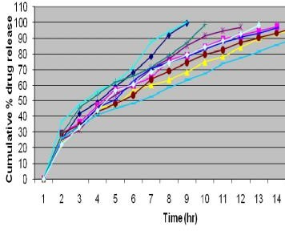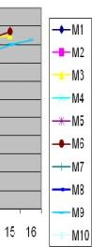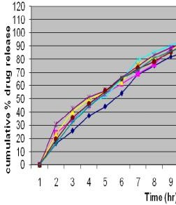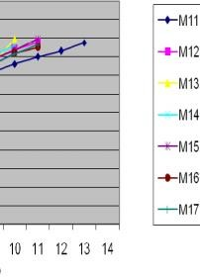

#### Figure 01: Dissolution Profile of Formulation M1 to M10 Gastro Retentive Floating Tablets of Famotidine

**Figure 02: Dissolution Profile of Formulation M11 to**

#### M17 Gastro Retentive Floating Tablets of Famotidine

**Figure 03: Dissolution T50 and T90 Values of Gastro Retentive Floating Tablets of Famotidine**

16

14

12

10

8

6

4

2

0

1 2 3 4 5 6 7 8 9 10 11 12 13 14 15 16 17

**Formulations**

T 50 (hr)

T 90 (hr)

18

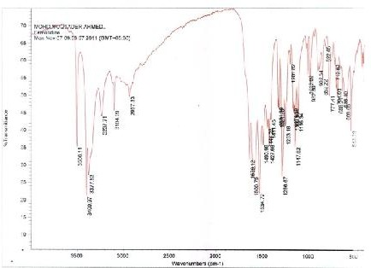

**time (hr)**

#### Figure 04(a): Pure Drug Famotidine

**Table 03: Stability Study of Formulation M15**

**Parameters For 4 weeks at 25 0C**

|  |  |  |
| --- | --- | --- |
|  | **±2 0C/60% RH ±5%** | **±2 0C/75 % RH ± 5%** |
| Physical | No change | No change |
| Average Weight (mg) | 193 | 193 |
| Friability (%) | 0.65 | 0.68 |
| Hardness (kg/cm2) | 5.02 | 5.00 |
| Drug content (%) | 99.15 | 98.99 |
| Buoyancy Lag Time( Sec) | 53 sec | 54 sec |
| Total Floating Time (hrs) | 24 | 24 |
| Cumulative % drug released ± SD 12h | 98.82±0.20 | 97.86±0.42 |
| Buoyancy on disturbing | Float | Float |

**For 12 Week at 40 0C**

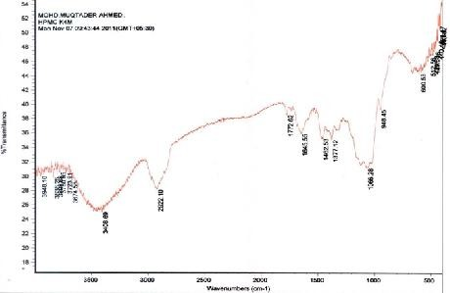

#### Figure 04(b): HPMC K4M

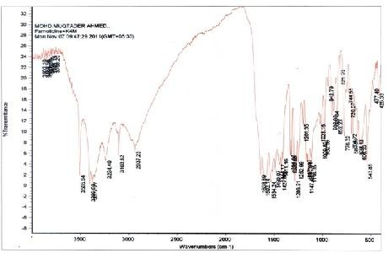

**Figure 04(c): Famotidine with HPMC K4M**

*In vitro* drug release studies exhibited a decrease drug release with an increase in polymer concentration which may be due to increase in viscosity of the gel as well as the gel layer with longer diffusional path. Formulations containing high viscosity grade HPMC showed slower drug release compared to formulations containing low viscosity polymers. There was no considerable effect of gas generating agents on the release of the drug.

IR spectroscopy was carried out for the selected formulation to assess any chemical interaction between the drug and the polymers. The spectrum obtained suggests that there was no chemical interaction between the drug and polymers and there was purely physical entrapment of the drug in the polymer matrix.

# Conclusion

From the results of the study it is evident that the gastro retentive floating tablets of Famotidine can be successfully developed by using cellulose derivatives in combination with gas generating agents and this would be a feasible alternative to conventional oral dosage form of Famotidine in order to retain the drug at the

site of its absorption and to increase the bioavailability of the drug thereby reducing dose or dosing interval.

# References

1. Patel R.P, Baria A.H, Pandya N.B. Stomach-specific drug delivery of famotidine using floating alginate beads. International Journal of Pharm Tech Research, 1(2), 2009, 288-291.
2. Shweta Arora, Javed Ali, Alka Ahuja, Roop K Khar, Sanjula Baboota. Floating drug delivery systems: an updated review. AAPS PharmSciTech, 6, 2005, E372–E390.
3. Banker GS, Anderson NR; Tablets: Lachman L, Lieberman HA, Kanig JL; The Theory and Practice of Industrial Pharmacy 3rded, Varghese Publication House, Bombay, 1987; 296-303.
4. Lachman L, Lieberman A, Herbert K, Joseph L. The theory and practice of industrial pharmacy. 3rd ed, Varghese Publishing House, Mumbai, 1991, 293- 373.
5. Indian Pharmacopoeia. Publications & information directorate (CSIR). New Delhi, 1996, Vol II, 179- 183, 662-663.
6. Rosa M, Zia H, Rhodes T. “Dosing and testing *in vitro* of a bioadhesive and floating drug delivery system for oral application”, Int J Pharm. 105, 1994, 65-70.
7. Zeenath S, Ramesh Gannu, Suresh Bandari. Development of gastroretentive systems for famotidine: *in vitro* Characterization. *Acta Pharmaceutica Sciencia.* 52, 2010, 495-504.
8. “Stability Testing of New Drug Substances and Products” Eur Medicines Agency, 2003, 1-20.
9. Patel Manish P, Patel Madhabhai M, Patel Dipti H, Patel Krisnakumar N. “Formulation Development, Optimization and evaluation of famotidine floating matrix tablets; 1(2), 2009, 85-90.