## Original Article

DOCKING STUDIES ON SYNTHESIZED QUINAZOLINE COMPOUNDS AGAINST ANDROGEN RECEPTOR

*Sri Ramya T, Sathyanathan V, Praveen kumar D, Manasa Chowdhari Ch



Mother Teresa Pharmacy College, Kothur, Sathupally, Andhra Pradesh, India -507 303.

**ISSN Print 2231 – 3648**

**Online 2231 – 3656**

# Introduction

**Abstract**

Quinazolines are found to possess broad spectrum of pharmacological responses. Cancer can be described as the uncontrolled growth of cells and is thought to be caused by the interaction of genetic susceptibility and environmental toxins. Chemotherapy is the most widely used method in the treatment of cancer. The newly synthesized Quinazoline compounds can be screened for their action virtually by the aid of docking softwares such as AutoDock version 1.4 of MGL tools. We performed docking studies for nearly ten derivatives of quinazolines and found that compounds 1e and 1g possess more potent anti-cancer activity than the remaining compounds. This concludes that docking can be employed not only for designing a drug molecule but also to identify its pharmacological activity.

**Key words:** Quinazolines, Cancer, Chemotherapy, Docking, MGL tools.

Bioinformatics is seen as an emerging field with the potential to significantly improve how drugs are found, brought to the clinical trials and eventually released to the market place. Bioinformatics can be thought of as a central hub that unites several disciplines and methodologies. Computer aided drug design (CADD) is a specialized discipline that uses computational methods to stimulate drug-receptor interactions. CADD1 methods are heavily dependent on bioinformatics tools, applications and databases. As such, there is considerable overlap in CADD research and bioinformatics. Computational Biology and bioinformatics have the potential not only of speeding up the drug discovery process, thus reducing the costs but also of changing the way drugs are designed. Rational drug design (RDD)1 helps to facilitate and speed up the drug designing process which involves variety of methods to identify novel compounds.

## Author for Correspondence:

Sri Ramya T,

Mother Teresa Pharmacy College, Kothur, Sathupally,

Andhra Pradesh, India - 507 303. Email: [sriramya98@gmail.com](mailto:sriramya98@gmail.com)

One such method is the Docking of the drug molecule with the receptor (Target). The sight of drug action which is ultimately responsible for the pharmacological effect is Prostate receptor. Docking is a process by which two molecules fit together in 3D space. Nitrogen heterocycles2 exhibit diverse biological and pharmacological activities due in part to the similarities with many natural and synthetic molecules with known biological activity. Moreover, quinazolines are the most extensively studied classes of heterocyclic compounds because of the diverse range of their biological activities and their applications in several areas as materials in electronics, in electrochemistry as anticorrosive agents, as polymers or optical materials and fluorescent tags in DNA sequencing.

The quinazoline moiety is an important pharmacophore moiety showing many types of pharmacological activities. Like benzodiazepines, quinazolines are considered to be the “privileged structure” for drug development. Aromatic quinazolines have found to possess tyrosine kinase inhibiting effects useful to inhibit tumor growth. This has inspired the development of new ring synthesis methods. Cancer can be described

as the uncontrolled growth of abnormal cells coupled with malignant behavior, invasion and metastasis. Cancer is thought to be caused by the interaction between genetic susceptibility and environmental toxins. Prostate cancer3 is a form of cancer that develops in prostate, a gland in the male reproductive system.

The cancer cells may metastasize from prostate to other parts of body particularly the bones and lymph nodes. The androgen receptor also known as NR3C4 (nuclear receptor subfamily 3, group C, member 4), is a type of nuclear receptor that is activated by binding either of the androgenic hormones, testosterone or dihydrotestosterone in the cytoplasm and then translocating into the nucleus. Docking studies4 is a modern tool of drug design and discovery. Through docking study, the activity of the newly synthesized compounds can be predicted. The Protein-Ligand interaction plays a significant role in structural based drug designing.

# Materials and Methods

### Materials

For the present study, bioinformatics tools, biological databases such as PubMed, PDB (Protein Data Bank) and software’s such as AutoDock version 4.0, Pymol (Python Molecule Viewer) and ACD ChemSketch were used.

Pubmed5 is a free digital archive of biomedical and life sciences journal literature at the U.S National Institute of Health (NIH) developed and managed by NIH’s National Library of Medicine (NLM). Pubmed is a free search engine for accessing the MEDLINE database of citations and abstracts of biomedical research articles.

PDB6 (Protein Data Bank) is the single worldwide archive of structural data of biological macromolecules, established in Brookhaven National Laboratories (BNL). It contains structural information of the macromolecules determined by X-ray crystallography, NMR methods etc. AutoDock7 version 4.0 is a software of MGL Tools

* + 1. developed by Molecular Graphics Laboratory Forum. This helps in prediction of active conformation of ligand and also in identification of the active target

site. The simulations were performed using Lamarckian Genetic Algorithm (LGA).

Pymol-Python Molecule Viewer is used for structural visualisation of Macromolecule (receptor) and Ligand (Drug). The program reads in molecular coordinate files and interactively displays the molecule on the screen in variety of representations and colour schemes.

ACD/ChemSketch is the powerful chemical drawing and graphics package from ACD Labs developed to draw molecules, reactions quickly and easily.

### Methods

Bioinformatics8 is seen as an emerging field with the potential to significantly improve how drugs are found, brought to the clinical trials and eventually released to the market place. Computer Aided Drug Design (CADD) is specialized disciplines that uses computational methods, are heavily dependent on bioinformatics tools and databases.

The structure of Human Androgen Receptor is obtained from PDB bearing the PDB id: 1Z95. Docking studies were performed on newly synthesized quinazoline compounds (1a-1j). The structures of these compounds were sketched in ChemSketch of ACD Labs. The Docking of these compounds against Androgen receptor obtained from PDB was carried by the AutoDock software by the employment of set of programs in various steps as follows:

* + - 1. Preparation of Macromolecule
      2. Preparation of Ligand
      3. Auto grid
      4. Preparation for Docking
      5. Docking
      6. Interpretation of results

Docking simulations were performed with Auto Dock

4.0 using a Lamarckian Genetic Algorithm9. The standard docking procedure was used for a rigid protein and a flexible ligand whose torsion angles were identified. A grid was built. The default settings were used for all other parameters. At the end of docking, ligands with the most favourable free energy of binding were selected as the resultant complex

structures. All calculations were carried out on PC based machines running Linux as operating systems10.

# Results and Discussion

Molecules ‘1a-1j’ were successfully docked onto the active site of Androgen receptor. The docking results obtained were tabulated and summarized in Table 1. Out of ten compounds studied, compounds ‘1e’ (1-(4- hydroxy benzoyl) -3-phenyl-2-thioxo-2, 3-dihydro- quinazolin -4(1H)-one) and ‘1g’ (1-(4-methyl benzoyl)- 3-phenyl-2-thioxo-2,3-dihydroquinazoli4(1H)-one) produced satisfactory binding energy values of

-8.45 kcal/mol at 1st conformation and -8.21 kcal/mol at 9th conformation respectively. Both the compounds got docked at the Methionine pockets of the macromolecule i.e, at MET745. The relative orientations of the ligands against the macromolecules were shown in Figure 1 and 2 respectively. This shows that the functional groups involved were same and by

modifying the functional group may bring changes in the activity or potency.

# Conclusion

Drug designing is a modern tool to develop many drug entities of desired pharmacological activity. Employment of software in the prediction of target site is a novel technique which reduces time and is cost efficient. Docking studies is a new advancement in the field of molecular modeling and is a novel tool for predicting the activities of the compounds along with the target site. Compounds 1e and 1g were found to be more active when compared to other compounds with binding energies of -8.45 kcal/mol and -8.21 kcal/mol respectively. Binding energy values obtained were very high when compared to previous analysis. The study also showed that METHIONINE is the target site for binding of the compound to show anticancer activity i.e., prostate cancer.

### Table 01

**Compound Conformation**

**No.**

**Binding Energy (kcal/mol)**

**Inhibitory Constant**

**Best Binding Pose No. of H-bond**

**Interactions (Score)**

**Rank (Based on Binding Energy)**

|  |  |  |  |  |  |  |
| --- | --- | --- | --- | --- | --- | --- |
| 1a | 7 | -7.44 | 3.51 µM | ASN756:  2.055 A° | 10 | 5 |
| 1b | 5 | -5.85 | 51.76 µM | GLU681: 2.46 A° | 6 | 8 |
| 1c | 4 | -7.55 | 6.67 µM | MET745: 2.681 A° | 7 | 4 |
| 1d | 8 | -3.85 | 1.51 mM | -- | 2 | 10 |
| 1e | 1 | -8.45 | 689.67 nM | MET745: 2.84 A° | 10 | 1 |
| 1f | 5 | -6.31 | 23.88 µM | -- | 1 | 7 |
| 1g | 9 | -8.21 | 970.28 nM | MET745: 2.744 A° | 10 | 2 |
| 1h | 4 | -7.99 | 1.39 µM | MET745: 2.961 A° | 8 | 3 |
| 1i | 3 | -6.43 | 5.68 µM | -- | 6 | 6 |
| 1j | 6 | -5.84 | 52.22 µM | VAL685: 2.142 A° | 7 | 9 |

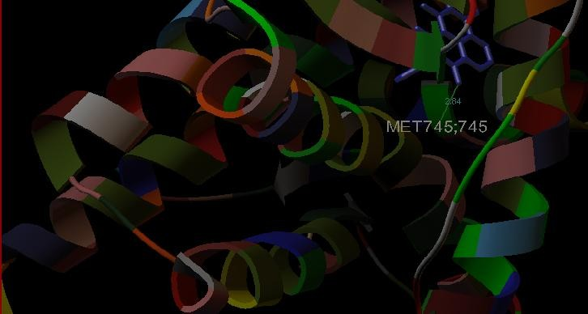

### Figure 01: Docking studies showed that 1st conformation of compound 1e proved to possess highest binding

**energy of -8.45 k.cal/mol. Hydrogen bonding was observed and a hydrogen bond length of 2.84Ao is noted.**

### Binding interaction was noticed with MET745 as residue.

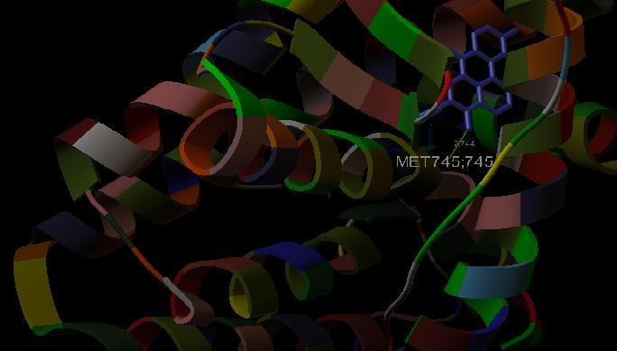

**Figure 02: 9th conformation of compound 1g also showed same binding energy as of 1st conformation i.e -8.21 k.cal/mol. A hydrogen bond length of 2.744Ao was observed with MET745 as the residue**

# Acknowledgement

We acknowledge this work to everyone who rendered us support throughout and made this study successful.

# References

1. Alberto Ambesi-Impiombato, Diego di Bernardo. ‘Computational Biology and Drug Discovery: From single-network Drugs’. *Curr. Bioinform,* 1(1), 2006, 3-13.
2. Theophil, Siegfried Hauptmann. *The chemistry of Heterocycles. Structure, Reactions, Synthesis and Aplications,* 2nd ed, Germany, Wiley-VCH GmbH & Co. KGaA, Weinheim, 2005, 261-348.
3. Meehan KL, Sadar MD, ‘Androgens and androgen receptor in prostate and ovarian malignancies’. *Front. Biosci*, 8, 2003, 780-800.
4. Lengaur T, Rarey M, ‘Computational methods for biomolecular docking’. *Curr. Opin. Struct. Biol*, 6, (3), 1996, 402-406.
5. PubMed: Online Search Engine for science and biomedical articles. [www.pubmedcentral.nih.gov.](http://www.pubmedcentral.nih.gov/)
6. ‘The Protein Data Bank’. *Nucleic Acids Research*, vol. 28, Oxfords University Press, 2000.
7. Kearsley Sk, Underwood DJ, Sheridan RP, Miller MD. ‘Flexibases: a way to enhance the use of molecular docking methods’. *J. Comput. Aided Mol. Des*, 8 (5), 1994, 565-582.
8. Friesner RA, Banks JL, Murphy RB, Halgren TA, Klicic JJ, Mainz DT, Repasky MP, Knoll EH, Shelley M, Perry JK, Shaw DE, Francis P, Shenkin PS. ‘Glide: a new approach for rapid, accurate docking and scoring. Method and assessment of docking accuracy’. *J. Med. Chem*, 47(7), 2004, 1739–1749.
9. Meng EC, Shoichet BK, Kuntz ID. ‘Automated docking with grid-based energy evaluation’. *J. Comput. Chem*, 13(4), 2004, 505-524.
10. Morris GM, Goodsell DS, Halliday RS, Huey R, Hart WE, Belew RK, Olson AJ. ‘Automated docking using a Lamarckian genetic algorithm and an empirical binding free energy function’. *J. Comput. Chem*, 19(14), 1998, 1639–1662.