Original Article METHOD DEVOLPMENT AND VALIDATION OF DESLORATADINE IN

BULK AND ITS TABLET DOSAGE FORMS

*Satish Bondili, Mentada Ramya
*School of Pharmaceutical Sciences, Vels University, Zameen Pallavaram, Chennai, T.N, India – 600 043.

Abstract
A simple and selective LC method is described for the determination of Desloratadine pharmaceutical dosage forms. Chromatographic separation was achieved on a c18 column using mobile phase of a mixture of phosphate buffer, acetonitrile and methanol (50:40:10) with detection of 247 nm. Linearity was observed in the range 20-100 μg/ml (r2 =0.998) for the amount of drugs estimated by the proposed methods was in good agreement with the label claim. The proposed methods were validated. The accuracy of the methods was assessed by recovery studies at three different levels. Recovery experiments indicated the absence of interference from commonly encountered pharmaceutical additives. The method was found to be precise as indicated by the repeatability, inter-day, intra-day analysis, showing %RSD less than 2. The results did not show any statistical difference between operators suggesting that methods developed were rugged. All statistical data proves validity of the methods and can be used for routine analysis of pharmaceutical formulation.

Keywords: LC, Desloratadine, C18 Column, Phosphate buffer, Acetonitrile, Methanol.

Introduction
The current pharmaceutical Analysis has got more emphasis to satisfy our query for better understanding of physiochemical properties of pharmaceutical compounds, by the use of advanced instrumental methods. It also plays an important tool for quality assurance of pharmaceutical product throughout the shelf life. The pharmaceutical industry is under increased scrutiny to constrain costs and yet consistently deliver to market safe, efficacious products that fulfill medical needs. As a part of this, drug analysis also plays an important role. Standard analytical procedure for newer drugs or formulation may not be available in pharmacopoeia; hence it is essential to develop new analytical methods which are accurate, precise, specific, linear, simple & rapid1,2.

Author for Correspondence:

Satish Bondili,
School of Pharmaceutical Sciences, Vels University, Zameen Pallavaram, Chennai, T.N, India – 600 043.
Email: satish.mpharmacy@gmail.com
Desloratadine3,4, an H1 receptor antihistaminic drug was developed on 2005. It is a metabolite of Loratadine, a second generation antihistaminic drug.
Extensive literature survey, it was revealed that there were a few methods reported for estimation of desloratadine from plasma and from pharmaceutical dosage forms. Therefore here an attempt was made to develop simple, cost effective and accurate spectroscopic methods and a more precise cost effective, sensitive and specific HPLC method for desloratadine.

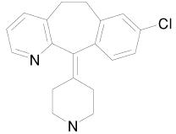

Fig 1: Structure of Desloratadine

Desloratadine5 is a second generation tri cyclic anti histaminic drug which has a selective and peripheral H1 antagonist action. It is active form of prodrug Loratadine. It is chemically 8-chloro-6, 11- di hydro- 11(4-piperdinylidene)-5H (5,6 cycloheptyal(1,2-b) pyridine. Molecular weight is 310.84 gm/mol and white to off white powder. It is mainly used in the treatment of allergic disorder and in common cold. Sedation and dryness of mouth are common adverse drug reaction.

B.M. Mahbubul Alam Razib et.al.,6 has studied the validation and application of a modified RP-HPLC method for quantification of Desloratadine in pharmaceutical dosage form. The purpose of study was to develop simple sensitive and rapid RP-HPLC method for determination of Desloratadine in market products

Meiling qi et.al7., has studied the determination of Desloratadine in drug substance and pharmaceutical preparations by liquid chromatography. The simple and selective LC method is described for the determination of Desloratadine in drug substances and pharmaceutical preparations

Dantu durgarao et.al8., has studied a validated stable indicating gradient reverse phase ultra performance liquid chromatography method was developed for determination of purity of Desloratadine in presence of its impurities and forced degradation products.

HPLC Method for Determination of Desloratadine
- Instrumentation:
Quantitative HPLC was performed on an isocratic LC – 10AT VP SHIMADZU High- Pressure Liquid Chromatographic instrument for the analysis. The instrument is provided with solvent delivery module with UV-visible detector SHIMADZU SPD-10A, ODS Reverse phase column (250 X 4.6mm). An auto injector and window based class vp software was used for its semi automatic operation, recording and analysis. A sartorious electronic balance was used for weighing the materials.

Reagents required:
Milli-Q-water
Ortho Phosphoric Acid - AR Grade Acetonitrile - HPLC Grade
Methanol - HPLC Grade Potassium Dihydrogen Phosphate - AR Grade

Mobile Phase:
A number of trials were made to find out the ideal solvent system (mobile phase) for eluting the drug. The mobile phase containing Buffer: Acetonitrile: methanol in different ratios (60: 30:10, 50:40:10) was tried. Better peak resolution with less tailing was obtained with the ratio of Buffer: Acetonitrile (HPLC grade): methanol (HPLC grade) (50:40:10).

Wavelength:
The sensitivity of the HPLC Method depends upon the proper selection of the detection wavelength. An ideal wavelength is one that’s give good response to be detected. The maximum peak area with Desloratadine solution (0.1mg/ml) was observed at 247nm with the Buffer: Acetonitrile: Methanol (50:40:10).

Flow Rate:
The mobile phase was run at different flow rates 0.8ml/min, 1.0ml/min, and 1.2 ml/min and observed with all these flow rates separation was good. The time of analysis was less at 0.8ml/min, but base-to-base peak was not observed. The time of analysis is more at 1.2ml/min flow rate time and also base-to-base peak was not observed. Hence for present study a flow rate of 0.8ml/min was selected because time of analysis is less and base-to-base peak area observed.

- Diluents:

Diluent 1: HPLC grade of methanol is used as first diluents for the preparation of standard stock solution.
Diluent 2: Prepared a mixture of buffer: Acetonitrile: Methanol in the ratio of 50: 40:10 which was used as second diluent for further dilution of standard stock solution.

Chromatographic conditions:
Instrument : Shimadzu pump LC - 10AT VP Detector : SPD-10AT VP U.V – visible detector

Column : Phenomix stainless steel Column
(250 X 4.6 mm) packed with ODS chemically bounded porous silica particles.
Temperature : 25±2oC Flow rate : 0.8ml/min Wave length : 247nm Runtime : 7 min Sample size : 20μl
Diluents : Buffer: Acetonitrile: Methanol (50:40:10)
Pipette 1ml of the clear solution in to 10ml volumetric flask and make up volume with diluent-2 (0.1mg/ml).

8. Validation Procedure9:
Separately injected the blank, triplicate injections of standard and duplicate injections of sample preparations in to the liquid chromatogram and record the areas for major peaks. The results for sample were shown in table1.

Table 1: Estimation of Desloratadine in dosage form

Sample retention time: 3.587 ± 0.06 min Asymmetry factor: 1.17

Sample
Labeled amount

(mg)
Amount of drug

obtained by proposed
% of drug

present

- Preparation of mobile phase, standard and sample solutions of Desloratadine

Mobile phase:
A mixture of 50 volume of Buffer, 40 volume of Acetonitrile (HPLC grade) and 10 volumes of Methanol as prepared. The mobile phase was sonicated for 10min to remove gases.

Buffer preparation:
8g of potassium di-hydrogen was weighed and dissolved in 100ml of water and volume was made up to 1000ml with water. Adjust the pH to 3.0 ±0.05 using dilute Ortho phosphoric acid. The buffer was filtered through 0.45mc filters to remove all fine particles and gases.

Standard solution of Desloratadine :
50mg of Desloratadine was dissolved into 50ml of
method
AA 5 4.97 99.33

9. Calculation:
The amount of Desloratadine present in the formulation by using the formula given below, and results shown in table 1.
TA Sw Dilutions P
= ------X ----------- X ------------- X X Average Wt. of tablet
SA Dilutions Tw 100

Where,
SA = Area due to standard preparation. TA = Area due to sample preparation.
Sw = Weight of Desloratadine working standard taken.
Tw = Weight of tablet powder taken.
P = % of potency of Desloratadine tablet.

Table 2: System Precision observed areas

diluent-1 (Methanol HPLC Grade) to get 1mg/ml solution; sonic ate for 5 min and mix. Pipette out 1ml of the above solution to 10ml volumetric flask and make up volume with diluent-2 (Buffer: Acetonitrile: Methanol
50:40:10) (0.1mg/ml).
Injection number
Desloratadine Acceptance criteria area

Sample solution of Desloratadine:
Sample name : Deslor Strength : 5mg
04 1178.125
05 1197.347
01 | 1184.202
02 | 1190.508  The %RSD of peak
03 | 1178.154 areas of Desloratadine

Mean 1185.66
%RSD 0.699
should not be more than 2.0

Make : SUN PHARMA

Table 3: System Suitability parameters

Weigh 20 tablets and crush them to powder. Weigh
accurately tablet powder equivalent to 50mg of
System suitability
parameter
Observed
value
Acceptance
criteria

Desloratadine and transfer in to 50ml volumetric flask, add 20ml of diluent-1, keep on rotary shaker for 30 minutes. Sonic ate for 10 minutes with occasional shaking in between. Make up the volume with diluent-1 and mix well. Centrifuge at 3000rpm for 10 minutes.
Asymmetry factor 1.17 In between
0.5 to 2.0

Results and Discussion
The proposed analytical method is simple, reliable, rapid, sensitive, reproducible and accurate for the

estimation of Desloratadine. A newer RP-HPLC method was developed for both bulk drug and formulation. This proposed method given reliably assay results with short analysis time (<5.0 min) using the mobile phase
of pH3 phosphate buffer: Acetonitrile: Methanol in the | 60 | 851.758
ratio of 50:40:10. | 80 | 1158.805
 | 100 | 1458.384

Table 7: Standard Concentration to peak response for
Desloratadine
Concentration Area

20 263.569
40 567.758

Table 4: Repeatability

Correlation coefficient(r)

0.998

Sample
number
Desloratadine
area
Slope (m) 14438
Intercept (b) 0.0

01 1118.908
02 1160.773
03 1169.208

Table 8: Effect of variation in organic phase

04 1171.972
System
Observed value

05 1183.204
06 1172.972
MEAN 1160.813
%RSD 0.76
Acceptance criteria: The %RSD of %drug recovery of
suitability parameter
Asymmetry factor of
90%
organic phase
100%
organic phase
110%
organic phase
Acceptance
criteria

In between

Desloratadine from five injections should be not more than 2.0.
Desloratadine
peak in standard
1.14 1.17 0.98
0.5 to 2.0

Table 5: intraday precision

Table 9: Effect of Variation in flow rate

Sample number Time intervals Area
System suitability parameter
Asymmetry factor of

0.8/min flow rate
Observed value
1.0ml/min 1.2ml/min flow rate flow rate
Acceptance criteria

In between

Acceptance criteria: The %RSD of %drug recovery of
01 | 00 | 1184.202
02 | 02 | 1190.508
03 | 04 | 1178.154
04 | 06 | 1178.125
05 | 08 | 1197.347
Mean |  | 1185.66
%RSD |  | 0.72

Desloratadine
peak in standard
1.13 1.17 1.15
0.5 to 2.0

Desloratadine from five injections should be not more than 2.0.
suitability | Buffer | Buffer | Buffer | criteria
parameter | pH 2.8 | pH3.0 | pH3.2
Asymmetry  factor of Desloratadine | 0.97 | 1.17 | 1.09 | In between  0.5 to 2.0
peak in
standard

Table 10: Effect of Variation in buffer pH

Table 6: Accuracy
Sample ID
Concentration
Percentage Recovery
Mean percentage recovery
Standard deviation
Relative standard deviation
System
Observed value Acceptance

Acceptance criteria:
1 | 80% | 100.26
2 | 80% | 100.04 | 99.91 | 1.90 | 0.204
3 | 80% | 99.68
4 | 100% | 100.49
5 | 100% | 99.01 | 99.99 | 6.61 | 0.601
6 | 100% | 100.48
7 | 120% | 99.96
8 | 120% | 99.89 | 99.993 | 4.788 | 0.377
9 | 120% | 100.13

The % RSD and asymmetry factor of Desloratadine standard should be in between 0.5 to2.0 for both variation of organic phase, flow rate and buffer pH. So the proposed method is robust for small variations in the test method.

Acceptance criteria: The mean % recovery of the Desloratadine at each level should be not less than 97.0% and not more than 103.0%.
The content of drug present in the formulation was found to be 4.91 mg (99.33%). All the above method doesn’t suffer from any interference due to common

excipients. Therefore it was shown that the proposed method could be successfully applied to estimate commercial Pharmaceutical products containing Desloratadine. Thus the above studies and findings will enable the quantification of the drug for future
investigation in the field of analytical chemistry. Among the established analytical method, this RP-HPLC method was found to be more precise and accurate. Hence RP- HPLC method can be applied for regular analysis of Desloratadine from bulk drug and its dosage forms.

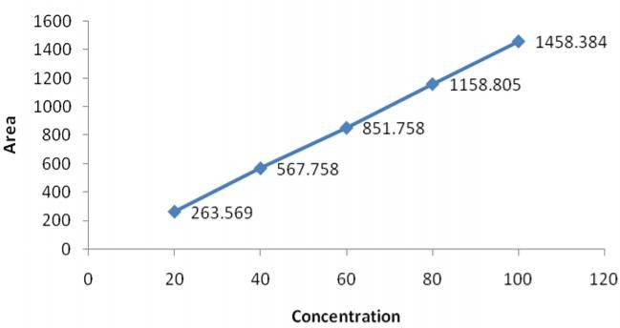

Fig 2: Linearity graph of Desloratadine

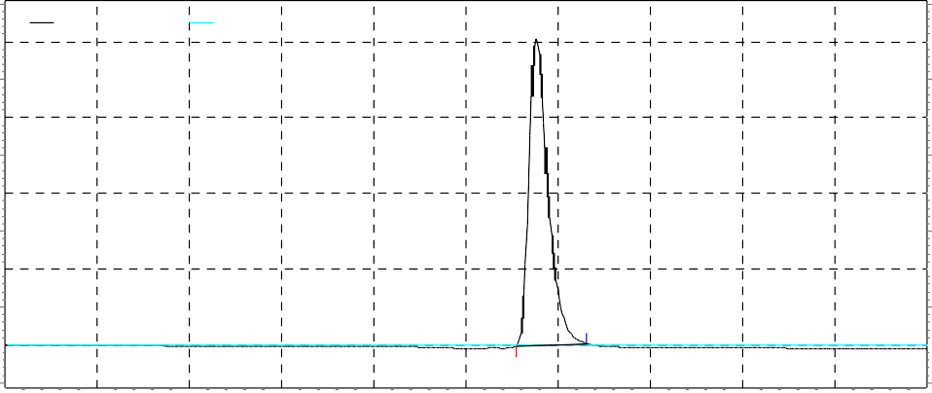0.0 0.5 1.0 1.5 2.0 2.5 3.0 3.5 4.0 4.5 5.0
Detector A (247nm) deslora 60 deslora60dat-Rep3
Pump pressure deslora 60 deslora60dat-Rep3
Area Area
Retention Time Retention Time
Asymmetry Asymmetry
Volts
2920061 2.883 0.00

Fig 3: Chromatogram of Desloratadine

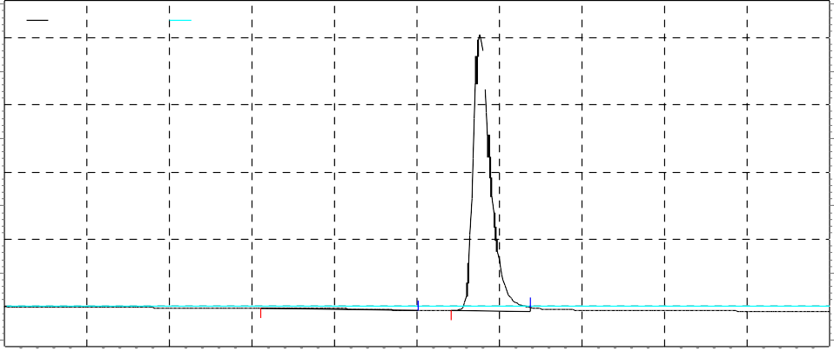0.0 0.5 1.0 1.5 2.0 2.5 3.0 3.5 4.0 4.5 5.0
Detector A (247nm) deslora 60 deslora60dat-Rep2
Pump pressure deslora 60 deslora60dat-Rep2
Area Area
Retention Time Retention Time
Asymmetry Asymmetry
Volts
47574 1.625 0.00
3057973 2.883 1.60

Fig 4: Chromatogram of sample Desloratadine

Acknowledgements
The authors are grateful to the Management of school of pharmaceutical sciences, VELS University, Chennai, for their continuous support and encouragement and for providing the necessary facilities.

References
- Beckett, A.H. and Stenlake, J.B, Practical Pharmaceutical Chemistry, part B. 4th edn., CBS publishers and Distributors, New Delhi, 2002, 272-280.
- Chatwal, R. Gurdeep and Sham, K. Anand. Instrumental Methods of Chemical Analysis. 5th Revised edn Himalaya publishing House, Mumbai, 2000, 2, 160.
- Indian Pharmacopeia, Indian pharmacopeia commission office, Delhi, 1996, Volume-II, appendix A, 158.
- British Pharmacopoeia, British Pharmacopoeia commission office, London, 2003, Volume-II, 1225.
- http://en.wikipedia.org/wiki/Desloratadine,june2 0,2010.
- B.M. Mahbubul Alam Razib, has studied the validation and application of a modified RP-HPLC method for quantification of Desloratadine in pharmaceutical dosage form. 2006, 113-115.
- Meiling qi, has studied the determination of Desloratadine in drug substance and pharmaceutical preparations by liquid chromatography. Journal of pharmaceutical and biomedical analysis, 2009, 355-359.
- Dantu durgarao, has studied a validated stable indicating gradient reverse phase ultra performance liquid chromatography method was developed for determination of purity of Desloratadine. Journal of pharmaceutical and biomedical analysis, 2010, 51, 736-742.
- Code-Q2A, Text on validation on Analytical method ICH harmonized tricartite guidelines. 1997.

