***Original Article* DEVELOPMENT AND VALIDATION OF STABILITY INDICATING**

HPLC-METHOD FOR ESTIMATION OF CEFOTAXIME SODIUM IN INJECTION



*Durga Mallikarjuna Rao Tippa, Narendra Singh

R. P. G College, Jamuhai, Jaunpur, Uttar Pradesh, India-222 002.

**Abstract**

A simple, stability-indicating, reversed-phase liquid chromatographic method was developed for the determination of Cefotaxime sodium in the presence of its degradation products. The analysis was carried out by using ODS (150 x 4.6mm) 5µm column. Mobile phase used was a mixture of buffer, methanol and acetonitrile in the ratio of 80:15:05, at a flow rate of 1.3 mL per minute and injection volume of 20µL with UV- detection at 254 nm with a run time of 10 minutes. The stability indicating capability of the method was proven by subjecting the drugs to stress conditions such as alkaline and acid hydrolysis, oxidation, photolysis, thermal degradation and resolution of the degradation products formed therein. This method showed good linearity in the range of 51.348 to 359.438 μg/mL. The suggested method was successfully applied for the analysis of Cefotaxime sodium from injection formulation and found the average assay data of 98.86% with a relative standard deviation of 0.48% for 6 samples. The Cefotaxime sodium was found to be stable in solution up to 14 hours at room temperature. The method validation data showed excellent results for precision, linearity and specificity. The present method can be successfully used for routine quality control and stability studies.

**Key words:** Cefotaxime sodium, HPLC-Method, Stability Indicating.

# Introduction

Cefotaxime Sodium is sodium 7-[2-(2-amino-4- thiazolyl) glyoxylamido]-3-(hydroxymethyl)-8-oxo-5- thia-1-azabicyclo [4.2.0] oct-2-ene-2-carboxylate 72 (Z)-(o-methyloxime), acetate (ester) with molecular formula C16H16N5NaO7S21. Cefotaxime is a third- generation parenteral cephalosporin antibacterial used in the treatment of infections due to susceptible Gram-positive and Gram-negative bacteria, including infections of the abdomen, bones and joints, CNS, skin and skin structure, genito-urinary tract (including gonorrhoea) and respiratory tract, in gynaecological infections, and in early Lyme disease2, 3. Cefotaxime has a pKa of 3.4. A 10% solution in water has a pH of between 4.5 and 6.5. Cefotaxime Sodium is freely soluble in water and slightly soluble in alcohol4.

***\* Author for Correspondence:***

Durga Mallikarjuna Rao Tippa,

R. P. G College, Jamuhai, Jaunpur, Uttar Pradesh, India-222 002. Email: [tdmrao@yahoo.in](mailto:tdmrao@yahoo.in)

This antibiotic displays a high antimicrobial potency, a broad antibacterial spectrum, high resistance against the action of beta-lactamases, as well as a low index of side effects and lowered toxicity profile compared to the predecessors5.

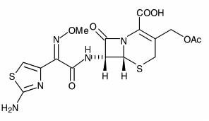

## Structure of Cefotaxime

Literature survey revealed that several HPLC6-14 HPTLC15,16 and spectrophotometric methods17-22 have been used for determination of Cefotaxime Sodium. Spectrophotometric methods are absolutely non- stability indicating and the published HPLC methods did not talk about the stability indicating nature and no common method is seen for the estimation of potency

and impurities in a single method. Since Cefotaxime is unstable in solution, its estimation method should be stability indicating in the assay method in order to estimate the actual Cefotaxime content. In the present study rapid, precise, accurate, simple and stability indicating method was developed for the estimation of Cefotaxime Sodium from injections and also verified the separation of its impurities in the same method and found that all the impurities are eluted within 10 minutes of HPLC run time.

# Materials and Methods

## Instrumentation

The high pressure liquid chromatographic (HPLC) system was used bearing the configuration by equipped with pump (Waters 2695 separators module), auto sampler, thermo stated column compartment and detector (Waters 2487 dual wavelength absorbance detector) controlled by Empower software. A column Symmetry ODS, 150mm X 4.6mm, 5µ, Make: Waters, was used as a stationary phase.

## Materials

Working standard and impurities of Cefotaxime sodium were received as a gift sample from Kreszent Pharma. Disodium hydrogen orthophosphate anhydrous, Potassium dihydrogen orthophosphate anhydrous and Orthophosphoric acid used were of analytical grade and methanol and acetonitrile were procured form commercial source and HPLC grade water was obtained using Millipore water purification system. All other chemicals were of analytical reagent grade unless specified.

## Methods

**Chromatographic conditions:**

The analysis was carried out on binary HPLC system using the column Symmetry ODS, 150mm X 4.6mm, 5µm with UV- detection of 254 nm at 25oC. The injection volume was 20μl with a flow rate of 1.3 ml per minute and a run time of 10 minutes.

## Mobile phase and solutions

Prepared a mixture of buffer (2.8 gm of disodium hydrogen orthophosphate anhydrous + 1.4gm potassium dihydrogen orthophosphate anhydrous in 1000 ml of water), methanol and acetonitrile in the ratio of 80:15:05. Adjusted the pH between 5.9 to 6.1 with diluted ortho phosphoric acid. Degassed and filtered through 0.45µ membrane filter

## Standard & Resolution solution Preparation of standard solution

Weighed and transferred accurately 26.3mg of Cefotaxime sodium working standard into 100 ml volumetric flask; dissolved and diluted up to the volume with mobile phase and mixed well.

## Preparation of resolution solution

Weighed and transferred accurately 1.2mg of each Cefotaxime sodium working standard and impurity-B into 10 ml of volumetric flask; dissolved the material in

1 ml of 1N hydrochloric acid (diluted 8.5 ml of concentrated hydrochloric acid to 100 ml with HPLC grade water) and 2 ml of acetonitrile. Diluted the solution to the volume with mobile phase and mixed well.

## Calibration

Seven different concentrations (51.348-359.43 μg/ml) of Cefotaxime sodium solutions were prepared for linearity studies. The responses were measured as peak areas and plotted against concentration.

## Estimation of Cefotaxime sodium from injectable formulation

Accurately weighed and transferred about 24.9 mg of Cefotaxime sodium for injection in to 100 mL volumetric flask, shaken well to dissolve and diluted to volume with mobile phase.

Forced degradation sample solutions – Forced degradation samples are neutralized after treatment of the sample in acidic and basic conditions.

Stressed sample solutions are further diluted with mobile phase to get a final concentration of 0.25mg/ml.

## Validation Parameters

Various method validation parameters ascertained are as follows:

## Precision

Injection repeatability (System precision):

The injection repeatability was established by six replicate injections of the standard solution containing the analyte of interest.

Sample repeatability (Method precision):

The sample repeatability was established by carrying out the analysis of the analytes six times.

## Specificity /selectivity

Specificity of the method was evaluated by injecting the blank, impurities spiked in sample and the sample solution to check the interference if any at the retention time of Cefotaxime peak.

## Stress testing (Forced degradation)

The Cefotaxime for injection sample was subjected to forced degradation under the following stress conditions.

1. Hydrolytic and Oxidative degradation

The Cefotaxime for injection sample was separately treated with 5ml of 0.5 N Hydrochloric acid, 5ml of 1N Sodium Hydroxide and 5ml of 10%v/v solution of hydrogen peroxide for 2 minutes.

1. Thermal Degradation

The sample was subjected to thermal degradation by keeping the sample at 80oC for 18 hours and analyzed as per the method.

1. Photolytic Degradation

The sample was exposed to sun light for about 24 hours and analyzed as per the developed method.

The spectral purity of the main peaks were evaluated using photodiode array detector and Empower software used to verify that the degradation peaks are well resolved from the main peaks.

## Stability of the solution

A sample solution of Cefotaxime for Injection was prepared as per the test method, analyzed initially and also analyzed at different time intervals by keeping the sample solution at room temperature.

## System suitability tests

The resolution solution was prepared and injected as per the test method during the course of validation study. The resolution between Cefotaxime and Impurity-B peaks was calculated using the chromatographic software. The standard solution was prepared and injected as per the test method. The tailing factor, theoretical plates of Cefotaxime peak and the percentage relative standard deviation of five replicate injections of standard preparation were calculated.

# Results and Discussion

## Precision

The values of the relative standard deviation of six replicate injections of the standard solution containing were lie well within the limits (% RSD ≤ 2), indicating the injection repeatability of the method. Specimen chromatogram of standard is given in figure 1.

## Specificity /selectivity

Specificity of the method was evaluated by injecting the blank to check the interference if any at the retention time of Cefotaxime peak from the blank solution. There was no peak eluted at the retention time Cefotaxime peak from the blank solution shows the method is specific. Also five impurities (namely impurity A, B, C, D and E) of Cefotaxime spiked in the sample were eluted separately and not interfered with the principle peak. Spiked impurity chromatogram and UV spectrum of Cefotaxime are given in figure 2 and 3 respectively.

## Stress testing (Forced degradation)

The results of forced degradation studies conducted on Cefotaxime for injection sample are summarized in Table 1. At every stage of forced degradation study peak purity of the Cefotaxime peak was checked using photodiode array detector (PDA). The peak purity data was found passed and it revealed that there are no co eluting peaks at the retention time of Cefotaxime peak and it is homogeneous. This illustrates the test method to separate degradation products from Cefotaxime peak.

## Linearity

Calibration curve obtained by the least square regression analysis between average peak area and concentration showed linear relationship with a

correlation coefficient of 0.999 over the calibration ranges tested. The linearity of response for Cefotaxime was determined in the range of 51.348 to

359.438 mcg/ml. Linearity graph is given in figure 4.

**Table 1 : Forced Degradation**

**Mode of Degradation**

**% Assay**

**%**

**Degradation w.r.t. untreated sample**

**Peak Purity**

|  |  |  |  |
| --- | --- | --- | --- |
| Untreated sample | 98.86 | - | Passes (No flag) |
| Acid | 81.54 | 17.32 | Passes (No flag) |

Alkali 75.67 23.19 Passes (No flag) Hydrogen Peroxide 80.25 18.61 Passes (No flag) Thermal 97.07 1.79 Passes (No flag)

Photolytic 98.14 0.72 Passes (No flag)

## Accuracy

Accuracy of the method is inferred from the data of specificity, linearity and precision data

**System suitability and stability of analytical solution** The tailing of Cefotaxime sodium was found in the range of 1.4 to 1.6. The % RSD for five replicate injection of standard was found in the range of 0.29 –

0.65. Resolution between the peaks was found in the range of 14.1 to 15.1.

A sample solution of Cefotaxime for Injection was analysed at different time intervals by keeping the sample solution at room temperature. The cumulative % RSD of area of Cefotaxime was found to be 1.36 indicates that solution is stable up to at least 14 hours.

## Figure 1.

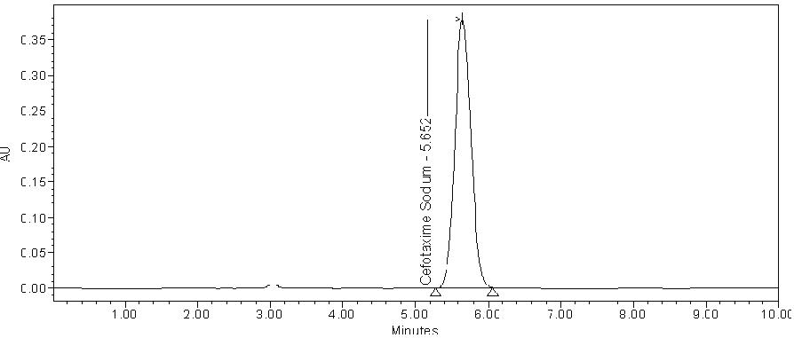**Chromatogram of Pure Cefotaxime**

## Conclusion

The analytical method is simple, specific and precise. The method is stability indicating and all the five potential impurities are eluted in the short HPLC run time of 10 minutes, where no published method is

available for the estimation of potency and impurities in a common method and in a very short time. Hence it can be used for routine quality control analysis as well as stability studies of injections, bulk and also for other dosage forms like solids (Tablet/Capsule).

## Figure 2.

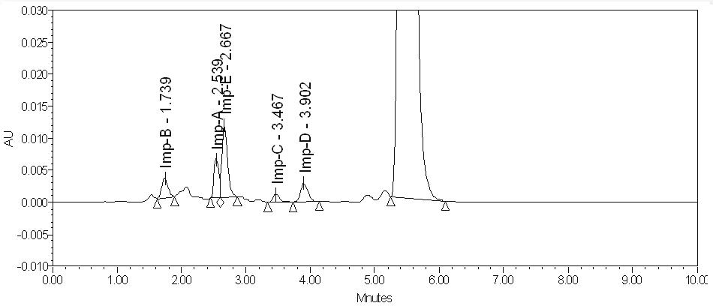**Chromatogram of test solution spiked with impurities**

## Figure 3.

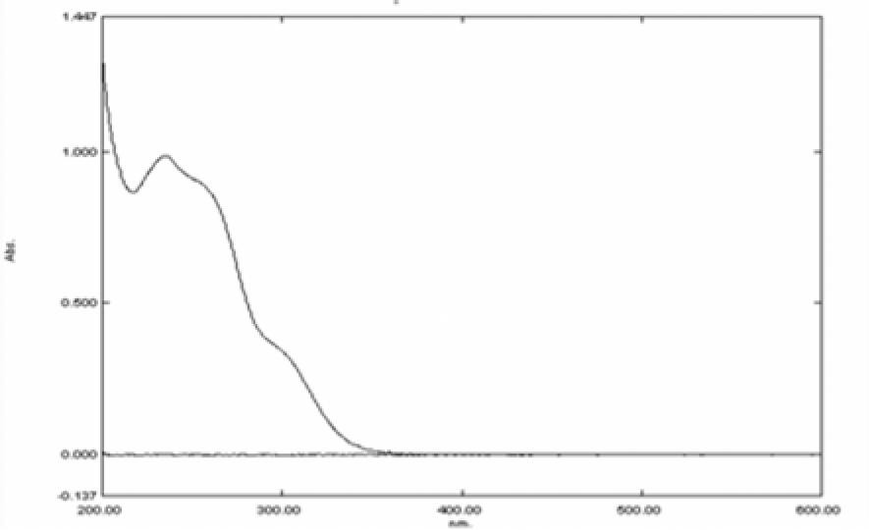**UV spectrum of Cefotaxime**

## Figure 4.

**Linearity Graph**

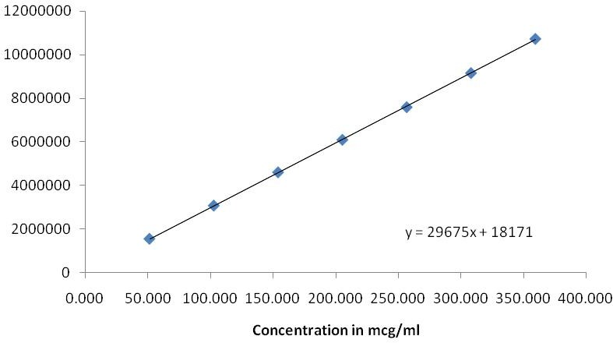

**Area**

## Acknowledgement

The help rendered by R.P.G College, Jamuhai for providing the facilities at Jaunpur, Uttar Pradesh was gratefully acknowledged. One of the author thanks to

Dr. Narendra Singh, Associate Professor, Department of Chemistry, R.P.G. College, Jamuhai, Jaunpur for his support.

## References

1. USP-27-NF, The United States Phamacopoeial Convection Inc. Rockville, MD, 2004, 328.
2. Martindale, The Extra Pharmacopeia, The Pharmaceutical Press, London, Edition 29, 1989, 151.
3. O. Layne and M.D. Gentry, Cefotaxime and prophylaxis: New approaches with a proven agent. *Am. J. Med*., 88, 1990, S32.
4. V. D. Gupta, stability of cefotaxime aodium after reconstitution in 0.9% sodium chloride injection and storage in polypropylene syringes for pediatric use, *Int. J. Pharm. Compound*., 6, 2002, 234.
5. M.Y.Yoon, H. B. Lee, H. Shin, *Bull.* Development of an Isolable Active Ester, Diethyl Thiophosphoryl [(*Z*)-(2-Aminothiazol-4-yl)-2-(Methoxyimino)acetate (DAMA) for the Synthesis of Cefotaxime. *Korean Chem. Soc*., 32, 2011, 407.
6. S. A. Signs, T. M. File and J. S. Tan. High pressure liquid chromatographic method for analysis of Cephalosporins, *Antimicrob. Agents Chemother*., 26, 1984, 652.
7. S. S.N. Ling, K.H. Yuen and S.A.Barker. Simple liquid chromatographic method for the determination of cefotaxime in human and rat plasma, *J. Chromatogr., B*. 1, 2003, 297.
8. D.Dell, J. Chambarlain and F. Coppin. Determination of cefotaxime and desacetylcefotaxime in plasma and urine by high- performance liquid chromatography *J. Chromatogr., B: Biomed. Sci. Appl,* 226, 1981, 431.
9. R. L. Yost and Derendorf. Rapid chromatographic determination of cefotaxime and its metabolite in biological fluids*. J. Chromatogr., B: Biomed. Sci. Appl,* 341, 1985, 131.
10. V. D. Gupta, stability of cefotaxime aodium after reconstitution in 0.9% sodium chloride injection and storage in polypropylene syringes for pediatric use, *Int. J. Pharm. Compound*., 6, 2002, 234.
11. T.E. Rivers, H.A. McBride and J.M. Trang, Stability of cefotaxime sodium and metronidazole in an IV admixture at 8° c, *Am J Hosp Pharm*., 48, 1981, 2638.
12. P.P Belliveau, C.H. Nightingale and R. Quintiliani, Stability of cefotaxime sodium and metronidazole in 0.9% sodium chloride injection or in ready to use metronidazole bags, *Am J Health Syst Pharm*., 52, 1995, 1561.
13. C.M. Paap, M.C. Nahata, Stability of cefotaxime sodium in two perotoneal dialysis solutions, *Am J Hosp Pharm*., 47, 1990, 147.
14. V.D. Gupta, Stability of cefotaxime sodium as determined by high performance liquid chromatography, *J Pharm Sci*., 73, 1984, 65.
15. S. Eric-Jovanovic, Agbaba D., Zivanov-Stakic. Dand Vladimirov. S., HPTLC determination of ceftriaxone, cefixime and cefotaxime in dosage forms., J

.Pharm. Biomed Anal., 18, 1998, 893-898

1. R.K. Nandha, V.V.Bhagwat, S.E. Potawale and S.C.Hamane. Development and validation of a HPTLC method for simultaneous densitometric analysis of Cefotaxime Sodium and sulbactam sodium as the bulk drugs and in the pharmaceutical dosage form. J. Pharm. Res., 3, 2010, 1667.
2. N. N. Okoye, G.I.C. Nwokedi, N.N. Ukwueze and

B.C. Festus. Spectrophotometric determination of some cephalosporin antibiotics using Prussian blue reaction. *Sci. Res. Essay*, 2, 2007, 342.

1. C. H. Aswani Kumar, T. Anil Kumar, B. M. Gurupadayya, S. Navya Sloka and M. B. Rahul Reddy. Novel spectrophotometric determination of Valacyclovir and Cefotaxime using 1, 2- napthaquinone-4-sulfonic acid sodium in bulk and pharmaceutical dosage form. *Archiv. Appl. Sci. Re*s., 2, 2010, 278.
2. B. Morelli. Derivative spectrophotometry in the analysis of mixtures of cefotaxime sodium and cefadroxil monohydrate. *J. Pharm. Biomed.* 32, 2003, 257.
3. L. Nuevas, R. Gonzalez, J.C. Rodriguez and J. Hoogmartens. Derivative spectrophotometric determination of the triethylammonium salt of cefotaxime in presence of related compounds from the synthesis. *J. Pharm. Biomed. Anal*.,18, 1998, 579.
4. M. M. Abdel-K.Halek, M.S. Mahrous. Use of ammonium molybdate in the colorimetric assay of cephalosporins. *Talanta*, 31, 1984, 635.
5. Y. N. Manohara, K. Srinivasa Rao, M. Chandra Sekar and B.M Gurupadayya. Spectrophotometric Determination of Cefotaxime Sodium. *Asian J. Chem*., 18, 2006, 2519.