Original Article IMPROVED CULTURING, SCREENING AND FERMENTATION OF SOIL ACTINOMYCETES FOR ANTIMICROBIAL AGENTS
*,1Balasubramaniam V, 2Ganesh S, 2Karunanithi V, 2Perumal P
*,1Smt. Sarojini Ramulamma College of Pharmacy, Mahabubnagar, Andhra Pradesh, India - 509 001.
2J.K.K.Nataraja College of Pharmacy, Komarapalayam, Tamilnadu, India – 638 183.

Abstract
Antibiotics are the secondary metabolites produced by microorganisms. Most of the Antibiotics are produced by Bacteria, Fungi, and Moulds etc. Out of which 2/3rd are produced by Actinomycetes. Actinomycetes are Gram + ve filamentous Bacteria and are mostly present in soil, hence soil screening is advantageous to isolate Actinomycetes. This work is designed to isolate antibiotic producing Actinomycetes from soil and to screen the productivity of antimicrobial substances of the isolated Actinomycetes. Due to resistance produced by micro-organism against all commonly used antimicrobial agents, there is a need of newer antibiotics. Only 1% percent of the microorganisms in soils are cultured. In order to explore the hidden diversity, soil screening of antimicrobial agents are performed for the detection of non culturable microorganism. Four soil samples have been collected. By crowded plate technique Actinomycetes were isolated. Anti- microbial activity of the isolates was performed by spektra plak technique. Fermentation was carried out for the isolate which have shown broad spectrum activity. The anti-microbial compounds were isolated by solvent extraction method by using ethyl acetate and the compounds were partially purified by evaporation. The anti-microbial activity was studied for the compounds which have been isolated by agar well method. 62.79 % of Actinomycetes which were isolated from the soil had shown antibacterial activity, 2.32 % had shown anti-fungal activity and 16.28 % had shown broad spectrum activity. These studies were done in partially purified antimicrobial compounds. It will be worthwhile to conduct this study with the purified form of antimicrobial compounds.

Key words: Anti-microbial, Actinomycetes, Antibiotics.

Introduction
Actinomycetes are ubiquitous in soils, where they usually are present in numbers of 105-106 colony-forming units per gram of soil1. The majority of Actinomycetes are free living saprophytic bacteria found widely distributed in soil, water and colonizing plants. Actinomycetes population has been identified as one of the major group of soil population, which may vary with the soil type. They have in common that they all are Gram-positive and have a high content of guanine plus cytosine in their DNA (>55 mol %). In general the optimal conditions for their growth are temperatures of 25-30°C (50°C for the thermo-Actinomycetes). Most are aerobic and neutrophilic. The Actinomycetes were initially regarded as minute fungi because of their mycelium-like growth and attention paid to this group rose notably after the discovery of streptomycin by Waksman and Schatz in 19432 and were finally recognized as bacteria. Their morphology, however, varies among the different genera, from cocci and pleomorphic rods to branched filaments that break down into spherical cells or aerial mycelium with long chains of spores.

* Author for Correspondence:
Balasubramaniam V,
Smt. Sarojini Ramulamma College of Pharmacy, Mahabubnagar, Andhra Pradesh, India - 509 001. Email: bala_nsv@yahoo.com

The spores are formed as a result of nutrient depletion and can survive prolonged desiccation until nutrients are again available3. This ability to sporulate is important for their survival in the environment.

Probably most of the interest in this group of microorganisms lies in their ability to produce secondary metabolites. Two thirds of the microbial antibiotics known today are produced by Actinomycetes4, mainly by Streptomyces species, although the number of rare Actinomycetes (non-Streptomyces) is increasing due to the application of new selective isolation methods5. Actinomycetes also produce secondary metabolites that show bioactivities other than antibiotics, such as enzyme inhibitors, immuno-suppressors, phytotoxins and pesticides1, 6.

The high percentage of new compounds derived from new target oriented screening methods is also of Actinomycetal origin. In the late 60s’, after the discovery of gentamycin, originated from Micromonospora, the study of non- Streptomycetal Actinomycetes received increasing attention. In general, it was observed that most of rare Actinomycetes products had already existed among Streptomycetes metabolites. Nevertheless, there were certain types of structure, which occurred more frequently in some rare Actinomycetes species than in Streptomycetes. The productivity of Streptomyces strains as antibiotic producers remains unique amongst Actinomycetales strains. The relatively low occurrence of non-Streptomycetes species as

producers of secondary metabolites is due to difficult techniques required for the isolation of these strains from the environment. Other problem is their complicated preservation and cultivation methods, which frequently require some specific and unusual conditions. These are the main reasons for regarding these microbes as rare organisms and the difficulties for investigations and manufacturing of their products. Some new screening programs have been already developed for discovering of new species or unknown bioactive substances7.

The traditional approach is ‘random screening’ in which the bacteria (mainly Actinomycetes) are isolated, grown and their activity spectrum was assessed. Even this has been done for more than 50 years still we are getting results in favor to us and thus we are sticking with this traditional approach8. It was assumed that different species are found in different habitats in Tamilnadu. It has not been well described with respect to its bacterial diversity. High bio- diversity, mixed topography and divergent habitats. Environment include Black soil, Red alluvium, Alluvial soil (Bank of river), Marshy soil. One of the modern approaches is isolation and screening of microorganisms from relatively unknown or unstudied areas. Due to large geographic variation, there is large variation in soil type and their contents in Tamilnadu and hence it is quite likely that the distribution of antibiotic producing Actinomycetes is also variable. This study is carried out to screen the antibiotic producing Actinomycetes from Alluvial soil (Bank of river Cauvery), Tamilnadu, India.

Methods

Isolation of Actinomycetes
Different samples (100-500 gm.) were collected from Lat. 10029’37” N and Long 78042’41” E to Lat. 11027’13” N
and Long 77040’43” E, Tamilnadu, India. These samples were collected from 2 inches depth from soil surface of the bank of the river Cauvery and put in sterile Petri dishes and polythene bags in order to avoid the other sources of contamination. Soil slurry was prepared by mixing a pinch of soil in 5 ml of Distilled water using a vortex mixer. This was repeated for all the four samples. 0.1-0.5ml of soil slurry was placed on a sterile Modified Glycerol Yeast Extract Agar plate and was spreaded with the spreading rod on the surface of the medium. This was repeated for all the four samples. The inverted plates were incubated at 280C for 5 to 7 days for further observations9.

The potent Actinomycetes selected from crowded plates were characterized by morphological and biochemical methods. Morphology of the Actinomycetes colonies was determined in the selective media, from which they had been isolated. Morphological methods consist of macroscopic and microscopic methods. The micro-morphological characteristics were studied by light microscopy on the 21st day cultures in MGYE media.

The microscopy characterization was done by cover slip culture method. Isolated species of Actinomycetes were grown on the surface of sterile cellophane placed on
solidified MGYE Agar medium. The culture was incubated at 300C till sporulation. The cellophane bearing growth was removed from the Agar surface. The mixture of stains [2 parts of Bismark Brown (0.1% w/v), 2 parts of Toluidine Blue (0.1% w/v) and 1 parts of saturated ammonium sulphate solution] was stained for 2 minutes. It was rinsed in distilled water and air dried. It was mounted in Canada balsam and was observed under oil immersion (1000 magnification). The mycelium structure, Color and arrangement of spores on the mycelium were observed. The observed structure was compared with Bergey’s manual of determinative Bacteriology, and the organism was identified10.The biochemical characterization was done by acid production from glucose & sucrose melanin formation, nitrate reduction, starch hydrolysis and urea hydrolysis7.

Primary Screening Preparation of Test Inoculum
The bacterial strains of Escherichia coli, Staphylococcus aureus, Bacillus subtilis, Salmonella typhi and fungal strain of Candida albicans were availed from National collection of Industrial micro-organisms, Pune.

Spektra-plak Technique11
Determination of antibacterial activities of pure Actinomycetes cultures were performed by using spektra- plak method (Perpendicular streak technique). Nutrient Agar plates were prepared and inoculated with working cultures of Actinomycetes by a single streak of inoculums in the center of the Petri dish and incubated at 270C for 4 days. Later, the plates were seeded with test organisms (S. aureus, B. subtilis, E. coli, S. typhi and C. albicans) by a single streak at a 900 angle to Actinomycetes strains without touching it. Antagonism was measured by the determination of the size of the inhibition zone.

Fermentation
The isolates which have shown broad spectrum activity during the primary screening were selected for secondary screening. The isolates were seeded into Modified Glycerol Yeast Extract Agar and grown into mass. The spores were harvested. Erlenmeyer flasks were used for the fermentation. Harvested spores of active isolates were grown in a 500ml flask containing 100ml of the culture medium (0.8g NaCl, 1g NH4Cl, 0.1g KCl, 0.1g KH2PO4, 0.2g MgSO4.7H2O, 0.04g
CaCl2.2H2O, 2g glucose, 3g yeast extract in 10ml of distilled water, pH 7.3). Incubation was carried out at 280C for 6 days under the standard condition of aeration and agitation. Then the fermentation process was terminated.

Isolation of Antibacterial Metabolites
From the fermented broth the mycelium was removed by filtration and the clear filtrate was used for further isolation. Then the anti-microbial compound was isolated from the filtrate by solvent extraction method12. Antibacterial compound was recovered from the filtrate by solvent extraction with ethyl acetate. Ethyl acetate was added to the filtrate in the ratio of 1:1 (v/v) and shaken vigorously for 1 hour for complete extraction. The ethyl acetate phase that contains an antibiotic was separated from the aqueous

phase. It was evaporated to dryness in a water bath at 800C – 900C and the residue obtained was used secondary screening.

Table – 1
Micro Morphology
Colour of

Secondary Screening
Actinomycetes
Isolates
aerial
Morphology of hyphae

The compounds which have been isolated from fermented medium were influenced for antimicrobial activity by agar well method. MIC test was carried out for all the seven compounds against B. subtilis, E. coli and C. albicans. This was compared with the standard antibacterial like Chloramphenicol, Oxy tetracycline and standard antifungal like Clotrimazole and Ketoconazole. The plates were incubated at 37°C for 18-24 hrs and examined. The diameter of the zones of complete inhibition was measured to the nearest whole millimeter.

Results and Discussion
Crowded plate produced (Figure No. 1, 2, 3 & 4) by the soil slurry culture was isolated in to pure cultures and were subjected to antimicrobial study. 58 strains were studied for this purpose and based on the results obtained from micro morphology (staining) and biochemical reactions 43 strains were found to be Actinomycetes species. The vegetative mycelium stained light yellow and the spores blue with red granules in the aerial hyphae. The isolated strains were named as Bal A 1 to 43 (Table No.1 & 2).

The antimicrobial compound producing ability of the 43 strains were found out by primary screening. In this investigation Spektra-plak method was employed. The results were very encouraging to note. Out of 43 isolates 27 were found to have activity against bacteria. 20 isolates were found to have activity against Gram + ve bacteria. 7 isolates were found to have broad spectrum activity. Only one isolate was found to have activity against fungi (Table No.3 & Figure No. 5, 6).

In the first three days the growth was very fast and a thick mass of mycelium was produced on the surface of the flasks. End of the 5th day colour change was observed from yellow to yellowish white. The compounds which have been isolated from fermented medium were in not free flowing and it was sticky in nature. Only one isolate was found to be hard cake and the remaining were found to be gummy. All partially purified extracts were yellow to brown in colour.

The partially purified compounds which have been isolated from fermented medium were detected for antimicrobial activity by agar well method. MIC test was performed for all seven compounds against Bacillus subtilis, Escherichia coli & Candida albicans. In this Bal A 28 was showing activity near to that of standard antibacterial (Chloramphenicol and Oxy-tetracycline) against Bacillus subtilis. Bal A 23 & 38 were showing activity near to that of standard antibacterial (Chloramphenicol and Oxy-tetracycline) against Escherichia coli. Bal A 28 was showing less antifungal activity compare to standard antifungals (Clotrimazole and Ketoconazole) against Candida albicans (Table No.4, Figure No. 7-13).
mycelium
Bal A 1 Yellow Long fragmented
Bal A 2 Brown Straight un-fragmented
Bal A 3 Yellow Long fragmented
Bal A 4 Red-haired Straight un-fragmented Bal A 5 Brown Extended spirals
Bal A 6 Brown Straight un-fragmented
Bal A 7 Grey Straight un-fragmented
Bal A 8 Yellow Long fragmented
Bal A 9 Grey Extended spirals
Bal A 10 Grey Straight un-fragmented Bal A 11 Pale-rose Straight looped end Bal A 12 Grey-violet Long fragmented
Bal A 13 Grey-yellow Long fragmented Bal A 14 Grey Extended spirals
Bal A 15 Grey Extended spirals
Bal A 16 Grey Extended spirals
Bal A 17 Yellow Straight un-fragmented Bal A 18 Grey-white Straight un-fragmented Bal A 19 Brown Straight looped end Bal A 20 Red-haired Extended spirals
Bal A 21 Yellow-brown Straight looped end Bal A 22 Pale-rose Long fragmented Bal A 23 Grey Extended spirals
Bal A 24 Yellow Straight un-fragmented
Bal A 25 Grey Straight un-fragmented Bal A 26 Grey-white Extended spirals
Bal A 27 Yellow Straight un-fragmented Bal A 28 Yellow-brown Straight un-fragmented Bal A 29 Grey Straight looped end
Bal A 30 Grey Long fragmented
Bal A 31 Yellow Extended spirals
Bal A 32 Brown Long fragmented
Bal A 33 Grey-violet Straight un-fragmented Bal A 34 Pale-rose Long fragmented
Bal A 35 Yellow-brown Straight looped end Bal A 36 Grey-white Extended spirals Bal A 37 Grey Straight looped end Bal A 38 Red-haired Extended spirals Bal A 39 Grey-Yellow Straight looped end
Bal A 40 Pale-rose Straight un-fragmented Bal A 41 Grey Long fragmented
Bal A 42 Brown Straight un-fragmented
Bal A 43 Red-haired Straight un-fragmented

Table – 2
Biochemical Characters

Actinomycetes Isolates
 | G | S
Bal A 1 | + | - | + | + | + | -
Bal A 2 | + | - | + | + | - | +
Bal A 3 | + | - | + | + | + | -
Bal A 4 | - | - | + | - | + | +
Bal A 5 | - | - | + | - | + | -
Bal A 6 | + | - | + | + | - | +
Bal A 7 | + | - | + | + | - | -
Bal A 8 | + | - | + | - | + | -
Bal A 9 | + | - | + | + | + | -
Bal A 10 | + | - | + | + | + | +
Bal A 11 | + | - | + | - | - | -
Bal A 12 | + | - | + | - | + | +
Bal A 13 | + | - | + | - | - | -
Bal A 14 | - | - | + | + | + | +
Bal A 15 | - | - | + | + | - | -
Bal A 16 | - | - | + | + | - | -
Bal A 17 | + | - | + | - | + | -
Bal A 18 | + | - | + | + | + | -
Bal A 19 | + | - | + | - | - | -
Bal A 20 | + | - | + | - | - | -
Bal A 21 | + | - | + | - | + | +
Bal A 22 | + | - | + | + | + | -
Bal A 23 | + | - | + | + | + | +
Bal A 24 | - | - | + | + | - | -
Bal A 25 | + | - | + | - | + | -
Bal A 26 | + | - | + | - | + | +
Bal A 27 | + | - | + | - | - | -
Bal A 28 | - | - | + | + | + | +
Bal A 29 | + | - | + | - | - | -
Bal A 30 | + | - | + | + | + | -
Bal A 31 | - | - | + | + | + | +
Bal A 32 | + | - | + | - | + | +
Bal A 33 | - | - | + | + | - | +
Bal A 34 | + | - | + | - | - | -
Bal A 35 | + | - | + | - | + | -
Bal A 36 | + | - | + | + | + | +
Bal A 37 | + | - | + | + | + | +
Bal A 38 | - | - | + | + | + | +
Bal A 39 | + | - | + | - | + | -
Bal A 40 | + | - | + | + | + | -
Bal A 41 | + | - | + | + | + | -
Bal A 42 | + | - | + | + | + | -
Bal A 43 | - | - | + | + | + | -

Acid Production Melanin
Formation
Nitrate Reduction
Starch Hydrolysis
Urea Hydrolysis

*G - Glucose, S – Sucrose, + : Positive results, - : Negative results

Crowded Plates
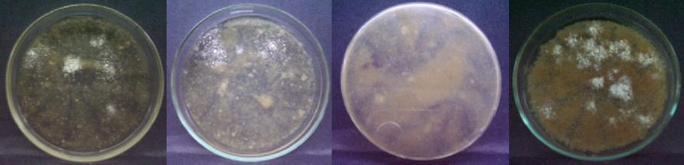
Figure No. 1 Figure No. 2 Figure No. 3 Figure No. 4

Table – 3
Sensitivity against Secondary Metabolites

Actinomycetes

B.subtilis S.aureus C.albicans E.coli S.typhi
Isolates
Bal A 1 | + | ++ | - | - | -
Bal A 2 | - | - | - | - | -
Bal A 3 | + | + | - | - | -
Bal A 4 | ++ | ++ | - | ++ | ++
Bal A 5 | - | - | - | - | -
Bal A 6 | ++ | ++ | - | - | -
Bal A 7 | ++ | ++ | - | - | -
Bal A 8 | - | - | - | - | -
Bal A 9 | ++ | + | - | - | -
Bal A 10 | ++ | ++ | - | + | +
Bal A 11 | - | - | - | - | -
Bal A 12 | - | - | - | - | -
Bal A 13 | - | - | - | - | -
Bal A 14 | ++ | ++ | - | ++ | ++
Bal A 15 | ++ | + | - | - | -
Bal A 16 | ++ | ++ | - | - | -
Bal A 17 | + | ++ | - | - | -
Bal A 18 | - | - | - | - | -
Bal A 19 | - | - | - | - | -
Bal A 20 | - | - | - | - | -
Bal A 21 | + | + | - | - | -
Bal A 22 | ++ | ++ | - | - | -
Bal A 23 | ++ | ++ | - | ++ | +
Bal A 24 | + | + | - | - | -
Bal A 25 | - | - | - | - | -
Bal A 26 | ++ | ++ | - | - | -
Bal A 27 | ++ | + | - | - | -
Bal A 28 | ++ | ++ | + | ++ | ++
Bal A 29 | - | - | - | - | -
Bal A 30 | + | ++ | - | - | -
Bal A 31 | - | - | - | - | -
Bal A 32 | ++ | ++ | - | + | ++
Bal A 33 | - | - | - | - | -
Bal A 34 | + | + | - | - | -
Bal A 35 | + | ++ | - | - | -
Bal A 36 | - | - | - | - | -
Bal A 37 | - | - | - | - | -
Bal A 38 | ++ | ++ | - | ++ | ++
Bal A 39 | ++ | + | - | - | -
Bal A 40 | ++ | + | - | - | -
Bal A 41 | + | ++ | - | - | -
Bal A 42 | - | - | - | - | -
Bal A 43 | + | + | - | - | -

+ : Minimum Inhibition, ++ : Maximum Inhibition, - : No Inhibition.
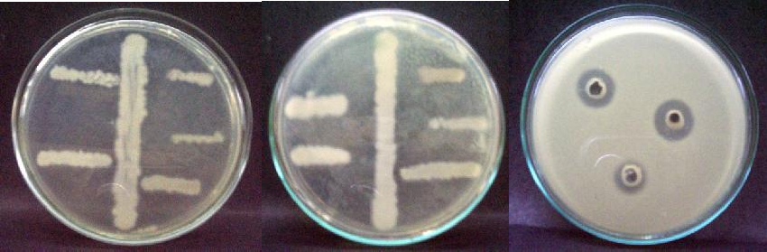
E. coli
B. subtilis
B. subtilis
Bal A- 4 Activity against
B. subtilis
E. coli
S. aureus
S. aureus
S. typhi
S. typhi
C. albicans
C. albicans

Figure No. 5 Figure No. 6 Figure No. 7

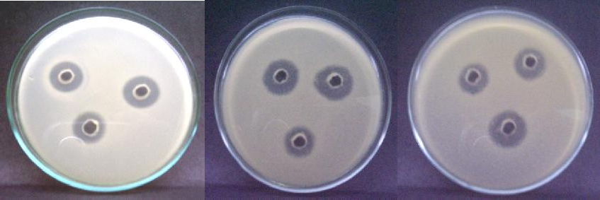
Bal A- 10 Activity against
B. subtilis
Bal A- 14 Activity against
B. subtilis
Bal A- 23 Activity against
E. coli
Figure No. 8 Figure No. 9 Figure No. 10

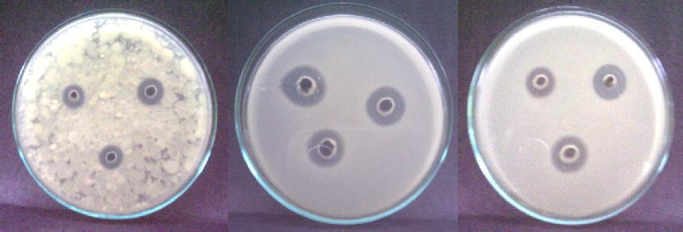
Bal A- 32 Activity against
B. subtilis
Bal A- 38 Activity against
E. coli
Bal A- 28 Activity against
C. albicans

Figure No. 11 Figure No. 12 Figure No. 13

Actinomycetes

Table – 4
Inhibition against Micro Organism
Zone of Inhibition (in mm)
A B C

Isolates
B.subtilis
E.coli
C.albicans

 | S1 | S2 | S3 | S1 | S2 | S3 | S1 | S4 | S5
Bal A 4 | 16 | 20 | 21 | 13 | 14 | 17 | - | 15 | 18
Bal A 10 | 15 | 19 | 22 | 11 | 14 | 16 | - | 17 | 19
Bal A 14 | 16 | 18 | 19 | 15 | 16 | 19 | - | 16 | 18
Bal A 23 | 12 | 14 | 16 | 17 | 19 | 21 | - | 14 | 17
Bal A 28 | 17 | 18 | 21 | 16 | 17 | 20 | 11 | 16 | 19
Bal A 32 | 16 | 18 | 20 | 13 | 15 | 16 | - | 15 | 17
Bal A 38 | 15 | 18 | 21 | 17 | 18 | 22 | - | 17 | 19

Conclusion
S1 : Isolated Antimicrobial Agent, S2: Chloramphenicol (Standard Antibacterial Agent)
S3: Oxytetracycline (Standard Antibacterial Agent), S4 : Clotrimazole (Standard Antifungal Agent) S5: Ketoconazole (Standard Antifungal Agent)

Four soil samples have been collected. By crowded plate technique Actinomycetes were isolated. Anti-microbial activity of the isolates was performed by spektra-plak technique. Fermentation was carried out for the isolate which have shown broad spectrum activity. The anti-microbial compounds were isolated by solvent extraction method by
using ethyl acetate and the compounds were partially purified by evaporation. The anti-microbial activity was studied for the compounds which have been isolated by agar well method. The partially purified antimicrobial compounds isolated from Bal A Species shows 62.79 % of antibacterial activity, 2.32 % of anti-fungal activity and
16.28 % of broad spectrum activity.

References
- Goodfellow M, Williams ST. Ecology of Actinomycetes. Annu. Rev. Microbiol, 1983, 37: 189-216.
- Erikson, D. The morphology, cytology and taxonomy of the actinomycetes. Annual Review of Microbiology, 1949, 3, 23-54.
- McCarthy, A.J. & Williams, S.T. Actinomycetes as agents of biodegradation in the environment - a review. Gene, 1992, 115, 189-192.
- Berdy, J., Are actinomycetes exhausted as a source of secondary metabolites? Biotechnologia, 1995, 7-8: 13- 34.
- Lazzarini, A., Cavaletti, L., Toppo, G. and Marinelli, F. Rare genera of actinomycetes as potential producers of new antibiotics. Antonie van Leeuwenhoek, 2000, 78, 399-405.
- Imada, C. Enzyme inhibitors and other bioactive compounds from marine actinomycetes. Antonie van Leeuwenhoek, 2005 87, 59-63.
- Penka Moncheva,Sava Tishkov, Nadezhda Dimitrova, Valentina Chipeva, Stefka Antonova-Nikolova1 and Nevena Bogatzevska, Journal Of Culture Collections, 2002, 3, 3-14.

- Wawrik, B., D. Kutliev, U. A. Abdivasievna, J. J. Kukor, G.
J. Zylstra, and L. Kerkhof. Biogeography of actinomycete communities and type II polyketide synthase genes in soils collected in New Jersey and Central Asia. Applied and Environmental Microbiology, 2007 73: 2982-9.
- Ozgur Ceylan, Gulten Okmen, Aysel Ugur, Isolation of soil Streptomyces as source antibiotics active against antibiotic-resistant bacteria, EurAsia J BioSci, 2008, 2, 73- 82.
- Williams ST, Goodfellow M, Wellington EMH, Vickers JC, Alderson G, Sneath PHA, Sackin MJ, Mortimer AM, A probability matrix for identification of Streptomyces. Journal of General Microbiology, 1983, 129, 1815-
1830.
- Oskay M, Tamer AU, Azeri C, Antibacterial activity of some Actinomycetes isolated from farming soils of Turkey. African Journal of Biotechnology, 2004, 3 (9), 441- 446.
- M. Hayakawa, Y. Yoshida and Y. Iimura, Selective isolation of bioactive soil actinomycetes belonging to the Streptomyces violaceusniger phenotypic cluster, Journal of Applied Microbiology, 2004, 96, 973–981.

