*Original Article* ESTIMATION OF SYNTHETIC COLORANT TARTRAZINE IN FOOD STUFF AND FORMULATIONS AND EFFECT OF COLORANT



ON THE PROTEIN BINDING OF DRUGS

*Sindhu Parakkot Ramakrishnan, Bagya Lakshmi J, Surya P R

* Sri Ramakrishna Institute of Paramedical Sciences, Coimbatore, Tamilnadu, India - 641 044.

# Abstract

An efficient and accurate reverse phase – high performance liquid chromatographic method was developed and validated for the separation and determination of synthetic food colorant Tartrazine E 102. This method was successfully applied for the estimation of tartrazine dye in certain food stuff (cream biscuits, Tang, gems, and candies) and in drugs (Aceclofenac and Metoprolol tablets - in which tartrazine (E102) was present as a coating agent). Interaction study was carried out to find the effect of tartrazine on the protein binding of Aceclofenac and metoprolol in Bovine serum albumin. A Phenomenex C 18 Gemini column (150×4.6 mm), 5 µ particle size was used as stationary phase. Mobile phase contained a mixture of 10mM ammonium acetate buffer: Acetonitrile : Methanol in the ratio of (50:25:25v/v/v) at PH 8. The E102 dye was successfully separated out at retention time of 1.299 min, by using isocratic elution technique at room temperature. Photo diode array detector monitored the wavelength of tartrazine dye as 426nm. The flow rate was selected was 1ml/min. The method was thoroughly validated. Limit of detection etection and limit of quantization for tartrazine were found to be 0.1ng and 1 ng ml respectively. The intra-day precision and inter-day precision were determined as 0.72 % RSD and 0.78 % RSD respectively. The objective of this research was to estimate the tartrazine dye in various food stuff and formulation, and to determine the effect of dye on drug. The dye E102 extracted and quantified in various food stuff such as (*Tang - 255µg/ml,* Cream biscuits - 633µg/ml, Gems – 147µg/ml, Candies - 67µg/ml) and found that tartrazine content was more in cream biscuits compared to other food stuff. The amount of E102present in Aceclofenac tablet was found to be 5.5 g/ tablet and that of metoprolol tablet was found to be 5.14g/ tablet. A study on protein binding of aceclofenac and metoprolol by UV spectroscopy and reverse phase high performance liquid chromatography was conducted. The effect of tartrazine on protein binding of aceclofenac in BSA and metoprolol in BSA and were carried out and determined that Protein binding of the drugs was altered by the effect of dye.

**Key words:** High performance liquid chromatography, Ibuprofen, Photo diode-array detector, Protein binding.

# Introduction

Colors are water soluble dyes and are extensively used in the pharmaceutical and food industries. Tartrazine is a synthetic dye used commercially as additive with an advantage of that, they can be easily mixed to achieve ideal colors because of its low price compared with the natural dyes.

The primary reasons of adding colours to foods include:

To provide a color to certain “fun foods” to identity to foods or to create a festive appearance, and to meet the customer demands. Moreover to protect flavors and vitamins that may be affected by sunlight during storage.

***\* Author for Correspondence:***

Sindhu Parakkot Ramakrishnan,

Sri Ramakrishna Institute of Paramedical Sciences, Coimbatore, Tamilnadu, India - 641 044.

Email: [sindhupr2005@gmail.com](mailto:sindhupr2005@gmail.com)

**Tartrazine: (F D and C Yellow 5):** Is Known to provoke asthma attacks (though the U.S FDA do not recognize this) and Urticaria in children (US FDA estimates 1/10000) also linked to thyroid tumors, chromosomal damage, urticaria and hyperactivity. Tartrazine sensitivity is also linked to aspirin sensitivity used to color drinks, sweets, jams, cereals, snak foods,packaged soups; Tartrazine is also used in, canned fish and, squash etc. So banned in Norway and Austria.

## Permitted Colors in India and their Acceptable daily intake (ADI)

The maximum permissible level of 200ppm of food color laid down in Rule 29 of the PFA Act was amended in 1997 to a level of 100ppm in the final food or beverage for consumption. But there is sufficient evidence for that at even in the permissible limit these dyes may lead to be carcinogenic.

Tartrazine is a yellow color synthetic color normally contain azo- functional groups and aromatic ring structures, so that

they are harmful to human health. Tartrazine have provoked allergic reactions varying from urticaria in children and also linked to thyroid tumors, chromosomal damage. It will also lead to dermatitis, angioedema and asthma. It is carcinogenic and mutagenic agent too. Tartrazine sensitivity was also observed in among those persons who were sensitive to aspirin. [***1-7]***

In addition to food stuff*,* dye is also present as a coating agent in case of aceclofenac, and metoprolol tablets and multivitamins [8]. So there are chances to exceed the intake of permissible level of dye in any day. Hence it is very very important to estimate the dye in food stuff as well as on formulation, and to study the effect of these dyes on drugs in bovine serum albumin. So that an efficient and precise reverse phase – high performance liquid chromatographic method was developed and validated for the determination of synthetic food colorant Tartrazine E 102. This method was also applied successfully for the separation and estimation of tartrazine dye in certain food stuff (cream biscuits, Tang, gems, and candies) and in drugs (Aceclofenac and Metoprolol tablets - in which E 102 was found as a coating agent). Interaction study was carried out to find the effect of tartrazine on the protein binding of Aceclofenac and metoprolol in Bovine serum albumin.

Binding of drugs to protein can affect the duration of action of the drug. When a highly protein bound drug displaced from binding siite by a second drug, a sharp increase in the free drug concentration in the plasma may occur leading to toxicity. So it is significant to study the effect of these dyes on protein binding of drugs in BSA.[9]

Hence the objective of this research work, to estimate the amount of tartrazine in selected food stuff and formulation has its own significance. It is also remarkable to study the effect of dye on drugs in BSA. The scope of the study is to

accomplish an accurate and reliable analytical method carried out for the estimation of tartrazine dye found in various food stuff and formulation (where the dye present as a coating agent) and to study the effect of dye on the protein binding of drug. The dye extracted from the food stuff by simple pre treatment like dilution or water extraction

# Materials and Methods

## Drug and Dye Sample

The gift samples of pure drugs were received from Ranbaxy Laboratories Limited, Mumbai, and Jenburkt pharmaceuticals Ltd, Gujarat and Abbots labs Goa. The dye was purchased from Bharath coats, Chennai. Methanol AR grade, HPLC grade (Qualigens Fine Chemicals, Mumbai.),Water HPLC grade (Merck Private Limited.), Acetonitrile HPLC grade (Merck Private Limited.), Hydrochloric Acid LR grade (sd fine chem limited, Mumbai.), Sulphuric Acid (Qualigens Fine Chemicals, Mumbai.), Sodium Hydroxide LR grade Potassium dihydrogen phosphate LR grade, Ammonium acetate LR grade, Triethylamine AR grade, Glacial acetic acid (sd fine chem, Mumbai.), Chloroform (Qualigens Fine Chemicals, Mumbai.), BSA ( Loba chem).

Jasco V- 530 UV/VIS Spectrophotometer, Shimadzu HPLC Class LC-10 AT VP system(Photodiode array detector), Pall Gelman Sciences, Vacuum pump, Elico Pvt. Limited, India, pH meter – LI 127, Shimadzu Digital Electronics Balance – BL220H, Remi Centrifuge.

## Tartrazine E 102

Chemical Formula: C 16H12N4O9S2

IUPAC Name[10-11] : 4, 8dihydro 5 oxo-1-(4-suplhophenyl)-

4[(4-suplhophenyl) azo]-4-pyrazole 3- carboxylic acid, trisodium salt.

## Method Development of Tartarazine Using RP-HPLC Coupled with PDA Detector

**Figure-01**

**Standard UV spectrum of tartrazine (**max 426nm)

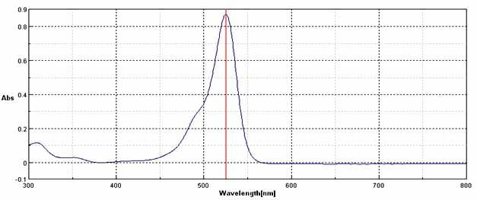

The sensitivity of the HPLC method depends upon the selection of proper wavelength. Ideal wavelength is one that gives maximum absorbance and good response for the drug to be detected. UV spectrum of tartrazine showed maximum absorbance at 426nm (Figure-01), so it was selected as the detection wavelength. Tartrazine was separated out

successfully by RP-HPLC, by isocratic elution techenique[12-16]. PhenomenexC18 Gemini column used as stationary phase, and a mixture of 10 mM Ammonium acetate buffer

:Acetonitrile: Methanol selected as mobile phase.Tartrazine eluted out,with a retention time of 1.299 min (Figure-02).

## Figure-02

**Chromatogram of standard tartrazine (0.8 µg /ml)**

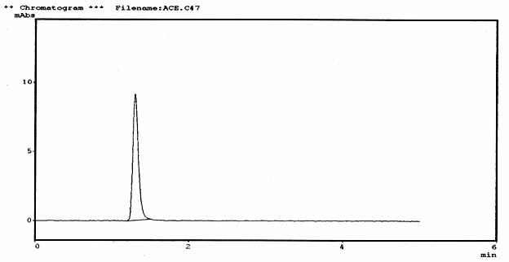

## Figure-03

**Calibration graph of tartrazine (0.2-1 mcg/ml) 5)**

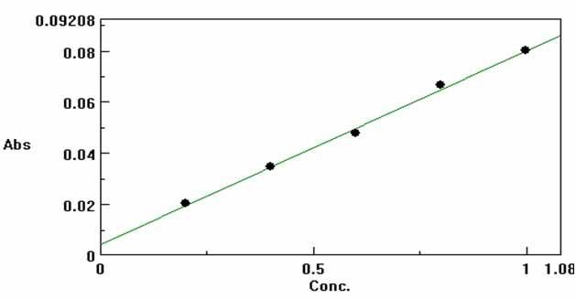

The standard stock solution containing tartrazine in the range of 0.2-1mcg/ml was found to be the most linear. Calibration graphs were plotted using peak area of standard tartrazine. The slope, intercept, and correlation coefficient

were found to be 0.0118, 0.0010 and 0.992643 respectively **(**Figure-03). LOD and LOQ were determined by progressively at lower concentrations of tartrazine. (Figure- 04 and Figure-05).

## Figure-04

**Chromatogram of limit of detection (LOD) (0.1ng/ml)**

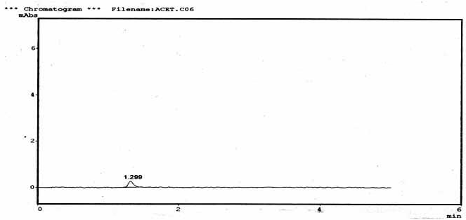

## Figure-05

**Chromatogram of limit of quantitation (LOQ) (1ng/ml)**

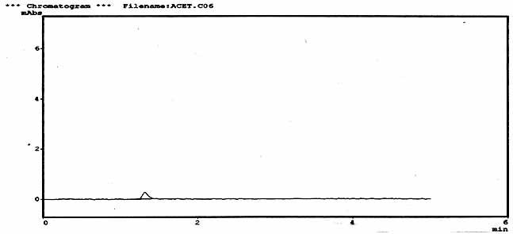

The method was thoroughly validated, intraday precision and Inter day precision found as: 0.78% RSD & 0.72% RSD respectively.

The Estimation of Tartrazine from Certain Food Stuff

The Extraction of dye tartrazine from the selected food stuff such as biscuits, gems, tank (soft drink) ,and candies(poppins) was carried out with simple pre treatment with water (suitable dilution or water extraction)[17-20]. Extracted solution was filtrated through what mann filter paper and 0.45µm disosable syringe filter, and injected to the column of RP- HPLC and readings were noted. (Figure - 06, 07, 08 & 09). Table-01 & 02 shows the Peak area of tartrazine from food

stuff & Estimated Amount of tartrazine present in selected food stuff.

Analysis of Dye Tartrazine from Formulation

The coat of tartrazine dye from the tablets, of aceclofenac and metoprolol was peeled out and accurately weighed to extract with water [17-20]. The solution was filtered and aliquots of sample solution prepared with mobile phase and injected to the RPHPLC column. The estimated level of

tartrazine dye was found to be 5.5 µg/ tabs and 5.14 µg/ tabs in aceclofenac (Figure-11, Table-03) and metoprolol (Fig 12, Table 4) tablet respectively (Fig 12, Table 4).

## Interaction Study

A Study on Protein Binding of Drugs by RP- HPLC and UV Spectrophotometer

## Preparation of standard stock solution

100Mg of drug aceclofenac dissolved in 2ml of 0.1N NaOH and made up to 1ml with distilled water to get 1000mcg/ml. This was used as primary stock solution for aceclofenac.

## Preparation of standard stock solution

100Mg of drug metoprolol dissolved in 2ml of 0.1N NaOH and made up to 1ml with distilled water to get 1000mcg/ml. This was used as primary stock solution for metoprolol.

## Preparation of pH 7.2 buffer solution

50ml of 0.2N Potassium hydrogen phosphate is added 34.7 ml of 0.2N NaOH solution and made up to 200ml with distilled water.

**Preparation of 2.8×10-4 m solution of egg albumin** 0.315g of egg albumin flakes is dissolved in distilled water. It is shaken well (till flakes are completely dissolved) and is kept aside.

1. **Preparation of Aceclofenac in Buffer:** Dissolve 10 mg of aceclofenac in 10 ml mobile phase to get 1000mcg/ml. From this 5.773 ml was transferred to a 100 ml standard flask and made upto the volume with the buffer 7.2pH. 1 ml of the above solution should contains 5.773 mcg, from this 25 ml is taken in a beaker and used for the following study. A boiling tube open on both sides is taken and a semi permeable membrane is tied onto the neck of the boiling tube.

The egg albumin solution 10ml is taken inside the semi permeable membrane. The boiling tube is then immersed into the beaker containing the drug Aceclofenac 1.63× 10 -4 M. Immediately at zero time 1ml of the drug solution is pipetted out from the beaker (which is replaced with 1 ml of water) and injected to RP-HPLC column. The procedure continued for different time intervals at 0, 10Min, 30Min, 45Min, 1hr, 1.15hr, 1.30hr, 1.45hr, 2hrs and corresponding readings are taken.

1. **Preparation of Metoprolol in buffer:** Dissolve 10 mg of metoprolol in 10 ml mobile phase to get 1000mcg/ml. From this 4.36 ml was transferred to a 100 ml standard flask and made upto the volume with the buffer 7.2pH. 1 ml of the above solution should contain 0.436 mcg, from this 25 ml is taken in a beaker and used for the following study. A boiling tube open on both sides is taken and a semi permeable membrane is tied onto the neck of the boiling tube. The egg albumin solution 10 ml is taken inside the semi permeable membrane. The boiling tube is then immersed into

the beaker containing the drug Metoprolol 1.63× 10 -4 M. Immediately at zero time 1 ml of the drug solution is pipette out from the beaker and is replaced with 1 ml of water and injected to RP-HPLC column. Readings are taken at intervals of 0, 10, 30,45,1 hr, 1.15, 1.30, 1.45, 2hrs. (Table-05, 06 &

1. and corresponding readings are taken.

*Once equilibrium is reached there will be no further change in absorbance, so the constant value of absorbance is noted. For this reason there will be no further change in peak area of particular drug. [9-11]

* 1. **Effect of Tartrazine on Aceclofenac in BSA by RP-HPLC: Solution-1(Drug):** A specific quantity of aceclofenac was weighed and dissolved in mobile phase, which diluted in order to get a concentration of 0.2-1µg/ml, used for the following study.

**Solution-2(Dye):** Tartrazine dye was prepared in a concentration range of (0.2-1 µg /ml)

## Stock solution of aceclofenac:

5ml of solution 1 and 5ml of BSA was added, evaporated to dryness by using nitrogen gas at room temperature in a flask and vortexes for 60sec. To that 5 ml of methanol was added & centrifuged at 2000rpm for 5minutes. From the organic layer, 1ml was taken, evaporated under nitrogen gas & finally the residue reconstituted in mobile phase and injected in to RPHPLC column & readings are noted.

## Stock solution of aceclofenac with tartrazine dye:

5ml of solution 1, was evaporated to dryness using nitrogen gas at room temperature in a flask along with 5 ml BSA and vortexed for 60 seconds. To that 5ml of solution 2 was added, thoroughly mixed and kept aside for 30 minutes. In to this 5ml of methanol was added & centrifuged at 2000rpmfor 5minutes.From this 1ml organic layer was pipette out & evaporated to dryness under nitrogen gas & finally the residue was reconstituted in mobile phase & injected to RPHPLC column and analyzed the effect of dye on drug. (Figure-13, Table-08). The concentration of the drug was found to be altered, due to the effect of dye.

## Effect of Tartrazine on Protein Binding of Metoprolol in BSA by RP-HPLC:

**Solution-1(Drug):** A specific quantity of metoprolol was weighed and dissolved in mobile phase, which diluted in order to get a concentration of 0.2-1µg/ml, used for the following study.

**Solution-2(Dye):** Tartrazine dye prepared in a concentration range of (0.2-1 µg /ml)

## Stock solution of metoprolol

5ml of solution 1 and 5ml of BSA was added, evaporated to dryness by using nitrogen gas at room temperature in a flask and vortexes for 60sec. To that 5 ml of methanol was added & centrifuged at 2000rpm for 5minutes. From the organic layer, 1ml was taken evaporated under nitrogen

gas & finally the residue reconstituted in mobile phase and injected in to RPHPLC column& readings are noted.

## Stock solution of metoprolol with tartrazine dye:

5ml of solution-1 was evaporated to dryness using nitrogen gas at room temperature in a flask along with 5 ml BSA and vortexed for 60 seconds. To that 5ml of solution 2 was added, thoroughly mixed and kept aside for 30 minutes. In

to this 5ml of methanol was added & centrifuged at 2000rpm for 5minutes.From this 1ml organic layer was pipette out & evaporated to dryness under nitrogen gas & finally the residue was reconstituted in mobile phase & injected to RPHPLC column and analyzed the effect of dye on drug. (Figure-14, Table-09). The concentration of the drug was found to be altered, due to the effect of dye.

## Figure-06 Chromatogram of tartrazine from GEMS

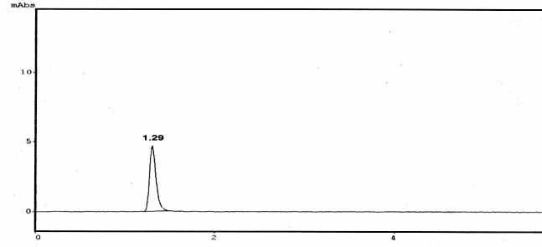

**Figure-07**

## Chromatogram of tartrazine from BISCUITS

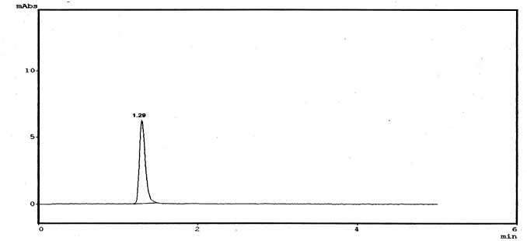

**Figure-08**

## Chromatogram of tartrazine from POPPINS

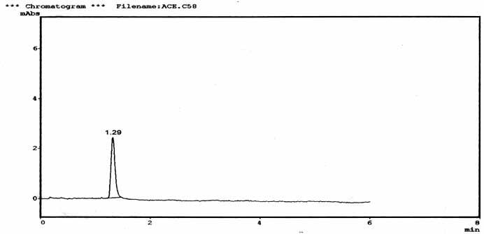

**Figure-09 Chromatogram of tartrazine from TANG**

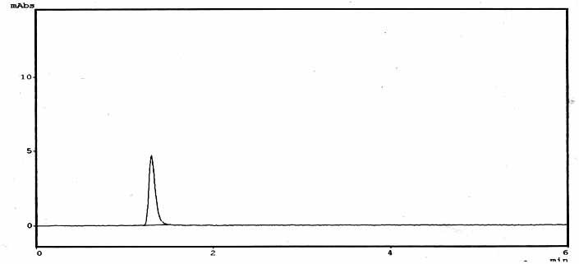

## Figure-10

**Graphical representation of tartrazine content in food stuff**

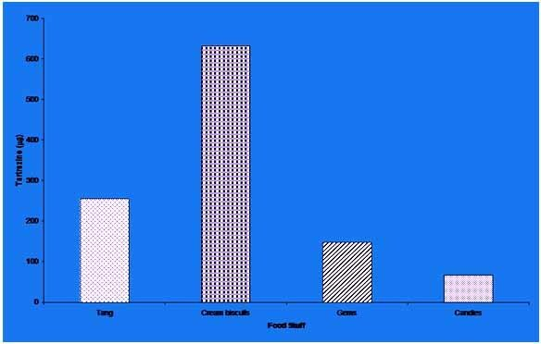

The amount of tartrazine content was found to be high in cream biscuits. When compared to other food stuff (Table-01, 02) & Figure-10.

## Figure-11

**Chromatogram of Tartrazine from Aceclofenac table**

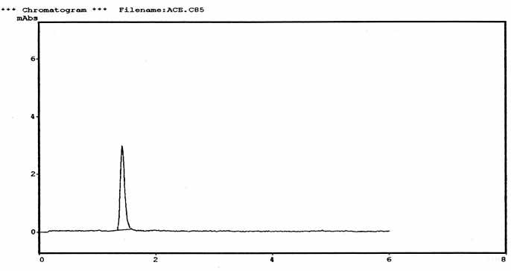

## Figure-12

**Chromatogram of tartrazine in metoprolol tablet**

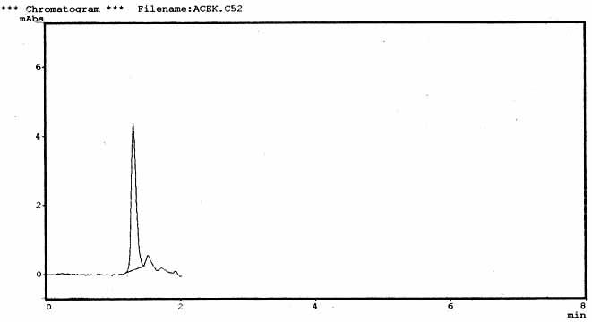

## Figure-13

**Chromatogram of standard aceclofenac in BSA with tartrazine (0.4µg/ml)**

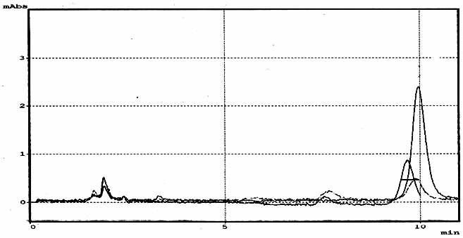

* Protein binding of drug was increased by the effect of dye; the unbound form of the drug is decreased by the effect of dye.
* Increase in the concentration of drug in BSA, the effect of dye on the drug was found to be more.

## Figure-14

**Chromatogram of standard metoprolol in BSA with tartrazine (0.4µg/ml)**

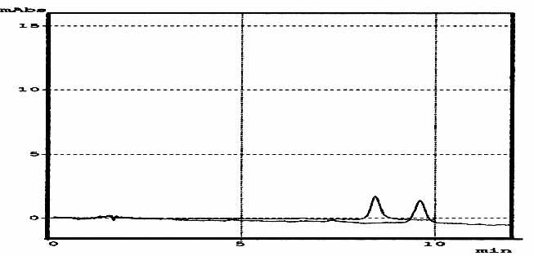

* Protein binding of drug was increased by the effect of dye; the unbound form of the drug is decreased by the effect of dye.
* Increase in the concentration of drug in BSA, the effect of dye on the drug was found to be more.

## Table-01

**Peak area of tartrazine from food stuff**

**Concentration**

|  |  |
| --- | --- |
| **(0.4µg/ml)** |  |
| Tang | 16800 |
| Gems | 9664 |
| Biscuits | 44878 |
| Candies | 5782 |

**Peak area**

## Table-02

**Estimated Amount of tartrazine present in selected food**

**stuff**

**Table-03**

**Analysis of dye from formulation**

**Amount of dye in aceclofenac**

**Food stuff Tartrazine in µg/ml**

**Dye**

**tab (µg/ tabs)**

Tartrazine 5.5

Tang 255 µg/ml

Cream biscuits 633 µg/ml Gems 1.47 µg/ml

Candies 0.67 µg/ml

## Table-04

**Analysis of tartrazine dye from formulation**

**Amount of dye in metoprolol**

**Dye tab (µg/ tabs)**

Tartrazine 5.14

## Table-05

**By UV Spectrophotometer**

## Table-09

**Peak area of Standard metoprolol Vs metoprolol along with tartrazine**

**Concentration (µg/ml)**

**Time in min**

**Absorbance of 1.63×10**

**-4 M**

**Aceclofenac at 276 nm**

**Absorbance of 1.63×10**

**-4 M**

**Metoprolol at 275 nm**

**Peak area of metoprolol**

**Peak area of metoprolol- tartrazine dye**

0 1.5347 0.2216

10 1.4507 0.2142

20 1.1823 0.1957*

40 1.0913 0.1969*

60 1.0641* 0.1969*

80 1.0548* 0.1969*

## Table-06

**By RP-HPLC**

**Time in min**

**Absorbance of 1.63×10 -4 M**

**Aceclofenac**

**Absorbance of 1.63×10 -4 M**

**metoprolol**

0 2045552 101767

10 2031920 101485

30 1924973 98278

45 1771791 88297

60 1765884 81240

75 1720688 74346

90 1667175 72267*

105 1411918* 72927*

120 1407894* 72950*

## Table-07

**Report for Protein Binding of Drugs [9-11]**

**Drug**

**% of Protein Binding**

**Peak Plasma Concentrati on (hrs)**

**Half life (hrs)**

**UV-results (hrs)**

**HPLC**

**Results (hrs)**

|  |  |  |  |  |  |
| --- | --- | --- | --- | --- | --- |
| Aceclofenac | 99 | 1-3 | 4 | 60-80 | 1.45 |
| Metoprolol | 11 | 1.30-2 | 3-4 | 20-40 | 1.15 |

## Table-08

**Peak area of Standard aceclofenac Vs aceclofenac**

**with tartrazine**

0.2 1268 5809

0.4 3194 1756

0.6 4632 2858

0.8 5581 4191

1.0 8632 9300

# Conclusion

1. A simple, precise and accurate RP-HPLC method was developed and validated for the estimation of tartrazine.
2. Tartrazine extracted from various food stuff and estimated.

Tang - 255µg/ml

Cream biscuits - 633µg/ml Gems –147µg/ml

Candies - 67µg/ml

Tartrazine content was found to be high in cream biscuits compared to other food stuffs.

1. Tartrazine extracted from formulations and estimated.
   * The amount of tartrazine present in aceclofenac tablet was found to be 5.5 µg/ tablets.
   * The amount of tartrazine present in metoprolol tablet was found to be 5.14µg/ tablets.
2. Interaction of dyes on protein binding of drugs
   * Protein binding of the drug was increased by the effect of dye.
   * Unbound form of the drug was decreased by the effect of dye.
   * Increase in the concentration of drug in BSA, the effect of dye on the drug was found to be more.

It is evidenced that even in the permitted colors are not in safe It is signatory to minimize the indiscriminate use of food colors. So it should be performed the need to harmonize the regulations in the use of these synthetic dyes especially tartrazine in order to safeguard the human health

# Acknowledgement

I am very much thankful, for the scholarship received from The Tamilnadu Pharmaceutical Sciences Welfare Trust, Chennai, India for the successful completion of my research work. And also I wish to thank my parents, brothers sisters, teachers and God Sree Krishna for their valuable support.

# References

**Concentration (µg/ml)**

**Peak area of aceclofenac**

**Peak area of aceclofenac-**

1. Clinical and Experimental Allergy Vol 10, *Issue 4, 1980,*

**tartrazine dye**

|  |  |  |  |
| --- | --- | --- | --- |
| 0.2 | 1271 | 2668 | 2. Wendy L Thompson M.D, Troy L Thompson 11, MD. |
| 0.4 | 3452 | 12035 | *Treating depression IBN asthmatic patients Vol 25, Issue* |
| 0.6 | 8250 | 95381 | *No 2, 1984, 809-812.* |
| 0.8 | 8875 | 21418 | 3. Laupan WI, Brima Combe,J, Richmonds E , Keller C. |
| 1.0 | 9279 | 18362 | *Anasthesia 61 (6) 2006, 524-527* |

*375-394.*

* 1. www.food colors material safety data sheet .com
  2. www.regulatoryguidelines concerning food additives
  3. Martindale. The complete drug reference, Vol no 8, Issue 32, 2000, P 12, 14, 907.
  4. Alfred Martin, James Swarbrick, Arthur Cammarata. Physical pharmacy, Physical Chemical Principles in the pharmaceutical sciences, Vol 12, Issue 3, 1998, P 2331,335-341.
  5. Wilson and gisvold’s, Text book of organic medicinal and pharmaceutical chemistry, Vol 12, Issue 8, 1996.
  6. Goodman Gillman’s the pharmacological basis of therpeutics. Editors: A Goodman gilman, T.W. Rall, AIS, Nies, P.Taylor,Vol 8, 10,2000,P 427.
  7. http;//[www.](http://www/) Chemisry mag.org ,Vol 5,issue 4,2003P4/
  8. M Ustun Ozgur, G. Alpdogan, Ikoyuncu. *Analytical letters Vol 35, Issue 4, 2000, 721-732.*
  9. Tanaka Masami, Asahi Yutaka, Masuda Seizo, Ota Tadatoshi. *Chemical and pharmaceutical bulletin vol.39, Issue NO.1, 1991, 1-4.*
  10. Canaparo R, Muntoni E , Zara GP, Della Pepa C, Berno E, *Costa M et al., biomedic chromatography Vol 14, issue 4, 2000, 219-226.*
  11. Katerina S Minioti, Christina F Sakellariou and Nikolas S Toadies. *Analytica chimica Acta, Vol 583, Issue 1, 2002,*

*103-110.*

* 1. Mahaparle PR, Sangshetti JN, Kuchekar BS. *Indian journal of pharmaceutical sciences, Vol 69, Issue 2, 2006,*

*289-292.*

* 1. Singhvi, Goyal anju. Indian journal of pharmaceutical sciences *Vol 69, Issue 1, 2007, 164-165.*
  2. Illona Fitos, Julia Visy, Miklo’S Simonyi, Jorgen Hermansson. Journal of National liberty of medicines *Vol 11, Issue 2, 2007, 115-120.*
  3. Hesham salem ad Ola M.Abdallah. *American journal of applied sciences. Vol 4, issue 9 ,* 2007, *709-717.*
  4. Erdal Dinc, A Hakan Aktas, Dumitru Baleanu And Ozgur Ustundag . *Journal of food and drug analysis, Vol 14, Issue No. 3, 2006 , 284-291.*
  5. Momin M, Yeole P, Puranik M, Wadher S. *Scientific commons, Vol 68, Issue No 4,* 2006, *387-389.*