Original Article SPECTROSCOPIC METHOD FOR DETERMINATION OF DESLORATADINE

IN BULK AND ITS TABLET DOSAGE FORMS.

*Satish Bondili, Sudarshan Reddy P
School of Pharmaceutical Sciences, Vels University, Zameen Pallavaram, Chennai, India – 600 117.

Abstract
A simple and sensitive spectroscopic method was developed for Desloratadine in pure and its tablet dosage forms. The method has been developed by using its free soluble property in Methanol at ambient temperature. At optimum condition of the experiment the absorbance read at 242 nm. The developed method was validated and applied to the determination of Desloratadine in tablets. The linearity range for the concentration of Desloratadine was found to be 2 -10µg/ml (r2
>0.996, RSD=1.8), precision (RSD=1.83) and accuracy (RSD<1.8). The LOD (0.11) and LOQ (0.33). The product remains stable up to 8 hours when kept at room temperature. The potency of Desloratadine in marketed product was determined by this method with acceptable precision and reproducibility.

Keywords: UV-Spectrophotometry, Desloratadine, Antihistaminic Drug.

Introduction
Today modern pharmaceutical analysis has got more emphasis to satisfy our query for better understanding of physiochemical properties of pharmaceutical compounds, using advanced instrumental methods. It also plays an important tool for quality assurance of pharmaceutical product throughout the shelf life. The pharmaceutical industry is under increased scrutiny to constrain costs and yet consistently deliver to market safe, efficacious products that fulfill medical needs. As a part of this, drug analysis also plays an important role. Standard analytical procedure for newer drugs or formulation may not be available in the pharmacopoeia; hence it is essential to develop a new analytical method, which is accurate, precise, specific, linear, simple & rapid1,2.

Desloratadine is an H1 receptor antihistaminic drug was developed on 2005. It is a metabolite of Loratadine, a second generation antihistaminic drug. Extensive literature survey, it was revealed that there were a few methods reported for estimation of desloratadine from plasma and from pharmaceutical dosage forms. Therefore here an attempt was made to develop simple, cost effective and accurate spectroscopic methods and a more precise cost effective, sensitive and specific HPLC method for desloratadine.3,4

* Author for Correspondence:

Satish Bondili,
School of Pharmaceutical Sciences, Vels University, Zameen Pallavaram, Chennai, India – 600 117.
Email: satish.mpharmacy@gmail.com

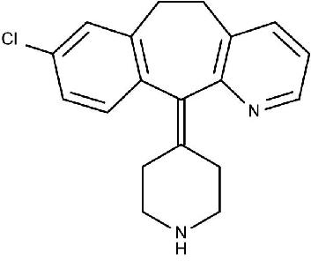

Structure of Desloratadine

Desloratadin5 is a second generation tri cyclic anti histaminic drug which has a selective and peripheral H1 antagonist action. It is active form of prodrug Loratadine. It is chemically 8-chloro-6, 11- di hydro-11(4-piperdinylidene)- 5H (5,6 cycloheptyal (1,2-b) pyridine. Molecular weight is
310.84 gm/mol and white to off white powder. It is mainly used in the treatment of allergic disorder and in common cold. Sedation and dryness of mouth are common adverse drug reaction.

Caglar6 has studied the sensitive spectrophotometric method for determination of Desloratadine in tablets. A simple, rapid and sensitive visible spectrophotometric method was developed for the first time for the analysis of Desloratadine in tablets. The method is based on deep blue colored radical anion formed by interaction of the drug with 7-7-8,-8 tetra acyanoquinodimethane in acetonitrile at ambient temperature.

Materials and Methods

Instrument
Absorption spectral measurements were carried out with a UV – Visible spectrophotometer (Shimadzu Model 1700, UV probe) was employed with spectral bandwidth of 1nm and wavelength accuracy of 0.3 nm (with automatic wavelength correction with a pair of 5 cm matched quartz cells).

Materials
Desloratadine pure drug was supplied by Sun pharmaceuticals, India as gift sample and used as such. Methanol was used as a solvent.

Linearity and Calibration
From the above standard solution 2ml was transferred in to a 100ml standard flask and made up to the mark with methanol to produce 20µg /ml solution. To the series of ten, 10ml volumetric flasks aliquots of 1-10 ml of 20µg/ml solutions were taken and made up to the mark with methanol. The absorbance was measured at 242 nm against methanol as blank. The calibration curve was plotted in the concentration range of 2- 20µg/ml. This was shown in Table
-01 & Figure-01.

Selection of solvent and λ max
The solubility of Desloratadine was determined in a variety of solvents ranging from non polar to polar. The drug was found more soluble in methanol. Some concentration of drug was added in methanol and was scanned within the range of 200-400 nm. The λ max was found to be 242 nm. This solubility of drug was determined at 28±°C. The plots of Beer’s law limit are shown in Fig.2.

Preparation of Standard stock Solution
An accurately weighed quantity of 25 mg Desloratadine (pure) was dissolved in minimum quantity of 25ml of methanol to produce 1mg/ml solution.

Quantification of Formulation
Twenty tablets of each formulation (DES-LOR) containing 5mg of Desloratadine were accurately weighed and powdered. Powdered tablet equivalent to 20mg of Desloratadine was transferred in to a 100ml volumetric flask, and to it 25ml of methanol was added and shaken vigorously for few minutes and repeated the extraction consequently by three times ( 3x 25ml) to produce 100ml with methanol, and then sonicated for 5 minutes. The solution was filtered through whattman filter paper NO: 41. From this clear solution 1ml was transferred 200ml standard flask and produce 2µg/ml solution. Like this absorbance measurements of 2µg /ml solution were made six times for each formulation. The absorbance was recorded at 242 nm.

Accuracy
The accuracy of the proposed methods was assessed by recovery studies at three different levels i.e. 80%, 100%, 120%. The recovery studies were carried out by adding known amount of standard solution of three drugs to preanalysed tablet solutions. The resulting solutions were then re-analysed by proposed methods; the results are shown in table-03.

Precision
Precision of the methods was studied as intra-day, inter day and repeatability. Intra-day study was performed by analyzing, the three different concentration of drug for three times in the same day. Inter-day precision was performed by analyzing six solutions of sample. The results are shown in table-04.

The limits of detection (LOD) and quantification (LOQ)
The limits of detection (LOD) and quantification(LOQ) calculated according to ICH guidelines using the formula: LOD = 3.3 S/b and LOQ = 10 S/b, where S is the standard deviation of blank absorbance values, and b is the slope of the calibration plot, are also presented in Table-05. The high values of molar absorptivity (ε), low values of Sandell sensitivity and LOD indicated the high sensitivity of the proposed methods. Results shown in Table-05.

Table-01
Optical characteristic and linearity data
Parameters Desloratadine
Nm 242
Beer’s law limits 2-10 μg/ ml Correlation coefficient 0.996
Regression equation
Y=0.0405-0.0086
Y=mx+c
Intercept(c) | -0.0086
Slope | 0.0418
Std error | 0.007685

Table-02
Analysis data of Tablet formulation

Results show in Table-02.
Drug
Label claim mg/tab
Amount found mg/tab
Label claim (%)
S.D.*
S.E*
Desloratadine 5 4.93 98.6 0.001414 0.007685

Validation of Method
The method was validated with reference to the ICH guide lines.7

S.D: Standard deviation, S.E: Standard error,
*Average of four estimation of tablet formulation.

Table-03
Recovery studies

Table-04
Precision Results

Amount Amount %
% conc | added | found | Recovery | %RSD | Parameters | Desloratadine
80 | 8 | 7.9 | 98.7 | 1.90
100 | 10 | 9.93 | 99.3 | 1.69 | Intra-day (n = 3) | 0.076

120 12 11.9 99.1 1.87

Mean 99.0
Inter-day (n = 3) 0.077

Figure-01 Linearity of Desloratadine
Absorbance
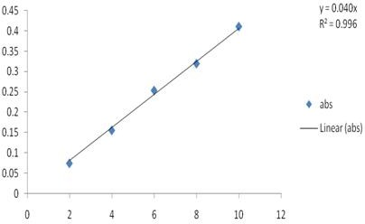
Concentration

Figure-02
UV spectra of Desloratadine

Figure-03
UV spectra of sample Desloratadine

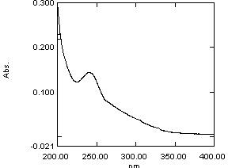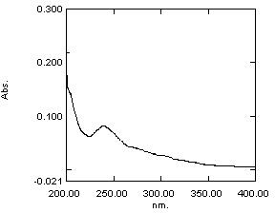

Table-05
The limits of detection (LOD) and quantitation (LOQ)
LOD in μg/ ml 0.11
LOQ in μg /ml 0.338

Result and Discussion

UV Spectroscopic method
The wavelengths 242nm (λmax for Desloratadine) was selected for analysis of the drugs in Methanol. Linearity was observed in the range 2-10 μg/ml (r2 =0.9976) for the amount of drugs estimated by the proposed methods was in good agreement with the label claim. The proposed methods were validated. The accuracy of the methods was assessed by recovery studies at three different levels. Recovery experiments indicated the absence of interference from commonly encountered pharmaceutical additives. The method was found to be precise as indicated by the repeatability, inter-day, intra-day analysis, showing %RSD less than 2. The results did not show any statistical difference between operators suggesting that methods developed were rugged. The results of precision shown in table-04. All statistical data proves validity of the methods and can be used for routine analysis of pharmaceutical formulation.

Acknowledgement
The authors are grateful to the Management of school of pharmaceutical sciences, VELS University, Chennai, for their continuous support and encouragement and for providing the necessary facilities.

References
- Beckett, A.H. and Stenlake, J.B, Practical Pharmaceutical Chemistry, part B. 4th edn., CBS publishers and Distributors, New Delhi, 2002, 272-280.
- Chatwal, R. Gurdeep and Sham, K. Anand, Instrumental Methods of Chemical Analysis. 5th Revised edn Himalaya publishing House, Mumbai, 2000, 2.160.
- Indian Pharmacopeia, Indian pharmacopeia commission office, Delhi, 1996, Volume-II, appendix A, 158.
- British Pharmacopoeia, British Pharmacopoeia commission office, London, 2003, Volume-II, 1225.
- http://en.wikipedia.org/wiki/Desloratadine,june20,2010.
- Caglar, Spectrophotometric Method for determination of Desloratadine in tablets. Journal of AOAC international March 2001, 01 (02), 191-194.
- Code-Q2A, 1997. Text on validation on Analytical method ICH harmonized tricartite guidelines.

