Original Article VALIDATED HPLC METHOD FOR SIMULTANEOUS ESTIMATION OF ZINC CARNOSINE AND ACECLOFENAC IN BULK AND

TABLET DOSAGE FORM
*Panjagala Satyanarayana, Shanmugasundaram P, Sudarshan reddy P, Chandra mohan rao G
School of Pharmaceutical Sciences, Vels University, Zameen Pallavaram, Chennai, India – 600 117.
Abstract
A validated HPLC method for simultaneous estimation of Zinc carnosine and Aceclofenac in pharmaceutical dosage forms. Chromatography was carried out on a C18 column [250mm, 4.6m, 5µm] using a mixture of potassium di-hydrogen phosphate buffer: Acetonitrile: methanol (50:30:20 v/v) as the mobile phase at a flow rate of 1 ml/min. Detection was carried out by using PDA detector. The retention time of the drug was 2.258 and 6.690 min. The method produced linear responses in the concentration range of 2 to 10μg/ml for both drugs. The LOD and LOQ values were found to be 33.4,
101.3 and 2.473, 7.495 ng/ml respectively. The method was validated for linearity, precision, accuracy, LOD &LOQ in accordance with ICH guidelines. The proposed method was found to be applicable for determination of the drug in tablet dosage forms.
Keywords: HPLC, Zinc carnosine & Aceclofenac method development, validation, Tablet.

Introduction
Zinc carnosine is a zinc salt of (2S)-2-[(3-Amino-1- oxopropyl)amino]- 3 -(3H-imidazol-4-yl) propanoic acid. Aceclofenac is 2-[2-[2-(2,6-Dichlorophenyl) aminophenyl] acetyl] oxyacetic acid. These are the prescribed drugs for Antiulcer, NSAID. There is no HPLC method have been reported for the determination of zinc carnosine and Aceclofenac. An attempt was made to report a simple, reliable and reproducible RP-HPLC method which was duly validated by statistical parameters precision, accuracy, linearity, LOD & LOQ. The method has been satisfactorily applied to the determination of zinc carnosine in pharmaceutical preparations. A simple, rapid and selective HPLC method has been developed for quantitation of aceclofenac and paracetamol from bulk drug and pharmaceutical formulations. Sensitive and reproducible methods for quantitative determination of aceclofenac in pure form and in pharmaceutical formulation by UV. Development and validation of RP-HPLP Method for simultaneous estimation of three tablet formulation containing Acetaminophen, Chlorzoxazone and Aceclofenac.

Materials and Methods

Chemicals and solvents
Potassium di hydrogen phosphate (AR grade, Qualigens) was used for preparing the buffer. HPLC grade acetonitrile, methanol was used.

* Author for Correspondence:
Panjagala Satyanarayana, School of Pharmaceutical Sciences,
Vels University, Zameen Pallavaram, Chennai, India – 600 117.
Email: p.satya.pharma@gmail.com

Pure sample of Zinc carnosine and Aceclofenac was a gift sample from a local pharmaceutical industry. Commercial samples of tablets containing the drug Zinc carnosine and Aceclofenac (Acenal safe) was purchased from the local pharmacy.

Chromatographic Conditions
A High pressure liquid chromatography (Shimadzu LC- 2010HT) with variable wavelength programmable UV- Visible detector and phenomenex C-18 column [250mm, 4.6m, 5µm] was used. The HPLC system was equipped with the soft ware Class VP series version 5.03 (Shimadzu). A freshly prepared mixture of potassium di-hydrogen phosphate buffer (0.02M,pH-3.5): Acetonitrile: methanol (50:30:20 v/v) used as the mobile phase. Buffer solution was prepared by dissolving 6.8gms of potassium dihydrogen phosphate in 1000ml of water. Adjust the pH to 3.5 with phosphoric acid. Mobile phase was filtered through a 0.45 μm membrane filter and sonicated before use. The flow rate of the mobile phase was maintained at 1ml/min. The detection was carried out by PDA detector.

Preparation of the mixed standard solution
Accurately weighed 10 mg of both drugs (zinc carnisone and Aceclofenac).Weighed powder of both drugs were accurately transferred to a same volumetric flask of 10mL and made volume up to the mark with diluent (Acetonitrile:Methanol) to obtain a mixed standard stock solution (solution A) of Zinc carnosine (10mg/mL) and Aceclofenac (10mg/mL). Acurately measured solution A of
0.02 ml was transferred to volumetric flask of 10mL and made volume up to the mark with diluent to obtain a mixed standard stock solution (solution B) of Zinc carnosine (2μg/mL) and Aceclofenac (2μg/mL).

Preparation of Sample solution
Twenty tablets were weighed and finely powdered. Powder equivalent to 40.86 mg of zinc carnosine and 42.82 mg of Aceclofenac was transferred to 10ml volumetric flask and made volume up to the mark with diluent to obtain solution of Zinc carnosine (10mg/mL) and Aceclofenac (10mg/mL). From this solution 0.2mL was transferred to 100mL volumetric flask and made volume up to the mark with diluent to obtain solution of Zinc carnosine (2mg/mL) and Aceclofenac (2mg/mL).

Method validation
T he proposed method was validated as per ICH guidelines. The drug solutions were prepared as per the earlier adopted procedure given in the experiment.

Linearity study
Linearity was performed by taking from stock solution aliquots of 0.02, 0.04, 0.06, 0.08 and 1.0 mL were taken in 10ml volumetric flasks and diluted upto the mark with diluent (Acetonitrile : Methanol). Such that the final concentration of Zinc carnosine in the range of 2 to 10 μg/mL. Volume of 20 μl of each sample was injected in five times for each concentration level and calibration curve was constructed by plotting the peak area versus the drug concentration. The observations and calibration curve is shown in Table 1, Fig.1,2.

Assay
Acurately weighed the powder equivalent to 40.86 mg of zinc carnosine and 42.82 mg of Aceclofenac was transfered to 10ml volumetric flask and made volume up to the mark with diluent to obtain solution of Zinc carnosine (10mg/mL) and Aceclofenac (10mg/mL). From this solution 0.2mL was transferred to 100mL volumetric flask and made volume up to the mark with diluent to obtain solution of Zinc carnosine (2mg/mL) and Aceclofenac (2mg/mL). The chromatogram was shown in Figure-3.

Accuracy as recovery
It was done by recovery study. Sample solutions were prepared by spiking at about 50 %, 100% and 150 % of specification limit to Placebo and analyzed by the proposed HPLC method. Results are shown in Table 3.

System precision
Precision is the measure of how close the data values are to each other for a number of measurements under the same analytical conditions. Standard solution of (2μg/ml) were prepared as per test method and injected for 3 times.

Limit of detection and limit of quantization
The parameters LOD and LOQ were determined on the basis of response and slope of the regression equation. Results are shown in Table 6.

Results and discussion
Zinc carnosine and Aceclofenac, indicated for the treatment of ulcer and relief of pain. Literature scan revealed no HPLC was developed for the determination of Zinc carnosine and Aceclofenac. Fig 2 shows typical chromatograms of Zinc carnosine and Aceclofenac. The retention time of Zinc carnosine and Aceclofenac was 2.260 , 6.690 min. The calibration curve was linear over the range 2 - 10 μg/ml for the determination of Zinc carnosine and Aceclofenac. The linearity of method was statistically confirmed. The correlation coefficients (r2) for calibration curves were not less than 0.999. The LOD and LOQ values of Zinc carnosine and Aceclofenac were found to be 33.4, 101.3 and 2.473,
7.495 ng ml-1 respectively. The Precision of the method was determined by repeatability (intra-day) and intermediate precision (inter-day). Precision was expressed as the RSD of the results. The values obtained for the precision studies presented (Table-4,5), indicates good repeatability and low inter day variability. The analytical recovery at five different concentrations of Zinc carnosine and Aceclofenac was determined and the recovery results were in the range for Zinc carnosine of 99.5-100.36% , for Aceclofenac 99- 99.83%.Therefore proposed validated method was successfully applied to determine Zinc carnosine and Aceclofenac in tablet dosage forms.

Conclusion
For the determination of Zinc carnosine and Aceclofenac, the proposed HPLC method was found to be superior due to high percentage recovery which shows that the method was free from interference of excipients used in the formulations. The results of the study indicate that the proposed HPLC method of analysis can be used in quality control department with respect to routine analysis for the assay of the tablets containing Zinc carnosine and Aceclofenac.

Acknowledgement
The authors are grateful to the Management of school of pharmaceutical sciences, VELS University, Chennai, for their continuous support and encouragement and for providing the necessary facilities.

Linearity
Table-1
Zinc carnosine and Aceclofenac

Results are shown in Table 4.
Concentration
Peak Area

S.No
1. 2 | 2250.42 | 6564.134
2. 4 | 4501.42 | 13656.37
3. 6 | 6791.41 | 20684.72
4. 8 | 9016.72 | 27567.86
5. 10 | 11109.42 | 34668.14

Method precision
Three samples were Prepared and analyzed as per the test method on same day and three different days and calculated the % RSD for Assay of five preparations. Results are shown in Table 5.
(μg/ml)
Zinc Carnosine Aceclofenac

Assay

Formulation

Labeled amount

Table-2
Observed amount*(mg)

%Amount %RSD
found

(mg)

Zinc carnosine

37.5 74.87 99.82 0.013

Aceclofenac 100 99.92 99.92 0.015

Accuracy
Table-3

Accuracy of Zinc carnosine and Aceclofenac

Label
Drug claim in mg
Sample conc in mg/mL
Amount added in µg
Amount added in µg
%
Recovery
Average recovery (%)

carnosine
Zinc 37.5 10 2 |  |  | 1.99±1.32 | 99.5
 |  | 4 | 4.03±1.7 | 100.83 100.23
 |  | 6 | 6.02±1.1 | 100.36
 |  | 2 | 1.98±0.01 | 99
Aceclofenac 100 | 10 | 4 | 3.99±0.152 | 99.75 99.52
 |  | 6 | 5.99±0.025 | 99.83

System precision

Method Precision

Table -4

Drug Injections | Peak Mean S.D %R.S.D Area
1 | 2255.366
Zinc carnosine 2 | 2252.729 2253.448 1.471 0.065
3 | 2251.518
4 | 2253.327
5 | 2254.303
1 | 6564.134
Aceclofenac 2 | 6565.421
3 | 6564.243 6564.307 0.824 0.012
4 | 6564.234
5 | 6563.432

Table-5

Inter-day precision Intra-day precision Concentrations

 | Mean ± S.D | %R.S.D | Mean ± S.D | %R.S.D
2 | 99.81±0.616 | 0.617 | 99.73±0.123 | 0.123
4 | 99.53±0.225 | 0.226 | 99.44±0.572 | 0.575
6 | 99.31±0.415 | 0.417 | 99.72±0.323 | 0.323

Table-6
Characteristics of HPLC method
Drug Parameters Determined Obtained Value

Zinc carnosine

Aceclofenac
Linearity range (μg/ml) Slope
Intercept Regression Coefficient(r2)
LOD(ng/ml) LOQ(ng/ml)
Linearity range(μg/ml) Slope
Intercept Regression Coefficient(r2)
LOD(ng/ml) LOQ(ng/ml)
2-10
0.1120
63.86
0.999
33.4
101.3
2-10
3505.52
-406.105
0.999
2.473
7.495

Figure-1 Zinc carnosine
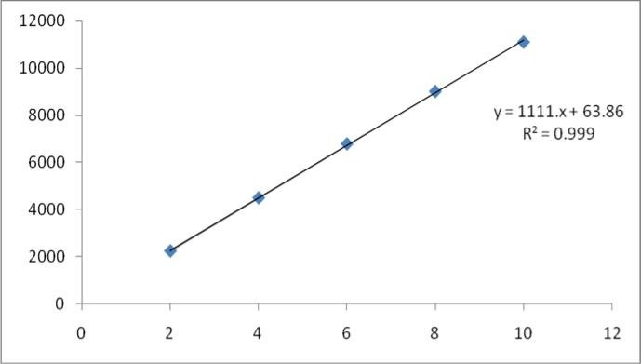

Figure-2 Aceclofenac
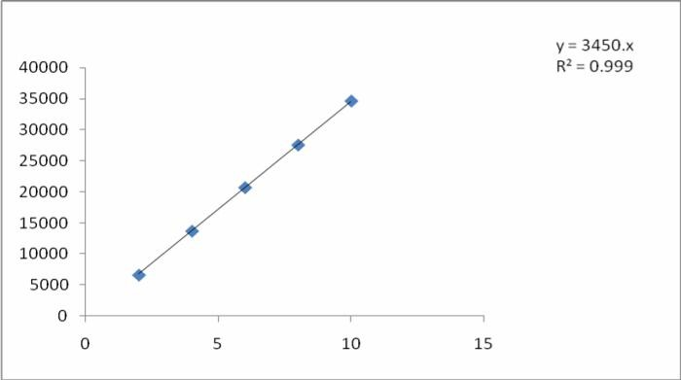

Figure-3
Standard chromatogram of Zinc carnosine and Aceclofenac
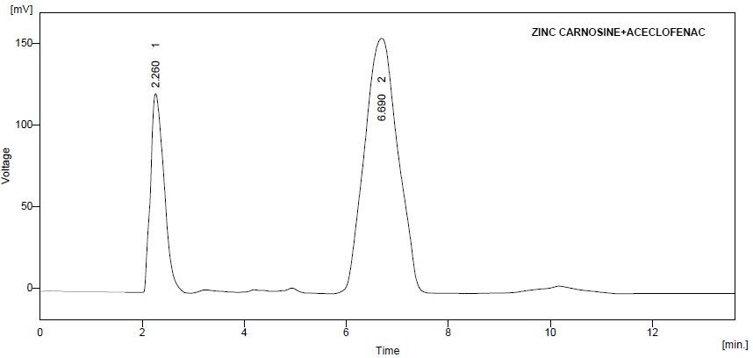

Figure-4
Sample chromatogram of Zinc carnosine and Aceclofenac
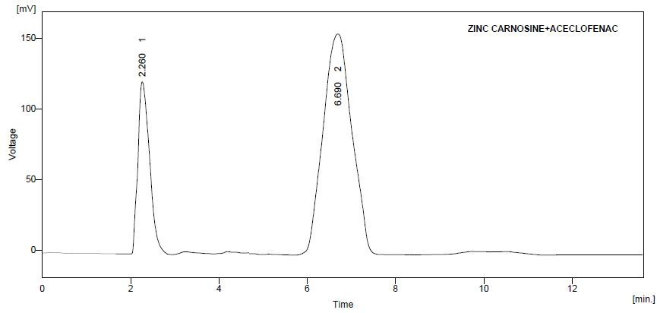

References
- Yoshikawa T., Naito Y., Tanigawa T., Yoneta T., Yasuda M., Ueda S., Oyamada H. and Kondo M., Effect of Zinc- Carnosine Chelate Compound (Z-103), A Novel Antioxidant, on Acute Gastric Mucosal Injury Induced by Ischemia - Reperfusion in Rats, Free Radical Research, 1991, 14, 4,289-296.
- Matsukura T. and Tanaka H., Applicability of Zinc Complex of L-Carnosine for Medical Use Biochemistry (Moscow), 2000, 65, 7, 817-823.
- Masaru Odashima, Michiro Otaka, Mario Jin, Isao Wada, Youhei Horikawa, Tamotsu Matsuhashi, Reina Ohba, Natsumi Hatakeyama, Jinko Oyake and Sumio Watanabe Zinc L-carnosine protects colonic mucosal injury through induction of heat shock protein 72 and suppression of NF-κB activation Life Sciences , 2006,79, 24,2245-2250.
- Razinah sharif, Philip Thomas, Peter Zalewski, Robin D. Graham and Micheal Fenech The effect of zinc sulphate and zinc carnosine on genome stability and cytotoxicity in the WIL2-NS human lymphoblastoid cell line Mutation Research/Genetic Toxicology and Environmental Mutagenesis 2011, 720, 1-2, 22-33.
- Godse VP. Deodhar MN, Bhosale AV, Sonawane RA, Sakpal PS, Borkar DD and Bafana YS. A simple, rapid and selective HPLC method has been developed for quantitation of aceclofenac and paracetamol frombulk drug and pharmaceutical formulations. Asian J. Research Chem. 2(1) 2009.
- Zawilla .N. M. Abdul ,Azim MohammadN. M. El Kousy and S. M. El-Moghazy Aly. A sensitive and reproducible methods for quantitative determination of aceclofenac in pure form and in pharmaceutical formulation by UV. Journal of Pharmaceutical and Biomedical Analysis. Volume 27, Issues 1-2, 1 January 2002, Pages 243-251.
- Joshi.R,Sharma.R., Development and validation of RP- HPLP Method for simultaneous estimation of three tablet formulation containing Acetaminophen ,Chlorzoxazone and Aceclofenac. Analytical letters.volume-41,issue- 18,2008,3297-3308.
- Singhvi, Anju Goyal .Developed aVisible spectrophotometric estimation of aceclofenac and indapamide from tablets using folin-ciocalteu reagent.Indian journal of pharmaceutical sciences, 2007, Volume -69, Issue-1, 164-165.
- Garg.G,Swarnlata Saraf, S Saraf., A Simultaneous estimation of aceclofenac, paracetamol and chlorzoxazone in tablets by UV-Spectroscopy. Indian journal of pharmaceutical sciences, 2007, Volume - 69, Issue -5, 692-694.
- Q2 (R1) 2005 – Text on Validation of analytical procedures, step-4, Consensus guideline, ICH Harmonized Tripartite Guidelines. ICH Guidelines Q2B, Validation of Analytical Procedure: Definitions, published in March 1996, Geneva, Switzerland.
- Lloyd R. Snyder et al., practical HPLC method development. John wiley & son’s publishers, 2nd edition, Pg. no 350-400.
- http://www.wikipedia.com. & www.Rxlist.com. April9

