Original Article NOVEL REVERSE PHASE HPLC METHOD DEVELOPMENT

AND VALIDATION OF QUETIAPINE FUMERATE IN BULK AND TABLET DOSAGE FORM
*Sudarshan Reddy P, Panjagala Satyanarayana, Karthik Varma K, Naga Raju, Siva Kumar G, Shanmugasundaram P
School of Pharmaceutical Sciences, Vels University, Zameen Pallavaram, Chennai, India – 600 117.
Abstract
A precise and feasible high-performance liquid chromatographic (HPLC) method for the analysis of the novel antipsychotic drug quetiapine in tablet dosage form has been developed. The analysis was carried out on a Phenomix Stainless Steel C18 (250 x 4.6 mm, 5 μ) reversed-phase column, using a mixture of phosphate buffer (pH 3), acetonitrile, methanol (50:40:10) as the mobile phase using a low pressure gradient mode with flow rate at 0.8ml/min. The injection volume was 20µl..The retention time of the drug was 4.69 min. The method produced linear responses in the concentration range of 1 to 5μg/ml of Quetiapine fumerate. The LOD and LOQ values for HPLC method were found to be 0.0167 and 0.0506 μg/ml respectively. The method was found to be applicable for determination of the drug in tablets.

Keywords: HPLC, Validation and quantification, Quetiapine fumerate, tablet.

Introduction
The chemical formula of Quetiapine fumarate is2-[2-(4- dibenzo [b, f][1,4] thiazepin-11-yl-1-Piperazinyl) ethoxy] ethanol hemifumarate. It is Antipsychotic drug which is White or almost white powder, soluble in water and soluble in Methanol & 0.1N HCl. It is used to treat psychosis associated with Parkinson's disease and chronic schizophrenia. The mode of action of Quetiapine fumarate, as with other drugs used to treat schizophrenia, is unknown. However, it is thought that the drug's therapeutic activity in schizophrenia is mediated through a combination of dopamine type 2 (D2) and serotonin type 2 (5HT2) receptor antagonisms. [1-2]
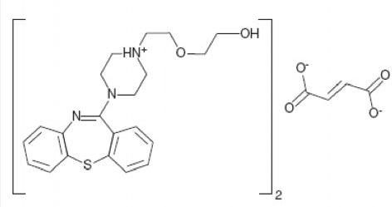

Structure of Quetiapine fumarate

* Author for Correspondence:
Sudarshan Reddy P,
School of Pharmaceutical Sciences, Vels University, Zameen Pallavaram, Chennai, India – 600 117.
Email: pr88274@gmail.com

Literature survey revealed that methods have been reported for a simple and accurate reverse phase liquid chromatographic method was developed for the of related substance and degradants of Quetiapine Fumarate bulk drug.[3] Asimple, fast and reliable derivative Spectrophotometric methods were developed for determination of Quetiapine fumarate in pharmaceutical formulation. Second order derivative ultraviolet Spectrophotometric methods were developed. [4] A sensitive, selective, precise, and stability-indicating HPTLC method for quantitative analysis of quetiapine fumarate both as the bulk drug and in formulations has been established and validated.[5] Arapid and sensitive gas chromatographic method using flame ionization detection (GC–FID) has been developed and validated for five processes related non- chromophoric impurities.[6] Asensitive high-performance liquid chromatography-tandem mass spectrometry method was developed and validated for the quantification of quetiapine in rat plasma.[7] A simple, sensitive isocratic rapid resolution liquid chromatographic assay method has been developed for the quantitative determination of quetiapine hemifumarate in bulk active pharmaceutical ingredient.[8] Pharmacokinetic measurement of the psychotropic compound quetiapine and four related metabolites in human plasma was conducted using a sensitive and specific liquid– chromatography tandem mass spectrometry (LC–MS/MS).[9] Two different analytical methods for the quality control of quetiapine in commercial formulations have been developed and compared.[10] An original HPLC and UV method has been developed for the simultaneous determination of the atypical antipsychotic quetiapine and the geometric isomers of the second-generation antidepressant ﬂuvoxamine.[11]

Materials and Methods

Chemicals and Reagents
Milli-Q-water, Ortho Phosphoric Acid & Potassium Dihydrogen Phosphate (AR Grade) and Acetonitrile & Methanol (HPLC Grade) were used.

Instrumentation
The LC system, used for the method development and validation was from Shimadzu LC-2010CHT series consists quaternary gradient pump, auto sampler, column oven and PDA detector. The out output signal was monitored and processed using CLASS-VP software on Pentium computer.
Preparation of mobile phase, standard and sample solutions of Quetiapine fumerate

Mobile phase
A mixture of 50 volume of Buffer, 40 volume of Acetonitrile (HPLC grade) and 10 volumes of methanol was prepared. The mobile phase was sonicated for 10min to remove gases.

Buffer preparation
8g of potassium dihydrogen was weighed and dissolved in 100ml of water and volume was made up to 1000ml with water. Adjust the pH to 3.0 ±0.05 using dilute Ortho phosphoric acid. The buffer was filtered through 0.45mc filters to remove all fine particles and gases.

Standard solution of Quetiapine fumerate
10mg of Quetiapine fumerate was dissolved into 10ml of diluent to get 1mg/ml solution; sonic ate for 5 min and mix.

Sample solution of Quetiapine fumerate
Tablet sample labelcliam 200mg. the average weight was determined with 20 tablets, which were grounded until fine powder. Accurately weighed amount of powder equivalent to 10mg (20.23mg) of Quetiapine fumerate was quantitatively transferred to 10 ml of calibrated flask with the aid of diluent. From the above solution 0.02ml was transferred to 10ml calibrated flask and volumes made up to the mark with the aid of diluent and sonicate for 10min and filtered.

Diluent
Prepared a mixture of buffer: Acetonitrile: Methanol in the ratio of 50: 40: 10 which was used as diluent for dilution of standard stock solution.

Chromatographic conditions
Instrument : Shimadzu pump LC – 2010HT Detector : PDA detector
Column : Phenomix Stainless Steel C18 Column (250 X 4.6 mm, 5µ) packed with ODS chemically bounded porous silica particles.
Temperature : 40oC
Flow rate : 0.8ml/min Wave length : 247nm Runtime : 7 min
Sample size : 20μl
Diluent (50: 40:10) : Buffer: Acetonitrile: Methanol Sample retention time : 4.69 ± 0.06 min

Method validation [12]
T he proposed method was validated as per ICH guidelines. The drug solutions were prepared as
Per the earlier adopted procedure given in the experiment.

Linearity study
Linearity was performed by taking from stock solution aliquots of 0.01, 0.02, 0.03, 0.04 and 0.05 ml were taken in 10ml volumetric flasks and diluted upto the mark with mobile phase such that the final concentration of Quetiapine fumarate in the range of 1-5 μg/ml. Volume of 20 μl of each sample was injected in five times for each concentration level and calibration curve was constructed by plotting the peak area versus the drug concentration. The observations and calibration curve is shown in Table 1, Fig.1.

Assay
Assay was performed by accurately weighed amount of powder equivalent to 20.23mg of Quetiapine fumerate was quantitatively transferred to 10 ml of calibrated flask with the aid of diluent. The volume was made up to mark, sonicate for 10min. From the stock solution aliquot of 0.02 was taken in 10ml volumetric flasks and diluted upto the mark with mobile phase and filtered, such that the final concentration of Quetiapine Fumarate was 2μg/ml.The chromatogram was shown in figure-3. Table-2.

Accuracy as recovery
It was done by recovery study. Sample solutions were prepared by spiking at about 50 %, 100% and 150 % of specification limit to Placebo and analyzed by the proposed HPLC method. Results are shown in Table-3.

System precision
Precision is the measure of how close the data values are to each other for a number of measurements under the same analytical conditions. Standard solution of (1μg/ml) were prepared as per test method and injected for 5times. Results are shown in Table -4.

Method precision
Three samples were Prepared and analyzed as per the test method on 3 different days and calculated the % RSD for Assay of five preparations. Results are shown in Table-5.

Limit of detection and limit of quantitation
The parameters LOD and LOQ were determined on the basis of response and slope of the regression equation. Results are shown in Table-6.

Specificity parameters
The specificity of the method was predicted by preparing diluent, sample and excipients as placebo sample and injected into the HPLC system. The results were calculated shown in table-7.

Results and discussion
Quetiapine Fumarate indicated for the treatment of schizophrenia. Fig-2 shows typical chromatograms of Quetiapine Fumarate. The retention time of Quetiapine Fumarate was 4.69min. The calibration curve was linear over the range 1 - 5 μg/ml for the determination of Quetiapine Fumarate. The linearity of method was statistically confirmed. The correlation coefficients (r2) for calibration curves were not less than 0.999. The LOD and LOQ values of Quetiapine Fumarate were found to be 0.0167μg/ml and 0.0506 μg/ml respectively. The Precision of the method was determined by repeatability (intra-day) and intermediate precision (inter-day). Precision was expressed as the RSD of the results. The values obtained for the precision studies presented (Table 4, 5), indicates good repeatability and low inter day variability. The analytical recovery at three different concentrations of Quetiapine Fumarate was determined and the recovery results are in the range of 98-102% .Therefore proposed validated method was successfully applied to determine Quetiapine Fumarate in tablet dosage form.

For the determination of Quetiapine Fumarate, the proposed HPLC method was found to be superior due to high percentage recovery which shows that the method was free from interference of excipients used in the formulations. The results of the study indicate that the proposed HPLC method of analysis can be used in quality control department with respect to routine
analysis for the assay of the tablets containing Quetiapine Fumarate.

Figure : 01
Linearity of Quetiapine Fumarate

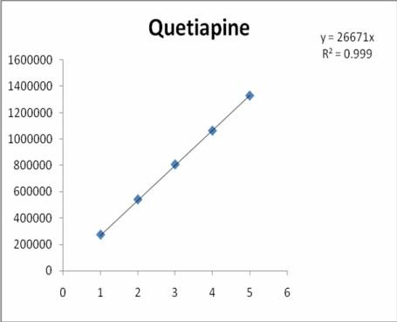

Table: 3 Accuracy
Label claim
Sample conc.,
(µg)
Amount added in µg
Amount Recovere d*
in µg
%
Recovery
*
Average recovery (%)
%RSD

2.05

Acknowledgements
The authors are grateful to the Management of school of pharmaceutical sciences, VELS University, Chennai, for their continuous support and encouragement and for providing the necessary facilities.
2
200 4
10
mg
6

4.03

5.92
102.5

100.75

98.66

100.64 1.91

Table: 1 Linearity
Table: 4 System precision

Concentration (μg/ml) | Peak Area |  | Inject | Peak
1 | 272206 |  | ions | Area
2 | 540163 |  | 1 | 540163
3 | 806202 |  | 2 | 545475
4 | 1062866 |  | 3 | 545758
5 | 1329391 |  | 4 | 543037
 |  |  | 5 | 545307

Labeled
Formulation amount (mg)

Table: 2 Assay

Amount found
*(mg)

%Amount %RSD found

Mean S.D

543948

2377.54

Quetipin 200 198.92 99.83 0.285
%R.S.D
0.437

Concentration

Table: 5 Method precision
INTER DAY INTRADAY

Figure : 03 Chromatogram of sample

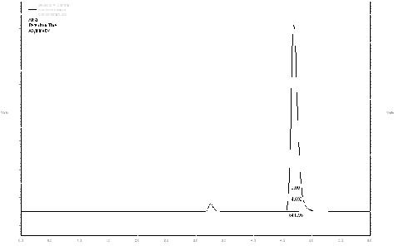
S.NO
 | µg/ml | S.D | %RSD | S.D | %RSD
1 | 1 | 1245.94 | 0.459 | 1734.81 | 0.63
2 | 3 | 1694.06 | 0.21 | 5666.9 | 0.70
3 | 5 | 2430.10 | 0.18 | 3064.8 | 0.23

Table: 6 Characteristics of HPLC method

Parameters Determined Obtained Value

Linearity range(μg/ml)

Slope Intercept
Regression Coefficient(r2) LOD(μg /ml) LOQ(μg /ml)

Table: 7
1-5

2637.07

11043.7

0.999

0.0167

0.0506

References
- http://www.drugs.com/mmx/quetiapine.html
- http://www.drugbank.ca/drugs/DB01224
- Radha Krishna S, Rao B.M, Someswara Rao N, A simple and accurate reverse phase liquid chromatographic method was developed for the of related substance and degradants of Quetiapine Fumarate bulk drug. Rasayan J. Chem 2008,1,3, 466-474.
- Nikam D.S, Bagade S.B., A simple, fast and reliable derivative Spectrophotometric methods were developed for determination of Quetiapine fumarate in pharmaceutical formulation. Second order derivative

Specificty Parameter of Quetiapine Fumerate

Component Observation

No interference
ultraviolet Spectrophotometric methods were developed. International Journal of ChemTech Research, 2009, 1(4), 898-904.
- Dhaneshwar S.R, Patre N.G, A sensitive, selective, precise, and stability-indicating HPTLC method for

Diluent

Placebo
at RT of analyte peak.
No interference at RT of analyte peak.
quantitative analysis of quetiapine fumarate both as the bulk drug and in formulations has been established and validated. Bio medical chromatography, 2008, 22,
1043-1055.
- Sanjay A Jadhav, Shashikant B Landge, A rapid and sensitive gas chromatographic method using flame ionization detection (GC–FID) has been developed and validated for five processes related non-chromophoric impurities. Chromatographia, 2006, 71, 11-12.

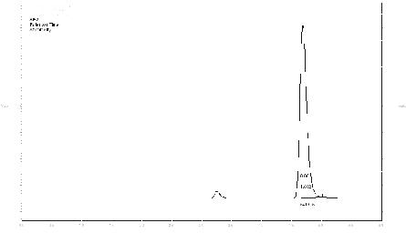
Figure : 02 Chromatogram of standard
- Ramakrishna Nirogi, Gopinadh Bhyrapuneni, A sensitive high-performance liquid chromatography-tandem mass spectrometry method was developed and validated for the quantification of quetiapine in rat plasma. Bio medical chromatography, 2008, 22, 1043-1055.
- Soma Raju V, A simple, sensitive isocratic rapid resolution liquid chromatographic assay method has been developed for the quantitative determination of quetiapine hemifumarate in bulk active pharmaceutical ingredient. Chromatographia, 2007, 70, 3-4.
- Patricia C. Davis Orlando Bravo, Mark Gehrke, Pharmacokinetic measurement of the psychotropic compound quetiapine and four related metabolites in human plasma was conducted using a sensitive and specific liquid–chromatography tandem mass

spectrometry (LC–MS/MS). Journal of pharmaceutical and biomedical analysis, 2010, 51, 1113-1119.
- Vincenzo Pucci, Roberto Mandrioli, Two different analytical methods for the quality control of quetiapine in commercial formulations have been developed and compared. Journal of pharmaceutical and biomedical analysis, 2003, 32, 1037-1044.
- Lawrence J. Albers, Roberto Merli, An original HPLC and UV method has been developed for the simultaneous determination of the atypical antipsychotic quetiapine and the geometric isomers of the second-generation antidepressant ﬂuvoxamine. Journal of chromatography 2006, 8, 227-233.
- Code Q2A, 1995 Text on Validation of analytical methods ICH harmonized tripartite guidelines.

