

***Original Article***

**FORMULATION AND EVALUATION OF GASTRORETENTIVE FLOATING TABLETS OF VENLAFAXINE HYDROCHLORIDE**

*Anil G, Satyanarayana T, Suresh Kumar P, Pavani S, C H Narasimha Raju B H, Mohideen S

Browns college of Pharmacy,

Ammapalem, Khammam, Andhra Pradesh, *India-* 507 305.

**Abstract**

The present study was undertaken with an aim to formulation development and evaluation of gastroretentive floating tablets of venlafaxine hydrochloride, which releases the drug in a sustained manner over a period of 12 hours. Three different viscosity grades of Hydroxypropylmethylcellulose (HPMC) namely K4M, K15M, and K100M were used for the preparation of tablets. The tablets were prepared by direct compression and evaluated for tablet thickness, weight variation, tablet hardness, friability, in vitro buoyancy test, in vitro drug release and Fourier transform infrared (FT-IR) spectroscopy. Formulation F3 can be considered as an ideal or optimized formulation for gastroretentive floating tablet of venlafaxine HCl. The optimized formulation showed sufficiently sustained drug release and remained buoyant on the surface of the medium for more than 12 hours. As the concentration of HPMC increases in the formulation the drug release rate was found to be decreased. It can be concluded that floating drug delivery system of venlafaxine HCl can be successfully formulated as an approach to increase gastric residence time and there by improving its bioavailability.

**Keywords:** Venlafaxine hydrochloride, Gastroretentive, Hydroxypropylmethylcellulose, Buoyancy.

# Introduction

Oral controlled drug delivery system is useful to maintain therapeutically effective plasma drug concentration levels for a longer duration there by reducing the dosing frequency and to minimize fluctuations in the plasma drug concentration at the steady state by delivering the drug in a controlled and reproducible manner1. Moreover, it is easy for administration, no patient compliances and flexibility in the formulation. One of the most feasible approaches for achieving a prolonged and predictable drug delivery in gastro intestinal tract (GIT) is to control gastric resistance time i.e., gastroretentive drug delivery system, which will provide us with new and important therapeutic options, which utilize several approaches: intragastric floating system, high density system, mucoadhesive system, magnetic system, unfoldable, extendable or expandable and super porous biodegradable hydrogel systems2. From the formulation and technology point of view, the floating drug delivery system is considerably easy and logical approaches in development of gastroretentive drug delivery system3. Venlafaxine is a unique antidepressant, and is referred to as a serotonin- norepinephrine - dopamine reuptake inhibitor4. Venlafaxine and its active metabolite, o-desmethyl venlafaxine (ODV) inhibit the neuronal uptake of norepinephrine, serotonin and to a lesser extent dopamine5. Hence it lacks the adverse anticholinergic, sedative and cardiovascular effects of tricyclic antidepressants6.

***\* Author for Correspondence:***

G Anil,

Browns college of Pharmacy, Ammapalem, Khammam,

Andhra Pradesh, *India-* 507 305. Email: [deenpharma@gmail.com](mailto:deenpharma@gmail.com)

The half life of venlafaxine and ODV are five and eleven hours respectively, necessitating the drug to be administered two or three times daily to maintain adequate plasma levels of drug7. The objective of this study was focused on development of floating tablets of venlafaxine HCl in order to achieve an extended retention in the upper GIT, to enhance the absorption and improve the bioavailability.

# Materials and Methods

## Materials

Venlafaxine HCl was procured as a gift sample from Lupin Pharmaceuticals, pune and used as a model drug. HPMC K4M, HPMC K15M and HPMC K 100M were obtained from Yarrow chem Products, Mumbai, India.

## Methods

**Preparations of Venlafaxine HCl floating tablets**

Tablets were made by direct compression. Venlafaxine HCl was mixed with the required quantities of polymers HPMC K4M, HPMC K15M, HPMC K100, sodium bicarbonate and citric acid by geometric mixing. The powder blends was then lubricated with magnesium stearate and talc mixed for about 3 minutes. Finally, the mixture was compressed on a rotary tablet machine (Cemac, Ahmadabad) using 8-mm standard flat-face punches to get 250mg weights of tablets. Composition of all formulations is given in Table 1.

## Evaluation of Tablets Evaluation of powder blend

The powder blends of all formulations was evaluated for Bulk density8, Tapped density8, Compressibility index9, Hausner ratio10 and Angle of repose11

## Evaluation of tablet properties

The prepared tablets were tested for Weight variation, Hardness (Monsanto hardness tester), Thickness (Vernier caliper), Friability (Roche Friabilator) and drug content.

## Floating property

The tablets were placed in a 100 ml beaker containing 0.1N HCl. The time required for the tablet to rise to the surface and float was determined as floating lag time and total duration of time by which dosage form remain buoyant is called total floating time12.

***In vitro* Drug Release Study**

The release rate of Venlafaxine HCl floating tablets was determined using USP Type 2 Apparatus. The dissolution test was performed in triplicate, using 900ml of 0.1N HCl, at 37± 0.5˚C at 50 rpm for 12 hrs. A 5ml sample was withdrawn from the dissolution apparatus at specified time points and the samples were replaced with fresh dissolution medium. The samples were filtered through a 0.45µm membrane filter and diluted if necessary. Absorbance’s of these solutions were measured at 224 nm using U.V-Visible Spectrophotometer.

## Mechanism of drug release

To analyze the mechanism of the drug release rate kinetics of the dosage form, the obtained data were fitted into zero- order, first order, Higuchi, and Korsmeyer Peppas release model.

## FT-IR spectroscopy Study

The infrared spectra of Venlafaxine HCl pure drug, physical mixture of optimized formulation were recorded between 400 to 4000cm-1 on FT-IR Spectroscopy. The IR spectra for the test samples were obtained using KBr disc method using an FT-IR spectrometer.

# Results and Discussion

The powder blend of nine formulations (F1 to F9) was evaluated for angle of repose, bulk density, tapped density, carr’s index and hausner ratio showed the pre-compressed blend has good flow property (Table 2).

The physical evaluation parameters and drug content were also tested for the tablets (Table 3).The total weight of each formulation was maintained constant; the weight variation of the tablets were within the permissible limits of 7.5%, as specified for tablet weighing less than 325 mg . Weight of the tablet was fixed at 250 mg and the weight variation for every batch was tested and found within the acceptable limits. Hardness of the tablet was fixed 4kg/cm2 and was maintained for all the batches in order to minimize the effect of hardness on the drug release because the effect of polymer concentration is the only area of interest.

Tablet thickness was also used to assess the quality of tablets. Under uniform conditions of manufacture, the total weight of tablet and thickness were linearly related. The thickness of floating tablets ranged from 3.18 to 3.50 mm

and linearly correlated with the weight of the tablets. Friability test of all the formulations was found satisfactory showing enough resistance to the mechanical shock and abrasion. Drug content uniformity in all formulations was calculated and the presence of active ingredient ranged from 97-99%.

## Evaluation of buoyancy of the tablets

The *in vitro* buoyancy studies in pH 1.2, revealed good buoyancy for all the formulations (Table 4). Citric acid and sodium bicarbonate combination was used as the effervescent base. Upon contact with the acidic medium, the fluid permeated into the tablet, causing neutralization reaction to occur, which generates carbon dioxide (CO2). The swelling polymer traps the CO2 so generated and thus provides continued buoyancy. Preliminary studies were done to estimate the ideal amount of the effervescent base needed to obtain short floating lag time together with prolonged buoyancy. This revealed that citric acid and sodium bicarbonate in the amount 10 mg and 70 mg were optimum for the desired formulation to provide good buoyancy with floating lag time less than a minute. All the tablets floated in the buffer solution for more than 12 h. The gas generating base decreases the lag time by accelerating the hydration of the swelling polymer, thus allowing a higher floating duration because of constant generation and subsequent trapping of CO2. Citric acid was used to accelerate the CO2 generation; also it permits the generation of CO2 even if the gastric pH is abnormally high13.

*In vitro* dissolution studies of all formulations are depicted in table 5. Formulation F1, F2 and F3 prepared with HPMC K4M were done in 0.1 N HCl and the drug release from formulations F3 was 98.05 in 12 h, formulations F1 and F2 unable to sustain the drug release for desired period of time this was considered due to different polymer concentrations in all the three formulations. All these three formulations floated for 12 h. Formulations F1 and F2 failed to show desired drug release profile. Formulation F3 showed the desired drug release profile and floated with a lag time of 30 sec, for this reason it was considered as best formulation among all the three formulations(Figure 1).

In vitro dissolution study of formulations F4, F5 and F6 prepared with HPMC K15M were done in 0.1N HCl and the drug release from formulations F5 and F6 was 94.93 and

90.91 in 12 h respectively. Formulation F4 unable to sustain the drug release within the desired period of time. On the other hand formulations F5 and F6 failed to meet the desired drug release profile. In vitro dissolution study of formulations F7 to F9 prepared with HPMC K100M were also done in 0.1N HCl and the drug released was calculated. The results indicated that higher viscosity grade of polymer concentrations retarded greatly release of drug (Figure 2, 3).

The above results were in good agreement by study of Sunada and Xu14 who reported that HPMC contents was the predominant controlling factor as the HPMC content

increased, the drug release rate decreased and *vice versa*. An increase in polymer concentration causes increase in viscosity of the gel as well as the gel layer with longer diffusion path. This could cause a decrease in effective diffusion coefficient of the drug and a reduction in drug release rate. Formulations containing higher HPMC viscosity grades have slower drug release rates when compared to formulations with lower HPMC viscosity grades i.e. formulations F1, F2, F3 containing HPMC K4M have showed the fastest and formulations F7, F8, F9 containing HPMC K100M showed the slowest drug release rates. The amount of drug released for a particular drug polymer ratio was found to be in the order of K4M > K15M> K100M.

The mechanism of release for the optimized formulations was determined by finding the R2 value for each kinetic model viz. Zero-order, First-order, Higuchi, and Korsmeyer-Peppas corresponding to the release data of formulations (Table 6). For most of the formulations the R2 value of Korsmeyer- Peppas and first-order model is very near to 1 than the R2 values of other kinetic models. Thus it can be said that the drug release follows Korsmeyer-Peppas and first-order model mechanism.

The n-values of Korsmeyer-Peppas model of the best formulations are in between 0.55-0.85. Therefore the most probable mechanism that the release patterns of the formulations followed was non-fickian diffusion or anomalous diffusion.

FT-IR spectra of the Venlafaxine HCl and drug with HPMC K4M revealed that there is no shifting of the peaks indicating the compatibility of the HPMC K4M polymer with the drug (figure 4a, 4b).

Floating tablet of venlafaxine HCl was formulated as an approach to increase gastric residence time and there by improve its bioavailability. Formulation F3 showed better controlled drug release in comparison to the other formulations, the extent of drug release was found to be 98.05% at the desired time 12 hrs. The drug release pattern of formulation F3 was best fitted to Korsmeyer-Peppas model and first order kinetics. Further the results reflect that release of drug from the tablets by non-fickian diffusion or anomalous diffusion. Drug-excipient interaction of formulations F3 was carried out by using FT-IR spectroscopy in these analysis drug-excipients interactions was not observed. Hence it was concluded that formulation F3 can be taken as an ideal or optimized formulation of gastroretentive tablets for 12 hours as it fulfils all the requirements for extended release tablet.

# Acknowledgement

Authors are thankful to Mr.Usha Kiran Kumar,M.Tech., President, Browns college of pharmacy, Khammam for providing the facilities for completion of this research work. We the authors extent our thanks to Lupin pharmaceuticals, Pune for their gift sample of venlafaxine HCl.

## Table: 1

**Formulation composition of floating tablets of venlafaxine**

**(mg/tablet)**

|  |  |  |  |  |  |  |  |  |  |
| --- | --- | --- | --- | --- | --- | --- | --- | --- | --- |
| **Ingredients F1** | | **F2** | **F3** | **F4** | **F5** | **F6** | **F7** | **F8** | **F9** |
| **Venlafaxine HCl** | 37.5 | 37.5 | 37.5 | 37.5 | 37.5 | 37.5 | 37.5 | 37.5 | 37.5 |
| **HPMC K4M** | 37.5 | 75 | 112.5 | - | - | - | - | - | - |
| **HPMC K15M** | - | - | - | 37.5 | 75 | 112.5 | - | - | - |
| **HPMC K100M** | - | - | - | - | - | - | 37.5 | 75 | 112.5 |
| **Sodium bi carbonate** | 70 | 70 | 70 | 70 | 70 | 70 | 70 | 70 | 70 |
| **Citric acid** | 10 | 10 | 10 | 10 | 10 | 10 | 10 | 10 | 10 |
| **MCC** | 90 | 52.5 | 15 | 90 | 52.5 | 15 | 90 | 52.5 | 15 |
| **Mg.Stearate** | 2.5 | 2.5 | 2.5 | 2.5 | 2.5 | 2.5 | 2.5 | 2.5 | 2.5 |
| **Talc** | 2.5 | 2.5 | 2.5 | 2.5 | 2.5 | 2.5 | 2.5 | 2.5 | 2.5 |

## Table: 2

**Flow properties of powder blends**

|  |  |  |  |  |  |
| --- | --- | --- | --- | --- | --- |
| **Formulation** | **Angle of Repose** | **Bulk Density** | **Tapped Density** | **Carr’s Index** | **Hauser Ratio** |
| **F1** | 28.13 | 0.486 | 0.614 | 18.12 | 0.154 |
| **F2** | 25.45 | 0.468 | 0.623 | 19.43 | 0.142 |
| **F3** | 28.67 | 0.431 | 0.591 | 22.10 | 0.065 |
| **F4** | 30.89 | 0.463 | 0.591 | 24.67 | 0.110 |
| **F5** | 24.34 | 0.521 | 0.632 | 17.32 | 0.146 |
| **F6** | 23.13 | 0.541 | 0.642 | 18.45 | 0.098 |
| **F7** | 28.15 | 0.561 | 0.632 | 21.78 | 0.141 |
| **F8** | 29.67 | 0.421 | 0.621 | 28.68 | 0.056 |
| **F9** | 30.90 | 0.458 | 0.581 | 25.90 | 0.078 |

## Table: 3

**Physical evaluation parameters and drug content**

## Table: 4

**Buoyancy of Venlafaxine HCl tablets**

**Formulation code**

**Formulation code**

**Hardness (Kg/cm2)**

**Thickness (mm)**

**Weight Variation (mg)**

**Friability (%)**

**Drug Content (%)**

**Lag time (sec)**

**Total**

**floating time (h)**

**F1** 4.5±0.24 3.384±0.4 248.60 ±5.12 0.1 97.23

**F2** 3.75±0.18 3.276±0.6 249.33±4.45 0.27 99.12

**F3** 4.45±0.37 3.186±0.3 245.80±4.63 0.19 98.32

**F4** 3.80±0.26 3.186±0.4 246.09±2.43 0.22 99.54

**F5** 4.55±0.54 3.234±0.6 248.05±4.51 0.18 99.43.

**F6** 4.40±0.35 3.45±0.06 245.37±3.89 0.21 98.67

**F7** 4.50±0.48 3.38±0.05 250.09±4.12 0.16 98.97

**F8** 4.45±0.25 3.45±0.25 246.65±4.20 0.16 98.28

**F9** 4.50±0.50 3.50±0.04 244.15±4.61 0.12 99.43

**F1** 26 >12

**F2** 20 >12

**F3** 30 >12

**F4** 36 >12

**F5** 28 >12

**F6** 39 >12

**F7** 46 >12

**F8** 49 >12

**F9** 51 >12

## Table:5

**In vitro dissolution studies: Cumulative percent drug release of formulation with HPMC K4M**

**Sampling time (h)**

|  |  |  |  |  |  |  |  |  |  |
| --- | --- | --- | --- | --- | --- | --- | --- | --- | --- |
| **F1** | | **F2** | **F3** | **F4** | **F5** | **F6** | **F7** | **F8** | **F9** |
| **1** | 42.21±1.4 | 32.46±2.5 | 23.12±1.5 | 30.94±3.2 | 25.75±1.7 | 21.19±2.3. | 15.51±1.9 | 12.10 ±1.4 | 10.10 ±1.1 |
| **2** | 54.42±2.2 | 37.7±1.4 | 31.84±1.9 | 38.98±3.1 | 31.08±1.5 | 31.44±2.1 | 24.38±1.6 | 18.25 ±1.2 | 15.4 1±1.3 |
| **3** | 65.36±2.1 | 45.24±1.4 | 42.16±1.9 | 52.6±2.9 | 37.05±1.6 | 41.02±2.4 | 33.56±1.5 | 25.91 ±1.3 | 20.52 ±1.2 |
| **4** | 71.52±2.2 | 54.96±1.2 | 49.52±2.3 | 55.68±2.7 | 41.46±1.8 | 51.11±2.6 | 38.92±2.5 | 31.58 ±1.4 | 26.80 ±1.6 |
| **5** | 77.82±1.4 | 58.57±1.4 | 54.65±1.6 | 63.01±3.1 | 46.65±1.8 | 56.65±2.3 | 42.81±2.2 | 38.34 ±1.1 | 31.11 ±1.4 |
| **6** | 84.23±2.2 | 64.3±1.7 | 63.52±1.6 | 72.85±2.8 | 51.67±1.7 | 63.91±2.4 | 52.15±1.6 | 40.22 ±1.4 | 37.48 ±1.3 |
| **7** | 93.5±1.8 | 79.89±1.2 | 70.21±2.2 | 75.93±3.2 | 54.70±1.4 | 73.84±2.1 | 60.62±2.5 | 46.35 ±1.2 | 42.23 ±1.1 |
| **8** | 98.23±2.5 | 85.24±1.4 | 77.65±2.2 | 88.41±3.1 | 59.12±1.5 | 79.56±2.5 | 69.02±1.8 | 50.10 ±1.3 | 49.49 ±1.3 |
| **9** | - | 88.86±1.9 | 85.23±1.4 | 93.72±3.4 | 68.59±1.6 | 80.81±2.3 | 71.05±1.5 | 59.82 ±1.5 | 55.63 ±1.4 |
| **10** | - | 91.06±1.4 | 90.88±2.1 | 99.96±2.8 | 79.52±1.8 | 81.27±2.4 | 73.65±1.7 | 61.40 ±1.1 | 61.76 ±1.4 |
| **11** | - | 99.12±1.8 | 95.03±1.4 | **-** | 88.48±1.7 | 85.39±2.3 | 79.87±2.4 | 69.77 ±1.3 | 65.61 ±1.3 |
| **12** | - | - | 98.05±1.5 | **-** | 94.93±1.6 | 90.91±2.1 | 86.25±1.3 | 80.05 ±1.4 | 72.74 ±1.1 |

Data represents mean ± SD (n=3)

## Table 6

**Release kinetics of optimized formulations**

|  |  |  |  |  |
| --- | --- | --- | --- | --- |
| **S. No.** | **Formulation** | **Zero order** | **First order** | **Higuchi Korsmeyer & Peppas**  **Peppas (n)** |
| **1** | F3 | 0.9668 | 0.9850 | 0.9887 0.9943 0.585 |

*Int. J. Pharm & Ind. Res Vol - 01 Issue - 02 Apr - Jun 2011*

## Figure: 1

120

100

80

60

40

20

0

0

2

4

6

8

10 12

14

Time(h)

F1 F2 F3

Cumulative % Drug release

**Cumulative % drug release from HPMC K4M Figure: 2**

120

100

80

60

40

20

0

0

2

4

6

8

10

12

14

**Time (h)**

F4 F5

F6

**Cumulative % Drug release**

## Cumulative % drug release from HPMC K15M Figure: 3

120

100

80

60

40

F7

F8 F9

20

0

0

2

4

6

8

10

12

14

**Time (h)**

**Cumulative % Drug release**

**Cumulative % drug release from HPMC K100M**

## Figure: 4.a

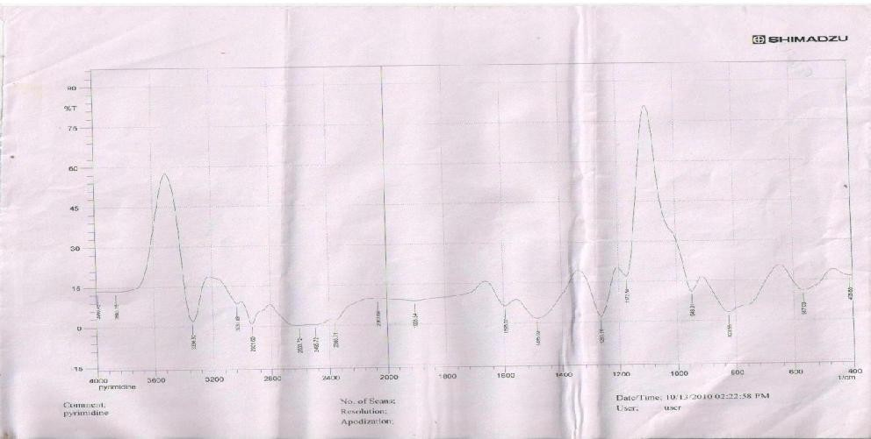

**Figure: 4.b**

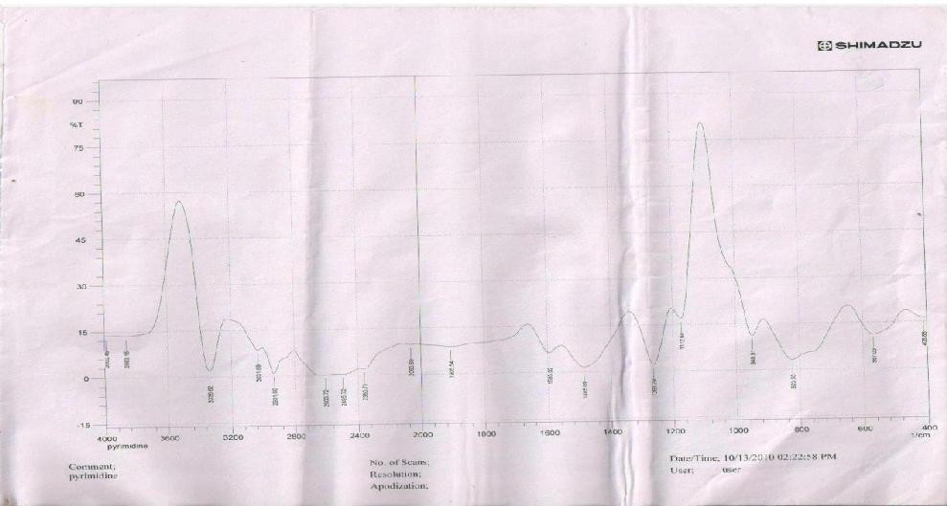

## The FT-IR spectra:

**4. a) pure drug, 4.b) Physical mixture of optimized formulation**

# Reference

1. Sood A, Panchagnula R. Design of Controlled Release Delivery Systems Using a Modified Pharmacokinetic Approach: A Case Study for Drugs having a Short Elimination Half-life and a Narrow Therapeutic Index. *Int J Pharm*. 261, 2003, 27-41.
2. Garg S, Sharma S. Gastroretentive Drug Delivery Systems. Buisness Briefing: *Pharmatech.* 1, 2003, 160- 166.
3. Singh BN, Kim KHJ. Floating Drug Delivery System: An Approaches to Oral Controlled Drug Delivery via Gastric Retention. *Contr Release*. 63, 2000, 235-259.
4. Keith S. Advances in Psychotropic Formulations. *Prog Neuro Psycopharmacol Biol Psych*. 30, 2006, 996-1008.
5. ric AM J, Moyer A, Haskins JT, Andree TH,.Husbands GEM. Biochemical, Neurophysiological, and Behavioral Effects of Wy-45,233 and other Identified Metabolites of the Antidepressant Venlafaxine. *Drug Dev. Res*. 23, 1991, 191-199.
6. Simona JS, Aguiar LM. Extended Release Venlafaxine in Relapse Prevention for Patients with Major Depressive Disorders, J Psychiatr Res. 38, 2004, 249-257.
7. Troy S.M, Parker VD, Fruncillo RJ, Chiang ST, The Pharmacokinetics of Venlafaxine When Given in a Twice- daily Regimen. *J Clin Pharmacol*. 35, 1995, 404-409.
8. Shah D, Shah Y, Rampradhan M. Development and Evaluation of Controlled Release Diltiazem Hydrochloride Microparticles Using Cross-linked Poly Vinyl Alcohol. *Drug Dev Ind Pharm*. 23, 1997, 567-564.
9. Aulton ME and Wells TI. Pharmaceutics: The science of Dosage Form Design. Churchill Livngstone, London,1998, pp. 247-248.
10. Lachman L, Liberman HA, Kanig JL. The Theory and Practice of Industrial Pharmacy, Lea and Febiger, Philadelphia, 1987, pp. 317-318.
11. Cooper J, Gunn C. Powder flow and compaction: Tutorial pharmacy, CBS Publishers and Distributiors, New Delhi, 1986, p.p. 211-213.
12. Ponchel R, Irache JM. Specific and Non-Specific Bioadhesive Particulate System for Oral Delivery to the Gastrointestinal Tract. *Adv Drug Del Rev*., 34, 1998, 191-

219.

1. Groning R, Bernyten M. Estimation of the Gastric Residence Time Magnetic Dosage Forms Using the Heidlberg Capsule. *pharmazie*. 51, 1996, 328-331.
2. Xu G, Sunada H. Influence of Formulation Change on Drug Release Kinetics from Hydroxypropylmethyl Cellulose Matrix Tablets. *Chem Pharm Bull.* 43, 1995, 483-487.