## Original Article



**EVALUATION OF ANTIULCER ACTIVITY IN THE METHANOL EXTRACT OF *ACANTHUS ILICIFOLIUS* LEAVES IN EXPERIMENTAL RATS**

*Nizamuddin Basha S1, Chitta Suresh1, Danamma B1, Mohd Dada2, Abdul Maajid3

1S.K.University, Anantapur, India - 515 055.

2Vels University, Chennai, Tamilnadu, *India-*600 117.

3Islamia college, Vaniyambadi, Tamilnadu, *India-*635 751.

**Abstract**

The anti-ulcer activity of Methanolic extracts of Acanthus ilicifolius Leaves (MEAI) was investigated in pylorus ligation and ethanol induced ulcer models in wistar albino rats. In both models, the common parameter determined was the ulcer index. MEAI at doses of 100, 200mg per kg body weight produced significant inhibition of the gastric lesions induced by pylorus ligation and ethanol induced gastric ulcers. The extract showed the significant reduction in the gastric volume, free acidity and ulcer index as compare to control. This present study indicates that Acanthus ilicifolius have potential anti ulcer activity in the both models. These results may further suggest that the Leaf Methanolic extracts were found to possess anti ulcerogenic as well as ulcer healing properties, which might be due to anti secretary activity.

**Keywords:** *Acanthus ilicifolius,* Methanol extract, Pylorus ligation, Ulcer index.

# Introduction

1Peptic ulcer is an excoriated area of the duodenal mucosa caused by the action of the gastric juice. It is generally recognized that peptic ulcer is caused by lack of equilibrium between the gastric aggressive factors and mucosal defensive factors2. The factors include acid-pepsin secretions, mucosal barrier, mucus secretions, blood flow and endogenous protective agents. Some other factors such as in adequate dietary habits, excessive consumption of NSAIDS, stress, infection by Helicobacter may be responsible for the development of peptic ulcer3. The plant kingdom provides many useful sources of new anti ulcer compounds. The aim of present study was to evaluate the anti ulcerogenic effect of Acanthus ilicifolius4.

# Material and Methods

### Plant collection

The whole plant of Acanthus ilicifolius was collected from forest of Chittoor district during the month of November It is identified and authenticated by Prof.Meera bai,M.sc, Ph.D, Department of Botany, Rayalaseema University, Kurnool.

### Preparation of extract4

The plant of Acanthus ilicifolius were shade dried and reduced to coarse powder in a mechanical grinder.

***\* Author for Correspondence:***

Nizamuddin Basha S, Dept of Biochemistry, S.K.University, Anantapur District,

Andhra Pradesh, India - 515 055. Email: [nizamhere@gmail.com](mailto:nizamhere@gmail.com)

The powdered material obtained was then subjected to successive extraction by hot percolation method using petroleum ether, chloroform and methanol solvents in a soxhlet extractor. The different extracts obtained were evaporated at 45°C to get a semisolid mass. The extracts thus obtained were subjected to photo-chemical analysis. The percentage yield alcoholic extracts was found to be 55.5%w/w and the Methanolic extracts was used for further studies.

### Preliminary Phyto chemical screening

The Phytochemical examination of the MEAI was performed by standard methods.

Tests for proteins-Xanthoprotein test: To 1ml of extract, few drops of nitric acid was added by the sides of the test tube and observed for formation of yellow colour.

Tests for resins5: Five milliliter of distilled water was added to the extract and observed for turbidity

Tests for steroids: Two milliliter of acetic anhydride was added to 0.5g of extract and 2ml of sulphuric acid was added by the sides of the test tube and observed the colour change from violet or blue-green.

Tests for tannins: About 0.5g of the each extract was taken in a boiling tube and boiled with 20ml distilled water and then filtered added few drops of 0.1% ferric chloride was added mixed well and allowed to stand some time. Observed for brownish green or a blue-black coloration.

Tests for glycosides-Keller-killani test: About 0.5ml of alcoholic extracts was taken and subjected to the following

test, 1ml of glacial acetic acid containing traces of ferric chloride and 1ml of conc. Sulphuric acid was added to extract and observed for the formation of reddish brown color at the junction of two layers and the upper layer turned bluish green in the presence of glycosides.

Tests for reducing sugar-fehling’s reagent: Few drops of Fehling’s solution A and B in equal volume were added in dilute extracts and heated for 30min and observed for the

Mobile phase: ethyl-acetate: water: formic acid: acetic acid (72:14: 7: 7).

The sample Aliquots: 10 *μ*g from the samples spoted. Migration distance: 7.5 cm.

Identification: Neu-PEG Reagent.

### Table 01 Phyto chemical

formation of brick red colored precipitate.

### components of

**MEAI**

**qualitative analysis**

Tests for carbohydrates-molisch test: Small quantities of alcoholic and aqueous extracts was dissolved in 5ml of distilled water and filtered. To this solution 2-3drops of *α*-naphthol was added and 1ml of concentrated sulphuric acid was added along the sides of inclined test tube so as to form two layers and observed for formation of violet coloured ring at the interface to detect the presence carbohydrates.

Tests for saponins: To 0.5g of extracts was added to 5ml of distilled water in a test tube. The solution was shaken vigorously and observed for a stable persistent froth. The frothing was mixed with 3 drops of olive oil and shaken vigorously after which it was observed for the formation of an emulsion.

Tests for sterols-Liebermann-buchard test 6: The insoluble residue was dissolved in chloroform and few drops of acetic anhydride were added along with a few drops of conc. Sulphuric acid from the sides of the test tube and observed for the formation of blue to blood red colour.

Tests for terpenoids-salkowski test 7: To 0.5g of the extract, 2ml of chloroform was added; Conc. H2So4 (3ml) was carefully added to form a layer. A reddish brown coloration of the interface indicates the presence of terpenoids.

Tests for phenols 8: The extracts were taken in water and warmed. To this 2ml of ferric chloride solution was added and observed for formation of green or blue colour.

Test for cardiac glycosides (Keller Killiani’s): Among 100mg of extract was dissolved in 1ml of glacial acetic acid containing 1 drop of ferric chloride solution. This was then underlayer with 1ml of concentrated sulphuric acid. A brown ring obtained at the interface indicated the presence of a de-oxy sugar charactersitcs of cardenolides.

Test for catachol 9: To 2 ml of test solution alcohol is added and erlich’s reagent and few drops of conc. hydrochloric acid was added. The result was obtained.

Test for flavonoids:10 The qualitative analysis of the flavonoids was performed by thin layer chromatography (TLC) in the following experimental conditions:

Stationary Phase: Silica gel G (Merck), ready-made plates 10x20 cm.

proteins -

Resins +

steroids +

tannins -

glycosides +

Reducing Sugars -

carbohydrates +

Saponins +

Sterols +

terpenoids +

Catachol -

Flavonoids +

### Animals used

Wistar albino rats of either sex weighing between 150 – 250gms were used. Animals were maintained under standard conditions in an animal house. Albino rats were obtained from National Institute of Nutrition, Hyderabad. The animals were housed in cages and maintained at 240°C

± 20°C less than 12 hours light/dark cycles and were read with standard pellet diet and free access to water.

# Methodology

Pyloric ligation in rats11

Animals are divided five Groups each consisting of six rats. Control group was received distilled water orally. Second Group was Pyloric ligated. Third & Fourth Groups received to Methanolic extract of Acanthus ilicifolius in a dose of 100 & 200mg/kg body weight. Ranitidine 150mg/kg body weight was administrated orally for fifth Group as reference drug. After 45 min of MEAI and Ranitidine treatment, pyloric ligation was done by ligating the pyloric end of the stomach of rat’s respective groups under ether anesthesia at a dose of 35mg/kg of body weight. Ligation was done without causing any damage to the blood supply of the stomach. Animals were allowed to recover and stabilize in individual cages and were deprived of water during a post operating period. After 4hours of surgery rats were sacrificed and ulcer scoring was done.

Ethanol induced Ulcer model 12

The ulcer was induced by administrating ethanol. All the animals were fasted for 36hrs before administration of ethanol. The animals were divided into five groups, each consisting of six rats. One Group represented the control group, which received distilled water orally. Second group received ethanol, third and fourth Groups received MEAI in

the dose of 100 and 200mg/kg and Ranitidine in the dose of 150mg/kg were administered orally for fifth group as a reference standard drug. The gastric ulcers were induced in rats by administrating ethanol orally. After 45min of Methanolic extract and Ranitidine treatment. They were kept in cages to prevent coprophagia during and after the experiment. The animals were anaesthetized one hour later with anesthetic ether and stomach was incised along the greater curvature and ulceration was scored. A score for the ulcer study was similar to pyloric ligation induced ulcer model.

### Scoring of ulcer will be made as follows:

Normal stomach - (0)

Red coloration - (0.5)

Spot ulcer - (1)

Hemorrhagic streak- (1.5)

Ulcers - (2)

Perforation - (3)

Mean ulcer score for each animal was expressed as Ulcer Index. The percentage of Ulcer protection was determined as follows.

% of Protective = Control Mean Ulcer Index - Test Mean Ulcer Index x 100

Control Mean Ulcer Index

Determination of Acidity:

Acidity = Volume of NaoH x Normality of NaoH x 100 m Eq/L 0.1

### Statistical Analysis

The values are represented as Mean ± S.E.M. and Statistical significance between treated and controlled group was analyzed using of one way ANOVA, followed by Dunnett’s test where P< 0.05 was considered statistically significant.

### Histo Pathological Evaluation 13

The gastric tissue samples were fixed in neutral buffered formalin for 24 hrs. Sections of tissue from stomachs were examined Histo pathologically to study the Ulcer and anti ulcer activity of *Acanthus ilicifolius*. The tissues were fixed in 10% buffer formalin and were processed using a tissue processor. The processed tissues were embedded in paraffin blocks and about 5µm thick sections were cut using rotarymicrotome. These sections were stained with hematoxylin and eosin using routine procedures. The slides were examined microscopically for morphological changes such as congestion haemorrhage, oedema and erosions using an Arbitrary Scale for the assessment of severity of these changes.

# Results and Discussion

The results of preliminary phyto chemical screening of the Methanolic extract shown in table 01 revealed that the presence of flavonoids, resins, terpenoids, carbohydrates, glycosides, saponins and steroids.

### Pyloric ligation induced gastric ulcer

In pyloric ligation induced ulcer model oral administration of MEAI into two different dose showed significant reduction in ulcer index, gastric volume, free acidity, total acidity as compare to the control group. It showed protection index of 75% and 80% at the dose of 100mg and 200mg/kg body weight respectively in comparison to control where as Ranitidine as a reference standard drug reduced ulcer of 82%.

### Ethanol induced gastric ulcer

In control animal oral administration of ethanol produced characteristic lesion in the stomach of rat which appeared as elongated bonds of thick, black &dark red lesions. MEAI has shown significant protection index of 55% and 65% with the dose of 100 & 200mg/kg respectively in comparison to control. Ranitidine as a reference standard drug reduced ulcer to 70%.

**Macroscopical and Histo pathological evaluation** Macroscopical change of pylorus ligation and ethanol induced models were shown in fig; (1A, 1B, 1C and 2A, 2B, 2C) Histo pathological changes on pylorus ligation model showed the degeneration, hemorrhage, oedematous appearance of gastric tissue where as MEAI (200mg/kg) and Ranitidine (150mg/kg) treated groups showed regeneration and prevents the formation of hemorrhage and oedema is shown in figure; 3A, 3B, 3C and 3D.

### Macroscopical view of Pylorus ligation induced ulcer

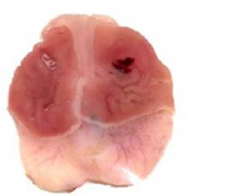

**Figure 1A**

Control PL shows severe damage of mucosal layer

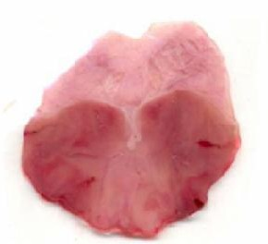

### Figure 1B

Ranitidine 150mg/kg shows protected mucosal layer

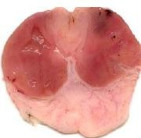 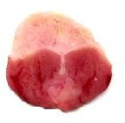

### Figure 1C

MEAI (200mg/kg) shows protected mucosal layer.

### Macroscopical view of Ethanol induced ulcer

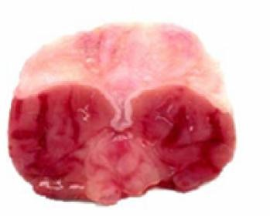

**Figure 2A**

Ethanol treated rat’s shows congestion, oedema, mucosal damage.

### Figure 2C

MEAI 200mg/kg shows protection of mucosal layer.

### Histopathology of Pyloric Ligation Induced Ulcer model (Hematoxin & Eosin 100X)

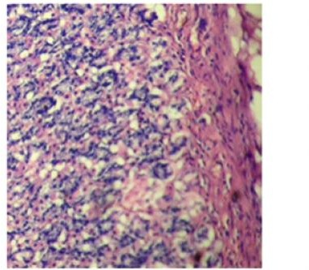

**Figure 3A.**

Section of gastric mucosal layer shows normal appearance Control

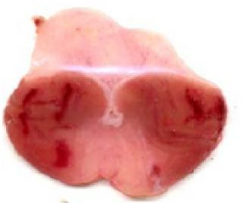 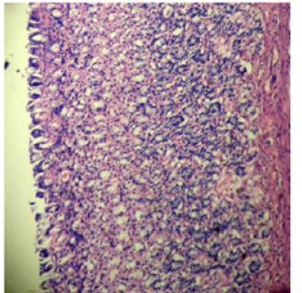

### Figure 2B

Ranitidine 150mg/kg shows protection of mucosal layer.

### Figure 3B.

PL Groups shows Mucosal ulceration and inflammation.

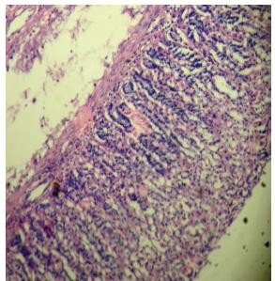 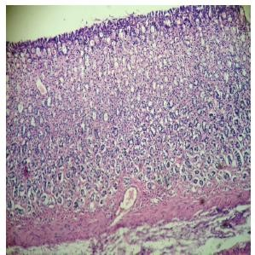

### Figure 3C.

Ranitidine 150mg/kg shows no significance changes in Histo pathology almost normal.

### Figure 3D.

MEAI (200mg/kg) shows no significance change in histopathology almost normal appearance

### Table: 2

Effect of *Acanthus ilicifolius* plant leaves extract on various parameters in pyloric ligation induced gastric ulcers.

|  |  |  |  |  |  |  |
| --- | --- | --- | --- | --- | --- | --- |
| **Group** | **Treatment** | **Ulcer index** | **Gastric juice in**  **Protection**  **ml** | **PH of**  **Gastric juice** | **Free acidity**  **mEq/L** | **Tot acidity**  **mEq/L** |
| I | Control | 14.5 ± 1.2 | --- 9.5 ± 1.8 | 2.2 ± 0.2 | 95.5 ± 1.3 | 115.5 ± 0.25 |
| II | Ranitidine | 2.2 ± 0.06 | 82 % 2.4 ± 0.15 | 4.7 ± 0.14 | 31.5 ± 2.5 | 45.4 ± 1.3 |
| III | MEAI | 3.4 ± 0.5 | 75 % 4.3 ± 0.1 | 3.6 ± 0.2 | 45.5 ± 1.3 | 65.6 ± .4 |
|  | (100mg/kg) |  |  |  |  |  |
| IV | MEAI | 2.7 ± 0.5 | 80 % 3.7 ± 0.14 | 4.6 ± 0.2 | 35.6 ± 1.2 | 62.5 ± 1.3 |
|  | (200mg/kg) |  |  |  |  |  |

### Table: 3

Effect of *Acanthus ilicifolius* plant leaves extract on various parameters in ethanol induced gastric ulcer.

|  |  |  |  |  |
| --- | --- | --- | --- | --- |
| **Group** | **Treatment** | **Ulcer index** | **Protection** | **PH of**  **Gastric juice** |
| I | Control | 12.6± 0.07 | --- | 2.9 ± 0.3 |
| II | Ranitidine | 3.3 ± 0.6 | 74 % | 5.4 ± 0.06 |
| III | MEAI (100mg/kg) | 5.5 ± 0.04 | 55 % | 3.6 ± 0.13 |
| IV | MEAI (200mg/kg) | 4.2 ± 0.03 | 65 % | 4.3 ± 0.15 |

The table 2 & 3 reveals the experimental reports of EFFECT of *Acanthus ilicifolius* plant leaves extract on various parameters in pyloric ligation induced gastric ulcers & ethanol induced gastric ulcer.

# Discussion

The history of disease of peptic ulcer is unknown in most of the cases it is generally accepted that it results from an imbalance between aggressive factors and maintenance of mucosal integrity. The pharmacological substances are used to inhibit the gastric acid secretions by increasing mucosal production, stabilizing the surface epithelial cells. The causes of gastric ulcer by pyloric ligation are believed to be due to stress induced increase in gastric Hcl secretion. Pylorus ligation induced ulcer was used to study the effect of plant extract on gastric acid secretion This increase in the gastric acid secretion causes ulcers in the stomach. The original rat model involves fasting of rats for 36hrs followed by ligation of the pyloric end of the stomach. The ulcer index is determined 5hrs after pyloric ligation. The present study revealed that MEAI and Ranitidine significantly decreased the total acidity and free acidity. This suggests that it has an anti secretary effect and anti-ulcer activity. The anti-ulcer activity of MEAI is further supported by histopathological study; it shows that protection of mucosal layer from ulceration. The extract show's protection against Characteristic lesions produced by ethanol administration. The anti-ulcer activity of MEAI due to the reduction in gastric acid secretion. The study concludes the methanolic extract of Acanthus ilicifolius leaves shows an anti- ulcer activity.

# Acknowledgement

The authors are very greatful to Dr.Chitta suresh kumar to give an encouragement and guide us to carry out the work. And also we extent our thanks to Ms.Sravani who has helped a lot during the work.

# References

1. Kulkarni S.K. hand book of experimental pharmacology, vallabha prakashan, New Delhi, 1999, 148-50.
2. Wichtl M.: Herbal Drugs and Phytopharmaceuticals, Ed. Medpharm, Stuttgart, 1994, 106- 108.
3. Harborne J.B.: Comparative Biochemistry of Flavonoids, Acad. Press, London-New York, 1967.
4. Surendra. S. Evaluation of gastric anti ulcer activity of fixed oil of tulsi and possibleMechanism, Indian journal of experimental biology. 1999, 253-57.
5. Dilwards J.B.: Comparative Biochemistry of plant products, Acad. Press, London-New York, 1967.
6. Parmer N.S., Parmer S. Anti ulcer potential of flavonoids. Indian journal of Physiology and Pharmacology. 1998, 343-51.
7. Mukherjee. P.K. Quality control of herbal drugs, business horizons, New Delhi, 2002, 382- 421.
8. Indian herbal pharmacopeia, Revised new, 2002, 166- 120.
9. Deb S, A selection of prime ayurvedic plant drugs, Annamacharya Publisher, New Delhi, 2006,126.
10. Nadkarni K.M. Indian Materia Medica, Popular Prakashan pvt ltd, Bombay, 1976, 1202- 1211.
11. Indian medicinal plants, Keerthikar, K.R.Basu, Lolit mohan basu publications, Allahabad, India,1935, 1020-23
12. Medical Physiology by Guyton & Hall, new edition, 2004.
13. Satyavathi G.V, Gupta A.K. Neeraj.P Medicinal plant of India, Vol-2, ICMR, New Delhi. 1987, 190.
14. Harborne J.B.:A Text book of Pathophysiology, Acad.

Press, London-New York, 1967.

*Int. J. Pharm & Ind. Res Vol – 01 Issue – 01 Jan - Mar 2011*