
Original Article FORMULATION AND EVALUATION OF DILTIAZEM HYDROCHLORIDE EXTENTED RELEASE TABLET BY MELT GRANULATION TECHNIQUE
*Senthil Kumar B1, Prem Anand D C1, Senthil Kumar K L2, Saravanakumar M3, Thirumurthy R3
1Research scholar PRIST University, Thanjavur, Tamilnadu, India.
2Padmavathi College of Pharmacy, Dharmapuri, Tamilnadu, India.
3SSM College of Pharmacy, Erode, Tamilnadu, India.

Abstract
Extended release drug delivery system have started gaining popularity and acceptance as new drug delivery system due to better control over release for extended time providing convenience of drug administration. Keeping in view economy of the process and simplicity involved in design, this study was undertaken to develop extended release tablets of Diltiazem using different hydrophobic polymers by melt granulation technique. Based on Preformulation studies the concentrations of the hydrophobic polymers to be used in the formulation were optimized. The compatibility between the pure drug and excipients used in design of the formulations were confirmed by IR studies. Hydrophobic polymers namely Compritol ATO 888 and Hydrogenated castor oil were used to formulate six different formulations. Other excipients used were of directly compressible grade. Aerosil used as a glidant. Lactose used as a diluent in the formulation. Extended release tablets were formulated using melt granulation technique. The tablets were then evaluated for their shapes, color, thickness, friability, weight variation, drug content and In-vitro dissolution studies. Drug release is inversely proportional to the level of rate retarding polymer present in matrix system i.e. extent of retardation of drug release increases with decrease in polymer content of the matrix. Hydrogenated castor oil was found to be a good retardant since it forms thin coating on surface of drug particle. Drug release from matrix is primarily controlled by diffusion process. This process seems to be governed by amount of hydrophobic polymer. Higher the amount of hydrophobic polymer tends to show diffusion controlled release of drug.

Key Words: Melt granulation, Diltiazem Hydrochloride, Extented Release.

INTRODUCTION
Melt granulation (thermoplastic granulation) is a process in which the granulation is obtained through the addition of binder, which melts or softens at relatively low temperature. After melting, a binder acts like a binding liquid. Lipids are considered as an alternative to polymer in the design of sustained drug delivery systems due to their advantages such as the low melt viscosity (thus avoiding the need of organic solvents for solubilization) absence of toxic impurities such as residual monomer catalysis and initiators, potential biocompatibility and biodegradability. The various meltable binders used for the sustained drug delivery systems are Bees wax, Carnauba wax, Glyceryl Behenate and Hydrogenated Castor Oil. In present work an attempt has been made to develop extended release tablets of diltiazem hydrochloride by melt granulation technique by

*Author for Correspondence:
B Senthil Kumar,
SSM College of Pharmacy, Chinniampalayam, Jambai, Bhavani, Erode,
Tamil Nadu, India – 638302.
Email: senthilindia1@rediffmail.com
using different concentrations of lipophilic matrix forming polymers. Hydrophobic polymers namely Compritol ATO 888 and Hydrogenated castor oil were used to formulate six different formulations. Other excipients used were of directly compressible grade. Aerosil used as a glidant. Lactose used as a diluent in the formulation. Extended release tablets were formulated using melt granulation technique. The tablets were then evaluated for their shapes, color, thickness, friability, weight variation, drug content and In-vitro dissolution studies. The release kinetics model for matrices prepared by melt granulation showed the correlation coefficient (r2) for the best statistical line revealed that Higuchi model was better applicable to release data.

Materials and Methods

Preparation of Matrices by Melt Granulation [1]
The meltable binder Compritol 888 and HCO were respectively melted in porcelain dish on a water bath maintained at constant temperature as per their melting points. Diltiazem HCl was gradually added to the molten wax with continuous stirring. The molten mixture was allowed to cool and solidified at room temperature. The drug was present in its solid form within the molten mass. The solidified mass was pulverized in mortar and sieved through a 16 # screen. The ratio of drug: binder was varied like 1:1,1:2,1:3 for both the binders as shown in table no. 1. The tablets

were prepared as per optimized formulation and evaluations were carried out.

Evaluation
Evaluation of granules [2,3,4]
The granules obtained by melt granulation were characterized by carrying out particle size distribution by sieve analysis and by IR to study the drug-binder compatibility. The results are shown in figure no. 1 to 4. The granules were also evaluated for angle of repose, bulk density, compressibility index and Hausner’s ratio to check the flowability. The results are shown in table no.2.

Evaluation Of Tablets [5,6]
Weight variation Test
To study weight variation, 20 tablets of each formulation were weighed using an electronic balance (Adventure OHAUS) and the test was performed according to the official method.

Thickness
Thickness and diameter of tablets was determined using calibrated Vernier caliper. Five tablets from each batch were used, and their average values calculated.

Friability
For each formulation, the friability of 20 tablets was determined using the Roche friabilator (Lab Hosp.). This test subjects a number of tablets to the combined effect of shock abrasion by utilizing a plastic chamber which revolves at a speed of 25 rpm, dropping the tablets to a distance of 6 inches in each revolution. A sample of preweighed 20 tablets was placed in Roche friabilator, which was then operated for 100 revolutions for 4 minutes. The tablets were then dusted and reweighed.

Hardness
For each formulation, the hardness of 6 tablets was determined using calibrated Monsanto hardness tester. The tablet was held along its oblong axis in between the two jaws of the tester. At this point, reading should be zero kg/cm2. Then constant force was applied by rotating the knob until the tablet fractured. The value at this point was noted in kg/cm2.

Drug content [7]
Five tablets were weighed individually, and these tablets were crushed in mortar. Drug equivalent to 10 mg of

Results

Table No. 1: Tablet Formulations
powder was taken, to this 10 ml of distilled water was added. The mixture was heated to melt (as per melting point of meltable binders) and allowed to cool to room temperature. The lipid was solidified and drug solution was filtered through Whatmann No.1 paper. The absorbance was measured at 237 nm after suitable dilution. The drug content was determined. According to USP Extended release Diltiazem HCl tablet contains NLT 90% and NMT 110% Diltiazem HCl.

In vitro Dissolution Studies
In vitro drug release study for the prepared matrix tablets was conducted for period of 8 hours using a six-station USP XXIII type II (paddle) apparatus at 370C ± 0.50C and 100rpm speed. The dissolution studies were carried out for 8 hours in acid buffer of pH 1.2 for first two hrs and further six hrs in Phosphate buffer pH 7.4, under sink condition. At first half an hour and then every 1- hour interval samples of 5 ml were withdrawn from dissolution medium and replaced with fresh medium to maintain the volume constant. After filtration and appropriate dilution, the sample solution was analyzed at 237nm for Diltiazem HCl by a UV-spectrophotometer. The amounts of drug present in the samples were calculated with the help of appropriate calibration curve constructed from reference standard. Also the in vitro drug release study for the marketed tablets (Dilgard XR 90 mg) was conducted. The results are shown in table no.4 and figure no.5.

Kinetic Modelling [8]
To analyse the mechanism for the release and release rate kinetics of the dosage form, the data obtained was fitted in to, Zero order, First order, Higuchi matrix, Peppas and Hixson Crowell model. In this by comparing the r-values obtained, the best-fit model was selected. The results are shown in table no.5 and 6.

Stability Study
In the present work, stability study was carried out for formulation containing 90mg Hydrogenated castor oil (F4), at 250 C ± 20C, RH 60% ± 5%;30°C ± 20C, RH 65% ±
5%; 40°C ± 20C, RH 75% ± 5% conditions for 30 days. Formulation F4 was selected for stability study because it was found to be good retardant and showed the release as per Higuchi Model which is also followed by Marketed Product (Dilgard XR 90).The formulation was evaluated for hardness, friability and in vitro drug release. The results were shown in table no.7, 8 and figure no.6.

Formulation code | Diltiazem HCl | Compritol | Hydrogenated castor oil | Lactose | Aerosil | Total weight
F1 | 90 | 90 | - | 215 | 5 | 400
F2 | 90 | 180 | - | 125 | 5 | 400
F3 | 90 | 270 | - | 35 | 5 | 400
F4 | 90 | - | 90 | 215 | 5 | 400
F5 | 90 | - | 180 | 125 | 5 | 400
F6 | 90 | - | 270 | 35 | 5 | 400
(All ingredients taken in mg per tablet)

Table No.2 Evaluation of granules

Formulations | Angle of Repose (θ) | Loose Bulk Density (gm/ml) | Tapped Bulk Density (gm/ml) | % Compressibility (Carr’s index) | Hausner’s ratio
F1 | 17.54 | 0.533 | 0.64 | 16.71 | 1.20
F2 | 16.36 | 0.409 | 0.491 | 16.70 | 1.20
F3 | 15.28 | 0.403 | 0.473 | 14.79 | 1.17
F4 | 14.41 | 0.669 | 0.836 | 19.97 | 1.25
F5 | 13.16 | 0.415 | 0.501 | 17.16 | 1.20
F6 | 13.52 | 0.424 | 0.520 | 18.46 | 1.22

Table No.3: Evaluation of Tablet Parameters

Formulation Code | Thickness (mm) | Hardness (kg/cm3) | Friability (%) | Weight Variation (mg) | Drug Content (%)
F1 | 3.96 | 5.6 | 0.34 | 398.2 | 100.0
F2 | 4.13 | 6.8 | 0.26 | 394.7 | 97.55
F3 | 4.39 | 7.6 | 0.22 | 397.1 | 98.10
F4 | 3.93 | 6.4 | 0.24 | 400.6 | 95.82
F5 | 4.42 | 7.8 | 0.19 | 401.8 | 98.77
F6 | 4.45 | 9.3 | 0.144 | 399.3 | 99.88

Table No. 4: Comparative in vitro dissolution study

Time(min) | Cumulative % Drug Release
Time(min) | F1 | F2 | F3 | F4 | F5 | F6 | Marketed
0 | 0 | 0 | 0 | 0 | 0 | 0 | 0
30 | 49.86 | 25.5 | 21.50 | 34.02 | 22.96 | 15.30 | 21.50
60 | 57.73 | 26.16 | 24.44 | 38.96 | 24.33 | 17.80 | 26.69
120 | 80.54 | 36.75 | 28.02 | 47.47 | 36.56 | 19.20 | 33.36
180 | 93.98 | 47.02 | 35.77 | 59.32 | 38.65 | 20.92 | 41.10
240 | 98.34 | 55.89 | 43.89 | 64.57 | 45.23 | 22.37 | 42.22
300 | 99.88 | 69.89 | 52.70 | 69.17 | 50.82 | 24.18 | 51.58
360 | 100.0 | 80.43 | 62.16 | 73.34 | 59.51 | 30.30 | 64.26
420 | - | 87.29 | 73.87 | 78.98 | 64.67 | 36.62 | 72.32
480 | - | 91.09 | 77.15 | 87.57 | 76.86 | 42.50 | 78.28

Table No. 5: Kinetic data of Sustained Release Matrix tablets of Diltiazem HCl

Formulation | Zero Order | First Order | Higuchi Matrix | Peppas model | Hixson Crowell
F1 | 0.831 | 0.9263 | 0.8180 | 0.9165 | 0.5691
F2 | 0.9403 | 0.9678 | 0.9825 | 0.9660 | 0.9799
F3 | 0.9575 | 0.9790 | 0.9730 | 0.9508 | 0.9832
F4 | 0.8069 | 0.9260 | 0.9847 | 0.9770 | 0.9396
F5 | 0.8609 | 0.9451 | 0.9590 | 0.8777 | 0.9354
F6 | 0.9293 | 0.9400 | 0.9004 | 0.7707 | 0.9383
Marketed Tablet | 0.9120 | 0.9810 | 0.9822 | 0.9282 | 0.9660

n value ranges for different release mechanisms
n | Mechanism
0.5 | Fickian diffusion
0.5 < n < 1 | Non-Fickian diffusion
1 | Case II transport

Table No. 6 Model fitting for Diltiazem HCl tablets

Formulation | Best Fit Model | n | R
F1 | First Order | 0.2511 | 0.9263
F2 | Matrix | 0.5013 | 0.9825
F3 | Hix-Crow | 0.5169 | 0.9832
F4 | Matrix | 0.4065 | 0.9847
F5 | Matrix | 0.6355 | 0.9590
F6 | First Order | 0.4294 | 0.9400
Marketed | Matrix | 0.5441 | 0.9822

Table No. 7 Evaluation of Formulation F4 kept for Stability study at different conditions

Conditions | Parameter | Initial | After 30 days
R.T. | Hardness (kg/cm2) | 6.4 | 6.3
R.T. | Friability (%) | 0.24 | 0.28
R.T. | Assay % | 95.82 | 95.02
30°C ± 20C, RH 65% ± 5%; | Hardness (kg/cm2) | 6.4 | 6.4
30°C ± 20C, RH 65% ± 5%; | Friability(%) | 0.24 | 0.31
30°C ± 20C, RH 65% ± 5%; | Assay % | 95.82 | 94.87
40°C ± 20C, RH 75% ± 5%; | Hardness(kg/cm2) | 6.4 | 6.1
40°C ± 20C, RH 75% ± 5%; | Friability(%) | 0.24 | 0.33
40°C ± 20C, RH 75% ± 5%; | Assay % | 95.82 | 94.12

Table No.8 Dissolution data for Cumulative % Drug Release from formulation F4 kept for stability study at different conditions. (After 30 days)

Time (Min) | R.T. | 30°C ± 2°C,  RH 65% ± 5% | 40°C ± 2°C,  RH 75% ± 5%
0 | 0 | 0 | 0
30 | 34.00 | 33.84 | 33.02
60 | 37.73 | 36.82 | 35.92
120 | 46.82 | 46.21 | 45.83
180 | 58.93 | 58.03 | 57.77
240 | 64.32 | 63.92 | 62.88
300 | 67.82 | 67.28 | 66.76
360 | 72.01 | 71.23 | 70.62
420 | 77.03 | 76.68 | 76.13
480 | 87.42 | 86.74 | 86.01

Fig. No. 1
Particle Size Distribution of Melt Granules Obtained by using Compritol 888 ATO

Fig. No. 2
Particle Size Distribution of Melt granules Obtained by Using HCO

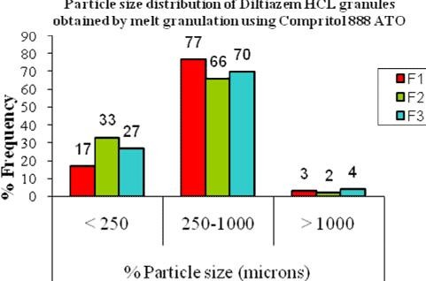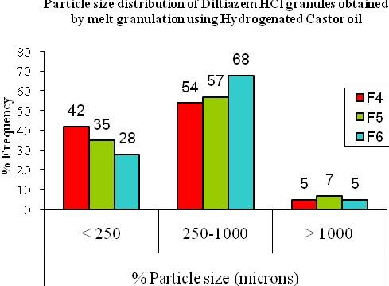

Fig. No. 3:
IR Spectrum of Formulation F2 Drug: Compritol (1:2)
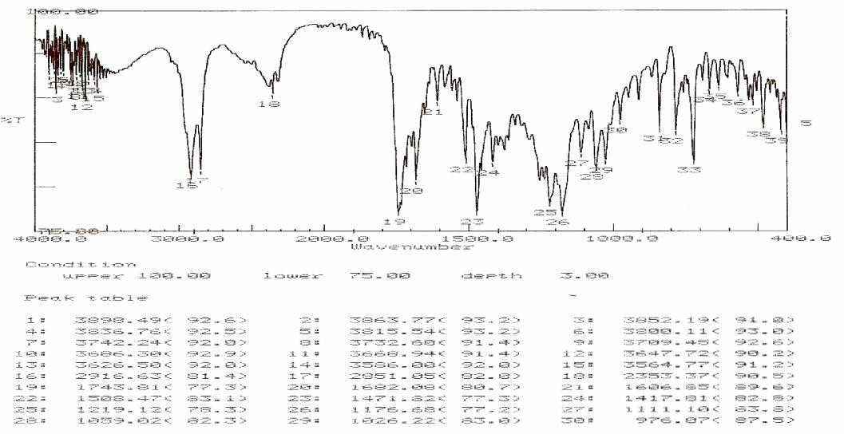

Fig. No. 4:
IR Spectrum of Formulation F4 Drug:Hydrogenaed Castor Oil (1:1)
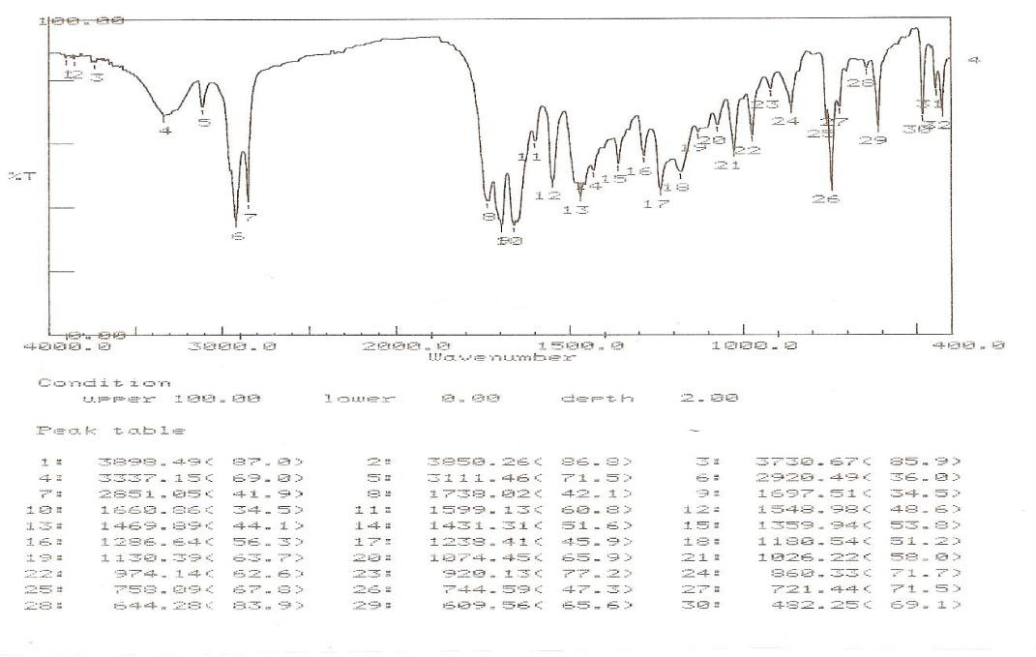

Fig. No. 5
Comparative In vitro Cumulative % Drug Release V/s Time in min of Formulations F2 to F6, and Marketed Formulation
Comparative Cumulative % Drug Release Vs. Time in min. (Formulation F1-F6 & Marketed)

Fig. No. 6
In vitro Cumulative % Drug Release V/s Time in Min of F4 Kept for Stability Study after 30 days
Cumulative % Drug Release v/s Time in min. for Formulation F4 kept for Stability Study at Different Conditions (30 days)
100
R.T.
30°C ± 2°C, RH 65% ± 5%
40°C ± 2°C, RH 75% ± 5%

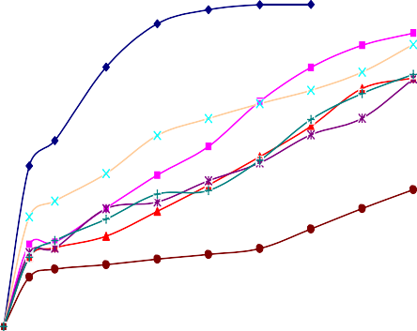120 90

80
100
Cumulative % Drug Release
70

80 60
F1 F2 F3 F4 F5 F6 M
Cumulative % Drug Release

50
60
40

40 30

20
20
10

0
0 100 200 300 400 500 600
Time in min.
0
0 100 200 300 400 500 600
Time in min.

Discussion
The particle size distribution study showed that the main fraction is 250-1000 µm and maximum percentage of granules was present in this range as shown in figure no.1 and 2. the IR study had revealed the compatibility of drug with compritol and hydrogenated castor oil. The values for angle of repose were found to be in the range of 13.16o to 17.54o indicating excellent flow. The percent compressibility for all the six formulations lies within the range of 14.79 to
19.97. All formulations show good compressibility. Hausner’s ratio was found to be in a range of 1.17 to 1.25 which shows good flow properties.

The percentage weight variations for all the formulation were found to be within the pharmacopoeia limits of 5%. All were found to be lying between 394.7 to 401.80 mg. The weights of all the tablets were found to be uniform. The mean values for thickness were found to be in the range
3.93 mm to 4.45 mm. Friability test revealed the good mechanical strength of the tablets. Hardness was found to be within 5.6 kg/cm2 to 9.3 kg/cm2. These values indicated that the hardness of all the formulations F1 to F6 were almost uniform and possess good mechanical strength with sufficient hardness. The drug content of the tablets was found between 95.82% to 100.0%.

The results of dissolution study are shown in table no.4 and figure no.5. This has revealed that higher the concentration of lipophilic polymer more is the retardation of drug release. For the formulations F2, F4, F5 and the Marketed preparation the best fitting linear parameter was that of the Higuchi Matrix model. This indicates that the drug release is controlled by diffusion of the drug through the pores. Formulations F1 and F6 best fitted in First order, where as F3 followed Hixson- Crowell model. It is shown in table no.6. Krosemeyer-Peppas model indicates that release mechanism is not well known or more than one type of release phenomena could be involved.

The 'n' value could be used to characterize different release mechanisms as shown in table no 5. In the present study, the n value for F1,F4,F6 lies between 0.2511 to 0.4294,so it was concluded that the drug release occurred via Fickian diffusion mechanism, where as for the formulations F2,F3,F5 and Marketed the n value lies between 0.5013 to 0.6355 indicating Non-Fickian diffusion mechanism.

Marketed formulation (Dilgard XR 90 mg) showed 78.29% drug release whereas the best formulations F2 and F4 showed 91.09% and 87.57% drug release in 8 hrs respectively.

Stability studies of Tablets F4 (Drug: Hydrogenated castor oil (1:1) )were carried out at different conditions as above for 30 days. The Tablets were evaluated for hardness, friability, Assay and In vitro drug release. The results of stability studies are shown in Table No.7, 8 & Figure No.6, which depicted that physical and chemical properties of the tested tablets (F4) were not altered significantly. So it may
consider as stable formulation.

Conclusion
Extended release matrix tablets of Diltiazem HCL were successfully formulated using waxy binders by melt granulation technique.
From the experimental results it can be concluded
that,
- The extended release matrix system can be formulated using different hydrophobic polymers like Compritol ATO 888 and Hydrogenated castor oil etc. by melt granulation technique.
- The IR spectral analysis revealed that, polymers and excipients used were compatible with drug.
- Analysis of micromeritic properties of formulated granules reveals good flow and compressibility.
- The formulated tablets showed compliance for various physiochemical parameters viz. tablet dimensions, hardness, friability, weight variation, and content uniformity.
- The in vitro studies revealed that formulation F2 (91.09%) and F4 (87.57%) showed maximum drug release in 8 hrs.
- Formulation F3 (77.15%) and F6 (42.50%) showed more retardation of drug release.
- Marketed formulation (Dilgard XR 90 mg) showed 78.29% drug release as compared with best formulations F2 and F4 showed 91.09% and 87.57% drug release in 8 hrs respectively.
- For formulations F2, F4, F5 and the Marketed preparation the best fitting linear parameter was that of the Higuchi Matrix model.
- Formulations F1 and F6 best fitted in First order, where as F3 followed Hixson- Crowell model.
- Further detailed investigation and elaborative study need to be carried out for bioavailability, preclinical, clinical and stability studies for providing platform for further development and optimization of this drug delivery system of Diltiazem in the form extended release matrix tablets.

Reference
- Paradkar AR, Maheshwari M, Chauban B. Sustained release matrices of Metformin Hydrochloride and Glyceryl behenate. Indian Drugs. June 2004; 41 (6).
- Aulton ME. Pharmaceutics: The Science of Dosage Form Design. Second Edn. Livingstone C. Elsevier Science Ltd. 2002; 315-20.
- Martin, P. Brustamannte, AHC Chun. Physical Pharmacy: Physical Chemical Principles in the Pharmaceutical Sciences, Fourth Edn, New Delhi.1997; 330-1, 437-8.
- The United State Pharmacopoeia. United State Pharmacopoeial Covenction, Rockville, MD. Asian Edn. 2000; 1941-3
- Lachman L, Liberman HA, Kanig JL. The Theory And Practice of Industrial Pharmacy. Varghese publishing house: Mumbai. Third Edn. 1990; 296-302.
- Indian Pharmacopoeia Government of India. Ministry of

Health and Family Welfare.The controller of publications. New Delhi. 1996; 736.
- Shimpi S, Paradkar AR. Preparation and evaluation of Diltiazem hydrochloride Gelucire 43/01 floating granules prepared by melt granulation, AAPS Pharmsci Tech. 2004; 5(3), article 43.
- Paulo C, Jose MS. Modeling and comparison of dissolution profiles. Euro J Pharma Sci. 2001; 13, 123- 33.
- Hamdani J. Amighi K. Development and evaluation of prolonged release pellets obtained by melt pelletization process. Int.J. Pharm. 2002; 425, 167-77.
- D’Souza JI, More HN. Design and evaluation of sustained release tablets of Diltiazem Hydrochloride. Indian Drugs. March 2004 ; 41 (3), 175-76.
- Rowe RC, Sheskey PJ, Weller PJ. A Handbook of Pharmaceutical excipients, Pharmaceutical Press, American Pharmaceutical Association, 4th edition. 2003; 267-268, 260-261, 669-671, 106-107.
- Chowdary KPR. Yeola G. Formulation and evaluation of extended release tablets of Diltiazem HCL by melt granulation technique. AAPS PharmsciTech. 2, 2007 132
- 139.

