
Original Article

FORMULATION AND EVALUATION OF NORFLOXACIN MICROSPHERES USING DIFFERENT POLYMERS
*Sindhuri P, Purushotaman M
Vasavi Institute of Pharmaceutical Sciences, Bhakarapet, Kadapa, Andhra Pradesh, India.

Abstract
Norfloxacin a fluoroquinoline derivative used as antibiotic requires multiple administration of drug, leading to fluctuation in plasma concentrations. The aim of present study is to formulate for sustained drug release. Norfloxacin microspheres (NM), by using various polymers like carbopol 934, Sodium Carboxy Methyl Cellulose (SCMC) using different drug : polymer ratios. Six formulations were prepared by using multiple emulsion solvent evaporation technique. NM were evaluated for parameters like angle of response, bulk density, particle size, drug content in microspheres, drug loading, encapsulation efficiency, In-vitro drug release studies. The prepared NM showed good flow properties, where spherical in shape with uniform surface morphology NM showed sustained release of the drug from the formulation for a period of 12 hours.

Key words: - Norfloxacin, carbopol, SCMC, microspheres.

Introduction
Microspheres are matrix system that contain drug throughout their structure and are potential candidates for oral controlled release. Microspheres can be defined as solid spherical particles ranging from 1 to 1000 µm in size[1-4]. These particles consist of drug which is the core material and a coating material. The coating material can be of various types ranging natural polymers such as albumin, gelatin, chitosan, and synthetic polymers such as sodium carboxymethylcellulose and carbopol[5,6]. Among the various coating materials used for the development of sustained release formulations, carbopol and SCMC have been reported to be most suitable for formulating oral sustained release dosage forms as suspending or viscosity increasing agents. Carbopols are generally regarded as essentially non toxic and non irritant materials.

Norfloxacin is a fluoroquinoline derivative used as an antibiotic requires multiple administration of drug, leading to fluctuation in plasma concentrations [7]. Based on certain studies which highlight dose related renal toxicity, seizures, nausea and vomiting with Norfloxacin. Hence in make of recent development there is a lot of scope of preparing sustained release dosage for which reduces the need of repeated doses.

* Author for Correspondence:
Ms.P.Sindhuri,
Dept. of Pharmaceutics,
Vasavi Institute of Pharmaceutical Sciences, Bhakarapet, Kadapa, India.
Email ID: sindhupolepalli@gmail.com

Materials and Methods
Norfloxacin was obtained as gift sample from Caplin point laboratory Ltd; Pondicherry, India. Sodium alginate was procured from SD Fine chem. Ltd., Carbopol 940, were purchased Himedia labs, Pvt,Ltd. All the other reagents used were of analytical grade belong to SD Fine chem. Ltd Procured from Hyderabad distribution office, India.

Methods
Norfloxacin microspheres were prepared with varying drug; polymer ratios by solvent evaporation technique[9]. Weighed quantity of sodium alginate and polymer (carbopol934, SCMC) as per the ratio mentioned in the table no.1 were dissolved in purified water to form a homogenous polymer solution. The drug Norfloxacin was added to the polymer solution and mixed homogenously to get a smooth viscous dispersion. The resulting dispersion was then added in a thin stream to about 500 ml of liquid paraffin and a 100 ml of heavy liquid paraffin in a 1000 ml volumetric flask, stirring with 400 rpm for 5 min to emulsify. Thereafter, 30 ml of calcium chloride (10% w/v) solution was added slowly while stirring for solvent emulsion method that resulted in spherical microspheres [10]. The microspheres were separated and washed with petroleum ether followed by a stream of water. These were dried at 450 c for 8 hrs and kept in desiccators.

Determination of Percentage Drug Entrapment
A weighed quantity of the microspheres was crushed and suspended in phosphate buffer, PH 7.4 to extract the drug from microspheres. After 24 hrs the filtrate was assayed spectrophotometrically at 243 nm for drug content (UV- ELICO SL159). Corresponding drug concentration in the sample were calculated from the calibration plot and drug

entrapment efficiency was calculated using the following formula
Percentage drug entrapment = [Calculated drug con /
Theoretical drug con] x 100

Determination of Mean Particle Size
Particle size analysis was carried out by using optical microscopy. About 200 microspheres were selected randomly and their size was determined using an optical microscope fitted with a standard micrometer scale [11].

Determination of Drug Loading in Microspheres [12]
The drug loading in microspheres was estimated by using the following formula,

L = (QM / WM) x 100
Where,
L = Percentage loading of microspheres
WM = Weight of microspheres
QM = Quantity of drug present in WM of
microspheres

Stability Studies
All the formulations were studied for their stability profiles for 60 days under different environmental conditions such as room temperature (27±2º, 65%RH), Oven temperature (40±2º, 75%RH), and in the refrigerator (5 - 8º). The microspheres were analyzed for drug content.[12]

In vitro release studies
Drug release studies were carried out using a USP type II Dissolution apparatus (ELICO LAB). The dissolution vessel was filled 900 ml of 0.1N HCl and the temperature was kept constant at 37±0.5 ºc. Samples were withdrawn at
predetermined time intervals with the same volume of fresh medium being added after each withdrawal. The sample was suitably diluted and absorbance was measured at 243 nm.

Result and Discussion
Norfloxacin microspheres with varying proportions of (carbopol934 & SCMC) were prepared by multiple emulsion solvent evaporation technique. The particle size was determined by optical microscopy and was found to increase with increasing polymer proportions. The mean particle size of microspheres is shown in table 1. The yield obtained by all the was good and in the range 60.16% to 80.64%, loading of different formulations ranged from 26.77% to 38.67%.The stability studies did not reveal any remarkable change in the drug content. This indicated that the formulation was stable in medium storage conditions.

The invitro release profiles of all formulations have been shown in figure 1. The release of Norfloxacin mainly depended on the viscosity of polymer. The release rate of the drug from the microspheres was found to decrease on increasing the viscosity of the polymer i.e., the grade of the polymer. Norfloxacin release from all the formulations was found to be slow and sustained over 12h. By the end of 12th hour , formulations F1,F2,F3,F4,F5,F6, were found to release 81.5%,80.4%,79.80%,89.3%,86.4%,84.13% and among
six formulations. Formulations 1 to 3 showed better sustained release than 4 to 6. For the conformation of microspheres the SEM report of the one formation (F2) is shown in the figure 2.

Figure no. : 1
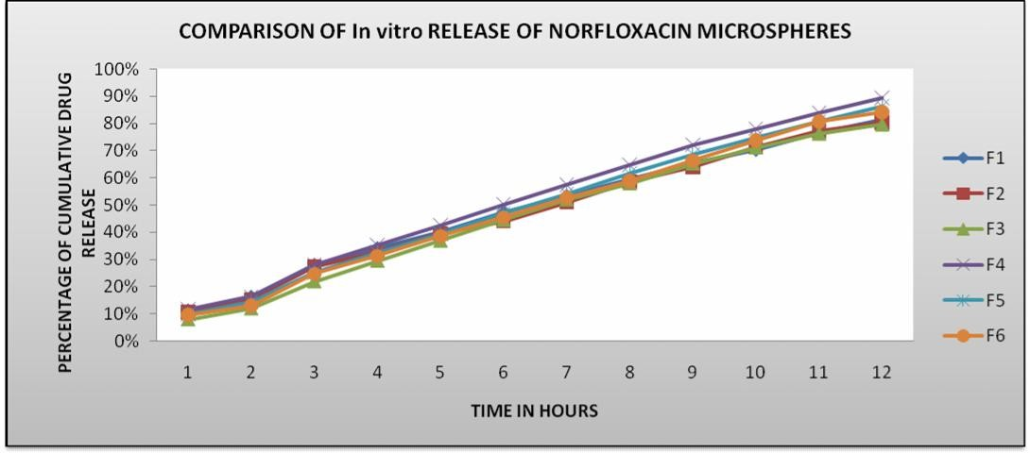

Figure No. : 2
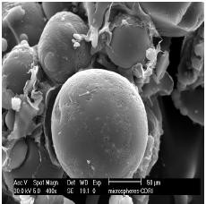

SEM Report of F2.

Table No. : 1
Yield, drug entrapment, and average particle size of Norfloxacin loaded carbopol934&SCMC microspheres

Formulation code | Drug:polymer | Percentage yield(%) | Drug entrapment % w/w | Average particle size (µm) | % of Encapsulation
F1 | 1:1 | 0.23 | 38.69 | 124.1 | 71.94
F2 | 1:1.5 | 0.30 | 33.17 | 139.65 | 76.7
F3 | 1:2 | 0.31 | 30.28 | 140.5 | 80.64
F4 | 1:1 | 0.38 | 35.63 | 168.2 | 64.86
F5 | 1:1.5 | 0.46 | 30.55 | 170.6 | 68.12
F6 | 1:2 | 0.55 | 26.77 | 199.9 | 70.68

Conclusion
The present method of preparation of Norfloxacin microspheres by using Carbopol 934 & SCMC in different ratio was found to be simple, reproducible and the carrier used is also proved that it is biocompatible. From the above data, we may conclude that drug loaded microspheres appear to be a suitable delivery system for Norfloxacin and may help to reduce dose of drug and frequency of administration.

Acknowledgement
We thank our management of Vasavi Institute of Pharmaceutical Sciences for providing required support for completing this research work successfully.

Reference
- Menzel C, Pharmaceutical Research and Development. Anal prof drug subs, 20, 1991, 557- 562.
- scirra JJ, Gidwani RN. Formulation and characterization of mucoadhesive buccal film of glipizide. J pharma sci, 02, 1972, 754-57.
- Singh D , Saraf S, Dixit VK, Saraf S. Formulation optimization of gentamicin loaded Eudragit RS100 microspheres using factorial design study. Biol pharm Bull, 31, 2008, 662-67.
- Das MK, Senapati PC. Furosemide loaded alginate microspheres prepared by ionic cross linking technique: Morphology and Release characteristics, Indian j pharm Sci., 70, 2008, 77-84.
- Vyas SP, Khar RK, editors. Targeted and controlled drug delivary novel carrier systems.1st ed .New Delhi: CBS Publishers; 2002, PP.418
- Jain SK, Awasti A M Jain NK, Agarwal GP. Calcium silicate based microspheres of repalinide for gastro-retentive floating drug delivery: preparation and invitro Characterization .J control Release, 9, 2005, 300 - 309.
- Haznedar S, Dortunc B. Preparation and in vitro evaluation of Eudragit smicrospheres containing acetazolamide. Int J Pharm,115, 1995, 115-118.
- Higuchi T. Mechanism of sustained –action medication: Theoritical analysis of rate of release of solid drugs dispersed in solid matrices. J Pharm Sci, 52, 1963, 1145 - 49.
- Kim B K, Hwang S J, Park H J, Characterization of felodipine loaded poly (e-caprolactone) Microspheres, J Microencapsulation., 22, 2003, 193-203.
- Jain SK, Aswati A M, Jain NK, Agarwal GP, Calcium silicate based microspheres of replaglinide for gastro retentive floating drug delivery,

Preparation and in vitro characterization. J Control Release, 107, 2005, 300-309.
- Anperiqou A, Geogarakis M. Controlled release salbutamol sulphate microspheres prepared by emulsion solvent evaporation technique and study
on the release affected parameters Int J Pharm, 8, 1995, 115 - 121.
- Haznedar S, Dortune B, Preparation and in vitro evaluation of Eudrajit microspheres containing Acetazolamide, Int J Pharm, 04, 2000, 427-431.

