
Original Article
EFFECT OF POLYMERS AND GAS FORMING AGENTS ON GASTRO-RETENTIVE FLOATING TABLETS OF ACYCLOVIR
* Denish Kalaria, Natarajan R, Mohan Kumar K, Rajendran N N Swamy Vivekanandha College of Pharmacy, Elayampalayam, Tiruchengode, Tamilnadu, India - 637 205.
Abstract
Acyclovir is a potent antiviral drug with low toxicity used in treatment of herpes simplex infection & varicella zoster infection. It has maximum absorption in the stomach, and half life is 3 hrs. Due to low gastric retention time, the bioavailability of drug is low as the large portion of drug misses the absorption window. Floating matrix tablets are designed to prolong the gastric residence time after oral administration, at a particular site and controlling the release of drug, especially useful for achieving controlled plasma level as well as improving bioavailability. With this objective, floating dosage form containing Acyclovir as drug was designed. Tablets containing hydroxypropylmethylcellulose (HPMC), drug and different additives were compressed using wet granulation. The study shows that tablet composition has great influence on the floating properties and drug release. Incorporation of gas-generating agent together with polymer improved drug release, besides optimal floating (floating lag time ~30 s; total floating time >12 h). The drug release was sufficiently sustained (more than 11h) and non-Fickian as well as zero-order was confirmed.

Keywords: Floating tablets, Acyclovir, Effect of polymer, HPMC K4M, HPMC K100M.

Introduction
Herpes simplex virus (HSV) is a member of family of herpes viridae, a DNA virus. There are two types of Herpes Simplex Viruses (HSV). Viz HSV type 1 and type 2. HSV type 1 is the herpes virus that is usually responsible for cold sores of the mouth, the so called “fever blisters”. HSV type 2 is the one that most commonly causes genital herpes. Currently the treatments available for herpes simplex are conventional tablets and topical gel for application on outbreaks. The drugs that are commonly used for herpes simplex are Acyclovir, Valaclovir and Famciclovir. Acyclovir, the first agent to be licensed for the treatment of herpes simplex virus infections, is the most widely used drug for infections such as cutaneous herpes, genital herpes, chicken pox, varicella zoster infections. Acyclovir is currently marketed as capsules (200 mg), tablets (200, 400 and 800 mg) and topical ointment. Oral acyclovir is mostly used as 200 mg tablets, five times a day. The presently available conventional therapy is associated with a number of drawbacks such as highly variable absorption and low bioavailability (30%) after oral administration. The main problem with the therapeutic effectiveness of acyclovir is its absorption, which is highly variable and dose dependent thus reducing the bioavailability to 30% and half life is 3 hrs. Acyclovir is soluble in acidic pH and is predominantly absorbed from stomach.[1]

* Author for Correspondence:
Denish Kalaria,
Swamy Vivekanandha College of Pharmacy, Elayampalayam, Tiruchengode, Tamilnadu, India-637205. Email: denishkalaria@gmail.com
Oral drug delivery remains the most user-friendly form of drug delivery, having the highest degree of patient compliance, and still the preferred route of drug administration. As such, drugs for chronic conditions are often administered orally or ease of long-term use. Drugs that are easily absorbed from the gastrointestinal tract and having a short biological half-life are eliminated quickly from the blood circulation. An incomplete release of the drug and shorter residence time of the dosage form in the upper gastro intestinal tract, a prominent site for the absorption of the many drugs, will lead to lower bioavailability. There fore, prolonged gastric retention is important in achieving control over the gastro retention time because this helps to retain the controlled release system in the stomach for a longer and predicted time.[2]

Various approaches for preparation of gastroretentive drug delivery system include floating systems, swellable and expandable systems, high density systems, bioadhesive systems, altered shape systems, gel forming solution or suspension system and sachet systems. Among these, the floating dosage form has been used most commonly. The floating systems include gas-generating systems, non- effervescent systems and raft forming systems.[3]

Substances used to modify drug release from a dosage form include natural products such as gelatin and alginic acid, chemically modified natural products such as cellulose ethers and esters and synthetic polymers such as polyvinyl chloride and methacrylate. The cellulose ethers group of semisynthetic cellulose derivatives has found wide applications in hydrophilic matrices. The non-ionic ones are among the most used, because of their gelling efficacy independent of the pH of the medium. Hydroxypropyl methylcellulose (HPMC)

89

was found especially useful in this field.[4] Hydroxy propyl methyl cellulose (HPMC), commonly used as hydrophilic polymer, is a mixed alkyl hydroxyalkyl cellulose either contains methoxy or hydroxy gruop. The hydration rate of HPMC increases with an increase in hydroxypropyl content, solubility of HPMC is pH independent. It is a widely accepted pharmaceutical excipient, because HPMC is available in a wide range of molecular weights and the effective control of gel viscosity is easily possible.[5]

The most important variable in hydrophilic matrix systems is the rate at which the drug substance is released. The release of drug is controlled by the formation of a hydrogel layer around the matrix following exposure to aqueous fluid. When a hydrophilic matrix comes into contact with water the pores near the surface of the matrix are filled with water and drug release is initially controlled by the dissolution of the drug in the water filled pores and by its diffusion in water. The high viscosity of the polymer solution in the pores slows down the drug transport by forming a gel layer.

The factors influencing the release of drugs from hydrophilic matrices include viscosity of the polymer, the ratio of the polymer to drug, mixtures of polymers, compression pressure, thickness of the tablet, particle size of the drug.[4] A Floating drug delivery system was planned for acyclovir as such a system when administered would remain buoyant on the gastric fluids for the prolonged period of time and the drug would be available in the dissolved form at the main site of its absorption, i.e. stomach. This was led to improvement in the bioavailability of the drug. In this way, it stands an advantage over conventional dosage form. In the present investigation floating tablets of Acyclovir are prepared by an effervescent approach using two different grades of HPMC (K4M and K100M). The aim of the work was to evaluate the effect of different viscosity grades of polymer like HPMC K4M and HPMC K100M on the drug release profile and the effect of gas forming agent like sodium bi-carbonate and citric acid on the buoyancy lag time.

Materials and Methods
Acyclovir was a gift sample from Biodeal Laboratories Pvt. Ltd, Surendranagar, Gujarat. HPMC K4M & HPMC K100M was provided by Colorcon Asia Pvt. Ltd. PVP K30 was purchased from Himedia Lab. Pvt. Ltd, Mumbai. Mg. stearate was purchased from Loba Chemical Pvt. Ltd, Mumbai. Lactose, Sodium bicarbonate & Talc were purchased from S.D. Fine chemicals. Citric acid was purchased from Nice Chemicals Pvt. Ltd. All Polymers and excipients used were of pharmaceutical or analytical grade.

Preparation of acyclovir floating matrix tablets
All the ingredients except magnesium stearate, and talc were blended in glass mortar uniformly. We mixed all the ingredients and passed through the sieve no.: 40 and then added Isopropyl Alcohol as a wetting agent to make a coherent mass. The coherent mass was then dried in a hot air oven at a temperature of 450C for 1 hrs. The dried granules were passed through sieve no.: 20 and were lubricated with
magnesium stearate and talc, which already passed through the sieve no.: 60. The tablets were compressed in a Mega rotary punching machine for 300 mg tablet. The compression force was adjusted to obtaining tablets with hardness in the range of 7-10 kg/cm2. The formulations of all the batches were shown in table 1. The tablets were around and flat with an average diameter of 10±0.1 mm and a thickness of 3±0.4 mm.

Evaluation of Floating Tablets
The prepared floating tablets were evaluated for Angle of Repose, hardness (Monsanto tester), and friability (Roche type friabilator), drug content, in vitro buoyancy and in vitro dissolution studies. The results are expressed as mean ± S.D. (n=3).

In vitro buoyancy studies
The in vitro buoyancy was determined by floating lag time. The tablets were placed in a 100 ml beaker containing 0.1N hydrochloric acid. The time required for the tablet to rise to the surface and float was determined as floating lag time. The duration of time the dosage form constantly remained on the surface of a medium was determined as the total floating time.[3]

Drug content
Weigh and finely powder 20 tablets. To a quantity of the powdered tablets containing 0.1 g of Acyclovir add 60 ml of 0.1M sodium hydroxide and disperse with the aid of ultrasound for 15 minutes. Add a sufficient quantity of 0.1M sodium hydroxide to produce 100 ml, mix well and filter. To 15 ml of the filtrate add 50 ml of water and 5.8 ml of 2M hydrochloric acid and sufficient water to produce 100 ml. To 5 ml of the solution add sufficient 0.1M hydrochloric acid to produce 50 ml and mix well. Measure the absorbance of the resulting solution at the maximum at 255 nm, using 0.1M hydrochloric acid in the reference cell.[6]

Water uptake study (determination of swelling index) Swelling of the tablet excipients particles involves the absorption of a liquid resulting in an increase in weight and volume. Liquid uptake by the particles may be due to saturation of capillary space within the particles or hydration of the macromolecule. The liquid enters the particles through pores and bind to large molecule; breaking the hydrogen bond and resulting in the swelling of particle. The extent of swelling can be measured in the terms of % weight gain by tablet.

One tablet was weighted and placed in a containing 200 ml of 0.1N HCl. After each hour, the tablet was removed from a beaker and weighed again upto 5 hrs. The % weight gain by the tablet was calculated by the formula,
Swelling Index (S.I) = {(Wt- Wo)/ Wo} x 100 Where,
S.I. = swelling index,
Wt = weight of tablet at time t,
Wo = weight of tablet before immersion [7]

In Vitro dissolution studies

In-vitro release studies were carried out using USP XXIII, paddle dissolution test apparatus. 900ml of simulated gastric fluid (pH 1.2) was taken in a dissolution vessel and the temperature of the medium was maintained at 370C±0.50C. The speed was 50rpm. 5ml of sample was withdrawn at predetermined time intervals dilute up to 50ml with medium and same volume of a fresh medium was replaced. The samples were analyzed for drug content against 0.1N HCl as a blank at λmax 255nm using U.V. Spectrophotometer.[6]

Result and Discussion
Angle of Repose: The angle of repose for the formulated blend was carried out. It concludes all the formulations blend was found to be in the range 24.12' to 27.49'.

Thickness of tablet: The Thickness for the formulated tablet was carried out. It concludes all the formulated tablet was found to be in the range 2.650mm to 3.207mm.

Friability Test: The % friability was less than 1% in all the formulations ensuring that the tablets were mechanically stable.

Drug content: The drug content for the formulated tablet was carried out. It concludes all the formulated tablet was found to be in the range 96.11% - 98.72% which is within limit as per B.P. 2007 (95-105%).

Buoyancy / Floating test
All the tablets were prepared by the effervescent approach. Sodium bicarbonate was added as a gas-generating agent. Sodium bicarbonate induced carbon dioxide generation in the presence of the dissolution medium (0.1N hydrochloric acid). The combination of sodium bicarbonate and citric acid provided desired floating ability and therefore this combination was selected for the formulation of the floating tablets.

The tablet floating lag time (FLT) was found to be minimum 30s and total floating time more than 12h. The floating lag time may be explained as a result of the time required for dissolution medium to penetrate the tablet matrix and develop the swollen layer for entrapment of CO2 generated in situ. The tablet mass decreased progressively due to liberation of CO2 and release of drug from the matrix. On the other hand, as solvent front penetrated the glassy polymer layer, the swelling of HPMC K4M and K100M caused an increase in volume of the tablet. The combined effect is a net reduction in density of the tablets, which prolongs the duration of floatation beyond 15h.

The pH of the stomach is elevated under the condition (~3.5), therefore citric acid was incorporated in the formulation to provide an acidic medium for sodium bicarbonate; more over citric acid has an stabilizing effect on Acyclovir formulation.
Formulations containing sodium bicarbonate and citric acid in different ratios were studied for their effect on floating lag time of Acyclovir. It was observed that formulation F1 contains sodium bicarbonate and citric acid in the ratio of 7:1showed FLT 92S., formulation F2 contains ratio 12:1 showed disintegrate or blast the tablet due to more concentration of gas forming agent and formulation F3 to F10 contains a ratio of 9:1 showed FLT 30 to 62S.

Water uptake study
The swelling of the polymers used could be determined by water uptake of the tablet. The complete swelling was achieved by the end of 5 hours, so percent swelling was determined at the end of 5 hours for all the developed formulation. The values of swelling index of various batches were evaluated as shown in table 3. There was a significant increase in the percent swelling of the tablet with increase in concentration of polymers. After 5 hours swelling index was observed between 73.49 to 85.24 %.

In vitro dissolution studies
The initial batches [F1-F4], made with HPMC K4M alone showed the complete release in 6 to 9 hrs. Tablets formulated with HPMC K100M alone (F5-F6), too showed a complete drug release in 9 to 11 hrs and where a formulation F7 showed a drug release in 12 hrs with 90.63% due to more concentration of HPMC K100M. The formulation [F8 to F10], made with the combination of HPMC K4M & HPMC K100M showed a drug release in 10 to 12 hrs. This was because tablets which are composed of a hydrophilic polymeric matrix, on contact with water build a gel layer around the tablet core which governs the drug release. The drug release from HPMC matrices is controlled for water soluble drug by diffusion and for water insoluble drugs by erosion of outer polymer layer.

Kinetic modeling of drug release
The formulations F1, F3, and F4 showed higher Regression values for first order plot and non- fickian indicating that the drug releases from these formulations were concentration dependent. The formulations F5, F6, F7, F8, F9 and F10 showed higher Regression values for zero order plots and non- fickian indicating that the drug releases from these formulations were concentration independent.

The effervescent-based floating drug delivery was a promising approach to achieve in vitro buoyancy. The addition of gel-forming polymer HPMC (K4M and K100M) and gas-generating agent sodium bicarbonate along with citric acid was essential to achieve in vitro buoyancy. The drug release from the tablets was sufficiently sustained and non-Fickian transport of the drug from tablets was confirmed.

Acknowledgement
The authors are thankful to Mr. Hitesh Koradia from Biodeal Lab. Pvt. Ltd. Surendranagar, Gujarat, India for their support and cooperation in carrying out the research work.

Table No. - 1
Formulation of Floating Tablets of Acyclovir Ingredients
F1 |  | F2 | F3 | F4 | F5 | F6 | F7 | F8 | F9 | F10
Qty(mg/tab)
Acyclovir | 100 | 100 | 100 | 100 | 100 | 100 | 100 | 100 | 100 | 100
Lactose(mono) | 106 | 66 | 84 | 74 | 94 | 84 | 74 | 84 | 74 | 64
HPMC K 4 M | 30 | 40 | 40 | 50 | - | - | - | 10 | 20 | 30
HPMC K100 M | - | - | - | - | 30 | 40 | 50 | 30 | 30 | 30
Sod.bicarbonate | 42 | 72 | 54 | 54 | 54 | 54 | 54 | 54 | 54 | 54
Citric Acid | 6 | 6 | 6 | 6 | 6 | 6 | 6 | 6 | 6 | 6
PVP K 30 | 12 | 12 | 12 | 12 | 12 | 12 | 12 | 12 | 12 | 12
Isopropyl Alcohol | qs | qs | qs | qs | qs | qs | qs | qs | qs | qs
Magnesium Stearate | 2 | 2 | 2 | 2 | 2 | 2 | 2 | 2 | 2 | 2
Talcum | 2 | 2 | 2 | 2 | 2 | 2 | 2 | 2 | 2 | 2
Total Weight | 300 | 300 | 300 | 300 | 300 | 300 | 300 | 300 | 300 | 300

Table No. - 2:
Floating Lag Time, Total Floating Time Formulation Code Floating Lag Time-FLT (sec.) Total Floating Time
 |  | TFT(mins)
F1 | 92 | 555
F2* | 0 | 0
F3 | 62 | 685
F4 | 51 | 760
F5 | 48 | 670
F6 | 56 | 695
F7 | 55 | 870
F8 | 30 | 665
F9 | 33 | 695
F10 | 35 | 765

*Formulation F2 tablet was disintegrate or blast after putting in 0.1N HCl, so it’s don’t have FLT and TFT.

Time
Table No. - 3

Swelling Index of Floating Tablet of Acyclovir
Swelling Index (%)

(In Hrs) | F1 | F3 | F4 | F5 | F6 | F7 | F8 | F9 | F10
1 | 28.23 | 30.56 | 34.45 | 32.82 | 36.49 | 32.53 | 36.64 | 35.39 | 34.87
2 | 39.76 | 47.18 | 45.04 | 47.68 | 49.57 | 39.34 | 46.27 | 49.45 | 46.09
3 | 54.32 | 56.03 | 53.61 | 58.55 | 60.22 | 59.66 | 58.18 | 65.01 | 68.33
4 | 66.07 | 69.47 | 68.59 | 70.71 | 73.44 | 76.62 | 70.72 | 80.07 | 79.68
5 | 76.18 | 73.49 | 75.36 | 77.29 | 80.06 | 79.16 | 83.63 | 82.44 | 85.24

Table No. - 4
Comparative Cumulative Percentage Drug Release Data for F1 - F10

Time in hrs
F1 F3 F4 F5 F6 F7 F8 F9 F10

0 0 0 0 0 0 0 0 0 0
1 18.66 14.66 17.61 15.19 10.38 13.78 12.11 12.98 12.02
2 39.09 35.13 34.97 21.35 15.9 23.00 22.38 21.34 19.84
3 65.77 60.95 48.29 35.72 27.27 28.21 30.45 29.31 24.22
4 84.61 79.01 66.13 40.68 39.98 35.9 42.01 33.93 29.08
5 91.8 85.12 75.84 52.56 45.87 41.41 47.06 43.93 34.95
6 96.35 89.69 85.17 67.42 58.99 48.76 55.11 50.62 41.09
7 -- 95.84 93.19 72.13 68.18 54.94 63.62 61.25 48.82
8 -- -- 96.64 82.83 79.93 61.48 75.66 71.19 57.87
9 -- -- 98.2 95.86 90.94 71.04 86.32 79.73 68.41
10 -- -- -- -- 92.20 81.68 98.57 86.6 79.39
11 -- -- -- -- 98.84 84.27 -- 95.27 89.81
12 -- -- -- -- -- 90.63 -- -- 97.1

Table No. – 5
Kinetic Values Obtained from Different Plots of Formulations (F1-F10) of Acyclovir

Formulation
Zero order plot

First order plot

Higuchi plot Korsemeyer Peppa’s plot

Possible mechanism

Regression Coefficient
 | (R2) | (R2) |  | (R2)
F1 | 0.956 | 0.962 | 0.955 | 0.972 | 0.956 First order  non fickian
F3 | 0.934 | 0.971 | 0.961 | 0.951 | 0.977 First order  non fickian
F4 | 0.944 | 0.950 | 0.983 | 0.979 | 0.798 non First order sion fickian diffu
F5 | 0.994 | 0.845 | 0.967 | 0.983 | 0.862 Zero order non fickian
F6 | 0.992 | 0.826 | 0.977 | 0.990 | 1.010 Zero order Class II
F7 | 0.993 | 0.917 | 0.969 | 0.991 | 0.764 Zero order non fickian
F8 | 0.994 | 0.698 | 0.961 | 0.995 | 0.889 Zero order non fickian
F9 | 0.996 | 0.853 | 0.964 | 0.990 | 0.845 Zero order non fickian
F10 | 0.984 | 0.759 | 0.921 | 0.968 | 0.846 Zero order non fickian

Regression Coefficient
Regression Coefficient (R2)

Regression Coefficient N
of drug release

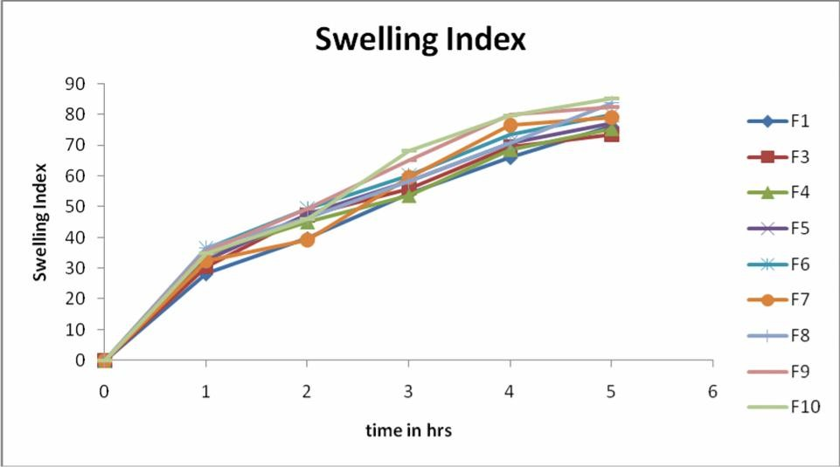

Figure -1
Swelling Index of Floating Tablet of Acyclovir

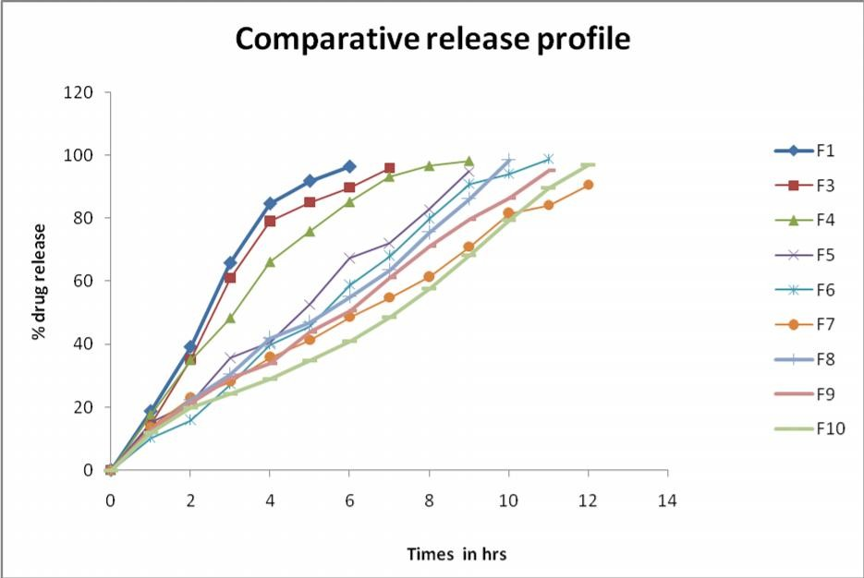

Figure - 2
Comparative Cumulative % of Drug Release Data for F1-F10

Reference
- Devi Kusum V, Bhosale U.V. Formulation and optimization of polymeric Nano drug delivery system of acyclovir using 3² Full factorial design. International Journal of PharmTech Research 2009; 1: 644-653.
- Rajesh Kaza, Usharani E, Nagaraju R, Haribabu R, Siva Reddy P.V. Design and Evaluation of Sustained release Floating tablets for the treatment of Gastric Ulcers. J. Pharm. Sci. & Res. 2009; 1 :81-87.
- Sanjay S. Patel, Ray S, Thakur R.S. Formualtion and evaluation of floating drug delivery System containing clarithromycin for helicobacter pylori. Acta Poloniae Pharmaceutica – Drug Research 2006; 63 :53-61.

- Maria E.C, Leopold V.R. Influence of the viscosity grade and the particle size of HPMC on metronidazole release from matrix tablets. European Journal of Pharmaceutics and Biopharmaceutics 1997; 43: 173- 178.
- Deepa Karthikeyan, Karthikeyan .M, Ramasamy .C. Effect of Different Viscosity Grades of HPMC on Drug Release Profile. Journal of Pharmacy Research. 2008;1
:23-28.
- British Pharmacopoeia, Official Monographs. 2008; 3: 2394- 2395.
- Kshirsagar.R.V, Vikas Jain, Wattamwar.S. Effect of different viscosity grade HPMC polymers on gastroretentive drug delivery of Metformin HCl. International journal of applied pharmaceutics 2009; 1: 44-50.

