Research Article

Available Online at: www.ijpir.com

International Journal of Pharmacy and Industrial Research

ISSN Print 2231 – 3648
Online 2231 – 3656

FORMULATION OF TRANSDERMAL PATCH BY FACTORIAL DESIGN IN MANAGEMENT OF HYPERTENSION: IN VITRO, EX VIVO AND IN VIVO SKIN IRRITATION EVALUATION

*¹Sunitha Sampathi, ²Sravanthi Anampally, ¹Nataraj Narra.
^{*1} Department of Pharmaceutics, National Institute of Pharmaceutical Education and Research (NIPERH), Balanagar, Hyderabad, A.P. 500037, India.
² Department of Pharmaceutics, Srikrupa Institute of Pharmaceutical Sciences, Vill: Velkatta, Siddipet. District: Medak, A.P. – 502103. India.

Abstract
An attempt was made to formulate and evaluate the trandolapril transdermal drug delivery system. The matrix type films were prepared by 3² factorial design using solvent casting technique with polymers like Eudragit RL 100 and HPMC K15M. Di-butyl phthalate and DMSO were used as plasticizer and penetration enhancer. The prepared films were evaluated for physicochemical characteristics. The drug excepient Compatibility was determined by Fourier transform infrared spectroscopy and Differential scanning calorimetry. In vitro permeation studies were performed using Franz diffusion cell. Ex vivo studies were performed using skin of albino rats. The results revealed that there is no interaction between drug and selected polymers. Drug content varied from 96.43 ± 0.38 - 99.08 ± 0.8%. Moisture content and moisture uptake were increased for the patches containing higher amount of HPMC due to its hydrophilic nature. It was found that the formulation release followed first order release kinetics with non-fickian anomalous diffusion of drug release mechanism.
Key words: Trandolapril, Eudragit RL 100, HPMC, Transdermal matrix films

Introduction
Tremendous efforts have been focussed on the development of new drug delivery systems ^{[1]}. Transdermal drug delivery system was introduced to overcome difficulties faced by the oral drug delivery systems. Transdermal patches are mainly used to deliver a specific dose of drug through the skin into blood stream and this was first approved by FDA in 1981. Transdermal delivery mainly provide sustained release of drug and useful for drugs with short half life ^{[2]}.These also improves patient compliance and interruption or termination of treatment when necessary ^{[3]}. Trandolapril (TLP)
the esterified prodrug of the active metabolite trandolaprilate is a nonsulfhydryl angiotensin- converting enzyme (ACE) inhibitor. It is approved for the management of hypertension and for use in stable patients who have evidence of left ventricular systolic dysfunction or symptoms of chronic heart failure within the first two days after acute myocardial infarction. TLP undergoes extensive first-pass metabolism leading to poor bioavailability of 9.5% ^{[4]}. It is converted by esterases into the diacid metabolite, trandolaprilate (bioavailability 40-60%), which is approximately, eight times more active as an inhibitor of ACE

Address for Correspondence:
Sunitha Sampathi,
National Institute of Pharmaceutical Education and Research (NIPERH), Balanagar, Hyderabad, A.P. 500037, India.
Email ID: sunithasampathiphd@gmail.com

activity. Peak plasma concentrations (C_{max}) of TLP were 1.68 to 1.88 ng/mL and were achieved with in
0.5 to 1.5 h when a single oral 2 mg of TLP was administered to healthy subjects ^{[5,} ^{6]}. It possess ideal characteristics such as low molecular weight of 430.54, logarithmic partition coefficient in octanol/water is 1.28 ^{[7]}, smaller dose (1-4 mg), short elimination half life (0.7 h), and poor oral bioavailability (9.5%) for formulation as transdermal patches. Polymers used should also precede consistent and effective delivery of the drug throughout the products intended shelf life and should be GRAS. Naturally occurring penetration enhancers like essential oils, terpenes, d-limonene, eucalyptus oil, peppermint oil, and turpentine oil are also clinically acceptable enhancers ^{[8,} ^{9]}. In the present study DMSO was used as penetration enhancer and di-butyl phthalate as plasticizer. The objective of the present study is an attempt to develop and evaluate the TLP transdermal system for physicochemical characteristics, compatibility studies and for in vitro release and ex vivo permeation studies.

Materials and methods

Materials
TLP was generous gift sample from Hetero Drugs Pvt. Ltd. (Hyderabad, India). Eudragit RL 100 was a gift sample from Natco, India, Hyderabad. Hydroxypropyl methylcellulose 15 cps, DMSO, disodium hydrogen phosphate, potassium dihydrogen phosphate, and sodium chloride were purchased from SD Fine Chemicals, Pvt. Ltd (Mumbai, India).

Experimental method
Preparation of the Transdermal films
Matrix type patches loaded with TLP were prepared by solvent casting method. The transdermal films containing Eudragit RL 100 and HPMC with 2 mg of drug per patch size of 2.25 cm² of TLP wt/wt with plasticizer (Dibutyl phthalate) and DMSO 5% as penetration enhancer were prepared. Hydrophilic ingredients were dissolved in distilled water and the hyphophobic ingredients were dissolved in ethanol and were then mixed and stirred on a cyclomixer to get homogenous mixture. The resulting solution was poured into a Teflon petridish of area 18.066 cm² containing 16 mg of the drug. An inverted funnel was placed over the petridish to prevent the fast evaporation of the solvent after a period 24h the dried medicated transdermal film were placed in a plastic seal bag and stored in desiccators ^{[11,} ^{12]}.

Factorial design
The formulation compositions are optimized by factorial design following 3² factorial analysis design. This experiment using factorial design allows one to examine simultaneously the effects of multiple independent variables and their degree of interaction. The formulae were developed as 9 sets varying the variables (polymers) following 3² full factorial design (3 levels) using Design expert®. (Table 1, 2, 3).

Table No. 01: Formulation and design of 3² full factorial experiment design layout

Trial Variable level in coded formulation
 | (X1) | (X2)
1 | -1 | -1
2 | -1 | 0
3 | -1 | +1
4 | 0 | -1
5 | 0 | 0
6 | 0 | +1
7 | +1 | -1
8 | +1 | 0
9 | +1 | +1
Table No. 02: Values of amounts of variables in 3² full factorial design
Coded values | Actual values (X1=Eudragits RL100) | Actual values (X2 =HPMC-  15cps)
-1 | 350 | 350
0 | 450 | 450
+1 | 550 | 550

Analytical method
Accurately 50 mg of drug was weighed and placed in a 50 mL volumetric flask and dissolved in phosphate buffer of pH 7.4 and volume adjusted to
50 mL. The Standard solution of drug was subsequently diluted with phosphate buffer to obtain a series of dilutions containing 5, 10, 15, and 20 µg/mL of the solutions. The absorbance of the

above dilutions was measured in double beam (Jasco) UV spectrophotometer at 224 nm with a quartz cell of 10 mm path length against phosphate buffer. A graph was plotted by taking concentration of TLP µg/mL on x-axis and absorbance on y-axis. The concentration of drug was calculated using the linear regression equation of the calibration curve.

Design Summary
Table No. 03: Factorial design (3²) Summary with responses

Study Type | Factorial |  | Runs | 9
Initial Design | Full Factorial |  | Blocks | No Blocks
Center Points | 0
Design Model | 2FI
Factor | Name | Units | Type | Low | High
A | Eudragit RL100 | mg | Cat | 350 | 550 | Levels: | 3
B | HPMC K15 | mg | Cat | 350 | 550 | Levels: | 3
Response | Name | Units | Obs | Analysis | Min | Max | Mean | Std. Dv. | Ratio
Y1 | Q 24 | % | 9 | Factorial | 44.33 | 73.6 | 55.076 | 9.2442 | 1.660
Y2 | Q 8 | % | 9 | Factorial | 15.5 | 38.43 | 27.735 | 6.9483 | 2.479
Y3 | RRC 1st Order |  | 9 | Factorial | 0.0104 | 0.023 | 0.0146 | 0.0039 | 2.211

Evaluation of physicochemical properties of the patches
Thickness and Weight variation
The thickness of the patches was checked at six different points of the film using a micrometer. For weight variation three films each of 1 cm² from each batch were weighted individually and the average weight was calculated.

Folding Endurance
The folding endurance was measured manually as per the method reported ^{[10]}. A strip of the film was cut and repeatedly folded at the same place until the film breaks. The more thin the film the more will be the flexibility of the film.
Other mechanical properties like tensile strength (TS), elastic modulus (EM) and elongation at break (E/B) were evaluated by using tensile strength apparatus (Ultra Test, Mecmesin, UK) equipped with 25 kg load cell. Film strip with dimensions 60mmX10mm and free from air bubbles or physical imperfections were held between two clamps positioned at a distance of 3 cm. during measurement, the top clamp at a rate of 2 mm/s pulled the strips to a distance till the film broke. The force and elongation were measured when the film broke. The mechanical properties were calculated according to the below formulae ^{[14]}. These properties were evaluated to confirm the physical quality of the patch which denotes patch/film durability and physical stability.

Mechanical properties

Tensile strength (kg. mm-2 ) =

Force at break (kg)

Initial cross sectional area of the sample (mm2 )

Elongation at break (% mm-2 ) = Increase in length (mm) X
Original length (mm)
100

Cross sectional area

Elastic modulus = Force at corresponding strain (kg) X
Cross sectional area (mm2 )

Strain = Tensile strength
Elastic modulus
100

Corresponding strain

Drug content
The drug content was determined by taking a patch (2.25 cm²) cut it into small pieces and added to a beaker containing 100 mL of PBS (pH 7.4). The film was completely dissolved by cyclomixer. The contents were filtered using Whattman filter paper and the drug content in the filtrate was estimated using a UV spectrophotometer at 244 nm using the reference solution consisting of placebo film.

Percentage of Moisture Content
The dried films were weighed individually and kept in a desiccator containing activated silica. The films were weighed regularly until a constant
weight was obtained. The percentage of moisture content was calculated as the difference between initial and final weight with respect to the final weight ^{[17]}.

Percentage of Moisture Uptake
The dried films were weighed and placed in desiccators containing 200 mL of saturated solution of potassium chloride (84% relative humidity) at room temperature. The percentage moisture uptake of the films was calculated as the difference between final and initial weight with respect to the initial weight ^{[15]}.

Skin irritation test
% Moisture Uptake = Final Weight − Initial Weight X100
Initial Weight
prepared transdermal film of 2.25 cm² was placed

The test was performed on a healthy albino rat weighing around 175 g. Aqueous solution of formalin 0.8% was used as the standard irritant. Placebo polymer patch of 2.25 cm² were used as the test patch. Standard irritant was applied on the left dorsal surface of each rat and placebo patch was applied on the right dorsal surface of the albino rat [Ethical Committee Reg. No: 1548/PO/a/11/CPCSEA]. The patches were removed after period of 24 h with the help of an
alcohol swab. The skin was examined for erythema or edema [2, 13, 16].

Drug-polymer compatibility studies
Fourier Transforms Infrared Spectroscopy (FTIR) and Differential scanning calorimetry (DSC) were used to know the compatibility between the drug and polymers used in the patches, by KBr pellet method in the wavelength region between 4000 to 400 cm⁻¹ the FTIR and DSC was performed for the pure drug, polymers and the physical mixtures of drug and the polymers used and were compared.

In vitro drug release studies
In vitro drug release studies were performed by using a Franz diffusion apparatus. The dialysis membrane was mounted between the donor and receptor compartment of the diffusion cell ^{[18]}. The
on the membrane which was previously soaked in phosphate buffer. The receptor compartment was filled with PBS pH 7.4. The total assembly was placed on a hot plate magnetic stirrer and stirred by maintaining the temperature at 32 ± 0.5°C. 5 mL of the samples were withdrawn at regular interval and replaced with an equal volume of PBS. The drug content was estimated spectrophotometrically at 244 nm.

Ex vivo skin permeation studies
The studies were performed by taking the rat skin as the membrane. Young albino rats weighing between 200 g to 250 g were taken and scarified by excess of chloroform inhalation. The abdominal hairs were removed and the abdominal skin was carefully separated from the body with the dermis part remaining intact. Subcutaneous tissue was surgically removed. The inner part of the skin was washed with distilled water thoroughly to separate the adhering fat. The full thickness of skin obtained was placed in normal saline solution and stored at 4
± 1°C until used for the experiment. The drug permeation from the transdermal patch through the skin was determined using Franz diffusion cell where the contents of donor and receptor was separated by placing the excised skin and the transdermal patch of 2.25 cm² containing the drug

was placed in the donor compartment containing the stratum corneum side of the skin. The Franz diffusion cell was placed on a magnetic stirrer and stirred by placing Teflon coated bead at 500 rpm. Samples were withdrawn periodically and replaced with PBS to maintain skin condition. The drug content was estimated spectrophotometrically at a wave length of 244 nm.

Results
Trandolapril transdermal patches were prepared and evaluated for various physical and release parameters. FTIR and DSC studies results revealed the drug excepient compatibility In IR spectra of trandolapril pure drug many number of peaks were found prominently at various wave numbers indicating the presence of functional groups & substitutions like peaks at 1650cm⁻¹, wave number
due to C-C stretching in aliphatic chain, prominent peaks at 1736cm⁻¹, 1280cm⁻¹, 1458 cm⁻¹ and 1193 cm⁻¹ due to C=O stretching, C-O stretching, C-O-H stretching, and C-O-C stretching in aliphatic chain respectively indicating presence of carboxylic group and keto group in the structure. Broad peaks appeared between 3448 cm⁻¹, 2943cm⁻¹ wave number are due to C=C stretching in aromatic structure. Peaks appeared at 3270cm⁻¹ and 1366cm⁻
¹ were because of C-H stretching aromatic and definite in CH₂ aliphatic respectively. A more intense peak was found at 3280cm⁻¹ because of N- H stretching indicating presence of amino group in the structure & peak at 1433cm⁻¹ wave number also indicates the presence of C-N stretching. All these peaks were appeared unchanged in IR spectra of combinations like trandolapril + EU + HPMC. (Figure 4).

Table No. 04: Physical properties of prepared trandolapril transdermal patches
Formulation | Weight | Thickness | Folding | Drug content | Moisture | Moisture
code | (mg/2.25 cm²) | (mm) | Endurance | (%) | uptake | content
TF1 | 57.14±0.96 | 1.16±0.06 | 137±3.60 | 99.08±0.8 | 8.57±0.59 | 4.39±0.46
TF2 | 54.41±1.02 | 1.13±0.05 | 165±5.68 | 97.54±1.09 | 16.80±2.55 | 2.72±0.50
TF3 | 46.4±1.8 | 1.01±0.05 | 222±3.21 | 97.85±0.91 | 18.92±0.34 | 4.55±0.38
TF4 | 45.40±1.04 | 0.99±0.05 | 142±7.09 | 97.33±0.77 | 9.98±0.30 | 2.12±0.30
TF5 | 61.55±1.37 | 0.96±0.18 | 124±8.71 | 98.10±0.84 | 18.36±0.95 | 2.4±0.24
TF6 | 57.64±1.17 | 0.96±0.04 | 175±6.80 | 97.52±0.55 | 15.69±0.38 | 4.25±0.18
TF7 | 58.11±30.62 | 1.03±0.05 | 129±7.23 | 98.73±0.36 | 15.22±0.75 | 3.41±0.22
TF8 | 52.67±1.11 | 1.02±0.04 | 132±3.78 | 96.43±0.38 | 17.94±0.53 | 1.24±0.21
TF9 | 41.86±0.79 | 1.03±0.044 | 135±4.04 | 97.54±0.55 | 17.48±0.66 | 2.62±0.23
Table No. 05: Release kinetic data of transdermal patches formulations (TF₁-TF₉)

Formulation | Zero Order | First Order | Higuchi | Peppas
 | (R²) | (R²) | (R²) | n | (R²)
TF₁ | 0.9185 | 0.9723 | 0.8409 | 0.5341 | 0.9133
TF₂ | 0.9242 | 0.9744 | 0.9807 | 0.6557 | 0.9887
TF₃ | 0.990 | 0.9815 | 0.982 | 0.6329 | 0.988
TF₄ | 0.9666 | 0.9924 | 0.9579 | 0.6215 | 0.9849
TF₅ | 0.9607 | 0.992 | 0.9608 | 0.5791 | 0.9842
TF₆ | 0.9451 | 0.9917 | 0.9753 | 0.5875 | 0.9815
TF₇ | 0.8662 | 0.9286 | 0.943 | 0.7814 | 0.9856
TF₈ | 0.9677 | 0.9977 | 0.9498 | 0.6363 | 0.9723
TF₉ | 0.973 | 0.9967 | 0.9515 | 0.7474 | 0.9878

The melting point of pure trandolapril was found at 127.91ºC & followed exothermic type of reaction where onset was started 123.26ºC & ends with 131.21ºC (Figure 3). The glass transition lag was found around 7.95oC & the same exothermic type of reactions was found in all combinations like trandolapril + EU + HPMC. No change was found
in melting point as well as glass transition lag but special peaks were found indicating melting point of eudragit at 98.22ºC, HPMC at 110.21ºC, & the influence of excepients were found only in changing on’s & end’s sets of melting point peaks of drug by absorbing heat but not by interactions. Finally, DSC data states that the crystallinity of

pure drug found unchanged & stable, and indirectly determines the compositions are compatible.

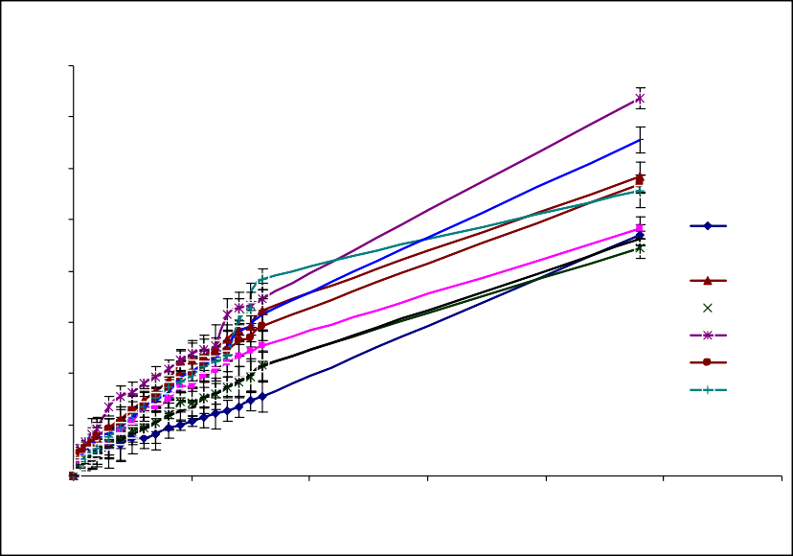Fig. 01: In vitro drug release plots of formulations TF₁ – TF₉
Cumulative % drug release plots of trandolapril transdermal patches (TF1-TF9)
80

70

60

50

40

30

20

10

0
0
5
10
15
Time (h)
20
25
30
TF1
TF2
TF3
TF4
TF5 TF6 TF7
TF8
TF9
% Drug release

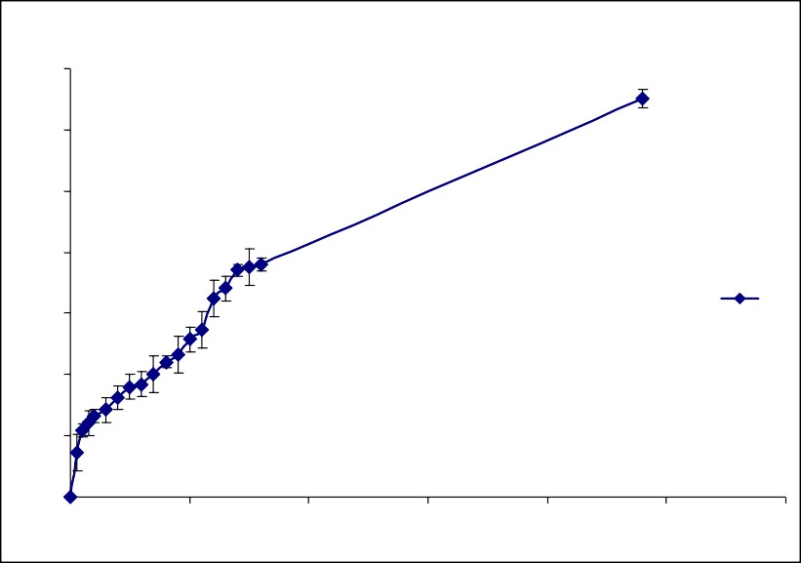Fig. 02: Ex vivo drug skin permeation studies plot of formulation TF₂
70
Ex vivo skin permeation studies plot of best release formulation in vitro (TF2)
60

50

40

30

20

10

0
0
5
10
Time (h)
15
20
25
30
TF2
% Drug release

Average weight of the patch with an area of 2.25 cm² was found least in formulation TF₉ around
41.86 ± 0.79 and highest in TF₅ 61.55 ± 1.37 mg. Thickness was found more in formulation TF₁ 1.16
± 0.06 and less in TF₆ 0.96 ± 0.04 mm. Folding endurance was found to be more with TF₃ formulation 222 ± 3.21 and less in TF₅ 124 ± 8.71,
% Drug content was found highest in TF₁ 99.08 ± 0.8% and least in TF₈ around 96.43 ± 0.38. Moisture uptake and moisture content was found more in TF₁ and TF₃ around 18.92 ± 0.34% and
4.55 ± 0.38% respectively and less in TF₃ and TF₈
around 8.57 ± 0.59% and 1.24 ± 0.21% respectively. Highest values of tensile strength and elastic modulus was found to be in formulation TF₁ around 1.93 ± 0.156 kg/m² and 3.66 ± 0.335 kg/mm² respectively with strain value of 0.527 and least values of above were found in formulations TF₇ and TF₅ around 0.96 ± 0.51 kg/m² and 0.56 ±
0.115 kg/mm² respectively. Elongation at break was found more in TF₂ around 161.3 ± 2.46 and less in formulation TF₇ around 74.5 ± 4.016 (Table 4).

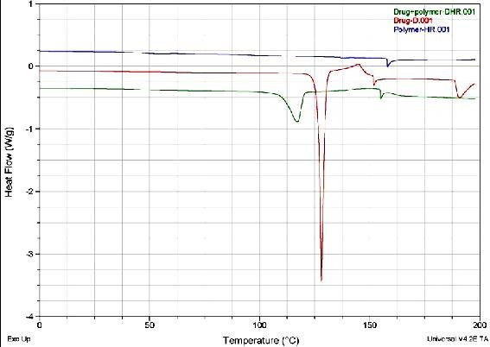
Fig. 03: DSC overlay thermograms of pure drug trandolapril, polymer blend and drug with polymer.

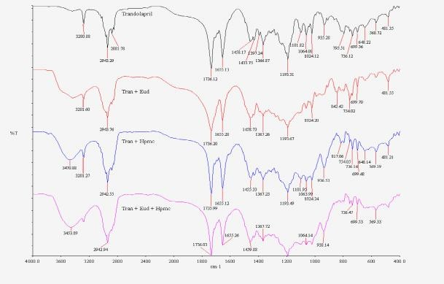
Fig. 04: FTIR overlay spectra of trandolapril pure drug, polymers and pure drug with polymers

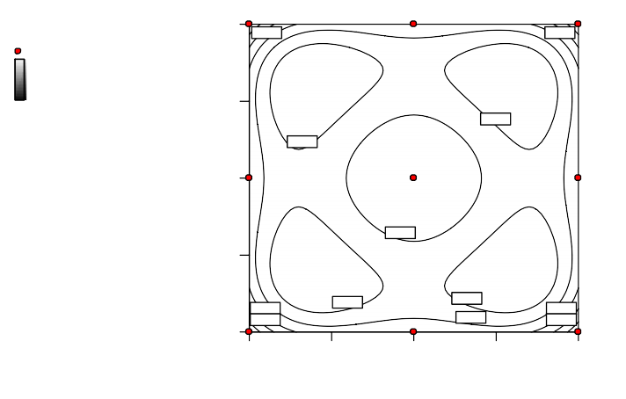Fig. 05: Standard error of design counter plot of 3² full factorial design
Design-Expert® Softw are
StdErr of Design
550.00
StdErr of Design Design Points 1.5
0.747
0.747
0.5
500.00
0.647
X1 = A: Eudragit RL 100 X2 = B: HPMC K15M
0.647
450.00
0.697
400.00
0.647
0.747
0.797
0.647
0.697
0.747
0.797
350.00
350.00
400.00
450.00 500.00
550.00
A: Eudragit RL 100
B: HPMC K15M

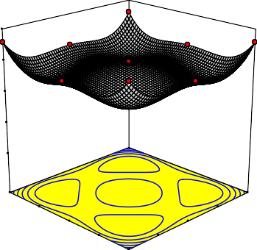Fig. 06: Standard error of design 3D plot of 3² full factorial design
Design-Expert® Softw are

StdErr of Design 1.5

0.5
1.000
X1 = A: Eudragit RL 100
X2 = B: HPMC K15M
0.750

0.500

0.250

0.000
550.00
550.00
500.00 500.00
450.00 450.00
B: HPMC K15M 400.00 400.00A: Eudragit RL 100
350.00 350.00
StdErr of Design

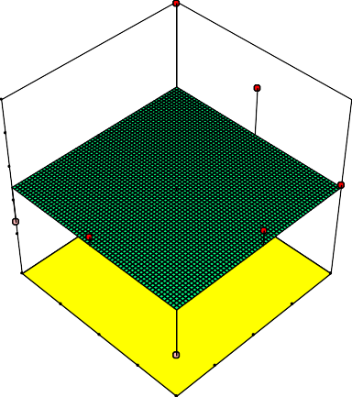Fig. 07: 3D plot of Q24 % drug release influenced by HPMC and Eudragit combinations
Design-Expert® Softw are

Q 24
73.6

44.33

X1 = A: Eudragit RL 100 X2 = B: HPMC K15M
74

66.5

59

51.5

44

550.00
550.00
500.00
500.00
450.00
450.00
B: HPMC K15M^{400.00}
^{400.}A⁰⁰: Eudragit RL 100
350.00 350.00
Q 24

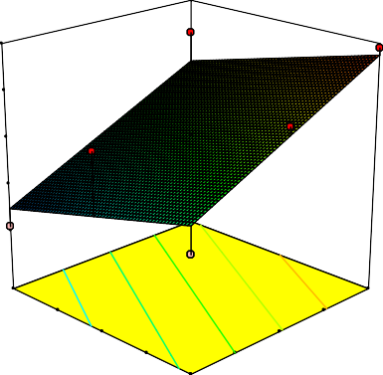Fig. 08: 3D plot of Q8 % drug release influenced by HPMC and Eudragit combinations
Design-Expert® Softw are

Q 8
38.43

15.5

X1 = A: Eudragit RL 100 X2 = B: HPMC K15M
39

33
27

21

15
550.00
550
500.00 500
450.00 450
B: HPMC K15M ^{400.00} ⁴⁰⁰ A: Eudragit RL 100
350.00 350
Q 8

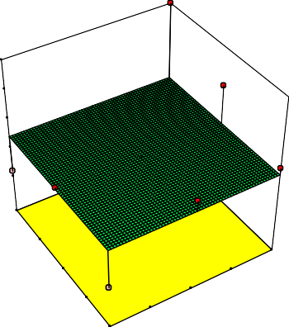Fig. 09: 3D plot of release rate constant (first order) influenced by HPMC and Eudragit combinations
Design-Expert® Softw are

RRC 1st Order 0.023

0.0104
0.023
X1 = A: Eudragit RL 100 X2 = B: HPMC K15M
0.01975

0.0165

0.01325

0.01

550.00
500.00
550.00
450.00
500.00
B: HPMC K15M
450.00
400.00
400.00
350.00 350.00
A: Eudragit RL 100
RRC 1st Order

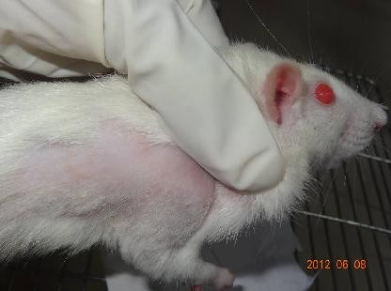
Fig. 10: Picture depicting the skin irritation test in rat by the formulation TF₄
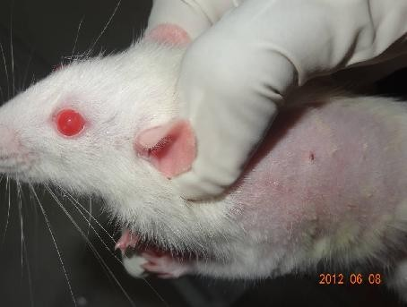
Fig. 11: Picture depicting the skin irritation test in rat by the standard (phenolic compound)

In In vitro drug release studies the more release retardation was found around 44.33 ± 2% in formulation TF₄ up to 24 h where as less retardation was observed around 73.60 ± 2.1% in formulation TF₅ after 24 h. All formulations followed first order non fickian release kinetics with anomalous transport mechanism (Figure 1) (Table 5, 6). Ex vivo characterization studies
carried by selecting formulation as per in vitro drug release results, with an intention to develop 48 h release plots formulation TF₂ was selected to perform Ex vivo permeation studies (Figure 2). Release was found more as compared to in vitro results where 65.15±1.5% was release with in 24 h. Skin irritation test in rats proved that the formulations are found to be less irritant as

compared to standard with less erythema (Figure 10, 11). The in vitro data is used to calculate various other dependable responses like Q₂₄, Q₈ and first order release rate constant. The data was
plotted as surface response graph and analysed statistically where the p – value was found significant (less that 0.050) (Figure 4, 5, 6, 7, 8).

Table No. 06: Release of drug at 24 h, 8 h and release rate constant (first order)
Formulation | Q24 (%) | Q8 (%) | Release rate constant (Ko)  (first order)
TF₁ | 46.89 | 15.50 | 0.0106
TF₂ | 48.37 | 25.33 | 0.0119
TF₃ | 58.33 | 32.27 | 0.0158
TF₄ | 44.33 | 21.50 | 0.0104
TF₅ | 73.60 | 34.53 | 0.0230
TF₆ | 56.87 | 29.33 | 0.0149
TF₇ | 55.50 | 38.43 | 0.0154
TF₈ | 65.47 | 31.50 | 0.0189
TF₉ | 46.33 | 21.23 | 0.0112

Discussion
All physical parameters evaluation results were found in acceptable range. Folding endurance was found more with formulations with high percentage of eudragit than HPMC. Tensile strength was found more in formulations with high percentage of eudragit where as the elongation and elastic modulus were found more in formulations containing high percentage of HPMC than Eudragit. The drug release from the formulations was sustained over an extended period of time i.e. up to 48 h. The study states the release depended on the polymers ratio. Formulations prepared using HPMC showed better sustained action and formulation TF₄ is confirmed as best formulation as it released maximum drug upto 48 h.

Conclusion
The development of the 48 h releasing transdermal films by solvent casting could be adaptable in laboratory as well as in industry since it is simple and reproducible. In conclusion, HPMC and EU formulations could be used for better sustained action. However further in vivo studies are needed to optimize for sustained action in human beings for better bioavailability, efficacy thus safety.

References
- Front line Strategic Consulting Inc. Alternative drug delivery systems series: Transdermal drug delivery systems, 2002, Front Line Strategic Consulting., Inc.
- Robinson JR, Lee VH. Controlled Drug Delivery: Fundamental and Applications; 2nd ed.; Marcel Dekker: New York, 1987; 523- 552.
- Guay DRP. Trandolapril: A newer angiotensin converting enzyme inhibitor. Clin Ther. 25(3), 2005, 713-775.
- Wiseman LR, Tanvish MC. Trandolapril: A review of its pharmacodynamic and pharmacokinetic properties, and therapeutic use in essential hypertension. Drugs. 48(1), 1994, 71-90.
- Danielson B, Querin S, LaRochelle P, Sultan E, Mouren M, Bryce T, Stepniewski J P, Lenfant B. Pharmacokinetic and pharmacodynamics of trandolapril after repeated administration of 2mg to patients with chronic renal failure and healthy control subjects. J Cardiovasc Pharmacol. 23, 1994, 50-59.
- Lenfant B, Mowren M, Bryce T, De Lauture D, Strauch G. Trandolapril: Pharmacokinetics of single oral doses in healthy male volunteers. J Cardiovasc Pharmacol. 23(4), 1994, 38-43.
- Remko M. Acidity, lipohilicity, solubility, absorption, and polar surface area of some ACE inhibitors. Chem Pap. 61(2), 2007, 133- 141.
- Williams A, Barry B. Terpenes and the lipid- protein partitioning theory of skin penetration enhancement. Pharm Res. 8(1), 1991, 17-24.

- Obata OH, Takayama K, Nagai T. Percutaneous absorption enhancing effect and skin irritation of monocyclic monoterpenes. Drug Disco Deliv. 6(3), 1990, 229-238.
- Das MK, Bhattacharya A, Ghosal SK. Transdermal delivery of trazodone hydrochloride from acrylic films prepared from aqueous latex. Indian J Pharm Sci. 68(1), 2006, 41-46.
- Deo MR, Sant VP, Parekh SR, Khopade AJ, Bankar UV. Proliposome based Transdermal delivery of levonorgesterol. J Biomat Appl. 12(1), 1997, 77-88.
- Rao PR, Ramakrishna S, Diwan PV. Drug release kinetics from polymeric films containing propanolol hydrochloride for transdermal use. Pharm Dev Technology. 5(4), 2000, 465-472.
- Wade Hull MS. Heat enhanced transdermal drug delivery: A Survey. Paer J Appl Res. 2, 2002, 1-9.
- Gannu R, Vishnu VY, Kishan V, Rao YM. Development of nitrendipine transdermal patches: In vitro and Ex vivo characterization. Curr Drug Del. 4, 2007, 69-76.
- Kusum Devi V, Saisivum S, Maria GR, Deepti PU. Design and evaluation of matrix diffusion controlled transdermal patches of verapamil hydrochloride. Drug Dev Ind Pharm. 29(5), 2003, 495-503.
- Libermmann and Lachman Pharmaceutical Dosage forms 2nd ed. Lea and Febiger; 1990: 265.
- Gupta R, Mukherjee B. Development and in vitro evaluation of diltiazem hydrochloride transdermal patches based on povidone- ethylcellulose matrices. Drug Dev Ind Pharm. 29(1), 2003, 1-7.
- Shinde AJ, Garala KL , More HN. Development and characterization of transdermal therapeutics systems of tramadol hydrochloride. Asian J Pharm. 2(4), 2008, 265-69.

