***Research Article***

**Available Online at:** [**www.ijpir.com**](http://www.ijpir.com/)



International Journal of Pharmacy and Industrial Research

**ISSN**

**Print 2231 – 3648**

**Online 2231 – 3656**

**PHARMACOGNOSTICAL STUDIES ON THE WOOD OF**

***AQUILARIA MALACCENSIS* LAM.**

# *,1Sathyanathan V, 2Saraswathy A, 3Jayaraman P

*1Arvindaksha Educational Society’s Group of Institutions, Suryapet- 508 376 A.P, India .

2Captain Sriniwasa Murthy Research Institute for Ayurveda and Siddha Drug Development, Arumbakkam, Chennai, - 600 106, TN, India.

3Plant Anatomy Research Centre, W.Tambaram, Chennai - 600 045 TN, India.

**Abstract**

The study claims importance in the context of some confusion and controversies relating to the authenticity and botanical diagnosis of original Agarwood/Akil, a highly valued wood in trade for its incense and medicinal properties. Due to severe scarcity and extreme endemism of the Agarwood or *Aquilaria malaccensis* Lam. (*A. agallocha* Roxb.) the traders have assorted to many trade wood samples which simulate the original Agarwood, to supply to the consumers. A perusal of literature revealed that a little fragmentary information on various perspectives of wood did not help to resolve scientific validation of the drug. The preliminary phytochemical details which are essential components in studying the microscopic identification are lacking for Agarwood and its adulterants. The present study aims at in depth pharmacognostical analysis of the Agarwood. The histochemical studies were carried out for sample tissues. The fluorescence analysis for the powder and treatment of powder with various solvents under UV was also done. The sample was subjected to qualitative phytochemical screening and physico - chemical evaluation. The results were very specific for the Agarwood which will contribute in identifying the drug from its adulterants, thus helpful for its further phytochemical and pharmacological investigations.

**Keywords:** Agarwood, Akil, Incense, Interxylary phloem, Volatile oil.

### Introduction

In the present paper an Indian drug Agarwood/ Akil, a plant drug of controversial identity is taken for investigation. The plant *A. malaccensis ie., A*garwood is termed as true ‘Akil’ ascribed in Siddha text and its uses were narrated1. From the ancient literature2, Akil is equated to eight different botanical binomials belonging to six families. A wood known as *Eagle wood* (Trade name), *Agaru* (Hindi), *Agil*, *Akil* (Tamil) is credited with several

pharmacological properties as per the literature claims; it is also a highly priced incense wood of much popular antiquity.

The *Aquilaria malaccensis* Lam. (=*A. agallocha* Roxb.) of Thymelaeaceae3 is a medium sized tree grown in North - Eastern parts of India and a number of countries of South - East Asia. *A. malaccensis* is reported to occur in Malaya, India, Myanmar, Sumatra, Borneo, Philippines, Hong

### Author for Correspondence:

Sathyanathan V**,**

Arvindaksha Educational Society’s Group of Institutions, Balemla (V), Suryapet – 508 376, Nalgonda Dist., A.P., India. Email: [vsathyanathan22@yahoo.com](mailto:vsathyanathan22@yahoo.com)

Kong and New Guinea4,5 although reports indicate that Java and Hainan are the historical sources of the product. In India *A. malaccensis* occurs in Arunachal Pradesh, Assam, West Bengal, Manipur, Meghalaya, Mizoram, Nagaland, Sikkim and Tripura. The tree flourishes well in the foot-hills of evergreen and semi evergreen forests. *A. malaccensis* is a large evergreen tree growing up to 30m high with a girth of 1.3-1.5m. The trunk is moderately straight and fluted, bearing thin pointed leaves (Fig.01). The values of the tree lie not on the timber, but on a brown or dark brown pathological product formed due to some fungal infestation on parts of the heart wood in certain trees of this species alone. It is this unique infested portion that contains concentrated amount of *oleoresin* of high commercial value. The agar formation on the wood makes it more valid in market for its aroma. It has been suggested that some fungal infection is required for formation of agar (Fig. 01c). The fungi associated with agar formation were isolated and identified as *Aspergillus* sp., *Penicillium* sp., and *Fusarium* species. The drug is used for many biological activities like in the treatment of rheumatism, as stimulant, as a liver tonic, carminative, tonic for pregnant women, palpitation of the heart, and the wood has proven for its antiallergic6,7 and neuroleptic properties8. The Agarwood has been reported to have aquilochin (a coumarinolignan)9, liriodenine (an alkaloid)10, gmelofuran, agarol (novel sesquiterpenes)11,12 and chromone derivatives13, Agarospirol and jinkoh- eremal are the major chemicals reported in agarwood oil14.

A wide lacuna in the protocol standards for the botanical identity and phytochemical parameters encourages the raw-drug dealers to market many country-woods under the name of Agarwood. The source seems to remain in controversial and confused state especially the botanical identity and genuineness of the original drug land us in still more state of bewildering and paradox. Under this backdrop, it was found worthy to contemplate on various pharmacognostic aspects of the wood and to contribute definite protocol on the Agarwood. These studies will include macroscopic, microscopic, histochemical studies, fluorescence analysis, preliminary phytochemical screening, and physico – chemical constants on the wood of the source taxon.

## Materials and methods

Authentic wood sample of *A. malaccensis* was procured from Assam, through Dr. A.B.D. Selvam, Scientist, Botanical Survey of India, Calcutta. The voucher specimen studied is deposited in CSMDRIA, Chennai.

1. Macroscopic and microscopic features for the sample were carried out by standard methods15. The microscopic features of the sample were collected and identified using the monographs on ‘Indian Woods’16. Botanical binomials and family details of the wood sample were traced with the help of Floras17,18. Certain anatomical characters relied on diagnosis of wood tissues has listed in standard texts19,20.

Microscopic descriptions of tissue were supplemented with micrographs wherever necessary. Photographs of different magnifications were taken using Nikon Labhot 2 Microscopic Unit. For normal observations bright field was used. For the study of crystals, starch grains and lignified cells, polarized light was employed. Since these structures have birefringent property, under polarized light they appear bright against dark background. Magnifications of the figures are indicated by the Scale – bars. Descriptive terms of the anatomical features are as given in the standard anatomy books21.

1. The histochemical studies were carried out for the sample tissues and microphotographs were taken22.
2. The fluorescence analysis for the wood powder and treatment of powder with various solvents under UV light (254 nm) was carried out**23**.
3. The alcoholic extract of the sample was subjected for qualitative phytochemical analysis24,25,26 using standard procedures.
4. Physico-chemical constants for the sample were also found using standard methods27,28.

## Results and discussion

### External Profile of the Plant

*A. malaccensis* is a large evergreen tree with thin bark, 18-21m sometimes upto 40m in height, 1.5 - 2.5m in diameter with a moderately straight and often fluted stem. The tree occurs commonly on the low hills of the borders of Assam, Meghalaya and Bangladesh; it also occurs in Burma. Leaves 5-9 cm long, thinly coriaceous, oblong – lanceolate, flowers white or green or dirty yellow in terminal,

sessile or shortly peduncled, umbellate cymes29 (Fig. 01).

### Macroscopic and Microscopic studies Exomorphic and Organoleptic Features of the Wood Sample

The wood is creamy white or yellow (Fig. 02). The wood is soft, light; No characteristic odour, taste, and is smooth to touch. The macroscopic features are tabulated (Table - 01).

### Microscopical Observation

**Bark:** Bark in TS view (Fig:03.1,2) is wide with smooth surface and homocellular phellem, measuring 200 m wide. Secondary phloem zone is also wide and continuous comprising of dilated rays and wide triangular bands of fibres and sieve elements.

**Secondary xylem** (wood): Growth rings wanting, vessels diffuse, thin walled, angular, in clusters or occasionally solitary or in radial multiples of 2 to many vessels (Fig. 03.2, 04.1). Diameter of the vessels varies from 40 – 70 m.

Xylem fibres are libriform type, thin walled with wide lumen; cross sectional outline is rectangular or squarish, arranged in regular radial files, tangential diameter of the fibres 20 – 25 m. Xylem rays thin, straight, not much prominent.

Included phloem or *interxylary phloem* is abundant forming fairly prominent tangential continuous or discontinuous bands. Some of the sieve elements in the median part of the tangential band are crushed, and those surrounding crushed cells are intact and functioning (Fig. 04.1).

### TLS features of the wood

In tangential longi sectional view of the wood, the xylem rays are short, either uniseriate or in part biseriate, the two types being equal in frequency (Fig. 04.2). The ray cells are vertically oblong or squarish. The marginal cells are longer in some of the rays (rays hetero cellular) and as long as the body cells (homo cellular rays). The height of the rays ranges from 70 – 230 m; ray frequency is 10

– 15 / mm.

### Powder Microscopy (Fig. 05, 06, 07)

The wood powder (macerated sample) exhibits vessel elements, fibres and wood parenchyma. The

vessel elements are narrowly cylindrical (Fig. 06.1,2 and 07) or short and broad. The perforation plate is simple and oblique. Some of the vessel elements have short, thin tails at both or one ends. The lateral wall pits are minute dense and multiseriate. The cylindrical vessel elements are up to 280 m long; the short broad elements are 250

m long (including the tails) (Fig. 05.1,2).

**Wood fibres** are thin walled and spindle shaped with tapering ends. The fibres are either wide or narrow lumened. The wide fibres are 350 - 500 m long; the narrow fibres are 500 – 600 m long. The fibres have no lateral wall pits.

**Xylem parenchyma**: The axial parenchyma cells are narrow, long and thin walled. The ray parenchyma cells are rectangular to squarish (Fig. 05, 06). The parenchyma cells also do not exhibit any prominent pits. The microscopic features are tabulated in Table - 01.

### Histochemical Localization

Proteins, Sugar, Alkaloids, Tannins and Essential Oil were localized by histochemical studies in the sample. Results and photomicrographs are presented (Table - 02) (Fig. 08).

### Fluorescence Analysis

The fluorescence analysis showed differences in fluorescence in both daylight and UV light (254 nm) for wood powder and treatment of powder with dilute alkalis, acids and organic solvents (Table - 03).

### Preliminary Phytochemical Screening

The preliminary phytochemical screening of the alcoholic extract of the wood showed the presence of lignin, saponin, flavonoid, quinone, protein, tannin, terpenoid, sterol, alkaloid, sugar and absence of gum (Table - 04).

### Physico-Chemical constants

The sample was also subjected to loss on drying at 105oC, pH at 5% aqueous solution, ash value, extractive value, solubility value, volatile oil content, and inorganic chemical analysis as the standards showing the physico - chemical properties of the wood and the results are presented in Table - 05.

**Macroscopic Features**

### Table No. 01: Macroscopic and Systematic Microscopic Features of Agarwood

**Observation Microscopic features Observation**

Colour White creamy or yellow

Growth Rings Not evident

Taste Bland GR Boundary -

Odour No specific Odour Vessel element length and

diameter µm

250-280µm/

40-70 µm

Texture Soft Vessel aggregation Solitary or Radial multiples

Xylem Rays Uni or inpart biseriate, heterocellular / homo cellular

Size of the rays µm 70-230µm

Axial parenchyma Scanty

Fibre length 350-600mm

### Table No. 02: Histochemical Localization

|  |  |  |  |  |
| --- | --- | --- | --- | --- |
| **Test for Alkaloids** | **Starch** | **Protein** | **Essential Oil** | **Tannin** |
| Localisation Included | Xylem | Phloem | Xylem rays, included | Included phloem and |
| phloem | Rays | parenchyma | phloem | xylem rays |

**Table No. 03: Fluorescence Analysis for Wood Powder, Powder with Dilute Alkali and Acids and its Extracts at 254 nm**

**Sl. No. Treatment Observation Inference Treatment Observation Inference**

1. Drug Powder

Day Light Brown Hexane extract

Day Light Pale Yellow

U.V. Light Dark Brown U.V. Light Pale Green

Brownish

1. Drug Powder + 1N Sodium

Day Light

Yellow Benzene

Day Light Dull Brown

Hydroxide (Aqueous)

U.V. Light Yellowish

Extract

Pale Greenish

Green U.V. Light Brown

Drug Powder + 1N Sodium

1. Hydroxide (Alcoholic)

Day Light Pale Yellow Chloroform Day Light Brown Extract

U.V. Light Pale Green U.V. Light Green

1. Drug Powder + 1N Hydrochloric Acid

Day Light Yellow tint Alcohol

Extract

Day Light Pink Greenish

U.V. Light Colorless U.V. Light Violet

1. Drug Powder + 50% Sulphuric Acid

Day Light Pale Yellow Acetone

Extract

Day Light Pale Brown Pale Greenish

U.V. Light Green tint U.V. Light Black

1. Water

Day Light Pale Orange Pale Greenish

Extract

UV Light

Brown

### Table No. 04: Preliminary Phytochemical Screening

Sl. No. Test for Result

|  |  |
| --- | --- |
| 1. Gum | - |
| 2. Lignin | + |
| 3. Saponin | + |
| 4. Flavonoid | + |
| 5. Quinone | + |
| 6. Protein | + |
| 7. Tannin | + |
| 8. Alkaloid | + |
| 9. Sterol | + |
| 10. Terpenoid | + |

11. Sugar +

(+) present (-) absent

|  |  |  |
| --- | --- | --- |
|  | **Table No. 05: Physico – Chemical Constants (Mean of 3 Values)** |  |
| **Sl. No.** | **Physico – chemical Parameters** | **Values** |
| I. | Loss on drying at 105o C (% w/w) | 13.26 |
| II. | pH for 5% aqueous solution | 6.0 |
| III. | a. Total ash (% w/w) | 1.4985 |
|  | b. Water soluble ash (% w/w) | 0.1998 |
|  | c. Alkalinity for water soluble ash ‘ml’ in 0.1 N hydrochloric acid / 100 g | 0.4850 |
|  | d. Acid insoluble ash (% w/w) | 0.0999 |
| IV. | i. n-Hexane extractive value (% w/w) | 0.63 |
|  | ii. Chloroform extractive value (% w/w) | 1.430 |
|  | i. Alcohol soluble extractive value (%w/w) | 2.3971 |
|  | ii. Water soluble extractive value (% w/w) | 1.5187 |
| V. | Volatile oil (% v/w) | 0.14 |
| VI. | Sodium (%) | 0.036 |
|  | Calcium (%) | 0.038 |
|  | Phosphorous (%) | 0.204 |
|  | Iron (ppm) | 0.78 |
|  | Magnesium (%) | 0.12 |
|  | Chloride (%) | 0.17 |
|  | Sulphate (%) | 0.22 |
|  | Carbonate (%) | 0.18 |

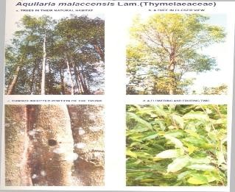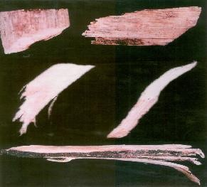

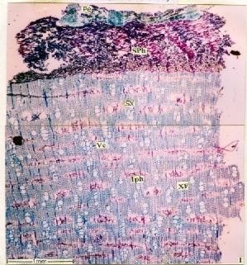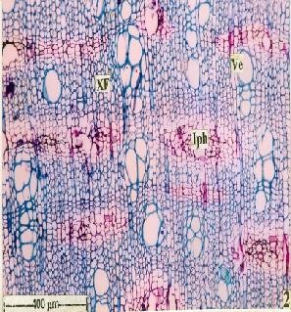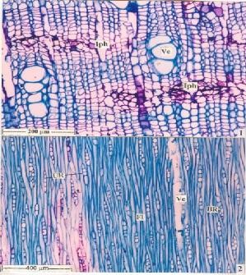**Fig. 01: Habit Sketch and External Profile of the Plant Fig. 02: Akil Wood Samples In Closer View**

**Fig. 03 Fig. 04**

**Salient Microscopic Features of Agarwood**

* 1. TS of wood showing bark and other portion of wood.
  2. A portion of the wood with included phloem enlarged.
  3. TS of wood-included phloem and vessels enlarged.
  4. TLS of wood showing uni - seriate, partly bi – seriate rays.

IPh – included phloem, Pe – Periderm, SPh – Secondary phloem, SX – Secondary xylem, Ve – vessel, XF – xylem fibre, BR – Bi seriate ray, Fi – Fibres, UR – uni - seriate ray.

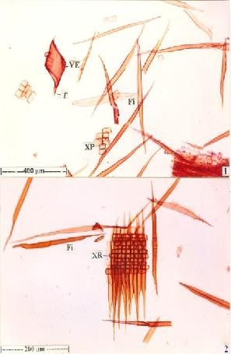 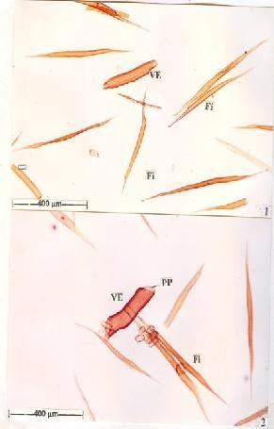 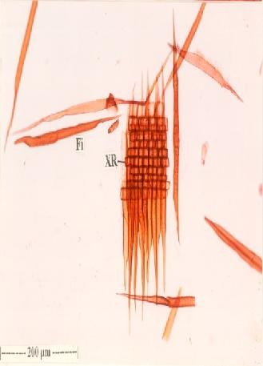

**Fig. 05 Fig. 06 Fig. 07 Powder Microscopic Studies of Agarwood**

5.1, 2. Macerated wood elements showing vessel elements, xylem fibres and xylem parenchyma. 6.1, 2. Macerated xylem elements showing cylindrical vessel elements and fibres.

7.0 Xylem ray enlarged.

Fi – Fibres, T – tail, XP – xylem parenchyma, XR – xylem ray, PP – perforation plate, VE – Vessel element.

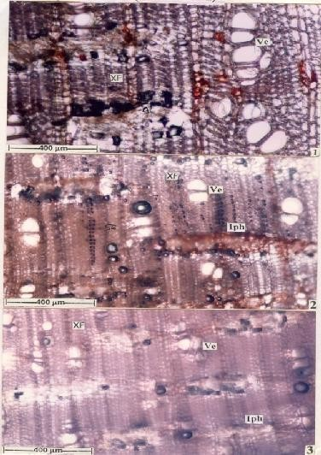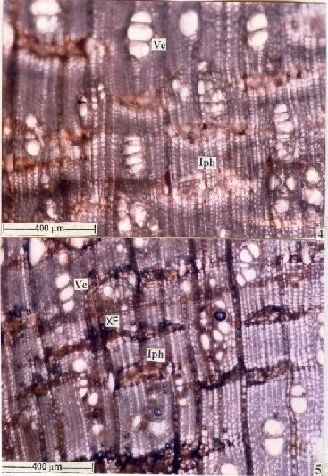

**Fig. 08: Histochemical Studies of Agarwood**

* 1. Alkaloids located in the parenchyma cells of the *inter xylary* phloem.
  2. Starch grains are located in the xylem rays.
  3. Proteins located in the parenchyma cells of the *inter xylary* phloem and in a few xylem parenchyma.
  4. Lipids are located abundantly in the *inter xylary* phloem as well as xylem rays.
  5. Tannins are seen fairly in dense concentration in the included phloem as well as some of the xylem rays. Iph – Included phloem (inter xylary phloem), Ve – Vessel, XF – Xylem fibre.

## Conclusion

The present study is believed to throw significant light on the pharmacognostical identification of the time-renowned drug. The original Agarwood exhibits highly specific microscopic features such as *interxylary* or *included phloem* in the wood, absence of *growth* rings, *diffused vessel* distribution, thin walled angular *clustered or solitary vessels,* short *uniseriate / biseriate heterocellular* xylem rays and *libriform* type of thin walled fibres. The microscopic features and the other constants are very specific for *Aquilaria malaccensis,* will be useful in authenticating the original Agarwood from its adulterants. The results are believed to fill in the lacuna in the Herbal Pharmacopoeia on the Pharmacognostical perspectives of Agarwood. The researchers and pharmaceutical industries may have the access of the protocol of Agarwood/Akil formulated by the present study.

## Acknowledgement

I convey my sincere thanks to Prof. Jayaraman, Founder of PARC, Tambaram, Chennai, for helping in taking microphotographs for the wood tissues. I acknowledge for all the members whoever rendered support to complete the work successfully.

## References

1. Kannuswamy Pillai, C. Siddha Vaithya Padhartha Guna Vilakkam, Materia Medica – Vegetable Kingdom, 1990, Rathina Nayakar Publisher, Chennai, 3.
2. Sambasivam Pillai, T.V. Tamil - English Dictionary of Medicinal Chemistry, Botany and Allied Science, 1991, Department of Indian Medicine and Homeopathy, Chennai, 1, 38.
3. Mabberley, D.J. The Plant Book, 2005, Press Syndicate of the University of Cambridge, U.K., 49.
4. Whitmore, T.C. The Flora of Malaysia, A Malaysia, A Manual for Foresters, 1972, 2, Longman, Kualalumpur.
5. Burkill, I.H. A Dictionary of the Economic Products of the Malay Peninsula, 1966, Ministry of Agriculture, Kualalumpur.
6. Kim, Y.C., Jeong, S.J. and Kim, H.M. Antiallergic Effect of *Aquilaria agallocha*, Yakhak Hoeji, 1997 a, 41(2), 255 - 259.
7. Kim, Y.C., Lee, E.H., Lee, Y.M. Kim, H.K., Song, B.K., Lee, E.J. and Kim, H.M. Effect of the Aqueous Extract of *Aquilaria agallocha* Stems on the Immediate Hypersensitivity Reactions, Journal of Ethno Pharmacology, 1997 b, 58(1), 31 - 38.
8. Okugawa, H., Ueda, R., Matsumoto, K., Kawanishi, K. and Kata, A. Effects of Agarwood extracts on Central Nervous System in Mice, Planta Medica, 1993, 59(1), 32 – 36.
9. Bhandhari, P., Pant, P. and Rastogi, R.P. Aquillochin, a Coumarinolignan isolated from Agarwood, Phytochemistry, 1982, 21(8), 2147

- 2149.

1. Natarajan, R.K., Natarajan, M. and Purushothaman, K.K. Alkaloids from Agaru, Bull. Med. Ethnobot., 1983, 4(1-2), 81 - 84.
2. Pant, P. and Rastogi, R.P. Sequiterpenes of *Aquilaria agallocha*, Indian J. Pharm. Sci., 1979, 40(6), 250.
3. Pant, P. and Rastogi, R.P. Agarol, a New Sesquiterpene from *Aquilaria agallocha*, Phytochemistry, 1980, 19(8), 1869 - 1870.
4. Yang, J.S., Wang, J.L. and Su, Y.L. Isolation and Characterization of Three 2-(2-phenyl ethyl) Chromone Derivatives, Acta Pharmaceutica Sinica, 1990, 25(3), 186 - 190.
5. Meier, M. and Kohlen Berg, B. Isolation of Analysis of Anisyl Acetone from Agarwood Oil, J. Essential Oil Research, 2003, 15(1), 54

- 56.

1. Wallis, T.E. Text Book of Pharmacognosy, 1985, CBS Publishers and Distributors, Delhi, India, I Edition, 652.
2. Purkayastha, S.K. Indian Woods – Their Identification, Properties and Uses, 1985, Controller of Publications, Delhi, 1 - 6, 126 - 127.
3. Gamble, G.S. Flora of Presidency of Madras, 1967, Reprinted Under the Authority of the Government of India, Kolkatta, Part I-IV, VII, 108.
4. Henry, A.N., Kumari, G.R. and Chitra, V. Flora of Tamil Nadu, 1987, Botanical Survey of India, Southern Circle, Coimbatore, India, 258.
5. Metcalfe, C.R. and Chalk, L. Anatomy of the Dicotyledons, 1957, I, II, Clarendron Press, Oxford, 276.
6. Chalk, L. and Chattaway, M.M. Identification of Woods with Included Phloem, Trop.Woods, 1937, 50.
7. IAWA Committee on Nomenclature, 1964, Multilngual Glossary of terms used in Wood Anatomy.
8. Krishnamoorthy, K.V. Methods in Plants Histochemistry, 1988, S. Viswanathan Printers and Publishers, Chennai.
9. Chase, C.R. and Pratt, R.J. Fluorescence Analysis, Hon. Am. Pharm Association Science, 1949, 30.
10. Overton, K.H. Isolation, Purification and Preliminary Observation in Elucidation of Structure by Physical and Chemical Method, 1963, K.W. Bently Ed. Interscience Pub., New York, 34.
11. Harborne, J.B. Phytochemical Methods of Plant Analysis, 1973, Chapmann and Hall, London, New York, Edition, 282.
12. Evans, W.C. and Daphene, E. Trease and Evans’ Pharmacognosy, 2002, W.B. Saunders Edinburgh, London, Philadelphia St., Louis Sydney, Toronto, XVth Edition, 549.
13. WHO, Quality Control Methods for Medicinal Plant Materials, 1998, Geneva, 10 - 31.
14. Indian Pharmacopoeia, Government of India, Ministry of Health and Family Welfare, 1996, Controller of Publications, Delhi, 2, A-53, 54, A-89, 947 - 949.
15. Anonymous, The Wealth of India, 1985, CSIR, New Delhi, 1, 109, 110, 120.