400

Research Article

Available Online at: www.ijpir.com

International Journal of Pharmacy and Industrial Research

ISSN
Print 2231 – 3648
Online 2231 – 3656

FORMULATION AND IN-VITRO EVALUATION OF SUSTAINED RELEASE TABLET OF ISOSORBIDE -5- MONONITRATE BY
POROUS OSMOTIC TECHNOLOGY
*R Margret chandira, Palanisamy P, Jayakar B, A Pasupathi, B S Venkateswaralu, Karthik Kumaran T
Department of pharmaceutical sciences, Vinayaka missions college of Pharmacy, Vinayaka mission University, Salem, Tamil nadu

Abstract
The objective of the present study was to develop sustained release tablet of Isosorbide Mononitrate by porous membrane osmotic technology. The drug is mainly indicated for the treatment of Stable and unstable angina pectoris, acute myocardial infarction and heart failure. The tablets were prepared by wet granulation method. The granules were evaluated for angle of repose, bulk density, tapped density, compressibility index and Hausner ratio. The tablets were subjected to thickness, hardness, friability, weight variations, and drug content by assay and in vitro dissolution studies. The drug release from Isosorbide Mononitrate sustained release was carried out in 1.2 N HCl,
4.5 pH acetate buffer and 6.8 pH phosphate buffer for 24hrs. The granules showed satisfactory flow properties, compressibility index and drug content. All the tablet formulations showed acceptable pharmaceutical properties. Formulation variables like type (PVP, PEG 4000 and HPMC) and level of pore former (0-55%, w/w of polymer), percent weight gain were found to affect the drug release from the developed formulations.The optimized formulation showed the highest f2 (f2 = 76.4) value. The drug release from the developed formulation was independent of pH and agitational intensity. The similarity factor F2 was applied between the optimized formulation and the theoretical dissolution profile. The drug release data were plotted using various kinetic equations (Zero order, first order, Higuchi’s kinetics, Korsmeyer and Peppas kinetics and Hixson and Crowell kinetics) to evaluate the drug release mechanism and kinetics. The formulations were found to be stable for after 2 months of accelerated stability studies.
Keywords: Coating; extended release; Isosorbide mononitrate; Osmotic pressure; Osmotic pump; Stability.

Introduction
Conventional drug delivery systems have little control over their drug release and almost no control over the effective concentration at the target site. This kind of dosing pattern may result in constantly changing, unpredictable plasma concentrations.
Drugs can be delivered in a controlled pattern over a long period of time by the process of osmosis. Osmotic devices are the most promising strategy based systems for controlled drug delivery. They are the most reliable controlled drug delivery systems and could be employed as oral drug delivery systems.

Author for Correspondence:
*R.Margret chandira,
Department of pharmaceutical sciences, Vinayaka missions college of Pharmacy, Vinayaka mission University, Salem, Tamil nadu Email: palanisamy2907@gmail.com

The present review is concerned with the study of drug release systems which are tablets coated with walls of controlled porosity. When these systems are exposed to water, low levels of water soluble additive is leached from polymeric material i.e. semi permeable membrane and drug releases in a controlled manner over an extended period of time. Drug delivery from this system is not influenced by the different physiological factors within the gut lumen and the release characteristics can be predicted easily from the known properties of the drug and the dosage form.
The various types of osmotically controlled drug delivery systems and the basic components of controlled porosity osmotic pump tablets have been discussed briefly. A controlled-porosity osmotic wall can be described as having a sponge like appearance. The pores can be continuous that have micro porous lamina, interconnected through tortuous paths of regular and irregular shapes. Generally, materials (in a concentration range of 5% to 95%) producing pores with a pore size from 10 Å -100 m can be used .This system is generally applicable for only water-soluble drugs. as poorly water soluble drugs cannot dissolve adequately in the volume of water drawn into the Osmotic Pump Tablet(OPT). Recently this problem can be overcome by adding agents like sulfobutyl ether--cyclodextrin (SBE)7m--CD or hydroxypropyl-
-cyclodextrin (HP--CD) as solubilizing and osmotic agents. Several approaches have been developed to prepare the porous membrane by spray coating using polymer solutions containing dissolved or suspended water-soluble materials. To carry out drug-excipients compatibility studies with excipients expected to be a part of final formulation. To develop and optimize proto type formulation for 20 mg dose. The aim of the work is to investigate the possibility of obtaining a prolonged, relatively constant level of isosorbide-5- mononitrate. Isosorbide -5-Mononitrate has long
elimination half life of 4-5 hours in comparison of isosorbide Di-nitrate. Despite of this long elimination half life, Isosorbide Mononitrate is prescribed 2-3 times/day for prophylactic treatment of angina leads to poor patient complaints and development of tolerance. Present studies investigate the possibility for the development of sustained release tablet of ISMN, to reduce the side effect, dosing frequency and improve patient compliance. Keeping these factors in view it is aim to formulate and evaluate SR tablet of 20 mg, to provide a controlled and predictable release of isososrbide-5-mononitrate, which is an organic nitrate used as anti-anginal drug for the treatment of stable and unstable angina pectoris, acute myocardial infarction for once daily administration.
The present study, aim towards the development of sustained release of drug from the tablet by using osmotic technology. Theoretically design zero – order delivery pattern for the release the drug from the formulation. Considering different formulation variables and the selection of the optimized formulation from the drug release profile, considering the cost of drug by reducing the drug dose and increasing its effectiveness and deliver drug at near constant rate. Evaluation for the stability of the formulation for 2 month

Methods and materials
Isosorbide Mononitrate was procured by Sangrose Lab.PVT.LTD (Kerala., India), Lactose, Sodium Chloride and PVP was gifted by FMC Biopolymer (India), Colloidal Silicon Dioxide, Magnesium Stearate and Eudragit was gifted by HMS (India), HPMC, PEG 4000, Ethyl Cellulose and Propylene Glycol was gifted by Nice Chemicals (India) and other chemicals all gifted by Merck Limited, India.

Table no: 1 Formulations of Core Tablets:

 | Serial No: | Ingredients |  | Quantity for 1 tablet (150 mg)
1 |  | Isosorbide Mononitrate | 20.00
2 |  | Lactose | 65.00
3 |  | Sodium Chloride | 35.00
4 |  | PVP | 10.00
5 |  | Magnesium Stearate | 2.00
6 |  | Silicon dioxide | 0.50
7 |  | Eudragit | 5.00
8 |  | Isopropyl Alcohol | q.s

Table no: 2 Development of various Tablet Formulations:

Ingredients | FI | F2 | F3 | F4 | F5 | F6 | F7
Ethyl | 3.95 | 3.66 | 3.30 | 3.00 | 2.74 | 2.74 | 2.74
Cellulose
HPMC | - | - | - | - | - | 1.52 | -
PEG 4000 | - | - | - | - | - | - | 1.52
PVP | - | 0.37 | 0.82 | 1.20 | 1.52 | - | -
Propylene | 1.05 | 0.98 | 0.88 | 0.80 | 0.73 | 0.73 | 0.73
Glycol
Ethanol | 38.00 | 38.00 | 38.00 | 38.00 | 38.00 | 38.00 | 38.00
Dichloro | 57.00 | 57.00 | 57.00 | 57.00 | 57.00 | 57.00 | 57.00
methane

Evaluation of the sustained release developed formulations:

Weight Variation Test:
Twenty tablets were randomly selected and weighed to determine the average weight and were compared with the individual tablet weight. The percentage weight variation was calculated. As per Indian Pharmacopoeia Specification, the tablet with an average weight less than 80 mg, the percentage deviation should not be more than ± 10%, tablet with an average weight between 80- 250 mg, the percentage deviation should not be more than ± 7.5% and tablet with an average weight more than 250mg should not be more than± 5%.

The results are given in Table no: 4

The thickness and diameter was calculated using the formula:

Hardness Test:
The hardness of tablet was carried out by using Monsanto type hardness tester. The hardness of the tablet in kg/cm² was measured. The results are given in the Table no:17

Thickness and Diameter:
Control of physical dimensions of the tablets such as thickness and diameter are essential for consumer’s acceptance and to maintain tablet to tablet uniformity. The dimensional specifications were measured using screw gauge. The thicknesses of the tablets are mostly related to the tablet hardness, can be used as an initial control parameter. The zero of the screw gauge was noted. Placed the tablet in gap and noted the reading on the main scale.
Reading = PSR + (Corrected HSR + Least count)

Where,
PSR = Pitch Scale Reading HSR = Head Scale Reading.

Friability Test:
Weighed a sample of 20 tablets and placed it in the Roche Friabilator. Rotated the equipment for 100 revolutions at 25 rpm for 4 minutes. The tablets were dedusted and reweighed. The loss of weight was calculated from which the friability was obtained.

The friability was calculated from the following formula:

% Friability = Loss in Weight x 100
Initial Weight
The results were given in the Table no: 4

Optimized Formulation:
The optimized formulation was selected by comparing the % drug release obtained by dissolution profile of all the formulation with the marketed formulation. The release profile from this formulation is shown in Figure 2.The formulation with maximum comparable %drug release from the developed formulation to the marketed formulation was considered as the optimizes formulation. Above all the formulation F5 shows maximum and comparable
% drug release after 24hrs of dissolution studies. Therefore, F5 is taken as the optimized formulation.

In vitro drug release kinetics:
In vitro dissolution studies were carried out at 37 ± 5ºC in 900ml of 1.2 N HCl/4.5 P^{H} acetate buffer/ 6.8 P^{H} phosphate buffer in USP- 1 (Basket type apparatus). The rotation speed was kept at 100rpm.

The kinetic release mechanism was analyzed according the following equation.

Curve fitting Analysis:
For the determination of the drug release kinetics from the porous osmotic pump tablet, the in vitro release data were analyzed by zero order, first order, Higuchi and Korsmeyer and Peppas equations.
- Zero order release kinetic
- First order release kinetics
- Higuchi release model
- Korsmeyer and Peppas kinetics

Stability protocol:
Accelerated stability studies have been carried out on optimized formulation batch of the product in ICH certified stability chamber maintained at
25ºC ± 2ºC / 75% ± 5%RH and room temperature for
2 month. The tablets were drawn periodically and evaluated for drug release studies, hardness drug contents.

Tablet storage condition and sampling plan for stability studies:
Accelerated Stability – 40⁰/75RH Room Temperature _ 25⁰/70RH
Stages _ 30 Days, 60 Days

Table no. 03: Cumulative %Drug Release profile of all tablets formulations:

Time(Hrs) | F1 | F2 | F3 | F4 | F5 | F6 | F7
0 | 0 | 0 | 0 | 0 | 0 | 0 | 0
0.5 | 0 | 0 | 0.789 | 1.053 | 1.900 | 0.066 | 1.053
1 | 0 | 0.0657 | 0.987 | 1.514 | 3.600 | 0.789 | 2.303
2 | 0 | 0.921 | 1.25 | 1.842 | 9.804 | 2.237 | 6.580
4 | 0 | 1.054 | 1.580 | 2.566 | 19.708 | 5.198 | 17.964
6 | 0 | 1.25 | 2.039 | 5.462 | 27.612 | 15.003 | 23.189
8 | 0 | 1.383 | 2.500 | 13.029 | 35.214 | 19.872 | 29.283
10 | 0 | 1.58 | 2.961 | 15.595 | 44.318 | 30.796 | 36.389
12 | 0.061 | 1.8004 | 3.422 | 20.004 | 54.422 | 37.048 | 43.365
16 | 0.064 | 1.908 | 3.553 | 30.007 | 74.915 | 54.420 | 62.842
20 | 0.066 | 2.039 | 3.619 | 35.797 | 93.519 | 72.318 | 80.367
24 | 0.066 | 2.106 | 3.685 | 36.916 | 98.122 | 94.684 | 96.455

Fig. 01: Cumulative % drug release of all formulations:
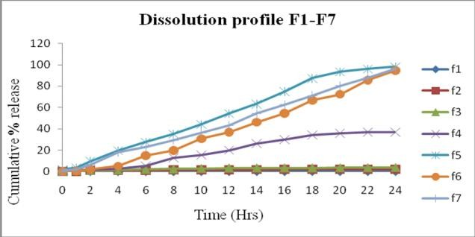

Table no. 04: Evaluation of tablet formulations

Parameter | F1 | F2 | F3 | F4 | F5 | F6 | F7
Uniformity of weight | Pass | Pass | Pass | Pass | Pass | Pass | Pass
Hardness (Kg/cm²) | 6.82 | 7.24 | 7.63 | 7.31 | 7.35 | 7.39 | 6.87
Thickness | 3.52 | 3.53 | 3.56 | 3.62 | 3.58 | 3.52 | 3.66
(mm)
Diameter | 6.51 | 6.50 | 6.52 | 6.51 | 6.50 | 6.49 | 6.50
(mm)
Friability (%) | 0.01 | 0.01 | 0.01 | 0.01 | 0.01 | 0.01 | 0.01
Drug Content (%) | 96.203 | 94.45 | 95.542 | 93.454 | 98.403 | 97.087 | 96.976

Table no. 05: Comparison of Cumulative % Drug release of optimized formulation with marketed SR tablet (Monit SR)

Time(Hrs) | Marketed SR tablet (Monit SR) | Optimized formulation (F5)
0 | 0 | 0
0.5 | 2.8 | 1.900
1 | 4.7 | 3.600
2 | 11.5 | 9.804
4 | 20.9 | 19.708
6 | 29.3 | 27.612
8 | 36.1 | 35.214
10 | 45.9 | 44.318
12 | 52.9 | 54.422
16 | 72.45 | 74.915
20 | 88.26 | 93.519
24 | 100.03 | 98.122

Fig. 02: Cumulative % drug release of optimized formulation and marketed product:
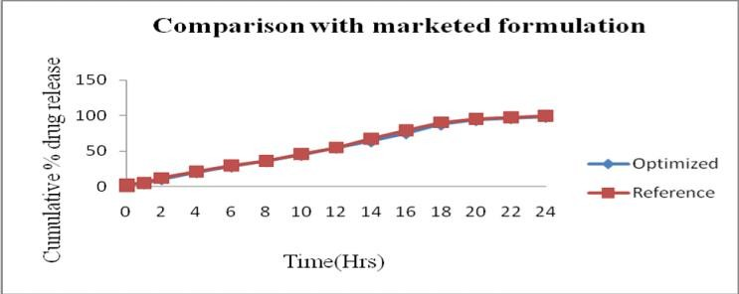

Table no. 06: Cumulative % Drug release in different dissolution medium (F5):

Time(Hrs) | 1.2N HCl | 4.5 pH Acetate Buffer | 6.8 pH Phosphate Buffer
0 | 0 | 0 | 0
0.5 | 1.67 | 1.91 | 1.900
1 | 3.45 | 3.58 | 3.600
2 | 9.8014 | 9.976 | 9.804
4 | 18.613 | 19.645 | 19.708
6 | 26.787 | 27.108 | 27.612
8 | 34.187 | 35.256 | 35.214
10 | 44.219 | 44.765 | 44.318
12 | 50.156 | 50.387 | 54.422
16 | 69.432 | 69.543 | 74.915
20 | 84.889 | 86.698 | 93.519
24 | 96.984 | 97.146 | 98.122

Fig. 03: Cumulative % drug release in different dissolution media
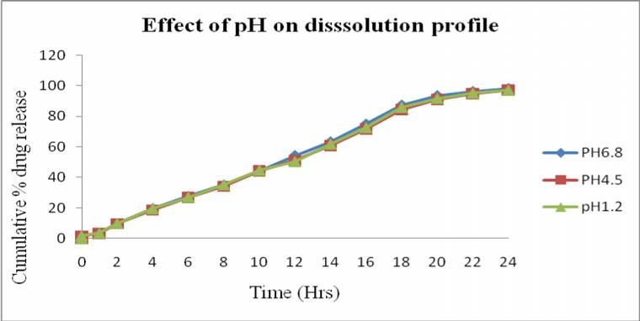

Table no. 07: Effect of level of pore former (PVP) on cumulative % drug release
Time(Hrs) | 0% PVP | 10% PVP | 25% PVP | 40% PVP | 55% PVP
0 | 0 | 0 | 0 | 0 | 0
0.5 | 0 | 0 | 0.789 | 1.053 | 1.900
1 | 0 | 0.0657 | 0.987 | 1.514 | 3.600
2 | 0 | 0.921 | 1.25 | 1.842 | 9.804
4 | 0 | 1.054 | 1.580 | 2.566 | 19.708
6 | 0 | 1.25 | 2.039 | 5.462 | 27.612
8 | 0 | 1.383 | 2.500 | 13.029 | 35.214
10 | 0 | 1.58 | 2.961 | 15.595 | 44.318
12 | 0.061 | 1.8004 | 3.422 | 20.004 | 54.422
16 | 0.064 | 1.908 | 3.553 | 30.007 | 74.915
20 | 0.066 | 2.039 | 3.619 | 35.797 | 93.519
24 | 0.066 | 2.106 | 3.685 | 36.916 | 98.122

Fig. 04: Cumulative % Drug release of different level of pore former (PVP)
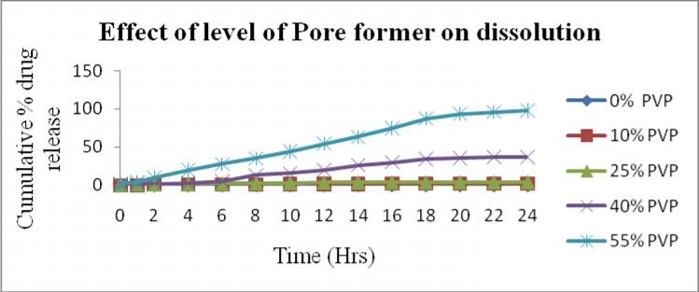

Table no 08: Cumulative % Drug release profile of different type of pore former:

Time(Hrs) | PVP(F5) | HPMC(F6) | PEG4000(F7)
0 | 0 | 0 | 0
0.5 | 1.900 | 0.066 | 1.053
1 | 3.600 | 0.789 | 2.303
2 | 9.804 | 2.237 | 6.580
4 | 19.708 | 5.198 | 17.964
6 | 27.612 | 15.003 | 23.189
8 | 35.214 | 19.872 | 29.283
10 | 44.318 | 30.796 | 36.389
12 | 54.422 | 37.048 | 43.365
16 | 74.915 | 54.420 | 62.842
20 | 93.519 | 72.318 | 80.367
24 | 98.122 | 94.684 | 96.455

Fig. 05: Cumulative % Drug release profile of different type of pore former
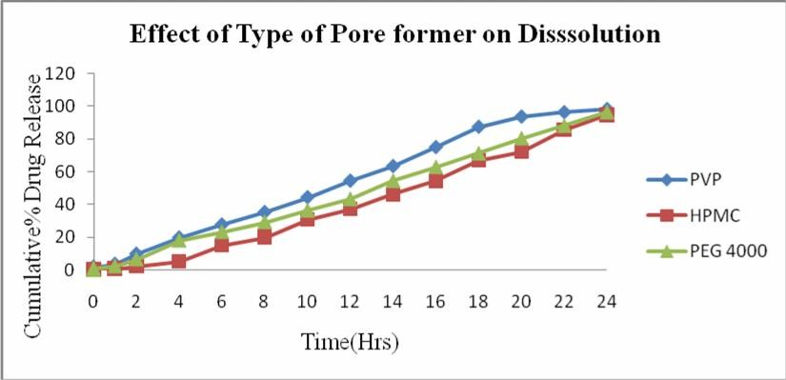

Table no. 09: Cumulative % Drug release profile of weight gain on optimized Formulation:
Time(hrs) | 3.533% | Weight gain | 5.733% Weight gain | 9.466% Weight gain
0 |  | 0 | 0 | 0
0.5 |  | 1.900 | 0.945 | 0.066
1 |  | 3.600 | 1.78 | 0.466
2 |  | 9.804 | 6.456 | 1.194
4 |  | 19.708 | 10.795 | 4.743
6 |  | 27.612 | 18.413 | 11.105
8 |  | 35.214 | 26.962 | 17.643
10 |  | 44.318 | 34.845 | 24.143
12 |  | 54.422 | 42.832 | 33.745
16 |  | 74.915 | 63.642 | 51.695
20 |  | 93.519 | 79.304 | 70.543
24 |  | 98.122 | 91.783 | 84.651

Fig. 06: Cumulative % Drug release profile of weight gain on optimized Formulation
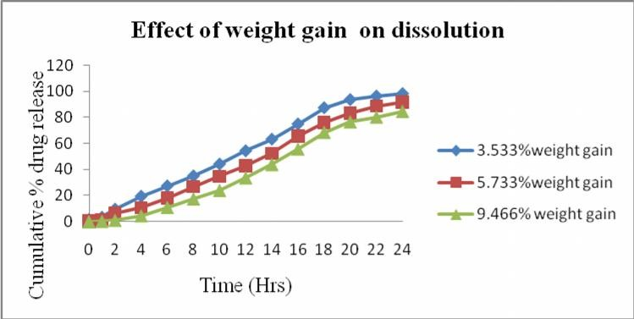
Table no. 10: Cumulative % Drug release profile of optimized formulation on agitational intensity

Time(Hrs) | 50 rpm | 100 rpm | 150 rpm
0 | 0 | 0 | 0
0.5 | 1.87 | 1.900 | 1.92
1 | 2.58 | 3.600 | 3.65
2 | 9.79 | 9.804 | 8.8114
4 | 18.6988 | 19.708 | 18.7143
6 | 27.604 | 27.612 | 26.343
8 | 35.208 | 35.214 | 34.367
10 | 43.311 | 44.318 | 43.456
12 | 49.145 | 54.422 | 49.543
16 | 69.86 | 74.915 | 68.004
20 | 84.456 | 93.519 | 84.689
24 | 96.045 | 98.122 | 96.174

Fig 07: Cumulative % Drug release profile of optimized formulation on agitational intensity
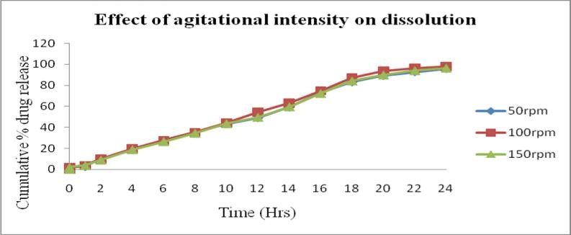

Kinetics of drug release
Label claim: 20 mg (F5 Formulation):
Zero Order kinetics (Cumulative % drug release Vs Time)

 | Table no. 11: Zero Order kinetics
S. No | Time(Hrs) | Cumulative %drug release
1 | 1 | 3.600
2 | 2 | 9.804
3 | 4 | 19.708
4 | 6 | 27.612
5 | 8 | 35.214
6 | 10 | 44.318
7 | 12 | 54.422
8 | 16 | 74.915
9 | 20 | 93.519
10 | 24 | 98.122

Fig. 08: Relationship between Cumulative % drug release Vs Time
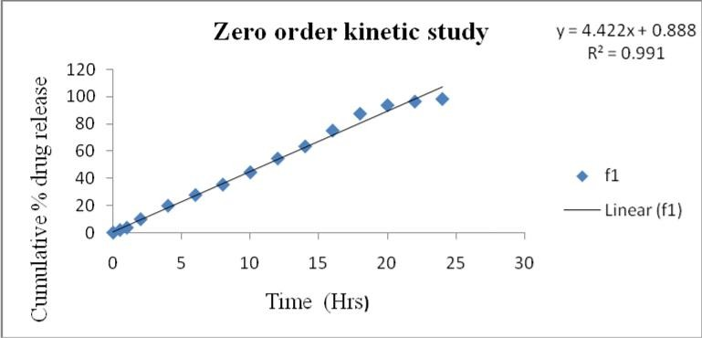

First Order Kinetics (Log Cumulative % drug remaining Vs Time
Table no. 12: First Order Kinetics
S. No: | Time(Hrs) | Cumulative% Drug Release | Cumulative % Drug retained | Log Cumulative %  retained | Drug
1 | 1 | 3.600 | 96.4 | 1.984
2 | 2 | 9.804 | 90.198 | 1.955
3 | 4 | 19.708 | 80.296 | 1.9046
4 | 6 | 27.612 | 72.394 | 1.859
5 | 8 | 35.214 | 64.793 | 1.8115
6 | 10 | 44.318 | 55.691 | 1.7457
7 | 12 | 54.422 | 49.589 | 1.6953
8 | 16 | 74.915 | 30.085 | 1.47835
9 | 20 | 93.519 | 14.481 | 1.160799
10 | 24 | 98.122 | 1.878 | 0.27369

Fig. 09: Relationship between log cumulative % drug retained Vs Time
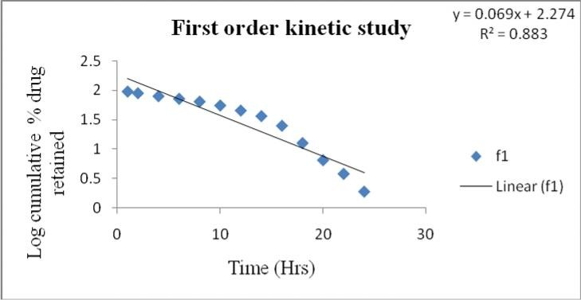

Higuchi Model (Cumulative % Drug release Vs SQRT)
Table no. 13: Higuchi Model Kinetics
S.No: | Time(Hrs) | SQRT | Cumulative %Drug release
1 | 1 | 1 | 3.600
2 | 2 | 1.4142 | 9.804
3 | 4 | 2 | 19.708
4 | 6 | 2.449 | 27.612
5 | 8 | 2.828 | 35.214
6 | 10 | 3.162 | 44.318
7 | 12 | 3.464 | 54.422
8 | 16 | 4 | 74.915
9 | 20 | 4.472 | 93.519
10 | 24 | 4.898 | 98.122

Fig. 10: Relationship between % drug release Vs SQRT
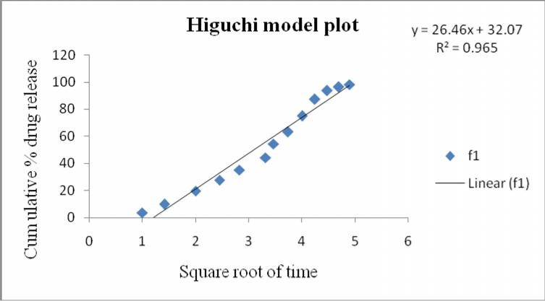

Hixson and Crowell Model Kinetics:
Table no. 14: Hixson and Crowell Model Kinetics
S.No. | Time(hrs) | Cumulative % drug release | Cumulative%  remaining | drug | Cube root
1 | 1 | 3.600 | 96.4 |  | 4.585
2 | 2 | 9.804 | 90.198 |  | 4.4846
3 | 4 | 19.708 | 80.296 |  | 4.3141
4 | 6 | 27.612 | 72.394 |  | 4.167
5 | 8 | 35.214 | 64.793 |  | 4.0164
6 | 10 | 44.318 | 55.691 |  | 3.8188
7 | 12 | 54.422 | 49.589 |  | 3.5723
8 | 16 | 74.915 | 30.085 |  | 2.9273
9 | 20 | 93.519 | 14.481 |  | 1.8644
10 | 24 | 98.122 | 1.878 |  | 1.2337

Fig. 11: Relationship between Cube root of Cumulative % drug retained Vs Time
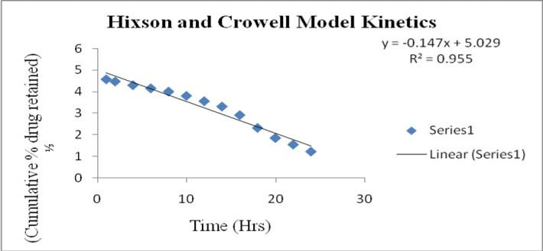

Korsmeyer and Peppas Model Kinetics

Table no. 15: Korsmeyer and Peppas Model Kinetics
S.No. | Time(Hrs) | Log Time | Cumulative % Drug release | Log Cumulative % Drug release
1 | 1 | 0 | 3.600 | 0.5563
2 | 2 | 0.3010 | 9.804 | 0.9913
3 | 4 | 0.6020 | 19.708 | 1.2945
4 | 6 | 0.778 | 27.612 | 1.4410
5 | 8 | 0.9030 | 35.214 | 1.5466
6 | 10 | 1 | 44.318 | 1.6464
7 | 12 | 1.079 | 54.422 | 1.7356
8 | 16 | 1.2041 | 74.915 | 1.8745
9 | 20 | 1.3010 | 93.519 | 1.9708
10 | 24 | 1.3802 | 98.122 | 1.9917

Fig. 12: Relationship between Log Cumulative %Drug Release Vs Log time
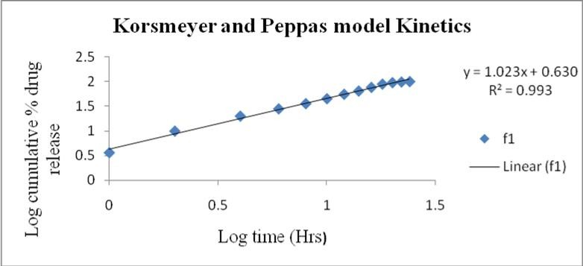

Linearity of Kinetics Models

Table no. 16: Linearity of Kinetics Models S.No. Kinetics Models R²
- Zero Order Kinetics 0.991
- First Order Kinetics 0.883
- Higuchi Model 0.965
- Hixson and Crowell Model 0.955
5 Korseny and Peppas Model 0.993

Stability studies
The fabricated sustained release optimized formulation (F5) was subjected to stability studies at
25º/60% RH and 40º/27% RH for 30 days. The product was evaluated for drug compatibility, drug content and drug release. The results were given in table no: 31, 33 and 34

Storage Condition at 40ºC ± 2ºC/ 75% RH ± 5%:
- Description:

Table no. 17: Description of drug
Test | Observation | Inference
Description(Colour change) | No colour change | Complies with the stability condition

- Dissolution data:
Table no. 18: Cumulative % drug release of stability samples stored at accelerated condition:
Time(Hrs) | Initial | (0 days) | 30 days | 60 days
1 |  | 3.600 | 3.66 | 2.599
2 |  | 9.804 | 6.76 | 6.068
4 |  | 19.708 | 18.702 | 17.287
6 |  | 27.612 | 25.599 | 25.087
8 |  | 35.214 | 33.184 | 34.086
10 |  | 44.318 | 42.264 | 41.169
12 |  | 54.422 | 53.414 | 53.285
16 |  | 74.915 | 72.908 | 71.869
20 |  | 93.519 | 92.458 | 91.175
24 |  | 98.122 | 96.098 | 96.99

Fig. 13: Cumulative % drug release of sample at accelerated condition
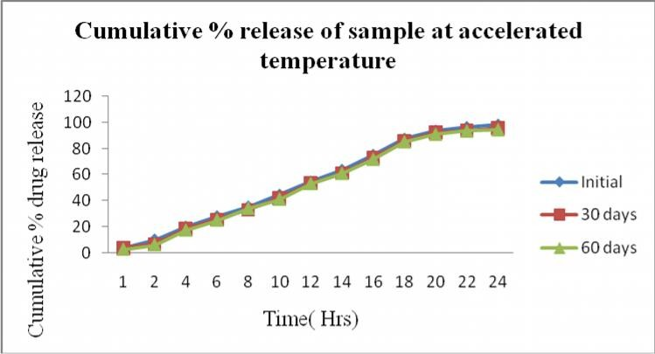

Room Temperature (25ºC ± 2ºC/60% RH ± 5%)
- Description

Table no. 19: Description of drug
Test | Observation | Inference
Description (Colour change) | No colour change | Complies with the stability condition

- Dissolution data:
Table no. 20: Cumulative % drug release of stability of samples stored at room temperature
Time(Hrs) | Initial (0 days) | 30 days | 60 days
1 | 3.600 | 3.64 | 3.554
2 | 9.804 | 9.812 | 9.668
4 | 19.708 | 19.706 | 19.678
6 | 27.612 | 27.609 | 27.487
8 | 35.214 | 35.221 | 35.195
10 | 44.318 | 44.326 | 44.207
12 | 54.422 | 54.206 | 54.167
16 | 74.915 | 74.918 | 73.995
20 | 93.519 | 93.499 | 92.784
24 98.122 98.007 97.873

Fig. 14: Cumulative % drug release of sample at room temperature:
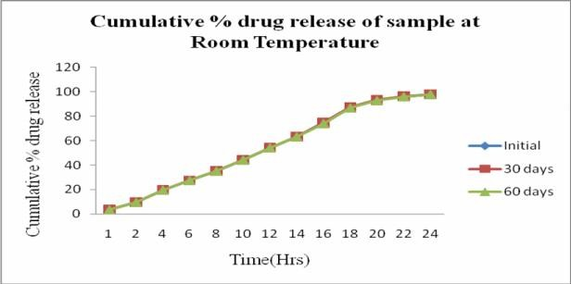

Drug Content:

Table No. 21: Drug Content
Room Temperature Accelerated Temperature

Initial 30 Days 60days Initial 30 Days 60 Days
98.403 96.203 94.450 98.403 95.542 93.454

Fig. 15: Drug content
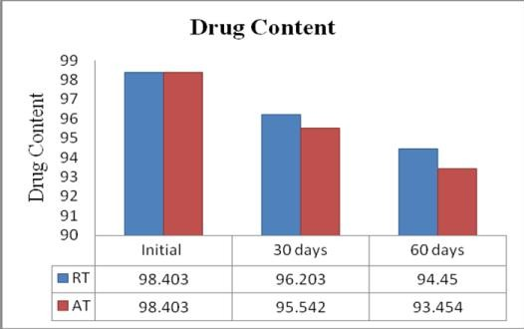

Summary and conclusion
The present work have been made to formulate sustained release tablet of Isosorbide -5-Mononitrate based on porous membrane osmotic technology by using Sodium chloride as osmogent and different formulation variables. Isosorbide Mononitrate which is preferably used as anti anginal drug for the treatment of stable and unstable angina pectoris , acute myocardial infarction and heart failure. In the present study, an attempt was made to formulate 20mg sustained release tablet which can provide effective drug release for 24hrs. Sustained release tablets of Isosorbide Mononitrate were prepared by wet granulation technique. In vitro studies showed formulation F5 was well suited to be sustained release formulation. The coating solutions were prepared by using various polymers and pore formers, meets all the ideal characteristics to formulate in the form of sustained release drug delivery system. Under pre formulation study, the organoleptic properties were complied with the BP specification. Physical properties such as bulk density and tapped density were more in case of granules ready for compression than that of Isosorbide-5 Mononitrate raw powder. The compatibility evaluation was performed by FT-IR spectroscopy analysis. The study implies that the drug and polymers were compatible with each other. There were no interactions found between the drug and the polymers.F5 formulation was optimized as it complied with all the pharmacopoeial specifications. The physical parameters like thickness, diameter, hardness, friability, weight variations were carried out. The assay was carried out for optimized formulation and the result was found to be 98.403%. The drug release from the developed formulations was independent of pH and agitational intensity of the release media. It was found that the drug release increases with increasing the level of pore former (PVP), the membrane became more porous after coming in contact with the aqueous environment. The drug release was found to decrease with the increase in the weight gain of the membrane. The drug release was found to be more with PVP than with HPMC, Ethyl Cellulose and PEG4000. The similarity factor f2 was applied between the dissolution profile of optimized batch and the theoretical dissolution profile, which also indicate a decent similarity between both dissolution profiles. Stability studies were carried out by keeping the Sustained release tablets at room temperature (25ºC ± 2ºC/ 60% ± 5% RH) and at accelerated temperature (40ºC ± 2ºC/ 75% ± 5% RH) in stability chamber for 60 days. The result of stability studies conducted on F5 revealed no change in physical appearance, drug content and in vitro dissolution profile, hence F5 formulation was found to be stable at tested
temperature. Finally the drug release from the selected formulation (F5) fitted well in the Zero order kinetics. From the results obtained, it can be concluded that formulation F5 has achieved the objectives of sustained drug release, patient convenience and cost effectiveness as a single daily dose of the drug. It could be concluded that sustained release tablet may be formulated by employing osmotic technology.

Acknowledgement
Authors are thankful to Prof.(Dr.) B.Jayakar, principal Vinayaka missions college of pharmacy, Salem,Tamilnadu and providing all the facilities for this research Project.

References
- Ming-Thau Sheu, Chun-Yu Wang, Hsiu-O Ho, Ling-Hong Lin, Ying-Ku Lin. Asymmetric membrane capsules for delivery of poorly water- soluble drugs by osmotic effects. Int. J. Pharm. 2005; 297: 89-97.
- Shailesh Sharma. Osmotic controlled drug delivery. Pharmainfo.net. 2008; 6(3).
- Toshiaki Nagakura, Ken Ishihara, Toshiyuki Furukawa, Kohji Masuda, Takao Tsuda. Auto- regulated Osmotic pump for insulin therapy by sensing glucose concentration without energy supply. Sensors and Actuators B. 1996; 34: 229- 233.
- Kazuto Okimoto, Roger A. Rajewski, and Valentino J. Stella. Release of testosterone from an osmotic pump tablet utilizing (SBE)7m-β- cyclodextrin as both a solubilizing and an osmotic pump agent J. Control. Rel. 1999; 58: 29-38.
- Giancarlo Santus, Richard Baker W. Osmotic drug Delivery: a review of the patent literature. J Control. Rel. 1995; 35: 1-21.
- Aulton M. E. Pharmaceutics The Science of Dosage form Design. Churchill Livingstone Press Elsevier. Third edition, 2007; pp.461.
- M. C. Gohel, Parikh .R.K, Shah. N.Y. Osmotic Drug Delivery: An Update. Pharma info.net. 2009; 7: 2.
- Thadani, U., Bittar, N. Effects of 8:00 A.M. and 2:00 P.M. doses of isosorbide-5 mononitrate during twice-daily therapy in stable angina pectoris. Am. J. Cardiol. 70, 286–292.
- Ricardo Seabra-Gomes, Arvind K. Bansal, Satish K Nachaegari. Co processed Excipients for Solid

Dosage Forms. Pharmaceutical Technology.
January 1990; 52-64.
- Hennings.M, Chrysant SG, Glasser SP, Bittar N, et al. Efficacy and safety of extended-release isosorbide mononitrate for stable effort angina pectoris. Am J Cardiol. 1991; 72: 1249- 1256.
- Thadani, U., Bittar, N., 1992. Effects of 8:00
A.M. and 2:00 P.M. doses of isosorbide-5 mononitrate during twice-daily therapy in stable angina pectoris. Am. J. Cardiol. 70, 286–292.
- Chen. Nyberg G. Current status of isosorbide-5- mononitrate therapy in chronic stable angina pectoris. Am J Ther: 1998; 1:93-101.
- Gunasekara, N.S., Noble, S., 1999. Isosorbide 5- mononitrate: a review of a sustained-release formulation (Imdur) in stable angina pectoris. Drugs 57, 261–277.
- Zwidermann M, V. Hutt, R. Bonn, E. Fritschi, H. Jaeger, Pharmacokinetics of isosorbide dinitrate and isosorbide-5- mononitrate, Int. J. Clin. Pharmacol. Ther. Toxicol. 27 (1989) 445–453.
- Verma, R.K., Garg, S., 2002. A validated high performance liquid chromatographic method for
analysis of Isosorbide Mononitrate in bulk material and extended release formulations. J. Pharm. Biomed. Anal. 30, 583–591.
- Raymond C.Rowe, PaulJ.Shekey , Weller P.J , Hand book of Pharmaceutical excipients, 4th edition . American Pharmaceutical Association Wasington D.C and Royal Pharmaceutical press (2003)
- Kenneth E.Avis , Herbert A. Lieberman and Leon Lachman , “Pharmaceutical Dosage Form”, Tablet. Vol 1 Chapter 3-4.
- European Pharmacopoeia:-1845;BP- 2549
- Vinod P.Shah , Yi Tsong, Pradeep Sathe and Roger L. Williams, Dissolution Profile Comparison using similarity factors, f2 , Office of Pharmaceutical Sciences, Centre for Drug Evaluation and Research Food And Drug Administration , Rockville, MD.
- International Conference on Harmonization Guidelines on validation of Analytical Procedures, definition and terminology federal register march1,1995.

