
Research Article

Available Online at: www.ijpir.com

International Journal of Pharmacy and Industrial Research

ISSN
Print 2231 – 3648
Online 2231 – 3656

DOCKING STUDY AND DESIGNING OF ANTIASTHMATIC DRUG USING sPLA2 AS A THERAPEUTIC TARGET PROTEIN
*Shikha Khandelwal, Aradhana Khare, SM Paul Khurana
Amity University, Haryana, Manesar, Gurgaon, India

Abstract
Asthma is a complex disease of the respiratory tract characterized by allergen-induced breathlessness that is, orchestrated by the interaction of immune, inflammatory, and resident lung cells which is controlled by number of target proteins. In this work sPLA2 is selected as potential target as it is expressed at the highest levels in airways of asthmatics. Attempt has been made to design a drug against this target protein. The homology modeling of sPLA2 protein, ligand designing and drug validation studies done by using bioinformatics tools and softwares. The result indicates that the designed ligand molecule 2(R) – 2 hydroxyl – 3 [(3-vinylbenzyl) oxy] propanamide possess non mutagenic, non tumerogenic, non irritant properties and could be a promising drug target for the disease asthma showing valid drug likeness score and negative gibbs free energy.
Keywords: sPLA2, Asthma, Drug Design, Homology Modelling, Docking

Introduction
Asthma is a chronic inflammatory disease of the respiratory system that affects about 300 million people worldwide, a total that is expected to rise to about 400 million over the next 15—20 years. In this disease the airway occasionally constricts, becomes inflamed, and is lined with excessive amounts of mucus, often in response to one or more triggers. The chronic inflammation is associated with airway hyper responsiveness that leads to recurrent episodes of wheezing, breathlessness, chest tightness and coughing particularly at night or in the early morning. These episodes may be triggered by exposure to an environmental stimulant (allergen), cold air, warm air, moist air, exercise or exertion, or emotional stress¹. Asthma may also be classified as atopic
(extrinsic) or non-atopic (intrinsic). Genetic mapping studies have demonstrated that one or more asthma susceptibility genes are located on chromosome 5q31-q33 in humans^{2,} ³. This chromosomal region contains a cytokine gene cluster that may potentially play a role in airway inflammation associated with atopic asthma. Interleukin (IL)-9, a Th2-type cytokine, is one of these cytokines and has been suggested as a candidate gene for asthma^{4,} ⁵. In the recent studies, a relationship between airway inflammation, Uteroglobin-related protein 1 (UGRP1) expression, (a secretory protein of 10 kDa that is highly expressed in epithelial cells of airways
i.e. the trachea, bronchus, and bronchioles ⁶) and interleukin-9 (IL-9), an asthma candidate gene, was evaluated by using a murine model of allergic

Author for Correspondence:
*Shikha Khandelwal,
Amity University, Haryana, Manesar, Gurgaon, India Email: writein.shikha@gmail.com

bronchial asthma. These studies showed that the UGRP1 is down regulated in inflamed airways, such as allergic asthmatics, and IL-9 might be an important mediator for modulating UGRP1 expression. Although the functional roles of UGRP1 in airway physiology are not understood. However, the following three lines of evidence suggest a possible involvement of UGRP1 in the pathogenesis of asthma: i) high levels of expression in lungs, ii) amino acid sequence similarities to uteroglobin (also called Clara cell secretory protein; CCSP), which is known as a regulator of airway inflammation^{7,8}, and
iii) chromosomal location of the human UGRP1 gene at 5q31-q32 ⁹, the region that has been assigned as one of asthma susceptibility loci¹⁰. Soluble phospholipase A₂ (sPLA₂) was suggested as a target protein for uteroglobin/CCSP that can inhibit sPLA₂ activity, resulting in an anti-inflammatory effect. As, UGRP1 has sequence and functional similarity to the uteroglobin/CCSP that is also secreted by the epithelial cells in airways. Therefore, it is possible that UGRP1 is able to inhibit sPLA₂ activity. Recent studies proved that sPLA2 groups V and X were differentially expressed in asthmatic subjects compared to non-asthmatic controls. Of the two sPLA2 enzymes, only sPLA2-X was over expressed in asthmatics relative to controls¹¹. Thus, sPLA2s are attractive therapeutic targets because these enzymes may be preferentially involved in the production of pro-inflammatory AA metabolites that are key for asthma immunopathogenesis¹². In this study a drug has been designed against the sPLA2 as a target protein using in silico approach.

Methodology
Homology modelling and model optimization The three dimensional structure of selected sPLA2 protein was not available in PDB Database (www.rcsb.org/pdb), hence, it is important to determine its three dimensional structure. Sequence of sPLA2 protein was retrieved from NCBI database (http://www.ncbi.nlm.nih.gov/) with ID: NP_003552 and performed NCBI BLAST (http://blast.ncbi.nlm
.nih.gov/Blast.cgi) for homology searching. Chain A Carboxylic Ester Hydrolase protein (PDB ID: 1LE6 A) was found to be much similar and used as template for homology modeling. The modeling was carried out using MODELLER 9V7
(http://www.salilab.org/modeller/). The target and template sequences were aligned and used to generate 3D structure of sPLA2 protein. Generated model was then undergo the process of loop refinement, model optimization and evaluation using Ramachandran plot and PROCHECK¹³ Program of Structural Analysis and Verification Server (SAVES) for the protein stability. After final analysis and validation process the best model was selected with maximum core value and zero bad contacts.

Active site prediction
After the selection of final protein model, the possible active sites were identified using LIGSITE¹⁴.

Virtual screening and designing of ligand molecule
Lead molecule was screened on the basis of already existing drugs of asthma and ligand molecules were generated from lead molecule using LIGBUILDER¹⁵.

Optimization and docking of ligand molecule
The generated ligand molecules were analyzed for drug relevant properties using online tools named OSIRIS property explorer, Molsoft LLC, and Molinspiration cheminformatics and finally better quality ligand molecule was taken for further docking study. The docking of ligand molecule to the active site of the sPLA2 protein was performed using QUANTUM 3.3 software¹⁶ to find out the value of Gibbs free energy.

Result and discussion
The sPLA2 protein sequence was retrieved from NCBI database and was found to contain 163 amino acids. The similarity searching was performed by NCBI BLAST against PDB, the protein from 43-165 sequence was found to be 100% homologous to 1-
123 amino acids of chain A Carboxylic Ester Hydrolase protein, which was taken as the template for homology modeling. The models which were generated using MODELLER 9V7, often contain unfavourable bond length, bond angles and bad contacts. Therefore it was essential to minimize the energy to regularise local bond and angle as well as to remove bad contacts. These models was optimized and verified by Ramachandran plot with the help of Swiss pdb viewer (energy minimization and build

loop formation) and then by PROCHECK program. The final model (Figure 1) selected was having 97.1% of the residues in the core region with zero bad contacts. (Table 1a and 1b).
The total energy of model protein was found to be - 4614.343Kj/mol initially, but after energy minimization it came down to -5180.187 Kj/mol.

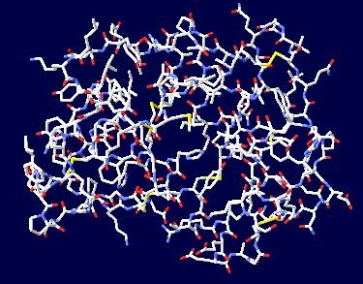

Figure 01: Selected Modeled sPLA2 protein structure

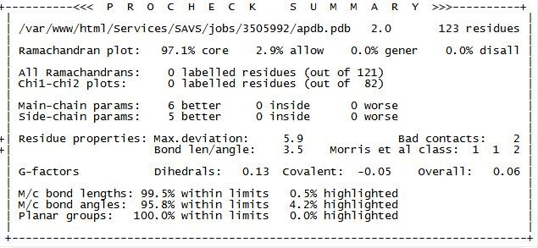
Table 1a: Procheck summary of the selected model of sPLA2 protein before energy minimization and loop build formation

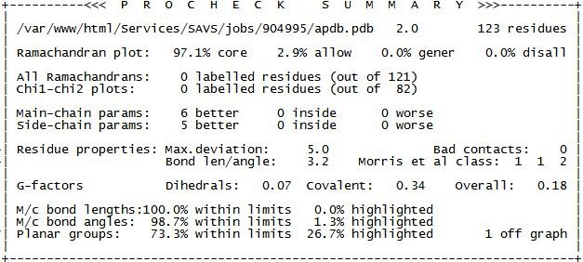

Table 1b: Procheck summary of the selected model of sPLA2 protein after energy minimization and loop build formation.

For the final model of sPLA2 protein, the active sites were identified using LIGSITE. Three possible sites were obtained and PKT 138 was chosen as the most biologically favorable site for the docking study (Figure 2). The minimum distance between the
residue to the active site position was identified which is important to dock lead molecule in the active site position of the target molecule.

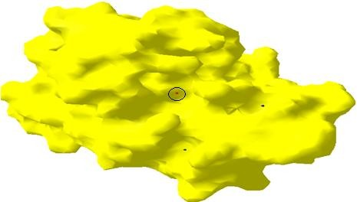

Figure 02: sPLA2 protein structure showing three active sites. Most favorable active site is red in colour.

Now on the basis of already existing drugs of asthma, Pyrrolidine was chosen as a lead molecule. After this, the rigid docking was performed using HEX 4.5 in which the lead molecule was docked with the target molecule to the minimum distance residue to the active site position. Using the coordinates
information of the lead molecule, the ligand molecules were generated using LIGBUILDER. Out of generated molecules, the best ligand molecule was selected on the basis of parachor value and drug likeness properties. As parachor value is an additive and constitutive molecular parameter which appears

to be important in the passage of the drug molecule from the site of administration or synthesis to the site of action.

The selected ligand molecule named as 2(R) – 2 hydroxyl – 3 [(3-vinylbenzyl) oxy] propanamide shows 496.2 cm³ parachor value (Figure 3) and has lipophilic behavior according to Log P value (0.4) (Figure 4) and is found to be hydrophobic in nature
which is a major determinant of drug likeness. On the other hand, the ligand molecule is also following physiochemical and biological parameters of Lipinski’s rule of five which states that in general, an orally active drug should have not more than 5 hydrogen bond donors, not more than 10 hydrogen bond acceptors, molecular weight from 160-480, lop P less than 5, molar refractivity from 40-130.

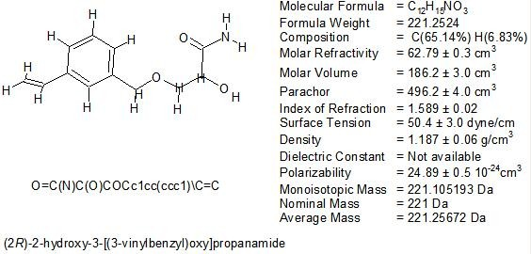

Figure 03: Structure of the ligand molecule with their physiochemical properties.
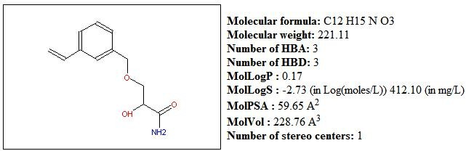

Figure 04: Diagram showing Molecular properties of the ligand molecule.

The data given in Figure 5 shows drug likeness score
-1.06 which falls in the suitable range of -12 to 8
which shows the overall potential of the selected ligand molecule to qualify for a drug.

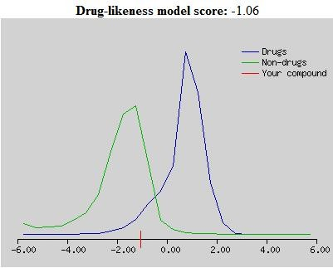

Figure 05: Diagram showing drug Likeness Score of the Ligand molecule

To understand the interaction between target protein and ligand molecule (Figure 6), flexible docking was performed using QUANTUM 3.3. The ligand molecule was attached at the suitable active site of the protein molecule showing -20.19 Kj Gibbs free
energy which is another major criterion for the selection of a drug molecule as negative and low docking energy indicate strong favourable bonds indicating ligand molecule in its most favourable conformation.

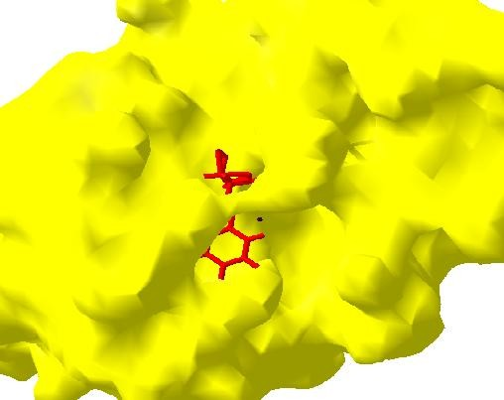

Figure 06: View of molecular surface of sPLA2 protein docked with Ligand molecule (red).

Conclusion
sPLA2 protein is supposed to be most potent drug target for asthma disease. In this work, an attempt has been made to design a three dimensional structure of sPLA2 protein on the basis of homology modeling using MODELLER 8V1 software. The most reliable and stable structure was selected by energy minimization and loop build formation using Ramachandran plot and PROCHECK program. The ligand molecule was designed by LIGBUILDER and assessed by Parachor value and ADMET properties
of drug. Docking of this ligand molecule with target protein shows negative Gibbs free energy which is a favourable condition for solubility in aqueous carrier solution. As this drug molecule shows good drug likeness and drug score with no violation to the Lipinski’s rule of five, therefore, it could be treated as potential drug for treating asthma disease.

Acknowledgement
We acknowledge this work to everyone who rendered us support throughout and made this study successful.

References
- Kay AB, Asthma and inflammation. J Allergy Clin Immunol. 1991 87: 893–910
- Collaborative Study on the Genetics of Asthma. A genome-wide search for asthma susceptibility loci in ethnically diverse populations. Nat Genet. 1997 15: 389–392
- Postma DS et al. Genetic susceptibility to asthma– bronchial hyper responsiveness coinherited with a major gene for atopy.N Engl J Med. 1995 333: 894–900
- Doull IJ et al. Allelic association of gene markers on chromosomes 5q and 11q with atopy and bronchial hyperresponsiveness. Am J Respir Crit Care Med. 1996 153: 1280–1284
- Nicolaides et al. Interleukin 9: a candidate gene for asthma. Proc Natl Acad Sci USA. 1997 94: 13175–13180
- Niimi et al. UGRP1, a uteroglobin/Clara cell secretory protein -relatedprotein, is a novel lung- enriched downstream target gene for the T/EBP/ NKX2.1 homeodomain transcription factor. Mol Endocrinol. 2001 15: 2021– 2036
- Mukherjee AB et al. Uteroglobin: a novel cytokine? Cell Mol Life Sci. 1999 55: 771–787
- Singh G & Katyal SL. Am J Respir Cell Mol Biol. 1997 17: 141–143
- Niimi T et al. A polymorphism in the human UGRP1 gene promoter that regulates transcription is associated with an increased risk of asthma.Am J Hum Genet. 2002 70: 718–725
- Postma DS et al. Genetic susceptibility to asthma– bronchial hyper responsiveness coinherited with a major gene for atopy. N Engl J Med. 1995 333: 894–900
- Boilard E et al. Secreted phospholipase A2 inhibitors are also potent blockers of binding to the M-type receptor. Biochemistry. 2006 45:13203-18.
- Triggiani M et al. Secretory phospholipases A2 in inflammatory and allergic diseases: not just enzymes. J Allergy Clin Immunol. 2005 116:1000–1006.
- Laskowski RA et al. PROCHECK - a program to check the stereochemical quality of protein structures. J. App. Cryst. 1993 26: 283-291
- Hendlich M et al.J LIGSITE: automatic and efficient detection of potential small molecule- binding sites in proteins. Mol Graph Model. 1997 15:359-63
- Yuan, YX et al. LigBuilder 2: A Practical de Novo Drug Design Approach. J Chem Inf Model 2011 51, 1083.
- Gao J & Truhlar DG. Quantum mechanical methods for enzyme kinetics. Annu. ReV. Phys.Chem.2002.53:467-505.

