Research Article

Available Online at: www.ijpir.com

International Journal of Pharmacy and Industrial Research

ISSN
Print 2231 – 3648
Online 2231 – 3656

FORMULATION AND EVALUATION OF IMMEDIATE RELEASE BILAYER TABLETS OF TELMISARTAN AND
AMLODIPINE BESYLATE

*Rajalakshmi.R, SenthilKumar.M, Valarmathi.S
Annai Veilankanni’s Pharmacy College, Chennai, TamilNadu, India - 600015.

Abstract
The main objective of this combination therapy is to develop a stable formulation of antihypertensive drugs of Telmisartan and Amlodipine Besylate as an immediate release bilayer tablet and evaluate their pre-compression and post-compression parameters. The FT-IR studies were also conducted and was found to have no interaction between drug and the excipients. The formulation of the developed work was initiated with wet granulation method for Telmisartan and direct compression for Amlodipine Besylate. Microcrystalline cellulose pH102 and mannitol were used as diluents. polyvinyl pyrolidone K30 in isopropyl alcohol was used as the binder. The sodium starch glycolate (SSG) was used as the disintegrant. Magnesium stearate and purified talc were used as lubricants. The prepared granules were compressed by a double-rotary compression machine. Thus, the tablets formulated with higher concentrations of SSG around 16% in F-9 formulation showed satisfactory physical parameters and was found to be stable. Invitro dissolution was carried out using USP dissolution apparatus type 2 (paddle) by using HPLC method. The optimized formulation F-9 had 96.68% of drug release for telmisartan layer and 95.73% drug release for amlodipine layer. The stability studies for optimized batches were carried out at 30 and 60 days and was found to be stable. The results suggest the feasibility of developing bilayer tablets with two drugs Telmisartan and Amlodipine Besylate for the convenience of patients with severe hypertension, especially when monotherapy fails to control the blood pressure.

Keywords: Bilayer tablet, Telmisartan, Amlodipine Besylate, immediate release.

Introduction
Hypertension has emerged as a major public health problem worldwide. If hypertension is

not controlled, it may lead to heart attack, brain stroke or kidney damage. Hence there is

Author for Correspondence:
Rajalakshmi.R,
Annai Veilankanni’s Pharmacy College, Chennai, TamilNadu, India - 600015.
Email: rlakshmi.pharma@gmail.com

a need to develop proper medications that would control hypertension for a longer period of time¹. Combination therapy is often recommended for the treatment of patients with severe hypertension². Normal blood pressure at rest is within the range of 100-140mmHg systolic and 60-90mmHg diastolic. High blood pressure is said to be present if it is persistently at or above 140/90mmHg. There are many factors causing hypertension, some of them occur due to heredity, gender (more affected in males than females), obesity, age (especially in elder persons which may due to hardening of arteries or atherosclerosis), sodium salt sensitivity, alcohol use and physical inactivity³.
Immediate - release dosage forms allows the drug to dissolve in the gastrointestinal contents, with no intention of delaying or prolonging the dissolution or absorption of the drug⁴. These dosage forms usually release (dissolve/disperse) the drug in a single action, which means the drug is released initially very quickly and then passes through the mucosal membrane into the body, reaching the highest plasma level in a comparatively short time. Their advantages are releases the drug immediately, more flexibility in adjusting the dose, no dose dumping problem and can be used in initial and final stages of disease.
Bilayer tablets usually consists of two layers one is immediate release layer and the other is sustained/controlled release layer. But in this formulation the second layer also designed to release the drug immediately⁵. Bilayer tablets are suitable for sequential release of two drugs in combination and separate two incompatible substances.
Telmisartan is a potent, long lasting, nonpeptide antagonist of angiotensin II (AT₁) receptor blocker (ARB), which is indicated for the treatment of hypertension⁶. It blocks the vasoconstrictor and aldosterone - secreting effects of angiotensin II. It is practically insoluble in water and soluble in strong base⁷. It has the longest half-life of any ARB (24 hours). It is also used to treat congestive heart failure and prevent strokes, heart attacks and kidney damage due to diabetes.
Amlodipine Besylate is a long - acting calcium channel blocker used in the treatment of
chronic stable angina, vasospastic angina and hypertension. It is a prototype second generation dihydropyridine calcium channel blocker⁶. It is sparingly soluble in water and have longer duration of action⁸. It inhibits calcium ion influx across the cell membranes selectively with a greater effect on vascular smooth muscle cells than on cardiac muscle cells. Serum calcium concentration is not affected by amlodipine. It has a half-life of 30-
50 hours. It is used in combination with other antihypertensives or antianginals.

Materials and methods
Telmisartan, AmlodipineBesylate, microcrystalline cellulose pH102 (MCC pH102), sodium starch glycolate (SSG), colloidal silicon dioxide, disodium phosphate, dicalcium phosphate anhydrous, mannitol, poloxamer 188, polyvinylpyrolidone K30 (PVP K30), magnesium stearate, purified talc, ponceau 4R lake, isopropyl alcohol, insta coat and methylene chloride.

Manufacturing process of granules

Telmisartan Layer:
Weighed quantity of telmisartan, microcrystalline cellulose, SSG, disodium phosphate, poloxamer 188, mannitol were sifted through #30 mesh sieve and mixed for 10 minutes. The binder solution containing PVP K30 in isopropyl alcohol was added slowly and granulated. The granules are air dried for 10 minutes and then passed through #20 mesh sieve and was finally dried at 65ºC. The lubricants magnesium stearate, talc, SSG, MCC pH102 was added and mixed well for 10 minutes and collected for compression.

Amlodipine besylate Layer:
Weighed quantity of amlodipine besylate, dicalcium phosphate anhydrous, MCC pH102, SSG, colloidal silicon dioxide, ponceau 4R lake and magnesium stearate were sifted through #30 mesh sieve. Amlodipine and MCC pH102 were geometrically mixed in the 1:1 ratio. The other ingredients were mixed with the above mixture in a hexagonal blender for 4hours and collected for compression.

Compression of bilayer tablet:
Specified amount of telmisartan granules was compressed lightly first and then amlodipine granules was placed on it and again compressed using a double rotary compression machine with a punch size of 13/32 inch standard concave circular shape with plain surface. Totally nine formulations were prepared with varying concentrations of SSG and magnesium stearate.
These values are given in the Table no. 1 and 2.

Evaluation tests

Pre-compression parameters¹⁰:
The granules of telmisartan and amlodipine were evaluated for its bulk density, tapped density, carr’s index, hausner’s ratio and angle of repose were evaluated.
Their results are tabulated in Table no: 3 and 4.

Bulk Density
Bulk density is the ratio of the mass of the powder to the bulk volume it occupies. It is expressed in gm/ml. Ten grams of granules was transferred into a 50 ml measuring cylinder without tapping, during transfer the volume occupied by granules was measured.

Bulk density was measured by using formula. ρ_{b} = W/V_{b}

Where,
ρ_{b} = Bulk density,
W = Mass of the blend, V_{b} = Untapped Volume

Tapped Density
Ten grams of granules was taken into graduated cylinder, volume occupied by granules was noted down. Then cylinder was subjected to 500 taps in tapped density tester (Electro Lab USP II).

The percentage volume variation was calculated by the following formula.

It is expressed in gm/ml.
ρ_{t} = m/V_{i}

Where,
ρ_{t} = Tapped density,
m = Mass of the blend, V_{i} = Tapped volume

Carr’s Index
Compressibility is the ability of powder to decrease in volume under pressure. Using untapped volume and tapped volume the percentage compressibility of granules were determined, which is given as carr’s index.

CI = V_{i}-V₀ / V_{i} × 100
Where,
CI = Carr’s index, V_{o} = Bulk density, Vi = Tapped density

Hausner’s Ratio
It is measurement of frictional resistance of the drug. It was determined by the ratio of tapped density and bulk density.
Hausner Ratio = V_{i}/V_{o}

Where,
Vo = Bulk density, V_{i} = Tapped density

Angle of repose
Angle of repose (θ) is the maximum angle between the surface of a pile of powder and horizontal plane. It is usually determined by fixed funnel method and is the measure of flow ability of the powder or granules.

θ = tan ⁻¹(h/r)

Where,
θ = Angle of repose,
h = height of heap of pile, r = radius of base of pile.

Table no. 01: Formulation of Telmisartan immediate release granules

Ingredients F-1
 | mg/tab | mg/tab | mg/tab | mg/tab | mg/tab | mg/tab | mg/tab | mg/tab
Telmisartan | 40.00 | 40.00 | 40.00 | 40.00 | 40.00 | 40.00 | 40.00 | 40.00 | 40.00
Disodium Phosphate | 40.00 | 40.00 | 40.00 | 20.00 | 20.00 | 29.60 | 28.76 | 23.16 | 21.76
Microcrystalline Cellulose | 101.52 | 117.60 | 100.80 | 136.60 | 133.80 | 120.00 | 120.00 | 120.00 | 120.00
Mannitol | 80.00 | 60.00 | 60.00 | 40.00 | 40.00 | 40.00 | 40.00 | 40.00 | 40.00
Sodium Starch Glycolate | - | 5.60 | 11.20 | 14.00 | 14.00 | 15.40 | 15.40 | 16.80 | 16.80
Polaxamer 188 | 2.80 | 2.80 | 2.80 | 2.80 | 4.20 | 4.20 | 4.20 | 5.60 | 5.60
PVP K-30 | - | 2.80 | 2.80 | 2.80 | 2.80 | 4.20 | 4.20 | 4.20 | 5.60
Isopropyl Alcohol | q.s | q.s | q.s | q.s | q.s | q.s | q.s | q.s | q.s
Sodium Starch Glycolate | 2.80 | - | 4.20 | 4.20 | 5.60 | 5.60 | 5.60 | 7.00 | 7.00
Microcrystalline Cellulose | 11.20 | 11.20 | 14.00 | 14.00 | 14.00 | 15.40 | 15.40 | 16.80 | 16.80
Magnesium Stearate | 1.40 | 2.80 | 2.80 | 4.20 | 4.20 | 4.20 | 4.20 | 4.20 | 4.20
Purified Talc | - | 1.40 | 1.40 | 1.40 | 1.40 | 1.40 | 2.24 | 2.24 | 2.24
Average weight | 280 | 280 | 280 | 280 | 280 | 280 | 280 | 280 | 280

F-2
F-3
F-4
F-5
F-6
F-7
F-8

F-9 mg/tab

Table no. 02: Formulation of Amlodipine Besylate immediate release granules

Ingredients

F-1

F-2

F-3

F-4

F-5

F-6 mg/tab F-7 mg/tab F-8 mg/tab F-9 mg/tab

 | mg/tab | mg/tab | mg/tab | mg/tab | mg/tab
Amlodipine | 5.00 | 5.00 | 5.00 | 5.00 | 5.00 5.00 | 5.00 | 5.00 | 5.00
Dicalcium Phosphate | 30.00 | 30.00 | 30.00 | 30.00 | 30.00 30.00 | 30.00 | 30.00 | 30.00
Microcrystalline Cellulose pH102 | 79.08 | 76.88 | 75.56 | 75.20 | 72.90 72.50 | 71.90 | 71.30 | 70.10
Sodium Starch Glycolate | 4.80 | 6.00 | 7.20 | 7.20 | 9.00 9.00 | 9.60 | 10.20 | 11.40
Colloidal silicon dioxide | - | 1.00 | 1.00 | 1.00 | 1.50 1.50 | 1.50 | 1.50 | 1.50
Ponceau 4R Lake | 1.00 | 1.00 | 1.00 | 1.00 | 1.00 1.00 | 1.00 | 1.00 | 1.00
Magnesium Stearate | 0.12 | 0.12 | 0.24 | 0.60 | 0.60 1.00 | 1.00 | 1.00 | 1.00
Average weight | 120 | 120 | 120 | 120 | 120 120 | 120 | 120 | 120

Table no 03: Evaluation of immediate release granules of Telmisartan (layer 1)

S.NO

Formulation code
Bulk Density (gm/ml)*

Tapped density (gm/ml)*
Carr’s index (%)*

Hausner’s ratio*
Angle of repose (degree)*

1. F-1 0.3010 ± 0.021 0.4100 ±
0.017
2. F-2 0.3125 ± 0.010 0.4166 ±
0.012
3. F-3 0.2779 ± 0.005 0.3142 ±
0.005
4. F-4 0.2127 ± 0.004 0.2784 ±
0.016
5. F-5 0.1786 ± 0.016 0.2217 ±
0.03
6. F-6 0.2274 ± 0.020 0.2560 ±
0.011
26.59 ± 0.56
24.99 ± 0.86
11.56 ± 1.04
23.54 ± 0.81
19.44 ± 0.74
11.17 ± 0.43
1.360 ± 0.03 43.95 ±
1.33
1.341 ± 0.07 39.38 ±
1.20
1.130 ± 0.02 34.80 ±
1.23
1.308 ± 0.02 37.90 ±
1.44
1.241 ± 0.05 30.16 ±
1.08
1.126 ± 0.03 30.65 ±
1.08

7. F-7 0.3621 ± 0.004 0.3940 ±
0.021
8. F-8 0.3660 ± 0.030 0.4050 ±
0.023
9. F-9 0.3710 ± 0.022 0.4020 ±
0.023
8.09 ± 0.59 1.089 ± 0.05 28.07 ±
1.10
9.6 ± 0.94 1.107 ± 0.07 28.02 ±
1.22
7.73 ± 1.24 1.083 ± 0.07 27.28 ±
0.54

* All the values are mean ± SD, n=3

Table no. 04: Evaluation of immediate release granules of Amlodipine Besylate (layer 2)

S.NO

Formulation code

Bulk density (gm/ml)*
Tapped density (gm/ml)*

Carr’s index (%)*

Hausner’s ratio*

Angle of repose (degree)*

1. F-1 0.3115 ± 0.012 0.3922 ±
0.004
2. F-2 0.3215 ± 0.016 0.4200 ±
0.006
3. F-3 0.3572 ± 0.021 0.4342 ±
0.015
4. F-4 0.3458 ± 0.005 0.4020 ±
0.021
5. F-5 0.3426 ± 0.011 0.3944 ±
0.004
6. F-6 0.3544 ± 0.014 0.4023 ±
0.007
7. F-7 0.3904 ± 0.021 0.4349 ±
0.015
8. F-8 0.3974 ± 0.023 0.4420 ±
0.020
9. F-9 0.3940 ± 0.021 0.4350 ±
0.024
20.57 ± 0.030
23.45 ± 0.021
17.73 ± 0.070
13.98 ± 0.040
13.13 ± 0.020
11.90 ± 0.090
10.23 ± 0.040
10.09 ± 0.060
9.400 ± 0.070
1.250 ± 1.10 44.18 ±
1.45
1.306 ± 0.42 36.58 ±
1.22
1.210 ± 0.03 35.36 ±
1.24
1.160 ± 0.42 34.59 ±
1.44
1.152 ± 0.53 34.76 ±
1.10
1.135 ± 0.76 32.37 ±
1.25
1.113 ± 0.92 29.94 ±
1.06
1.112 ± 0.78 29.94 ±
0.82
1.104 ± 1.03 27.22 ±
0.73

* All the values are mean ± SD, n=3

Post-compression parameters¹¹:
The shape of the tablet was identified by magnifying lens. Thickness and hardness was tested using vernier caliper and monsanto apparatus. The weight variation was done using
20 tablets which is individually and together weighed and calculated based on the average weight of the tablet which is 400mg. The friability test was done with 20 tablets using friabilator.

The results are given in Table no: 5.

Disintegration Test:
The disintegrating time was determined using the disintegration apparatus. One tablet was placed in each of six tubes placed in a beaker containing 1000ml of dissolution medium which is maintained at a temperature of 37±2ºC and the apparatus was operated. The time taken for the tablets to disintegrate was noted.

Assay by HPLC method¹²: Chromatographic condition:
HPLC with PDA detector, column: inertsil ods 3v 150 ×4.6mm, 5μ, wavelength: 237nm,
injection volume: 30μl, flow rate: 1.5ml/min, column temperature: 40⁰c ± 0.5⁰C, diluent: buffer:acetonitrile:methanol (35 : 40 : 10) [buffer preparation: 7ml of triethylamine was diluted in 1000ml of water and adjusted to pH 3.0 with orthophosphoric acid].

Preparation of standard solution:
55mg of amlodipine besylate WS was accurately weighed and transferred into a 100ml volumetric flask, 30ml of methanol was added to dissolve and volume was made up with the diluent. 32mg of telmisartan WS was accurately weighed and transferred into a 50ml volumetric flask and 30ml of methanol was added and sonicated to dissolve. 5ml of standard stock solution of amlodipine was added and made up the volume with diluent.

Preparation of sample solution:
Two intact tablets equivalent to 160mg of telmisartan was accurately weighed and transferred into a 250ml volumetric flask and 200ml of diluent was added and cooled to room temperature and sonicated for 10 minutes and made up the volume with diluent. Then filtered through whattman filter paper.

Procedure:
30 micro liters of standard and sample solutions was injected into the HPLC system. The chromatograms were recorded and responses was measured for the major peaks.

Invitro dissolution studies by HPLC method Dissolution for Telmisartan:
Six tablets of telmisartan and amlodipine were placed in the apparatus of USP II (paddle). The medium pH 7.5 phosphate buffer 900ml was used and was maintained at a temperature of 37±0.5ºC and the speed was fixed at 75rpm. The samples were withdrawn at 5, 10, 15, 30 and 45 min. The estimation was carried out using HPLC.

Standard preparation:
Accurately weighed 44mg of telmisartan WS was transferred into 100ml volumetric flask. 50ml of methanol was added and made upto volume with methanol. 10ml of above solution was pipetted out into a 50ml volumetric flask and volume made up with pH 7.5 phosphate buffer as dissolution medium.

Sample preparation: The dissolution apparatus was set and tablet was placed into each jar containing 900ml of pH 7.5 phosphate buffer medium, taking care to exclude air bubbles from the surface of the tablet and in medium. The apparatus was started. 10ml of the sample were withdrawn and filtered through whattman filter paper.

HPLC procedure:
30 micro liters of standard and sample solutions were injected into HPLC system. The chromatograms were recorded and responses of major peaks was measured.
Dissolution for Amlodipine Besylate: Six tablets of telmisartan and amlodipine were placed in the apparatus of USP II (paddle). The medium 0.1N Hcl 500ml was used and was maintained at a temperature of 37±0.5ºC and the speed was fixed at 75rpm. The samples were withdrawn at 5, 10, 15, 30, 45 and 60 min. The estimation was carried out using HPLC.

Standard preparation: Accurately weighed 69mg of amlodipine besylate WS was transferred into 100ml volumetric flask and 100ml of dissolution medium (0.01N Hcl) was added to dissolve and made up the volume with dissolution medium. 2ml of above solution was pipetted out into a 100ml volumetric flask and the volume was made up with dissolution medium.

Sample preparation: The dissolution apparatus was set and tablet was placed into each jar containing 500ml of 0.01N Hcl medium, taking care to exclude air bubbles from the surface of the tablet and in medium. The apparatus was started. 10ml of the sample was withdrawn and filtered through whattman filter paper.

HPLC procedure: 30 micro liters of standard and sample solutions were injected into HPLC system. The chromatograms were recorded and responses of major peaks was measured.

Stability Studies¹³:
The tablets were blister packed and stored at 40ºC±2°C/75%±5% RH for 30 and 60 days in a stability chamber. After 30 and 60 days the tablets were withdrawn and evaluated for its appearance, thickness, hardness, friability, weight variation, disintegration time, assay and invitro drug release.

Table no. 05: Evaluation of Post-compression of Telmisartan and Amlodipine Besylate immediate release bilayer tablets

S.No Tests Specification F-1 F-2 F-3 F-4 F-5 F-6 F-7 F-8 F-9

1. Description Thickness*
Pink coloured circular, Slightly biconvex shaped bilayer tablet
Passes the
Passes the

Passes
Passes the

Passes the test
test | test | the test test |  |  | the test test
4.57 | 4.63 | 4.84 4.92 | 4.79 | 4.91 4.72 | 4.78 4.82
±0.11 | ±0.01 | ±0.012 ±0.06 | ±0.011 | ±0.012 ±0.010 | ±0.012 ±0.02
7.2 | 8.1 | 8.1 8.3 | 8.9 | 9.2 10.4 | 10.4 11.1
±0.47 | ± 0.63 | ± 0.27 ±0.03 | ±0.23 | ±0.03 ± 0.13 | ±0.22 ±0.12
0.54 | 0.22 | 0.16 0.08 | 0.17 | 0.12 0.15 | 0.05 0.02
±0.01 | ± 0.02 | ±0.01 ±0.33 | ±0.06 | ±0.17 ±0.11 | ±0.21 ±0.11
402.9 | 405.8 | 404.7 405.4 | 406.1 | 406.2 405.6 | 403.9 403.4
±0.12 | ±0.32 | ±1.8 ±0.9 | ±1.01 | ±1.1 ±1.07 | ±0.42 ±0.18
31.45 | 30.02 | 29.97 29.80 | 29.20 | 27.60 25.92 | 25.64 24.55

Passes the test

Passes the test

Passes
Passes the

2. (mm) 4.7 ± 0.4 mm

Hardness*
- (kg/cm²)
Friability#
NLT 5.0
(kg/cm²)

- (%w/w) NMT 1% w/w

Uniformity Of
- weight (mg)#
Disintegration
- time (min & sec)
Avg wt ± 5% (Avg wt = 403mg)

NMT 30 min

* All the values are mean ± SD, n=5; # All the values are mean ± SD, n=20

Table no. 06: Invitro dissolution profile of Telmisartan and Amlodipine layer

Formulation Telmisartan layer at 45min
 | (limits:NLT 70%) | (limits:NLT 70%)
F-1 | 64.08% | 63.29%
F-2 | 79.20% | 72.73%
F-3 | 80.25% | 79.70%
F-4 | 80.66% | 80.69%
F-5 | 85.02% | 84.06%
F-6 | 88.36% | 89.85%
F-7 | 91.94% | 93.50%
F-8 | 95.56% | 94.90%
F-9 | 96.68% | 95.73%

Amlodipine layer at 60min

Fig no: 1 FT-IR of pure drug Telmisartan
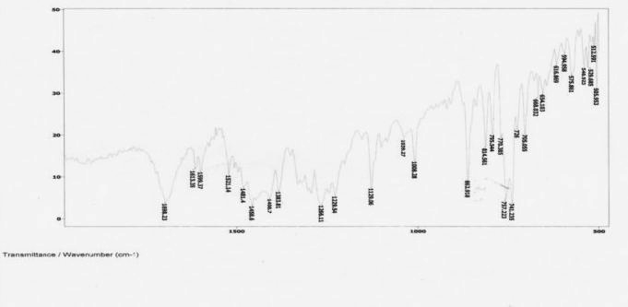

Fig no: 2 FT-IR of pure drug Telmisartan with the excipients
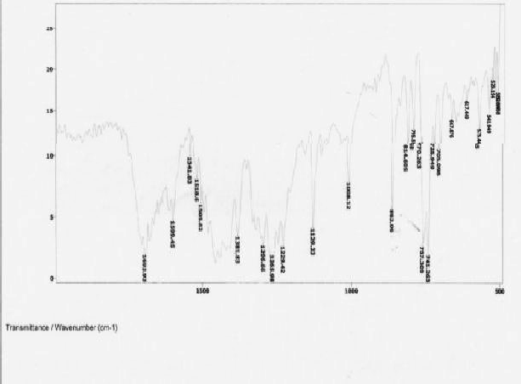

Fig no: 3 FT-IR of pure drug Amlodipine Besylate
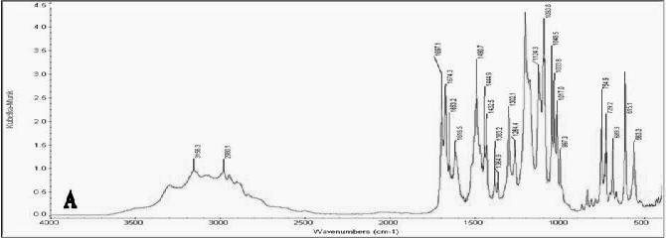

Fig no: 4 FT-IR of pure drug Amlodipine Besylate with the excipients
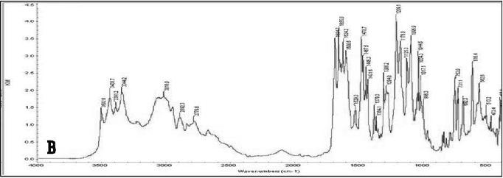

Fig no: 5 Comparative invitro dissolution profiles of Telmisartan layer formulations F- 1 to F-8
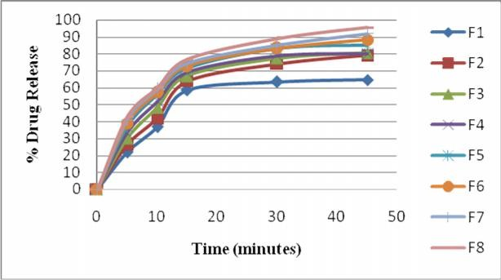

Fig no: 6 Comparative invitro dissolution profiles of Amlodipine Besylate layer formulations F-1 to F-8
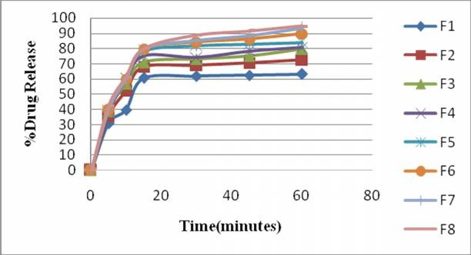

Fig no: 7 Invitro dissolution study of formulation F-9

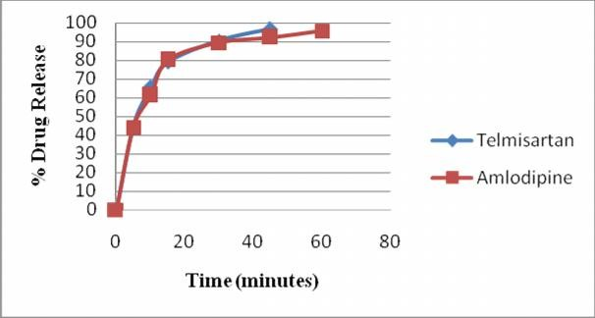

Results and discussion
The IR spectrum showed no considerable change in the peaks was observed in bands of telmisartan and amlodipine and hence no interaction between the drug and the excipients.
The immediate release layer of Telmisartan was designed with the dose of 40mg. The granules were prepared by wet granulation method using PVP K-30 as the binder. In F-1 to F-5 formulations the SSG concentration was 1-5%,

the drug release was not within the limits. Hence further more increase in SSG concentration in F-7 to F-9 to 6% produced immediate release of drug which was within the specified limits.
The amlodipine layer was also been formulated as the immediate release layer with 5mg dosage. Here SSG concentration was increased upto 9.5%. In F-1 to F-6 formulation the SSG concentration was 1-7%. The drug release was not satisfactory, hence further increase in SSG concentration to 9.5% in F-8 to F-9 formulations produced more than 90% of drug release at 60 min.
The pre-compression and post-compression results showed that the values obtained for all formulations except F-1 and F-2 which had less amount of disintegrant were within the limits and the drug content was also found to be in the range of 90-110%.
Dissolution samples were analyzed by HPLC method. The percentage invitro drug release for F2 to F9 were observed to be within the limits. The drug release of F-9 after 45 and 60 min for telmisartan and amlodipine layer was 96.68% and 95.73%. Among the nine trials F-9 was found to be satisfactory. The results are given in Table no: 6 with the corresponding graphs in Fig no: 5-7.
The stability studies for the optimized batch F-
9 after 30 and 60 days were evaluated for its drug release and was found to be 96.62% and 96.07% for telmisartan layer and for amlodipine layer was 95.36% and 95.1%, which indicated good stability.

Conclusion
This research was carried out to produce a Bilayer tablet of Telmisartan using binders, disintegrants and lubricants such as PVP K-30, mannitol, sodium starch glycolate and MCC pH102 for the immediate release layer. Sodium starch glycolate, magnesium stearate, colloidal silicon dioxide and MCC pH102 are used for immediate release layer of Amlodipine besylate. The F-9 formulation showed acceptable results for their pre-compression and post-compression parameters. Drug release was found to increase with increase in disintegrant sodium starch glycolate concentration, where the disintegrant was used in the concentration of 2%-16% of the average tablet weight.
The immediate release bilayer tablets of Telmisartan and Amlodipine Besylate (40mg+5mg) was successfully prepared using the disintegrant sodium starch glycolate. This combination therapy is indicated for the treatment of severe hypertension and coronary heart disease. Hence finally concluded that bilayer technique is best suitable for immediate
release tablets of Telmisartan and Amlodipine Besylate.

References
- Hypertension www.Medicine net.com
- Moen MD worked on telmisartan
/amlodipine a single-pill combination of telmisartan, an angiotensin II receptor antagonist, and amlodipine, a dihydropyridine calcium channel antagonist, WHO, 2010; 10 (6): 401-412.
- Hypertension – Wikipedia foundation http://en.wikipedia.org/wiki/hypertension
- Pharmaceutics of drug delivery and targeting. Pg. 8-10. Available at www.pharmapress.com
- Bilayer tablet: Review Journal of Applied Pharmaceutical Science 01 (08); 2011; 43- 47.
- TWYNSTA (telmisartan/amlodipine) tablet, multilayer, Boehringer Ingelheim Pharmaceuticals, Inc.
- United States Pharmacopeia 34 – National Formulary 29 (USP 34 - NF 29). 5040- 5041.
- Indian Pharmacopoeia 2010. 806-807.
- Natrajan R et al. Formulation and evaluation of immediate release bilayer tablets of telmisartan and hydrochlorthiazide. Int J Pharma Sci Nanotech, 2011; 4 (3): 1477-1482.
- Alfred Martin, Bustamante. P, and Chun. A, physical pharmacy - physical chemical principles in the pharmaceutical sciences, 4th ed., Lipincott Williams and Wilkins, Baltimore (2002); 446-448.
- Lachmann and Liebermann. The theory and practice of Industrial Pharmacy. 3rd Indian edition, 1991; 296-298.
- Margaret Chandira, et al. Design, development and optimization of Amlodipine Besylate tablets. Der Pharmacia Lettre, 2010; 2 (1): 528-539.
- Sekar V, Chellan V R. immediate release tablets of Telmisartan using super disintegrant – formulation, evaluation and stability studies. Chemical and pharmaceutical bulletin, 2008;56 (4): 575-7.

