# 344

***Research Article***



International Journal of Pharmacy and Industrial Research

**ISSN Print 2231 – 3648**

**Online 2231 – 3656**

**DESIGN AND EVALUATION OF MULTI UNIT FLOATING ALGINATE BEADS OF FAMOTIDINE**

# *Indira Muzib Y, Rekha Ch

Institute of Pharmaceutical Technology, Sri Padmavathi Mahila University, Tirupati, Andhra Pradesh, India – 517 502.

**Abstract**

Famotidine is widely prescribed drug in the treatment of ulcers. To get the local action gastro retentive dosage forms are more suitable. Very few works have done on formulation of famotidine alginate gel multiparticulate beads using emulsion gelation method. Hence the present work aimed to develop mineral oil emulsion alginate gel beads with sodium alginate, HPMC,mineral oil, through an ionotropic emulsion- gelation process. The beads were subjected to evaluate for particle size, %yield, entrapment efficiency and in vitro drug release characteristics. The alginate beads with oil addition were able to continuously float over the medium for more than 10 h. The alginate beads produced were smooth and small in size with an average diameter of about 0.987mm to 1.5mm. Sodium alginate beads containing 10% oil F5 (7:3): 1 P: D ratio, showed an optimum DEE of 87%. The famotidine was released in a sustained manner for more than 8h due to the addition of oil as a second diffusion barrier. The formulation F5 releases the drug (65.5%) at end of the 8 hr exhibited the optimum sustained release of famotidine, with excellent floating properties. Drug release was controlled by diffusion from the alginate beads that was slow and spreads over an extended period of time depending upon the drug polymer ratio. In vitro release kinetic studies shows it follows Higuchi mechanism.The results clearly indicated that the floating-type gastro retentive dosage form of famotidine loaded mineral oil entrapped beads can give sustained action for treating gastric ulcers.

**Keywords:** Floating beads, famotidine, Mineral oil, emulsion-gelation, In vitro release studies.

## Introduction

According to WHO 4.6 million people affected with peptic ulcer. Peptic ulcer is the most common ulcer of an area of the gastrointestinal tract that is usually acidic and thus extremely painful. As many as 70–90% of such ulcers are associated with Helicobacter pylori[1]. Peptic ulcer is the disorder of the

upper gastro intestinal tract that results when gastric acid, bacteria, drugs or other assaults cause breaks or sores in mucosa, the moist tissue that lines the stomach, duodenum and other areas of gastrointestinal tract. Gastric hyperacidity is one of the main causes of peptic ulcer[2]. Various attempts have been made to prolong the residence time of the dosage form in the stomach for both systemic

### Author for Correspondence:

Indira Muzib Y,

Institute of Pharmaceutical Technology, Sri Padmavathi Mahila University, Tirupati, Andhra Pradesh, India – 517 502. Email: [yindira1415@gmail.com](mailto:yindira1415@gmail.com)

Indira Muzib Y. et al., Int. Journal of Pharmacy & Industrial Research Vol – 02 Issue – 03 Jul – Sep 2012

345

and local action. One such method is the preparation of a floating device that remains buoyant in the stomach contents due to its lower density than that of the gastric fluids[2-7]. On the other hand, a floating system made of multiple unit forms has relative merits compared to a single unit preparation[8]. Indeed, the gastric emptying of a multi particulate floating system would occur in a consistent manner with small individual variations. On each subsequent gastric emptying, sunken particles will spread out more uniformly over a large area of absorption sites, increasing the opportunity for drug release profile and absorption in a more or less predictable way[9]. Moreover, since each dose consists of many subunits, the risk of dose dumping is reduced. The concept of floating micro beads can also be utilized to minimize the irritant effect of weakly acidic drugs on the stomach by avoiding direct contact with the mucosa and providing a mean of getting low dosage for prolonged periods.[10] Oil which is used in emulsion gelation method as a dispersed phase, generates emulsion creating uniform multiple small chambers in the bead matrix for better buoyancy. The formed emulsion is stabilized by the surface active ability of alginate and pectin[11-13]. The inclusion of oil provides a diffusion barrier towards drug escape from porous beads. In addition, oil due to its hydrophobic nature reduces drug loss during entrapment processes. Compared to fixed oils, mineral oil has a relative lower density that reduces the amount required to give buoyancy [14], added to a more prolonged drug release characteristics [15].Worldwide accepted clinical therapy of acid peptic disease is based on histamine H2 receptor antagonists. Famotidine is a histamine

H2-receptor antagonist. It is widely prescribed in gastric ulcers, duodenal ulcers, Zollinger- Ellison syndrome and gastroesophageal reflux disease[16] where gastro oesophageal reflux disease is associated with oesophageal ulceration. The low bioavailability (40-45%) and short biological half life (2.5-4.0 hours) of famotidine following oral administration favours development of a sustained release formulation.

There are very few works on preparation of floating beads or microspheres with emulsion gelation method. Famotidine beads developed with pectin[11] using this method but there is no work on SA,HPMC based famotidine floating microspheres. Hence the objective of this work was to develop and optimize the formulations of mineral oil entrapped famotidine floating alginate beads by using SA and HPMC by ionotropic-emulsion gelation method.

## Materials and Methods

Famotidine was received as a gift sample from Vasava Pharma Private Limited, Hyderabad, Hydroxy propyl methylcellulose (HPMC) was obtained as gift sample from matrix Pvt. Ltd, Hyderabad, India. Sodium alginate(SA), Mineral oil was procured from Merck (India) Ltd., Mumbai. All other ingredients, reagents and solvents were of analytical grade.

### Preparation of Famotidine loaded alginate mineral oil entrapped emulsion multi unit gel beads (MOEG) by using ionotropically emulsion- gelation method [17]

Famotidine loaded MOEG beads were prepared by the emulsion–gelation method. In this method, different polymer ratios of SA and HPMC F1(9:1), F2(8.5:1.5), F3(8:2),

F4(7.5:2.5), F5(7:3), F6(6.5:3.5), F7(6:4) were

[www.ijpir.com](http://www.ijpir.com/)

# 346

Indira Muzib Y. et al., Int. Journal of Pharmacy & Industrial Research Vol – 02 Issue – 03 Jul – Sep 2012

taken in 25 ml distilled water to prepare polymers solutions. Mineral oil, in concentration (10%w/w), was added to the polymer solution. Famotidine (100mg) was dispersed in the polymer solution in drug: polymer (D: P) (1:10) ratios. To ensure emulsion stabilization, the mixtures were homogenized at 8000 rpm using a homogenizer for 10 min. The bubble-free emulsion was extruded, using a syringe needle into 5% CaCl2 solution at room temperature. The emulsion gel beads were allowed to stand in the solution for 5min before being separated and washed with 100 ml distilled water. The beads were air-dried at room temperature.

### Evaluation of alginate beads Particle size analysis [18]

The size of the prepared alginate beads was measured by the optical microscopy method using a calibrated stage micrometer. Particle size was calculated by using equation.

g = 10 X [(ni x log xi) / N]

were measured simultaneously as a part of dissolution studies. The floating lag time and the duration of buoyancy were carried using USP XII paddle type dissolution apparatus in 900ml 0.1 N HCl at 37±0.50c and at 50 rpm.

### Percentage yield and Drug entrapment efficiency (DEE)

The alginate beads were evaluated for percentage yield and percent drug entrapment. The yield was calculated as per equation.



Drug loaded MOEG beads (100mg) were suspended in 100ml 0.1N HCl. The dispersion was kept for 24hrs and agitated for 5min and filtered through a Whatmann filter. The drug content determined spectrophotometrically (UV systronics – 117) at 265 nm using a regression equation derived from the standard graph (r2 = 0.9956). The drug entrapment efficiency (DEE) was calculated by the equation.

Where,

g is geometric mean diameter. ni is number of particles in range.

*DEE*

Where,

 *Pc* 

 *Tc*  *X*



100

xi is midpoint of range.

N is the total number of particles.

All the experimental units were analyzed in triplicate (n=3).

### Determination of Floating lag time and buoyancy duration [19]

The time between the introduction of beads in to the medium and its buoyancy to the upper one third of the dissolution vessel (buoyancy lag time) and the time for which the formulation constantly floated on the surface of the medium (duration of the buoyancy)

Pc is practical content

Tc is the Theoretical content.

All the formulations were analyzed in triplicate (n=3).

***In vitro* drug release studies**

*In vitro* drug release study was carried out in USP XII paddle type dissolution apparatus using 0.1 N HCl as dissolution medium. Weighed quantities of beads equivalent to 40 mg famotidine were introduced into the baskets which were rotated at 50 rpm in 900 ml 0.1N HCl, maintained at 37 ± 0.5 0C. At an

[www.ijpir.com](http://www.ijpir.com/)

Indira Muzib Y. et al., Int. Journal of Pharmacy & Industrial Research Vol – 02 Issue – 03 Jul – Sep 2012

347

interval of 1 hour, 5 ml of sample was withdrawn, 5 ml of fresh medium replaced and analyzed for drug content by UV-visible spectrophotometer at 265 nm.

***In vitro* drug release kinetic studies** Mechanism of drug release from the alginate beads, drug release data was analyzed according to zero order, first order, Higuchi and Korsemeyer – Peppas equations which have been described in the literature. The order of drug release from alginate beads was described by using zero order kinetics or first order kinetics. The mechanism of drug release

from matrix systems was studied by using Higuchi equation and Korsemeyer Peppas equations and release kinetics data were shown in table 3.

### Fourier Transforms Infrared Radiation measurement (FT-IR)

The FT-IR spectra acquired were taken from dried samples. A Fourier transform infrared (FT-IR) spectra of the samples were obtained in the range of 400 to 4,000 cm−1. A quantity equivalent to 2 mg of pure drug, empty microspheres of sodium alginate, HPMC and drug loaded alginate beads were selected separately.

**Results & discussion**

### Table No. 01: Evaluation parameters of various formulations of Famotidine MOEG beads

|  |  |  |  |  |  |
| --- | --- | --- | --- | --- | --- |
| **Formulation Buoyancy**  **code duration** | | **Floating lag time(sec)** | **Yield (%)** | **Particle size(mm)** | **DEE** |
|  | **(hrs)** |  |  |  |  |
| F1 | >10 hrs | 908 | 94 | 0.987 | 58.1 |
| F2 | >10 hrs | 508.2 | 93.4 | 1.123 | 73.4 |
| F3 | >10 hrs | 405.6 | 95.8 | 0.995 | 64.1 |
| F4 | >10 hrs | 363.6 | 93.5 | 0.998 | 48.0 |
| F5 | >10 hrs | 786.2 | 96.0 | 1.00 | 87.0 |
| F6 | >10 hrs | 318 | 91.9 | 1.5 | 71.4 |
| F7 | >10 hrs | 394.8 | 94.8 | 1.06 | 65.8 |

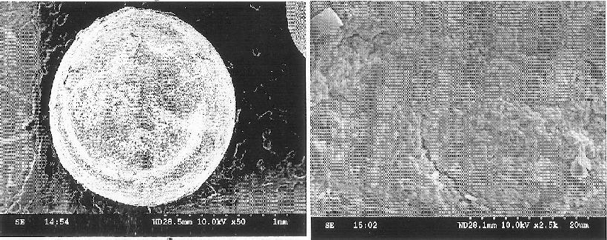

1. (b)

### Figure No. 01: (a)SEM photographs of MOEG beads famotidine

1. **SEM photographs external surface area of famotidine MOEG beads.**

[www.ijpir.com](http://www.ijpir.com/)

# 348

Indira Muzib Y. et al., Int. Journal of Pharmacy & Industrial Research Vol – 02 Issue – 03 Jul – Sep 2012

**Particle size analysis and surface property** The size of beads were analyzed by optical microscopy and Scanning electron microscopy for their surface and size analysis. The particle size range between 987.05 µm to 1.5 mm. These results were tabulated in table 1. The SEM photographs (figure-1a,b) showed that the fabricated beads were spherical in shape with smooth surface and exhibited a range of size was 1mm for F5 formulation. The smooth surface is appeared because of homogenization of the beads.

### Percentage yield and drug entrapment efficiency (DEE)

The percentage yield of all the formulations between 91.9% to 96% was found to be satisfactory and drug entrapment efficiency (DEE) between 48% to 87%, as summarized in Table-1. The formulation F5 showed higher DEE (87%) and higher yield (96%) among all the formulations.

### Floating lag time

Instantaneous in vitro floating behavior was observed for MOEG beads. All the formulations (F1-F7) sank in dissolution medium first and then gradually float, the floating lag time is >318 sec is shown in Table 2.

### Floating behavior

The floating test was performed to investigate the floatability of the prepared beads. The beads floated for prolonged time over the surface of the dissolution medium due to the incorporation of oil (10%w/w) as oil has low density, it has a great influence on beads buoyancy, and an additional property of buoyancy was observed. In vitro buoyancy duration >10hrs was observed for all the formulations. It shown in the table1.

### *In vitro* drug release profile of Famotidine floating alginate muti unit MOEG beads:

**Figure No. 02: Zero order drug release profile for formulations of famotidine**

[www.ijpir.com](http://www.ijpir.com/)

Indira Muzib Y. et al., Int. Journal of Pharmacy & Industrial Research Vol – 02 Issue – 03 Jul – Sep 2012

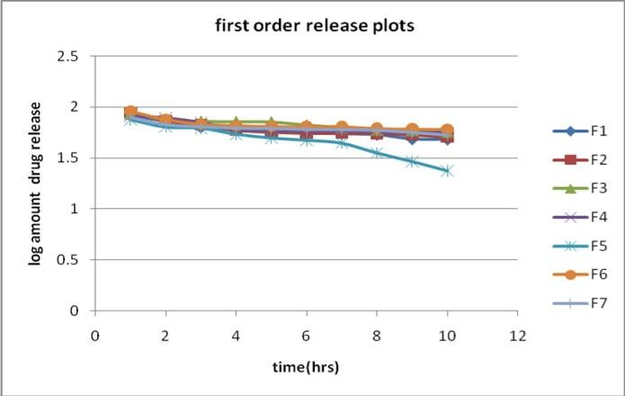

### Figure No. 03: first order drug release profile for formulations of famotidine

349

The results of *in vitro* dissolution studies of Famotidine floating microspheres with sodium alginate and HPMC were shown in figure-2. The results showed that Famotidine release from the formulation was extended over a period of 10 hrs. The cumulative release of Famotidine was observed to increase the concentrations of polymers and constant oil concentration. The release rate of Famotidine from these MOEG beads was slower than the dissolution of Famotidine marketed conventional tablet which occurred within 30 min.

Being a weak base and highly soluble in 0.1N HCl, Famotidine showed an initial burst effect, due to the presence of surface deposited drug along with rapid water infiltration creating aqueous channels for Famotidine to permeate out. Figures revealed that Famotidine was

released cumulatively from sodium alginate MOEG beads containing 10% w/w oil concentration, resulted in a decrease in Famotidine release rate consequently, prolonged drug release at all D:P ratios. These previous findings could be explained based on the following hypothesis: Famotidine was soluble in 0.1 N HCl; it will diffuse easily out of the beads increasing the rate of penetrant entry into the beads. Therefore, for the basic Famotidine, the hydrophobic diffusion barrier, offered by oil inclusion, was essential for retarding drug release. All the formulations were found to release Famotidine in a controlled manner for a prolonged period over 10 hrs but less in percentage drug release. The formulation F5 releases the drug (65%) at end of the 8 hr exhibited the optimum sustained release of famotidine, with good in vitro buoyancy and floating properties.

[www.ijpir.com](http://www.ijpir.com/)

# 350

Indira Muzib Y. et al., Int. Journal of Pharmacy & Industrial Research Vol – 02 Issue – 03 Jul – Sep 2012

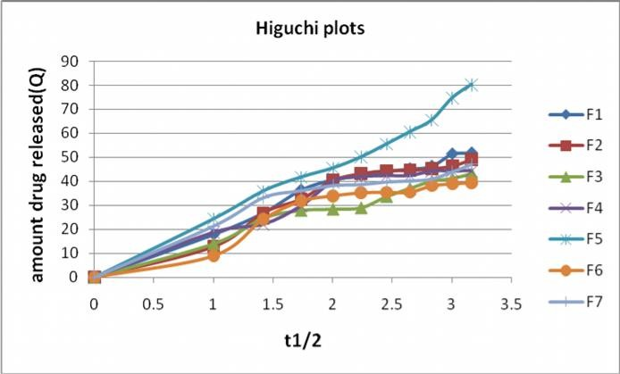***In vitro* drug release kinetics:**

### Figure No. 04: In vitro drug release kinetics of Famotidine MOEG beads Higuchi order plot

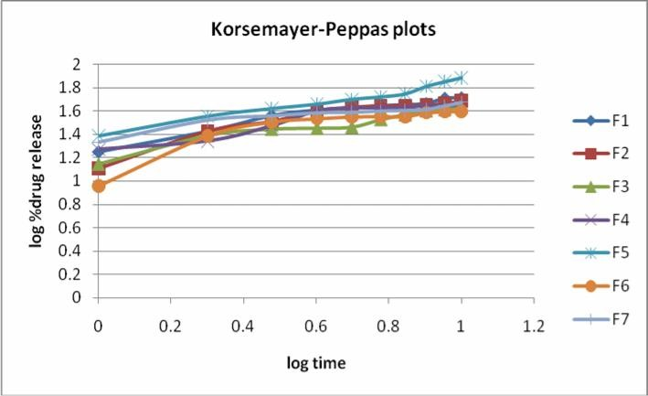

**Figure No. 05: In vitro drug release kinetics of Famotidine MOEG beads Korsemayer- Peppas Plot**

### Table No. 02: In vitro drug release kinetics of alginate MOEG famotidine beads

Formulation code Zero order plot First order plot Higuchi plot Korse mayer –Peppas

|  |  |  |  |  |  |  |  |
| --- | --- | --- | --- | --- | --- | --- | --- |
|  | R2 (k) R2 (k) R2 | | | | | R2 n | |
| F1 | 0.8084 | 4.2964 | 0.9056 | -0.0531 | 0.9643 | 0.9496 | 0.4396 |
| F2 | 0.7794 | 4.1964 | 0.8192 | -0.0502 | 0.9389 | 0.8875 | 0.526 |
| F3 | 0.8612 | 3.5955 | 0.9519 | -0.0416 | 0.9772 | 0.9483 | 0.4437 |
| F4 | 0.7567 | 3.7945 | 0.7883 | -0.0426 | 0.9296 | 0.9111 | 0.4159 |
| F5 | 0.911 | 6.2482 | 0.9521 | -0.1176 | 0.9841 | 0.9776 | 0.4586 |
| F6 | 0.7194 | 3.3491 | 0.7205 | -0.0350 | 0.897 | 0.793 | 0.5435 |
| F7 | 0.6695 | 3.2636 | 0.8306 | -0.0322 | 0.9006 | 0.8858 | 0.2793 |

[www.ijpir.com](http://www.ijpir.com/)

Indira Muzib Y. et al., Int. Journal of Pharmacy & Industrial Research Vol – 02 Issue – 03 Jul – Sep 2012

351

The drug release profiles of different GFDDS were fitted to various drug release kinetic parameters and the results were shown in Table-2 and Figures - 3, 4, 5. When a drug is incorporated in a hydrophilic matrix, it swells upon ingestion and the gel layer forms on the surface. This gel layer fills the interstices. Dissolution rate of insoluble drugs is controlled by both diffusion through the gel layer and by matrix erosion as seen from the release kinetics values (Table 2). All the formulations showed constant release profile to identify the kinetics of drug release from alginate beads, release data was analyzed according to different kinetic models. The data obtained for in vitro release were fitted into

equations for the zero order, first order, Higuchi and Korsmeyer- Peppas release models. Interpretation of data was based on the value of the resulting regression coefficients. The data shows that the release mechanism is chiefly by Higuchi square root equation. The drug release rate was following first order kinetics (Figure 3). The drug release mechanism of F1, F3, F4, F5, F7 formulations followed Fickian diffusion and F2, F6 formulations followed Non- fickian diffusion. FTIR studies shows there is no interaction between drug and polymer (Fig 6, 7, 8). From these results it can be concluded that mineral oil entrapped alginate beads of famotidine can be developed for controlled drug delivery to treat the peptic ulcers.

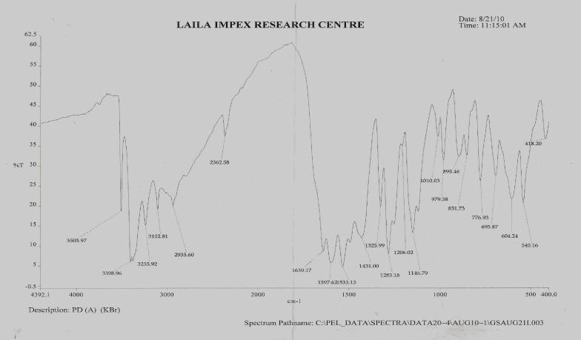

### Figure No. 06: FTIR Spectrum of pure drug famotidine

[www.ijpir.com](http://www.ijpir.com/)

# 352

Indira Muzib Y. et al., Int. Journal of Pharmacy & Industrial Research Vol – 02 Issue – 03 Jul – Sep 2012

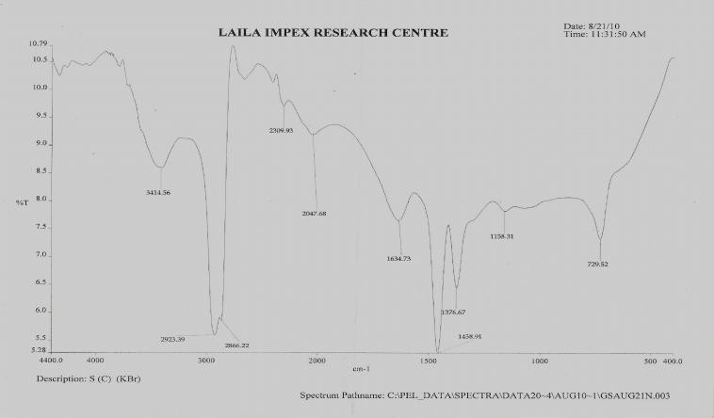

### Figure No. 07: FTIR Spectrum of floating alginate empty beads

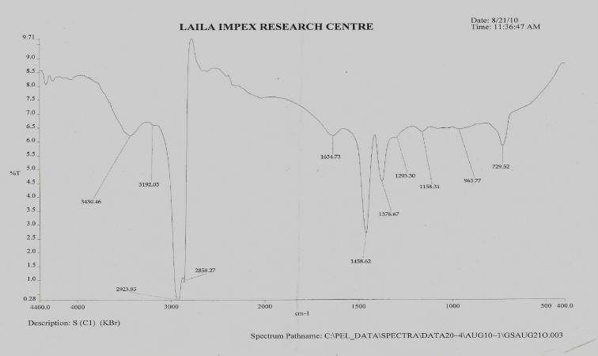

**Figure No. 08: FTIR Spectrum of famotidine floating alginate beads**

**Acknowledgements**

The authors thank to Vasava Pharma Private Limited, Hyderabad for gift sample of famotidine and Sri Padmavati Mahila Visvavidyalayam for providing facilities to carriedout this work.

## References

1. <http://en.wikipedia.org/wiki/Peptic_ulcer>
2. Gu JM, Robinson JR, Leung SH. Binding of acrylic polymers to mucin/ epithelial

structure property relationship. Crit Rev Ther. Drug Carr Syst 1998; 5:21-67.

1. Hardman, G.J., Limbird, L.E.,Goodman Gilman A., The Pharmacological Basis of Therapeutics. 10thed., McGrawHill Medical Publishing, New York 2001.
2. El- Kamel AH, Sokar MS, Al Gamal SS, Naggar VF. Preparation and evaluation of Ketoprofen floating oral delivery system. International Journal of Pharmaceutics. 2001; 220: 13-21.

[www.ijpir.com](http://www.ijpir.com/)

Indira Muzib Y. et al., Int. Journal of Pharmacy & Industrial Research Vol – 02 Issue – 03 Jul – Sep 2012

353

1. Porter SC, Ghebre-Sellassie , Key factors in the development of modified-release pellets. In:Ghebre-Sellassie, Ed. 1, Multiparticulate oral drug delivery, Marcel Dekker, New York, 1994; 217–284.
2. Desai S, Bolton S. A floating controlled- release drug delivery system: in vitro-in vivo evaluation. Pharm. Res. 1993;10, 1321–1325.
3. Deshpande AA, Rhodes CT, Shah NH, Malick AW. Controlled-release drug delivery systems for prolonged gastric residence; an overview. Drug. Dev. Ind. Pharm. 1996; 22, 531–539.
4. Kawashima Y, Niwa T, Takeuchi H, Hino T, Itoh Y. Hollow microspheres for use as a floating controlled drug delivery system in the stomach. J. Pharm. Sci. 1992;81, 135– 140.
5. Oth M, Franz M, Timmermans J, Moes A. The bilayer floating capsule: a stomach- dried drug delivery system for misoprostol. Pharm. Res. 1992; 9, 298–302.
6. Whitehead L, Fell JT, Collett JH, Sharma HL, Smith AM, An in vivo study demonstrating prolonged gastric retention. J. Control. Rel. 1998; 55, 3–12.
7. Iannuccelli V, Coppi G, Bernabei, MT, Cameroni R. Air compartment multiple-unit system for prolonged gastric residence. Part
   1. Formulation study. Int. J. Pharm. 1998;174, 47–54.
8. Acikgoz M, Kas HS, Hascelik Z, Milli U, Hinca AA. Chitosan microspheres of diclofenac sodium, II: In vitro and in vivo evaluation. Pharmazie 1995;50, 275–277.
9. Thanoo BC, Sunny MC, Jayakrishnan A 1993. Oral sustained-release drug delivery systems using polycarbonate microspheres

capable of floating on the gastric fluid. J. Pharm. Pharmacol. 45, 21–24.

1. Enas M.Elmowafy, Gehanne AS, Awad, Samar Mansour, Abd El-Hamid A. El- Shamy. Ionotropically emulsion gelled polysaccharides beads: Preparation, *in vitro* and *in vivo* evaluation. Carbohydrate Polymers. 2009; 75: 135–142.
2. Leroux J, Langendorff V, Schick G, Vaishnav V, Mazoyer J. Emulsion stabilizing properties of pectin. Food Hydrocolloids, 2003; 17, 455–462.
3. Reynolds JEF, Martindale. The Extra Pharmacopoeia, The Royal Pharmaceutical Society: London, 1996; 1218-20.
4. Choudhury PK, Kar M. Preparation of alginate gel beads containing metformin hydrochloride using emulsion–gelation method. Tropical Journal of Pharmaceutical Research, 2005; 4(2), 489–493.
5. Dave S. S, Sher P, Korde A.and A. P.Pawar. Development of hollow/ porouscalcium pectinate beads for floating-pulsatiledrug delivery. Euro. J. Pharm. 2007;65:85-93
6. Sharma S and Pawar A. Low density multiparticulate system for pulsatile release of meloxicam Int. J. Pharm.2006; 313:150- 158
7. S Gupta and N Aggarwal. Stomach-Specific Drug Delivery of 5-Fluorouracil Using Floating Alginate Beads. The AAPSJournal. 2007;8 (2): 48

[www.ijpir.com](http://www.ijpir.com/)