***Research Article***



International Journal of Pharmacy and Industrial Research

**ISSN Print 2231 – 3648**

**Online 2231 – 3656**

**STABILITY INDICATING HIGH PERFORMANCE LIQUID CHROMATOGRAPHIC ASSAY FOR THE SIMULTANEOUS DETERMINATION OF ATORVASTATIN CALCIUM AND FENOFIBRATE IN TABLET DOSAGE FORM**

# *Prakash V Diwan, Anusha N, Sanayaima Huidrom, Surendra N, Prasad V V L N

School of Pharmacy, Anurag group of institutions,

Venkatapur (V), Ghatkesar, Rangareddy district, Andhra Pradesh, India - 501301.

**Abstract**

A simple, rapid, precise and accurate isocratic reversed phase stability indicating RP- HPLC method was developed and validated for the simultaneous determination of Atorvastatin calcium and Fenofibrate in commercial tablets. The chromatographic separation was achieved on Phenomenex Luna C18 (250×4.6mm, 5μm) column using a mobile phase consisting of methanol and buffer (0.1% v/v triethylamine pH 3.5 adjusted with 0.1% v/v orthophosphoric acid) in the ratio of (90:10% v/v) at a flow rate of 1.0 ml/min and UV detection at 254 nm. The linearity of the proposed method was investigated in the range of 2.5-5 μg/ml (r2=0.9984) for Atorvastatin calcium and 2.5-5 μg/ml (r2=0.9987) for Fenofibrate. Retention time of Atorvastatin calcium and Fenofibrate were found to be 3.020 and 6.101. The method was validated for accuracy, repeatability, reproducibility and robustness, system suitability. LOD of Atorvastatin calcium and Fenofibrate were found to be 0.05901µg/ml and 0.03764µg/ml and LOQ of Atorvastatin calcium and Fenofibrate were found to be 0.19651µg/ml and 0.12547µg/ml. The stability studies of Atorvastatin calcium and Fenofibrate were conducted and the degradation characteristics were found to be much more prominent in alkaline hydrolysis (alkaline stress condition).

**Keywords:** Atorvastatin calcium, Fenofibrate, RP- HPLC, stability-indicating assay, simultaneous determination, validation.

## Introduction

Atorvastatin calcium (ATR), (3R, 5R)-7-[2-(4- fluorophenyl)-3-phenyl-4-(phenylcarbonyl)-5- (propan-2-yl)-1H-pyrrol-1-yl]-3, 5-dihydroxy - heptanoic acid is anticholestermic agent. Fenofibrate (FEN), propan-2-yl 2-{4-[4- chlorophenyl) carbonyl] phenoxy}-2-methyl

propanoate is antilipemic agent which reduces cholesterol and triglycerides in blood thus decreases the risk of heart diseases and prevent strokes. Atherosclerotic Vascular disease is a condition in which an artery wall thickness as a result of accumulation of fatty materials such as cholesterol. It affects mostly arterial blood

### Author for Correspondence:

Prakash V Diwan,

School of Pharmacy, Anurag group of institutions, Venkatapur (V), Ghatkesar, Rangareddy district, Andhra Pradesh, India - 501301.

Email: [diwanpv@gmail.com](mailto:diwanpv@gmail.com)

vessels, inflammatory response in walls of arteries commonly referred to as hardening of arteries. It is caused by formation of multiple plaques with in arteries. Some of drug combination like Atorvastatin calcium and Fenofibrate has a highly beneficial effect on all lipid parameters. Atorvastatin Calcium is more effective in reduction of cholesterol level where as Fenofibrate in reduction of triglycerides [1-3]. The literature survey reveals UV [4-8], HPLC [9-11] and UPLC [12] methods for analysis of Atorvastatin Calcium and Fenofibrate as single and in combined dosage forms. The developed RP-HPLC method was found to be accurate, precise, selective and rapid for simultaneous estimation of Atorvastatin and Fenofibrate in tablets.

### Materials and methods

Methanol and water (HPLC grade) were obtained from Fischer Limited, Mumbai. Sodium Hydroxide pellets, Hydrochloric acid, Hydrogen peroxide (1%) are obtained from SD Fine chemicals, Mumbai. Triethylamine (GR grade). Orthophosphoric acid 88% (GR grade). Pure drug samples of atorvstatin Calcium and Fenofibrate (fig.1 and 2) were obtained from Right aid Labs, Balanagar, Hyderabad. FIBATOR LS tablets (Atorvastatin calcium 10mg and Fenofibrate 72.5mg) are purchased from the local pharmacy. Different kinds of equipments like Analytical weighing balance, HPLC system SHIMADZU-SPD 20A,

Injector (Redone, 20µl), Sonicator, pH meter, Vaccum filter pump, Millipore filtration kit, mobile phase reservoir, Water bath, Sample filtration assembly and glassware’s were used throughout the experiment. Phenomenex Luna C18 (250×4.6mm, 5μm) column used as a stationary phase. The isocratic mobile phase

consisting of methanol and buffer (0.1% triethylamine, pH 3.5 adjusted with orthophosphoric acid) in the ratio of (90:10% v/v) was used throughout the analysis. The flow rate of the mobile phase was 1.0 ml/min. Detector signal was monitored at wavelength of 245 nm. The column temperature was kept ambient and injection volume was 20μl.

**Preparation of Mobile phase and preparation of standard stock solutions:** Mobile phase is prepared by mixing buffer and Methanol in the ratio of (10:90). The mobile phase is then sonicated using ultrasonicator to remove the impurities and dissolved gases, as they may lead to unwanted peaks in the chromatogram. Standard stock solution containing ATR (1000 μg/ml) and FEN (1000 μg/ml) was prepared by transferring 10 mg ATR and 10 mg FEN working standard into a

10 ml volumetric flask. A 5 ml portion of diluent (methanol-water 90:10, v/v) was added, sonicated and cooled to room temperature. The solution was diluted to the mark with diluent. Standard solution containing ATR (100 μg/ml) and FEN (100 μg/ml) was prepared by pipetting 1 ml stock solution into a 10 ml volumetric flask and diluting to volume with diluent. The solution was pipetted out into 10 ml volumetric flask to get a concentration of 2.5-5 mcg/ml of Atorvastatin and Fenofibrate after making up with mobile phase.

### Preparation of sample solution

Twenty tablets (FIBATOR LS) were weighed and the average weight was calculated. The tablets were crushed with a mortar and pestle for 10 min. A portion of powder equivalent to the weight of one tablet and 9 mg of

Atorvastatin (standard), 2.75 mg of Fenofibrate (standard) was accurately weighed and transferred to a 100 ml volumetric flask(standard addition method). Approximately 50 ml diluent was added and the mixture was sonicated for 15 min with intermittent shaking. The contents were restored to room temperature and diluted to volume with diluent to furnish stock test solution. The stock solution was filtered through 0.45μm membrane filters and 2.5 ml of the filtered solution was transferred to a 10 ml volumetric flask and diluted to volume with diluent to give test solution containing 2.5μg/ml ATR and 2.5μg/ml FEN (Table.1).

### Validation procedure Specificity

The specificity of the method was evaluated by assessing interference from excipients in the pharmaceutical dosage form prepared as a placebo solution. The specificity of the method for the drug was also established by checking for interference with drug quantification from degradation products formed during the forced degradation study.

### Linearity

Test solutions for assessment of the linearity of the method were prepared at five concentrations from 2.5 to 5% of the analyte concentration in the assay (i.e. 2.5, 3, 3.5, 4,

4.5, and 5μg/ml for ATR and 2.5, 3, 3.5, 4, 4.5 and 5μg/ml for FEN). Peak area and concentration data were then evaluated by linear regression analysis (Table.2).

### Precision

The precision of the method, as intra-day repeatability was evaluated by performing six independent assays of the test sample

preparation and calculating the RSD %. The intermediate (interday) precision of the method was checked by performing same procedure on different days by another person under the same experimental conditions (Table.2).

### Accuracy

Accuracy was studied by adding two different amounts (corresponding to 50% and 100% of the test preparation concentrations) of ATR and FEN to the placebo preparation and comparing the actual and measured concentrations. For each level, three solutions were prepared and each was injected in duplicate (Table.2).

### Limit of detection (LOD) and Limit of quantization (LOQ)

The LOD and LOQ of Atorvastatin calcium and Fenofibrate were calculated by mathematical equation.

LOD= 3.3×standard deviation ÷slope LOQ=10×standard deviation ÷slope

The LOD of Atorvastatin calcium and Fenofibrate were found to be 0.057mcg/ml and 0.056mcg/ml and the LOQ of Atorvastatin calcium and Fenofibrate were found to be 0.192μg /ml and 0.189μg/ml (Table.2)

### System suitability tests (SST)

In the system suitability standard solution of 100μg/ml ATR and 100μg/ml FEN (*n*=5) was prepared and injected. Then system suitability parameters like retention time, theoretical plates, peak asymmetry and resolution were calculated from the chromatogram (Table.2).

### Robustness

The robustness was studied by evaluating the effect of small but deliberate variations in the

chromatographic conditions. The conditions studied were mobile phase composition (by using 88:12 and 92:8 v/v methanol: buffer pH 3.5), buffer pH (altered by ±0.2) and use of HPLC columns from different batches.

### Forced degradation studies

Forced degradation studies were performed on Atorvastatin calcium and Fenofibrate to prove the stability indicating property of the method. The stress conditions employed for degradation study includes light exposure, acid hydrolysis (0.1 N HCL), base hydrolysis (0.1N NAOH), water hydrolysis, Oxidation (3% Hydrogen peroxide), UV light exposure. The

duration of time selected for degradation studies was 6 hours. The photolytic degradation was performed by exposing the solid drugs to sunlight for 6 hours. The concentration of 100 mcg/ml of each of Atorvastatin calcium and Fenofibrate were prepared using respective solvents (NAOH, HCL, water and Hydrogen peroxide) separately. The final concentration of 2.5mcg/ml Atorvastatin calcium and Fenofibrate were prepared from the above mentioned stock solutions after making up with the mobile phase. The final concentration of these drugs are analysed in the HPLC. The % degradation of both the drugs was found to be more in the alkali hydrolysis (Table.3 and 4).

### Table No. 01: Analysis of formulation

(**FIBATOR LS)** –Atorvastatin Calcium 10mg and Fenofibrate 72.5mg)

**Drugs Amount (mg/tab) % label claim %RSD labelled estimated**

|  |  |  |  |  |
| --- | --- | --- | --- | --- |
| Atorvastatin Calci | um 10 mg | 9.98mg | 99.8 | 0.3428 |
| Fenofibrate | 72.5 mg | 73.8mg | 101.793 | 0.5962 |

Mean of six observations

### Table No. 02: Summary of validation and SST parameters

**Parameter (units) Atorvastatin calcium Fenofibrate**

|  |  |  |
| --- | --- | --- |
| Linearity range(µg/ml) | 2.5-5µg/ml | 2.5-5µg/ml |
| Correlation coefficient | 0.9984 | 0.9987 |
| Slope | 44680 | 46381 |
| Intercept | 3699 | 4687 |
| Precision(%RSD) |  |  |
| Intraday(n=6) | 0.528µg/ml | 0.851µg/ml |
| Interday(n=6) | 0.759µg/ml | 0.461µg/ml |
| Recovery (%) |  |  |
| 50% | 102.04 | 101.73 |
| 100% | 100.14 | 99.82 |
| LOD(µg/ml) | 0.057 | 0.056 |
| LOQ(µg/ml) | 0.192 | 0.189 |
| Resolution | 1.9 | 2.3 |
| Theoritical plates | 5951.547 | 3568.372 |
| Assymetry factor | 1.21 | 1.30 |

Tailing factor 1.3 1.02

### Table No. 03: Results of stability indicating studies for Atorvastatin calcium

**Amount found (µg/ml)**

**Conditions**

**Duration of time in hours**

**% Degraded**

|  |  |  |  |  |  |  |  |
| --- | --- | --- | --- | --- | --- | --- | --- |
| **0 hr** | **1 hr** | **2hr** | **3 hr** | **4hr** | **5hr** | **6 hr** |  |
| Water (60c˚,6hrs) 99.52 | 99.32 | 98.92 | 98.62 | 98.16 | 97.59 | 96.36 | 3.64 |

0.1% Hcl (60c˚,6 hrs 95.62

|  |  |  |  |  |  |  |  |  |
| --- | --- | --- | --- | --- | --- | --- | --- | --- |
| 0.1%NaoH | ) 99.63 | 98.06 | 98.59 | 98.50 | 96.15 |  | 94.36 | 5.64 |
| ( 60c˚,6 hrs) | 99.76 | 98.37 | 90.49 | 85.58 | 79.47 | 72.26 | 68.24 | 31.66 |
| 3% H2O2 (6 hrs) | 99.26 | 99.03 | 98.62 | 97.26 | 96.39 | 95.43 | 95.41 | 5.59 |
| UV light (6 hrs) | 99.12 | 98.92 | 98.59 | 98.36 | 98.19 | 98.01 | 97.95 | 2.05 |
| Sunlight (6 hrs) | 99.32 | - | - | - | - | - | 94.67 | 5.33 |

### Table No. 04: Results of stability indicating studies for Fenofibrate

**Amount found (µg/ml)**

**Conditions**

**Duration of time in hours**

**% Degraded**

|  |  |  |  |  |  |  |  |
| --- | --- | --- | --- | --- | --- | --- | --- |
| **0 hr** | **1 hr** | **2hr** | **3 hr** | **4hr** | **5hr** | **6 hr** |  |
| Water (60c˚,6hrs) 99.89 | 99.56 | 99.00 | 98.42 | 98.16 | 97.59 | 97.52 | 2.48 |
| 0.1% Hcl (60c˚,6 hrs) 99.72 | 98.81 | 98.12 | 97.73 | 96.52 | 95.14 | 94.36 | 5.64 |
| 0.1%NaoH  ( 60˚c,6 hrs) 99.23 | 98.42 | 96.52 | 90.39 | 86.62 | 82.15 | 71.39 | 28.61 |
| 3% H2O2 (6 hrs) 99.65 | 98.39 | 98.15 | 97.69 | 96.32 | 95.17 | 95.17 | 5.38 |
| UV light (6 hrs) 99.35 | 99.24 | 99.12 | 99.00 | 98.62 | 98.42 | 98.40 | 1.6 |
| Sunlight (6 hrs) 99.46 | - | - | - | - | - | 93.96 | 6.04 |

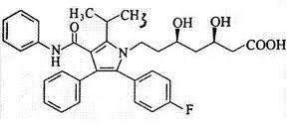

### Figure No. 01: structure of Atorvastatin calcium

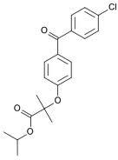

**Figure No. 02: Structure of Fenofibrate**

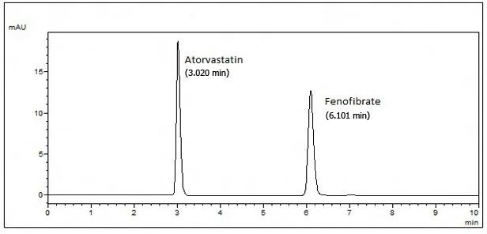

### Figure No. 03: Optimized chromatogram of mixture of Atorvastatin calcium and Fenofibrate

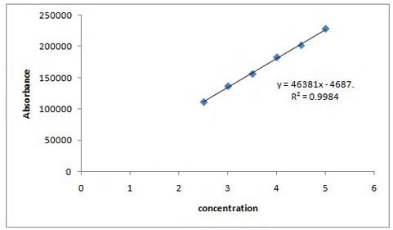

**Figure No. 04: Calibration graph of Atorvastatin calcium**

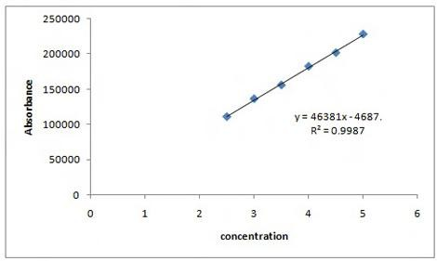

### Figure No. 05: Calibration graph of Fenofibrate

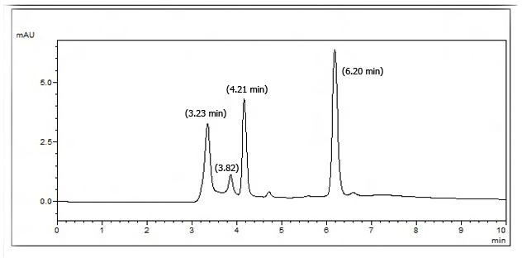

**Figure No. 06: Chromatogram of mixture of Atorvastatin and Fenofibrate degraded with 0.1N NaoH**

## Results and discussion

HPLC method with UV detection for analysis of ATR and FEN in a tablet formulation (FIBATOR LS) was developed and validated. The analytical conditions were selected after testing the different condition effecting HPLC analysis, for example diluent and buffer composition, buffer concentration, organic solvent in the mobile phase, buffer to organic solvent ratio and other chromatographic conditions. Preliminary trials with mobile phases comprising mixtures of water with methanol or acetonitrile did not give good peak shape. The best peak shape was obtained by use of methanol and 0.1% triethylamine buffer, adjusted to pH 3.5 with orthophosphoric acid and use of mobile phase of composition (v/v) methanol- 0.1%triethylamine buffer. Methanol chosen as a organic constituent of the mobile phase to reduce retention times and buffer was chosen to reduce peak asymmetry and achieve good peak shape. The optimized mobile phase enabled good resolution of ATR and FEN and of compounds generated during forced degradation. ATR and FEN were eluted after

3.020 and 6.101 min, respectively (fig.3). The newly developed analytical method was validated according to ICH guidelines [13-14]. System suitability was verified by measurement of peak asymmetry (A<2.0), resolution (Rs>3.0) and number of theoretical plates (*N*>2000) after chromatography of standard solution. The values of these properties were in accordance with in-house limits.

The specificity of the method was determined by checking for interference with the analytes from placebo components by measuring peak purity for ATR and FEN during the forced degradation study. Peak purity was satisfactory under the different stress conditions. ATR showed extensive degradation in alkaline conditions and extensive degradation of FEN also occurred in alkaline conditions. Both drugs show normal degradation in acidic conditions as shown in indicated the extent of degradation results of ATR and FEN under various stress conditions.

ATR and FEN showed linearity in the range of 2.5-5 μg/ml and 2.5-5 μg/ml, respectively. The

linear regression equations were y=44680x- 3699, correlation coefficient 0.9984 for ATR (fig.4) and y=46381x-4687, correlation coefficient 0.9987 for FEN (fig.5), where x is the concentration in μg/ml and y is the peak area in absorbance units. The limits of detection and quantification were evaluated by mathematical evaluation of ATR and FEN stock solution until the signal-to-noise ratios were 3:1 for LOD and 10:1 for LOQ.

The relative standard deviations were 0.47% for ATR and 0.27% for FEN, which are well within the acceptable limit of 2.0%. The RSDs for intermediate precision were found to be 0.21% for ATR and 0.30% for FEN. The recovery of ATR and FEN from placebo was determined at three different concentrations. Mean recovery was 98.54-101.54% for ATR and 98.81–100.86% for FEN.

In all deliberately varied conditions, the RSD of peak areas of ATR and FEN were found to be well within the acceptable limit of 2.0%. The tailing factor and asymmetry for both the peaks were found to be <1.2%.

The results obtained from study of the stability (fig.6) of the test preparation, It was concluded the test solution was stable for up to 6 h at 2-5° and at ambient temperature, because difference between measured and original values were

<2.0%.

## Conclusion

The proposed method is simple, sensitive and reproducible and hence can be used in routine for simultaneous determination of Atorvastatin calcium and Fenofibrate in bulk as well as in pharmaceutical preparation. Statistical analysis of the results has been carried out revealing high accuracy and good and precision.

## Acknowledgements

The authors are thankful to the management, Anurag group of institutions for providing the equipment and facilities for entire duration of the work and to Rightaid Laboratories, Hyderabad, for providing gift samples of and Atorvastatin calcium and Fenofibrate pure drugs.

## References

1. Remington, The science & practice of pharmacy, Wolters Kluwer Health Pvt.Ltd., 21st Ed, 2005, volume 2, 1369.
2. Indian pharmacopoeia, The Indian Pharmacopoeia Commission, 2007, volume 3, 1676-1678.
3. Goodman & Gillman’s, The Pharmacological Basis of Therapeutics, 11th Ed, 2006, 933-966.
4. Sevda RR, Ravetkar AS, Shirote PJ. UV spectrophotometric estimation of rosuvastatin and Fenofibrate in bulk drug and dosage form using simultaneous equation method. *Int J Chem Tech Res* 2011; *vol.3:629*-635.
5. Dhabale PN, Gharge DS. Simultaneous spectrophotometric estimation of Atorvastatin and Fenofibrate in bulk drug and dosage form by using simultaneous equation method. *Int J Chem Tech Res* 2010; *vol.2:325*-328.
6. Sharma S, Sharma M C. Method development and validation of Atorvastatin calcium using FeCl3 by using UV-Visible spectrophotomertric methods. *Am J Toxo Sci* 2011; 3(2):105-110.
7. Nagaraj, Kalamkar Vipul, Mashru Rajshree. Simultaneous quantitative resolution of Atorvastatin calcium and Fenofibrate in pharmaceutical preparation

by using derivative ratio spectrophotoetry and chemometric calibrations. *Anal Sci Japan Soc for Anal Chem* 2007; *vol 23*:33.

1. Subhash Chandra Bose E. Simultaneous spectrophotometric estimation of Atorvastatin and Fenofibrate in bulk and pharamaceutical dosage forms by absorbance ratio method (Q-analysis). *J Pharm Res* 2011; 2933-2934.
2. Jain N, Raghuwanshi R, Deepti Jain. Development and validation of RP-HPLC method for simultaneous estimation of Atorvastatin calcium and Fenofibrate in tablet dosage forms. *IJPS* 2008; 263-265.
3. Devika GS, Sudhakar M, Venkateshwara Rao J. A new improved RP-HPLC method for simultaneous estimation of rosuvastatin calcium and Fenofibrate in tablets. *Int J Pharm Sci* 2011s; *vol.3:264*- 269.
4. Deepan T, Paul Ambethkar K, Vijaya Lakshmi G, Dhanaraju MD. Analytical Method Development and Validation of RP-HPLC for Estimation of Atorvastatin calcium and Fenofibrate in Bulk Drug and Tablet Dosage Forms. *Eur J applied sci* 2011; 3(2):35-39.
5. Kadav A, Vora DN. Stablity indicating UPLC method for Simultaneous determination of Atorvastatin, Fenofibrate and their degradation products in tablets. *J pharm biomedical anal* 2008; 120-126.
6. International Conference on Harmonisation, (1996) Guidance for Industry in; Q2B Validation on Analytical Procedures: Methodology. Switcherland: IFPMA: 1-8.
7. ICH Q2A Guideline, Validation of Analytical Procedures. Definition and Terminology, ICH, Geneva, Switzerland, 1995.