***Research Article***



International Journal of Pharmacy and Industrial Research

**ISSN Print 2231 – 3648**

**Online 2231 – 3656**

**DEVELOPMENT AND VALIDATION OF ANALYTICAL METHODS FOR SIMULTANEOUS ESTIMATION OF SITAGLIPTIN PHOSPHATE AND METFORMIN HYDROCHLORIDE IN BULK AND TABLETS**

**BY USING UV-SPECTROSCOPY**

# *Surendra kumar N, Sanayaima huidrom, Anusha N, Prasad V V L N, Prakash V Diwan

School of Pharmacy, Anurag group of institutions,

Venkatapur (V), Ghatkesar, Rangareddy district, Andhra Pradesh, India - 501301.

**Abstract**

Two simple, rapid, precise and economical spectrophotometric methods have been developed for simultaneous estimation of sitagliptin phosphate and metformin hydrochloride from tablet dosage form. First method, Simultaneous equation method, involves the measurement of absorbances of sitagliptin and metformin at the wavelengths of 267nm (λmax of sitagliptin) and 232 nm (λmax of metformin). Second method involves second order derivative spectroscopy using 249 nm and 278 nm as zero crossing points for sitagliptin and metformin respectively. For the spectrophotometric method water was used as solvent .Linearity was observed in the concentration range of 5-50µg/ml for both sitagliptin and metformin for both the methods. The accuracy and precision of the methods were determined and validated statistically. Both the methods showed good reproducibility and recovery with % RSD less than 2. The proposed methods were found to be rapid, specific, precise, accurate and cost effective quality control tool for the routine analysis of sitagliptin and metformin in bulk and combined dosage form.

**Key words:** Sitagliptin, Metformin, Simultaneous equation method, second order derivative spectroscopy, validation.

## Introduction

Sitagliptin phosphate is an antidiabetic drug and it is 4-Oxo-4-(3-(trifluoromethyl)-5,6- dihydro(1,2,4)triazolo[4,3a]pyrazin-7(8H)-yl)- 1-(2,4,5-trifluorophenyl)butan-2-mine Phosphate (fig.1). Metformin hydrochloride is chemically N, N-dimethylimidodicarbonimidic diamide hydrochloride (1, 1-dimethyl biguanide hydrochloride) and is used as

antidiabetic drug (fig.2). Sitagliptin is a novel oral hypoglycemic drug of the dipeptidylpeptidase 4 inhibitor class. DPP-4 inhibitors represent a new therapeutic approach to the treatment of type 2 diabetes that functions to stimulate glucose-dependent insulin release and reduce glucagon levels. This is done through inhibition of the

### Author for Correspondence:

Surendra kumar N,

School of Pharmacy, Anurag group of institutions, Venkatapur (V), Ghatkesar, Rangareddy district, Andhra Pradesh, India - 501301.

Email: [nadipallipharma@gmail.com](mailto:nadipallipharma@gmail.com)

inactivation of incretins, particularly glucagon- like peptide-1 (GLP-1) and gastric inhibitory polypeptide (GIP), thereby improving glycemic control. Metformin is a biguanide drug effective in patients who lack functioning islet cells as it act by simulations of glycolysis in peripheral tissues. The combination of sitagliptin and metformin is available as a tablet formulation in the ratio 50:500 mg sitagliptin: metformin. The combination of metformin and a dipeptidyl peptidase 4inhibitor has been shown to be safe, effective and well-tolerated treatment for type 2 diabetes. The literature survey reveals that there are some of the methods have been reported for the estimation of sitagliptin by spectrophotometry [1], UV [2-3], HPLC [4-5] and determination of metformin by UV [6], HPLC [7- 11]. Among the various methods available for the determination of drugs, spectrophotometry continues to be very popular, because of their simplicity, specificity and low cost and the basic objective of the present study was to develop a new spectrophotometric method involving both simultaneous equation method and second order derivative for the simultaneous estimation of sitagliptin phosphate and metformin hydrochloride in bulk and tablet dosage forms.

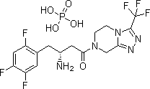

**Figure 01: Structure of sitagliptin phosphate**



**Figure 02: Structure of metformin Hcl**

## Materials and methods

### Materials

Pure drug samples of sitagliptin phosphate and metformin hydrochloride were obtained from Hetero drugs Limited, Hyderabad. JANUMET tablets (Sitagliptin phosphate 50mg and metformin hydrochloride 500 mg) were purchased from the local pharmacy. All the chemicals and reagents were of analytical grade purchased from the SD Fine chemicals, Mumbai.

### Equipments and apparatus

A double-beam Shimadzu 1800 UV-Visible spectrophotometer, with spectral bandwidth of 2 nm and a pair of 1-cm matched quartz cells was used to measure absorbance of the resulting solution. Analytical weighing balance, micropipette, sonicator and glassware’s were used throughout the experiment.

### Preparation of stock solution

Standard stock solution of sitagliptin and metformin were prepared by dissolving 10 mg of each drug in 100ml of distilled water and the resulting solution gives a concentration of 100µg/ml.

**Determination of Absorption Maxima** 10µg/ml of sitagliptin and 10µg/ml of metformin were prepared from the stock solution by appropriate dilution with distilled water. The resulting solutions were scanned separately in the range of 200-400 nm to determine the wavelength of maximum absorption for both the drugs. Sitagliptin showed absorbance maxima at 267 nm and metformin at 276 nm (Fig. 3).

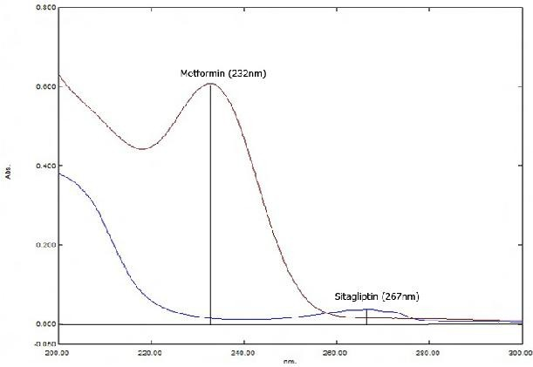

### Figure 03: Overlain spectra of Sitagliptin phosphate and Metformin hydrochloride

**Simultaneous equation method (Method I)** From the stock solution (100μg/ml), working standard solutions of 5-50µg/ml of sitagliptin and metformin were prepared by appropriate dilutions with water and were scanned separately in entire UV range to determine the λmax. The absorbances of these standard solutions were measured at 267 nm and 232 nm and calibration curves were plotted. The summary of analytical parameters and calibration data were presented in table.1 respectively.

### Second order derivative spectroscopy (Method II)

In this method solutions of sitagliptin (10μg/ml) and metformin (10μg/ml), were prepared separately by appropriate dilution of standard stock solution with the distilled water and scanned in the spectrum mode from 400 nm to 200 nm. The absorption spectra thus obtained were derivatized from first to fourth order. Second order derivative spectra were selected for analysis of both drugs. From the overlain spectra of both drugs (Fig. 4), wavelengths selected for quantitation were 278.0 nm for sitagliptin (zero crossing

point for metformin) and 249.0 nm for metformin (zero crossing point for sitagliptin). The concentration ranging from 5- 50µg/ml of sitagliptin and metformin were prepared from the standard stock solutions. The absorbances of these standard solutions were measured at 278 nm and 249 nm and calibration curves of sitagliptin and metformin were plotted. The concentration of the individual drug present in the mixture was determined against the calibration curve in quantitation mode. The calibration data were presented in table.1.

### Application of proposed method for pharmaceutical formulation

For the estimation of sitagliptin and metformin in the commercial formulations, twenty tablets (JANUMET) were weighed and average weight was calculated. The tablets were crushed in a mortar to obtain fine powder. Tablet powder equivalent to 10 mg of drug was dissolved in water and to it 9mg of sitagliptin (standard) was added (standard addition method) and diluted up to the mark with distilled water to get a concentration of 100µg/ml each of sitagliptin and metformin.

The resulting solution was ultra sonicated for

10 minutes and filtered through a Whatmann filter paper (No. 41). From the filtrate 1.0 ml was transferred to a 10.0 ml volumetric flask and diluted to the mark with the same solvent to obtain 10μg/ml of sitagliptin and 10μg/ml of metformin. Absorbances of sample solutions were measured at nm and 276.0 nm and 232 nm. The concentration of two drugs in the

sample were determined by using simultaneous equation (Method-I). The concentration of both sitagliptin and metformin were determined by measuring the absorbance of the sample at 278 nm and 249 nm in second order spectrum mode. The results of the formulation analysis were calculated against the calibration curve in quantitation mode (Method II).The results were tabulated in table.1.

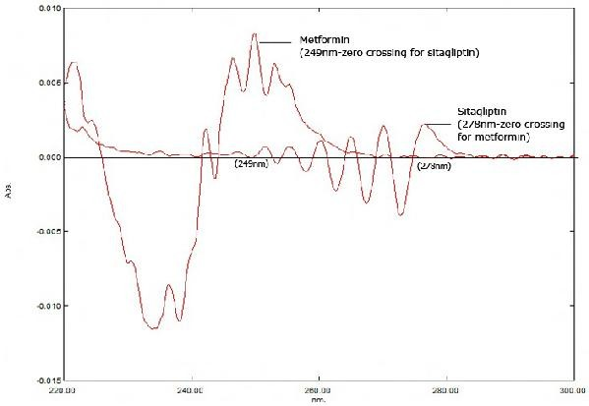

### Figure 04: Overlain second order derivative spectra of Sitagliptin and Metformin

**Table No. 01: Results of analysis of tablet formulation**

**Method**

**Tablet content Label claim (mg/tab)**

**Amount found**\* **%RSD (in mg) (in %)**

**I** sitagliptin 50 49.90 mg 99.8 0.24

metformin 500 503.2 mg 100.64 0.19

sitagliptin 50 49.34 mg 98.69 0.31

**II**

metformin 500 505.4 mg 101.08 0.41

Mean of three observations*

### Validation

The proposed method was validated as per International Conference on Harmonisation (ICH) guidelines [12-14].

### Linearity

The linearity of measurement was evaluated by analyzing different concentrations of the standard solutions of sitagliptin and metformin. For both simultaneous equation

method and second order derivative spectrophotometric method, the Beer- Lambert’s law obeyed in the concentration range o f 5-50μg/ml for both sitagliptin and metformin. The calibration graphs of sitagliptin and metformin for both the methods were shown in the figures (5 to 8). The results of their calibration data were shown in the table no: 2.

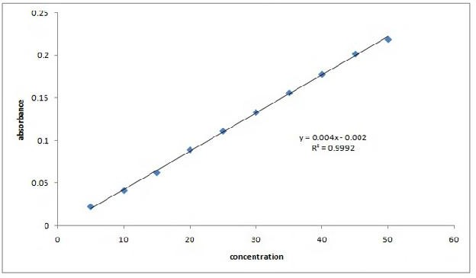

### Figure 05: Calibration graph of Sitagliptin phosphate in simultaneous equation method

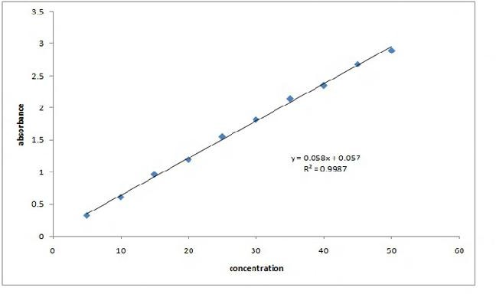

**Figure 06: Calibration graph of Metformin hydrochloride in simultaneous equation method**

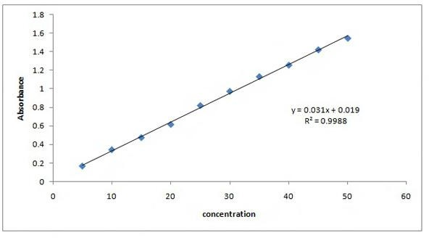

### Figure 07: Second order derivative calibration graph of Sitagliptin phosphate

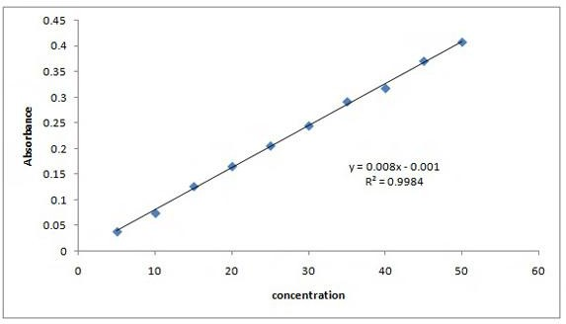

**Figure 08: Second order derivative calibration graph of Metformin hydrochloride**

### Table No. 02: Linear regression analysis of calibration curves

**Parameters Method 1 Method 2**

|  |  |  |  |  |
| --- | --- | --- | --- | --- |
|  | **Sitagliptin** | **Metformin** | **Sitagliptin** | **Metformin** |
| **Beer’s law limit (µg/ml)** | 5-50µg/ml | 5-50µg/ml | 5-50µg/ml | 5-50µg/ml |
| **Correlation coefficient (r)** | 0.9992 | 0.9987 | 0.9988 | 0.9984 |
| **Slope** | 0.004 | 0.058 | 0.031 | 0.008 |
| **Intercept** | 0.002 | 0.057 | 0.019 | 0.001 |
| **Limit of Detection (µg/ml)** | 0.825 | 0.086 | 0.106 | 0.630 |
| **Limit of Quantitation (µg/ml)** | 2.5 | 0.263 | 0.322 | 1.91 |

### Accuracy

In order to ensure the suitability and reliability of the proposed method, recovery studies were carried out. Recovery studies were carried out by standard addition method at two different levels 50% and 100% To an equivalent quantity of formulation powder (10 mg), 9 mg of standard sitagliptin was added to it (standard addition method), such that sample contains 10 mg each of sitagliptin

and metformin. Then a known quantity of standard sitagliptin and metformin were added to 50% and 100% level and the contents were reanalyzed by the proposed method. The % recovery and % RSD were calculated. The results of recovery data for both simultaneous equation method and second order derivative spectroscopic method were shown in the table.3.

### Table No. 03: Results of recovery studies

**Level of recovery**

**Amount of drug added**

**Drug**

**Method I Method II**

**% recovery %RSD % recovery %RSD**

|  |  |  |  |  |  |
| --- | --- | --- | --- | --- | --- |
| **(mg)** |  | | | | |
| **50%** 5 | sitagliptin | 98.4 | 0.24 | 99.1 | 0.41 |
| 5 | metformin | 102.1 | 0.45 | 101.6 | 0.32 |
| **100%** 10 | Sitagliptin | 98.6 | 0.39 | 99.3 | 0.46 |
| 10 | metformin | 101.42 | 0.23 | 101.31 | 0.43 |

Mean of three observations*

### Precision

The precision of the developed method was expressed in terms of % relative standard deviation (% RSD). The precision was done at two levels (intraday, interday). Intraday precision was done by analyzing the two concentrations of each drug (sitagliptin 25 and 30 µg/ml and metformin 25 and 30 µg/ml) for three times. Interday precision was measured over three consecutive days for the

same drug concentrations. The % R.S.D values found to be less than 2 for both sitagliptin and metformin in both simultaneous equation method and second order derivative spectroscopic method. Low RSD values indicate that this method is precise for the determination of sitagliptin and metformin. The results of precision studies were shown in the table.4.

### Table No. 04: Results of intermediate precision

**Method I Method II**

**Day**

**%RSD** %RSD

sitagliptin metformin sitagliptin metformin

**Intraday** 0.64 0.56 0.47 0.22

**Interday** 0.43 0.71 0.54 0.80

Mean of three observations*

### Limit of detection (LOD) and Limit of quantitation (LOQ)

The LOD and LOQ of sitagliptin phosphate and metformin hydrochloride were calculated by mathematical equation.

LOD = 3.3×standard deviation ÷ slope LOQ = 10×standard deviation ÷slope

The LOD of sitagliptin and metformin were found to be 0.825µg/ml and 0.086µg/ml in simultaneous equation method and 0.106µg/ml and 0.630µg/ml in second order derivative spectroscopic method. The LOQ of sitagliptin and metformin were found to be 2.5µg/ml and 0.263µg/ml in simultaneous equation method and 0.322µg/ml and 1.91µg/ml in second order derivative spectroscopic method.

## Results and discussion

The methods discussed in the present work provide a simple, precise, rapid and accurate way for simultaneous determination of sitagliptin and metformin. In simultaneous equation method, wavelength selected for

quantitation were 267nm (λmax of sitagliptin) and 232nm (λmax of metformin). In second order derivative spectroscopic method, wavelengths selected for quantitation were 278nm for sitagliptin (zero crossing point for metformin) and 249nm for metformin (zero crossing point for sitagliptin).The summary of analytical parameters with their calibration data were presented in (table: 2). Percent label claim for sitagliptin and metformin in tablet analysis was found to be 99.81% and 100.64% in simultaneous equation method 98.69% and 101.08% in second order derivative spectroscopic method respectively(table:1). The % RSD for precision studies were calculated for both the methods and the low RSD values obtained indicate that the methods were precise(table: 4). Accuracy of proposed methods was ascertained by recovery studies and the results were expressed as % recovery. Percent recovery for sitagliptin and metformin in simultaneous equation method was found to be 98.6% and 101.42% and 99.3% and 101.31%

in second order derivative spectroscopic method (table: 3).

## Conclusion

The proposed methods are simple, accurate, precise, reproducible and economical and can be employed for routine quality control of sitagliptin phosphate and metformin in combined dose tablet formulation.

## Acknowledgements

The authors are thankful to the management, Anurag group of institutions for providing the equipment and facilities for entire duration of the work and to Hetero Pharmaceuticals, Hyderabad, for providing gift samples of and sitagliptin phosphate and metformin hydrochloride pure drugs.

## References

1. Ramzia I El-Bagary, Ehab F Elkadyand, Bassam M Ayoub. Spectrophotometric Methods for the Determination of Sitagliptin and Pioglitazone in Bulk and Dosage Form. *Int J. Biomed. Sci*. 7, 2011, 55-61.
2. Parag Pathade, Md Imran, Vion Bairagi and Yogesh Ahire. Development and Validation of Stability Indicating UV Spectrophotometric Method for the Estimation of Sitagliptin Phosphate in Bulk and Target Dosage Form. *J. Pharm. Res*. 4(3), 2011, 871-873.
3. Ramzia IE, Ehab FE, Bassam MA. Spectroflourometric and Spectrophoto - metric Methods for Determination of Sitagliptin in Binary Mixture with Metformin and Ternary Mixture with Metformin and Sitagliptin Alkaline Degradation Product. *Int J. Biomed*. *Sci.* 7,

2011, 62–69.

1. Ramzia IE, Ehab FE, Bassam MA. Liquid Chromatographic Determination of Sitagliptin either alone or in Ternary Mixture with Metformin and Sitagliptin Degradation Product. *Talanta*. 85, 2011, 673–680.
2. Ramakrishna N, *et al*. Sensitive Liquid Chromatography Tandem Mass Spectrometry Method for the Quantification of Sitagliptin, a DPP-4 Inhibitor, in Human Plasma using Liquid Liquid Extraction. *Biomed. Chromatogr*. 22, 2008, 214–222.
3. Ajithdas A, Nancy K. Simultaneous Estimation of Metformin Hydrochloride and Glipizide in Solid Dosage Forms by Ultraviolet Spectrophotometry. *Indian Drugs.* 37(11), 2000, 533-6.
4. Arayne MS, Sultana N, Zuberi MH. Development and Validation of RP-HPLC Method for the Analysis of Metformin. *Pak J. Pharm. Sci*. 9(3), 2006, 231-235.
5. Sahoo PK, Sharma R and Chaturvedi SC. Simultaneous Estimation of Metformin Hydrochloride and Pioglitazone Hydrochloride by RP-HPLC Method from Combined Tablet Dosage form. *Indian J. Pharm. Sci*. 70(3), 2008, 383-386.
6. Bhanu R, Kulkarni S, Kadam A. Simultaneous Estimation of Gliclazide and Metformin in Pharmaceutical Dosage by Reverse Phase HPLC. *Indian Drugs.* 43(1), 2006, 16-20.
7. Yuen KH, Peh KK. Simple HPLC Method for the Determination of Metformin in Human Plasma. *J. Chromator. B.* 710(1- 2), 1998, 243-6.
8. Jain D, Jain S, Amin M. Simultaneous Estimation of Metformin Hydrochloride,

Pioglitazone Hydrochloride and Glimepride by RP-HPLC in Tablet Formulation. *J. Chromatogr. Sci*. 46(6), 2008, 501-504.

1. ICH Q2 (R1). Validation of Analytical Procedures: Text and Methodology. International conference on Harmonization of Technical Requirements for the Registration of Pharmaceutical for Human Use, Geneva, Switzerland. (2005).
2. International conference on Harmonization. Photo stability testing of new drug substance and products Q1B. International Conference on Harmonization, IFPMA, Geneva, 1996.
3. ICH Guidance on Analytical Method Validation, in: Proceedings of the International Convention on Quality for the Pharmaceutical Industry, Toronto, Canada and September 2002.