# 242

***Research Article***



International Journal of Pharmacy and Industrial Research

**ISSN Print 2231 – 3648**

**Online 2231 – 3656**

**FORMULATION AND EVALUATION OF ROPINIROLE HCL EXTENDED RELEASE MATRIX TABLETS**

# *Mohan M, Senthilkumar M, Hariharan D

Annai Veilan Kanni’s College of Pharmacy, Saidapet, Chennai, Tamilnadu, India – 600 015.

**Abstract**

The present study behind this work is to find to prepare extended release matrix tablets of Ropinirole HCl by compression method. First of all to formulate Ropinirole HCl extended release matrix tablets.

**Key words:** Natural Polymers, Ropinirole HCL, Extended release tablets, UV Analysis.

## Introduction

The oral route of drug delivery is one of the most convenient means to administer drug to the human body to obtain the desired therapeutic effect. Though it is a convenient route it provides several challenges to the formulator to design a medication such that it provides the drug in an optimum concentration needed to attain a plasma level of the drug which will fall within the therapeutic window to obtain the desired effect.

#### Ropinirole hydrochloride

**Chemical Name:** 4-[2-(dipropylamino) ethyl]- 1, 3-dihydro-2H-indol-2-one mono hydrochloride

**Empirical Formula:**C16H24N2O.HCl.

**Molecular Weight**: 296.84 (260.38 as the free base).

#### Structure

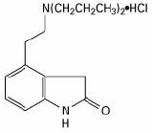

**Appearance:** White to pale greenish-yellow powder.

**Melting Range:**243° to 250°C

**Solubility**: 133 mg/ml in water, it has pH independent solubility

**Ultraviolet Spectrum**: max 210-250nm

**Drug Category:**Dopamine Agonists

**Dosage forms:**Tablet (0.25 mg, 0.5 mg, 1 mg,

2 mg, 4 mg or 5 mg)

#### Author for Correspondence:

Mohan M,

Annai Veilan Kanni’s College of Pharmacy, Saidapet, Chennai, Tamilnadu, India - 600015. Email: [harishmohan3686@yahoo.com](mailto:harishmohan3686@yahoo.com)

Mohan M et al., Int. Journal of Pharmacy & Industrial Research Vol – 02 Issue – 03 Jul – Sep 2012

243

**Storage:** Protect from light and moisture. Close container tightly after each use. Stored at controlled room temperature 20°-25°C (68°- 77°F).

#### Pharmacokinetics

**Absorption:** Tmax is 1 to 2 hrs. T1/2 of the drug is 6 hrs &C max is 2ng/ml/mg. High-fat meal increases Tmaxby 2.5 hrs and reduces Cmax by 25%, but does not affect extent of absorption. Absolute bioavailability is 55%. Steady state is reached within 2 days.

Extended-release Bioavailability is 45% to 55%. Steady state is reached within 4 days. Tmax is 6 to 10 hrs.

**Distribution:** Ropinirole is widely distributed throughout the body, with an apparent volume of distribution of 7.5 L/kg (cv = 32%). It is up to 40% bound to plasma proteins and has a blood-to-plasma ratio of 1:1.

**Metabolism:** Ropinirole is extensively metabolized by the liver. The major metabolic pathways are N-despropylation and hydroxylation to form the inactive N- despropyl metabolite and hydroxy metabolites. The N-despropyl metabolite is converted to carbamylglucuronide, carboxylic acid, and N- despropyl hydroxy metabolites. The hydroxy metabolite of ropinirole is rapidly glucuronidated. Ropinirole and its metabolites will cross placental barrier and appears in the milk.

**Elimination:** The clearance of ropinirole after oral administration to patients is 47 L/hr (cv = 45%) and its elimination half-life is approximately 6 hours. Less than 10% of the administered dose is excreted as unchanged

drug in urine. N-despropyl ropinirole is the predominant metabolite found in urine (40%), followed by the carboxylic acid metabolite (10%), and the glucuronide of the hydroxy metabolite (10%).

#### Preparation of standard curve of Ropinirole Hcl:

1. **Calibration curve in 0.1n HCl:**

100mg of Ropinirole HCl was accurately weighed and transferred into 100ml volumetric flask. It was dissolved and diluted to volume with 0.1N HCl to give stock solution containing 1000mcg/ml. The standard stock solution was then serially diluted with 0.1N HCl to get 2, 4, 6, 8, 12, 14 ,16, 18, 20, 25, 30

mcg/ml and the absorbance of the solution was measured against 0.1N HCl as the blank at 250 nm using with UV spectrophotometer (Analytical). The absorbance was plotted against concentration (mcg/ml) to obtain the standard calibration curve.

#### Calibration curve in PH 7.4 Phosphate buffer:

100mg of Ropinirole HCl was accurately weighed and transferred into 100ml volumetric flask. It was dissolved and diluted to volume with pH 7.4 Phosphate Buffer to give stock solution containing 1000mcg/ml. The standard stock solution was then serially diluted with pH 7.4 Phosphate Buffer to get 2, 4, 6, 8, 12,

14, 16, 18, 20, 25, 30 mcg/ml and the absorbance of the solution was measured against pH7.4 Phosphate Buffer as the blank at 250nm using with UV spectrophotometer (Analytical).The absorbance was plotted against concentration (mcg/ml) to obtain the standard calibration curve.

[www.ijpir.com](http://www.ijpir.com/)

# 244

Mohan M et al., Int. Journal of Pharmacy & Industrial Research Vol – 02 Issue – 03 Jul – Sep 2012

#### Formulation development:

Two strategies have been adopted to extend the release of freely water soluble drug from the formulation they are:

* 1. Wet granulation technique.
  2. Direct compression technique.

After formulating the finished dosage forms by any of the above two strategies, the finished dosage forms are charged for stability for one month, according to ICH guidelines. Finally

the samples are analyzed by UV spectroscopy, whether the release of the drug from the formulation is within the specifications or not and for drug content.

The following formulations are prepared by maintaining the effective processing conditions, NMT 50% RH and NMT 30ºC temperature. The formulations are done by wet granulation method and direct compression method for matrix tablets.

#### Table 01: Formulation development

|  |  |  |  |  |  |  |
| --- | --- | --- | --- | --- | --- | --- |
| **Ingredients(mg)** | **F1** | **F2** | **F3** | **F4** | **F5** | **F6** |
| Ropinirole HCl | 2 | 2 | 2 | 2 | 2 | 2 |
| Guar Gum | 2 | - | - | 5 | - | - |
| Sodium Alginate | - | 2 | - | - | 5 | - |
| Carbopol 940P | - | - | 2 | - | - | 5 |
| Magnesium Stearate | 3 | 3 | 3 | 3 | 3 | 3 |
| Talc | 3 | 3 | 3 | 3 | 3 | 3 |
| Micro Crystalline Cellulose | 290 | 290 | 290 | 287 | 287 | 287 |
| Total weight of the tablet | 300 | 300 | 300 | 300 | 300 | 300 |
| **Table 02: Formulation development** | | | | | | |

|  |  |  |  |  |  |  |  |  |
| --- | --- | --- | --- | --- | --- | --- | --- | --- |
| **Ingredients(mg)** | **F7** | **F8** | **F9** | **F10** | **F11** | **F12** | **F13** | **F14** |
| Ropinirole HCl | 2 | 2 | 2 | 2 | 2 | 2 | 2 | 2 |
| Guar gum | 2 | - | - | 5 | - | - | 1 | 1 |
| Sodium Alginate | - | 2 | - | - | 5 | - | 1 | 1 |
| Carbopol 940P | - | - | 2 | - | - | 5 | - | - |
| Magnesium Stearate | 3 | 3 | 3 | 3 | 3 | 3 | 3 | 3 |
| Talc | 3 | 3 | 3 | 3 | 3 | 3 | 3 | 3 |
| Micro crystalline cellulose | 290 | 290 | 290 | 287 | 287 | 287 | 290 | 290 |
| Total weight of the Tablet | 300 | 300 | 300 | 300 | 300 | 300 | 300 | 300 |

1. **Preformulation studies of drug and excipients**

Preformulation testing is the first step in the development of dosage forms of a drug substance. It can be defined as “investigation of physical and chemical propertiesof the drug substance alone and when combined with excipients”.These studies should focus on those physicochemical properties of the new compound that could affect the drug

performance and development of an efficacious dosage form.The overall objective of preformulation testing is to generate information useful to the formulator in developing stable and bioavailable dosage forms that can be mass-produced.

**Description / Appearance**

### Ropinirole hydrochloride is a white to pale greenish-yellow powder.

[www.ijpir.com](http://www.ijpir.com/)

Mohan M et al., Int. Journal of Pharmacy & Industrial Research Vol – 02 Issue – 03 Jul – Sep 2012

245

#### Determination of Melting Point:

Melting point of Ropinirole Hcl was determined by capillary method found to be in the range 243° to 250°C, which complied with USP standards, indicating purity of the drug sample.

1. **Standard curve of Ropinirole HCl** Standard curve of Ropinirole HCl was determined in PH 7.4 Phosphate buffer and 0.1N HCl, by plotting Absorbance against Concentration at 250 nm, and it follows the Beer’s law. Results were tabulated below.

#### Table 03: Standard curve of Ropinirole HCl in 0.1N HCl at 250nm

|  |  |
| --- | --- |
| **Concentration**  **(in mcg/ml)** | **Absorbance** |
| 2 | 0.064 |
| 4 | 0.124 |
| 6 | 0.187 |
| 8 | 0.248 |
| 10 | 0.305 |
| 12 | 0.371 |
| 16 | 0.496 |
| 20 | 0.605 |

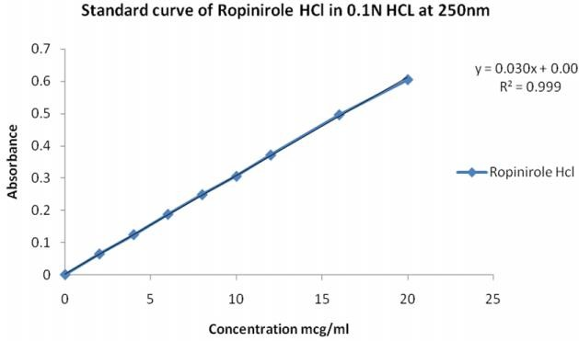

**Figure 01: Standard curve of Ropinirole HCl in 0.1N HCl at 250nm**

#### Table 04: Standard curve of Ropinirole HCl in pH 7.4 Phosphate buffer at 250nm

|  |  |
| --- | --- |
| **Concentration**  **(in mcg/ml)** | **Absorbance** |
| 2 | 0.055 |
| 4 | 0.110 |
| 6 | 0.185 |
| 8 | 0.225 |
| 12 | 0.334 |
| 14 | 0.400 |
| 16 | 0.450 |
| 18 | 0.524 |
| 20 | 0.580 |
| 25 | 0.705 |
| 30 | 0.850 |

[www.ijpir.com](http://www.ijpir.com/)

# 246

Mohan M et al., Int. Journal of Pharmacy & Industrial Research Vol – 02 Issue – 03 Jul – Sep 2012

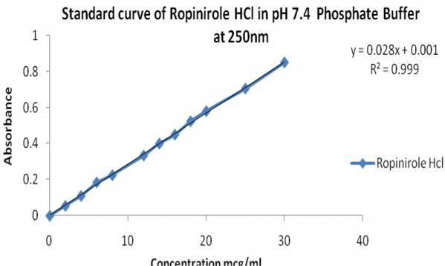

#### Figure 02: Standard curve of Ropinirole HCl in pH 7.4 Phosphate buffer at 250nm

1. **Formulation development**

Extended Release tablets of Ropinirole hydrochloride were prepared. In the present study 14 formulations with variable concentration of polymer were prepared and evaluated for physico-chemical parameters, in vitro release studies and stability studies.

#### Evaluation of tablet formulations: Pre-Compression Parameters:

1. **Angle of Repose:**The angle of repose for the formulated blend was carried out and it was found to be in the range 200.88' to 29..
2. **Bulk density:** The bulk density for the formulated blend was carried out.

**Compressibility Index:** Compressibility index was carried out, it found between 28.34% and 32.30% and results were shown in table.

#### Post-compression Parameters:

The tablets of different formulations were physically characterized by parameters like thickness, average weight, hardness, and friability, uniformity of weight and In vitro dissolution studies.

1. **Average weight***:* Weigh 20 tablets and average weight was calculated.
2. **Thickness:** The thickness of the formulations was found in the range of 5.6± 0.3mm. The tablets exhibited uniform thickness among the different formulations.
3. **Hardness:** The hardness of the tablets of all batches was ranged from 7-8 kg/cm2 which were sufficient to maintain the mechanical strength.
4. **Friability:** The percentage friability was less than 0.1%. In the present study, the percentage friability for all the formulations was found below 0.1% indicating that friability (%) is within the acceptable limits.
5. **Uniformity of Weight:** As per USP limit, the percentage deviation for tablets of weight greater than 324 mg is ± 5%. The percentage deviation of all tablet formulations was found within ±5% and hence all formulations pass the test for uniformity of weight.
6. **Assay:** Good uniformity in drug content was found among different batches of the tablets

[www.ijpir.com](http://www.ijpir.com/)

Mohan M et al., Int. Journal of Pharmacy & Industrial Research Vol – 02 Issue – 03 Jul – Sep 2012

247

and the percentage content was with in90%- 110%.

1. **Dissolution profile:** The dissolution profile of the tablets has been tabulated (according to strategies I, II respectively).

#### Table 05: Pre-compression Parameters for strategy I

**Powder**

**Angle of Repose**

**Loose Bulk Density**

**Tapped Bulk Density**

**Compressibility Index**

**Hausner**

|  |  |  |  |  |  |
| --- | --- | --- | --- | --- | --- |
| **blend** | **(0)** | **(g/ml)** | **(g/ml)** | **(%)** | **ratio** |
| **F1** | 24 | 0.59 | 0.77 | 23.41 | 1.33 |
| **F2** | 23.5 | 0.6 | 0.765 | 19.91 | 1.27 |
| **F3** | 22.0 | 0.562 | 0.692 | 18.78 | 1.23 |
| **F4** | 20.8 | 0.551 | 0.656 | 16.26 | 1.19 |
| **F5** | 21.9 | 0.556 | 0.684 | 18.71 | 1.22 |
| **F6** | 22.5 | 0.557 | 0.679 | 17.96 | 1.21 |

#### Table 06: Pre-compression Parameters for strategy II

**Powder**

**Angle of Repose**

**Loose Bulk Density**

**Tapped Bulk Density**

**Compressibility Index**

**Hausner**

|  |  |  |  |  |  |
| --- | --- | --- | --- | --- | --- |
| **blend** | **(0)** | **(g/ml)** | **(g/ml)** | **(%)** | **ratio** |
| **F7** | 24.30' | 0.422 | 0.600 | 29.57 | 1.42 |
| **F8** | 26.77' | 0.461 | 0.666 | 29.41 | 1.5 |
| **F9** | 25.28' | 0.410 | 0.652 | 34.24 | 1.52 |
| **F10** | 28.56' | 0.447 | 0.638 | 29.85 | 1.42 |
| **F11** | 29.88' | 0.434 | 0.652 | 33.33 | 1.41 |
| **F12** | 25.30' | 0.416 | 0.638 | 34.72 | 1.53 |
| **F13** | 26.47' | 0.404 | 0.603 | 32.432 | 1.48 |
| **F14** | 24.28' | 0.428 | 0.612 | 30.00 | 1.42 |

#### Table 07: Post -Compression parameters for strategy I

**Formulations**

**Average Weight (mg) (n = 20)**

**Friability (%)**

**Hardness (kg/cm2)**

**Thickness (mm)**

**Assay (%) (n = 6)**

#### Table 08: Post -Compression parameters for strategy II

|  |  |  |  |  |  |
| --- | --- | --- | --- | --- | --- |
|  | | **(n = 10)** | **(n = 3)** | **(n = 3)** |  |
| **F1** | 298 | 0.01 | 7-8 | 5.6 | 98.02 |
| **F2** | 289 | 0.02 | 7-8 | 5.7 | 103.9 |
| **F3** | 305 | 0.01 | 7-8 | 5.6 | 99.53 |
| **F4** | 305 | 0.02 | 6-8 | 5.5 | 98.01 |
| **F5** | 298 | 0.04 | 6-8 | 5.6 | 101.1 |
| **F6** | 295 | 0.01 | 6-8 | 5.6 | 99.3 |
| **MP** | 300 | 0.02 | 6-8 | 5.2 | 99.8 |

|  |  |  |
| --- | --- | --- |
| **Average Friability** | **Hardness** | **Thickness** |
| **Formulations Weight (%)** | **(kg/cm2)** | **(mm) Assay (%)** |
| **(mg) (n = 10)** | **(n = 3)** | **(n =3) (n = 6)** |

|  |  |  |  |  |  |
| --- | --- | --- | --- | --- | --- |
| **F7** | **(n = 20)**  298 | 0.01 | 7-8 | 5.7 | 102.3 |
| **F8** | 300 | 0.02 | 7-8 | 5.6 | 101.2 |
| **F9** | 305 | 0.01 | 6-8 | 5.6 | 99.3 |
| **F10** | 289 | 0.01 | 6-8 | 5.7 | 103.9 |
| **F11** | 303.5 | 0.02 | 7-8 | 5.6 | 99.53 |
| **F12** | 310 | 0.02 | 6-7 | 5.5 | 98.01 |
| **FT13** | 300 | 0.0 | 7-8 | 5.6 | 101.1 |
| **FT14** | 305 | 0.0 | 7-8 | 5.6 | 99.3 |
| **MP** | 300 | 0.01 | 6-8 | 5.2 | 99.8 |

[www.ijpir.com](http://www.ijpir.com/)

# 248

Mohan M et al., Int. Journal of Pharmacy & Industrial Research Vol – 02 Issue – 03 Jul – Sep 2012

## Dissolution studies for strategy (Wet granulation)

### Dissolution studies were conducted by taking 0.1N HCl as dissolution media for the first two hours period and replacing the medium with pH 7.4 Phosphate buffer for the next six hours.

**Time (in hrs)**

#### Table 09: Dissolution data of Ropinirole Hcl extended release tablets

**Cumulative % Drug Release**

|  |  |  |  |  |  |  |
| --- | --- | --- | --- | --- | --- | --- |
| **F1** | **F2** | **F3** | **F4** | **F5** | **F6** | **F7** |
| 0.5 35.28±0.11 | 41.51±1.25 | 49.61±1.26 | 49.26±1.07 | 43.25±1.27 | 35.24±0.08 | 36±0.21 |
| 1 53.11± 0.09 | 63.46±0.08 | 74.45±1.06 | 60.14±1.42 | 68.36±1.65 | 48.96±0.7 | 40.7±0.9 |
| 2 76.94± 1.26 | 78.98±1.19 | 87.71±1.11 | 69.25±1.44 | 71.48±1.05 | 67.28±1.09 | 45.5±1.01 |
| 3 87.31± 0.7 | 86.61±1.05 | 98.45±1.16 | 78.24±1.29 | 79.26±0.15 | 79.31±0.12 | 54.5±1.06 |
| 4 97.68± 0.59 | 99.86±1.01 | 99.45±1.26 | 88.26±0.12 | 89.24±0.35 | 92.36±1.16 | 68.5±1.07 |

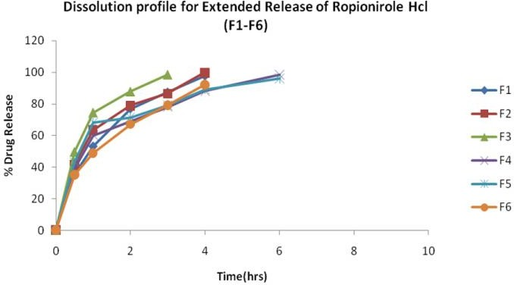

#### Figure 03: Dissolution Data of Ropinirole Hcl Extended Release Tablets of F1-F7.

**Dissolution studies for strategy ii (direct compression)**

Dissolution studies were conducted by taking 0.1N HCl as dissolution media for the first two hours period and replacing the medium with pH 7.4 Phosphate buffer for the next six hours.

#### Table 10: Dissolution profile for innovator

|  |  |  |
| --- | --- | --- |
| **Time(hrs)** | **INOVATOR** | **F7** |
| 0 | 35±0.21 | 36±0.21 |
| 1 | 42.7±0.9 | 40.7±0.9 |
| 2 | 49.5±1.01 | 45.5±1.01 |
| 3 | 56.5±1.06 | 54.5±1.06 |
| 4 | 63.5±1.07 | 68.5±1.07 |
| 6 | 85.6±0.12 | 82.6±0.12 |
| 8 | 98.1±0.09 | 98.4±0.09 |

[www.ijpir.com](http://www.ijpir.com/)

Mohan M et al., Int. Journal of Pharmacy & Industrial Research Vol – 02 Issue – 03 Jul – Sep 2012

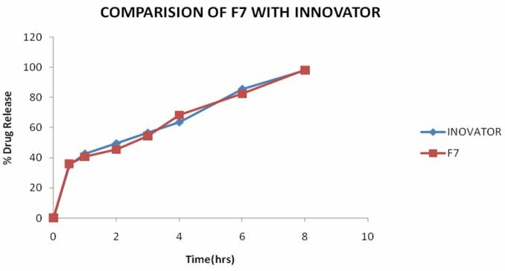

#### Figure 04: Dissolution Profile for Innovator Vs F7

249

## Results and discussion

Extended release tablets have come into light due to the development of several new chemical entities which have high solubility. The primary applications for rate controlling polymers is for decreasing dissolution rate and extend the release of water soluble drug. Successful drug design with polymers depends largely on understanding the physical, chemical and physiological factors that promote bioavailability. It requires a grasp of not only the drug candidates but also the role of the delivery system or the potential of the drug- excipient interplay in vitro as well as in vivo.

The development of an extended release tablets for a drug having high solubility is an approach to obtain a controlled release.

In one strategy, matrix formers are Guar gum, Sodium alginate, Carbopol 940P, were used in different quantities by using Wet Granulation method.

In other strategy same matrix formers are Guar gum, Sodium alginate, Carbopol 940P were employed in different quantities and formulated by using Direct compression technique.

## Conclusion

The conclusion of the study is as follows:

* In the Preformulation studies, it was found that Ropinirole HCl has solubility with independent of PH, i.e it is freely soluble in all PH values.
* The tablets prepared were found to be within the official limits with respect to hardness, weight variation, drug content, friability, thickness etc.
* In Strategy I, an Optimized formulation was obtained by using “Wet granulation technique”.
* In Strategy II, an Optimized formulation was obtained by using “Direct compression technique”.
* Among all the Fourteen formulations of strategy I and strategy II, the release profile of trial F7 was found to be showing better controlled release for an extended period of time.
* The Stability data reveals that the F7 of strategy II showed a negligible change in drug content after storage in various

[www.ijpir.com](http://www.ijpir.com/)

# 250

Mohan M et al., Int. Journal of Pharmacy & Industrial Research Vol – 02 Issue – 03 Jul – Sep 2012

conditions for one month according to ICH guidelines.

* The optimised extended release formulation (F7) was found similar and comparable to the innovator product.
* From the study, it may be concluded that F7 of strategy II is a successful formulation.

In Conclusion, The results demonstrated that the finished product formulations F7 fulfilled all the specifications of the physical properties and In vitro release in accordance with the extended release formulation.

## Acknowledgement

We are thanking full to our Principal Mr. M.Senthilkumar, M.pharm, PhD. & Prof. Mrs. Valarmathi f or their cooperation to finish the work. We are thanking our chairman Dr.S.Devaraj for providing the facilities to complete the work. We thank all our staff members & Friends for their support & help for successful competition.

## References

1. Berger K, Luedemann J, Trenkwalder C, John U, Kessler C. Sex and the risk of restless legs syndrome in the general population. *Arch Intern Med* 2004;164:196–202.
2. Allen RP, Walters AS, Montplaisir J, *et al*. Restless legs syndrome prevalence and impact: REST general population study. *Arch Intern Med* 2005;165:1286–1292.
3. Högl B, Kiechl S, Willeit J. Restless legs syndrome: a communitybased study of prevalence, severity, and risk factors. *Neurology*2005;64:1920–1924.
4. Hening W, Walters AS, Allen RP, Montplaisir J, Myers A, Ferini-Strambi L. Impact, diagnosis and treatment of restless legs syndrome (RLS) in a primary care population: The REST (RLS epidemiology, symptoms, and treatment) primary care study. *Sleep Med* 2004;5:237–246.
5. Hening WA, Allen RP, Chaudhuri KR. Clinical significance of RLS. *MovDisord* 2007;22(Suppl 18):S395–400.
6. Garcia-Borreguero D, Egatz R, Winkelmann J, Berger K. Epidemiology of restless legs syndrome: the current status. *Sleep Med Rev* 2006;10:153–167.
7. Allen RP, Walters AS, Montplaisir J. Restless legs syndrome prevalence and impact: REST general population study. *Arch Intern Med* 2005;165:1286–1292.
8. Picchietti D, Allen RP, Walters AS, Davidson JE, Myers A, FeriniStrambi L. Restless legs syndrome: prevalence and impact in children and adolescents, the Peds REST study. *Pediatric*s 2007;120:253–266.
9. Allen RP, Picchietti D, HeningWA. Restless legs syndrome: diagnostic criteria, special considerations, and epidemiology. A report from the restless legs syndrome diagnosis and epidemiology workshop at the National Institutes of Health.*Sleep Med*2003;4:101– 119.
10. Hening WA, Allen RP, Washburn M, Lesage SR, Earley CJ. The four diagnostic criteria for restless legs syndrome are unable to exclude confounding conditions (“mimics”). *Sleep Med* 2009, In press.
11. Earley CJ. Restless legs syndrome.*N Engl J Med*2003;348:2103–2109.

[www.ijpir.com](http://www.ijpir.com/)

Mohan M et al., Int. Journal of Pharmacy & Industrial Research Vol – 02 Issue – 03 Jul – Sep 2012

251

1. Winkelmann J, Prager M, Lieb R. “Anxietastibiarum”. Depression and anxiety disorders in patients with restless legs syndrome.*J Neurol* 2005;252:67–71.
2. Montplaisir J, Boucher S, Poirier G, Lavigne G, Lapierre O, Lespérance P. Clinical, polysomnographic, and genetic characteristics of restless legs syndrome: a study of 133 patients diagnosed with new standard criteria. *MovDisord*1997;12:61–

in rats: a possible model for restless legs syndrome. *MovDisord*1998;13:271–275.

1. Qu S, Ondo WG, Zhang X, Xie WJ, Pan TH, Le WD. Projections of diencephalic dopamine neurons into the spinal cord in mice. *Exp Brain Res* 2006;168:152–156.
2. Earley CJ, Allen RP, Connor JR, Ferrucci L, Troncoso J. The dopaminergic neurons of the A11 system in RLS autopsy brains appear normal. *SleepMed* 2009, In press.

|  |  |  |  |  |  |  |
| --- | --- | --- | --- | --- | --- | --- |
|  | 65. |  |  |  | 22. | Cervenka S, Palhagen SE, Comley RA. |
| 14. | Shapira | AHV. | Restless | legs |  | Support for dopaminergic hypoactivity in |

syndrome.*Drugs.*2004;64:149–158.

* 1. Abetz L, Allen R, Follet A. Evaluating the quality of life of patients with restless legs syndrome. *ClinTher* 2004;26:925–935.
  2. Winkelmann J. Genetics of restless legs syndrome. *CurrNeurolNeurosci Rep* 2008;8:211–216.
  3. Khaldy H, Leon J, Escames G, Bikjdaouene L, García JJ, Acuña- Castroviejo D. Circadian rhythms of dopamine and dihydroxyphenyl acetic acid in the mouse striatum: effects of pinealectomy and melatonin treatment. *Neuroendocrinology*2002;75:201–208.
  4. Clemens S, Rye D, Hochman S. Restless legs syndrome. Revisiting the dopamine hypothesis from the spinal cord perspective.*Neurology* 2006;67:125–130.
  5. Ondo WG, He Y, Rajasekaran S, Le WD. Clinical correlates of 6-hydroxydopamine injections into A11 dopaminergic neurons

restless legs syndrome: a PET study on D2-receptor binding. *Brain* 2006; 129:

2017–2028.

1. Etgen T, Draganski B, Ilg C. Bilateral thalami gray matter changes in patients with restless legs syndrome. *Neuroimage*2005;24:1242–1247.
2. Sewards TV, Sewards MA. The medial pain system: neural representations of the motivational aspect of pain. *Brain Res Bull*2002;59:163–180.
3. Spiczak S, Whone AL, Hammers A. The role of opioids in restless legs syndrome: an [11C]diprenorphine PET study. *Brain*2005;128:906–917.
4. Akpinar S. Treatment of restless legs syndrome with levodopa plus benserazide. *Arch Neurol*1982;39:739.
5. Akpinar S. Restless legs syndrome treatment with dopaminergic drugs. *ClinNeuropharmacol*1987;10:69–79.

[www.ijpir.com](http://www.ijpir.com/)