***Research Article***



International Journal of Pharmacy and Industrial Research

**ISSN Print 2231 – 3648**

**Online 2231 – 3656**

**ANTIULCER ACTIVITY OF**

**TABERNAEMONTANA DIVARICATA LINN. IN RATS**

# **\***Umarani V, Sudhakar M, Lakshmi B V S

Malla Reddy College of Pharmacy, Hyderabad, Andhra Pradesh, India – 500 014.

## Abstract

Antiulcer activity of *Tabernaemontana divaricata* was studied in rats in which gastric ulcers were induced by oral administration of ethanol or 0.6 M HCl or indomethacin or by pyloric ligation and duodenal ulcers were induced by oral administration of cysteamine HCl. AETP was administered in the dose of 1 to 20 mg/kg orally 30 min prior to ulcer induction. The antiulcer activity was assessed by determining and comparing the ulcer index in the test drug group with that of the vehicle control group. Gastric total acid output and pepsin activity were estimated in the pylorus ligated rats. Omeprazole was used as a reference drug. The ulcer index in the treated animals was found to be significantly less in all the models compared to vehicle control animals. This antiulcer property was more prominent in animals in which ulcers were induced by HCl, indomethacin and pyloric ligation. Omeprazole (8mg/kg) produced a significant gastric and duodenal ulcer protection when compared with the control group. The anti-ulcer activity of *Tabernaemontana divaricata* was however, less than that of omeprazole. Our results suggest that *Tabernaemontana divaricata* possesses significant antiulcer property which could be either due to cytoprotective action of the drug or by strengthening of gastric and duodenal mucosa and thus enhancing mucosal defence. Cytoprotection duodenal ulcer mucosal defence ulcer protection.

**Key words:** Cytoprotection, Duodenal ulcer mucosal, Defence ulcer protection.

## Introduction

*Tabernaemontana divaricata* is a plant, known as 'Nandivrksha' in Sanskrit and 'Chandni' in Hindi 1-3. It has been reported to possess hepatoprotective, mast cell stabilizing and erythrocyte membrane integrity enhancing effect in various experimental models4 , 5. In Ayurvedic literature *Tabernaemontana divaricata* is given the name of 'Sarwa wran vishapaha' which means that it has the property to cure all type of wounds. Since gastric and

duodenal ulcers are inner wounds, we have studied the antiulcer potential of this plant on different models of gastric and duodenal ulceration.

## Material and methods

### Experimental animals

The study was conducted on Albino rats (Wistar) of 150-200 g and maintained under standard conditions (room temperature 24-

### Author for Correspondence:

Umarani V,

Malla Reddy College of Pharmacy, Hyderabad, Andhra Pradesh, India – 500 014. Email: [rajeswarimpharm@gmail.com](mailto:rajeswarimpharm@gmail.com)

27oC and humidity 60-65%) with 12 h light and dark cycle. The food in the form of dry pellets (Amrut Lab., Pune) and water were available ad libitum. Rats of either sex, were randomly allocated to groups of 6- 10 animals each.

The animal experiments were approved by the ethics committee of the institute.Chemicals and drugs: Ethanol, HCl LR, cysteamine (Sigma Chemical Co., USA), indomethacin (Torrent Research Centre, Gandhinagar), omeprazole (Kopran Pharma Ltd., Mumbai), aqueous extract of *Tabernaemontana divaricata* and carboxy methyl cellulose (CMC) were used in the study.

### Preparation of aqueous extract of

***Tabernaemontana divaricata***

Since the plant *Tabernaemontana divaricata* grows wildly in Andhra Pradesh it was collected locally and identified by the Plant Anatomy Research Centre (PARC). A voucher specimen has been kept in the department for further reference. Aerial parts of the plants were removed and roots were cut into small pieces and dried under shade in a room. After 7 days of drying, the roots were powdered by grinding and sieved with a 40 # sieve. The powder was then macerated with distilled water for 24 h. Later the extract was filtered and dried at 45oC (yield 7.46%).

In all the experimental models of gastroduodenal ulcer formation the control (group I) and the reference group (group VI) received 0.5 % carboxy methyl cellulose (CMC), 1 ml/kg and omeprazole 8 mg/kg, p.o. respectively. The treatment groups (group II - V) received graded doses of *Tabernaemontana*

*divaricata* extract 1, 5, 10 (or) 20 mg/kg, p.o. as indicated in the tables.

### Gastric cytoprotection methods6

(Ethanol / 0.6 M HCl induced ulcers). Thirty minutes after the test or reference drug or the control vehicle treatment, 1 ml of ethanol or

0.6 M HCl was orally administered to each rat. After 1 h the rats were euthanized with excess of anesthetic ether and stomach was cut open along the greater curvature, cleared of residual matter with saline and the inner surface was examined for ulceration. Ulcer index and % ulcer protection were calculated by using the methods described earlier.

### Indomethacin-induced gastric mucosal damage6

The test drug or reference drug or the control vehicle was administered in two doses at an interval of 15 h. Indomethacin (10 mg/kg, p.o.) was administered by gavage needle in two doses after 30 min. of administration of each dose of test compound. One hour after the second dose of indomethacin all rats were sacrificed. The number of ulcer spots in the glandular portion of the stomach were counted in both control and drug treated animals and the ulcer index was calculated.

**Cysteamine-induced duodenal ulceration6** Cysteamine HCl (400 mg/kg, p.o. in 10% aqueous solution) was administered in two doses at an interval of 4 h to produce duodenal ulcers in rats. The *Tabernaemontana divaricata* extract or reference drug or control vehicle was administered 30 min before each dose of cysteamine HCl. All the animals were sacrificed 24h after the first dose of cysteamine and the duodenum was excised carefully and

opened along the antimesenteric side. The ulcer score was obtained by measuring the dimensions of the duodenal ulcer(s) in square millimeters and ulcer index was determined using the method described earlier.

### Pyloric ligation method6

In this method albino rats were fasted in individual cages for 24h. Care was being taken to avoid coprophagy. *Tabernaemontana divaricata* extract or reference drug or control vehicle was administered 30 min prior to pyloric ligation. Under light ether anesthesia, the abdomen was opened and the pylorus was ligated. The abdomen was then sutured. At the end of 4 h after ligation, the animals were sacrificed with excess of anesthetic ether, and the stomach was dissected out. Gastric juice was collected and its volume was measured. The glandular portion was then exposed and examined for ulceration. Ulcer index was determined.

### Total acid output and pepsin activity

Total acid output and pepsin activity were estimated from gastric juice collected from the 4 h pyloric ligated rats.

### Estimation of total acid output

Total acid output of the gastric juice was estimated7 by titration of 0.1 ml of gastric juice with 0.01 N sodium hydroxide using phenolphthalein as indicator. Total acid output was expressed as mEq/L per 100 gm of body weight.

### Estimation of pepsin activity

Pepsin activity was estimated using a method8 which incorporates the digestion of hemoglobin solution by pepsin resulting in the

formation of tyrosine. The formed tyrosine was separated and treated with alkaline reagent and phenol reagent so as to develop a blue color which was estimated using spectro- photometer at 610 nm.

### Statistical analysis

The statistical analysis was carried out using one-way ANOVA followed by Dunnett's multiple comparisons for the data which are normally distributed. For the data of ordinal type, a non parametric test was used. Kruskal- Wallis one-way ANOVA was computed for overall significance and for observing significant difference. Wilcoxon Rank Sum test was used to analyze independent groups or significant difference between them. All the result obtained in the study was compared with the vehicle control group. P values <0.05 were considered statistically significant.

## Results

**Effect of *Tabernaemontana divaricata* on ethanol induced gastric ulcers**

Pretreatment of rats with *Tabernaemontana divaricata* (1-20 mg /kg) produced a dose dependent protection from ethanol induced ulceration, as compared to control animals. However, the protection was not statistically significant at 1 mg/kg dose. Omeprazole (8 mg/kg) produced significant gastric ulcer protection as compared to control group animals (Table 1).. The protection was statistically significant only at 10 and 20 mg/kg dose. Omeprazole (8 mg/ kg) produced significant gastric ulcer protection as compared to control group (Table 1).

**Effect of *Tabernaemontana divaricata* on indomethacin induced gastric ulcers** Pretreatment of rats with *Tabernaemontana divaricata* (5-20 mg/ kg) produced a dose dependent protection from the indomethacin induced ulceration, as compared to control animals. The protection was statistically significant at 5, 10 and 20 mg/kg dose. Omeprazole (8 mg/kg) produced significant protection as compared to control group (Table 1).

**Effect of *Tabernaemontana divaricata* on cysteamine induced duodenal ulcers**

In the cysteamine induced duodenal ulcers oral administration of *Tabernaemontana divaricata* at the dose of 5-20 mg/ kg showed a reduction in ulcer index in a dose dependent manner. AETD (20 mg/kg) produced Effect of AETD on 0.6 M HCl induced gastric ulcers.

Pretreatment of rats with *Tabernaemontana divaricata* (5 -20 mg / kg) produced a dose dependent protection from the 0.6 M HCl induced ulceration, as compared to control statistically significant reduction in ulcer score as compared to control animals. Omeprazole (8 mg/kg) produced significant protection as compared to control group (Table 2).

**Effect of *Tabernaemontana divaricata* in pylorus ligated rats**

*Tabernaemontana divaricata* in the doses of 5- 10 mg/kg produced a significant reduction in the ulcer index. However, it failed to produce any significant effect on gastric volume, total acid output and pepsin activity. Omeprazole (8 mg/kg) produced significant reduction in gastric ulcer and total acid output as compared to control group (Table 3).

**Table 01: Effect of *Tabernaemontana divaricata* against ethanol/0.6 M HCl /indomethacin induced gastric ulcers in rats**

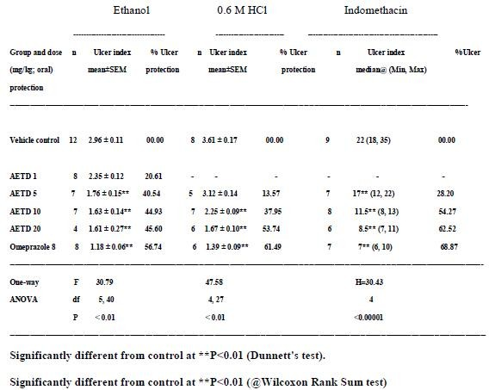

**Table 02: Effect of *Tabernaemontana divaricata* against cysteamine induced duodonal ulcers in rats.**

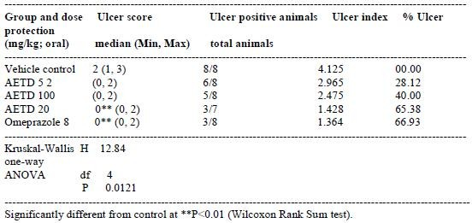

**Table 03: Effect of *Tabernaemontana divaricata* in pylorus ligated rats.**

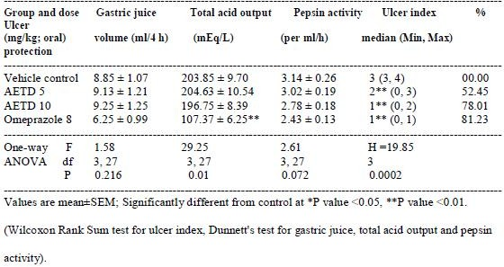

## Discussion

Results of this study establish a cytoprotective action of *Tabernaemontana divaricata* as it was found effective against both the models viz ethanol and 0.6 M HCl used for producing cytodestructive damage in the gastric mucosa of rats. Cytoprotection by drugs has been considered to be due to the generation of prostaglandins by anti-ulcer drugs when used in their non-anti secretory doses9. The cytoprotective action has also been substantiated by the protective effect of

*Tabernaemontana divaricata* extract against indomethacin induced gastric ulceration in rats which is caused by the inhibition of the synthesis of endogenous cytoprotective prostaglandins10.

It has also been observed that *Tabernae - montana divaricata* extract significantly and dose dependently reduced the extent of gastric ulceration in pylorus ligated rats without affecting the gastric secretion or pepsin activity. These results further point out to

cytoprotection as the major mechanism responsible for the anti-ulcer activity of this drug as *Tabernaemontana divaricata* produces significant anti-ulcer effect but not antisecretory effect. On the other hand omeprazole, the standard drug produces anti- ulcer effect by inhibiting gastric secretion and reducing pepsin activity. The protective effect of *Tabernaemontana divaricata* extract against cysteamine induced duodenal ulcers may be due to the strengthening of duodenal mucosa11 or by other mechanisms like increased gastric and duodenal alkaline secretion12 or by increased luminal prostaglandin levels13.

Though we have not studied the active principles responsible for the anti-ulcer activity of *Tabernaemontana divaricata*, it is likely that flavonoidal compounds tephrosin, pongaglabol and semiglabrin present in Tephrosia purpurea14 may be involved in this action as flavonoids have been reported to possess significant anti-ulcer activity in various experimental models of gastric and duodenal ulceration15. Thus our studies establish a significant antiulcer and cytoprotective effect of *Tabernaemontana divaricata* extract. However, further studies are required to establish its exact mode of action and the active principles involved in its anti- ulcer effect.

## References

1. Kirtikar KR, Basu BD. Indian medicinal plants. 2nd ed. Vol-1. Dehradun: International Book Distributors; 1975.
2. Nadkarni K M. Indian Materia Medica, 3rd ed. Vol 1.Mumbai: Popular Prakashan Ltd; 1989.
3. The Wealth of India-A dictionary of Indian raw materials and industrial products, Revised edition. Vol X. New Delhi:CSIR; 1982.
4. Murthy MSR, Srinivasan M. Hepato - protective effect ofTephrosia purpurea in experimental animals. Indian JPharmacol 1993;25:34-6.
5. Gokhale AB, Dikshit VJ, Damle AS, Kulkarni KR, Saraf MN.Influence of ethanolicextract of Tephrosia purpurea Linn.on mast cells and erythrocytes membrane integrity. IndianJ Exp Biol 2000;38:837-40.
6. Parmar NS, Desai JK. A review of the current methodologyfor the evaluation of gastric and duodenal antiulcergents. Indian J Pharmacol 1993;25: 120-35.
7. Hawk PB, Ostor BL. Hawk's physiological chemistry. 14th ed. New York: Mc Graw Hill; 1965.
8. Debnath PK, Gode KD, Govinda DA, Sanyal AK. Effect of propranolol on gastric secretion in albino rats. Br J Pharmacol 1974 ; 51 : 213.
9. Robert A, Nezmin JE, Lancaster C, Hanchar AJ. Cytoprotection by prostaglandins in rats. Prevention of gastric necrosis produced by HCl, NaOH, Hypertonic NaCl and thermal injury. Gastroenterogy 1979; 76: 439-43.
10. Lanza FL. A guideline for the treatment and prevention of NSAID-induced ulcers. Am J Gastroenterol, 1998 ; 90 : 2037 -45.
11. Garner A. Enhancing mucosal defense and repair mechanisms. In: Rees WDW, editor. Advances in peptic ulcer pathogenesis. Lancaster: MTP Press; 1988. p. 225-37.
12. Rees WDW, Turnberg LA. Mechanism of gastric mucosal protection: A role for the

"mucus bicarbonate" barrier. Clin Sci 1982; 62 : 343-8.

1. Konturek SJ, Bilski J, Kwiecien N, Obtulowicz W, Kopp B, Olesky J. De-Nol stimulates gastric and duodenal alkaline secretion through prostaglandin dependent mechanism. Gut 1987 ; 28: 1556-83.
2. Ahmed VU, Ali Z, Hussaini SR, Iqbal F, Zahid M, Abbas M, et al. Flavonoids of Tephrosia purpurea. Fitoterapia 1999; 70: 443-45.
3. Parmar NS, Parmar S. Antiulcer potential of flavonoids. Indian J Physiol Pharmacol 1998 ; 42 : 343-51.