# 212

***Research Article***



International Journal of Pharmacy and Industrial Research

**ISSN Print 2231 – 3648**

**Online 2231 – 3656**

**DISSOLUTION ENHANCEMENT OF PIOGLITAZONE HYDROCHLORIDE USING β- CYCLODEXTRIN**

**\***Sowmya C, Suryaprakash Reddy C, Bharath kumar G, Siva Prasad N Raghavendra Institute of Pharmaceutical Education and Research, Anantapur, Andhra Pradesh, India – 515 721.

## Abstract

Pioglitazone hydrochloride is an oral anti diabetic drug. It is poorly soluble in water. In the present investigation an attempt was made to increase the solubility and dissolution of Pioglitazone by preparing β- cyclodextrin complexes in different ratios. Prepared inclusion complexes were evaluated for angle of repose, Carr’s index, Hausner’s ratio and in *vitro* dissolution studies. The *in vitro* dissolution studies had shown that the complexes containing pioglitazone hydrochloride: β cyclodextrin in 1:10 ratio had shown better enhancement in dissolution rate when compared with other ratios.

**Key words:** Pioglitazone hydrochloride, β–cyclodextrin, Inclusion complex, Angle of repose, Invitro dissolution.

## Introduction

Solubility and dissolution of drug substance is prerequisite for absorption which are rate limiting steps in the bioavailability of poorly soluble drugs like Pioglitazone which belongs to BCS class II1, 2. There are various techniques to improve the solubility of hydrophobic drugs. Some traditional and novel approaches to improve the solubility and dissolution are Particle Size Reduction, Solid Dispersion, Nano suspension, Supercritical Fluid Technology, Cryogenic Technology, Inclusion Complex formation and Floating Granules3 etc. Solid dispersions are one of the most successful strategies to improve the drug

release of poorly soluble drugs. The beta and gamma cyclodextrins and several of their derivatives are unique in having the ability to form molecular inclusion complexes with hydrophobic drugs having poor aqueous solubility4. The molecularly encapsulated drug has greatly improved aqueous solubility and dissolution rate. β-cyclodextrins are cyclic oligosaccharides, whose molecule structure is like a cylinder compound from 7 glucose groups5. The function of β-Cyclodextrin depends on its cylinder molecule structure which can be easy to integrate other materials. That feature is applied widely in industry. The

### Author for Correspondence:

Sowmya C,

Raghavendra Institute of Pharmaceutical Education and Research,

Saigram, KR Pally cross, Chiyyedu, Anantapur, Andhra Pradesh, India– 515721. Email: [drsowmyariper@rediffmail.com](mailto:drsowmyariper@rediffmail.com)

Sowmya C et al., Int. Journal of Pharmacy & Industrial Research Vol – 02 Issue – 03 Jul – Sep 2012

213

solubility degree of β-Cyclodextrin in water is 1.85%w/w6. β cyclodextrins have many applications in the field of pharmacy as drug delivery vehicles, solubilizers, stabilizers7 etc.

## Experimental Materials

Pioglitazone HCl, β-cyclodextrins were obtained as gift samples from Matrix laboratories Ltd Hyderabad. Methanol was procured from Loba Chem. All chemicals were of analytical grade.

## Methods

### Preparation of inclusion complexes

β-cyclodextrin complexes of Pioglitazone were prepared by using solvent evaporation technique8. The drug was accurately weighed and taken in a mortar. The drug was properly triturated to remove any lumps. The polymer beta cyclodextrin was added in geometrical ratio, mixed and triturated well and about 20 ml of methanol was added such that the drug and polymer both were dissolved. Then slowly the solvent was allowed to evaporate and the complex was obtained.

**Table 01: Formulation of Pioglitazone HCl β cyclodextrin Inclusion complexes**

|  |  |  |  |
| --- | --- | --- | --- |
| **Ingredients(mg)** | **F1** | **F2** | **F3** |
| Drug | 100 | 100 | 100 |
| β cyclodextrin | 500 | 750 | 1000 |
| Methanol | q.s | q.s | q.s |

## Evaluation9, 10

### Angle of repose (θ)

These are the simple and related techniques for measuring the resistance to particle moment. Angle of repose is defined as the maximum

angle possible between the surface of a pile of powder and horizontal plane,

Tan θ = h/r θ = tan-1 h/r

Where,

h =height of pile

r =radius of base of pile θ =angle of repose

**Method:** A glass funnel is held in place with a clamp on a ring support over a tile. Approximately 100gms of powder is transferred into funnel through a mesh size number 20 keeping the orifice of the funnel blocked by the thumb.

When the powder is emptied from the funnel, the angle of the heap to the horizontal plane is measured with a scale. The height of the pile

(h) and the radius at the base is measured with a ruler. The angle of repose is thus estimated.

### Bulk density

Bulk density of a compound varies substantially with the method of crystallization, milling or formulation. Bulk density is of great importance when considers the size of high dose capsule product or homogenicity of allow dose formulation in which these are large differences in drug and excipient densities.

Bulk density is determined by graduated cylinder containing a known mass of powder whose initial volume is noted. Cylinder is fixed on the mechanical tapper apparatus. Then the final volume is noted, and this bulk

[www.ijpir.com](http://www.ijpir.com/)

# 214

Sowmya C et al., Int. Journal of Pharmacy & Industrial Research Vol – 02 Issue – 03 Jul – Sep 2012

volume. Then bulk density is calculated is using





### Compressibility index

It is defined as



**Method:** Using a suitable adhesive, the base of a 10 ml tarred measuring cylinder is fixed to the standard rubber bung at the top of the 250 ml cylinder. A powder sample (about 5.0 g) is transferred into the tarred 10 ml cylinder with the help of a funnel. The 250 ml measuring cylinder is placed on the tapping apparatus. The initial volume occupied by the powder is denoted as V0.

The contents are tapped in the following order, 2, 4, 6, 8, 10, 20, 30 and 50 taps. After completing the tappings, the volume is denoted as V2, V4 50.

The powder is carefully collected from the cylinder and weighed (W).

Fluff density (ρb, minimum) = w/vo g/cc Tapped density (ρb, maximum) = w/v50 g/cc Consolidation index can be calculated using the equation

The nature of flow is inferred by comparing the data with the index given in the below table

### Hausner ratio

It is defined as the ratio of the tapped density to bulk density it can also be calculated by using the formula by using Carr’s consolidation index.











Where, C is compressibility index value.

### *Invitro* dissolution test method development

**Preparation of standard stock solution** Standard stock solution of Pioglitazone Hcl is prepared by dissolving 10mg of drug in methanol and making up the volume to 10ml in three different 10ml volumetric flasks to get 1mg/ml

### Determination of λmax

From the stock solutions, a working standard was prepared. The absorption spectrum forpioglitazone Hcl was recorded using the concentration of 10 μg/mL and it was found to show absorption maxima at , 270 nm. The Calibration curve was prepared in the concentration range of 1-10 μg/mL, at selected wave length.

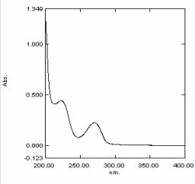

### Figure 01: UV spectra of Pioglitazone HCl standard

[www.ijpir.com](http://www.ijpir.com/)

Sowmya C et al., Int. Journal of Pharmacy & Industrial Research Vol – 02 Issue – 03 Jul – Sep 2012

215

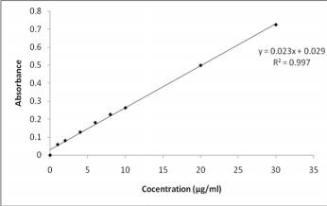

### Figure 02: standard graph of Pioglitazone HCl

The Pioglitazone HCl obeys Beer lamberts law in the range of 1-34µg/ml and it had shown a slope, intercept and R2 of 0.0234, 0.0297, 0.9972 respectively. The complexation mixtures equivalent to 10 mg of Pioglitazone HCl was added directly in to the dissolution

jars then dissolution was performed by using USP apparatus II (paddle type).Temperature was maintained at 37.5o.C11.

Dissolution parameters

The dissolution testing was performed using USP type II (paddle) dissolution apparatus using water as the medium, temperature of 37.5±0.5oc, and RPM of 50±2. Equal amounts of dissolution medium was collected and replaced with the fresh dissolution medium. The samples were analysed using Systronics UV Visible double beam Spectrophotometer 2202.

**Results and discussion**

### Table 02: flow properties of prepared complex mixtures

**Density(g/cm3)**

**Formulation Angle of Repose Hausner**

**Carr’s**

**Bulk Density ± Tap Density ±**

|  |  |  |  |  |  |
| --- | --- | --- | --- | --- | --- |
| **code** | **± SD** | **SD** | **SD** | **Ratio±SD** | **index±SD** |
| F1 | 23.54±0.032 | 0.456±0.0047 | 0.555±0.0093 | 1.13±0.044 | 14.51±0.086 |
| F2 | 23.47±0.044 | 0.465±0.0035 | 0.553±0.02 | 1.14±0.043 | 10.39±0.055 |
| F3 | 25.22±0.042 | 0.453±0.0046 | 0.500±0.008 | 1.12±0.032 | 13.51±0.086 |

The angle of repose was found to be 23.54 to 25.22, which show good flow property. The Density, Carr’s index and Hausner Ratio showed satisfactory results.

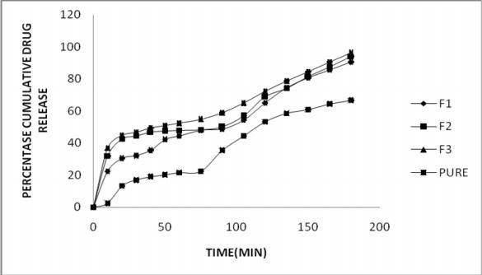

### Figure 03: Release profile of Pioglitazone HCl from β cyclodextrin inclusion complexes

From the graph it is clear that F3 (drug: β cyclodextrin, 1:10) had shown better release than the F2 (1:5), F1 (1:7.5) and pure. At 180th min the F1, F2,F3, pure had released 90.42, 94.09, 96.4, 66.66 mg of Pioglitazone HCl respectively.

[www.ijpir.com](http://www.ijpir.com/)

# 216

Sowmya C et al., Int. Journal of Pharmacy & Industrial Research Vol – 02 Issue – 03 Jul – Sep 2012

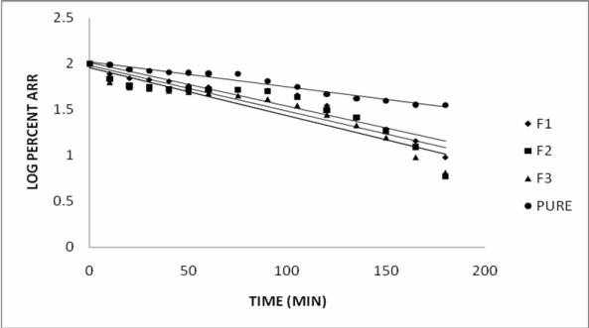

### Figure 04: First order plots

**Table 03: Release profiles of Pioglitazone HCl**

**Cumulative percent release ± sd\***

**Time (min) F1 F2 F3 PURE**

0 0 0 0 0

10 22.46±0.01 31.92±0.25 36.89±0.01 2.36±0.01

20 30.50±0.23 42.49±0.26 44.66±0.14 13.28±0.11

30 32.09±0.26 44.52±0.24 46.54±0.14 16.89±0.01

40 35.46±0.29 46.89±0.12 49.28±0.17 19.07±0.12

50 42.3±0.01 47.53±0.15 50.76±0.13 20.24±0.17

60 44.37±0.01 47.98±0.21 52.29±0.11 21.50±0.15

75 47.97±0.21 48.29±0.11 54.86±0.13 22.31±0.15

90 48.77±0.11 49.98±0.14 58.83±0.21 35.45±0.13

105 54.45±0.14 56.83±0.13 64.82±0.13 44.49±0.14

120 65.07±0.15 68.85±0.11 72.09±0.14 53.27±0.10

135 74.36±0.13 74.20±0.12 78.64±0.13 58.42±0.01

150 80.63±0.12 81.52±0.19 84.32±0.12 60.82±0.19

165 85.56±0.21 87.63±0.17 90.42±0.14 64.42±0.17

180 90.42±0.13 94.09±0.24 96.40±0.11 66.66±0.14

* mean of three replicates

### Table 04: Release characteristics

|  |  |  |  |  |  |
| --- | --- | --- | --- | --- | --- |
| **S.No** | **First order Equation** | **First order R2** | **K1(hr-1)** | ***t50* (min)** | ***t90* (min)** |
| F1 | Y=-0.0048x+2.022 | 0.9138 | 0.011 | 87 | 186 |
| F2 | Y=-0.005x+1.9804 | 0.8354 | 0.0115 | 70 | 168 |
| F3 | Y=-0.0058x+1.983 | 0.8393 | 0.013 | 42 | 164 |
| PURE | Y=-0.0027x+2.022 | 0.9653 | 0.006 | 116 | _ |

The F3 had shown K1 of 0.013 hr-1 which is more than F2 (0.0115 hr-1), F1 (0.011 hr-1) and pure (0.006 hr-1) and t50, t90 of F3 was found to be (42min, 164min); which is less than F2(70min, 168min); F1(87min, 186min); and pure(116min). Hence F3 has better than the F2, F1, and pure.

[www.ijpir.com](http://www.ijpir.com/)

Sowmya C et al., Int. Journal of Pharmacy & Industrial Research Vol – 02 Issue – 03 Jul – Sep 2012

217

**Conclusion**

The prepared formulations had shown good Angle of repose, Compressibility Index and Hausner Ratio. Among them F3 had shown better than F2, F1 and Pure. The F3 has shown better dissolution rate than the F2, F1, and pure. As the concentration of β cyclodextrin increases, the dissolution rate is also increased. So β cyclodextrins can be employed to improve the dissolution of poorly water soluble drug Pioglitazone HCl.

## References

* 1. Pouton CW. Formation of poorly water soluble drugs for oral administration physicochemical and physiological issues and lipid formation and classification. Eur J pharm sci. 29, 2006, 278-287.
  2. prasanthakumari M, Baskaran J, Kalyani CH, Kumar Raja J. Formulation and evaluation of sustained release matrix release tablets of pioglitazone HCl. Int J of Drug Form and Res. 2(4), 2011, 296-211.
  3. Sunil jaiswal B, Brahamankar DM. Biopharmaceutics and pharmacokinetics A Treatise. Vallabh prakashan, 1995, pp 335-371.
  4. Helana Dodziuk. Cyclodextrins and their complexes. Wiley Verlag GmbH and co KGaA 2006.
  5. Cal K, Centkowska K. Use of cyclodextrins in topical formulations: practical aspects. Eu J of Pharmaceutics and Biopharm. 68, 2008, 467-478.
  6. Matsuda H, Arima H. Cyclodextrins in transdermal and rectal delivery. Adv drug deliv rev. 36, 1999, 81-99.
  7. Brewster ME, Loftsson T. Cyclodextrins as pharmaceutical solubilizers. Adv drug Deliv Rev. 59, 2007, 645-666.
  8. Sudhranshu P, Acharya S, Gandhi J, Patel

N. Development and characterization of mucoadhesive patches of Glimepiride for Buccal administration. J of Pharm Sci and bio Scientific Res. 1(2), 2011, 102-107.

* 1. Aulton ME. The science of dosage form design. Churchill living stone Edn 2 1986 pp 134.
  2. Martin’s physical pharmacy and pharmaceutical sciences. Wolters Kluwer Lippincott Williams and Wilkins Edn 6 2011 pp 465-466.
  3. Chowdary KPR, Veeraiah E. Enhancement of dissolution rate and formulation development of Efavirenz tablets employing starch citrate: a new modified starch. J of Applied Pharm Sci 1(05), 2011, 119-123.

[www.ijpir.com](http://www.ijpir.com/)