***Original Article***



International Journal of Pharmacy and Industrial Research

**ISSN Print 2231 – 3648**

**Online 2231 – 3656**

**ISOLATION AND PARTIAL PURIFICATION OF LIPASE FROM IRANIAN YELLOW SCORPION *ODONTOBUTHUS DORIAE***

# *,1Azarpanah A, 2Jalali A, 3Aberumand M

*,1Razi Vaccine and Serum Production and Research Institute, Karaj, Iran.

2Faculty of Pharmacy, Jundishapur University of Medical sciences, Ahvaz, Iran.

3Faculty of Medicine, Jundishapur University of Medical Sciences, Ahvaz, Iran.

**Abstract**

The aim of the present study was isolation and characterization of Iranian yellow scorpion *Odontobuthus doriae.* Scorpion venoms are considered as a rich source of enzymes. Some types of enzymes such as phospholipase A2, proteolytic enzymes and phosphodiesterase are definitely characterized. However, few studies have been done about lipase. In this article, we study the isolation and purification of lipase from *Odontobuthus doriae* scorpion, belongs to *Buthidae* family. It can cause dangerous envenoming. A combination of gel filtration on Sephadex G-75, ion exchange chromatography on DEAE-cellulose and Colorimetric Lipase Assay were used respectively. The optimal pH and temperature for maximum activity of isolated lipase were 9 and 37ċ, respectively. The km of enzyme was 17 mM at 37ċ and its specific activity was 42.6 U/mg against 10 U/mg/min for the total desiccated venom. The enzyme was meaningfully stable at high pH values, and maintained about 65% of its activity after 4h incubation at pH 11. Lipase enzyme was inactivated after 5min at a temperature higher than 55ċ. The sodium dodecyl sulfate -polyacrilamide gel electrophoresis and then Sephadex G-75 techniques showed that enzyme had estimate molecular weight of 50 KDa.

**Key words:** Lipase enzyme; *Odonthobuthus doriae*; Partial purification; Sephadex G-75; Scorpion.

## Introduction

There are more than 1500 species of scorpions investigated in all over the world. Similar to other countries in the Middle East, Iran has several species of the most venomous scorpions that are the major cause of medical problems. Among the most fatal and venomous scorpions of Iran are those that belong to the family *Buthidae*1-3. The Iranian yellow scorpion *Odonthobuthus doriae* belongs to the *Buthidae* family and is

especially found in the central and southern regions of Iran. Its sting cause different effects such as local pain, inflammation and necrosis to muscle paralysis4.

Scorpion venom is a water soluble, antigenic compound with the pH ranging from alkaline to neutralized. Generally, scorpion venoms are consisting of mucosa, oligopeptides, nucleotides, amino acids and other compounds. It includes enzymes such as

### Author for Correspondence:

Azarpanah A,

Sattarkhan BLV, Alley 12, No. 332, Shiraz, Iran.

Email: [armita_azarpanah@yahoo.com](mailto:armita_azarpanah@yahoo.com)

phospholipase, hyaluronidase, lipase and low molecular weight compounds like serotonin, histamine, protease inhibitors, and histamine releasing agents. In comparison to snake and spider venoms, scorpion venoms include few amounts of enzymes with low activity, such as enzymes like acid phosphatase, ribonuclease, 5-nucleotidase, hyaluronidase, acetylcholine esterase and phospholipase A. 5-hydroxy triptamine and succinate dehydrogenase are found in *Centruroides exilicuada*, *Mesobuthus tumulus* and *Heterometrous fulvipes* scorpion venoms5-11.

Lipases are hydrolytic enzymes (EC 3.1.1.3), that convert triacylglycerols into free fatty acids and glycerol, and they begin chemical reactions at the surface of emulsified lipid substrates5,6. Lipase enzyme is an important enzyme in biotechnological applications, such as food industrials, detergent, and biochemical sciences9. Higher animal lipases are isolated and well characterized, however, much less is known about lipases belong to lower ones, such as scorpions7-9.

In order to figure out the biochemical and pathophysiological properties of unknown exact mechanism of this scorpion venom, it is necessary to isolate and characterize its ingredients such as enzymes. This paper will discuss the isolation and partial purification of an active lipase from the scorpion *Odontobuthus doriae*. The isolated lipase was characterized with respect to its biochemical properties.

## Materials and methods

Lyophilized *Odontubuthus doriae* scorpion venom was gifted by Razi Institute, Karaj,

Iran. Sephadex G-75 was purchased from Pharmacia Sweden. EDTA (Sigma Chemicals, USA), Ammonium acetate (Merck, Germany), Lipase Assay Kit was kindly obtained from Pars Azmun Company, Tehran, Iran. All other reagents were of the highest grade commercially available.

### Venom

Crude scorpion venom was delivered by Dr. Zare and Dr. Akbari, Department of Poisonous Animal, Vaccine and Serum Production and Research Institute of Razi, Karaj, Iran. Crude venom was obtained by electrical stimulation of the scorpion telsons. Venom was freeze dried, then stored at -50ċ until it is used.

### Partial purification process

**Sephadex G-75 column chromatography** The crude *O. doriae* scorpion venom (150 mg) was dissolved in 5ml ammonium acetate 0.1M buffer solution at pH 8. The mixture then loaded on previously equilibrated Sephadex G- 75 column (1.5×30cm), and the column was previously washed with 500 ml ammonium acetate buffer at pH 8. The venom components were eluted with ammonium acetate buffer at flow rate of 60 ml/h. the elution was gathered at 3 ml fraction tubes. Protein elution was monitored at 280 nm. The lipase activity in the collected fractions was monitored with a UV- Spectrophotometer at 570 nm. Fractions were dialyzed and lyophilized, then collected for the next step is shown in fig. 1.

**DEAE –cellulose column chromatography** The dialyzed fractions (41-52) showed lipase activity, these fractions were subjected to ion- exchange chromatography on a DEAE- cellulose column (1.5×18cm). The column was

previously equilibrated with 0.1 M ammonium acetate buffer at pH 8. The enzyme was eluted by using 250 ml 0-0.5 M NaCl linear gradient at a 24 ml/h flow rate. Fractions were collected at 4ml volumes. The fractions with lipase activity were considered, dialyzed and lyophilized is shown in fig. 2.

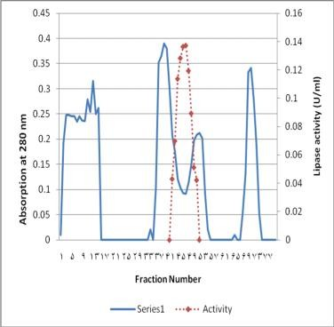

**Fig.1:**

**Gel filtration chromatography of *Odontobuthus doriae* venom with Sephadex G-75. The venom (150mg) dissolved in 5 ml ammonium acetate 0.1 M buffer at pH 8.The gel filtration chromatography column (1.5×30cm) was elutated with similar buffer before loading venom. Active fractions 41-52 were collected for the next step.**

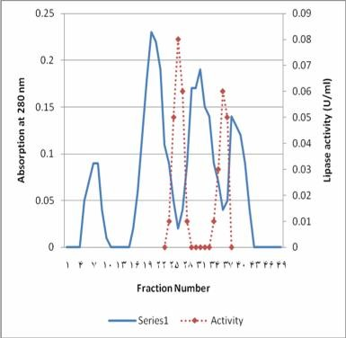

**Fig.2:**

**DEAE-cellulose chromatography of lipase fractions using Sephadex G-75.**

### Colorimetric Lipase Assay

Several test kits are available for evaluation of lipase activity. The tests are generally based on the enzyme clearing of an emulsion wherein decreases in absorbance values in the UV range (570 nm) are used to estimate lipase activity.

The Lipase Assay Kit allows rapid and easy measurement of lipase activity in vitro, in cell preparation or in vivo using the fluorescent fatty acid substrate. The reactions are described below:

**CHROMOGENIC SUBSTRATE**

1,2-o-Dilauryl-rac-glycero3-glutaric acid (6-methylresorufin) ester

↨ ***Lipase/ Colipase***

**UNSTABLE INTERMEDIATE**

↨

Glutaric acid –(6-methylresorufin)

↨ ***Spontaneous breakdown***

**ABSORBANCE MEASURED AT 570 nm**

(methyl resorufin)

The available reagents in the lipase Kit (Pars Azmun, Tehran, Iran) were two buffered solutions. Solution 1 contains, 3.4 mmol/l taurodesoxycholate, 2.6mmol/l desoxycholate, 12mmol/l calcium chloride, 1 mg/l colipase, 40mmol/l buffer with pH 8. The solution was also contained detergent and preservative. It was stable at least seven days at 2-8 ċ.

Solution 2 contains, 3.4mmol/l taurodes - oxycholate, 0.13 mmol/l color substrate, 1.5 mmol/l tartrate buffer with pH 4. The solution also was contained stabilizer and preservative. It was stored at 2-8ċ.

### Procedure

We measured lipase activity by rate assay, using the two separate solutions, with solution 1 as the starter reagent.

For the manual assay, 2000 µl of each collected sample-fractions following gel filtration chromatography Sephadex G-75 were added to the same volume of solution 1 as described by guideline of purchased Kit. Same procedure was done for the blank (2000 µl ammonium acetate buffer). Then 500 µl of solution 2, pre warmed at 37ċ was added. The absorbance change per minute was monitored at 570 nm for the sample versus the reagent blank.

The following equation showing the way in which we calculate lipase activity:

# ×



calibration concentration (U/L)

(Equation-1)

## Results and discussion

A two-step method was used for purification of lipase enzyme. The first step was gel filtration chromatography by Sephadex G-75. Figure 1 shows a 4-peak diagram with significant concentration of protein. As it was mentioned, fractions 41-52 shows lipase activity, so we can conclude the lipase is exist in fractions with less amounts of protein as illustrated in fig. 1.

The second step was related to DEAE- cellulose ion-exchange chromatography method. Fractions 41-52 obtained in step one, were used and fractioned in two peaks, with significant lipase concentration. Lipase activity was measured in collected fractions, (fig.2). Table 1 summarizes these findings. The enzyme was purified about 85.2%. The enzyme specific activity was 42.6 u/min per mg of protein.

### Km and Vmax determination

In order to determine the Km and Vmax for scorpion lipase enzyme, the concentration of enzyme was adjusted and added to substrate TC4 under optimal conditions temperature 37ċ and pH 9, in the presence of NaCl 150 mM and NaDC 1 mM. the velocity of the reaction was determined10.

The effect of different concentration of substrate on the initial scorpion lipase enzyme showed a hyperbolic saturation curve. The parameters Km and Vmax for lipase were calculated on the basis of Lineweaver-Burk plot. The enzyme Km and Vmax values were 17 mM and 6660 U/mg, respectively (Fig.3.)

**Molecular weight determination** Polyacrilamide gel electrophoresis of proteins in the presence of dodecyl sulfate (SDS- PAGE) was used for the molecular weight determination of the scorpion lipase enzyme as previously described by Laemli11.

The purified enzyme was subjected to 12% SDS-polyacrilamide gel electrophoresis at pH 8 by the use of ammonium acetate buffer. It was stained with Coomassie brilliant blue R-

250 for about 2 hours, then it was put in methanol:acetic acid:water solution with the ratio of 30:10:60, v/v for one night. After the SDS-PAGE analysis, the enzyme molecular weight was determined. The apparent molecular weight of scorpion lipase enzyme was 50 kDa.

### Stability of the enzyme

The optimal pH for lipase activity was 9 at 37ċ at standard conditions. Scorpion lipase is highly resistance to alkaline pH. It is stable at

pH 11 and maintains its activity up to 65%, but it loses its activity at pH values lower than 5. This characteristic emphasizes the use of scorpion lipase as a detergent. It must be

considered that the scorpion lipase loses its activity after incubated in temperature above 55ċ.

**Table no. 1: Summary of the purification of lipase from scorpion *Odontobuthus doriae* venom**

|  |  |  |  |  |  |
| --- | --- | --- | --- | --- | --- |
| **Total protein** | | **Total activity** | **Specific activity** | **Purification** | **Yield** |
| **Purification step** | **(mg)** | **(units)** | **(units/mg protein)** | **(fold)** | **(%)** |
| Crude venom | 1500 | 15000 | 10 | 1.0 | 100 |
| Sephadex G-75 | 14.9 | 5255 | 352 | 35.2 | 34.96 |
| DEAE-cellulose | 300 | 12800 | 42.6 | 4.26 | 85.2 |

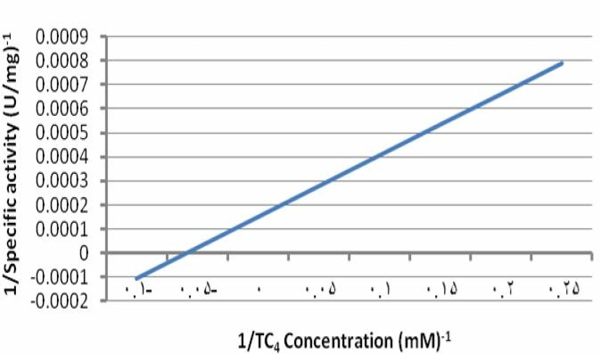

### Fig. 3:

**Lineweaver-Burk plot of the lipase activity. Experiments were performed at 37ċ and pH 9.**

## Discussion

The isolation and partial purification of lipase enzyme from scorpion *Odontobuthus doriae* is described in this paper for the first time. This enzyme is highly stable at alkaline pH values. Scorpion lipase enzyme has a molecular weight of 50 kDa. In this study specific activity of lipase enzyme in scorpion was determined. Isolation of different enzymes is a suitable way for obtaining highly purified enzymes. Such investigations make us know more about biochemical and pathophysiological properties of enzymes.

## Acknowledgements

I would like to extend my thanks to Dr.R.Tahmasbi (Faculty of statistics, Amir kabir University of Tehran, Iran) for his kind support through this study, and special thanks to S. Azarnia, Z. liaghat and A.Azarpanah because of their companionship and kindness.

## References

1. Jalali, A., Vatanpour H., Hosseininasab, Z., Rowan, E.G., Harvey, A.L., 2007. The effect of the venom of the yellow Iranian scorpion Odontobuthus doriae on skeletal

muscle preparations in vitro.Toxicon 50, 1019-1026.

1. Possani, L.D., Becerril, B., Delepierre, M., Tytgat, J., 1999.Scorpion toxins specific for Na+-channels. Eur. J. Biochem. 264, 287–300.
2. Fet, V., Sissom, W.D., Lowe, G., Braunwalder, M.E., 2000.Catalog of the Scorpions of the World (1758–1998). NewYork Entomological Society, New York..
3. Jalali, A., Bosmans, F., Amininasab, M., Clynen, E., Cuypers, E.,Zaremirakabadi, A., Sarbolouki, M.N., Schoofs, L., Vatanpour,H., Tytgat, J., 2005. OD1, the first toxin isolated fromthe venom of the scorpion Odontobuthus doriae active onvoltage-gated Na+ channels. FEBS Lett. 579, 4181–4186.
4. Zouari, N., Miled, N., Cherif, S., Mejdoub, H., Gargouri, Y.,2005. Purification and characterization of a novel lipase from the digestive glands of a primitive animal: The scorpion. Biochimica et Biophysica Acta, 1726, 67

– 74.

1. R. Verger, Pancreatic lipases, in: B. Borgstroˆm, H.L. Brockman (Eds.), Lipase, Elsevier, Amsterdam, 1984, pp. 121– 150.
2. Y. Gargouri, H. Moreau, R. Verger, Gastric lipases: biochemical and physiological studies, Biochim. Biophys. Acta 1006 (1989) 255– 271.
3. A. Ben Bacha, Y. Gargouri, Y. Ben Ali,

N. Miled, J. Reinbolt, H.Mejdoub, Purification and biochemical characterization of Ostrich Pancreatic Lipase, E. M. T. 37 (2005) 309–317.

1. Park, J., Cho, S.Y., Choi, S.J., 2007. Purification and characterization of hepatic lipase fromTodarodes pacificus. BMB reports,254-258.
2. Poh, C.H., Yuen, R., Chung, M.C.M., Khoo, H.E., 1992.Purification and partial characterization of hyaluronidase from stonefish (Synanceja horrida) venom. Comp. Biochem. Physiol101B, 159–163.
3. U.K. Laemmli, Cleavage of structural protein during the assembly of thehead of bacteriophage T4, Nature 227 (1970) 680– 685.