***Original Article***



International Journal of Pharmacy and Industrial Research

**ISSN Print 2231 – 3648**

**Online 2231 – 3656**

**FORMULATION AND *INVITRO* EVALUATION OF VENLAFAXINE MATRIX TABLETS**

# *Sowmya C, Reddy CSP, Santhosh Raja M

Raghavendra Institute of Pharmaceutical Education and Research, Anantapur, Andhra Pradesh, India - 515721.

## Abstract

Matrix tablets containing Venlafaxine HCl were formulated by wet granulation method. Venlafaxine is a bicyclic antidepressant and is categorized as serotonin, nor epinephrine reuptake inhibitor. Because of its shorter biological half life (2-5h) and its high water solubility it was chosen to prepare sustained release matrix tablets. The individual and combined effects of matrix forming polymers i.e. HPMC and Sod CMC on sustained release were also investigated. All the pre compression parameters like angle of repose, Hausner ratio were found to be with in acceptable limits. It was found that concentration of polymer has influenced drug release from the tablets. Prepared tablets were evaluated for different quality control tests viz hardness, friability, thickness and drug content were with in the specified limits. The formulation containing the single polymer either HPMC or Sod CMC could not control the release of the drug effectively. But the formulation containing the combinations of HPMC and Sod CMC had shown better control over the release of the drug. Drug excipient compatibility was investigated using the method of Differential scanning calorimetry, FT IR spectroscopy, UV spectral analysis and the thermograms demonstrated stability and no interaction between the drug and the polymers and with other formulation excipients. The release data showed good correlation coefficient with Higuchi and Peppas kinetics. Stability analysis of best formulations were performed and showed no significant difference in drug content and release profiles. From the *invitro* evaluation it was observed that the tablets prepared by using combination of polymers give better controlled release for a period greater than 12 hrs.

**Key words:** Venlafaxine HCl, HPMC, Sod CMC, matrix tablets.

## Introduction

Oral administration of a drug has been the most convenient and commonly employed route of drug delivery as it offers the greater flexibility in the dosage form design1, 2. Designing of controlled release polymers offers some advantages such as release of the drug at a required delivery rate, constant blood levels of drug, reduction of dosing frequency

and improved patient compliance3,4. However the development of oral controlled release formulations for water soluble drugs to achieve a constant release has always been a great release which includes bio adhesive systems5, mirocapsules, swelling and expanding systems6,7, but the matrix system is the most commonly adopted one for the preparation on oral controlled release dosage forms8.

### Author for Correspondence:

Sowmya C,

Raghavendra Institute of Pharmaceutical Education and Research,

Saigram, KR Pally cross, Chiyyedu, Anantapur, Andhra Pradesh, India– 515721. Email: [drsowmyariper@rediffmail.com](mailto:drsowmyariper@rediffmail.com)

Venlafaxine HCl is a bicyclic anti depressant and it is a neither serotonin- nor epinephrine reuptake inhibitor9 (SNRI) highly soluble in water. Its half-life is about 2-5 hrs10, necessitating the administration of drug for two to three times daily to maintain adequate plasma levels of drug. To reduce the dosing frequency, and to improve the patient compliance, to maintain steady state plasma concentration and to achieve constant rate input to the invivo availability it is essential to develop controlled release formulation of Venlafaxine. The objective of the study is to develop controlled release matrix tablets of venlafaxine HCl using HPMC and Sod CMC. The prepared tablets were evaluated for different control tests i.e drug content, *invitro* release and release patterns were studied. Selected formulations were subjected to stability testing. The crucial requirement for the successful formulation is the conformation of absence of chemical interaction between the drug and excipients during intended shelf life of the product. Thus the interaction studies of the developed formulation were evaluated using Differential Scanning Calorimetry (DSC), FT-IR and UV Spectroscopy.

## Experimental

### Materials

Venlafaxine HCl was a gift sample from Matrix laboratories Ltd Hyderabad. HPMC (K4M) and Sod CMC were obtained from Waksman Selman pharmaceuticals Anantapur, Talc, Mg Stearate and Lactose were procured from Loba Chem. All other chemicals were of analytical grade.

### Methods

**Preparation of tablets11**

The tablets were prepared by conventional wet granulation method. Weighed quantities of drug, HPMC, Sod CMC, Lactose were passed through 80 mesh to remove lumps of the powder materials. Required quantity of starch paste was sprinkled over powder blend to obtain wet mass. The wet granules were dried at 600 c for a period of 60 min. After drying, the dried granules were passed through 16 mesh. The resulting granules were lubricated with 2% Mg Stearate and Talc and compressed using 10 mm round flat faced punches on 12 station tabletting machine (Karnavati). Tablet of each batch (batch size 40 tab) contained 100 mg of Venlafaxine HCl.

Different concentrations of HPMC and Sod CMC were added to Venlafaxine HCl to obtain different formulations. The formulations of tablets with their codes were given in table 1.

### Evaluation of granules

1. ANGLE OF REPOSE the angle of repose was determined by funnel method was calculated by using the following equation

Tan θ = h/r

Where,

h = height of the powder pile r = radius of the powder pile

1. BULK DENSITY both Loose Bulk Density (LBD), Tapped Bulk Density (TBD) were determined. These are calculated by using following formulas LBD = weight of the powder/volume of the packing TBD = weight of the powder/tapped volume of the

packing

1. COMPRESSIBILITY INDEX carr’s compressibility index was determined by using following formula

Carr’s index(%) = [(TBD - LBD) x 100]/TBD

1. TOTAL POROSITY total porosity was determined by using the following formula

Porosity (%) = [(Vbulk – V) x 100]/Vbulk

1. DRUG CONTENT powder equivalent to 100mg of Venlafaxine was weighed and drug was extracted in buffer for 5hrs was filtered through 0.45µm membrane filter. The absorbance was measured at 222nm after suitable dilution against blank.

### Evaluation of tablets

1. THICKNESS the thickness of the tablets was determined using vernier calipers (NSP suppliers, guntur) five tablets from each batch were used and average values were calculated.
2. WEIGHT VARIATION 20 tablets of each formulation were weighed using (LC GC) and the test was performed according to the official method
3. HARDNESS AND FRIABILITY the hardness and friability of each formulation was determined by taking 6 tablets from each using Monsanto hardness tester (Cadmach, Ahmedabad, India) and the Roche friabilator (Electrolab EF2, Bombay, India) respectively.
4. SWELLING INDEX the swelling behavior of tablets was determined by the following method12

SI = {(Mt – Mo)/Mo}X 100

Where

Mt = weight of tablet at time t Mo = initial weight of the tablet

1. DETERMINATION OF VISCOSITY viscosity of the aqueous polymeric solution (2%wt/vol) was determined using Brookfield Viscometer (Amkette LV DV II Pro)
2. DRUG CONTENT Six tablets were weighed individually from each batch and then powder them separately. Powder equivalent to 100 mg of drug was weighed and drug was extracted in buffer for 5 hrs. The resultant solution was filtered through 0.45µ membrane filter. The absorbance was measured at 222 nm after suitable dilution against blank. Results were shown in table no 3.
3. *INVITRO* DISSOLUTION STUDIES drug release from the Controlled Release tablets was studied using 8 station dissolution rate test apparatus (Electrolab) employing a paddle stirrer at 50 rpm and at 37 ± 10c. The dissolution medium consisted phosphate buffer of pH 6.8 (900ml). The drug release at different time intervals was measured by UV visible spectrophotometer (Systronics 2202) at 222nm developed method was validated and it was made clear that none of the ingredients used in the matrix formulations interfered with the assay13. The drug release experiments were conducted in triplicate. The dissolution experiment was also performed for commercial tablets.
4. STUDY OF RELEASE KINETICS

The dissolution data was fitted into the following mathematical models

Zero order equation Q = Q0 – k0t First order equation ln Q = ln Q0 – kt Higuchi equation14 Q = k2t1/2

Korsemeyer and Peppas equation15 Q/Q0 = ktn Where

k0, k1, k2 were release rate constants, Q/Q0 was fraction of drug released at time t, k was a constant, n is the release exponent indicates mechanism of release. If n < 0.5,

fickian diffusion mediated release occurred, if n value is between 0.5 to 1.0 anamolous release (i.e diffusion coupled with polymer matrix relaxation) occurred and erosion (i.e complete matrix relaxation) mediated release occurred in n

= 1 for supercase transport II n value is > 1.

1. INTERACTION STUDIES Differential scanning calorimeter (DSC) and FT-IR and UV spectral studies were performed to characterize formulation for excipient compatibility. FT –IR spectra were recorded by using KBr disc as references on FT IR spectrophotometer (Bruker). The FT IR spectra were shown in fig 11, 12, 13 and 14. DSC studies were carried out using Metler TA 4000 system DSC 25 and thermograms were recorded for pure drug and formulation were shown in fig 15 and fig 16.
2. STABILITY STUDIES16

The stability studies were performed as per ICH guidelines at conditions of temperature and 400c and 75% RH using stability chambers for three months. The samples were analyzed for drug content.

## Results

The granules of different developed formulations were evaluated for Angle of Repose, LBD, TBD, Compressibility Index, Hausner ratio, Percentage Porosity and drug content. The results of Angle of Repose, Compressibility Index and Hausner ratio ranged from 23.25 ± 0.024 to 28.08 ± 0.016,

10.39 ± 0.055 to 14.71 ± 0.07 and 1.10 ± 0.037

to 1.14 ± 0.043 respectively. The results of LBD and TBD ranged from 0.434 ± 0.0078 to 0.468 ± 0.0045 and 0.527 ± 0.01 to 0.583 ±

0.0069 respectively. The results of percentage porosity ranged from 25.82 ± 0.05 to 36.18 ±

0.07. The drug content in a weighed quantity granules of prepared formulations ranged from

95.23 ± 0.05 to 98.66 ± 0.04%. matrix tablets each containing 100mg of Venlafaxine could be prepared employing different proportions of HPMC and Sod CMC as controlled release polymer by conventional wet granulation technique. Hardness of the tablets was in the rage of 4.05 ± 0.021 to 4.19 ± 0.048. Weight loss in the friability was less than 0.9% in all the cases. The thickness of the tablets was ranging from 3.08 ± 0.040 to 3.61 ± 0.077 mm. The average % deviation in weight variation was less than 5%. All the matrix tablets contained Venlafaxine within the label claim. The results of the swelling index ranged from 9.11 ± 1.0 to 24.24 ± 1.6. (Table 3, 3.1)

The formulations coded with H1, H2, H3 composed of 10%, 20%, and 40% of HPMC. The results of dissolution studies of these tablets are shown in figure 1 they showed the release of 41.3%, 38.1% and 32% of Venlafaxine at the end of 2 hrs and 88.6%, 75.2%, 71% at the end of 8 hrs and 98.2% and 93.1% at the end of 12 hrs for H2 and H3.

The formulations coded with N1, N2, N3 composed of 10%, 20%, and 40% of Sod CMC. These tablets showed the release of 60.1%, 50.4% and 41.4% of Venlafaxine at the

end of 2 hrs and 99.8%, 99.2%, 87.4% at the end of 8 hrs.

The formulations were further modified by incorporating different combinations of HPMC and Sod CMC such as 4:6, 5:5, 6:4 ratios. The results of the dissolution studies of these

tablets in figure 2 indicated that HN1, HN2, HN3 formulations released 34.5%, 30.3% and 33.1% of Venlafaxine at the end of 2 hrs and 97.2% at the end of 24 hrs for HN3 formulation. The results of the stability studies indicated that there is no significant change in the drug content and release profiles. (Table 6, fig 11).

## Discussion

Venlafaxine is a new class of anti-depressant medications that affect chemical messengers with in the brain. It is believed to work by inhibiting Serotonin – Nor epinephrine reuptake. For successful treatment of depression it is essential to maintain the constant plasma drug it can be achieved by giving the drug in controlled release dosage form which can improve the patient compliance. So, Venlafaxine is a suitable candidate to design controlled release dosage form. In the present investigation the commonly used hydrophilic matrix forming polymers like HPMC K4M and Sod CMC were employed to prepare controlled release dosage form of Venlafaxine.

Matrix tablets each containing 100mg of Venlafaxine could be prepared using different proportions of HPMC K4M and Sod CMC by conventional wet granulation method. A bulk powder is somewhat analogous to a non- Newtonian liquid as it exhibits plastic flow and sometimes dilatancy hence it hinders the flow. Hence granulation step is a key process in the production of tablets to increase the flow property.

The prepared granules were evaluated for precompression parameters like angle of

repose, compressibility index, Hausner ratio, LBD, TBD, total porosity for drug content table 2, 2.1.

The results of the angle of repose (<30) indicates good flow properties of the granules17,18. This was further confirmed by lower compressibility index (<15%) values and lower Hausner ratio values19**.** Loose bulk Density (LBD), Tapped Bulk Density (TBD) of the granules were <0.5 and <0.6 g/ml respectively and are more uniform values indicates that the prepared granules were of in uniform size. Percentage porosity values below 26% shoes the particles in the powder of greatly different sizes and if values were greater than 48% shows that the particles in the powder are in the form of aggregates or flocculates20**.** The percentage porosity of granules ranged from 25.82% to 36.18% indicating the packing of granules may be loose to close packing. The drug content values were found to be uniform (95.23% to 98.66%). All the above results indicate that the developed granules possessed satisfactory flow properties, compressibility index, Hausner ratio and drug content.

Matrix tablets each containing 100mg of Venlafaxine could be prepared by conventional wet granulation method. Prepared tablets were subjected to various evaluation tests such as thickness, hardness, friability, weight variation, drug content, disintegration test and invitro dissolution testing. All the formulations showed uniform thickness. Hardness of the tablets was in the range of 4.05 – 4.19 kg/cm2. Weight loss in the friability test was less than 0.82% in all the cases the pharmacopoeial limit for weight variation21. The percentage

deviation for tablet more than 250 mg is ± 5%. The average percentage deviation of all the prepared tablets was found to be within the pharmacopoeial limits hence all the formulations passed the test for uniformity of weight. As the prepared tablets were of good quality with regard to drug content contained Venlafaxine within of the label claim (100 mg). All the tablets were found to be non- disintegrating in water, acidic (pH1.2) and alkaline (pH 6.8) fluids.

Drug release from the controlled release tablets was studied by using 8 station dissolution rate test apparatus (Electrolab TDT 08L) employing a paddle stirrer at 50 rpm and at 37

± 10 c. Phosphate buffer of pH 6.8 (900ml) was used as dissolution fluid. Samples of 5ml each were withdrawn at different time intervals over a period of 24 hrs. Each sample withdrawn was replaced with an equal amount of fresh dissolution medium. Samples were diluted and assayed at 222nm for venlafaxine using systronics UV Visible spectrophotometer (2202). For comparision Venlafaxine release from commercial tablet was also studied. The drug release experiments were conducted in triplicate.

The results of the dissolution studies of H1, H2 and H3 formulations indicated that the drug release was decreased which is due to the increased swelling and viscosity of the dispersion with the usage of increased concentration of HPMC. In case of N1, N2 and N3 the amount of drug released was reduced with increasing concentration of Sod CMC. This may be due to increased viscosity of the dispersion and formation of gel state with dissolution medium. Amount of drug released

is more in case of N1, N2 and N3 when compared with H1, H2 and H3. This may be due to less swelling of Sod CMC when compared with HPMC. The formulations made with Sod CMC (N1, N2 and N3) released 100% of drug within 10 hrs, formulations made with HPMC were taken 12 hrs to release 100% of drug. In an attempt to prolong the release of drug the formulations (HN1, HN2 and HN3) were developed using different combinations of HPMC and Sod CMC. The results of the invitro dissolution studies showed that 50% of drug released in 3.6h, 2.4h and 5.6 h in case of HN1, HN2 and HN3 respectively (Table 5).

The formulations prepared by using the combinations of HPMC and Sod CMC released 100% of the drug in 10hr, 12hr and 24 hr for HN1, HN2 and HN3 respectively. Figure 2. Incorporation of high concentration of HPMC in combination with Sod CMC as in the case of HN3 formulation controlled the drug release in better manner which be due to increased swelling and formation of strong viscous gel on contact with aqueous media leading to decreased diffusion of drug from the matrix.

This HN3 formulation showed identical dissolution profile with the commercial formulation of Venlafaxine. Hence HN3 formulation is the most successful formulation among the matrix tablets developed in the present study.

To know the drug release mechanisms from these formulations the data was analyzed for zero order (cumulative % release vs time) (Fig 3,4), first order (log cumulative % of drug

remaining to be released vs time) (Fig 5,6), Higuchis (cumulative percentage of drug release vs square root of time) (Fig 7,8) and Korsmeyer et al’s (log cumulative percentage of drug released vs log time) (Fig 9,10) models.

As it was observed in table 4 that the release of Venlafaxine from all the matrix tablets formulated followed first order kinetics, the formulation showed fair linearity, with r2 values between 0.870 and 0.993. Release of drug from the matrix tablets formulated by using hydrophilic polymers generally involves factors of diffusion. Diffusion is the process of movement of drug from matrix into the medium depending on the concentration gradient, this is explained by Higuchi’s kinetics. In our study the invitro release profiles of all the formulations could be best

expressed by Higuchi’s equation, as the plots showed high linearity with correlation coefficient ranged from 0.9440 to 0.9960. To confirm the diffusion mechanism the data were fitted into Korsemeyer et al equation. The developed formulations showed good linearity (r2 0.926 to 0.995) with release exponent (n) value ranging from 0.39 to 0.66, indicating that diffusion is the predominant mechanism of drug release from all the developed formulations. When fitting the data in Higuchi and Korsemeyer et al equation the HN3 formulation showed high linearity r2 0.988 and r2 0.992 respectively with slope (n) value of

0.46. This n value of formulation indicates the anamolous release of drug that is diffusion coupled with polymers matrix relaxation, hence diffusion coupled with slight erosion may be the mechanism of drug release from HN3 formulation.

### Table 1: Formula for different formulations

|  |  |  |  |  |  |  |  |  |  |
| --- | --- | --- | --- | --- | --- | --- | --- | --- | --- |
| **Ingredients (mg)** | **H1** | **H2** | **H3** | **N1** | **N2** | **N3** | **HN1** | **HN2** | **HN3** |
| Venlafaxine | 100 | 100 | 100 | 100 | 100 | 100 | 100 | 100 | 100 |
| HPMC | 64 | 96 | 128 | - | - | - | 80 | 64 | 96 |
| NaCMC | - | - | - | 64 | 96 | 128 | 80 | 96 | 64 |
| Lactose | 146 | 114 | 82 | 146 | 114 | 82 | 150 | 50 | 50 |
| Starch Paste | q.s | q.s | q.s | q.s | q.s | q.s | q.s | q.s | q.s |
| Mg Stearate | 5 | 5 | 5 | 5 | 5 | 5 | 5 | 5 | 5 |
| Talc | 5 | 5 | 5 | 5 | 5 | 5 | 5 | 5 | 5 |

**Table 2: Evaluation of granules**

**Formulation**

|  |  |  |  |  |  |
| --- | --- | --- | --- | --- | --- |
|  | **SD\*** |  |  | **Index ± SD\*** | **SD\*** |
| H1 | 23.54 ± 0.032 | 0.456 ± 0.0048 | 0.554 ± 0.0094 | 14.51 ± 0.086 | 1.13 ± 0.044 |
| H2 | 23.47 ± 0.044 | 0.465 ± 0.0036 | 0.527 ± 0.01 | 10.39 ± 0.055 | 1.14 ± 0.043 |
| H3 | 25.22 ± 0.043 | 0.452 ± 0.0048 | 0.560 ± 0.008 | 13.51 ± 0.086 | 1.12 ± 0.032 |
| N1 | 26.22 ± 0.016 | 0.458 ± 0.0052 | 0.572 ± 0.0071 | 14.62 ± 0.057 | 1.13 ± 0.037 |
| N2 | 27.19 ± 0.016 | 0.461 ± 0.0085 | 0.583 ± 0.0069 | 6.74 ± 0.064 | 1.14 ± 0.032 |
| N3 | 25.24 ± 0.029 | 0.434 ± 0.0078 | 0.575 ± 0.0075 | 14.23 ± 0.083 | 1.13 ± 0.043 |
| HN1 | 24.18 ± 0.016 | 0.455 ± 0.0041 | 0.528 ± 0.0063 | 14.71 ± 0.07 | 1.12 ± 0.016 |
| HN2 | 23.25 ± 0.024 | 0.460 ± 0.0074 | 0.531 ± 0.0078 | 14.45 ± 0.077 | 1.10 ± 0.037 |
| HN3 | 28.08 ± 0.016 | 0.468 ± 0.0045 | 0.564 ± 0.018 | 14.63 ± 0.093 | 1.11 ± 0.069 |

**Angle of repose ±**

**LBD ± SD* g/ml TBD ± SD* g/ml**

**Compressibility**

**Hausner Ratio ±**

### Table 2.1: Evaluation of granules

|  |  |  |
| --- | --- | --- |
| **Formulation** | **Percentage Porosity** | **Drug Content** |
| H1 | 32.45 ± 0.625 | 97.36 ± 0.013 |
| H2 | 28.26 ± 0.126 | 96.46 ± 0.029 |
| H3 | 29.13 ± 0.060 | 98.32 ± 0.064 |
| N1 | 31.62 ± 0.021 | 95.23 ± 0.023 |
| N2 | 34.28 ± 0.126 | 95.42 ± 0.018 |
| N3 | 36.18 ± 0.132 | 98.39 ± 0.016 |
| HN1 | 24.42 ± 0.026 | 98.66 ± 0.042 |
| HN2 | 26.16 ± 0.101 | 98.26 ± 0.098 |
| HN3 | 25.82 ± 0.063 | 96.29 ± 0.056 |

**Table 3: Evaluation of tablets**

**Formulation**

|  |  |  |  |  |  |
| --- | --- | --- | --- | --- | --- |
|  | **SD\*** | **SD\*** | **SD\*** | **SD\*** | **SD\*** |
| H1 | 4.15 ±0.032 | 3.56 ± 0.102 | 0.71 ± 0.06 | 1.019 ± 0.005 | 99.16 ± 0.057 |
| H2 | 4.08 ± 0.021 | 3.61 ± 0.077 | 0.73 ± 0.02 | 1.040 ± 0.007 | 97.23 ± 0.049 |
| H3 | 4.08 ± 0.053 | 3.08 ± 0.040 | 0.82 ± 0.01 | 1.034 ± 0.009 | 98.69 ± 0.098 |
| N1 | 4.11 ± 0.032 | 3.60 ± 0.114 | 0.61 ± 0.02 | 1.028 ± 0.003 | 98.24 ± 0.049 |
| N2 | 4.05 ± 0.021 | 3.17 ± 0.057 | 0.58 ± 0.03 | 1.033 ± 0.006 | 99.25 ± 0.041 |
| N3 | 4.08 ± 0.024 | 3.14 ± 0.049 | 0.47 ± 0.04 | 1.030 ± 0.001 | 98.39 ± 0.057 |
| HN1 | 4.12 ± 0.024 | 3.13 ± 0.036 | 0.49 ± 0.02 | 1.039 ± 1.008 | 99.33 ± 0.049 |
| HN2 | 4.12 ± 0.048 | 3.11 ± 0.053 | 0.33 ± 0.04 | 1.084 ± 0.008 | 99.48 ± 0.046 |
| HN3 | 4.19 ± 0.048 | 3.16 ± 0.029 | 0.35 ± 0.04 | 1.077 ± 0.01 | 98.58 ± 0.040 |

**Hardness Kg/cm2 ±**

**Thickness mm ±**

**Friability ±**

**Weight variation % ±**

**Drug content ±**

**Table 3.1: Evaluation of tablets**

|  |  |  |
| --- | --- | --- |
| **Formulation** | **Swelling Index (%)** | **Viscosity (cps)** |
| H1 | 17.25 ± 2.3 | 780 ± 15 |
| H2 | 14.26 ± 3.5 | 960 ± 20 |
| H3 | 12.2 ± 1.6 | 1500 ± 15 |
| N1 | 14.27 ± 1.6 | 640 ± 15 |
| N2 | 12.27 ± 1.5 | 900 ± 15 |
| N3 | 9.11 ± 1.0 | 1260 ± 10 |
| HN1 | 24.15 ± 2.3 | 1550 ± 15 |
| HN2 | 24.24 ± 1.6 | 1680 ± 15 |
| HN3 | 23.32 ± 2.1 | 1600 ± 20 |

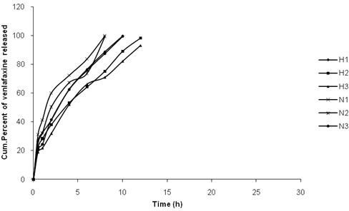

**Fig.1: Release profiles of different formulations of Venlafaxine in combination with HPMC, Sod CMC**

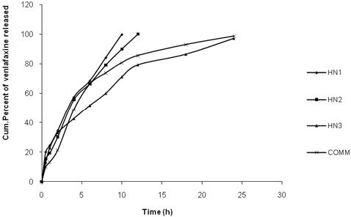

### Fig.2: Release profiles of different formulations of Venlafaxine HCl in combination with HPMC and Sod CMC, Commercial

**Table 4: Correlation coefficient (r) values in the analysis of release data of venlafaxine matrix tablets as per various kinetic models**

**Correlation coeffecient (r2)**

|  |  |  |  |  |
| --- | --- | --- | --- | --- |
| **Formulation code** | **Zero order** | **First order** | **Higuchi** | **Peppas** |
| H1 | 0.885 | 0.982 | 0.996 | 0.994 |
| H2 | 0.990 | 0.865 | 0.995 | 0.994 |
| H3 | 0.971 | 0.952 | 0.993 | 0.994 |
| N1 | 0.952 | 0.965 | 0.984 | 0.982 |
| N2 | 0.962 | 0.953 | 0.984 | 0.974 |
| N3 | 0.970 | 0.993 | 0.995 | 0.992 |
| HN1 | 0.966 | 0.981 | 0.987 | 0.995 |
| HN2 | 0.960 | 0.980 | 0.989 | 0.992 |
| HN3 | 0.870 | 0.965 | 0.988 | 0.992 |
| COMMERCIAL | 0.792 | 0.986 | 0.944 | 0.926 |

### Table 5: Release characteristics of different formulations of venlafaxine

**Release rateK0**

**Formulation T50 (h) T90 (h) K1(h-1) n in peppas equation**

|  |  |  |  |  |  |
| --- | --- | --- | --- | --- | --- |
|  | | | **(mg/hr)** |  | |
| H1 | 2.8 | 8.2 | 7.745 | 0.246 | 0.50 |
| H2 | 3.4 | 10.2 | 6.503 | 0.267 | 0.49 |
| H3 | 3.6 | 11.6 | 6.446 | 0.191 | 0.58 |
| N1 | 1.4 | 6.8 | 8.479 | 0.278 | 0.39 |
| N2 | 2 | 7.2 | 9.103 | 0.214 | 0.49 |
| N3 | 2.8 | 8.4 | 8.327 | 0.244 | 0.59 |
| HN1 | 3.6 | 8.8 | 9.100 | 0.209 | 0.61 |
| HN2 | 2.4 | 10 | 8.002 | 0.214 | 0.66 |
| HN3 | 5.6 | 20 | 3.789 | 0.131 | 0.46 |
| COMMERCIAL | 4 | 16 | 4.202 | 0.168 | 0.66 |

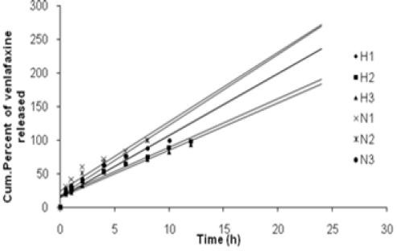

### Fig.3: Zero order drug release plots of different formulations of Venlafaxine in combination with HPMC, Sod CMC

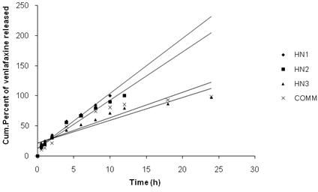

**Fig.4: Zero order drug release plots of different formulations of Venlafaxine in combination with HPMC and Sod CMC, Commercial.**

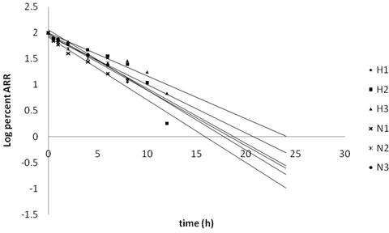

### Fig.5: First order drug release plots of different formulations of Venlafaxine in combination with HPMC, Sod CMC

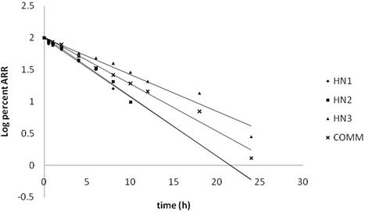

**Fig.6: First order drug release plots of different formulations of Venlafaxine in combination with HPMC and Sod CMC, Commercial.**

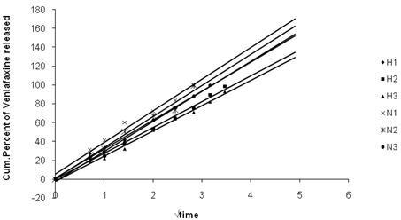

### Fig.7: Percent release Vs square root time plots of different formulations of Venlafaxine in combination with HPMC, Sod CMC

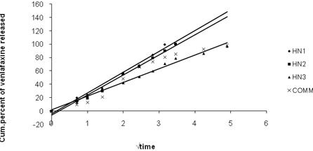

**Fig.8: Percent release Vs square root time plots of different formulations of Venlafaxine in combination with HPMC and Sod CMC, Commercial**

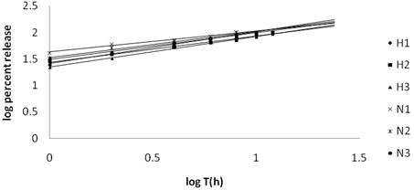

### Fig.9: Log percent drug release Vs log time plots of Venlafaxine with HPMC, Sod CMC

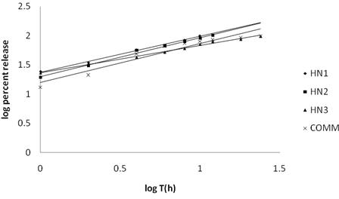

**Fig.10: Log percent drug release Vs log time plots of Venlafaxine with HPMC and Sod CMC, Commercial.**

### Table 6: Drug content of HN3 formulation before and after storage

**Drug content**

### Formulation code Before storage After storage at 400c, 75% RH

HN3 98.58 ± 0.040 96.82 ± 0.053

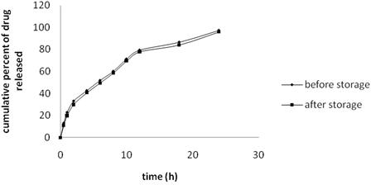

**Fig 11: Release profiles of HN3 formulation before and after storage**

## Conclusion

Matrix tablets of Venlafaxine HCl were prepared by using HPMC and Sod CMC. The release of the drug from the matrix tablet was affected by different concentration of chosen polymers. Pre and post compression parameters were with in the acceptable limits. Formulations containing the single polymer could not control the release of Venlafaxine HCl but blend of HPMC and Sod CMC successfully control the release of drug for a period of 24 hrs. The control release of drug from HPMC and Sod CMC combination was due to interaction between Sod CMC chain and HPMC chain, which results in the increasing viscosity of dissolution fluid by gel formation. The release of drug followed Higuchis and Korsemeyer-Peppas models and gave fickian and anamolous diffusion associated with swelling. From the FT IR spectra, DSC thermograms and stability studies it can be concluded that the selected formulation (HN3) was stable and showed no interactions with selected excipients. The study revealed that combination of Sod CMC and HPMC can be used for the formulation of sustained release matrix tablets of Venlafaxine HCl for once a day administration.

## References

1. Joseph, Robbinson R, Vincent H.L Lee. Controlled drug delivery fundamentals and applications, 2nd ed vol 29 p 1-23.
2. Haan PD, Lerk CF. Oral controlled release dosage forms a review. Pharma world and science 6(2) 1984 p 57-67.
3. Kale SN, Gudsoorkar VR, Shete JL. Eastern pharmacist 36, 423 (1993) 125.
4. Brabander C, Veravet C, Remon JP. Development and evaluation of sustained

release mini matrices prepared via hot melt extrusion. J of Control Rel 89(2) 2003 p 235-247.

1. Santus G, Lazzarini C, Bottoni G, Sandefer EP, Page RC, Doll WJ, Ryo VY, Digenis GE. An invitro- in vivo investigation of oral bioadhesive controlled release furosemide formulations. E J of Pharmaceutics and Biopharm 44(1) 1997 p 39-52.
2. Deshpande AA, Rhodes CT, Shah NH, Mallick AW. Controlled release drug delivery systems for prolonged gastric residence. Drug development and industrial pharmacy 22(6) 1996 p 531- 539.
3. Deshpande AA, Rhodes CT, Shah NH, Mallick AW. Development of a novel controlled release system for gastric retention. Pharmaceutical research 14(6) 1997 p 815-819.
4. Raghuram Reddy K, Srinivas M, Srinivas Reddy. Once daily sustained release matrix tablets of nicorandil formulation and invitro evaluation. AAPS Pharm Sci tech 4(4) 2003 p 61.
5. Rang HP, Dale MM, Flower RJ, Ritter JM. Rang and Dales pharmacology 6th ed p 57-63.
6. Good man and Gilman’s Manual of pharmacology and Therapeutics, section III Drugs acting on the CNS 2008 p 290.
7. Banker GS, Anderson LR. The Theory and Practise of Industrial Pharmacy 3rd ed 1987 p 293-345.
8. Deepak Kumar Mourya, Rishabha Malaviya, Mayank Bansal, Pramod kumar Sharma, Formulation and release characteristics of novel monolithic hydroxyl propyl methyl cellulose matrix

tablets containing metronidazole. Int J of Pharma and Biosciences 1(3) 2010.

1. Sowmya C, Reddy YP, Kiran Kumar, Santhosh Raja M, Development and validation of spectrophootometric method for the estimation of venlafaxine in bulk and formulations. Int J Chem Sci 9(1) 2011 p 52-58.
2. Higuchi T. Mechanism of sustained action medication- theoretical analysis of rate of release of solid drugs dispersed in solid matrices. J of pharmaceutical sciences 52(12) 1963 p 1145.
3. Ritger PL, Peppas NA. A simple equation for description of solute release Fickian and non fickian release from non swellable devices in the form of slabs,

spheres, cylinders or discs. J of Controlled Release 5(1) 1987 p 23-36.

1. ICH guidelines.
2. Cooper J, Gunn C. Tutorial pharmacy 6th ed 1986 p 211-233.
3. Aulton ME. The science of dosage form design 2nd ed 1986 p 134.
4. Aulton ME. The science of dosage form design 2nd ed 1986 p 135.
5. Martin’s physical pharmacy and pharmaceutical sciences. 6th ed 2011 p 465-466.
6. Indian Pharmacopoeia vol II 1996 p 734- 739.