Original Article

International Journal of Pharmacy and Industrial Research

ISSN Print 2231 – 3648
Online 2231 – 3656

A VALIDATED RP – HPLC METHOD FOR SIMULTANEOUS ESTIMATION OF DIACERINE AND ACECLOFENAC IN TABLET DOSAGE FORM

^{*,1} Chandran M, ² Kannan K
^{*,1} Ultra college of Pharmacy, Madurai , Tamilnadu, India - 625 020.
² Annamalai University, Annamalai Nagar, Tamilnadu, India - 608 002.

Abstract
A simple, rapid reverse-phase high performance liquid chromatographic method has been developed and validated for the simultaneous estimation of Diacerine and Aceclofenacin in tablet dosage form. The estimation was carried out on a Phenomenax Luna C₁₈ (150mmx 4.6 mm i.d, particle size 5 mcm ) column with a mixture of acetonitrile: methanol: buffer( potassium dihydrogen ortho phosphate PH 3.0) in the ratio of35:20:45 (v/v ) as mobile phase. UV detection was performed at 270nm. The flow rate was 2ml/min The method was validated for linearity, accuracy, precision, specificity and sensitivity as per ICH norms. The retention time was 6.3and 3.6 minute for Diacerine and Aceclofenac respectively. The flow rate was 2.0ml/min. The calibration curve was linear over the concentration range of 80-120mcg /ml for Diacerine and 160-240mcg /ml for Aceclofenac. The LOD and LOQ values were found to be 0.490 and 1.485 mcg/ml for Diacerine and 5.129and 15.542mcg/ml for Aceclofenac respectively. The developed and validated method was successfully used for the quantitative analysis of commercially available dosage form. The developed method has required accuracy and precision for routine analysis of Diacerine and Aceclofenac in tablet dosage form.

Keywords: Diacerine, Aceclofenac, RP- HPLC.

Introduction
Aceclofenac (ACE) is used mainly in the treatment of anti inflammatory^{1,2,3}, Chemically it is 2[(2,6 Dichlorophenyl) amino] acetyl oxy acetic acid. Diacerine (DIC) is chemically 1,8 diacetoxy 3 carboxy anthroquinone . It is mainly used for the anti inflammatory activity.^{1,2} Literature survey reveals that RP- HPLC⁴ and UV ^{6,} ^{7,} ^{8,} ¹³ methods have been
reported for the estimation of DIC alone in pharmaceutical formulation. Stability indicating HPLC⁴ method has also been reported. Similarly determination of ACE in human plasma by HPLC⁵ RP-HPLC¹⁰ and UV¹² method has also been reported. Simultaneous estimation of ACE with other analgesic ¹¹. Simultaneous spectrophotometric estimation of DIC and ACE in pharmaceutical formulation.^{9,14,15,16} simultaneous estimation of

Author for Correspondence:
Chandran M,
Ultra college of Pharmacy, Madurai , Tamilnadu, India - 625 020.
Email: mchandran.19@gmail.com

DIC and ACE by RP-HPLC^{17,} ¹⁸. Stability indicating HPLC¹⁹ The purpose of this study was to develop a shorter run time. And also to maintain a lower PH 3.0. for reducing the retension. Thus the peak tailing is minimised . So that it is a simple, rapid, precise and accurate RP- HPLC method for the simultaneous estimation of both the drug in combined tablet dosage form.

Materials and Methods

Chromatographic separation was carried out on Shimadzu LC-10 AT_{VP} solvent delivery system, with Shimadzu SPD-10 A_{VP} UV – Visible detector and Rheodyne 7725i universal loop injector of injection capacity 20mcL. The equipment was controlled by a PC work station with Winchrom software. Ultra - sonicator, Model Soltec -2200 MH was used. Reference standards of DIC and ACE were obtained as gift samples from Arthi drugs LTD and used as such, Pondicherry. The Tablet dosage form was procured from the local pharmacy, (Label claim : DIC 50mg and ACE 100mg),. All the chemicals and reagents used were of HPLC grade or Analytical Reagent grade purchased from Qualigens, Fine Chemicals, Mumbai, India.

Experiments and results: Chromatographic Condition:
Column : Phenomenex Luna C₁₈ column (150mm x4.6mm i.d, 5mm particle)
Mobile phase : Acetonitrile: Methanol: buffer ( potassium dihydrogen ortho phosphate PH - 3.0) in the ratio of35:20:45 %[v/v] was prepared and degassed with Ultra-sonicator. Filtered through 0.45µ membrane.
Detector wavelength : 270 nm Injection volume : 20 µl
Temperature : Ambient

Construction of calibration curve: Standard stock solution of DIC and ACE were prepared separately in 50ml of mobile phase to get the concentration of 50mcg/ml and 500mcg/ml respectively. From the standard stock solution of drugs, different dilutions were prepared, injected and their peak area was measured and calibration curves were constructed. (Fig 3.)
Physical mixture: From the standard stock solution of the drugs, physical mixtures containing DIC and ACE in the ratio of 2:12
,4:10, 6:8, 8:6, 10:4, 12:2 respectively were prepared and analysed and the results are given in Table 1.
Sample Preparation: Average weight of the tablet was determined by weighing twenty tablets. The tablets were crushed to a fine powder and the tablet powder equivalent to 100mg of ACE was transferred to 100ml volumetric flask, dissolved in about 60ml of methanol by sonication for 15 minutes and made up to the volume with methanol. The solution was filtered through Whatman filter paper#41.This filtrate was further diluted with mobile phase to get the final concentration of 80mcg/ml for DIC and 160mcg /ml for ACE. The resulting solution was injected for quantitative analysis. The amount of DIC and ACE was calculated by using the calibration curve. The results are reported in Table 2.

Validation of the developed method Specificity
To evaluate the specificity solution of DIC, solution of ACE and solution of placebo, all

prepared in mobile phase individually, were injected in to the system and it was observed that DIC and ACE peaks were well separated and there was no interference from placebo (Fig 2)

System suitability

Solution containing both DIC and ACE in the mobile phase was injected and the system suitability parameters were determined. The results are given in Table: 3

Linearity

Linearity was evaluated from the calibration curve data and linear response was observed between 80 to 120 mcg/ml for DIC and 160 to
240 mcg/ml for ACE with a correlation coefficient of 0.996 for DIC and 0.999 for ACE. Regression equations were constructed for both the drug and given below
Y _{DIC}= 53.71X _{DIC} + 82.615 [r2= 0.996]
Y _{ACE}= 22.0752X _{ACE} - 228.808 [r2= O.999]

Where Y _{DIC} and Y_{ACE} are response [peak area] for DIC and ACE respectively and X _{DIC} and X _{ACE} are the concentration of DIC and ACE respectively.

Accuracy

Accuracy of developed method was confirmed by doing recovery study at three different concentration levels 80%, 100% and 120% each in triplicate. The result of accuracy study is reported in Table.4

Precision

The tablet formulation was analysed for the content of DICand ACE six times on the same day to determine intra day precision. The results are given in Table: 2 and analysed on three different days to determine inter-day precision. The results are given Table: 5

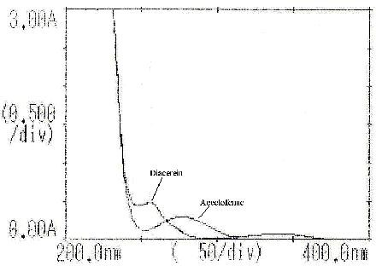

Figure 01: Overlain Spectra of DIC and ACE
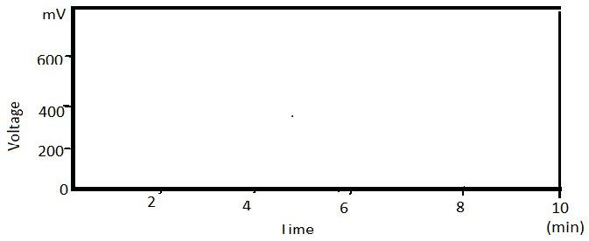
Figure 02: Chromatogram of Placebo

Table 01: Analysis of Physical Mixture
Theoretical Concentration of (mcg/ml) Experimental values for (mcg/ml) % of theoretical value

DIC | ACE | DIC | ACE | DIC | ACE
160 | 1920 | 159.04 | 1934.10 | 99.40 | 100.50
320 | 1600 | 316.18 | 1570.80 | 98.80 | 98.27
480 | 1280 | 472.00 | 1275.21 | 98.33 | 99.62
640 | 960 | 630.28 | 967.41 | 98.40 | 100.70
800 | 640 | 794.12 | 638.12 | 99.26 | 99.71
960 | 320 | 968.20 | 315.90 | 100.80 | 98.73
 |  |  | Mean | 99.18 | 99.56
 |  |  | Standard Deviation | 0.7681 | 0.8712

Table 02: Assay of Tablet Formulation
 | DIC | ACE | DIC | ACE
01 | 50.32 | 100,41 | 100.64 | 100.86
02 | 50.26 | 99.06 | 100.52 | 98.93
03 | 49.85 | 99.29 | 99.70 | 98.40
04 | 50.65 | 101.30 | 101.30 | 99.60
05 | 49.29 | 98.58 | 98.58 | 100.40
06 | 50.52 | 101.04 | 101.04 | 100.83
SD |  |  | 0’5901 | 0.5789
%COV |  |  | 0.595 | 0.5815
SE |  |  | 0.3515 | 0.3950

Replicate AMOUNT found (mg) % label claim

Lable claim: DIC 50mg/tablet and ACE 100mg/tablet.SD: standard deviation, COV: coefficient of variance, SE: standard error.

Table 03: System suitability parameters

Property | DIC | ACE
Retension time | 6.287 | 3.606
Tailing factor | 1.263 | 0.917
Capacity factor | 2.160 | 2.124
Number of theoretical plates | 3830 | 6722
Resolution | 9.948
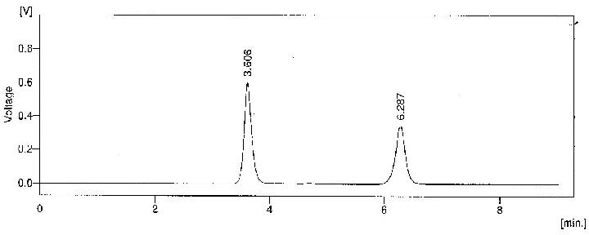
Figure 03: Chromatogram of DIC and ACE in mixed standard solutions

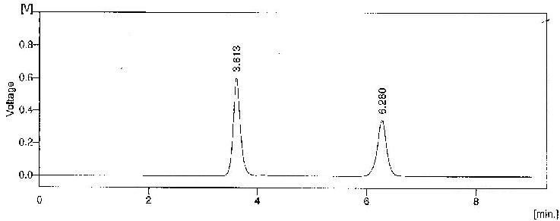

Figure 04: Chromatogram of DIC and ACE in sample solution with their retention time

Table 04: Recovery Studies

Amount Added (mg) Amount found % recovery Drug
DIC ACE DIC ACE DIC ACE

80% | 39.123 | 79.451 | 39.316 | 79.021 | 100.49 | 99.45
 | 39.594 | 80.034 | 39.054 | 79.512 | 98.63 | 99.33
 | 40.256 | 79.812 | 40.126 | 80.042 | 99.67 | 100.20
100% | 50.854 | 99.464 | 50.364 | 99.360 | 99.01 | 99.89
 | 49.694 | 99.742 | 50.014 | 99.442 | 100.61 | 100.86
 | 49.952 | 99.455 | 49.746 | 99.211 | 99.58 | 100.12
120% | 59.918 | 119.246 | 59.840 | 119.960 | 99.86 | 100.59
 | 59.105 | 120.081 | 59.464 | 119.246 | 100.60 | 99.30
 | 60.515 | 120.142 | 60.024 | 119.061 | 99.18 | 101.01
 |  | Mean |  |  | 99.76 | 100.09
 |  | %COV |  |  | 0.6481 | . 0.5796

Table 05: Inter Day Precision
Amount found (mg) % label claim

 | DIC | ACE | DIC | ACE
Day-1 | 50.32 | 99.61 | 100.64 | 99.61
 | 50.80 | 99.12 | 101.60 | 99.12
 | 49.42 | 98.46 | 98.82 | 98.46
Day-2 | 49.66 | 100.34 | 99.32 | 100.34
 | 50.45 | 99.80 | 100.90 | 99.80
 | 49.40 | 98.94 | 98.80 | 98.94
Day-3 | 50.60 | 99,20 | 101.20 | 99.20
 | 50.24 | 101.15 | 100.48 | 101.15
 | 49.20 | 98.85 | 98.40 | 98.85
SD |  |  | 0.792 | 1.1185
%COV |  |  | 0.8002 | 1.1184
Label claim: DIC 50mg/tablet and ACE 100mg/tablet.SD: standard deviation, COV: coefficient of variance

Table 06: Robustness for flow rate studies (temperature)
Temperature (ºC) | Area (DIC) * | Area(ACE)*
30 | 5317509 | 4152287
%RSD | 0.4142 | 0. 4896
25 | 5316879 | 4151672
%RSD | 0.6927 | 0.7971
35 | 5315468 | 4152329
%RSD | 0.9657 | 0.6058
* mean of three readings.

Table 07: Robustness for PH studies

pH Area (DIC) * Area (ACE) *

Table 08: Robustness for Flow rate Studies

Flow rate (ml./mt) Area (TAD) * Area (DAP) *

%
2.9 | 5318760 | 4153468 | 1.8 | 5318654 | 4153607
 |  |  | %RSD | 0.0854 | 0.5624
RSD 0.6502 0.3750 2.0 5318990 4152697
3.0 | 5317654 | 4152659 | %RSD | 0.3451 | 0.2435

2.2 | 5317236 | 4151683
%RSD | 0.0947 | 0.3462

%RSD
0.3547
0.4524

3.1 5316549 4153469
%RSD 0.6992 0.5984
* mean of three readings.
*mean of three readings.

Limit of Detection and Limit of Quantization

The proposed method was estimated in terms of limit of quantification (LOQ) and the lowest concentration detected under the chromatographic conditions as the limit of detection (LOD). The LOD and LOQ were calculated by the use of the equation LOD = 3.3X N/B and LOQ = 10XN/B where N is the standard deviation of the peak areas of the corresponding drug sample, taken as the measure of the noise, and B is the slope of the corresponding calibration plot.

The LOD was found to be 0. 490 mcg/ml , 5.129mcg/ml for DIC and ACE respectively where as the LOQ was found to be 1.485 mcg/ml, 15.542 mcg/ml for DIC and ACE respectively

Robustness
Robustness was established in a triplicate by analyzing system suitability standard and

sample at 25° and 35°C (nominal temperature 30 C ) at flow rates of 1.8 and 2.2 (nominal flow rate 2mL/min ) and pH 2.9 and 3.1 (nominal pH 3.0) and the % RSD of peak area was calculated. The results are reported in (Table 6, 7, 8)

Discussion

HPLC method development and optimization Preliminary study on column selection revealed that C₁₈ column gave a better resolution and run time than C8 and hence C18 column was used for further study. Mobile phase and flow rate selection was based on the peak parameters [height, area, tailing, theoretical plates, capacity factor and resolution] and run time. Good separation could be obtained by use of35: 20: 45 [v/v] ratio of acetonitrile, methanol : buffer (potassium dihydrogen ortho phosphate PH 3.0) with 2.0mL/min. UV spectrum of DIC exhibited absorption maximum at about 258

nm where as ACE exhibited absorption maximum at about 275nm Considering the absorptivity of the drugs and their relative quantity in the formulation , 270 nm was selected as detector wavelength.. From the overlain UV spectra [Shimadzu-1700], suitable wave length considered for monitoring the drugs was 270 nm. [Fig 1] Under the optimized chromatographic conditions the drug peaks are well separated and there was no interfering peak from placebo, thus the method has required specificity. The retention time obtained for DIC and ACE were 6.287 and 3.606, respectively ( Fig 4).
The capacity factor, tailing factor, theoretical plates count and resolution are with in the acceptance criteria (Table-3). From the physical mixture analysis, the Statistical results were found to be within the range of acceptance ie . %COV < 2 .0 and S.D. < 1.0 (Table 1).
The mean recovery was 99.76 and 100.09% for DIC and ACE respectively which confirms the accuracy of the method. (Table 4).
Small change in the experimental parameters did not did not affect the chromatographic behaviour indicating the robustness of the method .( Table 6,7,8).

Conclusion
A new, reversed –phase HPLC method has been developed for simultaneous analysis of DIC and ACE in a tablet formulations. It has been shown that, the method is, accurate, precise and specific proving the reliability of the method. The run time is relatively short , i.e, 7 min., which enable rapid determination of any samples in routine quality control analysis of tablet formulations.. Hence the
proposed method is suitable for routine analysis of the tablet formulation containing DIC and ACE.

Acknowledgement

The authors are thankful to Arthi Drugs LTD Puduchery for providing the gift samples of DIC and ACE.

References

- Budawari s, The Merck Index; 13th edition, Merck and Co. Inc Whitehouse Station. NJ, 2001.
- Martindale; The Complete Drug Reference; 33 rd Edition, Pharmaceutical Press, London. 2002
- Indian pharmacopeia, 2007, Published by the Controller of Publications, New Delhi on behalf of Govt, of India Ministry of Health and Family Welfare, Vol iii, page 1743.
- Giannellini V, Salvatore F, Bartolucci G, Coran SA, Albertis MB,. J. pharm Biomed. Anal 2005; 39: 776-80.
- Osha A, Rathod.r, padh H,. J. Chromatogr B. 2009. 877: 1145-8.
- Borgmann SH, Parcianello L.M Arend MZ, Cardoso SG, Pharmazie 2007, 62- 483-5.
- Diacerin in pharmaceutical dosage form by UV spectroscopy method. International journal of pharm Tech. Research coden [USA] IJPRIF Dec 2010 vol z no 4 pp 2313-2318.
- Manzoor A, Manohara YN and Appala Raju S, the Indian Pharmacist 2005, 11; 102-3.

- Carolin Nimila, P.Balan S.Rajasekar, Pharma Tech vol. 2 no 4 p-2313-2318 oct 2010.
- Raja R K, Sankar GC , Rao A L and Sheshagiri R J. Indian drugs 2005, 42 [10]
: 693-695.

- Gharge, D, Dhabale,P Simultaneous estimation of aceclofenac and paracetamol International journal of chem. TECH. research 2010;2[2].
- PR. Mahaparale, JN. Sangshelti, B S Kuchekar, Indian journal of pharmaceutical sciences 2007; 69:2
- Topale, M.R Gaikwad, N.J, and Tajane M. R Indian drugs 2003 40 ;119.
- Manoj Charde, Imran shekh, Avinesh kesture Journal of pharmacy research vol 3 no. 6. 2010
- Ritu.V, Kimbahune, NIkunji kumar patel Vaibher Desmukhe. Journal pharmacy research vol. 4 no. 6 2011
- M.V. Bhure, A.K. Hemke and K.R. Gupta. Journal of pharmaceutical sciences and research vol.2(7) 2010 p-426-432.
- R.Sivkumar, N. Srisutherson, W.D Sam Soloman, P.Kumar Nallasivam R.Venkatanarayanan Pharma Tech vol.2 no 1 p 940-944 March 2010.
- V.Sekar, S. Jayaseelan , N.Subash, P.perumal. Chem Tech vol 2. No. 1 pp 168-171.
- S.P. Gandhi, M.G. Dewani T.C Borole and M.C.Damle IJRPC vol 1(4) 2011.
- ICH Q 2 (R1). Validation procedure; Text and Methodology, International conference on Harmonization. Geneva 2003.

