***Original Article***



International Journal of Pharmacy and Industrial Research

**ISSN Print 2231 – 3648**

**Online 2231 – 3656**

**PRELIMINARY QUALITY CONTROL PARAMETERS OF**

***CLERODENDRUM PHLOMIDIS* LEAVES**

# *Agilandeswari D

JSS College of Pharmacy, Ootacamund, Tamilnadu, India - 643001.

## Abstract

In India, Ayurvedic, Siddha and other herbal derived products which are used either as active ingredients or as adjuvants hold paramount importance as alternative medicines but their quality evaluation poses a great challenge to practitioners and consumers. *Clerodendrum phlomidis* Linn. f. (syn. *Clerodendrum multiflorum* (Burm.f) O. Kuntze) of the family Lamiaceae is an important and well known medicinal plant in Ayurveda and Siddha system of medicines. Considering the wide range of therapeutic applications of this plant and to ensure the identity, quality of the plant material, the present study was planned to determine the preliminary quality control parameters of *Clerodendrum phlomidis* leaves. Foreign organic matter, morphology, anatomy, histology, powder microscopy and proximate analysis (ash values, extractive values, loss on drying and bitterness value) were determined. Arsenic, heavy metal and microbial content were determined. Complete qualitative phytochemical analysis of successive extracts was also carried out. Plant materials are used throughout developing and also in developed countries as home remedies, over-the- counter drug products, raw materials for the pharmaceutical industry, and represent a substantial proportion of the global drug market. It is therefore essential to assess their quality by using modern quality control techniques. The determined quality control parameters of *Clerodendrum phlomidis* leaves can used to identify and assess the quality of the raw material.

**Keywords:** *Clerodendrum phlomidis*, Proximate analysis, Phytochemical screening, Quality control.

## Introduction

In India, Ayurvedic, Siddha and other herbal derived products which are used either as active ingredients or as adjuvants hold paramount importance as alternative medicines but their quality evaluation poses a great challenge to practitioners and consumers. Correct identification of these drugs is often problematic in entire form as well as in powder form, since these medicinal plants are known

by a variety of vernacular names and frequently many medicinal plants are known by one vernacular name1. *Clerodendrum phlomidis* Linn. f. (syn. *Clerodendrum multiflorum* (Burm.f) O. Kuntze) of the family Lamiaceae is an important and well known medicinal plant in Ayurveda and Siddha system of medicines. It is commonly known as Thalludhalai, Agnimantha, Arani and a constituent of more than 50 indigenous medicinal formulations. Popular uses include

### Author for Correspondence:

Agilandeswari D,

JSS College of Pharmacy,

Ootacamund, Tamilnadu, India - 643001. Email: [agilandeswaridevarajan@gmail.com](mailto:agilandeswaridevarajan@gmail.com)

the treatment of inflammation, diabetes, nervous disorders, asthma, rheumatism, digestive disorders, and urinary disorders and also as a bitter tonic. Non-clinical investigations have revealed anti- inflammatory, hypoglycemic, immune- modulatory, antidiarrhoeal and antiplasmodial properties2. Considering the wide range of therapeutic applications of this plant and to ensure the identity, quality of the plant material, the present study was planned to determine the preliminary quality control parameters of *Clerodendrum phlomidis* leaves.

## Materials and Methods

### Chemicals and reagents

All solvents, chemicals and reagents used were of analytical grade.

### Collection and authentication of plant materials

Leaves of *Clerodendrum phlomidis* were collected from Trichy, Tamilnadu, India. The plant was identified and authenticated by comparing with the voucher specimen at the Survey of Medicinal Plants and Collection Unit, Government Arts College, Ootacamund, India.

### Determination of foreign matter

Accurately weighed 250 g of the leaf material was spread in to thin layer and the foreign matter was sorted into groups by visual inspection, using a magnifying lens. The remaining sample was sifted through a number

250 sieve; dust was regarded as mineral admixture. The content of each group was calculated in grams per 100 g of air-dried sample3.

### Morphology, anatomy, histology and powder microscopy

The leaf specimens were cut and fixed in FAA [Formalin (5 ml) + Acetic acid (5 ml) + 70 % Ethyl alcohol (90 ml)]. After 24 h of fixing, the specimens were dehydrated with graded series of tertiary butyl alcohol (TBA). Infiltrations of the specimens were carried by gradual addition of paraffin wax (melting point 58-60oC) until TBA solution attained supersaturation. Then the specimens were cast into paraffin blocks. The paraffin embedded specimens were sectioned with the help of Rotary Microtome with thickness of 10–12μm. Sections were stained with blue after dewaxing. Wherever necessary, the sections were stained with safranin, fastgreen and iodine (for starch). For studying the stomatal morphology, venation pattern and trichome distribution, paradermal sections (sections taken parallel to the surface of leaf) were taken after clearing with 5 % sodium hydroxide or epidermal peeling by partial maceration employing Jeffrey’s maceration fluid. Glycerin mounted temporary preparations were prepared for macerated/cleared materials4,5,6. Photographs of different magnification were taken with Nikon Labphot 2 microscopic unit. For normal observations bright field was used. For the study of crystals, starch grains, and lignified cells, polarized light was employed. Magnifications of the figures were indicated by the scale-bars7,8.

### Proximate analysis

Determination of ash values like total ash, acid insoluble, water soluble, sulphated ash and extractive values like water soluble, ethanol soluble and ether soluble were carried out by the procedures of WHO, 20053 and Anonymous, 19969. Loss on drying (LOD), bitterness value, arsenic-heavy metals and

microbial count were determined by the procedures of WHO, 20053.

### Successive extraction

The air-dried leaf materials were grounded to coarse powder and extracted successively in a soxhlet apparatus until exhaustion with solvents of increasing polarity viz., petroleum ether (60-80 oC), benzene, diethyl ether, chloroform, ethyl acetate, acetone, methanol and water. The extracts were concentrated in a rotary evaporator and dried in a dessicator.

### Preliminary qualitative phytochemical screening

All the extracts were studied for the presence and absence of secondary metabolites like, alkaloids, glycosides, saponins, phytosterols, phenolics, terpenoids, flavonoids, coumarins and tannins by qualitative chemical tests10-16.

## Results and Discussion

### Determination of foreign matter

Foreign matter is material consisting of any or all of the following;

1. Parts of the medicinal plant material or materials other than those named with the limits specified for the plant material concerned;
2. Any organism, part or product of an organism, other than that named in the specification and description of the plant material concerned;
3. Mineral admixtures not adhering to the medicinal plant materials, such as soil, stones sand and dust.

**Table 01: Foreign matter in *C.phlomidis* leaves**

As the presence of foreign matter in medicinal plant materials may interfere throughout the study, it is crucial to quantify them. Macroscopic examination can conveniently be employed for determining the presence of foreign matter in whole or cut plant materials. However, microscopy is indispensable for powdered materials. The leaf material showed 6.728 %w/w of total foreign matter (Table 1), which is relatively high. It is seldom possible to obtain plant materials that are entirely free from some form of foreign matter. 1.2 %w/w of mineral admixture indicates the presence of appreciable quantity of soil, stones, sand and dust. 4.32 %w/w of other plant materials indicates the presence of other morphological parts of *C. phlomidis* mostly stem. 1.128

%w/w of other organic matter includes moulds or insects, and other animal contamination, including animal excreta.

### Morphology, anatomy, histology and powder microscopy

The leaves are deltoid ovate, charteceous, glabrescent, margins coarsely serrate, panicle axillary and terminal. Toluidine blue is a polychromatic stain, hence the staining results were remarkably good; and some cytochemical reactions were also obtained. The dye rendered pink colour to the cellulose walls, blue to the lignified cells, dark green to suberin, violet to the mucilage and blue to the protein bodies. Since crystals, starch grains, and lignified cells have birefringent property, under polarized light they appeared bright against dark background. The leaf is dorsiventral,

amphistomatic, smooth and with prominent

**Mineral admixture**

**Other plant**

**Other organic**

**Total foreign**

midrib (Figure 1). The midrib is planoconvex

**materials matter matter**

1.2 %w/w 4.32 %w/w 1.128 %w/w 6.728 %w/w

in cross sectional view with hemispherical abaxial part and flat adaxial side. The ground

tissue of the midrib consists of compact, thin walled, angular parenchyma cells both on the adaxial and abaxial parts. The vascular bundles of the midrib may be a single strand (Figure 2) or a group of 3 strands (Figure 3). In the single strand vascular bundle there is a mass of xylem elements with abaxial phloem; the 3-stranded vascular bundle are 3 discrete xylem masses each with phloem strands. The strand is 800 μm in vertical plane and 600 μm in horizontal plane. The lamina is 300 μm thick; the epidermis layers are even and fairly thick. The adaxial epidermal layer has rectangular or squarish cells with thin cuticle; the abaxial epidermis is slightly thinner and consists of spindle shaped or oblong cells. The adaxial epidermis is 25 μm thick while the abaxial layer has 20 μm thick cells. The mesophyll tissue is thin walled and chlorenchymatous, it is differentiated in to adaxial zone of palisade cells and abaxial zone of spongy mesophyll tissue (Figure 4, 5). The palisade consists of 2 layers of vertically elongated cylindrical cells (Figure 6). The spongy mesophyll consists of 3 or 4 layers of spherical cells which are less compact. Glandular trichomes are frequently seen apart from the normal non glandular trichomes. The glandular trichomes have a short stalk cell which is attached to the epidermis. The body of the trichomes may be unicellular and spherical or it may be a part of

6 or more cells (Figure 7). The cells have dense cytoplasm and prominent nuclei.

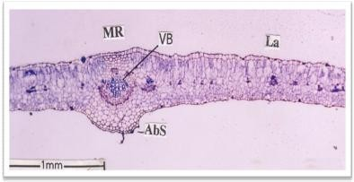

**Figure 1: TS of *C. phlomidis* showing prominent midrib**

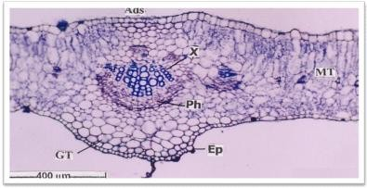

**Figure 2: TS of *C. phlomidis* showing single strand vascular bundles**

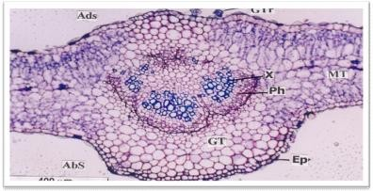

**Figure 3: TS of *C. phlomidis* showing three strands of vascular bundles**

**Legend for figures**: AbS-Abaxial side;

AdS-Adaxial side; Ep-Epidermis; GT-Ground tissue; GTr- Glandular trichome; La-Lamina; MT-Mesophyll tissue; Mr-Midrib; Ph-Phloem; VB-Vascular bundle; X-Xylem.

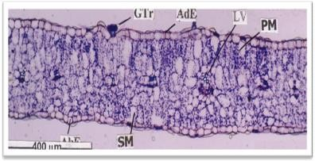

**Figure 4: TS of *C. phlomidis* showing the lamina region**

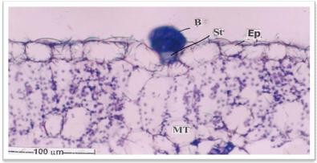

**Figure 5: TS of *C. phlomidis* showing glandular trichomes**

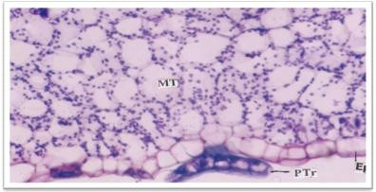

**Figure 6: TS of *C. phlomidis* showing peltate trichomes**

**Legend for figures:** AbE-Abaxial epidermis; AdE- Adaxial epidermis; B-Body cells; Ep-Epidermis; GTr Glandular trichomes; LV-Lateral vein; MT-Mesophyll tissue; PM-Palisade mesophyll; PTr-Peltate trichomes; SM-Spongy mesophyll; St-Stalk cells.

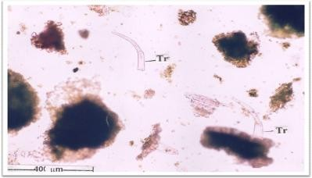

**Figure 7: Powder analysis of *C. phlomidis* showing trichomes.**

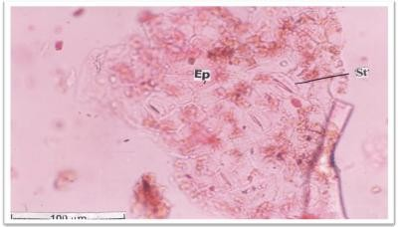

**Figure 8: Powder analysis of *C. phlomidis* showing stomata**

**Legend for figures:** Ep-Epidermis; St-Stomata; Tr- Trichomes.

The powder analysis of leaf shows numerous glandular trichomes. These trichomes are multicelluar, unbranched and uniseriate. The walls are thick and the terminal cell is tapering in to a pointed tip. There are also small fragments showing stomata (Figure 8). The epidermal cells are thin walled and straight. The stomata are anomocytic type; the guard cells have no distinct subsidiary cells.

### Proximate analysis

Ash values of *C. phlomidis* leaves show relatively high total ash of 9.66 %w/w and sulphated ash (6.24 %w/w), indicating high quantity of carbonates and oxides (Table 2). Low acid insoluble ash indicates less silicious materials like earth or sand. Ash values are helpful in determining the quality and purity of crude drugs in powdered form. The total ash usually consists of inorganic radicals like carbonates, phosphates, silicates and silica of sodium, potassium, magnesium and calcium.

Sometimes, inorganic variables like calcium oxalate, silica, carbonate content of crude drug affects “total ash” values, such variables are then removed by treating with acid (as they are soluble in hydrochloric acid) and then acid- insoluble ash value is determined. The values vary within fairly wide limits and are therefore an important parameter for the purpose of evaluation of crude drugs. A high ash value is indicative of contamination, substitution or adulteration. Ash insoluble in hydrochloric acid is the residue obtained after extracting the sulfated or total ash with hydrochloric acid. This acid-insoluble ash value particularly indicates contamination with silicious materials like earth or sand. Water soluble ash is that part of the total ash content which is soluble in water. It is a good indicator of either previous extraction of water soluble salts in the drug or incorrect preparation. While determining the total ash, very high temperature (> 600° C) may result in the conversion of carbonates to oxides. The treatment with sulphuric acid results in sulphated ash where the oxides are converted to sulphates.

**Table 2: Proximate analysis of *C.phlomidis* leaves**

|  |  |
| --- | --- |
| **Parameters** | **Values** |
| Total ash | 9.66 %w/w |
| Acid-insoluble ash | 3.28 %w/w |
| Water-soluble ash | 4.65 %w/w |
| Sulphated ash | 6.24 %w/w |
| Water-soluble extractive | 37.6 %w/w |
| Ethanol-soluble extractive | 11.2 %w/w |
| Ether-soluble extractive | 3.2 %w/w |
| Loss on drying (LOD) | 7.33 %w/w |
| Bitterness value | 220 |

Extractive values of *C. phlomidis* leaves show very high quantity of polar constituents than non-polar constituents (Table 2). Extractive values determine the amount of active

constituents extracted with solvents from a given amount of medicinal plant material. It is employed for materials for which as yet no suitable chemical or biological assay exists. Extractive values are useful for evaluation of crude drugs and give an idea about the nature of chemical constituents present in them. The amount of extractive drug yield to a given solvent is often an approximate measure of a certain constituent or group of related constituents the drug contains. In some cases the amount of drug soluble in a given solvent is an index of its purity. The solvent used for extraction should be in a position to dissolve appreciable quantities of substances desired.

The LOD of *C. phlomidis* leaves is 7.33 %w/w (Table 2). Loss on drying determines both water and volatile matter. Excess of water in medicinal plant materials will encourage microbial growth and deterioration following hydrolysis. This is especially important for materials that absorb moisture easily or deteriorate quickly in the presence of water.

The bitterness value is expressed in units equivalent to the bitterness of a solution containing 1 g of quinine hydrochloride in 2000 ml. The bitterness value of *C. phlomidis* leaves is 220 (Table 2). The value is comparatively very less than quinine. Bitterness test should not be carried out until the identity of the plant material has been confirmed. Medicinal plant materials that have a strong bitter taste ("bitters") are employed therapeutically. Their bitterness stimulates secretions in the gastrointestinal tract, especially of gastric juice. However, since they are mostly composed of two or more constituents with various degrees of bitterness,

it is first necessary to measure total bitterness by taste.

The bitter properties of plant material are determined by comparing the threshold bitter concentration of an extract of the materials with that of a dilute solution of quinine hydrochloride. Safe drinking-water should be used as a vehicle for the extraction of plant materials and for the mouth-wash after each tasting. Taste buds dull quickly if distilled water is used. Sensitivity to bitterness varies from person to person, and even for the same person it may be different at different times (because of fatigue, smoking, or after eating strongly flavoured food). Therefore, the same person should taste both the material to be tested and the quinine hydrochloride solution within a short space of time. The bitter sensation is not felt by the whole surface of the tongue, but is limited to the middle section of the upper surface of the tongue. A certain amount of training is required to perform this test. A person who does not appreciate a bitter sensation when tasting a solution of 0.058 mg of quinine hydrochloride in 10 ml of water is not suitable to undertake this determination.

**Determination of arsenic and heavy metals** High sodium, iron and potassium levels (Table 3) suggest the presence of higher quantity of salts. The official limits for arsenic and mercury in herbal medicines are 2 and 0.2 ppm respectively, the quantity of arsenic and mercury detected in *C. phlomidis* leaves are within limits. Negligible quantity of arsenic, mercury, lead and cadmium indicates lesser use of pesticides and the healthy habitat of C*. phlomidis*.

**Table 3: Quantity of arsenic and heavy metals in *C. phlomidis* leaves Metals Quantity present**

Arsenic 0.13008 ppm

Mercury 0.01122 ppm

Lead Below detection level Cadmium Below detection level Manganese 64.97 ppm

Zinc 66.11 ppm

Copper 22.48 ppm

Sodium 2490 ppm

Iron 781 ppm

Potassium 120.18 ppm

### Determination of microbial content

*C. phlomidis* shows high fungal contamination than bacterial. *Escherichia coli*, *Pseudomonas aeruginosa*, *Stapylococcus aureus* and *Salmonella* sp*.* were detected as the major bacterial species (Table 4).

**Table 4: Microbial content of *C. phlomidis* leaves Microorganisms Colony forming**

**units per gram (cfu/g)**

Total viable count 6000

Total bacterial count 2800

*E. coli*,

*Pseudomonas aeruginosa*, *Stapylococcus aureus*, *Salmonella* sp*.*

Total fungal count 3200

Medicinal plant materials normally carry a great number of bacteria and fungus, often originating in soil. While a large range of bacteria and fungi form the naturally occurring microflora of herbs, aerobic spore-forming bacteria frequently predominate. The practices of harvesting, handling and production may cause additional contamination and microbial growth. The determination of *Escherichia coli* and fungus may indicate the quality of production and harvesting practices.

### Preliminary qualitative phytochemical screening

Wide arrays of natural compounds like, alkaloids, glycosides, saponins, phytosterols, phenolics, terpenoids, flavonoids, coumarins and tannins which exert physiological activity are synthesized in the plant, in addition to carbohydrates, proteins and lipids utilized by man as food. A systematic and complete study of crude drugs by different qualitative chemical tests will provide detailed information regarding the presence and absence of both primary and secondary metabolites derived as a result of plant metabolism. Establishing phyto-chemical profile of the extracts reveals the nature of chemical constituents and their composition. Like any Cleodendrum member *C. phlomidis* leaf shows steroids as major secondary metabolites. Phenolics and flavonoids were detected in acetone, methanol and water extract. Alkaloids were detected in acetone and methanol extract. Quantitatively water soluble constituents are higher than non-polar constituents. The % yield, appearance and nature of different extracts are shown in Table 5.

## Conclusion

Plant materials are used throughout developing and also in developed countries as home remedies, over-the-counter drug products, raw materials for the pharmaceutical industry, and represent a substantial proportion of the global drug market. It is therefore essential to assess their quality by using modern quality control techniques. The determined quality control parameters of *Clerodendrum phlomidis* leaves can used to identify and assess the quality of the raw material.

**Table 5: Preliminary qualitative phytochemical screening of *C. phlomidis* extracts**

**Successive extract Yield**

**% w/w**

**Appearance Odour Secondary metabolites**

Petroleum ether 2.72

Yellowish brown sticky mass

No characteristic odour

Steroids, steroidal

glycosides Steroids, steroidal

Benzene 2.17 Blackish green sticky mass Faint odour

glycosides, phenolics

Diethyl ether 0.17 Greenish black sticky mass Faint odour Steroids, saponins

Chloroform 1.08

Blackish green resinous mass

Slightly pungent

Steroids, steroidal

glycosides Phenols, saponins,

Ethyl acetate 0.57 Green sticky mass Characteristic odour

Acetone 0.72 Blackish green mass Characteristic odour Methanol 8.73 Reddish brown sticky mass Characteristic odour

Pleasant, tea like

coumarins Alkaloids, steroids,

flavonoids, phenolics Alkaloids, steroids, coumarins, flavonoids

Steroids, coumarins,

Water 27.24 Brown shiny powder

odour

flavonoids, phenolics

## References

1. Mohan Maruga Raja MK, Mishra SH. Quantification of l-dopa, lupeol and β- sitosterol from leaves of Clerodendrum phlomidis by TLC. Herba Polonica. 55, 2009, 44-51.
2. Mohan Maruga Raja MK, Patel RS, Mishra SH. Identification and quantification of adrenaline from the leaves of Clerodendrum phlomidis using thin-layer chromatography. J Chin Integr Med. 9, 2011, 105-108.
3. WHO. Quality control methods for medicinal plant materials. World Health Organization, Geneva, 2005.
4. Solerder H. 1899. Systematic Anatomy of the Dicotylendons. Clarendron Press, 1899.
5. Johanson DA. Plant Microtechnique. Mc Graw Hill Book Co, 1940.
6. Metcalfe CR, Chalk L. Anatomy of the Dicotyledons Vol I, Clarendon Press, 1979.
7. Sass JE. Elements of Botanical Microtechnique. Mc Graw Hill Book Co, 1940.
8. O’Brien TP, Feder N, Mc Cull ME. Polychromatic Staining of Plant Cell walls by toluidine blue-O. Protoplasma. 59, 1964, 364-373.
9. Anonymous. Indian Pharmacopoeia Vol

II. Ministry of Health & Family Welfare, Govt of India, Controller of Publications, 1996.

1. Rosenthaler L. The chemical investigation of plants. G Bell and Sons Ltd, 1930.
2. Peach K, Tracey MV. Modern Methods of Plant Analysis Vol I. Springler-Verlag, 1955.
3. Middelton H. Systematic Qualitative Organic Analysis. Edward Arnold Publishers Ltd, 1956.
4. Shah BS, Quadry JS. A Textbook of Pharmacognosy 3rd Edn, BS Shah Prakashan, 1980.
5. Wagner H, Bladt S, Zgainski E. Plant Drug Analysis - A Thin Layer Chromatography Atlas. Springer – Verlag, 1984.
6. Kokate CK. Practial Pharmacognosy, 2nd Edn, Vallabh Prakashan, 1991.
7. Wallis TE. Textbook of Pharmacognosy 3rd Edn, JA Churchill Ltd, 1960.