85

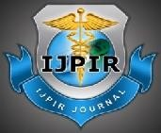Original Article

International Journal of Pharmacy and Industrial Research

ISSN Print 2231 – 3648
Online 2231 – 3656

MICROSCOPICAL OBSERVATION AND BIOCHEMICAL ANALYSIS OF LIVER FOR HEPATOPROTECTIVE EFFECT OF VITAMIN - E & C IN ALBINO RATS

*Ganesh E, Chowdhury A, Malarvani T, Ashok vardhan N

SRM Medical College Hospital and Research Center, SRM University, Potheri, Tamilnadu, India – 603203.

Abstract
The Hepatoprotective effects of Vitamins E and C (VEC) were evaluated in Carbon tetrachloride (CCl₄) or Paracetamol (PC) induced hepatotoxicity in albino rats. Liver necrosis was induced by administering single dose of either carbon tetrachloride (CCl₄, 1ml/k g, 50% v/v with olive oil, s.c.) or Paracetamol (PC, 1g/kg, p.o.). The liver damage was evidenced by Microscopic observation of Hepatic lobule configuration and the analysis of the levels of Serum glutamate oxaloacetate transaminase (SGOT), Serum glutamate pyruvate transaminase (SGPT), Serum alkaline phosphatase (ALP), Hepatic Thio-barbituric acid reacting substances (TBARS) and Superoxide dismutase (SOD) . VEC treatment (50/100 mg/kg Vitamin-E and 100/200 mg/kg Vitamin-C) by intraperitoneal injection, significantly (P<0.001) reduced CCl₄ or PC- induced elevations of the levels of SGOT, SGPT, ALP and SOD, while it reduced the concentration of TBARS. Microscopical analysis using Hematoxylin and Eosin (H&E) stain of the VEC administered rats’ revealed remarkable normal Hepatic lobule configuration, unlike the hepatotoxic rats whose hepatic cells were necrotic.

Keywords: Hepatotoxicity, Vitamin-E, Vitamin-C, Antioxidant, Carbon-tetrachloride (CCl₄), Paracetamol (PC).

Introduction
Oxidative stress have been implicated as an predominant pathogenic factor for many degenerative diseases, including hepatitis, jaundice, atherosclerosis and cancer^{1,} ².Many ingredients of the formulation were earlier investigated for their protective effects against
different models of experimental hepatotoxicity ^{1–}
⁵. The present study is focused on observation of the Hepatoprotective effects of Vitamins E and C (VEC) were evaluated in Carbon tetrachloride (CCl₄) or Paracetamol (PC) induced hepatotoxicity in albino rats. Oxidative damage through free radical generation ^{6–7} is among the various

Author for Correspondence:
Ganesh E,
SRM Medical College Hospital and Research Center, SRM University, Potheri,
Tamilnadu, India– 603203.
Email: physiovesalius@gmail.com

86
Ganesh et al., Int. Journal of Pharmacy & Industrial Research Vol – 02 Issue – 02 Apr – Jun 2012

mechanisms involved in the hepatotoxic effect of carbon tetrachloride (CCl₄) and paracetamol (PC). An anti-oxidant property is claimed to be one of the mechanisms of hepatoprotective effect of VEC. In the present study, VEC (50/100 mg/kg Vitamin-E and 100/200 mg/kg Vitamin-C (i.p.)) ⁸ was investigated for its effect against carbon tetrachloride (CCl₄) and paracetamol (PC) induced hepatotoxicity in albino rats.

Materials and Methods

Chemical Agents
Carbon tetrachloride (CCl₄, 1ml/k g, 50% v/v with olive oil, s.c.) or Paracetamol (PC, 1g/kg, p.o.). The Vitamins-E and C supplemented diabetic rats that were given by intraperitoneal injection, 50/100 mg/kg Vitamin-E and 100/200 mg/kg
Group I: Normal Control group, (C) with normal diet (Saline solution, p.o.) for 9 days.

Carbon tetrachloride (CCl₄) Group
Group II: Negative Control group – 1, (NCg-1) with normal diet (Saline solution, p.o.)for 9 days and carbon tetrachloride (CCl₄) 1 ml/kg, 50% v/v with olive oil, s.c. on day 7th.
Group III: Positive Control group - 1, (PCg-1) with Silymarin 25 mg/kg p.o., once daily for 9 days and CCl₄ 1 ml/kg, s.c., on day 7th.
Group IV: Observation group – 1, (Og-1) with VEC pretreated (50 mg/kg Vitamin-E and 100 mg/kg Vitamin-C) by intraperitoneal injection for 9 days and CCl₄ 1 ml/kg, s.c., on day 7th.
Group V: Observation group – 2, (Og-2) VEC pretreated (100 mg/kg Vitamin-E and 200 mg/kg
Vitamin-C) by intraperitoneal injection for 9 days

Vitamin-C ⁸.

Animals
and CCl₄
1 ml/kg, s.c., on day 7th.

The experiments were performed on Albino rats (approx 200 - 250 g) obtained from Animal House, SRM University, Tamilnadu, India. All aspects of animal care complied with the ethical guidelines and technical requirements approved by the Institutional Animal Ethics Committee. Animals were housed individually in cages in an environmentally controlled animal facility (room temperature, 12 h light:
12 h dark cycle) with free access to a standard commercial diet and water ad libitum. The experiment was conducted for a period of two weeks. All animals were fed on normal diet for seven days of acclimatization. Hepatotoxicity was induced by administration of Carbon tetrachloride (CCl₄, 1ml/k g, 50% v/v with olive oil, s.c.) or Paracetamol (PC, 1g/kg, p.o.). ⁹⁻¹⁰

Experimental Design
The animals were randomly divided into nine groups (n = 6) as follows:

Paracetamol (PC) Group
Group VI: Negative Control group – 2, (NCg-2) with normal diet (Saline solution, p.o.) for 9 days and paracetamol (PC) 1 g/kg, p.o. on day 7th.
Group VII: Positive Control group - 2, (PCg- 2)Silymarin 25 mg/kg, p.o., once daily for 9 days and PC 1 g/kg, p.o. on day 7th.

Group VIII: Observation group – 3, (Og-3)
with VEC pretreated (50 mg/kg Vitamin-E and
100 mg/kg Vitamin-C) by intraperitoneal injection for 9 days and PC 1 g/kg, p.o. on day 7th.
Group IX: Observation group – 4, (Og-4) with VEC pretreated (200 mg/kg vitamin C and 100 mg/kg vitamin E) by intraperitoneal injection for 9 days and PC 1 g/kg, p.o. on day 7th.

Methods of Analysis
After 48 hours of hepatotoxins (Carbon tetrachloride (CCl₄) or Paracetamol (PC)) administration, the animals were sacrificed under deep ether anesthesia. The Liver tissue were

87
Ganesh et al., Int. Journal of Pharmacy & Industrial Research Vol – 02 Issue – 02 Apr – Jun 2012

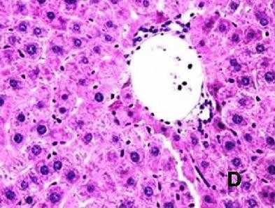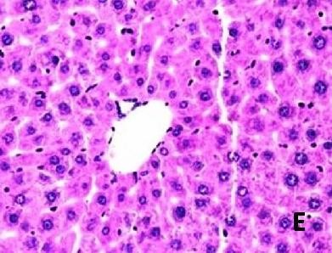dissected and fixed with the 10% Neutral Buffered formalin for Histopathological study and the blood were collected from the carotid artery, used for the assay of SGOT, SGPT and ALP. The livers were removed immediately, washed with ice-cold saline and a 10% homogenate prepared in phosphate buffer (pH 7.0). The homogenate was centrifuged at 3000 rpm for 15 min at 4°C and the supernatant was used for the estimation of TBARS and SOD. Enzymes like, SGOT, SGPT and ALP were assayed using standard kits from J.K.Mitra Diagnostics Limited, India ^{11–12}. Lipid peroxidation was quantitating by measuring the concentration of TBARS in liver homogenate using the method of Onkawa e al., 1979¹³. The results were expressed as n.mol of MDA/mg of protein. SOD was estimated in the liver homogenate using epinephrine by the method of Mishra and Fridovich, 1972 ¹⁴ and protein was estimated by the method of Lowery et al., 1951¹⁴. Statistical Analysis
m
Result of biochemical estimations have been indicated in terms of mean ± SEM. The difference among means has been analyzed by Student’s unpaired t - test ¹⁶. Minimum level of significance was P<0.05.

Results

Microscopical Observation

To observe the Liver histology of all groups in carbon tetrachloride (CCl₄) and Paracetamol (PC)
TBARS was enhanced to 5.9 ± 0.007 (Table 01). VEC pretreated at the dose of 50 mg/kg Vitamin-E and 100 mg/kg Vitamin-C by intraperitoneal injection, also significantly (P<0.001) reversed CCl₄ induced changes in SOD (0.9 ± 0.04) and TBARS (4.3 ± 0.008).
Similar types of findings were observed with VEC pretreated (100 mg/kg Vitamin-E and
200 mg/kg Vitamin-C) by intraperitoneal injection (SOD 1.5 ± 0.02 and TBARS 3.9 ±
induced hepatotoxicity in rats, Sections were stained with Hematoxylin-Eosin to display the Hepatocellular morphological changes. The observations are displayed in Figure-I & II (A-E).

Biochemical Analysis
- Carbon tetrachloride induced hepatotoxicity:
The results of SGOT, SGPT and ALP in control rats were 42 ± 2.52, 56 ± 1.25 and 35 ± 2.25 respectively, whereas in carbon tetrachloride (CCl₄) treated rats, these levels were elevated to 99 ± 5.62, 108 ± 5.05 and 88 ± 3.60 respectively. VEC pretreated at the dose of 50 mg/kg Vitamin-E and 100 mg/kg Vitamin-C by intraperitoneal injection, significantly (P<0.001) prevented the CCl₄ induced rise in the SGOT, SGPT and ALP to 72 ± 4.08, 78 ± 3.96 and 55 ± 1.32 respectively being compared to CCl₄ treated group. With higher dose of VEC pretreated 100 mg/kg Vitamin-E and 200 mg/kg Vitamin-C) by intraperitoneal injection, further reduction of SGOT, SGPT and ALP to 49 ± 3.54, 63 ± 3.25
and 48 ± 2.92 respectively were noted. Silymarin (25 ml/ kg) pretreatment also prevented the CCl₄ induced rise in SGOT, SGPT and ALP to 54.2 ± 5.60, 60 ± 5.80 and 40.3 ± 4.62 respectively (Table 01). The liver SOD was 1.5±0.01 observed in control, whereas TBARS was 3.2 ± 0.019. But significant changes were noted in CCl₄ treated group, SOD was reduced to 0.3 ± 0.04 and

88
Ganesh et al., Int. Journal of Pharmacy & Industrial Research Vol – 02 Issue – 02 Apr – Jun 2012

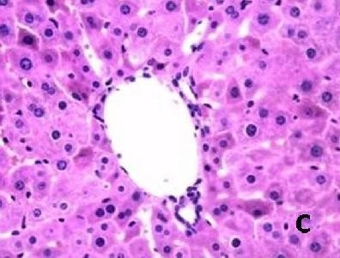
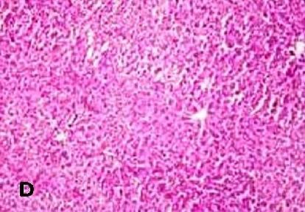
0.002). Silymarin corroborated these findings (SOD 1.5 ± 0.02 and TBARS 3.55 ± 0.001).

Figure 01: Effect of Vitamin E & C (VEC) pretreatment on carbon tetrachloride (CCl₄) induced hepatic toxicity in rats.

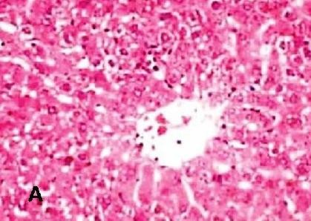
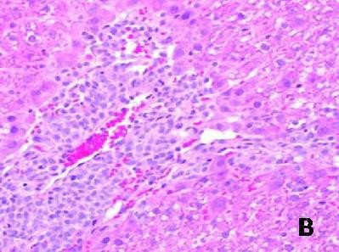

Liver histology of all groups in carbon tetrachloride (CCl₄) induced hepatic toxicity in rats. Hematoxylin-eosin-stained liver sections displayed representative hepatocellular morphological changes. Original magnification × 200 & 400

A: Liver section showed a normal lobular structure in Normal Control Group (C); B: Liver section of Negative Control group – 1, (NCg-1) (carbon tetrachloride (CCl₄) 1 ml/kg, 50% v/v with olive oil, s.c.) showed large areas of centrilobular necrosis; C: Liver section of positive control group – 1, (PCg-
  - (Silymarin 25 mg/kg p.o.); D: Liver section of VEC pretreated (50 mg/kg Vitamin-E and 100 mg/kg
Vitamin-C) by intraperitoneal injection (Observation group – 1, (Og-1)) showed a significant alleviation of liver injury; E: Liver section of VEC pretreated (100 mg/kg Vitamin-E and 200 mg/kg Vitamin-C) by intraperitoneal injection (Observation group – 1, (Og-1)) showed absence of necrosis and almost normal lobular structure.

Paracetamol induced hepatotoxicity
In paracetamol (PC) treated rats SGOT, SGPT and ALP levels were elevated significantly to (108 ± 4.06,
102 ± 2.62
and 85 ±
5.18
respectively
) in
comparison to control.
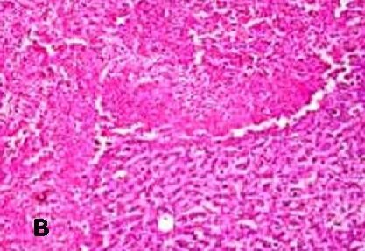
But, VEC
pretreated at the dose of
50 mg/kg Vitamin-E and 100
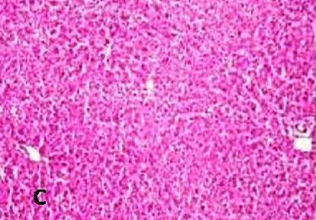
mg/kg Vitamin-C by intraperitone al injection, prevented PC induced rises in
SGOT,
SGPT and ALP to 70 ± 3.55, 74 ±
3.94 and 55
± 3.62
respectively being

89
Ganesh et al., Int. Journal of Pharmacy & Industrial Research Vol – 02 Issue – 02 Apr – Jun 2012

compared to PC treated group. With higher dose of VEC pretreated (100 mg/kg Vitamin-E and 200 mg/kg Vitamin-C) by intraperitoneal injection, further reduction of SGOT, SGPT and ALP to 47 ± 5.85, 62 ± 4.62 and 38 ± 4.24
respectively were noted. Silymarin (25 mg/ kg) pretreatment also prevented the PC induced rise in SGOT, SGPT and ALP to 46 ± 4.04, 59
± 3.40 and 35 ± 2.96 respectively (Table 02). After PC treatment it was noted that, liver SOD was reduced to 0.7 ± 0.05 and TBARS was enhanced to 5.1 ± 0.088 in comparison to the control (Table 02). VEC pretreated at the dose of 50 mg/kg Vitamin-E and 100 mg/kg Vitamin-C by intraperitoneal injection, significantly (P<0.001) reversed PC induced changes in the level of SOD (1.4 ± 0.02) and TBARS (4.7 ± 0.010). Similar types of findings were observed rats were pretreated
with VEC (100 mg/kg Vitamin-E and 200 mg/kg Vitamin-C) by intraperitoneal injection, (SOD 1.6 ± 0.02 and TBARS 3.6 ± 0.033).
Standard Hepatoprotective drug, Silymarin showed similar results (SOD 1.7 ± 0.02 and TBARS 3.5 ± 0.024).

Figure 02: Effect of Vitamin E & C (VEC) pretreatment on paracetamol (PC) induced hepatic toxicity in rats.

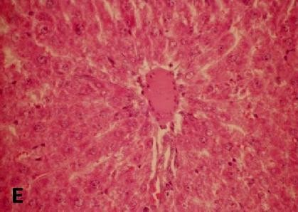

Liver histology of all groups in carbon tetrachloride (CCl₄) induced hepatic toxicity in rats. Hematoxylin-eosin-stained liver sections displayed representative hepatocellular morphological changes. Original magnification × 100 & 200
A: Liver section showed a normal lobular structure in Normal Control Group (C); B: Liver section of Negative Control group – 2, (NCg-2) (paracetamol (PC) 1 g/kg, p.o.) showed large areas of centrilobular necrosis; C: Liver section of positive control group – 2, (PCg-2) (Silymarin 25 mg/kg p.o.); D: Liver section of VEC pretreated (50 mg/kg Vitamin-E and 100 mg/kg Vitamin-C) by intraperitoneal injection (Observation group – 3, (Og-3)) showed a significant alleviation of liver injury; E: Liver section of VEC pretreated (100 mg/kg Vitamin-E and 200 mg/kg Vitamin-C) by intraperitoneal injection (Observation group – 4, (Og-4)) showed absence of necrosis and almost normal lobular structure.

Table 01: Effect of Vitamin E & C (VEC) pretreatment on carbon tetrachloride (CCl₄) induced hepatic toxicity in rats.

90
 | I | II | III | IV | V
Analysis | (Control) | (Negative | (Positive | (Observation | (Observ

Ganesh et al., Int. Journal of Pharmacy & Industrial Research Vol – 02 Issue – 02 Apr – Jun 2012

Groups

 | Control - 1) | Control - 1) | Group - 1) | ation Group - 2)
SGOT (U/L) | 42± 2.52 99± 5.62# | 54.2± 5.60# | 72± 4.08# | 49± 3.54#
SGPT (U/L) | 56± 1.25 108± 5.05# | 60.7± 5.80* | 78± 3.96* | 63± 3.25*
ALP (KAU) | 35± 2.25 88± 3.60# | 40.3± 4.62* | 55± 1.32* | 48± 2.92*
Liver TBARS  (MDA nM/mg protein) | 3.2± 0.019 5.9± 0.007# | 3.55± 0001* | 4.3± 0.008* | 3.9± 0.002*
Liver SOD (U) | 1.5± 0.01 0.3± 0.04# | 1.5± 0.02* | 0.9± 0.04* | 1.5± 0.02*

Values are Mean ± SEM
#P<0.001 when compared with Group I (Control)
*P<0.001 when compared with Group II (CC4 treated). Student’s unpaired t-test

Table 02: Effect of Vitamin E & C (VEC) pretreatment on paracetamol (PC) induced hepatic toxicity in rats.

Groups
Analysis | I | VI | VII | VIII | IX
 | (Control) | (Negative | (Positive | (Observation | (Observ

 | Control - 2) | Control - 2) | group - 3) | ation Group - 4)
SGOT (U/L) | 42± 2.52 108± 4.06# | 46± 4.04* | 70± 3.55* | 47± 5.85*
SGPT (U/L) | 56± 1.25 102± 2.62# | 59± 3.40* | 74± 3.94* | 62± 4.62*
ALP (KAU) | 35± 2.25 85± 5.18# | 35± 2.96* | 55± 3.62* | 38± 4.24*
Liver TBARS  (MDA nM/mg protein) | 3.2± 0.019 5.1± 0.088# | 3.5± 0.024* | 4.7± 0.010* | 3.6± 0.033*
Liver SOD (U) | 1.5± 0.01 0.7± 0.05# | 1.7± 0.02* | 1.4± 0.02* | 1.6± 0.02*

Values are Mean ± SEM
#P<0.001 when compared with Group I (Control).
*P<0.001 when compared with Group VI (PC treated). Student’s unpaired t-test.
Discussion

91
Ganesh et al., Int. Journal of Pharmacy & Industrial Research Vol – 02 Issue – 02 Apr – Jun 2012

Large doses of carbon tetrachloride (CCl₄) and paracetamol (PC) induces hepatic necrosis in humans and experimental animals. CCl₄ is metabolized in the liver to the highly reactive trichloromethyl radical. This free radical leads to auto-oxidation of the fatty acids present in the cytoplasmic membrane phospholipids and causes functional and morphological changes in the cell membrane ^{6,} ¹⁷. Whereas, PC is primarily metabolized by sulphation and glucuronidation (unreactive metabolites), and then activated by cytochrome P450 system to induce hepatic injury^{7,}
¹⁸. Observation of the preventive effect to the liver damage, caused by CCl₄and PC may give an indication of the hepatoprotective effect of drugs in general. This is evidenced by an elevation in the
serum marker enzymes namely SGOT, SGPT and
The finding of this study supports the hepatoprotective activity of VEC by modulating the antioxidant pathway. Therefore, it may be conjectured that VEC have preventive action both on carbon tetrachloride (CCl₄) and paracetamol (PC) induced hepatotoxicities in albino rats. It is due to the potential anti-oxidant mechanism of hepatoprotective action of VEC.

References
- Santra A, Das S, Maity A. Prevention of carbon tetrachloride-induced hepatic injury in mice by Picrorhizakurroa. Indian J Gastroenterol 1998; 17: 6–9.
- Rawat AK, Mehrotra S, Tripathi SC, Shome
U. Hepatoprotective activity of Boerhaviadiffusa L. roots-a popular Indian ethnomedicine. J Ethnopharmacol 1997; 56: 61–66.

ALP by CCl₄
or PC and reversal of these effects
- Rege NN, Javle H, Bapat RD. Antiendotoxic effect of Tinosporacordifolia : An experiment

by any Hepatoprotective drug. VEC significantly
reduced these elevations of liver enzymes induced

by CCl₄ and PC, dose dependently. Silymarin, a prototype hepatoprotective agent also showed similar changes. The anti-oxidation activity or the inhibition of the generation of free radicals is important in the protection against CCl₄ as well as PC induced liver lesions ^{17,} ¹⁹.In this work, elevation in the levels of end products of lipid peroxidation or MDA in liver of rats treated with CCl₄ and PC were observed. Pretreatment with VEC, significantly reversed these changes. VEC also significantly prevented the diminution in the level of the protective enzyme SOD, induced by CCl₄ or PC, when examined in the liver homogenate. It is well known that SOD plays an important role as a protective enzyme against lipid peroxidation in tissues ^{20–21}.

Conclusion
study in rats. Indian J Surg 1998; 60: 303–
305.
- Koul IB, Kapil A. Effect of diterpenes from Andrographispaniculata on antioxidant defense system and lipid peroxidation. Indian J Pharmacol 1994; 26: 296–300.
- Gulati RK, Agarwal S, Agarwal SS. Hepatoprotective studies on Phyllanthusemblica Linn. Indian J ExpBiol 1995; 33: 261–268.
- Recknagel RO. Carbon tetrachloride hepatotoxicity. Pharmacol Rev 1967; 19: 145– 208.
- Hinson JA. Biochemical toxicology of acetaminophen. Rev BiochemToxicol 1980; 2: 103–129.
- Nurten AT, Huseyin V, Tevfik S, Oktay A, Sahin A. Beneficial effects of vitamins C and E against oxidative stress in diabetic rats. Nutrition Research, 25, 2005, 625–630.
- Vogel HG, Vogel WH. In: Drug Discovery and Evaluation. New York, Springer, 1997; p.531–532.
- Hiroshini A, Toshiharu H, Masahiro H, Shohi
  - An alteration in liver microsomal membrane of the rat following paracetamol overdose. J Pharm Pharmacol 1987; 38: 1047–1049

92
Ganesh et al., Int. Journal of Pharmacy & Industrial Research Vol – 02 Issue – 02 Apr – Jun 2012

- Reitman S, Frankel S. A colorimetric method for the determination of sGOT and sGPT. Am J ClinPathol 1957; 28: 56–63.
- Kind PRN, Kings EJ. Estimation of plasma phosphatase by determination of hydrolysed phenol with antipyrine. J ClinPathol 1954; 7: 322–330.
- Ohishi N, Yagi K. Assay for lipid peroxides in animal tissues by thiobarbituric acid reaction. Ann Biochem 1979; 95: 351–358.
- Misra HP, Fridovich I. The role of superoxide anion in the auto-oxidation of epinephrine and simple assay for superoxide dismutase. J BiolChem 1972; 247: 3170–3175.
- Lowry OH, Rosenberg NJ, Farr AL, Randall RJ. Protein measurement with Folin Phenol reagent. J BiolChem 1951; 193: 265–275.
- Das D, Das A. In : Statistics in Biology and Psychology. 2nd edition; Academic Publishers, Calcultta, 1993; p.99–111.
- Johnston DE, Kroening C. Mechanism of early carbon tetrachloride toxicity in cultured rat hepatocytes. Pharmacol Toxicol 1998; 39: 231– 239.
- Mitchell JR. Acetaminophen toxicity. N Engl J Med 1988; 319: 1601–1602.
- Wendel A, Feuerstein S, Konz KH. Acute paracetamol intoxication in starved mice leads to lipids peroxidation, in vivo. BiochemPharmacol 1987; 28: 56–63.
- Kappus H, Sies H. Toxic drug effects associated with oxygen metabolism: Redox cycline and lipid peroxidation. Experimentia 1981; 37: 1233–1241.
- Comporti M. Biology of disease, lipid peroxidation and cellular damage in toxic liver injury. Lab Invest 1993; 52: 599–625.

