Original Article


ISSN Print 2231 – 3648
Online 2231 – 3656

NEW VISIBLE SPECTROPHOTOMETRIC METHODS FOR THE DETERMINATION OF AMPICILLIN TRIHYDRATE IN BULK DRUG AND THEIR FORMULATIONS

*Imam pasha S, Fazlu Rehman, Taqui Mohammed, Sanjyothi Y, Shravan kumar A
Global College of Pharmacy, Moinabad, R.R.Dist, A.P, India - 504 501.

Abstract
Two simple, sensitive and economical spectrophotometric methods were developed for the determination of ampicillin trihydrate in pharmaceutical formulations. Method A is based on the formation of pink colored complex by the reaction of drug with ferric chloride and 2, 2 bipyridyl, which absorbs maximally at 500 nm. Method B is based on the formation of orange colored complex by the reaction of drug with ferric chloride and 1,10 phenanthroline, which absorbs maximally at 523nm.Beer’s law is obeyed at a concentration range of 1-10 and 1-12 mcg/ml for method A and method B. Both the methods have been successfully applied for the assay of the drug in pharmaceutical formulations.

Keywords: Ampicillin trihydrate, Ferric chloride, 1, 10 Phenanthroline, 2, 2 Bipyridyl, Spectrophotometry.

Introduction
Ampicillin [generic name-ampicillin trihydrate], (2S, 5R, 6R)-6-[[(2R)-2-amino-2-phenylacetyl] amino]-3, 3- dimethyl-7-oxo- 4-thia-1-azabicyclo [3.2.0] heptane- 2-carboxylic acid is a broad spectrum antibiotic belongs to amino penicillin’s. Ampicillin shows the antibiotic activity by inhibiting the cell wall synthesis of microorganisms. It is effective against both gram positive and gram negative bacteria, so it widely used in the infections of upper respiratory tract, urinary tract, meningitis and salmonella sps. The drug has been determined by variety of analytical techniques such as high performance liquid chromatography assay with 1,2,4 triazole and mercury chloride[Jun Haginaka and Junko Wakai Analyst, 1985, 110, 1277-1281], spectroflourimetric study catalyzed by metal ions[P. Gutiérez Navarro, A. El Bekkouri and E. Rodriguez Reinoso Analyst, 1998, 123, 2263-2266],

Author for Correspondence:
Imam pasha S,
Global College of Pharmacy, Moinabad, R.R.Dist,
A.P, India - 504 501.
Email: impazam@gmail.com

Determination in fermentation media by high- performance liquid chromatography using pre-column derivatisation with 1-hydroxybenzotriazole[Ajit J.Shah, Maxwell W. Adlard and Geoffrey Holt Analyst, 1988, 113, 1197-1200], Study of spectrophotometric and mercurimetric methods[B. Nowak and H. Wollmann Pharmazie, 1987, 42(12), 862-863], Determination of ampicillin in the presence of cloxacillin[A. O. Akanni and J. S. K. Ayim, Department of Pharmaceutical Chemistry, University of Ibadan, Ibadan, Nigeria], Simultaneous spectro -photometric and volumetric determinations [Qureshi SZ, Qayoom T, Helalet MI, Department of Chemistry, Analytical Research Laboratory, Aligarh Muslim University, India.] The estimation of ampicillin was carried out using different methods like spectrophotometric determination of Ampicillin [J. W. G. Smith, G. E. de Grey and V. J. Patel Analyst, 1967, 92, 247-252], quality control assay [L.A.Okoro E.N.Ejike], Copper(II) complexation with Ampicillin[S.V.Lapshin and V.G.Aleksee], determination of spectrophotmetric method with pyrocatechol violet [Amin AS], department of Chemistry, Faculty of Science, Benha University, Benha, Egypt.], Spectrophotometric determination of some penicillin’s with ammonium

vanadate.[ Ibrahim el-SA, Beltagy YA, El-Khalek ], Studies on readymix suspension of ampicillin trihydrate[Jafar m.*, Aejaz a. Vol 2, Suppl 2, 2010]. Different spectrophotmetric have been recommended which include Reaction of hydrochloric acid and potassium iodate followed by na2so4[analytical abstracts 1997], reaction of borate buffer with methanolic chloranil[analytical abstracts 1998], analytical investigation using paramolybdate anion [P.B.Issopoulos,J.Pharm,Biomed,analysis,1998], spectrophotometric method by the reaction of Ce(III) ions complexed with arsenazo III [analytical abstracts 2001], This paper describes two simple and sensitive spectrophotometric methods. Method A includes formation of pink colored complex by the reaction of drug with ferric chloride and 2, 2 bipyridyl, which absorbs maximally at 523 nm. Method B is based on the formation of orange colored complex by the reaction of drug with ferric chloride and 1, 10 phenanthroline, which absorbs maximally at 500nm.

Materials and Methods

Apparatus
Ultraviolet-Visible-Spectrophotometer SHIMADZU- 1700 with 1 cm matched quartz cells was used for all spectral measurements.

Reagents and standards
All the chemicals used were of analytical reagent grade. 1,10-Phenanthroline AR grade (0.1008M): 2g of 1, 10 phenantroline is dissolved in 100 ml of methanol AR grade. 2, 2 bipyridyl AR grade(0.1128M): 2g of 2, 2 bipyridyl is dissolved in
100 ml of methanol AR grade. Ferric chloride hexahydrate AR grade(0.012M): 200mg of ferric chloride is dissolved in 100 ml of distilled water.

Procedure
Preparation of standard solution of Ampicillin trihydrate: Standard stock solution was prepared by dissolving 1g of ampicillin trihydrate in 10 ml of Methanol AR grade, then volume is made upto 100ml by using Methanol AR grade to get the concentration of 10000 mcg/ml. This is further diluted to get the working standard solution of 100 mcg/ml.

Method-A:
Recommended procedure for the determination of Ampicillin trihydrate
Aliquots of working sample of Ampicillin trihydrate RS containing (10-50 mcg/ml ) is transferred into a series of 10ml graduated test tubes. To each test tube 1ml of (0.1128M) solution of 2, 2 bipyridyl and 0.3 ml of (0.012 M) solution of ferric chloride is added. These test tubes along with the blank were heated at a temperature of 700 c for 15 minutes. After heating these test tubes are cooled at room temperature and the volume is made up to 5ml using Methanol AR grade. The absorbance of the pink colored chromogen was measured at a maximal wavelength of 500nm against a reagent blank and the concentration was measured using calibration curve.

Method-B:
Recommended procedure for the determination of Ampicillin trihydrate
Aliquots of working sample of Ampicillin trihydrate RS containing(10-100mcg/ml) was transferred into a series of 10ml graduated test tubes. To each test tube 1ml of (0.1008M) solution of 1,10-Phenanthroline and
0.3 ml of (0.012 M) solution of ferric chloride was added, these test tubes along with the blank were heated at a temperature of 700 c for about 15 minutes. After heating these test tubes were cooled at room temperature and the volume is made upto 5ml using Methanol AR grade. The absorbance of orange colored chromogen was measured at a maximal wavelength of 523nm against reagent blank and the concentration was measured using calibration curve.

Procedure for the Assay of Ampicillin trihydrate in Pharmaceutical Formulations
The methods were extended for the determination of Ampicillin Trihydrate from Ampicillin Trihydrate formulations. The total contents of 20 Ampilin capsules were emptied and the powder equivalent to 1g was dissolved in 10 ml of Methanol AR grade and the volume if made to 100ml of Methanol AR grade. The above solution was further diluted and analyzed as described in the above mentioned methods. The

analysis procedure was repeated three times with Ampicillin Trihydrate formulations.

Method – B:
The ferrous (II) ion formed by the oxidation of drug

undergoes reaction with 3 molecules of 1,10-

Results and Discussion
Iron(Fe) exihibits variable valency and exisists as ferrous (FeII) and ferric (FeIII) salts. Ferrous (Fe II) salts acts as a reductant and involved in complex formation with 1,10 Phenanthroline and 2,2 bipyridyl which have a tendency to get oxidized.
Phenanthroline to form orange colored tris complex.

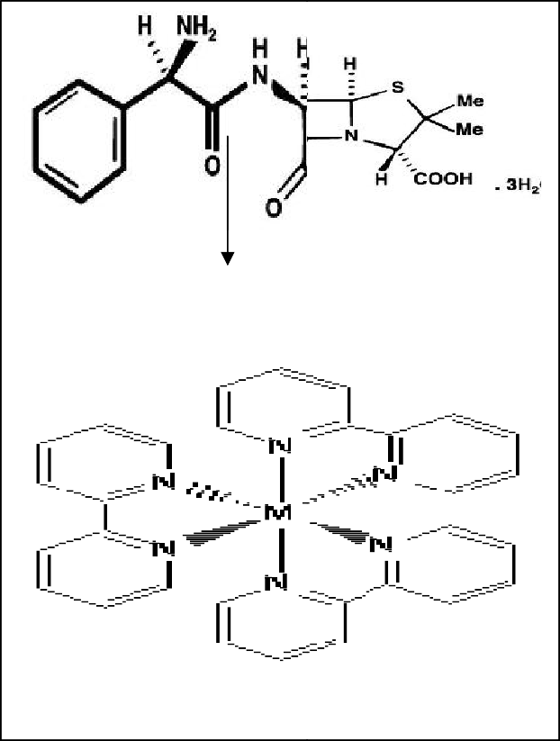Drug when reacted with known amount of iron (FeIII)
FeCl3
1,10-Phenanthroline
Colored complex
Here M =Fe
undergoes oxidation to give reduced form of iron i.e. ferrous (FeII) ion which has a tendency to give coloured complex with 1,10 phenanthroline and 2,2 bipyridyl.

Reaction Mechanism Method A:
The ferrous (Fe II) ion formed by the oxidation of drug undergoes reaction with 3 molecules of 2, 2 bipyridyl to form pink colored tris complex.

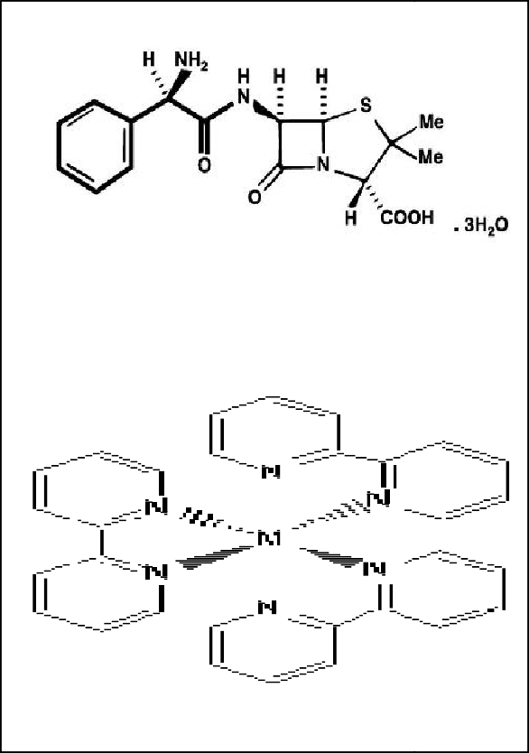Table 01: (Method – A) Optical characteristics & precision
FeCl3
2,2- Bipyridyl
Colored complex
Here M =Fe

λ max (nm)
Parameters

500
Method

Beer’s law limits Molar absorptivity

Sand ell’s sensitivity

Regression Equation* (Y) Slope (m)
Intercept (c)
Correlation Coefficient(r)
Precision**
(%Relative Standard Deviation) Standard error of mean
Y= bC + a
1-10 mcg/ml
1.624 x 103 (l/mol.cm)
0.089
(mcg/ml/cm2/0.001 absorbance unit)

0.0104
0.2188
0.999
0.269
0.0142

Where C is the concentration of Ampicillin trihydrate in mcg/ml and Y is the absorbance at the respective lambda max.
**for eight measurements.

Table 02: (Method – B) Optical characteristics & precision

Parameters Method
λ max (nm) 523
Beer’s law limits 1-12 mcg/ml
Molar absorptivity 3.09 x 103 (l/mol.cm)
0.0238

Conclusion
Two simple visible spectrophotometric methods for the determination of Ampicillin trihydrate in pure and its dosage forms were developed. The absorbance of the chromogens was measured at maximum absorbance of 500nm and 523nm against the corresponding reagent blanks. The methods are found to be simple, precise,

Sand ell’s sensitivity

Regression Equation* (Y)
(mcg/ml/cm2/0.001 absorbance unit)
economic, and less time consuming. The method were
also been statistically evaluated and the results

Slope (m) 0.0587
Intercept (c) 0.0137
Correlation Coefficient(r) 0.9997
obtained were accurate, precise and free from the
interferences of other additives present in the formulation.

Precision**
(%Relative Standard Deviation)
0.29

Acknowledgement

Standard error of mean 0.0149

Y= bC + a
Where C is the concentration of Ampicillin trihydrate in mcg/ml and Y is the absorbance at the respective lambda max.
**for eight measurements.

Table 03: Evaluation of Ampicillin trihydrate in pharmaceutical dosage forms by Method–A
Formulation (Brand)
Labeled Amount (mg/cap)
Amount Obtained By Proposed method A
% Recovery**
±S.D

Ampilin 500 496.2 99.4±0.023
Ampicillin 500 501.2 99.0±0.013
Ampicillin Trihydrate 500 498.7 100.4±0.037

**Average ± S.D.of eight determinations.

Table 04: Evaluation ofAmpicillin trihydrate in pharmaceutical dosage forms by Method–B
Formulation (Brand)
Labeled Amount (mg/cap)
Amount Obtained By Proposed method B
% Recovery**
±S.D

Ampilin 500 502.5 99.4±0.023
Ampicillin 500 496 99.6±0.013
Ampicillin Trihydrate 500 495 101.3±0.037

**Average ± S.D.of eight determinations.
- Global college of pharmacy, Moinabad, R.Rdist for providing research facilities.
- Mr.K.Ramakrishna,Quality control department manager, Endoven pvt limted, Balanagar, Hyderabad for providing the sample of pure Ampicillin trihydrate RS.

References
- Naveen kumar G.Sand Harish K.H, spectrophoto - metric determination of nebivolo hydrochloride in bulk and in pharmaceutical dosage forms, Indian Drugs. 2011, 48(4), 41-43.
- Martindale, the complete drug reference, 34th ed, royal pharmaceutical society of great Britain, the pharmaceutical press, London,2005, 155, 467, 566, 653.
- Alfred Goodman, Gilman, Joel G.hardman and Limbird, Text book of organic and medicinal and pharmaceutical chemistry10th edition, Mc graw-hill medical Publishing divison, New delhi, 2001, 1184, 1192, 1200.
- Wilson and Gisvold’s,John H.Block and John, M.Beale, organic and medicinal Pharmaceutical chemistry Lippincott Williams and wilkins, 351-west Camden street, baltimere,2004, 316.
- David A.Williams, Thomas.L.Lemke, Foye’s principles of medicinal chemistry, 5th edition, Lippincott Williams and wilkins, 351-west Camden street,baltimere, 2007, 849.
- S.M.Khopkar,Basic concepts of analytical chemistry, new age international publishers, New delhi, 2008, 249.
- Skoog, west, holler, creuch, Fundamentals of Analytical Chemistry,8th edition, estern press pvt.ltd, Banglore, 2004, 20.

