Original Article


ISSN Print 2231 – 3648
Online 2231 – 3656

SYNTHESIS, CHARACTERIZATION AND ANALGESIC ACTIVITY OF 1,3,4-OXADIAZOLE DERIVATIVES

*1Selvakumar K, 1Joysa Ruby J, 2Rajamanickam V, 1Vignesh M, 1Parkavi V,
1MuthuMohamed J, 3Jesindha Beyatricks K
*1Masterskill University College of Health Sciences, 43200 Cheras, Selangor, Malaysia.
2Arulmigu Kalasalingam College of Pharmacy, Krisnankoil, Tamilnadu, India – 626 190.
3Hillside College of Pharmacy and Research Centre, Bangalore, India – 560 062.

Abstract
Oxadiazole derivatives have played a vital part in the development of heterocyclic compounds. In this present work, a series of 5-(2-aminophenyl)-1,3,4-oxadiazole-2(3H)-thione derivatives (1a-f) have been synthesized by mannich reaction. The reaction progress of the synthesized compounds was checked by TLC. The structures of the newly synthesized compounds were confirmed by IR and 1H NMR spectral data. The analgesic activity of 1,3,4-oxadiazoles (1a-f) was assessed by hot plate and tail flick methods. Among the newly synthesized 1,3,4- oxadiazoles, compounds 1a,1b,1c,1d showed highly significant (p<0.001) analgesic activity in experimented animal models where, Pentazocine (5mg/ml, i.p.) was used as reference standard.

Key words: 1, 3, 4-oxadiazole, Mannich reaction, Analgesic, Hot plate method, Tail flick method.

Introduction
The Oxadiazole types of heterocyclic compounds contain oxygen and two nitrogen atoms. Various 1,3,4- oxadiazoles have been reported to have a broad biological activities including analgesic1, anti- inflammatory2, anticancer3, anti-HIV4, anti-parkinson5, antibacterial6, antifungal7 and anti-tubercular8 agents. These observations prompted to synthesis 5-(2- aminophenyl)-1,3,4-oxadiazole-2(3H)-thione and followed by a novel series of mannich bases of 5-(2- aminophenyl)-1,3,4-oxadiazole-2(3H)-thione.
Oxadiazole is a heterocycle nucleus and is considered to be derived from furan by replacement of two methane (‐CH=) group in furan replaced by two pyridine type nitrogen. Among the methods employed in synthesis of 1,3,4-oxadiazole, cyclization reaction of acid hydrazide and its derivatives were prepared by incorporation of secondary amines with aldehydes.
Author for Correspondence:
K.Selvakumar,
Faculty of Pharmacy,
Masterskill University College of Health Sciences, Jalan Kemacahaya 11, Taman Kemacahaya, Batu 9, 43200 Cheras, Selangor, Malaysia.
Email: kselva_pharma@yahoo.co.in

Materials and Methods

Synthesis of substituted 1,3,4-oxadiazole
Anthranilic acid (0.01 mol) was dissolved in 20 ml ethanol. To this, concentrated sulphuric acid was added drop wise until the white precipitate was formed and it was dried. Then the residue was dissolved in ethanol and hydrazine hydrate (0.5 mol) was added to this solution with constant shaking for 10 min. The white precipitate obtained was collected by filtration and dissolved in ethanol. Potassium hydroxide (0.56 mol) was added into the above solution followed by carbon disulphide solution (0.76 mol) drop wise with constant shaking until the formation of yellow precipitate of substituted oxadiazole (1) and it was recrystallized from ethanol.

Synthesis of Mannich base substituted 1,3,4- oxadiazoles 9 (1a-f)
Equimolar quantities (0.01mol) of substituted oxadiazole (1) and respective compound containing secondary amine such as N-(4-hydroxyphenyl) acetamide, N-(2,3-xylyl) anthranilic acid and potassium 2-(2-(2,6-dichloro anilino) phenyl) acetate were dissolved in ethanol (30 mL). To the above mixture, the corresponding aldehyde (0.01 mol) such as formaldehyde and acetaldehyde was added and

reflux for 3-5 h. The content was kept overnight in the freezer. The respective compound obtained (1a-f) was recrystallised from ethanol.

Melting point was determined on electrical melting point apparatus by open-ended capillary tube. The purity of the compounds were checked by TLC using Silica Gel as stationary phase and chloroform- methanol (8:2) as eluent and the spots were visually detected in an Iodine chamber10. The structure of the synthesized compounds was elucidated by IR spectra in υmax (cm-1) on FT-IR (Shizmadu-8400 series) using KBr disc technique 11,12 and 1H NMR spectra in δ units (ppm) relative to an internal standard of tetramethylsilane on 1H NMR (Brucker 400 MHz) in DMSO-d6 13. The synthetic method is depicted in Scheme 1.

5-(2-aminophenyl)-1,3,4-oxadiazole-2(3H)-thione (1) C8H7N3OS; Yield: 85.5%; mp: 155-1570C; Rf: 0.45; IR (KBr,υmax cm-1): 3482.24 (NH2 ), 3154 (NH), 1624.32 (N –N), 1224.21 (C=S), 1224.21 (C=S); 1H NMR (δ ppm): 3.8 (s,NH2, 2H), 6.0 (s, NH, 1H), 6.6 – 7.8 (m, ArH, 4H).

N-((5-(2-aminophenyl)-2-thioxo-1,3,4-oxadiazol-3(2H)- yl)methyl)-N-(4-hydroxyphenyl) acetamide (1a) C17H16N4O3S; Yield: 71.78%; mp: 178-180oC; Rf 0.581.IR (KBr, υmax cm-1): 3426 (OH), 3343 (NH2),
1651 (N –N),1457(CH3), 1426 (CH2) 1120 (C=S); 1H NMR (δ ppm): 2.2(s,3H, CH3), 3.5 (s, 2H, NH2), 4.7(s,
2H, CH2), 6.6 – 7.4 (m,8H, ArH), 9.8 (s, 1H, OH).

N-(1-(5-(2-aminophenyl)-2-thioxo-1,3,4-oxadiazol- 3(2H)-yl)ethyl)-N-(4-hydroxyphenyl) acetamide (1b) C18H18N4O3S; Yield: 70.76%; m.p.198-200oC; Rf 0.641. IR (KBr, υmax cm-1): 3386 (OH), 3286 (NH2),
2084 (CH),1605(N-N), 1454 (CH3), 1422 (CH2), 1122
(C=S); 1H NMR (δppm): 1.28 (d, 3H, CH3), 1.98 (s, 3H,
CH3), 3.42 (s, 2H,NH2), 4.64(q, 1H, CH), 6.46 – 7.44 (m, 8H, ArH), 9.62 (s,1H, OH).

Potassium-2-(2-(((5-(2-aminophenyl)-2-thioxo-1,3,4- oxadiazol-3(2H)-yl)methyl)(2,6-dichloro phenyl) amino)phenyl) acetate (1c)
C23H17N4O3SCl2K; Yield: 69.19%; m.p. 210-212oC; Rf 0.612.IR (KBr, υmax cm-1): 3257 (NH2), 1650 (C=O),
1615 (N-N),1436(CH2), 1120( C=S); 1H NMR (δ ppm)
: 1H NMR (δppm): 3.44 (s, 2H, CH2), 4.62 (s, 2H, CH),
4.26 (s, 2H, NH2),6.52 – 7.48 (m, 11H, ArH).

Potassium-2-(2-((1-(5-(2-aminophenyl)-2-thioxo- 1,3,4-oxadiazol-3(2H)-yl)ethyl)(2,6-dichloro phenyl) amino)phenyl) acetate (1d)
C24H19N4O3SCl2K; Yield: 59.18%; m.p. 186-188oC; Rf 0.812.IR (KBr, υmax cm-1): 3272 (NH2), 1649 (C=O),
1622 (N-N),1456 (CH3), 1449 (CH2), 1121(C=S); 1H
NMR (δ ppm): 1.26(d, 3H, CH3), 3.52 (s, 2H, CH2), 3.98
(q, 1H, CH), 4.12 (s, 2H,NH2), 6.36 – 7.24 (m, 11H, ArH), 9.62 (s, 1H, OH).

2-(((5-(2-aminophenyl)-2-thioxo-1,3,4-oxadiazol-3(2H)- yl)methyl)(2,3-dimethylphenyl) amino benzoic acid (1e) C24H22N4O3S; Yield: 68.70 %; m.p 254-256oC; Rf 0.840. IR (KBr, υmax cm-1):.3335(OH), 3226(NH2),
1675(C=O), 1615 (N-N), 1459 (CH3), 1439 (CH2),
1190 (C=S); 1H NMR(δ ppm) : 2.28 (s, 3H, CH3),
4.46(s, 2H, CH2), 3.82 (s, 2H,NH2), 6.16 – 7.64 (m,
11H, ArH), 10.46 (br, 1H, OH).

2-((1-(5-(2-aminophenyl)-2-thioxo-1,3,4-oxadiazol-3(2H)- yl)ethyl)(2,3-dimethylphenyl) amino) benzoic acid (1f) C25H24N4O3S; Yield: 70.76 %; m.p. 244-246oC; Rf 0.770. IR(KBr, υmax cm-1):. 3343 (OH), 3286 (NH2),
1650 (C=O),1628 (N-N), 1449 (CH3), 1428 (CH2), 1123 (C=S); 1H NMR (δppm) 1.24 (d, 3H, CH3), 2.26 (s, 3H,
CH3), 3.72 (s, 2H,NH2), 6.08 – 8.24 (m, 11H, ArH), 10.64
(br, 1H, OH).

Analgesic Activity 14
The newly synthesized compounds were tested for analgesic activity by the method suggested by Eddy and Leimbach. The animals were divided into 12 groups of 5 mice each. From this the first group was served as a control, next group was treated with standard drug Pentazocine (5mg/kg) and the remaining groups were treated with the newly synthesized series of oxadiazole derivatives (25mg/kg) respectively and administered into intraperitoneal route. The reaction time was noted for all groups on Eddy’s hot plate before and after 15 min treatment with standard drug and synthesized compounds.

The data (Mean ± SEM) were analyzed statistically by
students “t” test 15 and recorded in the following table 1.

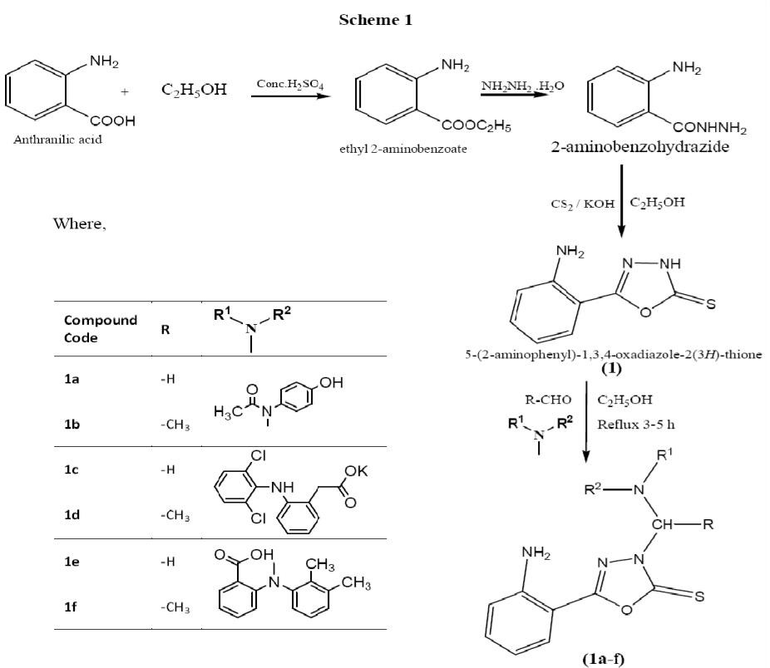

Scheme 1: Synthetic method of titled compounds

Table 1: Analgesic activity of titled compounds

S.No. Treatment
Reaction time (in sec) before treatment (Mean ± SEM)
Reaction time (in sec) after 15 min
(Mean ± SEM)
anthranilic acid with ethanol in presence of sulphuric acid followed by reacting with hydrazine hydrate, carbon disulphide and alkali. The titled oxadiazole

1. Control 2.86 ± 0.5642 3.12 ± 0.6242
2. Standard 4.56 ± 0.4562 10.85 ± 0.7216**
3. OFP 4.52 ± 0.3846 6.44 ± 0.8124**
4. OAP 3.86 ± 0.0244 6.41 ± 0.9162**
5. OFD 3.92 ± 0.4242 8.96 ± 0.9216**
6. OAD 4.82 ± 0.3812 9.12 ± 0.3416**
7. OFM 2.82 ± 0.3812 4.22 ± 0.3612
8. OAM 1.82 ± 0.3812 3.82 ± 0.3822

P < 0.001 indicates the significant difference compared with control
** Highly significant

Results and Discussion
The substituted oxadiazole, 5-(2-aminophenyl)-1,3,4- oxadiazole-2(3H)-thione was synthesized by reacting
derivatives were synthesized by making substitution at free N-(3H) position of substituted oxadiazole, 5-(2- aminophenyl)-1,3,4-oxadiazole-2(3H)-thione through mannich condensation with secondary amine bearing compounds such as N-(4-hydroxyphenyl) acetamide, N- (2,3-xylyl) anthranilic acid, potassium 2-(2-(2,6- dichloro anilino) phenyl) acetate and series of aldehydes like formaldehyde, acetaldehyde. The synthesized compounds were characterized by various methods such as melting point, IR Spectroscopy, NMR spectroscopy. The compounds purity was further established by chromatographic method (TLC).

Among these synthesized compounds, the compounds of 1a, 1b, 1c, 1d, 1e and 1f were screened for analgesic activity by Eddy’s Hot Plate method at a dose of 25mg/kg. The highly significant analgesic activity was observed in 1a, 1b, 1c and1d when compared with standard drug pentazocine 5mg/kg.

Conclusion
The titled oxadiazole derivatives were synthesized by making substitution at free N-(3H) position of 5-(2- aminophenyl)-1,3,4-oxadiazole-2(3H)-thione through mannich condensation. The evaluated compounds possessed highly significant analgesic activity at a dose of 25mg/kg when compared with standard, pentazocine 5mg/kg. It gives a future scope to study the mechanism of action and would be worthy of further investigation.

Acknowledgements
The authors are thankful to everyone who rendered us support throughout and made this study successful.

References
- Sudhir B, Bharat P, Narendra P and Sharma V. Microwave Assisted Synthesis and Pharmacological Evaluation of Some 1,3,4-Oxadiazole Derivatives. Archives of Applied Science Research. 3, 2011, 558-567.
- Harish R, Murli D, Kharya B and Pradeep M. Synthesis of Some Novel Oxadiazole and Oxadiazoline Analogues for Their Anti- inflammatory Activity. Indian Journal of Chemistry. 45, 2006, 2506-2511.
- Sanmati K, Arvind K and Pragya N. 3D QSAR Analysis on Oxadiazole Derivatives as Anticancer Agents. International Journal of Pharmaceutical Sciences and Drug Research. 3, 2011, 230-235.
- Ali A, El-Emam, Omar A, Al-Deeb A, Mohamed A and Jochen L. Synthesis, Antimicrobial, and Anti- HIV-1 activity of certain 5-(1-adamantyl)-2- substituted thio-1,3,4- oxadiazoles and 5-(1- adamantyl)-3-substituted aminomethyl-1,3,4- oxadiazoline-2-thiones. Bioorganic & Medicinal Chemistry. 12, 2004, 5107–5113.
- Nagaraj, Chaluvaraju K, Niranjan M and Kiran S. 1, 3, 4- Oxadiazole A Potent Drug Candidate with Various Pharmacological Activities. International Journal of Pharmacy and Pharmaceutical Sciences.3, 2011, 8-16.
- Ravitas D, Jha A.K, Alok Singh T and Dhansay D. Synthesis and Antibacterial Activity of Some 1, 3, 4-Oxadiazole derivatives and their Thione Analogues. International Journal of Research in Pharmaceutical and Biomedical Sciences. 2, 2011, 215-219.
- Manish S, Deepak S, Aashish Singh K and Gokulan
P. Synthesis and Biological Evaluation of Some New 1-3-4-Oxadizole Derivatives. Journal of Current Pharmaceutical Research. 4, 2010, 20-24.
- Dhansay D, Alok P, Sivakumar T, Rajavel R and Dhar D. Synthesis of some Novel 2, 5- Disubstituted 1, 3, 4-Oxadiazole and its Analgesic, Anti- Inflammatory, Anti- Bacterial and Anti- Tubercular Activity. International Journal of ChemTech Research. 2, 2010, 1397-1412.
- Selvakumar K, Anandarajagopal K, Rajamanickam V, Ajaykumar TV, Jesindha Beyatricks K. 5-(2- aminophenyl)-1,3,4-oxadiazole-2(3h)-thione derivatives: synthesis, characterization and antimicrobial evaluation. International Journal of Pharmaceutical Sciences Review and Research. 6(1), 2011, 64-67.
- A.H. Stead and Clark. Isolation and Identification of Drugs. Edn 2, pp1106-1109.
- John R. Dyer. Applications of Absorption Spectroscopy of Organic Compounds. Edn 1. Prentice-Hall of India press, New Delhi, 1969, pp. 33-38.
- Robert M, Francis X and Webster. Spectrometric Identification of Organic Compounds. Edn 6, John Willey Sons, 1998, pp. 146-154.
- Y. R. Sharma. Elementary Organic Spectroscopy. Edn 1, 1980, pp.65-203.
- R.K. Goyal. Practical in Pharmacology. Edn 3, 2003, pp.108-109.
- M.N. Ghosh. Fundamentals of Experimental Pharmacology. Edn 2, 1998, pp.187-191.

