***Research Article***

**Available Online at:** [**www.ijpir.com**](http://www.ijpir.com/)



International Journal of Pharmacy and Industrial Research

**ISSN**

**Print 2231 – 3648**

**Online 2231 – 3656**

**DESIGN AND EVALUATION OF CAPSULES CONTAINING IMMEDIATE RELEASE AND SUSTAINED RELEASE PROPRANOLOL BLENDS**

# *Chithirra Anbalaghan, Mohammed Halith, K K Pillai, Abirami, Natarajan

Department of Pharmaceutics, K.M College of Pharmacy, Madurai-625107, India.

## Abstract

The present research was focused on immediate release and sustained release propranolol microspheres blends for enhancing bioavailability and reduces short half-life Problem. Propranolol is a antihypertensive agent it is also used in angina pectoris. Since it has short half life, bioavailability problems the research was emphasized on preparing immediate and sustained release propranolol microspheres. Immediate release blends release the drug for quick onset of action because of presence of superdisintegrant crospovidone.. Sonication and Solvent evaporation techniques were adapted to formulate sustained release micro particles. EudragitRL-100 was taken as a polymer for preparation of microspheres. Polaxamer act as a stabilizer. Particle size was controlled by solvent precipitation method. The formulated microparticles were evaluated for drug encapsulation, invitro drug release, surface morphology, interaction study, elemental characterization study. Micro particles were characterized by SEM. FT-IR studies revealed that there was no interaction between drug and polymers used in the study. In-vitro dissolution studies were carried out for all trials. SEM study confirmed that particles are existing in micrometer level. The drug release from F5 formulation was found to zero order kinetics. It was also found linear in Higuchi’s plot which confirms that diffusion is one of the mechanisms of drug release. In this investigation optimized formulation F5 releases the drug up to 12 hours and it also fulfilled requirements such as easy to fabricate, inexpensive and high patient compliance.

**Keywords:** Microparticles, Sustained release, Eudragit RL-100, Super disintegrant, Propranolol hydrochloride.

## Introduction

Microencapsulation is one of the most interesting mode of drug delivery system .it is a process in which very tiny droplets or particles of liquid or solid material are surrounded with a continuous film of polymeric film of polymeic material ranging in size from 1 to 5000 microns. This technique is mainly used for bitter drugs, formulation of controlled release and sustained action dosage forms, separation of incompatible materials1. Eudragit RL100 is one of the sustained

release polymers which gives the release up to 24hours.The Eudragit RL100 properties are insoluble, high permeability, PH independent, swelling. Benefits of Eudragit RL100 are time- controlled release of active ingredient therapeutically2. The primary objective of sustained release drug delivery system is to ensure safety, efficacy, reduced dose and frequency result in improved patient compliance. This study was also focused on immediate release blends for quick

### Author for Correspondence:

Chithirra Anbalaghan, Department of Pharmaceutics,

K.M College of Pharmacy, Madurai-625107, India. E.mail: [chithirraanbalaghan@gmail.com](mailto:chithirraanbalaghan@gmail.com)

onset of action. The absolute bioavailability is only approximately 26% due to extensive hepatic metabolism3. Propranolol is a beta-blocker used to treat hypertension and congestive heart failure by

.It lowers the production of angiotension - II therefore relaxing arterial muscle while at the same time enlarging the arteries allowing the heart

.Propranolol half life is 4 to 6 hours4. Because of its shorter biological life it is eliminated from plasma Propranolol decreased cardiac out put ,inhibition of rennin. Propranolol hydrochloride is a non-specific beta adrenergic blocking agent used in the treatment of hypertension release compartments within few hours. So frequent administration is necessary .It make an ideal candidate for a modified release5, 6. In this study solvent evaporation method is selected to prepare micro particles .Sonicator and flash evaporator are beneficial to make microspheres7.

## Materials

Propranolol was obtained as a gift sample from Arbro pharmaceuticals, Newdelhi. Sodium dodecyl Sulphate was procured from Himedia; Eudragit RL

100 was obtained from Matrix pharmaceuticals, Mumbai. Talc, Magnesium stearate were obtained from Sun pharma, Chennai. Starch was furnished

from Swastika pharmaceuticals, Crospovidone were furnished from tablets India, Chennai. Polaxamer was procured from Himedia, and methanol was purchased from SD Fine chemicals, Mumbai

### Preparation and characterization of immediate release and sustained release blends

The immediate release and sustained release blends of propranolol hydrochloride were filled in “2“size empty gelatin capsules. The drug and polymers for both fast release and sustaining blends were passed through a 180 mm seive before their use in the formulation.

**Formulation of the immediate release blends**8 The dose in the formulation for fast release was 12mg, the maintenance dose or sustained dose 28 mg of propranolol was calculated as per modified release tablets limit given in U.S.P9 the fast release granules were prepared by wet gum method by blending propranolol uniformly with sodium dodecyl sulphate and crospovidone given in table I. The granules were mixed with talc and magnesium stearate. Formed immediate release blends were filled in “2 size empty gelatin capsules.

### Table No. 01: Composition of immediate release blends

|  |  |  |
| --- | --- | --- |
| **S.No** | **Composition of immediate release blends** | **Quantities** |
| 1. | Propranolol hydrochloride | 12mg |
| 2. | Crospovidone | 3mg |
| 3. | Sodium dodecyl sulphate | 2mg |
| 4. | Starch (binding and disintegrant) | 31mg |
| 5. | Talc | 1mg |
| 6. | Magnesium stearate | 1mg |

**Preparation of sustained release propranolol micro blends10**

Propranolol, eudragitRL-100 were dissolved in 2ml of ethanol in different proportion are given in Table

1. The above internal organic phase solution were slowly injected into 10ml of external aqueous solution containing different proportion of polaxmer and mixture were sonicated to 20 seconds by probe sonicator (Bandelin Sono Plus HD 2010) Finally ethanol was completely removed by flash evaporator (Equitron. Medica Instrument Co,

Mumbai) stirred for100 rpm under a temperature bath at 60˚c. Micro particles formed were filtered using a 0.8µm filter and centrifuged. The supernatant was separated and analyzed by UV for free drug content. Eudragit -RL100 cationic copolymer has been and widely used to improve solubility of poorly water soluble drug with controlled release.11, 12. Prepared microspheres equivalent to 28mg drug was filled along with immediate release blends in ‘2’ size empty gelatin capsules.

### Table No. 02: Composition of sustained release microspheres

**Drug : Eudragit Ratio**

|  |  |  |  |  |  |
| --- | --- | --- | --- | --- | --- |
| **Composition** | **F1**  **(1:1) (mg)** | **F2**  **(1:2) (mg)** | **F3**  **(1:3) (mg)** | **F4**  **(1:4) (mg)** | **F5**  **(1:5) (mg)** |
| Propranolol Hydrochloride | 28 | 28 | 28 | 28 | 28 |
| Eudragit RL100 | 28 | 56 | 84 | 112 | 140 |
| Polaxamer | 2 | 2 | 2 | 2 | 2 |

### Evaluation of microparticles Drug entrapment study13, 14

The percentage of drug incorporated during micro particle preparation was determined indirectly. Solid micro particle were separated from the supernatant containing excess of propranolol by ultracentrifugation. One ml of supernatant was withdrawn and suitably diluted with solvent media.the absorbance of solution was measured at 218nm spectrophotometrically and the drug concentration in the supernatant was obtained by comparison with analytical curve previously constructed .The amount of proparnolol entrapped in the micro particles was obtained by subtracting the quantity of drug in the supernatant from the total amount used for preparation. Then entrapped drug was calculated by following equation.

Entrapment efficiency = Winitial - Wfree

------------------------------------

Winitial

### Percentage of drug content15

Microcapsules equivalent to 40 mg of propranolol were weighed accurately and dissolved in the 10ml of methanol. The solution was filtered, diluted suitably and drug content was analyzed at 218nm by UVspectrophotometer. Percentage drug content was calculated for all batches using the equation as follows:

Actual drug content

% drug content = ×100

Theoretical weight of drug

### Scanning electron microscopy16

The surface morphology of micro particles were characterized by scanning electron microscopy. Sample was analyzed in SEM operator, 15KV and image was taken .Obtained figure shown all the particles were shown in micrometer level.

### Invitro drug release studies17

Invitro drug release study was carried out by using the diffusion membrane technique .The micro particle preparation was placed in dialysis membrane at edge and kept in beaker containing 20ml of diffusion buffer medium (Phosphate buffer PH7.4) The medium was at 370 C under magnetic stirrer maintained fixed speed at fixed time the sample was collected and replaced by 1ml of buffer. This process was carried out for 24 hours. The sample measured UV spectrophotometrically at 218nm .The percentage of drug release at various time intervals was calculated with help of calibration graph.

## Result and discussion

In this study the propranolol micro particles were prepared by solvent evaporation method. Sonicator and flash evaporators were used for this study

.Propranolol is the water soluble drug. So sustained release is a challenged one. To overcome this, EudragitRL-100 was taken as a polymer .It retarded the release and provides the 12 hours prolonged release. Capsules also containing immediate release blends will take over quick onset of action.

### FT-IR Study

I.R studies ruled out the permeability of interaction between the selected polymer and drug. The spectrum obtained from I.R studies at wavelength from 4000cm-1 to 400cm-1 Showed that there are neither major shift nor any loss of functional peaks between the spectra of drug. The drug was entrapped in to polymer matrix without any chemical interaction. FT-IR of pure drug and micro particles suggest that no significant interaction was produced when formulating micro particles with eudragit RL100 polymer. It is a tool which gives the idea about the polymer was selected for formulation of micro particles as the better candidate.

### Table No. 03: Data of characterization of sustained release micorspheres

|  |  |  |
| --- | --- | --- |
| **Formulation code** | **Entrapment efficiency (%)** | **Drug content (%)** |
| F1(1:1) | 30+/-0.2 | 85.8±0.2 |
| F2(1:2) | 51+/-0.3 | 87.3±0.02 |
| F3(1:3) | 65+/-0.02 | 90.5±0.03 |
| F4(1:4) | 85+/-0.01 | 96.6±0.01 |
| F5 (1:5) | 86.4+/-0.05 | 98.5±0.05 |

Formulation F5 showed highest Entrapment efficiency of 86.4% .All the formulation showed different entrapment efficiency which may be due to the various proportion of polymer content. The best formulation F5 which has good entrapment efficiency and desired release profile. The maximum drug release was depend upon the polymer concentration .At F5 (1:5) concentration

maximum percentage of drug was released and it also gave burst release at initial stages .It is owing to surfactant polaxamer. Then morphology of optimized micro particle was revealed by Scanning electron microscope. The scanning electron microscope study was held at karunya university, Coimbatore.

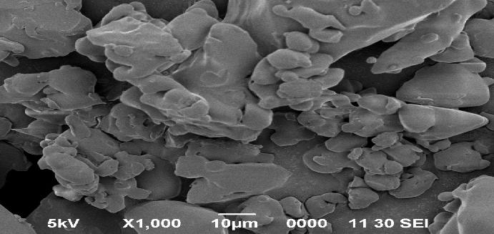

### SEM image of sustained release microparticle

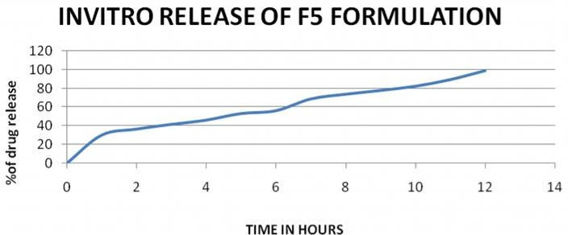

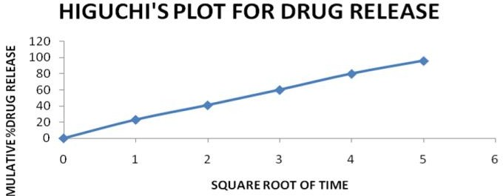

**Invitro release**

The Invitro release studies were done for all the sustained release formulation. But F5 formulation constantly releases maximum drug up to 12 hours. The entrapment efficiency is also maximum for F5 formulation. Immediate release blends provide burst release of medicament to quick onset of action. It is essential for quick recovery of angina pectoris and hyper tension patients. Super disintegrates are the key substances for immediate release. Eudragit RL 100 has been used as the release retardant polymer in controlled release dosage forms.EudragitRL100 reduced the drug release due to Reduction in the penetration of the solvent molecular into the system because of hydrophobic nature. The rate of release is controlled by the permeability of matrix structure. Drug: Polymer ratio 1:01, 1:0.2, 1:03, 1:04 shows that it could not sustain the release beyond 10 hours.1:0.5 showed the desired release profile over the test period for 12 hours.

## Conclusion

As per this study immediate release and sustained release microsphere blends were filled in “2” size capsules. Invitro release profile reveals that it provide quick onset of action and prolonged release for 12 hours. Quick onset of action due to immediate release blends. Prolonged release is due to sustained release microspheres. Sustained release propranolol microspheres were formulated by using Eudragit RL-100 as a release retardant material by solvent evaporation method. Micro particles are spherical, discrete and free flowing in nature. This formulation is definitely helpful for hypertension and angina pectoris patients.

## References

1. Baken J.A., Lachman and Liberman (Eds) The Theory and practice of Industrial Pharmacy, Varghese publishing House, Mumbai 1987, pp 412-429.
2. [www.rohacell.com/en/pharma](http://www.rohacell.com/en/pharma) polymers/eudragit/qua lity/specification
3. Kuchekar BS, Bhise SB, Arumugam V, Design of fast dissolving tablets, Indian J. Pharm. Educ.2001; 35 : 150-152.
4. Madhusmruti khandai,Santanu chakra borty, Development of propranolol hydrochloride matrix tablets: an matrix investigation on effects of combination of hydrophilic and hydrophobic formers using multiple analysis

comparison, International Journal of Pharmaceutical Sciences Review and Research: 1(2), 2010; 1 -5.

1. Sivakumar. T,Manna, M.,Manavalan, R.,Iranian J Pharm Sci 2007,3,1-12.
2. Brogden,R.N.,Heel.,R.C.,Pakes,G.E.,Speight,T

.M.,Avery,G.S.,Drugs 1980,20,24-48.

1. Li, Xiujuan; Chang, Si; Encapsulation of azithromycin into polymeric microspheres by reduced pressure-solvent evaporation method**.**

/ In: International Journal of Pharmaceutics, Vol. 433, No. 1-2, 2012, Pages. 79-88.

1. Mallikarjune settee, D.V.K.Prasad, U.R.M.Gupta, Development of fast dispersible Aceclofenac tablets. Journal of Indian pharmaceutical sciences 2008. Vol 70Issue 2 pages: 180-185.10.
2. United states pharmacopoeia National formulary2002 Carbamazepine Extended release tablets, 2002, P.No.303, 724.
3. Mitalikakran et al preparation of nanoparticles of Poorly water soluble antioxidant cur cumin by ant solvent precipitation methods. J.nanoparticles Res, springer (2012)14:757.
4. Jung JY, Yoos. D et al enhanced solubility and dissolution rate of itraconazole by a solid Dispersion technique, Int.J. Pharm 1999; 187:209-218 (Pub med).
5. Ubrich N, Schmidt C, Bodmeirer R, Oral evaluation in rabbits of cyclosporine loaded eudragit RS or RL nanoparticles Int. J.Pharm. 2005:288:169-175.
6. Souto E.B., Wissing S.A., et al Developmemt of a controlled release formulation based On SLN and NLC for topical clotrimazole delivery, Int.J.Pharm 2004.02.032 (pub med)
7. Hou D et al production and characteristic of solid lipid nanoparticles biomaterials 2003, 24:1781-1785 doi: 10.1016/so142 (02)00578.
8. Puranik, M.P, Wadher, S.J., Yeole P.G., Shinde P, international journal of Pharmaceutical Excipients.2005, 2, 29-3318.
9. Chowdary K.P.R, Rao Y.S, Mucoadhesive microcapsules of glipizide: Characterization in Vitro and in vivo evaluation, Indian J.Pharm.Sci., 65(3), 2003, 279-284.
10. A Ni, Shivarkar, UV-Spectrophotometric method development and validation of propranolol hydrochloride and flunarizine Dihydrochloride in bulk drug and capsule dosage form, Contemporary investigations and observations in pharmacy2012, 1(1), 19-23.