***Review Article***

**Available Online at:** [**www.ijpir.com**](http://www.ijpir.com/)



International Journal of Pharmacy and Industrial Research

**ISSN**

**Print 2231 – 3648**

**Online 2231 – 3656**

**A SIMPLE AND VALIDATED UV SPECTRPHOTOMETRIC METHOD FOR ESTIMATION OF ARMODAFINIL IN BULK AND PHARMACEUTICAL DOSAGE FORM**

# *Tejaswi Jonnalagadda, Shanta Kumari Katakam

Department of Pharmaceutical Analysis, Nirmala College of Pharmacy, Nagarjuna University, Mangalagiri, Guntur-522503, Andhra Pradesh, India.

## Abstract

Armodafinil is an enantiopure of the vigilance-promoting drug Modafinil; it is useful for treating excessive day time sleepiness. In the present a simple, sensitive and accurate and economical spectroscopic method has been developed for the estimation of Armodafinil in bulk and pharmaceutical dosage forms. An absorption maxima was found to be at 230nm with the solvent system methanol: water (3:97). The drug follows Beer Lambert law in the range of 2- 15µg/ml with correlation coefficient of 0.9995. The percentage recovery of Armodafinil in Pharmaceutical dosage form was with in the specified limits. Results of the analysis were validated for accuracy, precision, LOD, LOQ and were found to be satisfactory. The proposed method is simple, rapid and suitable for the routine quality control analysis.

**Keywords:** Armodafinil, UV Spectrophotometry, Estimation, Validation.

## Introduction

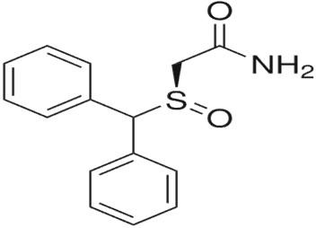Armodafinil (ARM), IUPAC name (–)-2-[(R)- (diphenylmethyl) sulfinyl] acetamide. It is soluble [1] in methanol, slightly1 soluble in water. It is an enantiopure of the vigilance-promoting drug,2 or eugeroic, Modafinil (Provigil). It is useful for treating excessive day time sleepiness3 associated with obstructive sleep apnea, narcolepsy, and shift work disorder.4 It is not official in Indian and British pharmacopoeia, it was approved by US-

FDA in 2007.5, 6 Till now there were no reported methods for the

Spectrophotometric estimation of Armodafinil.

### Author for Correspondence:

Tejaswi Jonnalagadda,

Department of Pharmaceutical Analysis,

Nirmala College of Pharmacy, Nagarjuna University, Mangalagiri, Guntur-522503, Andhra Pradesh, India. E.mail: [jonnalagaddatejaswi@gmail.com](mailto:jonnalagaddatejaswi@gmail.com)

## Materials and methods

### Instrumentation

Analysis was performed on Thermo scientific double beam UV-Visible spectrophotometer evolution 201. Other equipments used in the study were analytical balance (SHIMADZU) and ultra sonic bath.

### Chemicals and reagents

All the reagents and chemicals used were AR grade. Methanol – Merk, Armodafinil tablets, Waklert (50mg).

### Method development

**Preparation of standard stock solution and calibration curve**

Standard stock solution of 1mg/ml of Armodafinil was prepared by dissolving in 3ml of methanol and the volume was made with distilled water. The ARM stock solution was diluted with diluent to give working standard solutions containing 2, 4, 6,8,10 µg/ml concentrations. These solutions were measured at 230 nm. The Linearity was determined for ARM and calibration curve was constructed by plotting area against the respective concentrations.

### Validation of method

The UV Spectrophotometric method was validated in accordance with ICH guidelines.

### Linearity

Fresh aliquots were prepared from stock solution (100µg/ml) ranging from 2- 10 µg/ml. The samples were scanned in UV-Visible spectrophotometer using methanol and water as blank. It was found that the selected drug shows linearity between 2- 15µg/ml. The results were reported in Table 1.

### Accuracy

Accuracy of the method confirmed by studying recovery at 3 different concentrations for 80, 100 and 120% of these expected, in accordance with ICH guidelines, by replicate analysis. Standard drug solution was added to a pre analyzed sample solution and percentage drug content was measured. The results from study of accuracy were reported in Table 2.

### Precision

Precision (intra-day Precision) of the method was evaluated by carrying out the six independent test samples of Armodafinil. The intermediate precision

(inter- day precision) of the method was also evaluated using two different analyst, and different days in the same laboratory. The percent relative standard deviation (% RSD) was found to be within the specified limits. The results from study of precision were reported in Table 3.

### Robustness

Robustness of the method was evaluated by carrying out the six replicate samples of Armodafinil at 230±2 nm. The relative standard deviation was found within the specified limits. The results were reported in Table no.4

### Assay of armodafinil tablets

For the analysis of the dosage form 20 tablets were weighed. Powder equivalent to 50 mg of ARM was taken into a 100ml volumetric flask. The formulation first dissolved in methanol (3ml) and sonicated for about 5-10 min. Finally the volume was made up with distilled water. The final concentration of the sample 6µg/ml was prepared and absorbance was measured against reagent blank at 230nm. The amount of Armodafinil was computed by using equation referring to the calibration curve. The results were reported in Table 5.

### RESULTS AND DISCUSSIONS

Armodafinil shown its λ max at 230 nm in the solvent (methanol: water- 3:97) with a good correlation coefficient 0.9995.

## Conclusion

The low standard deviation, %RSD and variation was in conformity with standards. Hence, it can be concluded that the developed Spectroscopic method is accurate, precise and selective and can be employed successfully for the estimation of ARM in bulk and marketed formulation for routine quality control analysis.

## Acknowledgement

The authors are thankful to Nirmala College of pharmacy mangalagiri, Guntur, Andhra Pradesh, India for providing necessary facilities to carry out the research work.

Tejaswi Jonnalagadda. et al., Int. J. Pharm & Ind. Res., Vol.–04 (03) 2014 [91 - 94]

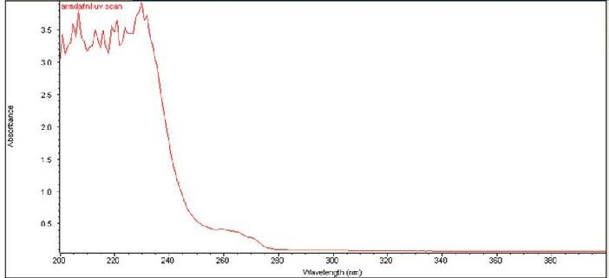

### Fig. No. 01: Scanned spectrum of Armodafinil

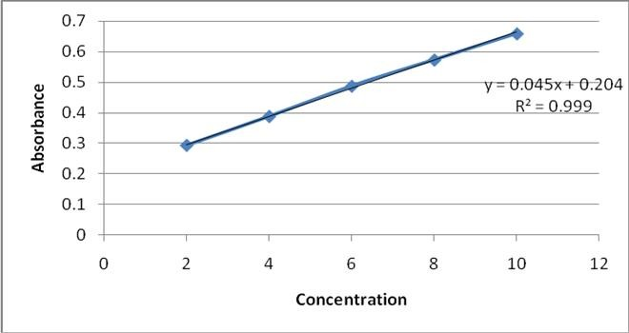

**Fig. No. 02: Calibration curve of Armodafinil Table No. 01: Linearity**

### Table No. 02: Accuracy

|  |  |  |
| --- | --- | --- |
| **S.N0** | **Concentration(µg/ml)** | **Absorbance** |
| 1 | 2 | 0.293 |
| 2 | 4 | 0.383 |
| 3 | 6 | 0.487 |
| 4 | 8 | 0.573 |
| 5 | 10 | 0.659 |

|  |  |  |  |  |  |
| --- | --- | --- | --- | --- | --- |
| **S.No %Level of** | | **Amount of sample added** | **Amount of API added\*** | **Amount found\*** | **%** |
|  | **recovery** | **(µg/ml)** | **(µg/ml)** | **(µg/ml)** | **Recovery\*** |
| 1 | 80 | 4.8 | 6 | 5.88 | 98.05 |
| 2 | 100 | 6 | 6 | 5.99 | 99.7 |
| 3 | 120 | 7.2 | 6 | 5.92 | 98.73 |

*Average of three values

### Table No. 03: Precision

|  |  |  |
| --- | --- | --- |
| **S.No** | **Intra day precision** | **Inter day precision** |
| 1 | 0.721 | 0.477 |
| 2 | 0.712 | 0.476 |
| 3 | 0.715 | 0.476 |
| 4 | 0.708 | 0.476 |
| 5 | 0.726 | 0.476 |
| 6 | 0.702 | 0.476 |
| %RSD | 0.36 | 0.00027 |

[www.ijpir.com](http://www.ijpir.com/)

### Table No. 04: Robustness values

|  |  |  |
| --- | --- | --- |
|  | **At 232 nm** | **At 228 nm** |
| 1 | 0.415 | 0.583 |
| 2 | 0.415 | 0.582 |
| 3 | 0.414 | 0.582 |
| 4 | 0.414 | 0.582 |
| 5 | 0.414 | 0.582 |
| 6 | 0.414 | 0.582 |
| %RSD | 0.003 | 0.0002 |

**Sample Absorbance**

### Table No. 05: Assay value

**Drug Label claim**

**(mg/tablet)**

**Calculated value (mg±SD/tablet)**

**% of Assay**

ARM 50 50.70 101%

## References

1. <http://www.rxlist.com/nuvigil-drug.htm>
2. Ferraro L, Antonelli T, Tanganelli S, O'Connor WT, Perez de la Mora M, Mendez-Franco J, Rambert FA, Fuxe K (April 1999). "The vigilance promoting drug modafinil increases extracellular glutamate levels in the medial preoptic area and the posterior hypothalamus of the conscious rat: prevention by local GABAA receptor.
3. Darwish, M.; Kirby, M.; Hellriegel, E. T.; Robertson Jr, P. (2009). "Armodafinil and Modafinil Have Substantially Different

Pharmacokinetic Profiles Despite Having the Same Terminal Half-Lives". *Clinical Drug Investigation* 29 (9):613–623. doi:10.2165/

11315280-000000000-00000. PMID 19663523

1. <http://www.nuvigil.com/PDF/Full_Prescribing>

_Information.pdf

1. "CDER Drug and Biologic Approvals for Calendar Year 2007.
2. "Search results from the "OB_Rx" table for query on "021875."", *Orange Book* (U.S.Food and Drug Administration), March 2012, retrieved April 30, 2012.