Research Article

Available Online at: www.ijpir.com

International Journal of Pharmacy and Industrial Research

ISSN
Print 2231 – 3648
Online 2231 – 3656

FORMULATION AND IN-VITRO EVALUATION OF HYDROGEL BASED ORAL CONTROLLED DRUG DELIVERY OF RITONAVIR

^{*1,2}Sandhya Pamu, ¹Ayesha Khan, ¹Hameeda Zareen Durani
^{*1}Shadan Womens College of Pharmacy, Khairatabad, Hyderabad, India – 500 004.
²University College of Pharmacy, Osmania University, Hyderabad, India – 500 007.

Abstract
Hydrogel matrix tablets of Ritonavir were formulated using guar gum, chitosan and HPMC of various grades such as K4M, K15M, and K100M With the aim to study drug release kinetics and to attain a near zero order release. Tablet formulations were prepared by direct compression technique and were evaluated for precompression and post compression parameters. In-vitro dissolution studies were carried out using USP type II dissolution test apparatus. Among different formulations of direct compression containing drug to polymer ratio 1:1 and polymers guar gum and chitosan used in combination (3:1 ratio) gives best dissolution profile and dissolution efficiency and among tablet formulations compared with other formulations. The best-fit release kinetics was achieved with the zero-order plot. Guar Gum and chitosan as a combination (3:1 ratio) are found to be with good physical integrity, free from any drug‐polymer interaction and provided a method of achieving controlled drug action through uniform drug release upto 10 hours.

Keywords: Hydrogel, controlled release drug delivery, matrix tablets, Ritonavir.

Introduction
During the last two decades there has been remarkable increase in interest in controlled release drug delivery system. This has been due to various factor viz. the prohibitive cost of developing new drug entities, expiration of existing international patents, discovery of new polymeric materials suitable for prolonging the drug release, and the improvement in therapeutic efficiency and safety achieved by these delivery systems. Now-a-days the technology of controlled release is also being applied to veterinary products also¹. Oral controlled drug delivery is one which delivers the drug at a predetermined rate, locally or systemically, for a

specified period of time. There is continuous oral delivery of drugs at predictable and reproducible kinetics for predetermined period throughout the course of gastrointestinal tract².

Among various technologies available for the controlled drug delivery, monolithic matrices‐ matrix tablets continue to be popular because of simple processing technologies required, reproducibility, and stability of the materials and dosage form as well as ease of scale‐up operation. In particular, the interest awakened by matrix type deliveries is completely justified in view of their

Author for Correspondence:
Sandhya Pamu,
Head of the Department of Pharmaceutics, Shadan Womens College of Pharmacy, Khairatabad, Hyderabad, India - 500 004. E-mail: sandhyapasikanti@gmail.com

biopharmaceutical and pharmacokinetics advantages over the conventional dosage forms. These are release systems for delayed and controlled release of a drug that is dissolved or dispersed in a resistant support to disintegration. During the last two decades swelling polymers are being used as sustained or controlled release devices ³.

Hydrogels, the swellable polymeric materials are hydrophilic, three-dimensional networks, which are able to imbibe large amounts of water or biological fluids. Hydrogels do not dissolve in water due to the presence of the chemical or physical cross- links, but absorb and retain a large amount of water, in some cases up to a thousand times its dry weight.⁴ Thus Hydrophilic polymer networks imbibed with a large amount of water or other biological ﬂuids are known as hydrogel⁵ .

Hydrogels as controlled drug delivery
The water content in the hydrogels affect different properties like permeability, mechanical properties, surface properties and biocompatibility. Hydrogels have similar physical properties as that of living tissue, and this similarity is due to the high water content, soft and rubbery consistency, and low interfacial tension with water or biological fluid. The ability of molecules of different size to diffuse into (drug loading), and out (release drug) of hydrogels, permit the use of hydrogels as delivery systems. Since hydrogels have high permeability for water soluble drugs and proteins, the most common mechanism of drug release in the
hydrogel system, is diffusion. Factors like polymer composition, water content, cross linking density, and crystallinity, can be used to control the release rate and release mechanism from hydrogels⁶. These controlled drug delivery systems are designed for zero order release kinetics which ensures constant drug release over a prolonged period of time.

Materials and methodology

Materials
Ritonavir, Guar gum, chitosan and HPMC of various grades such as K4M, K15M, K100M, MCC, talc and magnesium stearate were procured from S.D. fine chemicals.

Method of preparation of controlled release matrix tablets
All the ingredients were sieved through sieve number 120. Weighed quantities of drug, polymer, lubricant (Talc and Magnesium sterate) and diluent (microcrystalline cellulose) were mixed in geometric proportion using a mortar and pestle. Controlled released tablets were prepared by direct compression method. Hydroxypropylmethyl cellulose (HPMC–K-4-M, HPMC-K-100M and HPMC-K-15M), Guar Gum and Chitosan were used as retardant material for preparation of tablets. The resultant mixture was blended in a closed polythene bag. Remaining amount of lubricants were added and was subjected to compression to form tablet with target weight of 350mg using hydraulic press having 9 mm diameter flat punches. The hardness of all tablets was maintained at 5 to 7 Kg/cm².

Table No. 01: Working formulae for formulations F1-F12
Formulation code | F1 | F2 | F3 | F4 | F5 | F6 | F7 | F8 | F9 | F10 | F11 | F12
Drug | 100 | 100 | 100 | 100 | 100 | 100 | 100 | 100 | 100 | 100 | 100 | 100
Chitosan | 50 | 75 | 25 | 50 | 75 | 25 | 50 | 75 | 25 | 50 | 75 | 25
Guar gum | 50 | 25 | 75 | _ | _ | _ | _ | _ | _ | _ | _ | _
HPMC K4M | _ | _ | _ | 50 | 25 | 75 | _ | _ | _ | _ | _ | _
HPMC K15M | _ | _ | _ | _ | _ | _ | 50 | 25 | 75 | _ | _ | _
HPMC K100M | _ | _ | _ | _ | _ | _ |  | _ | _ | 50 | 25 | 75
Magnesium stearate | 5 | 5 | 5 | 5 | 5 | 5 | 5 | 5 | 5 | 5 | 5 | 5
Talc | 5 | 5 | 5 | 5 | 5 | 5 | 5 | 5 | 5 | 5 | 5 | 5
MCC | 140 | 140 | 140 | 140 | 140 | 140 | 140 | 140 | 140 | 140 | 140 | 140
Total Weight | 350 | 350 | 350 | 350 | 350 | 350 | 350 | 350 | 350 | 350 | 350 | 350

Pre compression parameters Bulk density (Db)
It is a ratio of mass of powder to bulk volume. The bulk density depends on particle size distribution, shape and cohesiveness of particles. Accurately
weighed quantity of powder was carefully poured in to graduated measuring cylinder through large funnel and volume was measured, which is called initial bulk volume. It is expressed in gm/ml and is given by

Db = M / V0
Where,
M is the mass of powder,
V0 is the bulk volume of the powder.

Tapped density (Dt)
Ten gram of powder was introduced into a clean, dry 100 ml measuring cylinder. The cylinder was then tapped 100 times from a constant height and the tapped volume was read. It is expressed in gm/ml and is given by,

Dt = M / Vt
Where,
M is the mass of powder.
TVs is the tapped volume of the powder.

Angle of repose (θ)
It is defined as the maximum angle possible between the surface of the pile of the powder and the horizontal plane. Fixed funnel method was used. A funnel was fixed with its tip at a given height ‘h, above a flat horizontal surface to which a graph paper was placed. Powder was carefully poured through a funnel till the apex of the conical pile just touches the tip of the funnel. The angle of repose was then calculated using following equation,

θ = Tan ⁻¹(h/r)
Where,
θ =Angle of repose, h=Height of pile, r=Radius of the base of the pile.

Carr’s Consolidation Index (I)
Carr’s index is an indication of the compressibility of a powder. It is expressed in percentage and is given by

I = Dt – Db / Dt x 100
Where,
Dt=Tapped density, Db=Bulk density

Post compression parameters Thickness
Control of physical dimensions of the tablet such as thickness is essential for consumer acceptance and tablet uniformity. The thickness of the tablet was measured using Vernier Calipers. It is measured in mm.

Hardness
The Monsanto hardness tester was used to determine the tablet hardness .The tablet was held between affixed and moving jaw. Scale was
adjusted to zero; load was gradually increased until the tablet fractured. The value of the load at that point gives a measure of the hardness of the tablet. It is expressed in kg/cm2.

Friability (F)
Tablet strength was tested by Roche friabilator. Pre weighed tablets were allowed for 100 revolutions in 4 min and were dedusted. The percentage weight loss was calculated by reweighing the tablets. The
% friability was then calculated by: ‐ Friability = ( [ w₀ – w] / w₀) × 100 Where,
w₀ = weight of the tablet at time zero before revolutions.
W = weight of the tablet after 100 revolutions.

Weight variation
Randomly selected twenty tablets were weighed individually and together in a single pan balance. The average weight was noted and standard deviation calculated. The tablet passes the test if not more than two tablets fall outside the percentage limit and none of the tablet differs by more than double percentage limit. IP limit for weight variation in case of tablets weighting up to 120 mg is ± 10%, 120 mg to 300 mg is ± 7.5% and more than 300 mg is ± 5%.

PD = (W avg ) – (W initial) / (W avg ) x 100
Where,
PD= Percentage deviation,
Wavg =Average weight of tablet, Initial =Individual weight of tablet.

Uniformity of drug content
The Uniformity of drug content was calculated in five randomly selected tablets of each formulation. The five tablets were weighed individually and grinded in mortar to get powder; this 350 mg powder was dissolved in 0.1 N HCL by sonication for 30 min and filtered through filter paper. The drug content was analyzed spectrophotometrically at 245 nm using spectrophotometer. Each measurement was carried out in triplicate and the average drug content was calculated.

In vitro Release studies
In vitro dissolution studies for all the Matrix tablets were carried out using USP type II Dissolution apparatus in 900 ml of0.1 N HCL for first two hours and then in phosphate buffer (pH 7.4) as dissolution media for next 8 hours, maintained at

37±0.5ºC at 50 rpm. 5 ml aliquots were withdrawn at every 1 hour and replaced by 5 ml of fresh
dissolution media (37ºC). The collected samples were analyzed after suitable dilution (if required).

Results & discussion

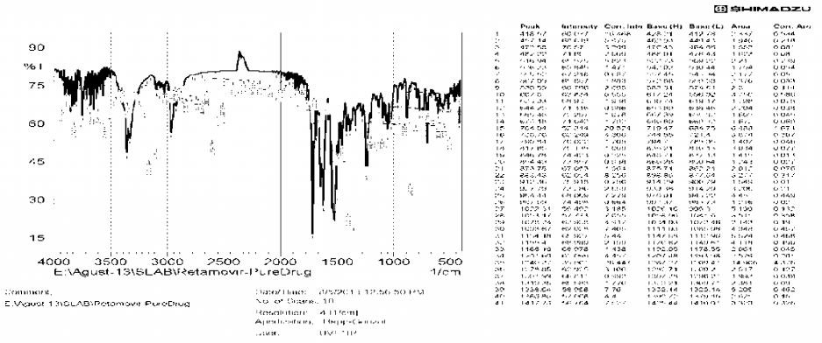
FTIR spectra of Ritonavir pure drug
Fig. No. 01: FTIR spectra of Ritonavir pure drug

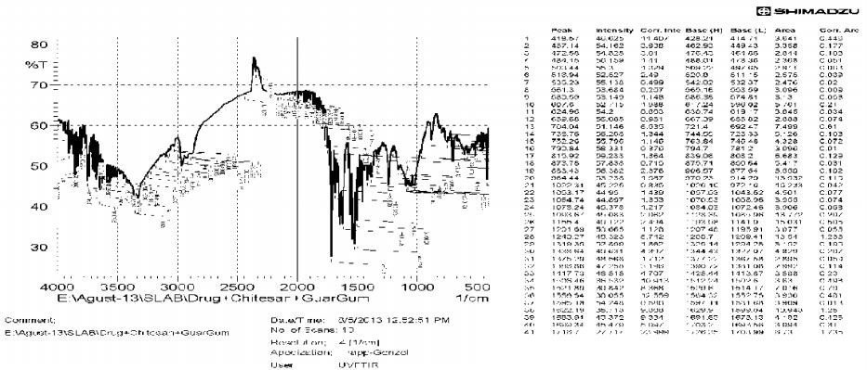
Fig. No. 02: FTIR spectra of Ritonavir + guar gum + chitosan Pre compression Results of Working Formulations F1-F12
Table No. 02: Pre compression Results of Formulations F1-F12
Formulations | Bulk density (gm/cm³) | Tap density (gm/cm³) | Carr’s index  % | Hausner’s  ratio | Angle of repose ( ⁰ )
F1 | 0.44 | 0.52 | 13.28 | 1.19 | 29
F2 | 0.41 | 0.55 | 17.24 | 1.21 | 28
F3 | 0.43 | 0.56 | 16.59 | 1.14 | 25
F4 | 0.42 | 0.58 | 15.34 | 1.22 | 27
F5 | 0.47 | 0.51 | 13.79 | 1.18 | 26
F6 | 0.49 | 0.56 | 18 | 1.17 | 29
F7 | 0.41 | 0.58 | 17.23 | 1.16 | 28
F8 | 0.46 | 0.59 | 13.33 | 1.15 | 27
F9 | 0.45 | 0.53 | 17.55 | 1.19 | 29
F10 | 0.41 | 0.56 | 18.21 | 1.17 | 28
F11 | 0.49 | 0.57 | 14.76 | 1.21 | 26
F12 | 0.45 | 0.53 | 17.78 | 1.178 | 26

Post Compression Parameters of Control Release Tablets Of Ritonavir F1-F12
Table No. 03: Post Compression Parameters of Ritonavir F1-F12

Formulations Average weight
(mean + S.D)
Thickness (mm) Hardness (Kg/cm²) Friability % Drug Content

F1 350±2.12 3.3±0.00 5.0±0.72 0.35 99±0.63
F2 349±3.01 3.5±0.06 5.2±0.35 0.25 95±0.51
F3 350±2.55 3.2±0.00 5.6±0.72 0.36 98±0.72
F4 354±3.11 3.1±0.00 5.7±0.62 0.15 95±0.36
F5 351±3.41 3.2±0.03 5.5±0.48 0.39 96±0.52
F6 350±3.43 3.0±0.01 5.8±0.38 0.54 97±0.87
F7 354±1.22 2.9±0.00 5.9±0.68 0.56 95±0.73
F8 354±1.19 3.4±0.03 5.1±0.47 0.63 97±0.51
F9 353±3.303 3.6±0.05 5.3±0.69 0.42 98±0.39
F10 350±1.32 3.5±0.04 5.9±0.56 0.45 95.8±0.42
F11 352±2.07 3.1±0.05 6±0.57 0.63 96.6±0.64
F12 353±1.19 2.9±0.03 6.1±0.35 0.30 97.12±64

In-vitro drug release studies of formulations F1-F12
Table No. 04: In-vitro drug release studies of formulations F1-F12
Time (hrs) | F1 | F2 | F3 | F4 | F5 | F6 | F7 | F8 | F9 | F10 | F11 | F12
0 | 0 | 0 | 0 | 0 | 0 | 0 | 0 | 0 | 0 | 0 | 0 | 0
0.5 | 2.607 | 42.5 | 3.6818 | 2.76 | 60.56 | 48.52 | 3.98 | 2.86 | 2.53 | 2.14 | 2.86 | 3.68
1 | 5.934 | 59.3 | 5.7309 | 4.55 | 79.3 | 58.46 | 5.27 | 4.91 | 4.96 | 4.70 | 4.75 | 5.06
2 | 11.672 | 80 | 9.6741 | 11.83 | 89.4 | 99.3 | 8.39 | 7.37 | 6.80 | 6.24 | 8.59 | 7.88
3 | 25.373 | - | 19.6353 | 17.99 | - | - | 11.81 | 12.83 | 8.90 | 10.88 | 11.33 | 10.68
4 | 32.35 | - | 27.0189 | 25.23 | - | - | 23.94 | 16.15 | 13.55 | 15.05 | 14.75 | 13.25
5 | 46.83 | - | 35.5342 | 33.92 | - | - | 31.84 | 24.28 | 17.79 | 23.52 | 25.06 | 22.77
6 | 61.223 | - | 43.0696 | 41.35 | - | - | 44.10 | 33.06 | 26.06 | 32.21 | 34.09 | 31.49
7 | 69.79 | - | 59.1578 | 49.90 | - | - | 52.65 | 42.37 | 35.19 | 40.62 | 43.39 | 39.63
8 | 76.66 | - | 76.9871 | 58.12 | - | - | 60.19 | 49.55 | 44.09 | 48.87 | 55.69 | 47.50
9 | 84.56 | - | 84.1786 | 67.37 | - | - | 69.10 | 57.10 | 52.20 | 57.09 | 66.65 | 55.04
10 | 89.2 | - | 93.7787 | 75.9 | - | - | 77.34 | 65.66 | 60.17 | 60.35 | 74.88 | 63.26
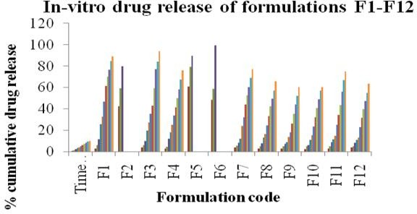

Fig. No. 03: In vitro-drug release of formulations F1-F12

Swelling studies

Table No. 05: In-vitro Swelling studies of formulations F1-F12

Time | F1 | F2 | F3 | F4 | F5 | F6 | F7 | F8 | F9 | F10 | F11 | F12
0 | 0 | 0 | 0 | 0 | 0 | 0 | 0 | 0 | 0 | 0 | 0 | 0
1 | 16 | 4 | 6 | 8 | 10 | 9 | 8 | 8 | 7 | 7 | 8 | 9
2 | 29 | 10 | 13 | 15 | 19 | 17 | 15 | 15 | 15 | 14 | 15 | 17
3 | 37 | 17 | 21 | 23 | 28 | 25 | 26 | 24 | 22 | 21 | 23 | 28
4 | 49 | 24 | 37 | 30 | 37 | 39 | 35 | 35 | 30 | 29 | 31 | 36
5 | 58 | 31 | 49 | 38 | 46 | 52 | 47 | 44 | 39 | 36 | 39 | 45
6 | 70 | 43 | 60 | 46 | 55 | 65 | 54 | 54 | 43 | 46 | 46 | 54
7 | 82 | 56 | 75 | 55 | 63 | 76 | 62 | 63 | 50 | 54 | 54 | 63
8 | 97 | 64 | 90 | 63 | 70 | 89 | 69 | 74 | 59 | 63 | 63 | 72
9 | 112 | 71 | 105 | 72 | 78 | 109 | 76 | 85 | 68 | 72 | 72 | 81
10 128 79 125 80 82 117 81 96 86 81 80 90

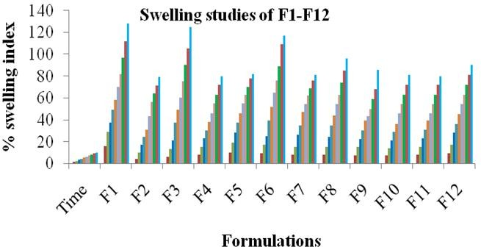

Fig. No. 04: In-vitro Swelling studies of formulations F1-F12

Release kinetics of optimized formulation
Table No. 06: Kinetics of drug release
Formulations | Zero order | First order Peppas Higuichi
F3 | 0.976 | 0.924 0.975 0.851

Discussion

Compatibility Studies
In order to investigate the possible interactions between Ritonavir and distinct polymers or diluents, FT-IR studies were carried out. FT-IR results proved that the drug was found to be compatible with excipients as wave numbers are almost similar for pure drug and also drug excipients mixture. The results were shown in figure 1, 2.

Evaluation of pre-compression parameters Based on the results of pre-compression tests, all the formulations showed angle of repose ranging from 25⁰ to 29⁰ indicating a good flow property (Table 2) and Carr’s index ranging from 13 % to 19%, indicating compressibility of the granules is fairly passable (Table 2).

Evaluation of post-compression parameters
The tablets of different formulations were subjected to various evaluation tests, such as thickness, uniformity of weight, hardness, friability, and drug content. All the formulations showed uniform thickness. The thickness of the tablets were in the range of 2.9±0.00 to 3.6±0.05mm.The hardness of the tablets were in the range of 5.0±0.72 to 6.1±0.35 kg/cm². The percentage friability was found to be less than 1% indicating that the friability is within the prescribed limits. In weight variation test, the average percentage deviation of all tablet formulations was
found to be within the limit, and hence they met the test as per official requirements and were found to contain 95±0.36 to 98±0.72 mg of the labeled amount of Ritonavir indicating uniformity of drug content. The results are shown in Table 3.

In-vitro drug release
Tablets subjected for dissolution studies shown drug release at 1 hr was ranging between 4 to 58 %. As the dissolution studies continued, the release from each dosage form showed an incremental release in sustained manner for a long time. The release of the drug at 10 hrs varied from 60.35 to
93.77 % indicating that the overall drug release from the dosage form depends upon the composition of tablet matrix which varies from one formula to another. From this study it may be concluded, that the independent variables included in the study were found to show significant variation for the response variables. The results were shown in Table 4, figure 3.

Curve fitting analysis
To study the release kinetics from hydrogel based matrix tablets, the release data were fitted to the well-known exponential equation (Korsmeyer– Peppas equation) and which is often used to describe the drug release behavior from polymeric systems when the mechanism is not well known or when more than one type of release phenomenon is involved. All the formulations exhibited anomalous (non Fickian transport) diffusion/polymer

relaxation mechanism with a value ranging from
0.5 to 1. All formulations exhibited zero-order
release profile as their ‘n’ values were very close to
0.89. The results for optimized formulation with n value of 0.976 confirmed that the formulation followed zero order kinetics indicating Ritonavir release from controlled drug delivery system was by non –fickian or anamolous diffusion . The results are shown in Table 6.

Conclusion
From the findings formulation F 3 have been optimized containing Guar Gum and chitosan in (3:1 ratio) is a promising concentration for oral controlled release tablets of Ritonavir. Formulated tablets exhibited nearly zero order kinetics and the release profile was of matrix diffusion type. From the study, it is possible to design promising Hydrogel based oral controlled release tablets containing Ritonavir used in the treatment of AIDS. The in-vitro kinetics of drug release obeyed zero order kinetics with mechanism of release by non-fickian diffusion due to more hydrophilic nature of polymer and drug. The increase in concentration of polymer decreases the release of drug.

References
- Yie WCand Senshang L: Drug Delivery: Controlled Release. Encyclopedia of Pharmaceutical Technology, Informal Healthcare, USA, Edition 3, Vol. 2, 2007:1082-1103.
- Chien Y.W., Novel Drug Delivery Systems, IInd edition, Revised and expanded, Marcel Dekker, New York, 1992, 139-140.
- Turner S, Federici C, Hite M, Fassihi R. Formulation development and human in vitro‐in vivo correlation for a novel, monolithic controlled release matrix system of high load and highly water-soluble drug niacin. Drug Development and Industrial Pharmacy 2004; 30:797‐07.
- Seung GL, Giuseppe F, Brunello,David G,Bucknall,. Molecular Dynamics Simulation Study of (Pvp-Co-Hema)Hydrogels : Effect of Water Content on Equilibrium Structures and Mechanical Properties. Biomaterials .2009 30:6130-41
- Mehrdad H, Amir A, Pedram R. Hydrogel nanoparticles in drug delivery. Adv Drug Delivery Rev.2008;601638-1649
- CS Satish, KP Satish, HG Shivakumar Hydrogels as controlled drug delivery systems: Synthesis, crosslinking, water and drug transport mechanism 10.4103/0250- 474X.25706
- Brahmankar D.M., jaiswal SB, Biopharmaceutics And Pharmacokinetics –A Treatise 2 nd edition Vallabh Prakasan Delhi, 2009:399-405
- Turner S, Federici C, Hite M, Fassihi R. Formulation development and human in vitro‐in vivo correlation for a novel, monolithic controlled release matrix system of high load and highly water‐soluble drug niacin. Drug Development and Industrial Pharmacy 2004; 30:797‐07.
- Saima Amin, Saeid Rajabnezhad, Kanchan Kohli Hydrogels as potential drug delivery systems Scientific Research and Essay Vol. 3 (11), pp. 1175-1183, November, 2009 Academic Journals ISSN 1992-2248
- Graham NB, Mc-Neil ME (1984). Hydrogels for controlled drug delivery. Biomaterials 5 (1): 27-36.
- Seung GL, Giuseppe F, Brunello,David G,Bucknall,.molecular dynamics simulation study of (PVP-co-HEMA)hydrogels:effect of water content on equilibrium structuresand mechanical properties. Biomaterials. 2009 30:6130-41.
- Tao W, Sundaram G. State of water in chitosan-PVA Hydrogel. J Appl Polym Sci. 2006;101:3227-32.

