# 274

***Research Article***

**Available Online at:** [**www.ijpir.com**](http://www.ijpir.com/)



International Journal of Pharmacy and Industrial Research

**ISSN**

**Print 2231 – 3648**

**Online 2231 – 3656**

**FORMULATION AND EVALUATION OF ELETRIPTAN HYDROBROMIDE PELLETS**

# *Venkatesh B, Gnanaprakash K, Suresh K, Balaji G, Sankar P

Ratnam Institute of Pharmacy, Pidthapolur, SPSRNellore District, Andhra Pradesh, India – 524 346.

## Abstract

The aim of the present study was to formulate and evaluate Eletriptan hydrobromide pellets. Eletriptan hydrobromide Immediate and controlled release pellets were prepared by Solution/Suspension layering technique by using croscarmellose and povidone in former case and three different polymers HPMC K 100, Ethyl cellulose and Eudragit RS 100 as rate controlling polymer in four different ratios like 1:0.5, 1:1, 1:1.5 and 1:2 to achieve desired release in later case. Evaluation was performed according to the Pharmacopoeia standards including Drug Excipients compatibility, Percentage yield, Particle size distribution, Drug content analysis and *in-vitro* release study. The best results were found to be using Eletriptan and Eudragit RS 100 in 1:2 ratios. A broad variety of drug release pattern could be achieved by variation of polymers ratios which was optimized to match the target release profile. In comparison of *in-vitro* release studies for different controlled release formulations, F12 releases 98.54% of drug at the end of 12th hour and was considered as best formulation. Stability study has shown no significant change in the drug content analysis and *in-vitro* dissolution study of best formulation even after 6 months. The stability data were analyzed using software “Stab”, predicted shelf life period of best formulation was estimated at 14 months.

**Keywords:** Eletriptan, Controlled release, Dissolution profile, *in-vitro* drug release, Stability studies.

## Introduction

Pelletization can be defined as an agglomeration (size-enlargement) process that converts fine powders or particles of bulk drugs and excipients into small, free-flowing, more or less spherical units, and called pellets1. Pellets are multi-unit dosage forms have both therapeutic and pharmaceutical advantages.Therapeutic advantages include modification of drug release, division of dose strength, and free dispersion in the gastro intestinal tract when administered orally. The pharmaceutical advantages include a high degree of flexibility in design and development during delivery of incompatible bioactive agents due to the

low surface area to volume ratio compared to powders and granules. Successful coating can be applied onto pellets due to their ideal spherical shape and low surface area-to-volume ratio.2

The major mechanism by which the drug is released from pellets depends on the type of coating; insoluble coating, pH-dependent coating (whose solubility changes dramatically at some location in GI tract) and slowly erodible coating3. The method of application and processing conditions may influence the porosity of the coating and consequently the release mechanism.

### Author for Correspondence:

Gnanaprakash K,

Ratnam Institute of Pharmacy, SPSRNellore, Andhra Pradesh, India. E-mail: [venkatesh.60b@gmail.com](mailto:venkatesh.60b@gmail.com)

Venkatesh B. et al., Int. J. Pharm & Ind. Res., Vol.–03 (03) 2013 [274 - 287]

275

Eletriptan hydrobromide is a selective 5-hydroxytryptamine 1B/1D (5-HT1B/1D) receptor agonist, used in the treatment of migraine attacks. Eletriptan is chemically designated as (R)-3-[(l- Methyl -2- pyrrolidinyl) methyl] -5- [2- (phenyl sulfonyl) ethyl]-l, H-indole monohydrobromide. The empirical formula is C22H26N2O2S.HBr, and its molecular weight 463.40. Eletriptan hydrobromide is a white to light pale colored powder that is readily soluble in water. The terminal elimination half-life of Eletriptan is approximately 4 hours, and is primarily metabolized by cytochrome P-450 enzyme CYP3A4 after oral administration. Although Eletriptan is well absorbed after oral administration, it undergoes first pass metabolism with oral bioavailability of approximately 50%. Eletriptan daily dose to be administered 20 mg or 40 mg or 80 mg to relieve symptoms of a migraine attack. Usually, the higher dose is more effective, but it can cause more side effects4.

The aim of the present study was to formulate and evaluate Eletriptan hydrobromide Pellets. The process involves Eletriptan hydrobromide Immediate and controlled release pellets were prepared by Solution/Suspension layering technique by using croscarmellose sodium and povidone in former case and three different polymers HPMC K 100, Ethyl cellulose and Eudragit RS 100 as rate controlling polymer in four different ratios like 1:0.5, 1:1, 1:1.5 and 1:2 to achieve desired release in later case, drug release from the pellets was optimized by using concentration and type of polymers as process parameters.

## Material and methods

### Materials

Eletriptan hydrobromide was obtained as a gift sample from Orchids Pvt. Ltd. Chennai, Non-pariel seeds having sieve size #22/#24 obtained from Aadhya Biotech Pvt. Ltd, Hyderabad, HPMC K 100, Eudragit RS 100, Ethyl cellulose and Crosscarmellose sodium were procured from Loba chemicals pvt. Ltd., Mumbai, HPMC E5 received from Himedia Laboratories Pvt. Ltd. Mumbai Solvents like acetone, ethanol, dichloromethane and isopropyl alcohol are obtained from S.D. Fine Chem. Ltd. Mumbai. All other reagents used were of analytical grade.

### Methods

**Drug and Excipient compatibility study**

Drug and Excipient compatibility study was performed by FTIR mentioned as below.

### Drug and Excipient compatibility study by FTIR

Fourier-transform infrared **(**FTIR) spectra were obtained using an FTIR spectrometer (Bruker Pvt. Ltd, Germany). The pure drug and excipients were mixed to prepare binary mixtures. The mixtures were mixed thoroughly with potassium bromide, an infrared transparent matrix, KBr pellets were prepared so as to contain approximately 2% (2:100) of drug and excipient mixture at a pressure of 30.7 MPa and a dwell time of 3 minutes were shown in the figure 1, 2, 3, 4. The spectrum for drug was recorded over the range of 4000 to 400 cm–1.

### Formulation of pellets by Solution/Suspension layer technique

The reported pellets were prepared by Solution/Suspension layering technique of pelletization. Due to Non-pariel seeds (sugar pellets) (#22/#24) having high solubility, the sugar spheres immediately get dissolved in aqueous media without build up of sufficient osmotic pressure in the core. In order, to retard the dissolution rate of non-pariel seeds initially coated with 2% (w/w) HPMC E5 as a seal coat.

### Preparation and coating procedure of Eletriptan immediate release pellets

Slurry of Eletriptan hydrobromide with 6% Croscarmellose sodium, 1% povidone K-30 (w/w) and add 0.01% tween 80 were dissolved in 100 ml acetone. The seal coated sugar pellets (Non-pariel seeds) (#22/#24) were preheated to about 35o C with gentle movement in a pan coater, and then sprayed prepared slurry coating % weight build up 30% w/w on sugar pellets while spraying the drug solution pan were allowed to rotate for about 10 mins until uniform drug loading occurs. Spray rate, inlet air temperature were adjusted in such a way that the core bed reaches a temperature of about 35o

C. Over wetting of the cores is to be avoided as it may cause agglomeration. After complete quantity of the drug loading solution was consumed. The pellets were then dried in a tray drier at about 45o C to moisture content of <2%. The dried pellets were sized on a sifter to remove agglomerates, broken pellets and fine powder5.

# 276

Venkatesh B. et al., Int. J. Pharm & Ind. Res., Vol.–03 (03) 2013 [274 - 287]

### Preparation of Coating solution

Eletriptan Hydrobromide and HPMC K 100, Ethyl Cellulose and Eudragit RS 100 were taken in 4 different ratios 1:0.5, 1:1, 1:1.5 and 1:2 as per the table 1 were dissolved in 1:1 ratio of methanol and dichloromethane, ethanol and acetone and acetone respectively. Finally, added 0.1% Tween 80 and 0.5% PEG 400.Composition of coating solution is coded with C1, C2, C3, C4, C5, C6, C7, C8, C9,

C10, C11, C12. The solutions were filtered through nylon cloth and taken into the spray gun.

### Coating Procedure

Initially, Seal coated sugar pellets (Non-pariel seeds) (#22/#24) were taken and preheated to about 35o C with gentle movement in a pan coater, and then sprayed prepared Eletriptan hydrobromide, HPMC K 100, Ethyl Cellulose and Eudragit RS 100 of 4 different ratios 1:0.5; 1:1, 1:1.5 and 1:2 on sugar pellets coating % weight buildup for 30%, 31%, 32% and 33% respectively, while spraying the solution pan were allowed to rotate until uniform drug and polymer loading occurs. However, an excessively high inlet temperature can potentially cause difficulties in processing such as electrostatic interactions and agglomeration of the



### Particle size distribution by sieve analysis

Sieve analysis is done by using electromagnetic sieve shaker (Kavin Scientific Products). Five sieves i.e. #18, #20, #22, #44 and a collector plate were taken, cleaned and dried in an oven for free of moisture. The sieves were arranged in increasing order of sieve number from top to bottom and a collector plate is placed behind the highest sieve number on sieves holder. A quantity of 25 g of pellets were taken on the top sieve, close with a plate and run the apparatus with 20watts power for about 20 min. After that sieves were weighed and calculated the percentage of material remaining on each sieve. The average particle sizes of the pellets were analyzed by simple sieve analysis method. The particle sizes of various batches of pellets were given in the table 47. Graph plotted against sieve aperture size (µm) and cumulative % of pellets retained was shown in the figure 5.

beads because of excessive drying or softening and sticking of the coating. Spray rate, inlet air temperature were adjusted in such a way that the core bed reaches a temperature of about 35o C. Over wetting of the cores is to be avoided as it may cause agglomeration. After complete quantity of the drug loading solution was consumed. The pellets were then dried in a tray drier at about 45o C to moisture content of <2%. The dried pellets were sized on a sifter to remove agglomerates, broken pellets and fine powder. After coating the pellets with different composition of coating solution coded as Formulation F1, F2, F3, F4, F5, F6, F7, F8, F9, F10, F11 and F12. Optimized process variables for all formulations F1-F12 are tabulated in table 2.

### Evaluation studies Percentage yield

All the batches of Immediate and controlled release Eletriptan hydrobromide pellets prepared by pan coating were evaluated for percentage yield of the pellets. The actual percentage yields of pellets were calculated by using the following formula**.** The % yields of various batches of pellets were given in table 36.







### Drug Content Analysis

Drug content of pellets were determined by U.V spectrophotometry, pellets containing 40 mg equivalent of drug were transferred to 100ml volumetric flask containing pH 7.4 phosphate buffers. For ensuring complete solubility sonication was done for 30 mins filtered through Watmann filter paper. The filtrate was analyzed by U.V spectrophotometer after appropriate dilution at 221 nm. The drug content analyses of various batches of pellets were given in the table 37.

***In-vitro* drug release study**

Eletriptan hydrobromide 40mg equivalent weight of both immediate release (10mg) and controlled release (30 mg) pellets were filled in ‘0’ size hard gelatin capsule by hand filling capsule Machine (Kavin Scientific Products) and drug release studies were carried out for each formulation by using Dissolution test apparatus (Lab India, DS8000 Model) Type I. The basket rotation speed were adjusted to 100 rpm, 900 ml 0.1N HCl for 2

Venkatesh B. et al., Int. J. Pharm & Ind. Res., Vol.–03 (03) 2013 [274 - 287]

277

hrs and followed by pH 7.4 phosphate buffer for 10 hrs were taken as dissolution media, the temperature being maintained at 37±0.50C throughout the study, 1ml sample of dissolution medium were withdrawn at predetermined time interval of 1 hr to 12 hrs and replaced with fresh dissolution medium. The collected sample was filtered through 0.45 μ Whatmann filter paper. The samples were analyzed for drug concentration by UV-Visible spectrophotometer (UV – Spectrometer 2060 plus) at 221 nm. The data obtained from the *in-vitro* dissolution studies were subjected for kinetic treatment to obtain the order of release and best fit model. The *in-vitro* studies of various batches of pellets were given in the table 5 and 6.

### Kinetic models of all formulations

Kinetic studies were conducted for all formulations. Zero order plot, First order plot, Higuchi plot and Korsemeyer-peppas were plotted for all formulations F1-F12 were shown in the

figure 7, 8, 9 and 10 respectively, based on the regression coefficient values obtained kinetics of all formulations were studied9-12.

### Stability study on Storage

Accelerated stability study was conducted for the optimized enteric coated formulation at 40oC / 75% RH for about 6 months using Ostwald stability chamber. Samples were analyzed for assay and dissolution at the end of 2nd, 4th and 6th month8.

The stability data were analyzed using software “Stab”. The observed and calculated values were given in the table 7. The residuals obtained from the calculated values are shown in Figure 12. The predicted shelf life was shown in figure 11. Comparison of dissolution data of time versus cumulative percentage drug release profile are given in the table 8 and release pattern plots were shown in figure 13.

**Results**

### Drug excipients Compatibility studies

**Fig. 01: FTIR spectra of Eletriptan hydrobromide**

# 278

Venkatesh B. et al., Int. J. Pharm & Ind. Res., Vol.–03 (03) 2013 [274 - 287]

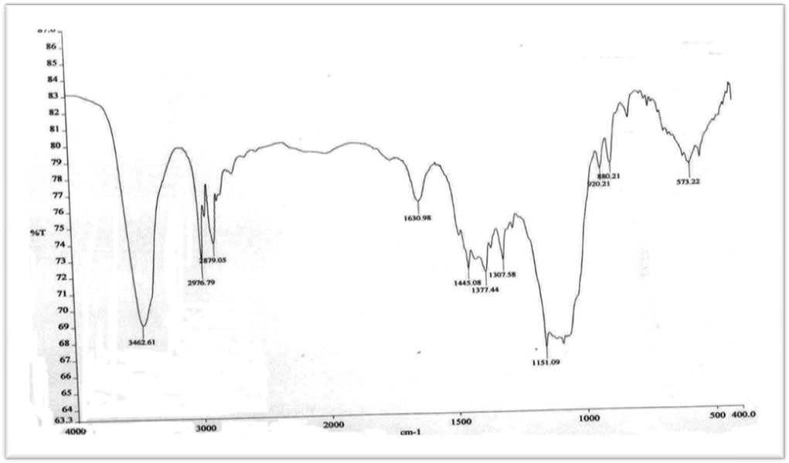

### Fig. 02: FTIR spectra of Eletriptan + HPMC K 100

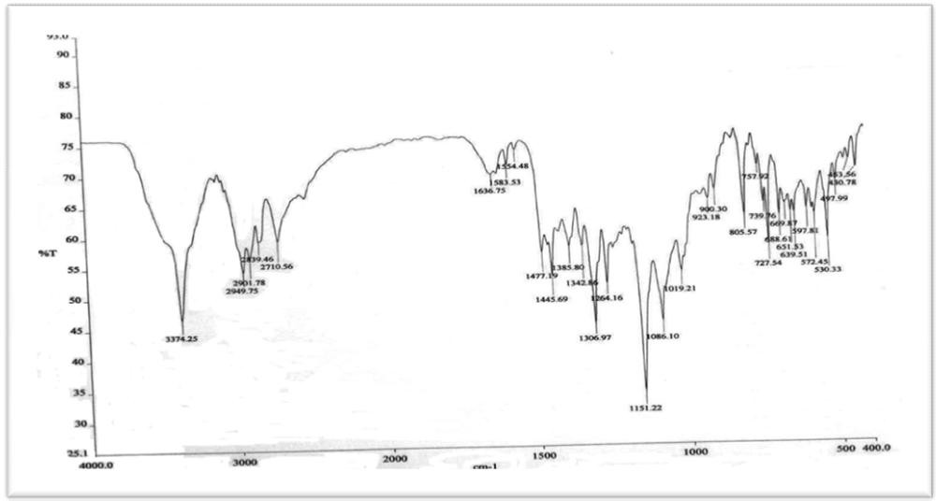

**Fig. 03: FTIR spectra of Eletriptan + Ethyl cellulose**

Venkatesh B. et al., Int. J. Pharm & Ind. Res., Vol.–03 (03) 2013 [274 - 287]

279

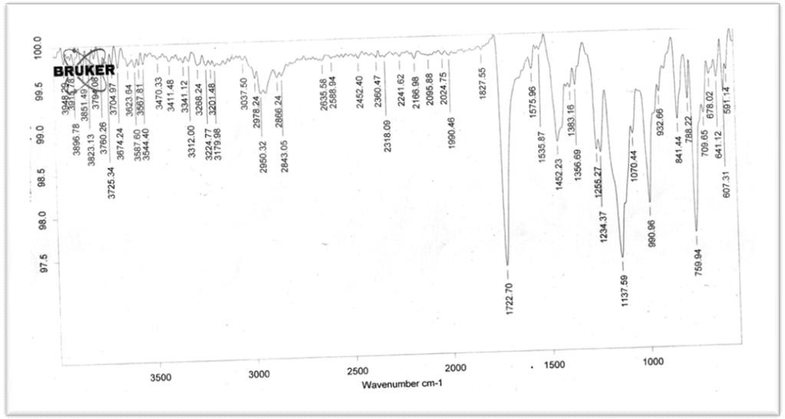

### Fig. 04: FTIR spectra of Eletriptan + Eudragit RS 100

|  |  |  |
| --- | --- | --- |
| **Table No. 01: Composition of Coating Solution** | | |
| **Coating Batches** | **Drug: Polymer Ratio** | **Percentage of Coating (%) Polymers used** |
| C1 | 1:0.5 | 30 |
| C2 | 1:1 | 31 HPMC K-100 |
| C3 | 1:1.5 | 32 |
| C4 | 1:2 | 33 |
| C5 | 1:0.5 | 30 |
| C6 | 1:1 | 31 Ethyl Cellulose |
| C7 | 1:1.5 | 32 |
| C8 | 1:2 | 33 |
| C9 | 1:0.5 | 30 |
| C10 | 1:1 | 31 |
| C11 | 1:1.5 | 32 Eudragit RS 100 |
| C12 | 1:2 | 33 |
| **Table No. 02: Optimized Process variables for different stages of coating** | | |

|  |  |
| --- | --- |
| **Process Variables Specifications**  Inlet air temperature (0C) 38-42 | |
| Product bed temperature (0C) | 33-37 |
| Atomization air pressure (bar) | 1.2-1.5 |
| Spray rate (g/min) | 10-15 |

Pan speed (rpm) 8 - 15

### Table No. 03: % Yield of pellets and % Drug content Analysis data of prepared pellets

|  |  |  |
| --- | --- | --- |
| **Formulation Code** | **% Yield of Pellets** | **% Drug content Analysis ± SD** |
| Immediate Release | 93.6 | 97.69 ± 0.8 |
| F1 | 84.5 | 92.02 ± 0.6 |
| F2 | 89.6 | 91.89 ± 0.3 |
| F3 | 91.6 | 95.20 ± 0.5 |
| F4 | 92.9 | 97.11 ± 0.4 |
| F5 | 86.2 | 90.14 ± 0.7 |
| F6 | 89.8 | 97.01 ± 0.3 |
| F7 | 90.7 | 90.20 ± 0.9 |
| F8 | 91.4 | 92.84 ± 0.8 |
| F9 | 85.8 | 95.40 ± 0.9 |
| F10 | 89.6 | 94.81 ± 0.6 |
| F11 | 91.3 | 95.51 ± 0.7 |

F12 94.97 99.90 ± 0.6

# 280

Venkatesh B. et al., Int. J. Pharm & Ind. Res., Vol.–03 (03) 2013 [274 - 287]

### Sieve Analysis Method

**Table No. 04: Particle Size distribution data of Eletriptan hydrobromide Pellets**

**Formulation Code**

**Nominal mesh Aperture size (µm)**

**% Wt. of Pellets Retained**

**Cumulative % of Pellets Retained**

Immediate Release

F1

F2

F3

F4

F5

F6

F7

F8

F9

F10

F11

F12

1000 0 0

850 8 8

710 85 93

355 6 99

1000 0 0

850 9 9

710 83.5 92.5

355 7 99.5

1000 0 0

850 8 8

710 81 89

355 9 98

1000 0 0

850 8 8

710 87 95

355 4 99

1000 0 0

850 8 8

710 84 92

355 7 99

1000 0 0

850 9 9

710 85 94

355 5 99

1000 0 0

850 10 10

710 83.5 93.5

355 5 98.5

1000 0 0

850 6 6

710 85 91

355 8 99

1000 0 0

850 8 8

710 86 94

355 4 98

1000 0 0

850 7 7

710 84 91

355 7.7 98.7

1000 0 0

850 7 7

710 86 93

355 6 99

1000 0 0

850 7 7

710 82 89

355 8 97

1000 0 0

850 8 8

710 87 87

355 4 99

Venkatesh B. et al., Int. J. Pharm & Ind. Res., Vol.–03 (03) 2013 [274 - 287]

281

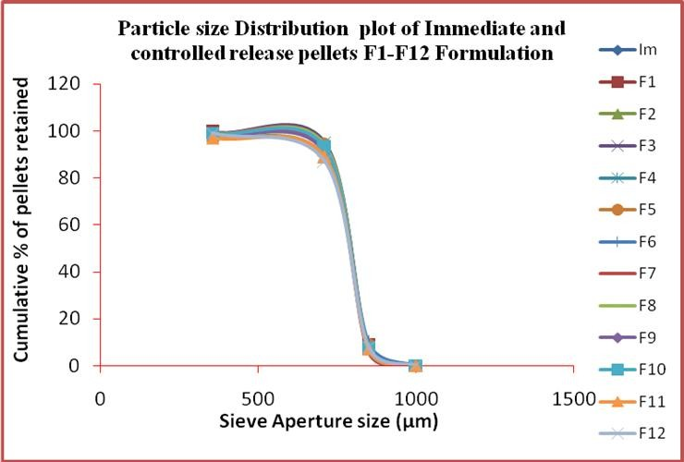

**Fig. No. 05: Particle size Distribution plot of Immediate and controlled release pellets F1-F12 Formulation**

***In-vitro* Dissolution Study**

### Table No. 05: *In-vitro* Drug release data from Formulation F1-F6

|  |  |  |  |  |  |  |
| --- | --- | --- | --- | --- | --- | --- |
|  | **F1** | **F2** | **F3** | **F4** | **F5** | **F6** |
| 1.2 1 | 35.65 | 34.60 | 38.34 | 37.36 | 32.32 | 33.73 |
| 2 | 40.12 | 39.66 | 43.76 | 46.38 | 43.65 | 42.21 |
| 3 | 44.68 | 43.56 | 48.65 | 51.39 | 48.73 | 48.73 |
| 4 | 49.56 | 48.87 | 53.76 | 56.28 | 53.36 | 53.96 |
| 5 | 54.53 | 53.56 | 58.75 | 60.15 | 59.76 | 59.74 |
| 6 | 59.32 | 59.87 | 63.54 | 64.30 | 64.26 | 65.28 |
| 7 | 64.97 | 64.14 | 68.54 | 68.45 | 68.27 | 71.73 |
| 8 | 69.74 | 70.86 | 73.34 | 73.25 | 73.56 | 76.95 |
| 7.4 9 | 74.83 | 75.56 | 78.21 | 78.45 | 78.21 | 81.35 |
| 10 | 80.43 | 81.76 | 83.58 | 83.25 | 83.29 | 86.32 |
| 11 | 86.51 | 87.28 | 88.49 | 88.25 | 87.29 | 90.51 |
| 12 | 90.28 | 91.56 | 92.78 | 93.25 | 91.28 | 94.29 |

**pH Time (Hrs) Cumulative % Drug Release**

### Table No. 06: *In-vitro* Drug release data from Formulation F7-F12

**pH Time (Hrs) Cumulative % Drug Release**

|  |  |  |  |  |  |  |  |
| --- | --- | --- | --- | --- | --- | --- | --- |
|  | | **F7** | **F8** | **F9** | **F10** | **F11** | **F12** |
| 1.2 | 1 | 39.98 | 36.53 | 40.13 | 33.36 | 31.56 | 38.16 |
|  | 2 | 48.12 | 43.43 | 47.56 | 40.45 | 40.26 | 46.44 |
|  | 3 | 53.63 | 50.86 | 52.87 | 46.76 | 45.16 | 55.33 |
|  | 4 | 58.16 | 55.92 | 58.45 | 51.12 | 50.16 | 59.76 |
|  | 5 | 63.53 | 61.62 | 62.21 | 56.26 | 56.24 | 64.96 |
|  | 6 | 68.32 | 66.15 | 67.87 | 61.83 | 61.16 | 69.18 |
| 7.4 | 7 | 73.97 | 71.36 | 71.65 | 66.12 | 66.24 | 73.84 |
|  | 8 | 78.74 | 75.16 | 76.63 | 71.76 | 71.16 | 78.04 |
|  | 9 | 83.83 | 80.29 | 81.18 | 76.96 | 76.34 | 83.54 |
|  | 10 | 87.43 | 85.15 | 86.28 | 81.14 | 82.72 | 87.18 |
|  | 11 | 91.51 | 90.62 | 91.86 | 86.24 | 88.14 | 92.66 |
|  | 12 | 95.38 | 96.75 | 95.64 | 91.16 | 93.74 | 98.54 |

# 282

Venkatesh B. et al., Int. J. Pharm & Ind. Res., Vol.–03 (03) 2013 [274 - 287]

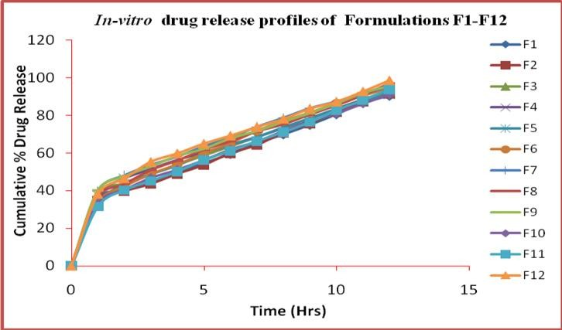

### Fig. 06: *In-vitro* drug release profiles of Formulations F1-F12

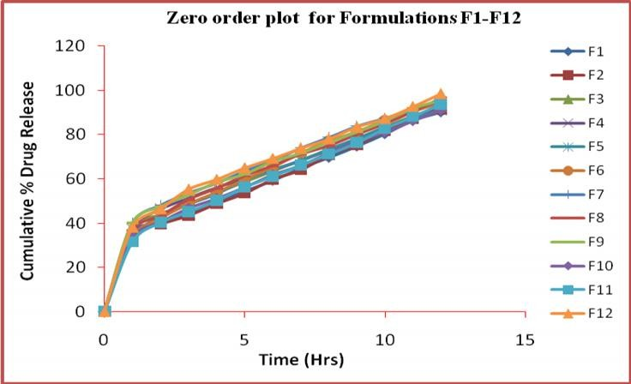

**Fig. 07: Comparison of Zero order release for Formulations F1 -12**

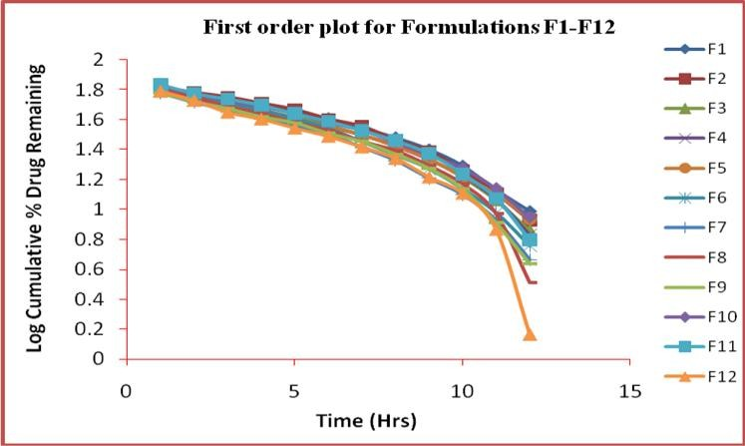

### Fig. 08: Comparison of First order release for Formulations F1-F12

Venkatesh B. et al., Int. J. Pharm & Ind. Res., Vol.–03 (03) 2013 [274 - 287]

283

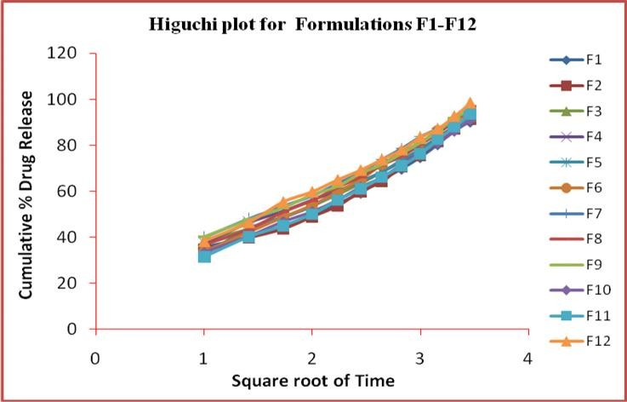

### Fig. 09: Comparison of Higuchi plot for Formulations F1-F12

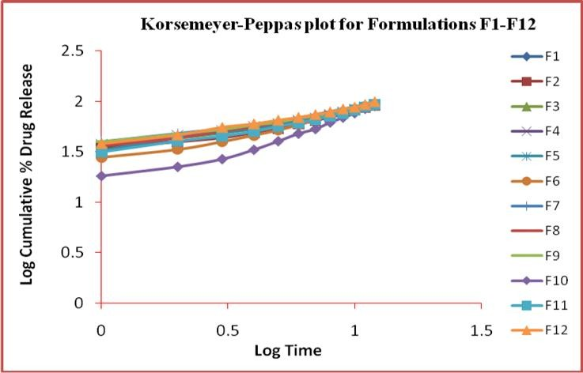

**Fig. 10: Comparison of Korsemeyer-Peppas plot for Formulations F1-F12**

### Stability study

**Table No. 07: Comparison of observed assay with calculated assay of best formulation F12 subjected to stability study**

**Time in months Observed Assay (%)**

|  |  |  |
| --- | --- | --- |
|  | **Mean ± SD** | **Mean ± SD** |
| 0 | 99.90 ± 0.44 | 99.60±0.80 |
| 1 | 99.30±0.2 | 99.37±0.71 |
| 2 | 98.59±0.3 | 98.75±0.66 |
| 3 | 97.79±0.6 | 98.13±0.77 |
| 4 | 97.41±0.4 | 97.51±0.71 |
| 5 | 96.91±0.4 | 96.90±0.71 |
| 6 | 96.58±0.4 | 96.28±0.71 |

**Calculated Assay (%)**

# 284

Venkatesh B. et al., Int. J. Pharm & Ind. Res., Vol.–03 (03) 2013 [274 - 287]

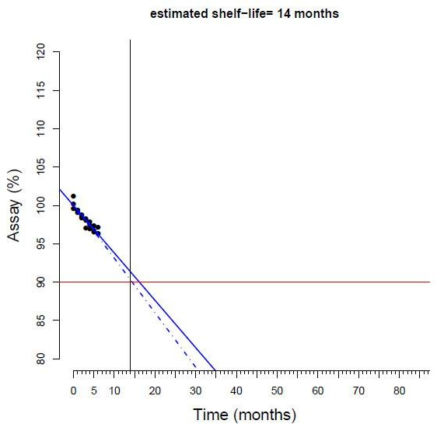

### Fig. 11: Graph showing predicted shelf life of best formulation

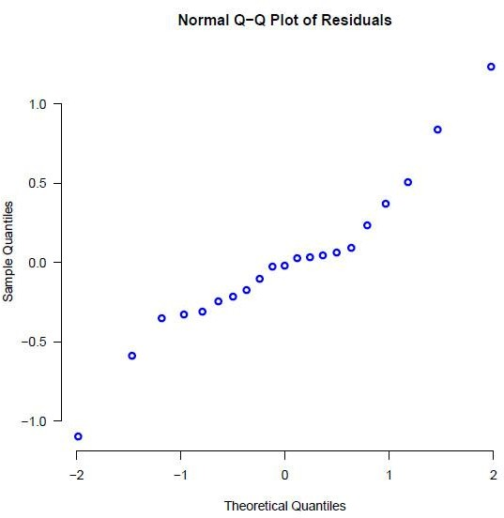

**Fig. 12: Normal Q-Q plot of residuals obtained from calculated values of best formulation F12 subjected for stability study**

Venkatesh B. et al., Int. J. Pharm & Ind. Res., Vol.–03 (03) 2013 [274 - 287]

285

### Table No. 08: Comparison of dissolution data of best formulation F12 subjected to stability study with standard release

**Time Cumulative % drug release of best formulation**

|  |  |  |  |  |
| --- | --- | --- | --- | --- |
| **(Hrs)** | **Standard** | **After 2 months** | **After 4 months** | **After 6 months** |
| 0 | 0 | 0 | 0 | 0 |
| 1 | 38.16 | 37.86 | 37.02 | 36.78 |
| 2 | 46.44 | 46.01 | 45.72 | 45.03 |
| 3 | 55.33 | 55.0 | 54.76 | 54.05 |
| 4 | 59.76 | 59.07 | 58.86 | 58.11 |
| 5 | 64.96 | 64.21 | 63.81 | 63.04 |
| 6 | 69.18 | 68.78 | 68.14 | 67.66 |
| 7 | 73.84 | 73.10 | 72.86 | 72.01 |
| 8 | 78.04 | 77.92 | 77.10 | 76.88 |
| 9 | 83.54 | 83.13 | 82.90 | 82.30 |
| 10 | 87.18 | 86.88 | 86.34 | 86.02 |
| 11 | 92.66 | 92.22 | 92.03 | 91.93 |

12 98.54 98.06 97.58 96.86

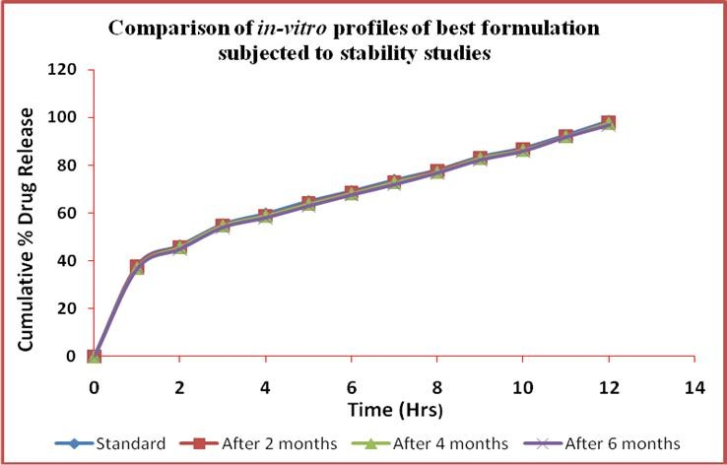

**Fig. 13: Drug release pattern of best formulation during stability study for every 2 month up to 6 months**

**Discussion**

**Drug Excipient Compatibility studies** Compatibility of the Eletriptan hydrobromide and polymers was determined by FTIR Spectroscopy (Bruker Pvt. Ltd, Germany) results shown that the Eletriptan is compatible with HPMC K 100, Ethyl cellulose and Eudragit RS 100 polymers.

### Evaluation studies

1. **% Yield Strength**

The percentage yield of Eletriptan hydrobromide pellets was calculated. The percentage yield of Immediate release pellets was found to be 93.6 % and controlled release pellets formulations F1 to F12 was found to be in the range of 84.51 % to

94.97 % were shown in the table 3.

### Drug Content Analysis

Percentage drug content of Eletriptan hydrobromide pellets of immediate and F1-F12 of all formulations were determined by UV spectrometric method. Three trials from each formulation were analyzed. The mean value and standard deviation of all formulations were calculated. The Drug content Analysis of Immediate release pellets was found to be in the range of 97.69 ± 0.8 % and for controlled release formulations F1 to F12 was found to be in the range of 90.14 ± 0.7 % to 99.90 ± 0.6 %. The drug content analysis of pellets was found to be within the limits as per IP were shown in the table 3.

# 286

Venkatesh B. et al., Int. J. Pharm & Ind. Res., Vol.–03 (03) 2013 [274 - 287]

### Sieve Analysis Method

The particle size distribution were carried out for both Immediate release and controlled release pellets from F1-F12 Formulations indicates that majority of the pellets 81-87% falls in the size range of 850-710 µm (# 20/22) mesh fraction i.e., 20 pass and 22 retained. The yield of # 20/22 mesh fraction was found to be good. 5-10% pellets were found in the size range of 1000-850 µm (#18/20) i.e., 18 pass and 20 retained.4-8 % pellets were found in the size range of 710-355 µm (#22/44) i.e., 22 pass and 44 retained.1-2% pellets were found fines were shown in the table 4. Graphs were plotted against Sieve apertures size (µm) Vs Cumulative % of pellets retained were shown in the figure 5.

1. ***In-vitro* Dissolution Study**

The dissolution studies of Eletriptan hydrobromide pellets carried out in acid buffer of pH 1.2 (0.1 N HCl) for 12 hrs by using USP XXIII dissolution apparatus. The sample were withdrawn at different time intervals and analyzed at 221 nm. *In-vitro* release studies of pellets shows burst effect in 1st hour because due to the presence of croscarmellose sodium as superdisintegrant were shown in the figure 5 and 6, followed by all formulations from F1 to F4, F5 to F8 and F9 to F12 which were coated with 3 different polymers in 4 different ratios by increasing coating percentage weight buildup with 30%, 31%, 32% and 33% respectively shows the release in the range from 90.28 % to

98.54 % for 12 hrs. As the coating percentage weight build up of polymer increases release rate also increases. *In-vitro* release studies of all formulations from F1 to F12 were compared, among all the formulations F12 shows best release rate with 98.54 % at the end of 12 hrs in which contains drug and Eudragit RS 100 ratio 1:2 were shown in the table 5 and 6. *In-vitro* drug release data are plotted in the graphs against time (hrs) Vs cumulative % drug release for formulation F1-F12 were shown in the Figure 6.

Drug Release order in decreasing order of F1-F12 shows in the following order

**F12** > F8 > F9 > F7 > F6 > F11 > F4 > F3 > F2 > F10 > F1

### Kinetic Models Data Analysis

F1, F2, F3, F4, F5, F6, F7, F8, F9, F10 and F11

formulations were followed Korsemeyer-Peppas with correlation coefficient R2= 0.9689, 0.9814,

0.9326, 0.9936, 0.971, 0.9576, 0.9781, 0.9613,

0.9684, 0.9575 and 0.9838 respectively. F12

formulation shown both Zero order and Korsemeyer-Peppas model with R2=0.9929 and 0.989 respectively, and follows non-fickian diffusion mechanism and Zero order release with n= 0.957, remaining all formulations F1-F11 were found to be follow anomalous diffusion mechanism with n= 0.5 to 1 when applied to Korsemeyer- Peppas kinetic model. Kinetic release graphs were plotted for zero order, first order, Higuchi and Korsemeyer-peppas plot for all formulations F1- F12 against Time (hrs) Vs cumulative % drug release, Time (hrs) Vs Log cumulative % drug remaining, Square root of time Vs cumulative % drug release and Log time Vs Log cumulative % drug release were shown in the figure 7, 8, 9 and 10 respectively.

### Stability Study

Stability studies were carried out for formulation F12 as per ICH guidelines. Accelerated stability studies were conducted for 6 months. Assay performed for 6 months at one month interval, through this comparison of Observed assay and calculated assay data are shown in the table 7. Predicted estimated shelf life period was 14 months shown in the figure 11 and residuals obtained from calculated values of best formulation were shown in the figure 12*. In-vitro* drug release study of standard are compared with test release for 2nd month, 4th month and 6th month data are tabulated in the table 8 and dissolution data comparison was shown in the figure 13. It shown good stability and the values were within permissible limits.

**Acknowledgement**

The authors are sincerely thankful to Ratnam Institute of Pharmacy, Nellore, A.P, India for providing us infrastructure facilities and moral support to carry out this research work. I sincerely express my gratitude to Orchids Pvt Ltd., Chennai for providing Eletriptan hydrobrimide as a gift sample and Aadhya Biotech Pvt. Ltd., Hyderabad for providing Non-pariel seeds.

## References

1. Palmieri F. G., Grifantini R., Di Martino P., Martelli S., Emulsion/Solvent evaporation as an Alternative Technique in Pellet Preparation, Drug Dev. Ind. Pharm., 26 (11), 1151 – 1158, 2000;
2. Ross AC, Macrae RJ, Walther M, Stevens HNE, Chronopharmaceutical drug delivery

Venkatesh B. et al., Int. J. Pharm & Ind. Res., Vol.–03 (03) 2013 [274 - 287]

287

from a pulsatile capsule device based on programmable erosion. J.Pharm. Pharmacol. 2000, 52, 903–909.

1. Roy P, Shahiwala A, Multiparticulate formulation approach to pulsatile drug delivery: current perspectives. Journal of Controlled Release 2008, 134, 74-80.
2. Shivanand K, Raju SA, Nizamuddin S, Jayakar

B. In vivo bioavailability studies of sumatriptan succinate buccal tablets DARU 2011; 19(3): 224-230. <http://nervous-system.emedtv.com/> eletriptan/eletriptan-dosing.html

1. Ghebre-Sellasie I., Pelletization Techniques. Third Edition 2002, Pg. no. 2067-2080.
2. Srikanth Baloju et al., Nifedipine Sustained Release Pellets Formulation Development and Evaluation Pharma Scient, Volume 2, Issue 1, 2013: 12-17.
3. T.Akelesh et al., Formulation and Evaluation of Nifedipine Sustained Release Pellets IRJP 2 (8) 2011 177-180.
4. FDA, Center for Drug Evaluation and Research (CDER) Guidance for industry, Dissolution testing of immediate release solid oral dosage forms, Aug 1997, pg. 8-10.
5. Korsmeyer RW, Gurny R, Doelker E Buri P, Peppas NA, mechanisms of solute release from porous hydrophilic polymers; International Journal of Pharmaceutics 1983, 25–35.
6. Wagner JG, Interpretation of percent dissolved- time plots derived from in vitro testing of conventional tablets and capsules; Journal of Pharmaceutical sciences 1969, 58, 1253-1257.
7. Costa P, Sousa JM, Modeling and comparison of dissolution profiles; European Journal of Pharmaceutical Sciences. 2001, 13, 123-133.
8. Dash S, Murthy NP, Nath L, Chowdhury P, kinetic modeling on drug release from controlled drug delivery systems. Acta Poloniae Pharmaceutica and Drug Research 2010, 67, 217-223.