***Review Article***

**Available Online at:** [**www.ijpir.com**](http://www.ijpir.com/)



International Journal of Pharmacy and Industrial Research

**ISSN**

**Print 2231 – 3648**

**Online 2231 – 3656**

**TO STUDY THE ANALYSIS OF DRUG IN BIOLOGICAL SAMPLE INCLUDING THE STORAGE, PRE –TREATMENT AND SAMPLE PREPARATION**

# *Sanghadiya Divyang G, Patel Priyanka P

Saraswati Institute of Pharmaceutical Sciences, Dhanap - post, Gandhinagar, India - 382 355.

## Abstract

The biological samples are the body fluids in which the analysis of drug is required to determine the effect of the drug in specific organ of the body. Such as, Blood, Plasma, Serum, Tissue homogenates, Urine, Feces, Gastric contents, Saliva, Breath, Cerebrospinal fluids, Seminal fluid, Sputum, Bile are the biological sample. Several methods for storage & pre-treatment of the biological sample & it is necessary to achieve the desire effect. Different techniques for sample preparation mainly include solid phase extraction & liquid-liquid extraction.

**Keywords:** Overview of analysis of drug in biological sample, its storage, pre-treatment and sample preparation [Solid Phase Extractions (SPE) & Liquid –Liquid Extraction. (LLE)].

## Introduction1

### Analysis of drugs in biological fluids

* Biopharmaceutical analysis is the quantitative determination of trace levels of organic or inorganic medicaments and their metabolites in biological fluids.
* This technique is used very early in the drug development process to provide support to drug discovery programs on the metabolic fate and pharmacokinetics of chemicals in living cells and in animals.
* Its use continues throughout the preclinical and clinical drug development phases, into post- marketing support and may sometimes extend into clinical therapeutic drug monitoring.

### Specific roles of biopharmaceutical analysis

* Bioavailability and Bioequivalence studies
* Drug Discovery & lead optimization
* Drug abuse problem
* Preclinical-ADME and metabolic identification
* Clinical pharmacokinetics
* Therapeutic drug monitoring
* Research in basic biomedical and pharmaceutical sciences.

### Biological Sample 1

The biological samples are the body fluids in which the analysis of drug is required to be done. Such as, Blood, Plasma, Serum, Tissue homogenates, Urine, Feces, Gastric contents, Saliva, Breath, Cerebrospinal fluids, Seminal fluid, Sputum, Bile.

### Author for Correspondence:

Sanghadiya Divyang G,

Saraswati Institute of Pharmaceutical Sciences, Dhanap - post, Gandhinagar, India - 382 355.

E-mail: [divyang3227@gmail.com](mailto:divyang3227@gmail.com)

### Types of biological samples

|  |  |  |
| --- | --- | --- |
| **S. No.** | **Purpose** | **Media** |
| 1 | Pharmacokinetic study | Blood , Urine & Saliva |
| 2 | Bioavailability/Bioequivalence study | Blood & Urine |
| 3 | Drug identification/Drug abuse problem | Feces |
| 4 | Drug studies in children | Saliva |

**Collection of biological sample**

**Sample Collection**

Blood By venupuncture either with a hypodermic syringe or a Vacationer apparatus. Plasma Blood with anticoagulant is centrifuged.

Higher yield, higher drug, few problems of sensitivity.

Serum Blood without anticoagulant is centrifuged. Specially used in microbiological assays.

Urine Easy to collect, large in amount, concentrated. Frequently utilized in drug metabolism studies.

Feces In aluminum foils & lyophilized.

High protein content & difficult to handle.

### Storage of biological sample 2,3

* In order to avoid decomposition or other potential changes in the drugs to be analyzed, biological samples should be frozen immediately upon collection and thawed before analysis.
* If plasma or serum to be used the fresh whole blood should be centrifuged immediately at 2000×g for approximately 5 to 10 minutes, and the supernant should be transferred by a means of suitable device such as a Pasteur pipette, to a clean container.
* When the drugs are susceptible to plasma esterase the addition of esterase’s inhibitor such as sodium fluoride to blood sample immediately upon collection can help to prevent drug decomposition.

### Selection of the vessel

* + Analyst should be wary of artifacts from tubing or storage vessel.
  + For eg. plunger plugs Vacationer tubes contain tributoxyethyl phosphate which can interfere in certain drug analyses.
  + Glass is usually recommended because no leaching problems are seen as with plastic containers.
  + Unbreakable nature of plastic makes it highly competitive especially when samples must be shipped by mail to other laboratories.

### Selection of material

* + Adsorbent used in the clean up procedures should be free of the hydrocarbons.
  + Citrate should be used as anticoagulant because it offers less interference.
  + Use of dry ice should be discouraged especially with the glass storage containers because sudden change in temperature can crack the vials.

### Selecting the storage temperature and the pH

* + Some drugs may undergo decomposition unless stored at low temperature.
  + So in any case experiments should be performed with spiked biological samples to determine the problems caused by the containers or closures, temperature and PH.

### Objectives for sample preparation

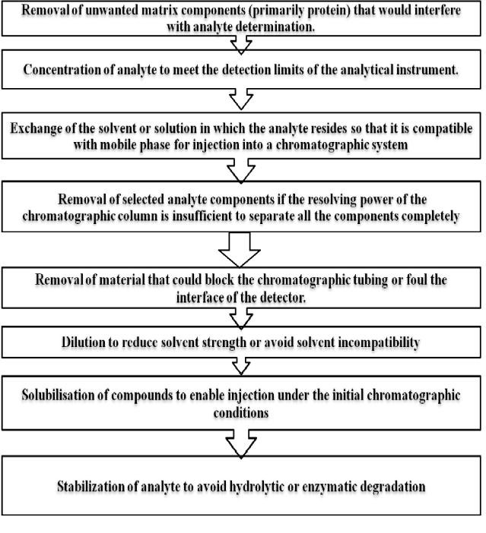

**Pre-treatment of biological sample**

* Pretreatment of samples needed as the factors such as the texture, chemical composition, degree of drug-protein binding, chemical stability and the types of interferences can affect the final measurement step.
* So, various pretreatment steps are carried out as follows.

### Protein precipitation

* + **Lyophilization**

### Hydrolysis of conjugates

* + **Homogenization**

### o Chemical derivatization as a prelude to extraction

**Protien precipitation4**

* Biologic material such as Plasma, faces, and saliva contain significant quantities of protein which can bind a drug.
* The drug may have to be freed from protein before further manipulation (e.g. extraction). An analyst usually assumes that any denaturation procedure does free a drug from the protein. Protein denaturation is important in the analysis

of drugs in plasma when direct injection of a sample on to a column is desired, as in HPLC.

* The presence of proteins, lipids, salts, and other endogenous material in the sample can cause rapid deterioration of HPLC column.
* Methanol and Acetonitrile frequently have been used as protein denaturants of biological samples, especially in HPLC. Methanol is sometimes preferred because it produces flocculent precipitate and not the gummy mass obtained with Acetonitrile.
* Methanol also gives clearer supernatant and may prevent drug entrapment that can be observed after Acetonitrile precipitation.

### Advantage:

Fast & inexpensive

Relatively clean samples obtained.

### Lyophilisation5

Effectively prepares biological samples for storage and analysis.

Mainly used for:

* Biological samples with excess volume
* Highly water soluble drugs
* To prepare dried extract by chemical derivatization
* Steam volatile inorganic compounds that co- vaporises with matrix materials
* Chemically or thermally unstable compounds
* For feces samples.

### Hydrolysis of conjugates

For drugs present as glucuronides conjugates or sulfates.

### Acid or enzymatic hydrolysis

* Presence of drug metabolites as conjugates such as glucuronides and sulfates, in biologic samples cannot be ignored. The effect of the drug samples is depend on the completely in the extent of the biotransformation that occurs in body.
* So it very important to isolate the actual conjugates. Isolation of conjugates is usually lengthy because they are hydrophilic and/or ionized at physiologic pH. Thus, conjugates are not amenable to classic solvent extraction techniques.
* To overcome these problems, samples containing either glucuronides acetyls or sulfates esters are usually pretreated using enzymatic or acid hydrolysis.
* The unconjugated metabolites that results from the hydrolysis procedure are less hydrophilic than conjugates and usually can be extracted from the biologic matrix.
* A nonspecific acid hydrolysis can be accomplished by heating a biologic sample for 30 min at 90°C to 100°C in 2 to 5N HCl. Upon cooling, the pH of the sample can be adjusted to the desired level and the metabolite removed by the solvent extraction.
* Particularly stable conjugates sometimes require hydrolysis in autoclave. However, these are bomb- like condition and may lead to alteration of the parent chemical, especially in isotopic studies. The need of these actions should be determined experimentally.

### Homogenisation

* For sample containing **insoluble proteins** such as muscle or tissue homogenization using 1N HCl is done.
* For **gelatinous sample** such as **seminal fluid** or sputum liquefaction is achieved via **sonication**.
* For solid **sample** such as **feces** homogenization can be done with minimum amount of methanol.
* For the sample containing insoluble proteins, such as muscle or other related tissues, a homogenization or solubilizing step using 1N HCl may be required before treating the sample such as seminal fluid or sputum, liquefaction is achieved via sonication.

### Chemical derivatization as prelude to extraction

* For a drug or metabolite chemically unstable in pH range necessary for efficient solvent extraction or not amendable to solvent extraction.
* The substance is reacted with a suitable reagent to form a stable derivative successfully extracted in terms of original drug concentration.

### Example:

* Hydralazine is a unstable in the basic pH range. so quantitative extraction from biological material with organic solvent is difficult.
* After treating a plasma sample containing hydralazine with sodium nitrite at acidic PH it is converted to tetrazolo (1,5a) pthlazine a stable derivative that can be quantitatively extracted from plasma and analyzed in terms of hydralazine concentration.

**General techniques for sample preparation**

* Dilution followed by injection
* Protein precipitation
* Filtration
* Protein removal by equilibrium dialysis or ultra filtration
* Liquid-liquid extraction
* Solid-supported liquid-liquid extraction
* Solid-phase extraction (off-line)
* Solid-phase extraction (on-line)
* Turbulent flow chromatography
* Restricted access media
* Monolithic columns
* Immunoaffinity extraction

### Liquid-liquid extraction 9

Liquid-liquid extraction (LLE), also called solvent extraction, is technique used to separate analytes from interferences in the sample matrix by partitioning the analytes between two immiscible liquid.

### Principle

Partioning or distribution of a drug between two immiscible liquid phases can be expressed in terms of a partition or distribution co-efficient, usually called “P”.

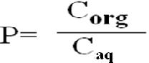

P can be determined by distributing a small quantity of the compound between equal volumes of two immiscible phases in a separating funnel.

### Procedure

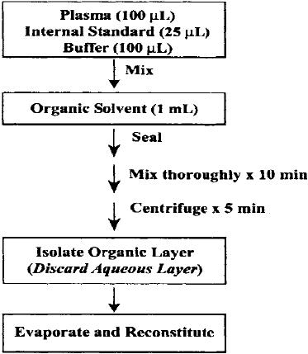

**Factors affecting the partition coefficient**

### Choice of solvent

* 1. **Polarity**

### Cost

* 1. **Toxicity & Flammability**

### Nature of solvent

* 1. **Ease of handling**

### Density

1. **PH**

### Ionic strength of the aqueous phase

**Advantages of Liquid- Liquid Extraction**

1. Liquid-liquid extraction is a very popular technique for sample preparation.
2. A major benefit is that LLE is of wide general applicability for many drug compounds.
3. The technique is very simple and rapid and relatively small cost factor per sample.
4. Very clean extracts can be obtained with good selectivity for the target analytes.
5. Inorganic salts are insoluble in the solvents commonly used for LLE and remain behind in the aqueous phase along with proteins and water soluble endogenous components. The removal of these unwanted matrix materials provides potential benefits of extending LC column lifetime and minimizing the downtime of the mass spectrometer caused by interface fouling.
6. The time required for method development is relatively short; usually within two days, an advantage when time is at a premium as it is in pharmaceutical research laboratories.
7. The extracted material can be redissolved in small volumes (100µl to 500µl) there by extending the sensitivity limits of limit assays.
8. It is possible to extract more than one sample concurrently.
9. Near quantitative recoveries (90% or better)of most drugs can be obtained through multiple or continuous extractions

### Disadvantages of Liquid- Liquid Extraction

1. It is a very labour intensive procedure because of multiple transfer steps and the need to frequently cap and uncap tubes.
2. It requires large volumes of organic solvents which can be expensive to purchase and presents added costs for disposal as hazardous waste.
3. Exposure of these solvents to personnel can present health hazards.
4. The procedure has been difficult to fully automate using traditional liquid handling instruments.
5. Evaporative losses may sometimes occur upon dry-down with volatile or oxygen labile reactive analytes.
6. Emulsion formation is a potential problems.

### Solid phase extraction 6-8 ,10,11

* Involves the selective extraction process between a solid phase resin and a liquid sample containing Analyte.
* Solid Phase: XAD-2 Resin, Silica, Alumina, Charcoal, Aluminum silicate.

### Types of phases:

* 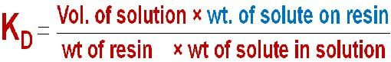Reverse phase
* Normal phase
* Ion-exchange

### Smaller the KD value sharper the separation & easy elution How to use SPE????

|  |  |
| --- | --- |
| **1.Selective Extraction**    Select an SPE sorbent that will bind selected components of the sample either the compounds of interest or the sample impurities.  The selected components are retained when the sample passes through the SPE tube or disk (the effluent will contain the sample minus the adsorbed components). Then, either collect the adsorbed compounds of interest through elution, or discard the tube containing the extracted  impurities. | **2. Selective Washing**    The compounds of interest and the impurities are retained on the SPE packing when the sample passes through; the impurities are rinsed through with wash solutions that are strong enough to remove them, but weak enough to leave the compounds of interest behind. |
| **3.Selective Elution**    The adsorbed compounds of interest are eluted in a solvent that leaves the strongly retained impurities behind. | |

* Solid phase extraction is used to separate compounds of interest from the impurities in three ways. Choose the most appropriate scheme for separation.

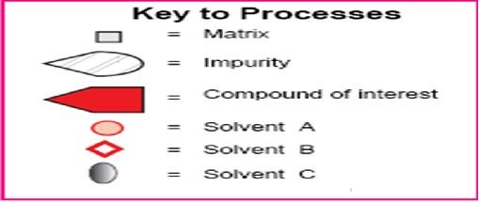

### Procedure for SPE

|  |  |
| --- | --- |
| **STEP-1 SELECTION OF TUBE**     * Step 1 mainly includes the selection of the proper SPE tube and phase according to the type of extraction * SPE is a five step process that provides samples free of matrix components and concentrated enough for detection.   For, reversed phase normal phase or ion exchange SPE procedures of five steps typically are needed. | **STEP-2 CONDITIONING & STEP-3 ADD THE SAMPLE**    **STEP-2**  To condition the SPE tubes rinse the SPE tube with one- tube full of solvent before extracting the sample. For the SPE disks use 5 to 10ml.  **STEP-3**  Accurately transfer the sample the tube or reservoir, using a volumetric pipette or micropipette. The sample must be in a form that is compatible with SPE. |
| **STEP-4 WASH THE PACKING**     * If compounds of interest are retained on the packing, wash off unwanted, unretained materials using the same solution in which the sample was dissolved, or another solution that will not remove the desired compounds. | **STEP-5 ELUTION**     * Rinse the packing with a small volume (typically 200μL to 2mLdepending on the tube size, or 5-10mL depending on the disk size) of a solution that removes compounds of interest. |

**Advantage of SPE over LLE**

1. With SPE, many of the problems associated with liquid/liquid extraction can be prevented, such as incomplete phase separations, less-than- quantitative recoveries, use of expensive,

breakable speciality glassware, and disposal of large quantities of organic solvents.

1. High recoveries for polar compounds.
2. SPE is more efficient than liquid/liquid extraction, yields quantitative extractions that

are easy to perform, is rapid, and can be automated.

1. Solvent use and lab time are reduced.
2. Cleaner extracts are obtained.

### Methods for measurement

* + **Chromatographic methods**

Thin layer chromatography (TLC), Gas chromatography(GC), High performance liquid chromatography (HPLC), Gel permeation chromatography, Ion exchange chromatography (IEC), Liquid chromatography mass spectro - photometry (LC-MS)

### Radiochemical Method

* + **Fluorimetry and Phosphorimetry**

### Enzymatic analysis

* + **Immunoassay techniques (ELISA, RIA, EMIT etc)**

## Reference

1. Astrazeneca.com/humanbio-sample
2. [www.bioline.org](http://www.bioline.org/)
3. www.org/memo/specification
4. <http://www.chemistry.adelaide.edu.au/external/> soc-rel/home.htm
5. [www.springerlink.com](http://www.springerlink.com/)
6. Nigel J. K. Simson, Solid Phase Extraction, Page no: 10-15.
7. Michael J. Telepchak, Thomas F. August, Glynn Chaney, Forensic and Clinical Application of Solid Phase Extraction, Page no: 33-38
8. [www.en.wikipedia.org/wiki/Solid_Phase_Extra](http://www.en.wikipedia.org/wiki/Solid_Phase_Extra) ction
9. [www.oxfrodjournals.org/bio](http://www.oxfrodjournals.org/bio)
10. Drug & metabolite analysis in biological samples, Miliford, man, waters associates inc.1978.
11. Lloyd R. Synder, Joseph J. Kirkland, Joseph L.Glajch, Practical HPLC Method Development, Second Edition, A wiley intersciecnce publication, Page no: 119-130.