# 250

***Research Article***

**Available Online at:** [**www.ijpir.com**](http://www.ijpir.com/)



International Journal of Pharmacy and Industrial Research

**ISSN**

**Print 2231 – 3648**

**Online 2231 – 3656**

**FORMULATION AND EVALUATION OF SUSTAINED RELEASE MATRIX TABLETS OF STAVUDINE USING HYDROPHILIC POLYMER**

# *Dattatraya S Palave, Patil V R, Chaudhari K P, Thakare V

TVE’S Madhukarrao Chaudhari College of Pharmacy, Faizpur, District-Jalgaon, Maharashtra, India - 425503.

## Abstract

Stavudine is a potent antiviral agent used in the treatment of chronic viral diseases such as AIDS**/**HIV, other viral infection. Such viral diseases requires long term drug therapy but the major drawback of antiretroviral drugs for the treatment of AIDS are their adverse effect during long term therapy, poor patient compliance and there huge cost. So it is necessary to formulate antiretroviral drugs in to a such delivery system, which provide uniform drug level for long period of time, reduce dose and side effect, better patient compliance and increases the safety margin for high potency drug .The objective of present work to develop and evaluate of sustained release matrix tablet of Stavudine by using hydrophilic polymer such as HPMC K4M and Methyl Cellulose. The tablet was prepared by direct compression method. The pre-compressive parameters for the blend and post- compressive parameters for the prepared tablets were evaluated. All formulations showed desired pre and post- compressive characteristics. FTIR study showed no evidence of drug excipient interaction. The optimized formulation was found to be F5, which showed 97% drug release at the end of 12hrs. It was concluded that the formulated stavudine matrix tablet using widely accepted and physiological safe polymer was capable of exhibiting sustained release for a period 12hrs.

**Keywords:** Sustained release, Stavudine, HPMC K4M, Methyl Cellulose, Direct compression.

## Introduction

The oral route is the route most often used for a administration of drugs. Tablets are the most popular oral formulation available in the market and are preferred by patient and physicians. In long-term therapy, for the treatment of chronic disease condition conventional tablet are required to be administered in multiple doses and therefore have several disadvantages.1 Sustained release (SR) tablet formulation are preferred for such therapy because they offer better patient compliance,

maintained uniform drug level, reduce dose and side effect and increases the safety margin of high potency drugs.**2** The matrix tablet are the vehicle to carry a drug at desired site of action and delayed the drug release. The matrix tablet is defined as “A well mixed composite of one or more drug with gelling agent i.e hydrophilic or hydrophobic polymer.’’**3** Stavudine is highly water soluble, thymidine analogue reverse transcriptase inhibitor that is active in-vitro against HIV-1 and HIV-2.

### Author for Correspondence:

Dattatraya S Palave,

TVE’S Madhukarrao Chaudhari College of Pharmacy, Faizpur, District - Jalgaon,

Maharashtra, India - 425503.

E-mail: [dattatrayapalave77@gmail.com](mailto:dattatrayapalave77@gmail.com)

# 251

Dattatraya S Palave. et al., Int. J. Pharm & Ind. Res., Vol.–03 (03) 2013 [250 - 256]

Stavudine absorbed rapidly following oral administration producing peak plasma concentration with l hr with 86% bioavailability. Elimination half life is 1to 1.5hrs following single or multiple dose. Sustained release delivery system for oral dosing are effective in achieving optimal therapy that have narrow therapeutic range of blood concentration which eliminate rapidly. **5-6**

In the present study, an attempt was made to developed oral sustained release formulation through matrix tablet for highly water soluble drug stavudine. Different polymers have been used in the formulation of matrix based SR drug delivery system. Reports are found on the use of hydrophilic polymers like HPMC, methyl cellulose, sodium carboxy methyl cellulose, carbopol and polyvinyl alcohol for the preparation of SR formulation of different drug**7**. Hydrophilic polymer matrix systems are widely used for designing oral sustained drug delivery dosage forms because of their flexibility to provide a desirable drug release profile, cost effective and broad regulatory acceptance**8**.

The present study was intended to select the HPMCK4M and methyl cellulose hydrophilic polymer to formulate the sustained release matrix tablet. Direct compression method was employed to formulate the tablet, because of its cost effectiveness and due to reduce number of manufacturing steps.

## Materials and Methods

Stavudine was obtained as a gift sample from Matrix Laboratories Pvt. Ltd. Hydrabad. HPMC K4M, Methyl cellulose was obtained from Pure chem. Lab Mumbai and other excipients were obtained from Loba chemie Pvt. Ltd. Mumbai.

### Preparation of matrix tablets

Tablet formulation was prepared by direct compression method**.** All the ingredients accurately weighted including drugs and excipients were passed through 40 mesh, then the blend was mixed for 5min and then finally talc and magnesium stearate was added and mixed for 5min. The tablet compression done by 12 station automatic compression machine using 10mm flat face punch.9

### Drug carrier compatibility Study

The compatibility study between drug and carrier was checked by using FT-IR study. In FT-IR study the mixture of drug and polymer is evaluated by using KBr disc method. In which KBr pellets are used and Scanning range was 400 to4000 cm-1. (10)

### Evaluation Parameters for Sustained release matrix tablet:

**Precompression parameters:**

The prepared powder mixtures were evaluated for the blend property like bulk density, tapped density, Carr’s index, angle of repose.

### Post-compression parameters:

The prepared tablet were evaluated by using thickness, hardness, friability, weight variation, uniformity of drug content, swelling index and in vitro drug release study.

### Thickness:11

Thickness of tablets indicates the strength to withstand compression force applied during manufacturing process. Thickness of tablets was measured by digital caliper or micrometer

### Hardness:11

The hardness was tested using Monsantotester. “Hardness factor”, the average of the six determinations, was determined and reported. The force was measured in kilograms per centimeter square.

### Friability:12

Friability is the measure of tablet strength. Roche friabilator was used for testing the friability using the following procedure. Twenty tablets were weighed accurately and placed in the tumbling apparatus that revolves at 25 rpm dropping the tablets through a distance of six inches with each revolution. After 4 min, the tablets were weighed and the percentage loss in tablet weight was determined.

%Friability = initial weight - final weight/initial weight x 100

### Weight variation:13

To find out weight variation 20 tablets of each formulation were weighed individually using an electronic balance, average weight was calculated and individual tablet weight was then compared with average weight. The percentage difference in weight variation should be within permissible limits (±5).

# 252

Dattatraya S Palave. et al., Int. J. Pharm & Ind. Res., Vol.–03 (03) 2013 [250 - 256]

### Uniformity of drug content :13

Five tablets were powdered in a mortar. An accurately weighed quantity of powdered tablets (100 mg) was extracted with pH 7.4 buffer and the solution was filtered through 0.45 μ membranes. The absorbance was measured at 266 nm after suitable dilution. Content uniformity was calculated using formula,

% Purity = 10 C (Au / As) Where, C = Concentration,

Au and As = Absorbance’s obtained from std preparation and assay preparation.



**In-Vitro Dissolution Study:15**

The in-vitro dissolution studies were carried out using USP XXVII Dissolution apparatus at 50rpm. For the first 2hr the dissolution medium was 0.1N HCL and phosphate buffer pH7.4 from 3-24 hr (900ml), maintained at 37°C±0.50°C. At each time point 5ml sample was withdraw and it was replaced with 5ml of fresh medium. The drug release at different time interval was measured by UV- Visible spectrophotometer. The release studies were conducted in triplicate and the mean values were plotted versus time.

**Result and discussion**

**Fourier Transform Infra-Red Studies:**

FT-IR spectroscopic studies conducted for possible drug: carrier interactions. FT-IR spectra of pure drug Stavudine, HPMCK4M, Methyl cellulose and mixture of all ingredients which are as shown in figure 3 & 4 indicating no significant evidence of chemical interaction between drug and carrier, which confirms the stability of drug with the polymer.

**Preparation and Evaluation of sustained release matrix Tablets:**

Appropriate quantity of all ingredients were sieved through mesh 40 and mixed all ingredients for 5- 10min after mixing at the time of compression the specified quantity of talc and magnesium stearate were added to blend and mixed properly. The tablets were prepared by direct compression method.

**Pre-compressive parameters:**

* Powder blend was evaluated for values of angle of repose which were found to be in the range of

23.25 – 27.250 indicating powder flow of formulations were good.

### Swelling Behaviour of Tablets:14

The swelling properties of matrix tablet were determined by placing the tablet Matrices in the dissolution test apparatus in 0.1N HCl at 37 ± 0.5оC. The Swelling behavior of all the tablets after 1hr interval were noted upto the 12hr. The tablets were withdrawn periodically from the dissolution medium and blotted with a tissue paper to remove excess test liquid and reweighed. The swelling behavior of tablet was calculated as follow.



* Bulk density of formulations was found to be in the range of 0.34 – 0.39 g/ml while tapped density was in the range of 0.41 – 0.48 g/ml.
* The percent compressibility index of all formulation was found to be 14.29 – 20.63. These results indicated that the powder had good to fairly acceptable flow property. Hence the prepared blends possessed good flow properties and can be used for manufacturing of tablets by Direction compression method.

### Post-compressive parameters:

* Hardness of tablets of each formulation was measured and found in the range of 5.7- 6.1 kg/cm2.
* The friability of the tablets of each formulation was measured and found to be in the range of 0.13 to 0.29% which was under acceptable limit i.e.**≤** 1%w/w.
* Tablets from each batch showed uniformity of weight as per IP limits.
* Tablets from each batch showed uniformity of content in the range 97.35% to 100.74%.
* The swelling index of matrix tablet was increases as the increasing of time which indicates that the drug release retarding property of tablet was good.

### In-vitro Drug release study

The tablets were evaluated for *in vitro* dissolution studies in 0.1 N HCL for first two hrs and then in phosphate buffer solution pH 7.4. The formulations F1toF8 prepared with different concentration of HPMCK4M and methyl cellulose showed 84.95%, 87.47%, 84%, 88%, 97%, 83%, 72%, 79% drug

release within 13hrs. Among all the formulation F5 was showed optimum drug release with in 13 hrs about 97.58%.

Dattatraya S Palave. et al., Int. J. Pharm & Ind. Res., Vol.–03 (03) 2013 [250 - 256]

### Table No. 01: Formula for sustained release matrix tablets of Stavudine (300mg).

**Formulation**

253

**Ingredients**

**F1 F2 F3 F4 F5 F6 F7 F8**

|  |  |  |  |  |  |  |  |  |
| --- | --- | --- | --- | --- | --- | --- | --- | --- |
| Stavudine(mg) | 80 | 80 | 80 | 80 | 80 | 80 | 80 | 80 |
| HPMCK4M(mg) | 40 | 60 | 80 | 120 | 100 | 80 | 60 | 40 |
| Methylcellulose(mg) | 80 | 60 | 40 | 40 | 60 | 80 | 100 | 120 |
| Lactose(mg) | 89 | 89 | 89 | 49 | 49 | 49 | 49 | 49 |
| PVP K30(mg) | 5.78 | 5.78 | 5.78 | 5.78 | 5.78 | 5.78 | 5.78 | 5.78 |
| Mg stearate(mg) | 2.61 | 2.61 | 2.61 | 2.61 | 2.61 | 2.61 | 2.61 | 2.61 |

Talc(mg) 2.61 2.61 2.61 2.61 2.61 2.61 2.61 2.61

### Table No. 02: Pre-compression parameters of drug and excipients

**Formulations**

|  |  |  |  |  |
| --- | --- | --- | --- | --- |
|  | **(± SD)** | **(± SD)** |  | |
| F1 | 0.39±0.26 | 0.46±0.22 | 15.22**±**0.31 | 24.14±0.29 |
| F2 | 0.35±0.19 | 0.47±0.18 | 17.88±0.23 | 27.25±0.19 |
| F3 | 0.37±0.17 | 0.46±0.24 | 18.45±0.14 | 24.41±0.21 |
| F4 | 0.36±0.25 | 0.42±0.12 | 14.29±0.20 | 25.73±0.18 |
| F5 | 0.38±0.17 | 0.48±0.14 | 20.63±0.27 | 27.68±0.27 |
| F6 | 0.39±0.12 | 0.45±0.23 | 15.22±0.22 | 28.21±0.20 |
| F7 | 0.36±0.12 | 0.43±0.16 | 17.25±0.22 | 23.25±0.15 |
| F8 | 0.34±0.14 | 0.41±0.14 | 15.21±0.20 | 24.24±0.18 |
| (n=3) |  |  |  |  |

**Bulk Density (g/ml)\***

**Tapped Density (g/ml)\***

**Compressibility Index (%)* (± SD)**

**Angle of Repose* (± SD)**

### Table No. 03: Physical evaluation of Stavudine sustained release matrix tablet

|  |  |  |  |  |  |
| --- | --- | --- | --- | --- | --- |
| **Formulatio** | **n Thickness**  **± SD\*** | **Hardness**  **(kg/cm2) ± SD\*** | **Friability Weight Uniformity**  **(%) ± SD* (mg) ± SD\*** | | **Uniformity of content ± SD**\* |
| F1 | 4.42±0.14 | 5.8±0.28 | 0.22±0.29 | 301**±** 0.5 | 98.56±0.25 |
| F2 | 4.46±0.23 | 6.0±0.62 | 0.13±0.12 | 299**±** 0.4 | 97.35±0.22 |
| F3 | 4.45±0.17 | 5.7±0.40 | 0.25±0.10 | 304**±** 0.8 | 98.73±0.37 |
| F4 | 4.42±0.22 | 5.9±0.97 | 0.28±0.17 | 305**±** 0.1 | 99.46±0.29 |
| F5 | 4.45±0.14 | 5.8±0.64 | 0.29±0.19 | 300**±** 0.01 | 98.57±0.31 |
| F6 | 4.44±0.28 | 6.1±0.14 | 0.19±0.26 | 306**±** 0.5 | 100.74±0.22 |
| F7 | 4.43±0.24 | 5.6± 0.16 | 0.16±0.25 | 304**±** 0.6 | 99.45± 0.28 |
| F8 | 4.41±0.16 | 5.7± 0.19 | 0.19± 0.15 | 302**±**0.2 | 97.56± 0.26 |

(n=3)

### Table No. 04: Swelling index of matrix tablet of Stavudine

**Time (hrs) % Swelling Index**

(n=3)

|  |  |  |  |  |  |  |  |
| --- | --- | --- | --- | --- | --- | --- | --- |
| **F1** | **F2** | **F3** | **F4** | **F5** | **F6** | **F7** | **F8** |
| 0 0 | 0 | 0 | 0 | 0 | 0 | 0 | 0 |
| 1 32.39 | 30.26 | 38.26 | 42.93 | 41.29 | 44.35 | 40.23 | 42.21 |
| ±0.16 | ±0.23 | ±0.39 | ±0.29 | ±0.33 | ±0.20 | ±0.22 | ±0.24 |
| 2 53.02 | 44.64 | 54.28 | 56.85 | 52.47 | 54.48 | 56.50 | 53.42 |
| ±0.21 | ± 0.25 | ±0.46 | ±0.40 | ±0.39 | ±0.33 | ±0.14 | ±0.11 |
| 3 65.44 | 65.48 | 60.30 | 68.79 | 72.28 | 78.30 | 74.52 | 71.45 |
| ±026 | ±0.42 | ±0.35 | ±0.45 | ±0.28 | ±0.36 | ±0.26 | ±0.19 |
| 4 82.38 | 78.80 | 80.25 | 91.93 | 83.07 | 88.04 | 82.26 | 80.45 |
| ±0.22 | ±0.56 | ±0.32 | ±0.38 | ±0.33 | ±0.16 | ±0.12 | ±0.19 |
| 5 93.01 | 95.05 | 102.04 | 102.93 | 100.74 | 104.26 | 108.32 | 111.45 |
| ±41 | ±0.49 | ±0.29 | ±0.23 | ±0.19 | ±0.19 | ±0.19 | ±0.22 |
| 6 98.15 | 115.28 | 128.84 | 132.16 | 121.01 | 128.04 | 129.52 | 132.12 |
| ±46 | ± 0.19 | ±0.41 | ±0.29 | ±0.36 | ±0.23 | ±0.25 | ±0.27 |
| 7 105.10 | 130.36 | 154.30 | 147.02 | 136.35 | 142.32 | 146.46 | 140.42 |
| ±0.41 | ±0.46 | ±0.19 | ±0.48 | ±0.29 | ±0.44 | ±0.46 | ±0.32 |
| 8 120.18 | 142.38 | 178.47 | 168.16 | 154.61 | 164.52 | 159.25 | 156.41 |
| ±0.41 | ±0.36 | ±0.36 | ±0.26 | ±032 | ±0.39 | ±0.32 | ±0.30 |
| 9 138.12 | 162.02 | 184.04 | 183.67 | 171.65 | 180.44 | 174.28 | 178.23 |
| ±0.26 | ±0.58 | ±0.14 | ±0.23 | ±0.20 | ±0.36 | ±0.31 | ±0.24 |
| 10 150.39 | 174.02 | 195.32 | 202.25 | 188.43 | 210.24 | 218.52 | 216.23 |
| ±0.38 | ±0.37 | ±0.39 | ±0.34 | ±0.25 | ±0.38 | ±0.26 | ±0.18 |
| 11 160.09 | 180.40 | 201.21 | 218.66 | 206.41 | 218.80 | 220.45 | 218.42 |
| ±0.45 | ±0.39 | ±0.31 | ±0.28 | ±0.39 | ±0.27 | ±0.7 | ±0.18 |
| 12 158.27 | 178.44 | 180.66 | 196.25 | 195.04 | 190.24 | 196.14 | 190.45 |
| ±0.39 | ±0.43 | ±0.26 | ±0.35 | ±0.31 | ±0.32 | ±0.22 | ±0.23 |

# 254

Dattatraya S Palave. et al., Int. J. Pharm & Ind. Res., Vol.–03 (03) 2013 [250 - 256]

### Table 5: In-vitro drug release study of sustained release matrix tablets of Stavudine

|  |  |  |  |  |  |  |  |  |
| --- | --- | --- | --- | --- | --- | --- | --- | --- |
|  | **F1** | **F2** | **F3** | **F4** | **F5** | **F6** | **F7** | **F8** |
| 0 | 0 | 0 | 0 | 0 | 0 | 0 | 0 | 0 |
| 1 | 15.07±0.21 | 14.49±0.18 | 13.90±0.16 | 14.19±0.22 | 13.61±0.25 | 14.49±0.27 | 10.77±0.14 | 11.47±0.12 |
| 2 | 16.40±0.18 | 15.96±0.21 | 15.51±0.21 | 15.81±0.16 | 15.37±0.27 | 16.10±0.25 | 12.10±0.20 | 13.10±0.21 |
| 3 | 34.0±0.23 | 32.53±0.25 | 31.49±0.23 | 32.96±0.23 | 31.78±0.15 | 36.65±0.28 | 18.63±0.18 | 22.36±0.28 |
| 4 | 41.34±0.3 | 38.98±0.26 | 36.6±0.28 | 40.0±0.25 | 38.52±0.22 | 40.58±0.7 | 26.33±0.12 | 32.45±0.17 |
| 5 | 48.46±0.22 | 49.43±0.17 | 47.47±0.19 | 46.38±0.15 | 45.76±0.24 | 46.81±0.16 | 38.56±0.28 | 42.48±0.16 |
| 6 | 51.72±0.17 | 58.83±0.16 | 49.86±0.25 | 56.19±0.19 | 54.26±0.28 | 56.76±0.19 | 48.18±0.19 | 52.25±0.19 |
| 7 | 62.30±0.18 | 66.29±0.19 | 63.35±0.26 | 62.6±0.20 | 65.61±0.18 | 61.86±0.14 | 54.26±0.14 | 61.68±0.11 |
| 8 | 65.13±0.21 | 69.9±0.22 | 67.66±0.18 | 73.31±0.25 | 69.65±0.19 | 69.93±0.22 | 59.33±0.22 | 69.93±0.20 |
| 9 | 71.19±0.19 | 77.76±0.29 | 77.5±0.19 | 80.33±0.21 | 83.35±0.21 | 68.61±0.23 | 64.56±0.23 | 70.33±0.18 |
| 10 | 78.47±0.24 | 81.48±0.24 | 77.74±0.14 | 85.39±0.29 | 88.3±0.26 | 82.50±0.17 | 68.66±0.17 | 72.46±0.14 |
| 11 | 83.05±0.21 | 87.41±0.21 | 84.08±0.23 | 87.3±0.22 | 92.57±0.14 | 85.32±0.19 | 70.32±0.19 | 74.32±0.16 |
| 12 | 87.07±0.19 | 89.47±0.23 | 86.84±0.28 | 89.21±0.23 | 95.66±0.21 | 86.92±0.28 | 74.92±0.28 | 78.92±0.28 |
| 13 | 84.95±0.17 | 87.47±0.19 | 84.67±0.26 | 88.22±0.30 | 97.58±0.24 | 83.87±0.25 | 72..87±0.5 | 79..87±0.24 |

**Time (hrs) % Cumulative drug release ± SD**

(n=3)

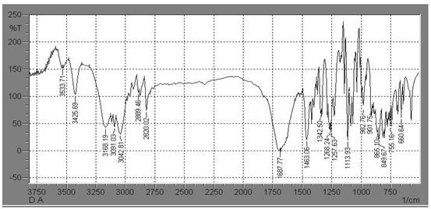

### Fig. No. 01: FTIR Spectra of stavudine

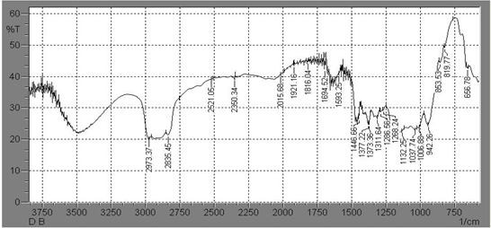

**Fig. No. 02: FTIR Spectra of HPMCK4M**

# 255

Dattatraya S Palave. et al., Int. J. Pharm & Ind. Res., Vol.–03 (03) 2013 [250 - 256]

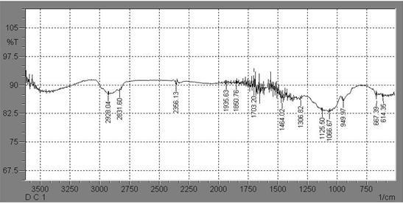

### Fig. No. 03: FTIR Spectra of Methyl cellulose

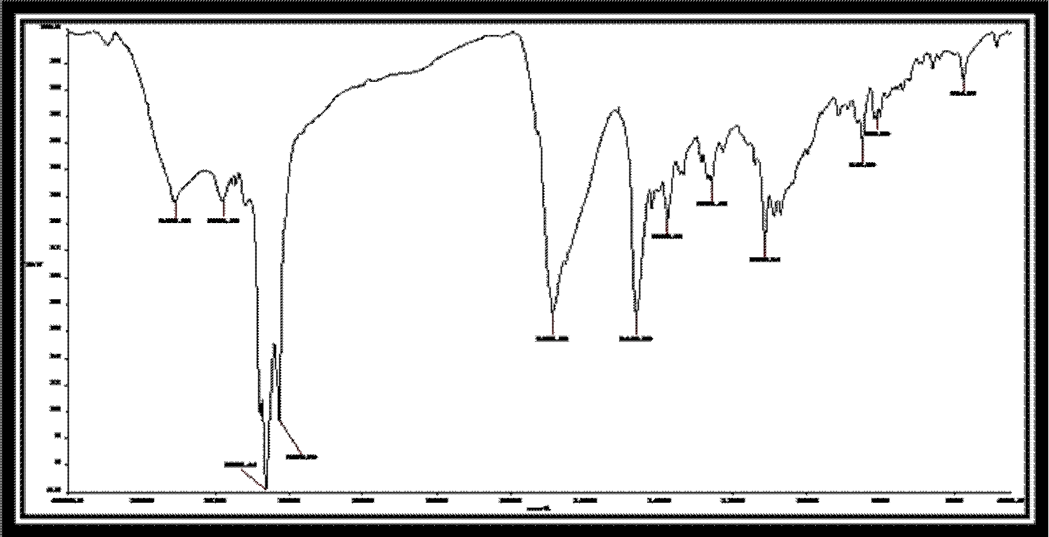

**Fig. No. 04: FTIR spectra of optimized batch F5**

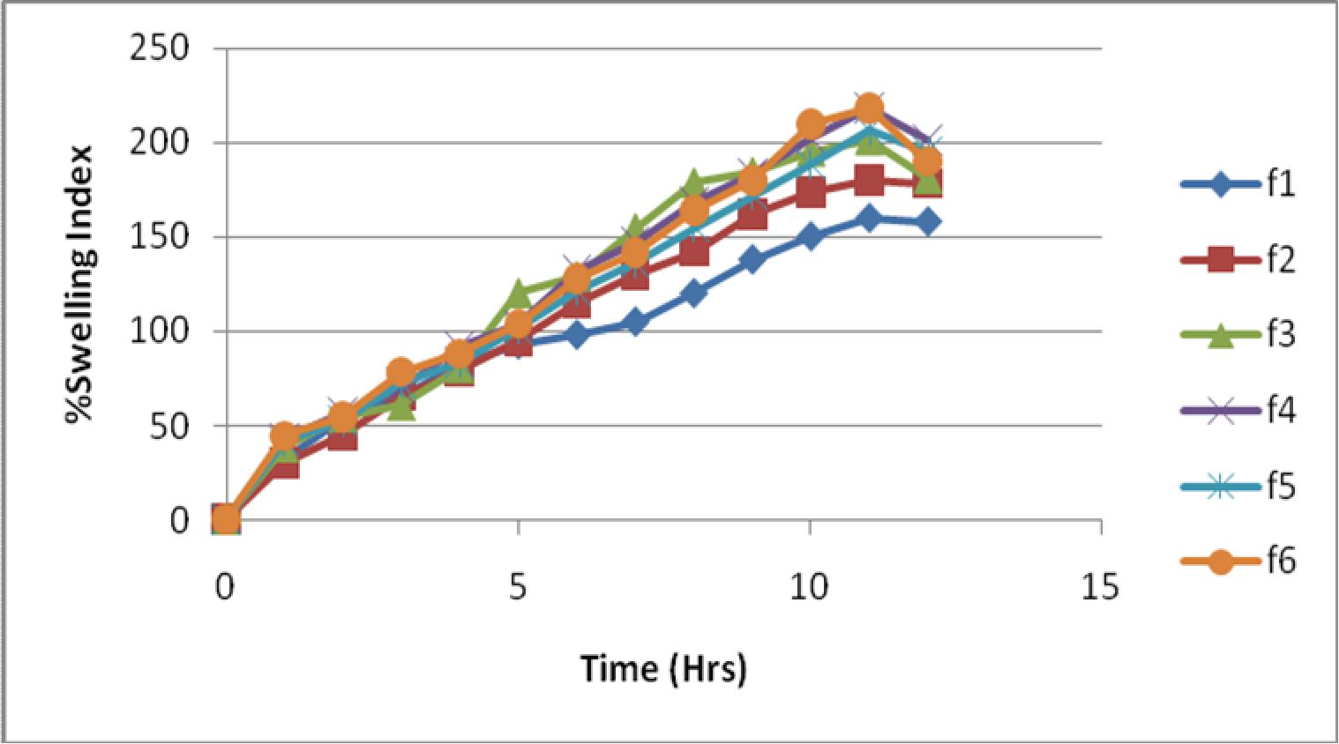

**Fig. No. 05: Plot for % swelling index**

# 256

Dattatraya S Palave. et al., Int. J. Pharm & Ind. Res., Vol.–03 (03) 2013 [250 - 256]

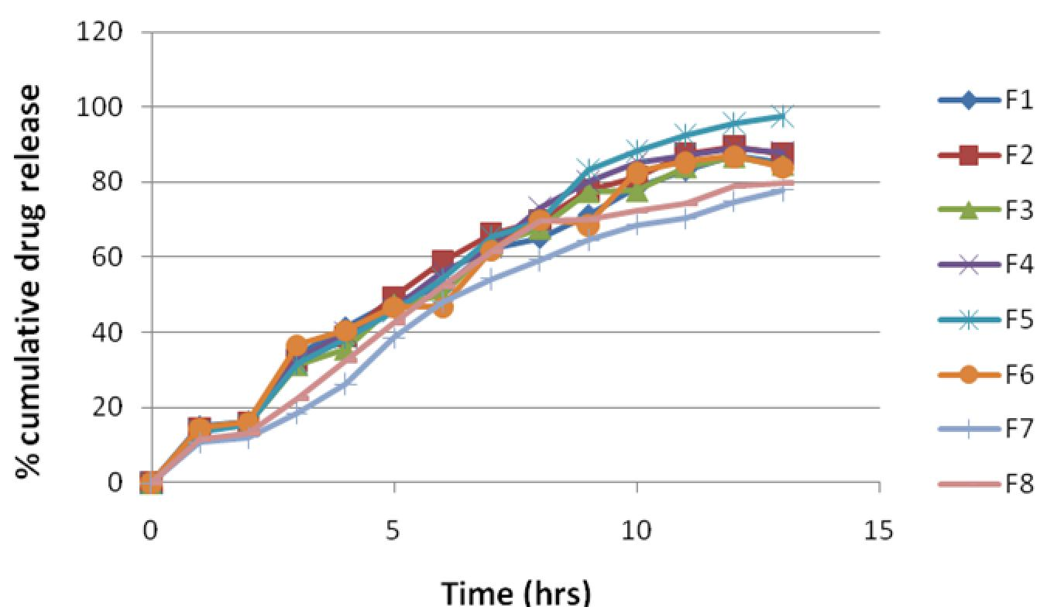

**Fig. No. 06: % Cumulative drug release of SR matrix tablet of stavudine**

**Conclusion**

Matrix tablet containing stavudine can be prepared successfully by using simplest, easy, cost effective direct comprssion method. The matrix tablets were found to be effective in sustaining the drug release more than 12hrs. Among all the formulation F5 showed 97.58% release at the end of 12hrs Drug release was diffusion controlled and follows mixed zero order and first order kinetics. Stability studies revealed that there were no significant changes in hardnes, friability ,and drug content of selected formulation (F5)*.* Based on the observation , it can be concluded that the formulated stavudine matrix tablet using widely accepted and physiological safe polymer was capable of exhibiting sustained release for a period 12hrs . They are thus may be reduce frequency of dosing thereby minimizing side effect , improved bioavailability and increase the effectiveness of the drug.

## References

1. Chien Y.W., 1992., Novel Drug Delivery system**.,** 2nd edition., Marcel Dekker Publisher., New York., 193-196.
2. Vyas S.P.**,** Khar R.K., 2002., Controlled drug delivery: Concepts and Advances, 1st edition. Delhi, India: Vallabh Prakashan, 2002; 15.
3. Barun M.T., Shruti K., Vinay M., Shilpa B., 2012., Matrix tablet : “A potential drug carrier for oral drug delivery” Journal of Pharmacy Research.,5(5) 2448- 2456.
4. Tripathi K.D., 2008., Essential medicinal pharmacology., 6th edition Jaypee brothers publishe new Delhi., 770-771.
5. Martindale.,2002., The complete drug reference, sweetman SC(ed)., 34th edition., Great Britain, Pharmaceutical Press Publisher., 641.
6. Welling P.G., Dobrinska M.R.,1978., Sustained

and controlled release drug delivery System., Marcel Dekker Inc., New York.,778.

1. Ranga R.K., Padmalatha D.K., Buri B., 1988., Cellulose matrices for zero-order release of soluble drugs. Drug Dev. Ind Pharm.,(14)., 2299- 2320.
2. Alderman D.A., 1984., A review of cellulose ethers in hydrophilic matrices for oral controlled- release dosage forms., International journal of pharmaceuitical (5).,1-9.
3. Dhirendra K.**,** Vivek D., Shaila L., 2010., Design and evaluation of sustained release matrix tablet once daily formulation of stavudine., International journal of drug delivery., 125- 134.
4. Chatwal G.R., Anand S.K., 2007., Instrumental methods of chemical analysis. 5th edition., Himalaya publication house, Mumbai., 2.44-2.45.
5. Lachman L., Lieberman H.A., Kanig J., 1991., The theory and practice of industrial Pharmacy.,2nd edition, 4th Indian reprint, Verghese publishing house, Mumbai.,293-340.
6. Leon Lachman, Herbert A. Lieberman 2009.The theory and practice of industrial pharmacy**,** special Indian edition .296-203.
7. Indian Pharmacopoeia., 2007. Government of India Ministry of Health and Family Welfare., Controller of Publications, New Delhi, vol-1., 177,190.
8. Ranjit K.P., Suresh V.K., Vinod R., 2010., Design and characterization of controlled release matrix tablet of stavudine” International journal of pharmaceuitical and clinical research 2(1) 46-50.
9. Shilpa A., Rama R.T., Mohammed A.H., 2012., Formulation and in-vitro evaluation of once daily sustained release matrix tablet of stavudine” Journal of pharmaceutical and scientific Innovation., 64-68.