# 224

***Research Article***

**Available Online at:** [**www.ijpir.com**](http://www.ijpir.com/)



International Journal of Pharmacy and Industrial Research

**ISSN**

**Print 2231 – 3648**

**Online 2231 – 3656**

**FORMULATION AND EVALUATION OF DOMPERIDONE MALEATE BILAYER TABLET**

*Pratap B Bhalerao, Raundal M J, Kandharkar S U, Patil P P, Bari M M, Barhate S D Shree Sureshdada Jain Institute of Pharmaceutical Education & Research,

Jamner, Jalgaon, India - 424206.

**Abstract**

Bilayer tablet of domperidone maleate formulated and evaluated with same drug in both layer immediate and sustained release biphasic dosage form. Domperidone maleate bilayer tablet prepared using the polymers like HPMC K100M, Metolose as a matrix forming agent and superdisintegrant like Croscarmellose sodium, sodium starch glycolate. Different effect of these polymer concentration and superdisintegrant were studied and evaluated by the dissolution study of prepared bilayer tablet along with weight variation, hardness, friability and content uniformity.

**Keywords:** Bilayer tablet, Domperidone maleate, Sustained release tablet.

## Introduction

Oral ingestion has long been the most convenient and commonly employed route of drug delivery due to its ease of administration. It is well known that modified release dosage forms may offer one or more advantages over conventional release formulations of the same drug. Bi-layer tablet is suitable for sequential release of two drugs in combination or same drug in both layer separate two incompatible substances and also for sustained release tablet in which one layer is immediate release as initial dose and second layer is maintenance dose. Bi-layer tablet has been developed to achieve controlled delivery of different drugs with pre-defined release profiles.

Emesis occurs due to the stimulation of emetic centre situated in medulla oblongata. The chemoreceptor trigger zone located in the area of

nucleus tractus solitarius are the important for afferent impulses arising in GIT, throat and viscera CTZ accessible to blood borne drugs hormones and toxins etc. Domperidone maleate was chosen as model drug because Domperidone blocks the dopamine action. It has strong affinities for the D2 and D3 dopamine receptors, which are found in the chemoreceptor trigger zone, located just outside the blood brain barrier, which among others regulates nausea and vomiting. Domperidone maleate is white colorless powder; slightly soluble in water, and sparingly soluble in N, N- Dimethyl formamide. The protein binding of domperidone is 91- 93% and elimination half life 7.5 hours. It is chemically described as 5- chloro-1- [1-[3-(-2-oxo- 1,3-dihydrobenzimidazol-1-yl) propyl] 4-piperidyl]- 1,3-dihydrobenzimidazol- 2 – one maleate. To maintain the therapeutic range the drug should be

### Author for Correspondence:

Pratap B Bhalerao,

Shree Sureshdada Jain Institute of Pharmaceutical Education & Research, Jamner, Jalgaon, India - 424206.

E-mail: [pratapbhalerao7@gmail.com](mailto:pratapbhalerao7@gmail.com)

Pratap B Bhalerao. et al., Int. J. Pharm & Ind. Res., Vol.–03 (03) 2013 [224 - 231]

225

administered 3-4 times a day. The objective of the present study is to develop bilayer tablets of Domperidone maleate and to study the effect of functionality differences of superdisintegrant on the tablet properties as well as to improve the patient compliance without compromising the therapeutic efficacy.

## Material and method

Domperidone maleate was obtained as a gift sample from Lubrizol Corporation, Mumbai. Also polymer like HPMC K100M, Metolose and superdisintegrant like croscarmellose sodium and sodium starch glycolate was obtained as gift sample from Lubrizol Corporation, Mumbai other reagent and chemicals used were of analytical grade.

### Preparation of IR layer

IR layer containing 10mg of domperidone maleate and super disintegrant like croscarmellose sodium, sodium starch glycolate were prepared by wet granulation method as per given formulae. Weight accurate all ingredient and pass through sieve No. 80 then sunset yellow lake and PVP K-30 dissolved in water. The binder solution was mixed with the powder mixture to form a damp mass. The mass was passed through sieve no. 16 and dried at 40°c for 30 minutes. The granules were then lubricated using talc and magnesium stearate. Finally granules were passed through sieve no.22 for the uniform size of particle and granules are ready for compression.

### Preparation of SR layer

IR layer containing 20mg of domperidone maleate and polymer like HPMC K100M, Metolose were prepared by wet granulation method as per given formulae. Weight accurate all ingredient and pass through sieve No. 80 then PVP K-30 dissolved in water. The binder solution was mixed with the powder mixture to form a damp mass. The mass was passed through sieve no. 16 and dried at 40°c for 30 minutes. The granules were then lubricated using talc and magnesium stearate. Finally granules were passed through sieve no.22 for the uniform size of particle and granules are ready for compression.

### Compression of bilayer tablets

The granules were compressed into bilayer tablets using CIP LAB PRESS bilayer tablet punching

machine with 9mm s/c punches. The SR layer was introduced first into the die cavity and a slight compression was made. The IR layer was then introduced over the slightly compressed SR layer and final compression was made to get the bilayer tablets.

### Physical evaluation of bilayer tablet Weight variation

Randomly selected 20 tablets were weighed individually using electronic balance (Wensar PGP200) Weight values were reported in milligram. The average weight was noted and standard deviation was calculated.

### Thickness and diameter

Thickness and diameter of the tablet was measured by Vernier caliper in mm. thickness and diameter is essential for the consumer acceptance and tablet uniformity.

### Hardness

The Monsanto hardness tester was used to determine the tablet hardness. The value of the load at that point gives a measure of the hardness of the tablet which was expressed in kg/cm2.

### Friability

Tablet friability was measured by Roche friabilator. The pre-weighed tablets were allowed for 100 revolutions in 4 min and were dedusted. The percentage weight loss was calculated by reweighing the tablets. The percent friability was then calculated by

%F = (W0-W)/W0 X 100

Where,

W0-initial weight of tablet,

W- Weight of tablet after test.

### Disintegration time

One tablet was placed in each of six tubes of disintegration test apparatus. The test was carried out at 37±2˚C according to USP XXII. Disintegration test apparatus was used without disc. Time required for complete disintegration of tablet fragments through sieve (#10) was considered as a disintegration time of tablet.

### Content uniformity

The same procedure was followed for content uniformity testing as described under assay procedure for 10 dosage units.

# 226

Pratap B Bhalerao. et al., Int. J. Pharm & Ind. Res., Vol.–03 (03) 2013 [224 - 231]

### Drug content

10 tablets of same weight were selected and crushed using mortar and pestle. Powder equivalent to the average weight of the tablet was weighed and dissolved in 0.1 M HCl and diluted suitably. The concentration of drug in the samples was detected using ultra violet (UV)-visible spectrophotometer.

### Procedure for standard curve

The first stock solution was prepared by dissolving 100 mg of Domperidone maleate in 100 ml of 0.1N HCl (1mg/ml). From the second stock solution 5, 10, 15, 20, 25, 30 μg/ml dilutions were prepared. The absorbance of each sample was measured at

280 nm. Standard curve of concentration vs. absorbance was plotted.

### FT-IR Analysis

The FT-IR spectrum of Domperidone maleate was recorded using FTIR spectrophotometer using KBr pellet technique. Drug –Excipient compatibility study was done by FT-IR analysis. FT-IR graph (of pure drug, croscarmellose sodium, metolose, HPMC K100M, and their physical mixtures) comparison study has been done. By observing graph, shift in peak of pure drug due to polymer is observed to check the interaction. Thus, study gave compatibility between drug and polymer.

***In vitro-* drug release Studies**

The *in vitro* study of domperidone maleate bilayer tablets for a period of 12 hours was studied. The values obtained are shown in table. The *in vitro* dissolution study of domperidone maleate tablets was performed according to British Pharmacopoeia using USP apparatus II (model TDT-08L, Electrolab, Mumbai, India) fitted with paddles (50 rpm) at 37 °C ± 0.5 °C and using hydrochloric acid (pH 1.2, 900 ml) as a dissolution medium for first two hours and 7.4 phosphate buffer solution for next 12hr . At the predetermined time interval, 5- ml samples were withdrawn filtered through a 0.45 μm membrane filter diluted, and assayed at 280 nm using a Shimadzu UV/Vis double- beam spectrophotometer (Shimadzu-1800, Japan). Cumulative percentage drug release was calculated using an equation obtained from a calibration curve.

**Result and discussion**

Domperidone maleate was prepared with various concentrations of superdisintegrants: Sodium starch glycolate, Crosscarmellose Sodium, and polymer like HPMC K100M, metolose and other excipients Starch, Microcrystalline cellulose, Magnesium stearate, talc were used in the formulation for both layer ( Table No. 1,2).

### Table No. 01: Composition of various batches of domperidone maleate IR layer

|  |  |  |  |  |
| --- | --- | --- | --- | --- |
| **Ingredient** | **IR1** | **IR2** | **IR3** | **IR4** |
| Domperidone maleate | 10 | 10 | 10 | 10 |
| Starch | 25 | 25 | 25 | 25 |
| Microcrystalline cellulose PH 101 | 54.75 | 54.25 | 54.75 | 54.25 |
| Croscarmellose sodium | 3 | 3.5 | - | - |
| Sodium starch glycolate | - | - | 3 | 3.5 |
| PVP K-30 | 2 | 2 | 2 | 2 |
| Sunset yellow lake | 0.25 | 0.25 | 0.25 | 0.25 |
| Purified water | q.s. | q.s. | q.s. | q.s. |
| Magnesium stearate | 3 | 3 | 3 | 3 |
| Talc | 2 | 2 | 2 | 2 |
| Total weight | 100 | 100 | 100 | 100 |

* All quantities in mg.

### Table No. 02: Composition of various batches of domperidone maleate SR layar.

|  |  |  |  |  |
| --- | --- | --- | --- | --- |
| **Ingredient** | **SR1** | **SR2** | **SR3** | **SR4** |
| Domperidone maleate | 20 | 20 | 20 | 20 |
| Starch | 25 | 25 | 25 | 25 |
| Lactose monohydrate | 105 | 100 | 100 | 95 |
| HPMC K100M | 40 | 45 | - | - |
| Metolose | - | - | 45 | 50 |
| PVP K-30 | 5 | 5 | 5 | 5 |
| Isopropyl alcohol | q.s. | q.s. | q.s. | q.s. |
| Magnesium stearate | 3 | 3 | 3 | 3 |
| Talc | 2 | 2 | 2 | 2 |
| Total weight | 200 | 200 | 200 | 200 |

*All quantities in mg.

Pratap B Bhalerao. et al., Int. J. Pharm & Ind. Res., Vol.–03 (03) 2013 [224 - 231]

227

For each formulation, blend of drug and excipients were prepared and evaluated for various parameters as explained earlier. The powder blend was compressed using wet granulation technique. Bulk density, was found in the range of 0.308-0.437g/ml and the tapped density between 0.390- 0.494 g/ml. The Hausner’s ratio and Compressibility index was calculated using bulk and tapped density data. Hausner’s ratio for prepared formulation was found to be <1.33 which indicates good flow property.

The compressibility index was found to be between 11.35% - 25.35% which indicates good flow property of the powder blend. The excellent flow property of the powder blend was also evidenced with angle of repose (ranging from 17.92˚- 24.14˚) which is near to 25˚, indicating excellent flow property (Table No. 3,4). Tablets were prepared using wet granulation technique. Since the powder material was free flowing, tablets were obtained of uniform weight due of uniform die fill, with acceptable weight variations as per B.P

### Table No. 03: Result of pre-compression parameter of domperidone maleate IR layer

|  |  |  |  |  |
| --- | --- | --- | --- | --- |
| **Properties** | **IR 1** | **IR 2** | **IR 3** | **IR 4** |
| **Tapped density (gm/cc)** | 0.390 | 0.418 | 0.493 | 0.481 |
| **Bulk density(gm/cc)** | 0.308 | 0.312 | 0.437 | 0.385 |
| **Compressibility index (%)** | 21.02 | 25.35 | 11.35 | 19.95 |
| **Hausner’s ratio** | 1.26 | 1.33 | 1.12 | 1.24 |
| **Angle of repose(°)** | 17.92 | 22.10 | 24.14 | 22.67 |

**Table No. 04: Result of pre-compression parameter of domperidone maleate SR layer**

|  |  |  |  |  |
| --- | --- | --- | --- | --- |
| **Properties** | **SR 1** | **SR 2** | **SR 3** | **SR 4** |
| **Tapped density (gm/cc)** | 0.555 | 0.530 | 0.470 | 0.560 |
| **Bulk density (gm/cc)** | 0.456 | 0.426 | 0.376 | 0.465 |
| **Compressibility index ( % )** | 17.11 | 19.62 | 20.00 | 16.96 |
| **Hausner’s ratio** | 1.21 | 1.24 | 1.25 | 1.20 |
| **Angle of repose (°)** | 19.75 | 21.55 | 20.38 | 19.86 |

### Table No. 05: Result of post compression parameter of domperidone maleate bilayer tablet

|  |  |  |  |  |
| --- | --- | --- | --- | --- |
| **Properties** | **BT 1** | **BT 2** | **BT 3** | **BT 4** |
| **\*Weight variation (mg)** | 299±1 | 300±1 | 299±1 | 299±2 |
| **Hardness (kg/cm2)** | 4.6 | 4.3 | 4.4 | 5.0 |
| **Thickness (mm ± S.D.)** | 4.55 | 4.30 | 4.34 | 4.36 |
| **% Friability** | 0.43 | 0.32 | 0.34 | 0.37 |
| **Disintegration time (sec)** | 51 | 46 | 54 | 47 |
| **Drug content (%)** | 98.34 | 99.33 | 99.17 | 99.03 |

**\*Value expressed as mean±SD, n=3**

The drug content was found in the range of 99.3 %

- 101.1% (acceptable limit). Friability of the tablets was found below 0.34% and hardness was found between 4.0-5.2kg/cm2, indicating a good mechanical resistance of the tablets, and the parameters were found well within the specified limit. (Table No.5). The standard curve of domperidone maleate is excellent linearity and R2=0.999 in phosphate buffer & R2=0.998 0.1 N HCl (Fig. 1,2). The *in- vitro* disintegration time (DT) of the tablets was found to less than 1 min. Tablets containing 3.5% Sodium starch glycolate and 3.5% Croscarmellose sodium had disintegration

time of 46sec. From the results of the dissolution rate of all the formulations, it is demonstrated that although functionality differences existed between the superdisintegrants, the bilayer domperidone bilayer tablets could be prepared by using any of the superdisintegrants used. Four formulations BT 1, BT 2, BT 3, BT 4 were studied by drugs two formulation of SSG with Metolose, Two formulation of CCS with HPMCK100M. The maximum increase in the dissolution rate was observed with HPMC K100M with crosscarmellose sodium amongst the super- disintegrants.

# 228

Pratap B Bhalerao. et al., Int. J. Pharm & Ind. Res., Vol.–03 (03) 2013 [224 - 231]

### Table No.06: In-vitro drug release of domperidone maleate immediate release layer.

|  |  |  |  |  |
| --- | --- | --- | --- | --- |
|  | **IR 1** | **IR 2** | **IR 3** | **IR 4** |
| 0 | 0 | 0 | 0 | 0 |
| 5 | 30.6 | 33.59 | 26.89 | 31.2 |
| 10 | 58.43 | 68.54 | 63.98 | 72.12 |
| 15 | 76.66 | 85.56 | 74.34 | 83.76 |
| 20 | 84.34 | 90.33 | 86.23 | 90.67 |
| 25 | 93.44 | 95.67 | 92.89 | 95.88 |
| 30 | 97.78 | 99.39 | 97.32 | 98.22 |

**Time (min) Formulation code**

### Table No. 07: In-vitro drug release of domperidone maleate sustained release layer.

|  |  |  |  |  |
| --- | --- | --- | --- | --- |
|  | **SR 1** | **SR 2** | **SR 3** | **SR 4** |
| 0 | 0 | 0 | 0 | 0 |
| 1 | 22.74 | 21.33 | 26.23 | 24.75 |
| 2 | 33.67 | 32.93 | 45.96 | 44.69 |
| 3 | 48.34 | 46.23 | 63.75 | 61.64 |
| 6 | 69.94 | 65.45 | 84.67 | 81.95 |
| 9 | 90.56 | 89.21 | 91.33 | 90.48 |
| 12 | 96.78 | 99.3 | 93.56 | 98.43 |

**Time (hr) Formulation code**

From the above data we can conclude that batch BT 2 containing HPMC K100M as a polymer and croscarmellose sodium as a superdisintegrant gave better drug release as compared with other

formulation is an excellent formulation as it released the drug sustained in 12 hours high percentage of drug released.

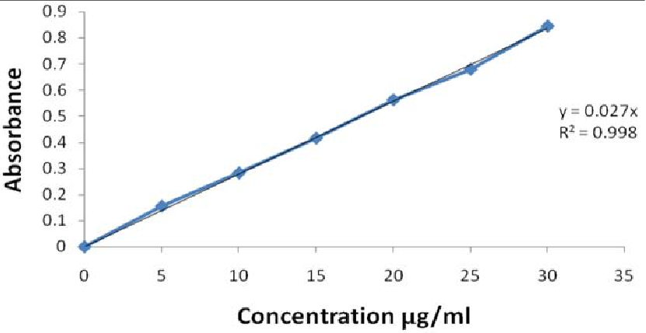

### Fig. No. 01: Standard calibration curve of domperidone maleate in 0.1 N HCl (pH 1.2)

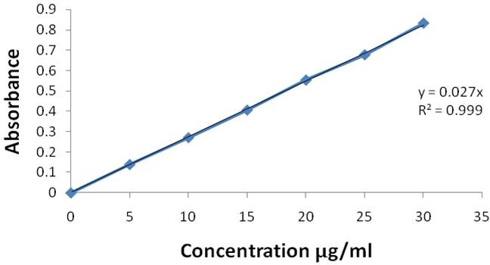

**Fig. No. 02: Standard calibration curve of domperidone maleate in phosphate buffer (pH 7.4)**

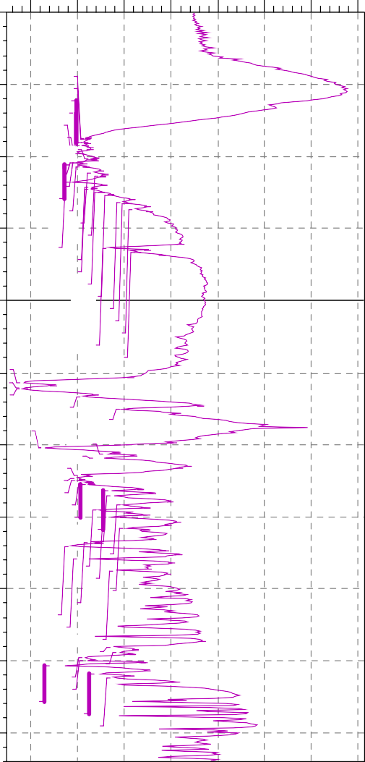

3 1 2 4 .7 9

3 1 1 6 .1 1

3 0 9 3 .9 2

3 0 7 2 .7 1

3 0 2 6 .4 1

3 0 1 7 .7 3

2 9 8 0 .1 2

2 9 7 4 .3 3

2 9 5 6 .9 7

2 9 5 2 .1 5

2 9 3 7 .6 8

2 9 2 4 .1 8

2 8 8 6 .5 7

2 8 6 5 .3 5

2 8 1 9 .0 6

2 7 8 2 .4 1

2 7 6 7 .9 4

2 7 5 1 .5 5

2 7 2 9 .3 7

2 6 8 0 .1 8

2 6 7 1 .5 0

2 6 3 0 .9 9

2 3 6 1 .9 1

2 3 3 2 .9 8

1 6 6 7 .5 2

1 6 2 4 .1 2

4 8 9 .1 0

1 4 6 8 .8 4

1 4 5 5 .3 4

1 3 9 4 .5 8

1 3 8 4 .9 4

1 3 7 5 .2 9

1 3 6 7 .5 8

1 3 6 1 .7 9

1 3 3 9 .6 1

1 3 2 3 .2 1

1 2 9 0 .4 2

1 2 7 3 .0 6

1 2 4 9 .9 1

1 2 1 0 .3 7

1 1 6 0 .2 2

1 1 4 7 .6 8

1 1 0 3 .3 2

1 0 6 2 .8 1

7 9 6 .6 3

7 7 8 .3 0

7 5 9 .9 8

7 4 9 .3 7

7 3 2 .0 1

7 0 4 .0 4

6 9 0 .5 4

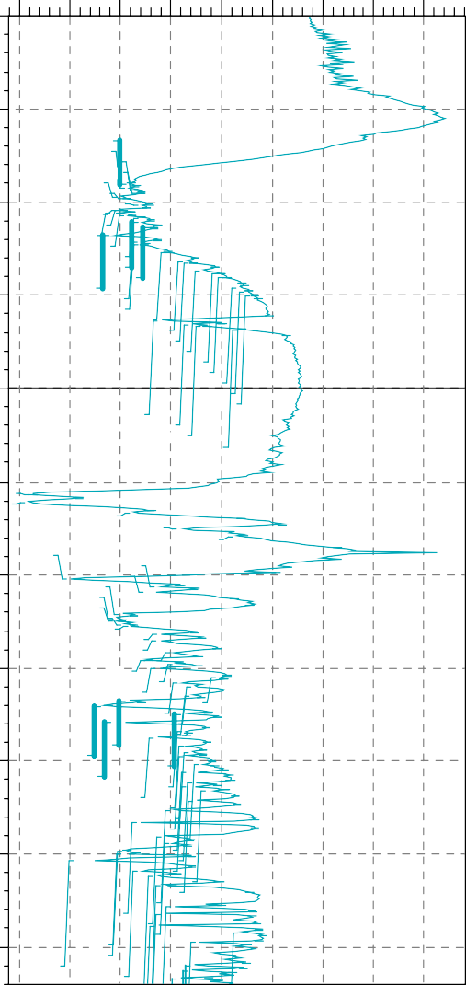

3 0 9 8 .7 5

3 0 7 2 .7 1

3 0 6 1 .1 3

3 0 4 7 .6 3

3 0 2 6 .4 1

3 0 1 8 .7 0

2 9 7 9 .1 6

2 9 5 6 .9 7

2 9 5 1 .1 9

2 9 3 7 .6 8

2 9 2 4 .1 8

2 9 1 4 .5 4

2 8 8 7 .5 3

2 8 6 3 .4 2

2 8 1 9 .0 6

2 7 8 3 .3 7

2 7 6 8 .9 1

2 7 2 9 .3 7

2 6 8 0 .1 8

2 6 6 9 .5 7

2 6 3 0 .9 9

2 6 1 1 .7 0

2 5 9 3 .3 8

2 5 3 9 .3 7

2 5 1 9 .1 2

2 4 9 3 .0 8

2 3 6 1 .9 1

2 3 4 1 .6 6

2 3 3 1 .0 5

2 3 1 3 .6 9

7 0

1 6 6 7 .5 2

1 6 2 4 .1 2

1 6 0 4 .8 3

1 4 8 9 .1 0

1 4 6 8 .8 4

1 4 5 5 .3 4

1 3 9 5 .5 4

1 3 8 3 .9 7

1 3 7 5 .2 9

1 3 6 7 .5 8

1 3 6 1 .7 9

1 3 3 9 .6 1

1 3 2 3 .2 1

1 2 9 0 .4 2

1 2 7 0 .1 7

1 2 6 1 .4 9

1 2 4 9 .9 1

1 2 2 2 .9 1

1 2 1 0 .3 7

1 1 9 9 .7 6

1 1 7 6 .6 2

1 1 6 0 .2 2

1 1 4 7 .6 8

1 1 2 5 .5 0

1 1 0 3 .3 2

1 0 7 9 .2 1

1 0 6 2 .8 1

1 0 3 8 .7 0

1 0 2 3 .2 7

1 0 1 2 .6 6

9 9 0 .4 8

9 6 9 .2 6

9 3 9 .3 6

9 2 9 .7 2

9 1 9 .1 1

8 9 3 .0 7

8 6 7 .0 3

8 3 3 .2 8

7 9 6 .6 3

7 7 8 .3 0

7 5 8 .0 5

7 4 9 .3 7

7 3 2 .0 1

7 0 3 .0 8

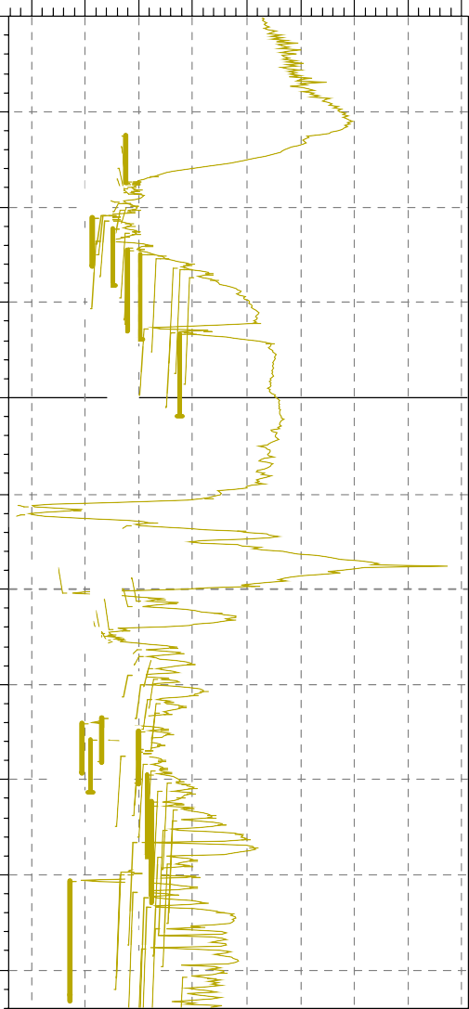

3 1 3 1 .5 4

3 1 2 3 .8 2

3 1 1 9 .0 0

3 0 9 8 .7 5

3 0 7 2 .7 1

3 0 6 4 .9 9

3 0 2 5 .4 5

3 0 1 5 .8 0

2 9 9 8 .4 4

2 9 7 9 .1 6

2 9 5 6 .9 7

2 9 5 1 .1 9

2 9 3 7 .6 8

2 9 2 4 .1 8

2 8 8 6 .5 7

2 8 6 5 .3 5

2 8 1 9 .0 6

2 7 8 3 .3 7

2 7 6 8 .9 1

2 7 5 1 .5 5

2 7 2 9 .3 7

2 6 8 0 .1 8

2 6 6 9 .5 7

2 6 3 1 .9 6

2 3 6 1 .9 1

2 3 4 1 .6 6

2 3 3 2 .9 8

7

1 6 6 7 .5 2

1 4 9 0 .0 6

1 3 7 5 .2 9

1 4 5 5 .3 4

1 3 9 4 .5 8

1 3 8 3 .9 7

1 4 6 8 .8 4

1 3 6 7 .5 8

1 3 6 1 .7 9

1 3 3 9 .6 1

1 3 2 3 .2 1

1 3 1 4 .5 3

1 2 9 0 .4 2

1 2 7 3 .0 6

1 2 6 2 .4 5

1 2 4 ~~9~~ .9 1

1 2 1 0 .3 7

1 1 9 9 .7 6

1 1 7 6 .6 2

1 1 6 0 .2 2

1 1 4 7 .6 8

1 1 2 5 .5 0

1 1 0 3 .3 2

1 0 7 9 .2 1

1 0 7 0 .5 3

1 0 6 2 .8 1

1 0 3 8 .7 0

1 0 2 3 .2 7

1 0 1 2 .6 6

9 9 0 .4 8

9 6 9 .2 6

9 3 9 .3 6

9 2 9 .7 2

9 1 9 .1 1

8 9 3 .0 7

8 3 3 .2 8

8 6 7 .0 3

7 9 6 .6 3

7 7 8 .3 0

7 3 2 .0 1

7 5 7 .0 9

7 4 9 .3 7

229

Pratap B Bhalerao. et al., Int. J. Pharm & Ind. Res., Vol.–03 (03) 2013 [224 - 231]

2 0 0

% T

1 7 5

1 5 0

1 2 5

1 0 0

7 5

5 0

2 5

4 0 0 0

3 5 0 0

3 0 0 0 2 5 0 0

2 0 0 0

1 7 5 0

1 5 0 0

1 2 5 0

1 0 0 0

7 5 0

5 0 0

1 / c m

D o m p e r id o m e , C O P S H A H A D A

**Fig. No. 03: FT-IR spectrum of Domperidone maleate**

1 3 5

% T

1 2 0

1 0 5

9 0

7 5

6 0

4 5

3 0

1 5

4 0 0 0

3 5 0 0

3 0 0 0

2 5 0 0

2 0 0 0

1 7 5 0

1 5 0 0

1 2 5 0

1 0 0 0

7 5 0

5 0 0

1 / c m

D o m p e r id o m e + C ro s s c a rm e l lo s e , C O P S H A H A D A

**Fig. No. 04: FT-IR spectrum of domperidone maleate + croscarmellose sodium**

1 8 0

% T

1 6 0

1 4 0

1 2 0

1 0 0

8 0

6 0

4 0

2 0

4 0 0 0

3 5 0 0

3 0 0 0

2 5 0 0

2 0 0 0

1 7 5 0

1 5 0 0

1 2 5 0

1 0 0 0

7 5 0

5 0 0

1 / c m

D o m p e r id o m e + H P M C K 1 0 0 , C O P S H A H A D A

**Fig. No. 05: FT-IR spectrum of domperidone maleate + HPMC K100M polymer**

[www.ijpir.com](http://www.ijpir.com/)

# 230

Pratap B Bhalerao. et al., Int. J. Pharm & Ind. Res., Vol.–03 (03) 2013 [224 - 231]

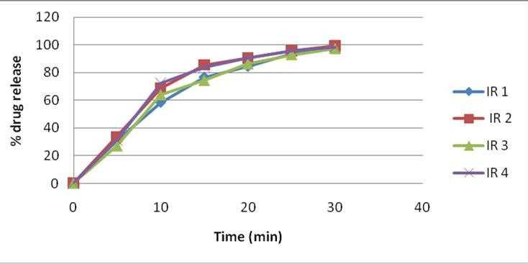

### Fig. No. 06: In-vitro drug release profile of domperidone maleate IR release layer

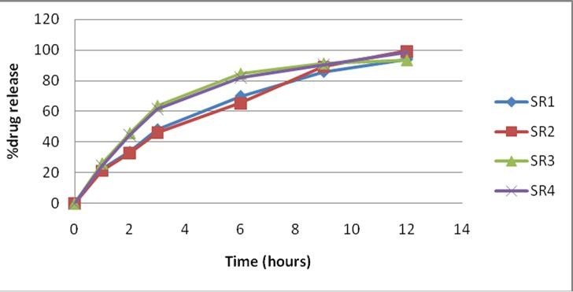

**Fig. No. 07: In-vitro drug release profile of domperidone maleate sustained release layer**

**Conclusion**

Preliminary trial batches of domperidone maleate sustained release bilayer tablet was successfully prepared and developed using various polymer such as HPMC K100M, Metolose and superdisintegrant such as croscarmellose sodium, sodium starch glycolate. The result generated in this formulation shows the various release profile of drug were the function of superdisintegrant and polymer concentration in the formulation.

The design of two different phases can be easily adjusted in both delivery rate and ratio of the dose fraction, according to pharmacokinetic and therapeutic needs. The result obtained with the dissolution test show that the release profile is depend on polymer and superdisintegrant in the formulation of bilayer tablet. Finally, it is concluded that by adopting a systematic formulation approach delivery of drug in two release pattern, a single dosage form can be

obtained which could improve patient compliance and give better disease management.

## References

1. Albright M, Use of domperidone as a prokinetic and anti-emetic health and wellness Int. j. pharma compound 2005;pp9, 120-125
2. Tripathi KD, essentials of medical pharmacology, Jaypee Brothers Medical Publishers (p) Ltd. Daryaganj, New Delhi, India. 2001, 649-650
3. Brunton L, Lazo J and Parkar K, Goodman & Gilmann’s The Pharmacological Basis of Therapeutics, McGraw-Hill Profession Division, New York. 996, 933.
4. Arun AS and Srinatha A: Sustained release bilayer tablets of diltiazem hydrochloride using insoluble matrix system. Ind. J. Pharm. Sci.2004, 66, 433-437.

Pratap B Bhalerao. et al., Int. J. Pharm & Ind. Res., Vol.–03 (03) 2013 [224 - 231]

231

1. Buri P. and Doelkar E: Formulation of sustained release tablet. Pharm. Acta. Helve.1980.55, 189-197.
2. British Pharmacopoeia 2005, Vol. I, Published by the Stationary Office. London. 2005,697-698
3. Cartensen JT, Wright JI and Blessel KW: USP dissolution test. J. Pharm. Sci. 1978,67, 48-50
4. Desphande NH, Rhodes CT, et al., Controlled release drug delivery systems for prolonged residence and overview.1998;
5. Lachman L, Liberman HA and Kanig JL: The Theory and Practice of Industrial Pharmacy. 3rd edition.Varghese Publishing House, Bombay, 1987: 293-342.
6. Gohil et al.,Formulation And Characterization Of Bambuterol Hydrochloride Fast Dissolving

Tablet Using Various Superdisintegrants , IJPSR 2011; Vol. 2(1): 98-103

1. Sangeetha et al., Design and Evaluation of Lamotrigine Oral Sustained Release Tablets IJPSR, 2011; Vol. 2(2): 462-467.
2. Ramesh D. Sathis Kumar, Guruviah, A.Harani., Formulation and evaluation of bilayered sustained release matrix tablets of Metformin HCl Sr and Pioglitazone., American Eurasian journal of Scientific Research. 2010, 5(3) 176‐182.
3. Dixit RB, Gupta RR, Patel HV, Patel PS, Dixit BC. Formulation and Characterization of SustainedRelease Matrix Tablet of Metformin Hydrochloride., International Journal of Pharma Recent Research. 2009, 1(1), 49‐53.