***Research Article***

**Available Online at:** [**www.ijpir.com**](http://www.ijpir.com/)



International Journal of Pharmacy and Industrial Research

**ISSN**

**Print 2231 – 3648**

**Online 2231 – 3656**

**FORMULATION AND EVALUATION OF ORAL DISINTEGRATING FILMS OF SUMATRIPTAN SUCCINATE**

# *1,2Sandhya P, 1Fouzia Ansari, 2Rao Patnaik K S K, 3Subrahmanyam C V S

*,1Shadan Womens College of Pharmacy, Hyderabad, India.

2University College of Technology, Osmania University, Hyderabad, India.

3Gokaraju Rangaraju College of Pharmacy, Hyderabad, India.

**Abstract**

The aim of the present investigation was to develop oral disintegrating film of sumatriptan succinate, anti migraine agent and investigate the effect of the formulation variables like concentration of film forming polymer, emulsifying agent and plasticizer on the physico chemical properties and in vitro diffusion studies. Hydroxyl propyl methyl cellulose was used as a film former, tween 80 as an emulsifying agent and glycerin as plasticizer. The three variables were studied at two level thus, a 23 full factorial design was applied and eight different formulations were developed by solvent casting method and evaluated. The role of HPMC in deciding the film properties was significant. It affected folding endurance, tensile strength, percentage elongation, disintegration time and invitro diffusion rate significantly. The in low level and tween 80 (5mg / film ie. 2x3 cm2) and PEG 4000 (8mg/fil ie. 2x3 cm2) in high level was found to be suitable for film formation with desirable physiochemical properties, faster disintegration and optimum invitro release. Here tween 80 and glycerin at high level which acted as solubility enhancers.

**Keywords:** Oral disintegrating film, Sumatriptan succinate, Anti migraine agent.

## Introduction

The pharmaceutical dosages are administered in the form of pills, granules, powders and liquids. Generally, a pill is designed for swallowing intact or chewing to deliver a precise dose of medication to patients. The pills, which include tablets and capsules, are able to retain their shapes under moderate pressure. However some patients, particularly pediatric and geriatric patients, have difficulty in swallowing or chewing solid dosage forms. Many pediatric and geriatric patients are unwilling to take these solid preparations due to

fear of throat choking. In order to assist these patients, several fast dissolving drug delivery have been developed. Fast dissolving drug delivery systems can be manufactured by a variety of technologies, including direct compression, wet granulation and freeze drying. Some make use of different disintegrating mechanisms, such as high level of disintegrating or effervescent agents, which cause the dosages to disintegrate rapidly in the mouth. Most of the existing fast dissolving drug delivery systems are in the form of tablets and are

### Author for Correspondence:

Sandhya P,

Shadan Women’s College of Pharmacy, Hyderabad, India.

E-mail: [sandhyapasikanti@gmail.com](mailto:sandhyapasikanti@gmail.com)

designed to dissolve or disintegrate in the patient’s mouth within a few seconds or minutes without the need of water or chew.

The oral route of administration still continues to be widely used accepted route, contributing to 50 - 60% of total drug formulations because of ease of administration, self-medication, and pain avoidance as compared to parenterals. Mainly elderly patients may experience problems in swallowing solid dosage forms. Oral administration of conventional tablets poses problems, when patient is mentally ill, developmentally disabled and in nausea. In some cases motion sickness, sudden episode of allergic attack or coughing and unavailability of water, poses problem in swallowing. To fulfill these medical needs pharmaceutical technologists developed several mouth dissolving drug delivery systems.

### Following are the characteristics of the mouth dissolving film:

1. Require no water for the administration (to swallow).
2. Dissolve or disintegrate in the mouth in few seconds.
3. Posses pleasant taste, high stability and transportability.
4. Leave minimal or no residue in the mouth after administration.
5. Need no special packaging materials or processing requirements.

### Advantages of mouth dissolving films:

1. The film alleviates fear of throat choking.
2. The film is easy to handle and administer.
3. The film maintains a simple and convenient packaging.
4. The film alleviates unpleasant taste and is easy to manufacturer.
5. This system allows children, elderly and the general population to take their medication directly wherever and whenever needed.
6. The fast dissolving action is primarily due to the large surface area of the film.
7. The films are tough, solid, soft, flexible and do not require special packaging.
8. The films are thin and can be carried in a patients pocket, wallet.

## Materials and methods

### Table No. 01: List of chemicals

**S.No Drug / Excipients Source**

1. Sumatriptan Succinate Gift sample from KAPL
2. HPMC (15 cps) Gift sample from Remidex
3. Glycerin Ranbaxy fine chemicals ltd
4. Ethanol Ranbaxy fine chemicals ltd
5. Polysorbate – 80 Rea chem

06. Menthol Thomas Baker Chemicals ltd

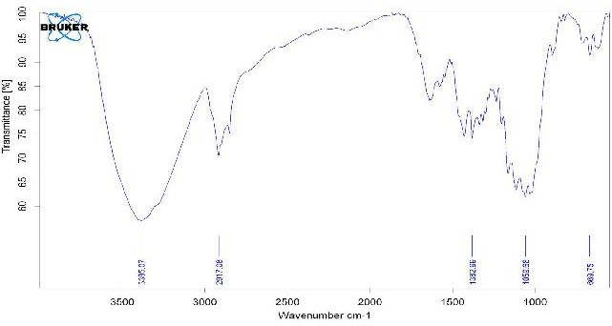

### Fig. No. 01: Sumatriptan Optimized formula

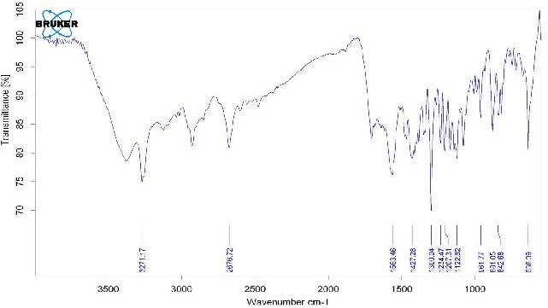

**Fig. No. 02: Sumatriptan Succinate Solid**

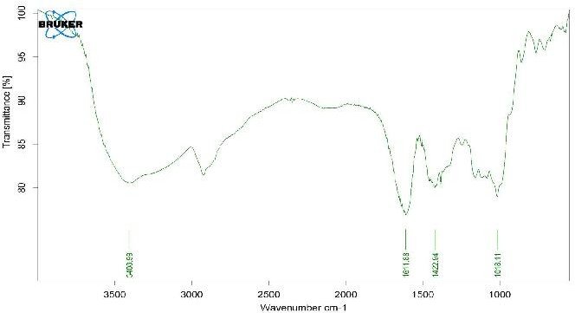

### Fig. No. 03: Sumatriptan + HPMC K 100 Solid

**Formulation of mouth dissolving films**

Mouth dissolving films containing Sumatriptan Succinate were prepared by casting method. The films of HPMC (low viscosity) were prepared with an objective to dissolve the film in the mouth. 3 and 4 % w/v each of HPMC films were exhibited

desired mouth dissolving time and other film parameters, compared to 1 and 2 % w/v of HPMC films which were difficult to remove from the mould. 5 and 6 % w/v of HPMC films exhibited unacceptable mouth dissolving time. Hence 3 and 4

% w/v of HPMC films were used for the study.

### Table No. 02: Formulae of oral thin films of Sumatriptan Succinate

**Formulation**

|  |  |  |  |  |  |
| --- | --- | --- | --- | --- | --- |
| **Code** |  | | | | |
| F1 | 400mg | 30mg | 45mg | 70mg | 30ml |
| F2 | 300mg | 30 mg | 45mg | 70mg | 30ml |
| F3 | 400mg | 40 mg | 45mg | 70mg | 30ml |
| F4 | 300mg | 40 mg | 45mg | 70mg | 30ml |
| F5 | 400mg | 30 mg | 60mg | 70mg | 30ml |
| F6 | 300mg | 30 mg | 60mg | 70mg | 30ml |
| F7 | 400mg | 40 mg | 60mg | 70mg | 30ml |
| F8 | 300mg | 40 mg | 60mg | 70mg | 30ml |

**HPMC Tween 80 Glycerol Citric Acid Methnol**

## Results

### Table No. 03: FT-IR Spectra data of Sumatriptan and polymers

(Lactones) (Alkanes) (Aromatic)

|  |  |  |
| --- | --- | --- |
| **Frequency of**  **Group in cm-1 Standard Frequency Sumatriptan**  **in cm-1 Optimized**  **formula in cm-1** | **Frequency of Sumatriptan Succinate Solid**  **in cm-1** | **Frequency of Sumatriptan + HPMC K 100**  **Solid in cm-1** |
| 1740 – 1795 C=O stretching 1382.99 | 1563.46 | 1422.94 |
| 2840 – 3000 C– H stretching 2917.08 | 2676.72 | _ |
| 3000 – 3100 C– H stretching 3385.07 | 3271.17 | 3408.99 |
| 1120 - 1160 S=O Sulfones 1059.68 | 1122.62 | 1018.11 |
| 700 – 750 Monosubstituted 669.75 | 638.39 |  |

Benzene

### Thickness of the film

The thickness of the drug loaded films were measured with the help of screw gauge by combining of eight films of film, as it was difficult

to measure the thickness of the single film, thickness varies from 0.323 ± 0.0208 to 0.3633 ±

0.0153 mm.

### Table No. 04: Comparative evaluation of Thickness of the mouth dissolving films

|  |  |  |  |  |  |
| --- | --- | --- | --- | --- | --- |
|  | **Code** | **Trial 01** | **Trial 02** | **Trial 03** |  |
| 01 | F1 | 0.31 | 0.34 | 0.33 | 0.326 ± 0.015 |
| 02 | F2 | 0.35 | 0.38 | 0.36 | 0.363 ± 0.015 |
| 03 | F3 | 0.25 | 0.28 | 0.27 | 0.266 ± 0.447 |
| 04 | F4 | 0.28 | 0.32 | 0.31 | 0.303 ± 0.547 |
| 05 | F5 | 0.24 | 0.28 | 0.27 | 0.263 ± 0.526 |
| 06 | F6 | 0.25 | 0.27 | 0.26 | 0.266 ±0.538 |
| 07 | F7 | 0.21 | 0.25 | 0.24 | 0.233 ± 0.753 |
| 08 | F8 | 0.26 | 0.29 | 0.28 | 0.276 ±0.634 |

**SL.No Formulation Average thickness in mm Mean ± S.D\***

**THICKNESS (MM)**

0.16

0.14

0.12

0.1

0.08

0.06

0.04

0.02

0

F1

F2

F3

F4

F5

F6

F7

F8

### Fig. No. 04: Comparison of Thickness of the film

**Tensile strength of the films**

The film of 3 inch X 10 mm was taken for the studies. From the results it is clear that when the concentration of the polymer increases, the tensile strength of the film also increases. The formulation F II shows the maximum tensile strength, percentage elongation and folding endurance.

Presence of glycerin as a plasticizer imparts the flexibility to the polymers. Tensile strength measures the ability of the film to withstand rupture. The formulation F II shows the maximum value of tensile strength 1.526 ± 0.0745,percentage elongation 31.74 ± 0.8442 and folding endurance was 183 (no of folds) as shown in the table 5.

### Table No. 05: Tensile strength of mouth dissolving films

|  |  |  |  |  |  |
| --- | --- | --- | --- | --- | --- |
|  | **Code** | **Trial 01** | **Trial 02** | **Trial 03** |  |
| 01 | F1 | 2.849 | 2.965 | 2.645 | 2.819 |
| 02 | F2 | 3.143 | 3.294 | 3.046 | 3.161 |
| 03 | F3 | 2.267 | 2.345 | 2.142 | 2.251 |
| 04 | F4 | 2.486 | 2.621 | 2.216 | 2.441 |
| 05 | F5 | 2.142 | 2.326 | 2.012 | 2.160 |
| 06 | F6 | 1.621 | 1.781 | 1.221 | 1.541 |
| 07 | F7 | 1.159 | 1.205 | 1.105 | 1.156 |
| 08 | F8 | 1.346 | 1.374 | 1.290 | 1.336 |

**SL.NO Formulation Tensile Strength in kgs Mean**

**TENSILE STRENGTH**

3.5

3

2.5

2

1.5

1

0.5

0

F1

F2

F3

F4

F5

F6

F7

F8

### Fig. No. 05: Comparison of Tensile Strength of the films

**Folding endurance of the films**

A strip of film 4squre cm was cut and subjected for the folding endurance studies until it broke at the

same place. Folding endurance increases with increase in polymer concentration.

### Table No. 06: Comparative evaluation of folding endurance of mouth dissolving films

**SL.NO Formulation**

**Code**

**Folding endurance (no of folds) Trial 01 Trial 02 Trial 03**

**Mean**

01 F1 92 85 97 91.3

02 F2 108 115 95 10.6

03 F3 90 115 95 88.3

04 F4 105 112 93 103.3

05 F5 88 80 90 86

06 F6 102 108 91 100.3

07 F7 84 77 88 83

08 F8 98 102 86 95.3

**FOLDING ENDURANCE**

120

100

80

60

40

20

0

F1 F2 F3 F4 F5 F6 F7 F8

### Fig. No. 06: Comparison of Folding Endurance

**Disintegration time**

The disintegration time of the film was done by using tablet disintegration test apparatus. A size of one square inch film was subjected for this study. Disintegration times of the films were found to be increased with increase in the concentration of the polymer. The formulation F2 shows 62.6Sec

(disintegration time) and F7 fastest disintegration (32Sec). Being emulsifier it facilitates the dissolution of fluid into the film resulting in faster disintegration of the film. Hence the films formulated with high Tween 80 content dissolution faster as compared to the films prepared with low Tween 80 content.

### Table No. 07: Comparative evaluation of Disintegration time of mouth dissolving films

**Disintegration time in Sec**

**SL.NO Formulation**

|  |  |  |  |  |  |
| --- | --- | --- | --- | --- | --- |
|  | **Code** |  | | | |
| 01 | F1 | 58 | 54 | 60 | 57.3 |
| 02 | F2 | 60 | 58 | 70 | 62.6 |
| 03 | F3 | 42 | 41 | 45 | 42.6 |
| 04 | F4 | 45 | 42 | 38 | 41.6 |
| 05 | F5 | 38 | 36 | 43 | 39 |
| 06 | F6 | 40 | 36 | 41 | 39 |
| 07 | F7 | 32 | 31 | 34 | 32 |
| 08 | F8 | 34 | 32 | 36 | 34 |

**Trial 01 Trial 02 Trial 03**

**Mean**



**DISINTEGRATION TIME**

70

60

50

40

30

20

10

0

F1

F2

F3

F4 F5

F6

F7

F8

### Fig. No. 07: Comparison of Disintegration Time

***In vitro* dissolution studies**

Dissolution profiles of the mouth dissolving films containing Sumatriptan Succinate formulations were compared with pure drug. Comparative dissolution profile of all batches is given in Fig.8. Formulation F7 released drug completely in about 30 min. this may be due to low level of HPMC and

high level of Tween 80 and glycerol. Whereas release rates of formulation F2 is slowest. This indicates when HPMC is present in high concentration and emulsifier and plasticizer are present in low concentration drug release is retarded. Here the role of plasticizer and emulsifier must be to act as dissolution facilitating agent.

### Table No. 08: Comparative evaluation of *Invitro* dissolution profiles of Mouth Dissolving Films

**SL.No. Formulation**

|  |  |  |  |  |  |  |  |
| --- | --- | --- | --- | --- | --- | --- | --- |
|  | **Code** | **3** | **6** | **9** | **12** | **15** | **18** |
| 01 | F1 | 30 | 36 | 44.6 | 52.4 | 64.5 | 75.2 |
| 02 | F2 | 28 | 33 | 41 | 47.2 | 61 | 73 |
| 03 | F3 | 35 | 40 | 48 | 55 | 68 | 78 |
| 04 | F4 | 32.4 | 38.2 | 45 | 53.5 | 65 | 74 |
| 05 | F5 | 38.8 | 45 | 54 | 58 | 75 | 87 |
| 06 | F6 | 36.2 | 43 | 51.6 | 64 | 76 | 84 |
| 07 | F7 | 45 | 49.6 | 58.2 | 65 | 86 | 93.8 |
| 08 | F8 | 42 | 46.3 | 55.7 | 64 | 82 | 91.4 |

**Time in minutes**

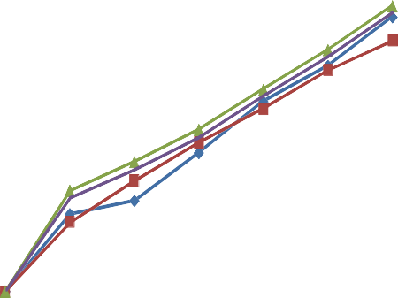

14

12

10

F1

F2

8 F3

6

4

2

F4

F5 F6 F7 F8

0

0

5

10

15

20

25

30

35

**Fig. No. 08 : Comparison of dissolution of Mouth Dissolving Films**

## Conclusion

Oral fast disintegrating thin films of sumatriptan succinate with fast disintegration time and suitable mechanical strength for treatment of migraine disease were prepared. Average daily dose of sumatripton 10mg 2 to 3 divided doses.The film can be formulated using HPMC K15 hydrophillic polymer bases of the film, while glycerine were used as plasticizer and Polysorbate 80 as emulsifying agent, additionally citric acid as a taste stimulating agent.

The uniformity invitro disintegration time, drug release, folding endurance, tensile strength, thickness and percentage elongation were examined. The invitro result showed that 94%. Sumatriptan was released Within 30min with mean disintegration time of 32sec. Result of the stability studies indicated that film containing high percentage of polymer and percentage of plasticizer and emulsifier become brittle after storing at high temperature. Physical changes were not observed in the formulation F7 and F8.These films (F7 & F8) that contain HPMC (300mg) in low level and tween 80 (40mg) in high level was found to be suitable for film with desirable physiochemical properties, faster disintegration and optimum invitro release. Therefore, sumatriptan can be conveniently administered orally in the form of films with lesser occurrence of its side effects and with improved bio availability.

## References

1. Suresh B. Borsadia, David O’ Halloran, and James L. Osborne, Quick Dissolving Films – A Novel Approach To Drug, Delivery, [www.drugdeliverytech.com](http://www.drugdeliverytech.com/)
2. Robert M. Silver stein., Spectrometric Identification Of Organic Compounds, 6th edition, 120 – 143.,Publisher :John Wiley and Sons,Inc., New York.
3. [www.aquafilm.com](http://www.aquafilm.com/)
4. Zerbe, Horst George, Guo, Jian-Hwa, Serino, United States Patent No: 6,592,887, 5th June 2002.
5. Reddy M.N., Murthy T.K and Shanthakumar., Indian Drugs, Jan – 2002, 39(1), 39 –40.
6. Kusum Devi and Dr.K.L.K.Paranjothy., The Eastern Pharmacist, May – 1998, Vol 41,No.485, 97 – 100.
7. S.Raghuraman, G.Velrajan, R.Ravi, B.Jeyabalan and D.Benito Johnson, Indian Journal of Pharmaceutical Sciences, Jan – Feb 2002, 64 (1), 32 –36.
8. L.Panigrahi and S.K.Ghosol., Indian Journal Of Pharmaceutical Sciences, Jan– Feb 2002, 64 (1), 79 – 82.
9. Rawat S and Jain S.K., Indian Drugs, July 2003, 40(7), 416 – 418.
10. Pharmacist Drug Hand Book, Publisher: American Society of Health System Pharmacists, Bethesda, Maryland, 1010 – 1012.
11. Alfred Martin., James Swarbrik., Physical Pharmacy, 3rd edition, Publisher: Henry Kimpton, London, 272 –273.