# 206

***Research Article***

**Available Online at:** [**www.ijpir.com**](http://www.ijpir.com/)



International Journal of Pharmacy and Industrial Research

**ISSN**

**Print 2231 – 3648**

**Online 2231 – 3656**

**FORMULATION AND EVALUATION OF MOUTH DISSOLVING TABLETS OF TELMISARTAN BY SOLID DISPERSIONS TECHNIQUE**

# *Wasiq A khan, Barhate S D, Bari M M, Patil P P

Shree Sureshdada Jain Institute of Pharmaceutical Education & Research Jamner, District - Jalgaon, Maharashtra, India – 424 206.

## Abstract

Telmisartan (TLM) is an angiotensin II receptor antagonist used in the treatment of hypertension. Due to sudden onset of attack, it is necessary to formulate anti hypertensive drug into such a delivery system, which provide immediate relief. The aim of present investigation was to prepare Mouth dissolving tablets of an Anti hypertensive drug Telmisartan. The solubility of poorly soluble drug was enhanced by preparing solid Dispersions of the drug with Poloxamer 407 & PEG 3350 in various concentrations by Kneading method. The optimized solid Dispersions (Drug: Poloxamer 407, 1:3 ratio) were further kneaded with suitable proportions of superdisintegrants such as; Crosscarmellose, Sodium starch glycolate and Crosspovidone. Mouth dissolving tablets of Telmisartan was prepared by direct compression method. The pre-compressive parameters for the blends and post-compressive parameters for the prepared tablets were evaluated. All formulations showed desired pre and post-compressive characteristics. FTIR study showed no evidence of drug excipient interaction. The optimized formulation was found to be F6. It was concluded that Mouth dissolving tablets of Telmisartan can be prepared by solid Dispersions of drug with Poloxamer 407 and combination of superdisintegrants provide complete and better dissolution within in shorter period of time. Hence effective Hypertensive treatment anywhere, and anytime particularly for geriatric, pediatric, mentally ill, bedridden and patients who do not have easy access to water.

**Keywords:** Telmisartan, Poloxamer 407, PEG 3350, Superdisintegrants, Kneading method, Mouth dissolving tablets.

## Introduction

An ideal dosage regimen in the drug therapy of any disease is the one, which immediately attains the desire therapeutics concentration of drug in plasma (or at the site of action) and maintains it constant for the entire duration of treatment. To fulfill these medical needs, formulators have devoted considerable efforts for developing a novel type of dosage form for oral administration known as

mouth dissolving tablets (MDT).1,2 It is define as “a tablet that disintegrates and dissolves rapidly in the saliva within a few seconds without the need of drinking water or chewing.” A mouth dissolving tablet usually dissolves in the oral cavity within 15 s to 3 min. Most of the MDTs include certain superdisintegrants and taste masking agents.3

### Author for Correspondence:

Wasiq A khan,

Shree Sureshdada Jain Institute of Pharmaceutical Education & Research Jamner, District - Jalgaon, Maharashtra, India – 424 206.

E-mail: [wasique.1030@rediffmail.com](mailto:wasique.1030@rediffmail.com)

Wasiq A khan. et al., Int. J. Pharm & Ind. Res., Vol.–03 (02) 2013 [206 - 216]

207

‘Fast Dissolve’, ‘Quick Dissolve’, ‘Rapid Melt’, ‘Quick Disintegrating’, ‘Mouth Dissolving’, ‘Orally Disintegrating’, ‘Oro Dispersible’, ‘Melt-in-Mouth’ etc. are terms that represent the same drug delivery systems.4

Telmisartan is chemically described as 4'-[(1,4'- dimethyl-2'-propyl [2,6'-bi-1H-benzimidazol]-1'- yl)methyl]- [1,1'-biphenyl] -2-carboxylic acid. Telmisartan is practically insoluble in water and in the pH range of 3 to 9, sparingly soluble in strong acid (except insoluble in hydrochloric acid), and soluble in strong base. TLM is an angiotensin II receptor antagonist and is widely used in the management of hypertension to reduce cardiovascular motility in patients with left ventricular dysfunction following myocardial infarction and in the management of heart failure.5,6 In the present study an attempt will be made to formulate mouth dissolving tablets of Telmisartan.

The present study was intended to select the best possible diluents-disintegrant combination to formulate rapidly disintegrating tablets. Direct compression method was employed to formulate the tablets, because of its cost effectiveness and due to reduced number of manufacturing steps. In the present work an attempt is done to prepare solid Dispersions of drug with Poloxamer 407 and PEG 3350 using kneading method. The best solid Dispersions will be incorporated in to mouth dissolving tablet using superdisintegrants like crosscarmellose sodium, sodium starch glycolate & crosspovidone.

## Materials and Methods

Telmisartan, Poloxamer 407 and PEG 3350 were obtained as gift samples from Viraj Pharma Pvt. Ltd. Mumbai. Crosscarmellose sodium and Crospovidone was obtained from FMC Biopolymer, Mumbai. Sodium starch glycolate and other excipient were obtained from Haffkin Ajintha, Jalgaon.

### Preparation of Telmisartan Solid Dispersions by Physical mixing

Physical mixtures were prepared by mixing pre- weighed quantity of Telmisartan and carriers (Poloxamer 407, PEG 3350) in 1:1, 1:2, 1:3 and 1:4, ratios. Four batches of drug: carrier in different ratios was prepared.

### Preparation of Telmisartan Solid Dispersions by kneading method

Solid Dispersions was prepared by kneading method. The different ratio of drug with PXM 407 & PEG 3350 was prepared like 1:1, 1:2, 1:3 and 1:4 respectively in a mortar with methanol and water mixture (1:1, by volume). Then kneaded the wet mixture thoroughly with a pestle to obtain a paste like consistency. The paste was then dried under vacuum at room temperature, pulverized by passing through sieve no. 80 and stored in a dessicator till further use.17

### Evaluation parameters for Solid Dispersions13, 17

**Practical Yield**

Solid Dispersions were collected and weighed to determine practical yield (PY) from the following equation.

Practical Mass (Solid Dispersions)

PY (%) = ×100

Theoretical Mass (Drug + carrier)

### Drug content

Equivalent to 10 mg of the drug was weighed accurately, dissolved in methanol and suitably diluted with phosphate buffer solution of pH 6.8. The content of Telmisartan was determined spectrophotometrically at 296 nm against blank using UV-visible spectrophotometer (Shimadzu).

### Solubility study

The apparent solubility of solid Dispersions of Telmisartan with Poloxamer 404 & PEG 3350 was determined in distilled water & Phosphate buffer pH 6.8 at 37◦C. Each solid Dispersions equivalent to 10 mg was added to 10 ml of solvent in glass vials with rubber closures. Then the vials were kept in an Shaking incubator at 37± 0.5° C for 24 hr. After shaking, the vials were kept in an shaking incubator at 37± 0.5° C for equilibrium for 12 hr. The solution was then filtered through 0.45mcm filter paper and the filtrate was assayed Spectrophotometrically at 296 nm.

***In Vitro* Dissolution Studies of Solid Dispersions** The quantity of solid Dispersions equivalent to 40 mg of Telmisartan was placed in dissolution medium. The dissolution study of solid Dispersions was conducted using dissolution testing apparatus II (paddle method) in 900 ml of phosphate buffer solution of pH 6.8 at 37ºC and at a speed of

# 208

Wasiq A khan. et al., Int. J. Pharm & Ind. Res., Vol.–03 (02) 2013 [206 - 216]

50 rpm. Aliquots of 5 ml was withdrawn at predetermined time interval and equivalent amount of fresh medium was replaced to maintain a constant volume after each sampling and analyzed spectrophotometrically at 296 nm against suitable blank using UV-visible spectrophotometer (Shimadzu).

### Drug carrier compatibility study

**Fourier Transform infrared spectroscopy (FTIR)**

The drug-carrier mixtures of Telmisartan were prepared in the form of KBr pellets and subjected for scanning from 4000 cm-1 to 400 cm-1 using FTIR spectrophotometer.

**Differential scanning calorimetry (DSC)** Approximately 2 mg of telmisartan or drug-carrier mixture was taken in aluminium pan, sealed with aluminium cap and kept under nitrogen purging (atmosphere). Both the samples were scanned from 50-400 °C with the scanning rate of 10 °C rise/min using differential scanning calorimeter.

### Preparation of Tablet Blend of Mouth Dissolving Tablets

The composition of preliminary trial batches of mouth dissolving tablets of Telmisartan were shown in table 04. Solid Dispersions of Telmisartan, Crospovidone, crosscarmellose sodium, Sodium starch glycolate, Pearlitol SD 200, MCC PH 102 and Aspartame were passed through sieve #22, while talc and magnesium stearate were passed through sieve #60. Firstly, all the ingredients were mixed with the help of mortar and pestle. Magnesium stearate and Talc were finally added as lubricants. The blend was compressed into 250 mg weight of hardness 2.0 - 2.5kg/cm2 using 9 mm flat-faced punch on a tablet punching machine.

### Evaluation Parameters for Mouth Dissolving Tablets of Telmisartan

**Precompression parameters**

The prepared powder mixtures were evaluated for the blend property like bulk density, tapped density, Carr’s index, angle of repose and Hausner’s ratio.

hardness, friability, drug content, in vitro Dispersions time, water absorption ratio, wetting time & in vitro drug release studies.

### Thickness8

Thickness of tablets indicates the strength to withstand compression force applied during manufacturing process. Thickness of tablets was measured by digital caliper.

### Hardness Test8

The hardness was tested using Monsantotester. “Hardness factor”, the average of the six determinations, was determined and reported. The force was measured in kilograms per centimeter square.

### Weight Uniformity Test10

Twenty tablets were weighed individually and all together. Average weight was calculated from the total weight of all tablets. The individual weights were compared with the average weight. The percentage difference in the weight variation should be within the permissible limits (±7.5%).

### Friability 12

Friabillator consist of a plastic-chamber that revolves at 25 rpm, dropping those tablets at a distance of 6 inches with each revolution. The tablets were rotated in the friabillator for at least 4 minutes. At the end of test tablets were dusted and reweighed, the loss in the weight of tablet is the measure of friability and is expressed in percentage as:

%Friability = initial weight- final weight/initial weight x 10

### Water absorption ratio13

It was tested by using double folded tissue paper and the Petri dish contains 6ml of Saliva buffer pH

6.8. Firstly randomly taken tablets form the all formulations weight was calculated it was denoted as Wb and then the tablets were allowed to place on the tissue paper. After completely wet of the tablet weight was calculated and it was denoted as Wa. And by using the following formula water absorption ratio (R) was measured.

R = 100 { (Wa – Wb) / Wb}

### Post-compression parameters

The tablets after punching of every batch were eval uated for in-process and finished product quality control tests i.e. thickness, weight uniformity test,

Where,

Wb = Weight of tablet before absorption Wa = Weight of tablet after absorption.

### Wetting time12

Wasiq A khan. et al., Int. J. Pharm & Ind. Res., Vol.–03 (02) 2013 [206 - 216]

### Solubility

209

Simple tissue paper (12 cm X 10.75 cm) folded twice was placed in a small Petri dish (Internal Diameter = 6.5 cm) containing 6 ml of Phosphate buffer pH 6.8. A tablet was put on the paper, and the time for complete wetting was measured.

### Uniformity of Drug Content 15

Five tablets of each type of formulation were weighed and crushed in mortar and powder equivalent to 40 mg of Telmisartan was weighed and dissolved in 100 ml of Phosphate buffer (pH 6.8) This was the stock solution from which 1 ml sample was withdrawn and diluted to 10 ml with Phosphate buffer (pH 6.8). The absorbance was measured at wavelength 296 nm using UV-Visible spectrophotometer.

Content uniformity was calculated using formula:

% Purity = 10 C (Au / As) Where, C - Concentration

Au and As = Absorbance of unknown and standard respectively.

### Disintegration Time 15

Initially the disintegration time for Orodispersible tablets was measured using the conventional test for tablets as described in the Pharmacopoeia. Tablets required for complete disintegration that is without leaving any residues on the screen was recorded as disintegration time.

***In vitro* drug release study of tablets 15**

*In vitro* release of the tablets was conducted using USP dissolution apparatus II (Electrolab, Mumbai) at 75 rpm, using Phosphate buffer pH 6.8 as a dissolution media maintained at 37±0.5°. Samples were withdrawn at various time intervals, filtered through a 0.45 micron membrane filter, diluted and assayed at 296 nm, using an UV/VIS spectrophotometer.

**Result and discussion**

### Preparation of Solid Dispersions

In the present investigation the solubility of poorly water soluble Telmisartan was enhanced by preparing solid Dispersions with Poloxamer 407 (Kneading method). The drug and carrier ratio of 1:1, 1:2, 1:3 and 1:4 were used for preparation of solid Dispersions by Kneading method to enhance the solubility of TEL.

The solubility of TEL in water was reported as 4.69µg/ml, therefore, TEL can be considered as a practically insoluble drug. According to observations obtained from the solubility analysis of physical mixture of drug and carrier, there were significant changes in the solubility of drug as compared to that of pure drug in distilled water. The solubility values of physical mixtures for drug and carrier Poloxamer 407 in ratios 1:1, 1:2, 1:3

and 1: 4 were found to be 20.10, 20.00, 21.60, and 21.01µg/ml, respectively in distilled water. Similarly, the solubility values of physical mixtures for drug and carrier PEG 3350 in ratios 1:1, 1:2, 1:3 and 1:4 were found to be 19.09, 19.60, 18.62 and 19.14µg/ml, respectively in Distilled water. The increase in Solubility rate is in the order of PLX 407 > PEG 3350.

**Drug content and % Yield of solid Dispersions** The percent drug content was found to be 92±2% for all the solid Dispersions formulations. The % Yield was found to be 87.50±4% for all the solid Dispersions formulations.

### In-Vitro Dissolution Study

In vitro release studies reveal that there is marked increase in the dissolution rate of Telmisartan from all the solid Dispersions when compared to pure Telmisartan itself. The increase in dissolution rate is in the order of PLX 407 > PEG 3350. From the in vitro drug release profile, it can be seen that formulation A3 containing PLX 407 (1:3 ratio of drug: PLX 407) shows higher dissolution rates. This may be attributed to the increase in the wettability, conversion to amorphous form and solubilisation of the drug due to hydrophilic carrier. But as the amount of PLX 407 is increased (1:4 ratio of drug: PLX 407) in formulation, the dissolution rate was decreased. This might be due to formation of viscous layer around the drug particles leading to decrease in the dissolution rate. So, formulation ratio 1:3 (A3) was selected for further studies and tablets were formulated.

### Fourier Transform Infra-Red Studies

FT-IR spectroscopic studies conducted for possible drug: carrier interactions. FT-IR spectra of pure drug Telmisartan, Poloxamer 407 and Solid Dispersions which are as shown in figure 02 & 03 indicating no significant evidence of chemical interaction between drug and carrier, which

# 210

Wasiq A khan. et al., Int. J. Pharm & Ind. Res., Vol.–03 (02) 2013 [206 - 216]

confirms the stability of drug with its Solid Dispersions.

### DSC Thermogram

DSC was used to assess the thermal behavior of the drug (TLM) and its solid Dispersions prepared. In figure, DSC thermogram of telmisartan shows a single sharp characteristic endothermic peak (Tpeak = 269.06°C) corresponding to its melting, indicating its crystalline nature and a single peak indicates that the drug sample is free from impurities.

However, the characteristic endothermic peak corresponding to drug melting was broadened and shifted toward lower temperature with reduced intensity in the solid Dispersions prepared by kneading method (Figures 04 & 05). This could be attributed to higher polymer concentration and uniform distribution of drug in the crust of carrier, resulting in complete miscibility of drug in the carrier.

### Preparation and Evaluation of Mouth Dissolving Tablets

Appropriate quantity of solid Dispersions was blended with superdisintegrants. After adding filler, sweetener, glident and lubricating agent; Mouth dissolving tablets were prepared by direct compression method. The super-disintegrants i.e., Crospovidone, Croscarmellose sodium and Sodium starch glycolate were taken in various ratios to find the optimum concentration of the super- disintegrants required to yield formulation having least wetting time and disintegration time.

### Pre-compressive parameters

* The values for angle of repose were found in the range of 25.74 to 27.59°.
* Loose bulk and tapped densities of the blend was found as 0.68 to 0.74 and 0.74 to 0.80 (g/ml) respectively.
* Carr’s index of the prepared blends falls in the range of 7.14 to 9.85 **%** and this is also supported by Hausner’s factor values which were in the range of 1.07 – 1.09**.** Hence the prepared

blends possessed good flow properties and can be used for manufacturing of tablets by Direction compression method.

### Post-compressive parameters

The hardness of tablets was found to be 2.0 to 2.6 kg/cm2. All the tablets shows % friability in the range of 0.66-0.85 % which is within the limit. All the formulations passes the weight variation test as all tablets within the range limit for weight variation. The disintegration time is very important and it is desired to be less than 1 minute. The quick disintegration may assist quick swallowing and drug absorption inbuccal cavity, thus greater bioavailability of the drug. The disintegration time was found 37 to 53 sec. The Wetting time is the indicator for the ease of disintegration of the tablet in buccal cavity.

It was observed that wetting time of tablets was in the range of 30 to 47 seconds. Assay for the prepared formulations was performed to determine drug content uniformity and it was found between 97.10 to 99.50 %.

### In-vitro drug release study

Finally, the tablets were evaluated for *in vitro*

dissolution studies in phosphate buffer solution pH

6.8. Among all the formulations F1 to F3 prepared with different concentration of superdisintegrant (Crosscarmellose sodium) showed 89.39% to 97.84% drug release within 30 min and F4 to F6 prepared with different concentration of superdisintegrant (Sodium starch glycolate) showed 92.69% to 98.78% drug release within 30 min and formulations F7 to F9 prepared with different concentration of superdisintegrant (Crosspovidone) showed 89.56% to 95.26% drug release within 30 min respectively. This result suggests a direct relationship of concentration of superdisintegrants with drug release.

As the amount of superdisintegrant increases in the acceptable range, the drug release also increases. Among all the formulations F6 showed maximum Drug Release 98.78%, Prepared by using SSG as a superdisintegrant.

Wasiq A khan. et al., Int. J. Pharm & Ind. Res., Vol.–03 (02) 2013 [206 - 216]

211

### Table No. 01: Solid Dispersions of Telmisartan with Poloxamer 407 and PEG 3350 prepared by Kneading method.

**Formulation**

|  |  |  |  |  |
| --- | --- | --- | --- | --- |
| **code** |  | **Drug** | **Poloxamer 407** | **PEG 3350** |
| A1 | Kneading method | 100 | 100 | - |
| A2 | Kneading method | 100 | 200 | - |
| A3 | Kneading method | 100 | 300 | - |
| A4 | Kneading method | 100 | 400 | - |
| B1 | Kneading method | 100 | - | 100 |
| B2 | Kneading method | 100 | - | 200 |
| B3 | Kneading method | 100 | - | 300 |
| B4 | Kneading method | 100 | - | 400 |

**Method of preparation Content (mg)**

### Table No. 02: Characterization of Solid Dispersions prepared by kneading method

|  |  |  |  |
| --- | --- | --- | --- |
| **Formulation code** | **% Yield** | **%Drug content** | **Solubility µg/ml** |
| A1 | 85.00 | 92.01 | 20.10 |
| A2 | 87.50 | 91.56 | 20.00 |
| A3 | 90.12 | 94.40 | 21.60 |
| A4 | 89.00 | 93.90 | 21.01 |
| B1 | 84.37 | 91.60 | 19.09 |
| B2 | 82.11 | 92.90 | 19.60 |
| B3 | 89.18 | 92.60 | 18.62 |
| B4 | 91.11 | 93.11 | 19.14 |

**Table No. 03: In – vitro dissolution profile of TEL, TEL: PLX 407 & TEL: PEG 3350 Solid Dispersions prepared by Kneading method in Phosphate buffer (pH 6.8)**

**% Drug dissolved**

|  |  |  |  |  |  |  |  |  |  |  |
| --- | --- | --- | --- | --- | --- | --- | --- | --- | --- | --- |
| Sr.no | Time (min) | Pure drug | A1 | A2 | **A3** | A4 | B1 | **B2** | B3 | B4 |
| 1. | 05 | 38.78 | 40.01 | 55.13 | **60.72** | 59.70 | 50.11 | **58.78** | 59.33 | 58.13 |
| 2. | 15 | 45.80 | 48.35 | 60.19 | **68.20** | 65.91 | 54.35 | **64.11** | 64.00 | 60.11 |
| 3. | 30 | 55.80 | 58.11 | 64.44 | **75.45** | 74.33 | 59.19 | **73.23** | 72.11 | 68.45 |
| 4. | 60 | 60.40 | 61.34 | 69.24 | **80.11** | 75.51 | 63.28 | **76.11** | 74.09 | 71.39 |
| 5. | 120 | 68.69 | 70.11 | 76.36 | **86.70** | 82.33 | 69.97 | **81.19** | 78.38 | 72.19 |

*A1-A4 = In vitro Drug release of TEL: PLX 407 Solid Dispersions

*B1-B4 = In vitro Drug release of TEL: PEG 3350 Solid Dispersions

### Table No. 04: Formula for Mouth Dissolving tablets of Telmisartan.

|  |  |  |  |  |  |  |  |  |  |
| --- | --- | --- | --- | --- | --- | --- | --- | --- | --- |
|  | **F1** | **F2** | **F3** | **F4** | **F5** | **F6** | **F7** | **F8** | **F9** |
| SD eq. to 40mg TEL | 160 | 160 | 160 | 160 | 160 | 160 | 160 | 160 | 160 |
| Pearlitol SD 200 | 36.5 | 30.5 | 40 | 36.5 | 30.5 | 40 | 36.5 | 30.5 | 40 |
| MCC PH-102 | 36.5 | 40 | 28 | 36.5 | 40 | 28 | 36.5 | 40 | 28 |
| Crosscarmellose sod. | 7.5 | 10 | 12.5 | - | - | - | - | - | - |
| Sodium Starch Gly. | - | - | - | 7.5 | 10 | 12.5 | - | - | - |
| Crosspovidone | - | - | - | - | - | - | 7.5 | 10 | 12.5 |
| Aspartame | 5 | 5 | 5 | 5 | 5 | 5 | 5 | 5 | 5 |
| Magnesium Stearate | 1.5 | 1.5 | 1.5 | 1.5 | 1.5 | 1.5 | 1.5 | 1.5 | 1.5 |
| Talc | 2.5 | 2.5 | 2.5 | 2.5 | 2.5 | 2.5 | 2.5 | 2.5 | 2.5 |
| Aerosil | 0.5 | 0.5 | 0.5 | 0.5 | 0.5 | 0.5 | 0.5 | 0.5 | 0.5 |
| Average weight | 250 | 250 | 250 | 250 | 250 | 250 | 250 | 250 | 250 |

**Ingredients Batches**

***\*All quantities are in mg***

# 212

Wasiq A khan. et al., Int. J. Pharm & Ind. Res., Vol.–03 (02) 2013 [206 - 216]

### Table No. 05: Precompression parameters of priminary trial batches of Mouth dissolving tablet of Telmisartan

|  |  |  |  |  |  |  |  |  |  |  |  |  |
| --- | --- | --- | --- | --- | --- | --- | --- | --- | --- | --- | --- | --- |
| **Parameters** | | **F1** | **F2** | **F3** | | **F4** | **F5** | **F6** | **F7** | **F8** | **F9** |  |
| Bulk Density (mg/ml) | | 0.68 | 0.71 | 0.74 | | 0.70 | 0.73 | 0.74 | 0.73 | 0.71 | 0.72 |
| Tapped Density (mg/ml) | | 0.74 | 0.78 | 0.80 | | 0.75 | 0.79 | 0.80 | 0.79 | 0.77 | 0.79 |
| Hausner’s ratio | | 1.08 | 1.09 | 1.08 | | 1.07 | 1.08 | 1.08 | 1.08 | 1.08 | 1.09 |
| Carr’s Index (%) | | 8.82 | 9.85 | 8.10 | | 7.14 | 8.21 | 8.10 | 8.21 | 8.45 | 9.72 |
| Angle of repose (degree) | | 27.59 | 25.74 | 26.31 | | 25.85 | 27.59 | 26.71 | 26.31 | 25.74 | 25.93 |
| **Table No. 06: Physical parameters of Telmisartan Mouth Dissolving tablets** | | | | | | | | | | | |
| **Evaluation**  **parameters** | **F1** | **F2** | **F3** | **F4** | | | **F5** | **F6** | **F7** | | **F8** | **F9** |
| wt. variation (mg) | 249 | 250 | 251 | | 249 | | 248.5 | 250 | 249.5 | | 248 | 250 |
| Thickness (mm) | 2.62 | 2.63 | 2.54 | | 2.37 | | 2.43 | 2.64 | 2.52 | | 2.31 | 2.63 |
| Hardness (kg/cm2) | 2.1 | 2.0 | 2.2 | | 2.4 | | 2.3 | 2.0 | 2.2 | | 2.6 | 2.2 |
| % Friability (%) | 0.80 | 0.85 | 0.72 | | 0.65 | | 0.79 | 0.66 | 0.72 | | 0.69 | 0.83 |
| Content uniformity (%) | 98.72 | 98.99 | 99.21 | | 99.09 | | 98.23 | 99.34 | 98.72 | | 98.21 | 98.90 |
| Wetting time (sec) | 47±1.00 | 38±1.15 | 32±2.00 | | 45±1.00 | | 40±1.15 | 30±1.00 | 39±1.15 | | 35±2.00 | 36±1.00 |
| Water absorption ratio  (%) | 81.08 | 85.02 | 87.63 | | 63.08 | | 65.33 | 90.01 | 86.63 | | 83.02 | 82.10 |
| Disintegration time  (sec) | 53 | 43 | 40 | | 51 | | 46 | 37 | 43 | | 41 | 42 |
| % Drug content | 97.10 | 98.30 | 98.75 | | 98.00 | | 95.80 | 99.50 | 97.50 | | 97.90 | 98.75 |

**Table No. 07: In-vitro release study of Mouth dissolving tablets of Telmisartan**

**% Drug Release**

|  |  |  |  |  |  |  |  |  |  |
| --- | --- | --- | --- | --- | --- | --- | --- | --- | --- |
| **Time (sec)** | **F1** | **F2** | **F3** | **F4** | **F5** | **F6** | **F7** | **F8** | **F9** |
| 00 | 00 | 00 | 00 | 00 | 00 | 00 | 00 | 00 | 00 |
| 05 | 50.92 | 58.71 | 59.43 | 51.48 | 57.62 | 62.25 | 54.87 | 56.03 | 57.07 |
| 10 | 63.04 | 69.75 | 70.57 | 65.09 | 70.29 | 70.95 | 68.10 | 68.92 | 70.24 |
| 15 | 77.81 | 82.37 | 85.55 | 80.45 | 84.62 | 85.77 | 81.71 | 82.31 | 85.06 |
| 20 | 87.14 | 93.18 | 95.65 | 90.88 | 95.03 | 97.02 | 87.42 | 88.84 | 92.74 |
| 25 | 88.78 | 96.58 | 96.58 | 92.58 | 96.18 | 98.17 | 88.90 | 89.89 | 93.45 |
| 30 | 89.39 | 97.02 | 97.84 | 92.69 | 96.68 | 98.78 | 89.56 | 90.00 | 95.26 |

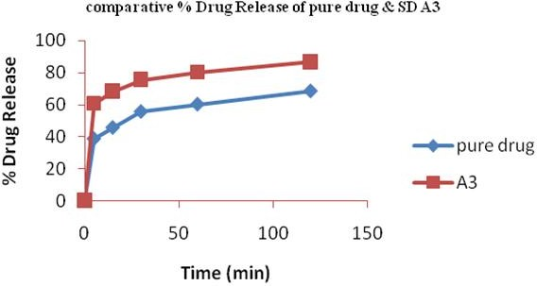

### Fig. No. 01: Comparative Drug release of pure drug and solid dispersions of TEL: PLX 407 (A3)

Wasiq A khan. et al., Int. J. Pharm & Ind. Res., Vol.–03 (02) 2013 [206 - 216]

213

2 0 0

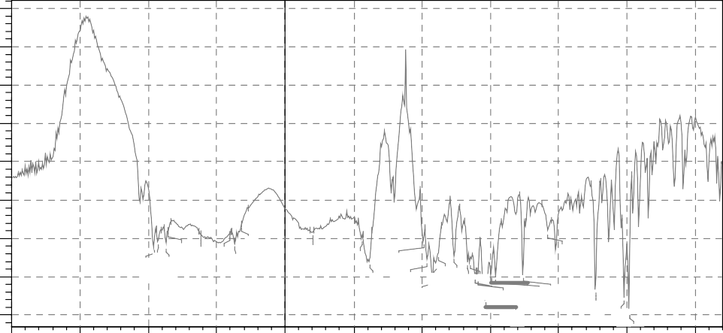

% T

1 8 0

1 6 0

1 4 0

1 2 0

1 0 0

8 0

2 4 0 5 .3 1

2 3 6 7 .7 0

2 3 1 5 .6 2

1 8 9 8 .9 8

6 0

2 9 5 6 .0 1

2 9 2 6 .1 1

2 8 6 9 .2 1

2 8 5 1 .8 5

2 6 1 5 .5 6

1 7 1 9 .6 0

1 6 9 3 .5 6

1 4 9 4 .8 8

1 4 8 2 .3 4

1 4 6 1 .1 3

1 4 4 8 .5 9

1 4 4 0 .8 7

1 3 8 2 .0 4

1 3 3 2 .8 6

1 3 2 3 .2 1

1 3 0 4 .8 9

1 2 9 6 .2 1

8 .2 4

1 2 4 7 .0 2

1 2 3 0 .6 3

1 1 2 9 .3 6

1 0 3 9 .6 7

4 0

8 6 4 .1 4

5 9 .0 1

4 0 0 0

3 5 0 0

3 0 0 0

2 5 0 0

2 0 0 0

1 7 5 0

1 5 0 0

1 2 5 0

1 0 0 0

7 5 0

5 0 0

T e lm is a r t a n , C O P S H A H A D A

### Fig. No. 02: FTIR spectrum of Telmisartan

1 / c m

1 6 5

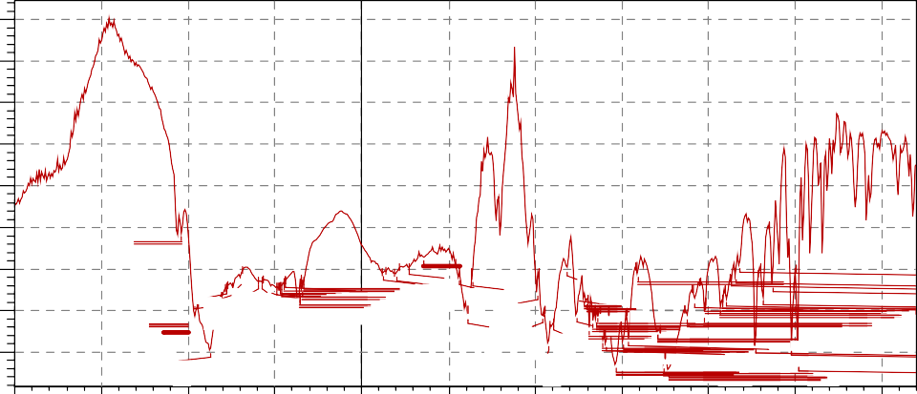

% T 1 5 0

1 3 5

1 2 0

1 0 5

9 0

7 5

3 0 3 7 . 0 2

1 8 1 8 . 9 3

1 7 2 0 . 5 6

6 0

2 9 5 6 . 0 1

2 9 2 5 . 1 5

6 8 . 2 4

2 8 0 4 . 5 9

2 7 7 5 . 6 6

2 7 3 8 . 0 5

2 6 9 4 . 6 5

2 5 9 6 . 2 7

2 5 7 5 . 0 5

2 5 1 9 . 1 2

2 4 8 5 . 3 6

2 4 6 9 . 9 3

2 4 6 1 . 2 5

2 4 4 2 . 9 3

2 4 3 6 . 1 8

2 3 5 5 . 1 6

2 3 4 0 . 7 0

2 3 2 9 . 1 2

1 9 3 6 . 6 0

1 8 9 8 . 9 8

1 8 6 1 . 3 7

1 6 8 2 . 9 5

1 4 9 4 . 8 8

1 4 8 0 . 4 2

1 4 0 ~~9~~ . 0 5

1 3 7 2 . 4 0

1 3 5 9 . 8 6

1 3 5 2 . 1 4

1 2 0 4 . 5 9

1 0 6 0 . 8 8

1 0 4 0 . 6 3

1 0 1 1 . 7 0

1 0 0 7 . 8 4

9 6 4 . 4 4

4 5

1 6 9 4 . 5 2

1 4 6 3 . 0 6

1 4 4 7 . 6 2

1 3 8 1 . 0 8

1 3 4 3 . 4 6

1 3 3 2 . 8 6

1 3 2 4 . 1 8

1 3 1 8 . 3 9

1 3 0 4 . 8 9

2 9 6 . 2 1

2 4

1 2 4 7 . 0 2

1 2 3 0 . 6 3

1 1 4 7 . 6 8

6

4 0 0 0

3 5 0 0

3 0 0 0

2 5 0 0

2 0 0 0

1 7 5 0

1 5 0 0

1 2 5 0

1 0 0 0

7 5 0

5 0 0

T e l m i s a r t a n + S D w i t h P o l a x o m e r , C O P S H A H A D A

### Fig. No. 03: FTIR spectrum of SD of TEL with PLX 407

1 / c m

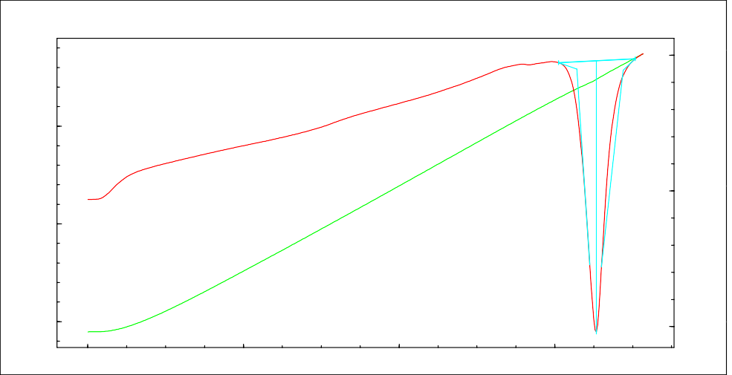

DSC

mW

Thermal Analysis Result

Temp C

300.00

5.00

File Name: Detector: Acquisition Date Acquisition Time Sample Name: Sample Weight: Annotation:

Telmisartan.tad DSC60 13/05/06

11:59:26

Telmisartan 4.040[mg]

Start

End

0.00

Peak Onset Endset Heat

Height

268.49 0xC10

297.96 0xC10

282.13 0Cx10

275.24 0Cx10

293.24 0Cx10

-254.52 0xm1J0

-63.00 0Jx/1g0

-13.88 0mx1W0

200.00

-5.00

100.00

0.00

2.00

4.00

6.00

Time [min]

**Fig. No. 04: DSC thermograms of Telmisartan**

# 214

Wasiq A khan. et al., Int. J. Pharm & Ind. Res., Vol.–03 (02) 2013 [206 - 216]

|  |  |  |  |  |  |  |  |  |
| --- | --- | --- | --- | --- | --- | --- | --- | --- |
| DSC Thermal Analysis Result Temp  mW C | | | | | | | | |
|  | File Name: Detector: Acquisition Date Acquisition Time Sample Name: Sample Weight: Annotation: | Solid Dispersion of Telmisartan.tad DSC60  13/05/06  12:13:47  Solid Dispersion of Telmisartan 7.290[mg] |  |  |  | Start End Peak Onset Endset Heat  Height | 251.64 0xC10  264.24 0Cx10  264.24 0xC10  252.58 0xC10  257.42 0Cx10  -7.23 0xm1J0  -0.99 0Jx/1g0  0.00 0mx1W0 |  |
|  | 300.00 |
| 8.00 |  |
| 6.00 |  |
|  | 200.00 |
| 4.00 |  |
| 2.00 |  |
| 0.00 | 100.00 |
|  | 0.00 | 2.00 | Time | [min] | 4.00 | 6.00 |  |  |

### Fig. No. 05: DSC thermograms of solid dispersions with PLX 407

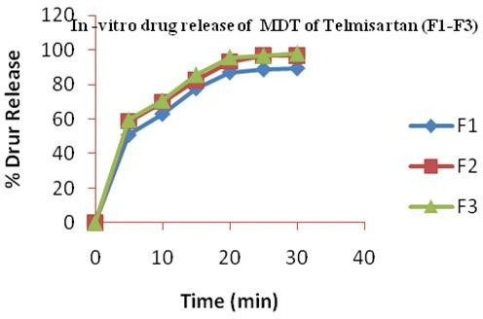

**Fig. No. 06: In-vitro drug release study of Mouth dissolving tablets of Telmisartan prepared by using Crosscarmellose sodium as a Superdisintegrant (F1-F3)**

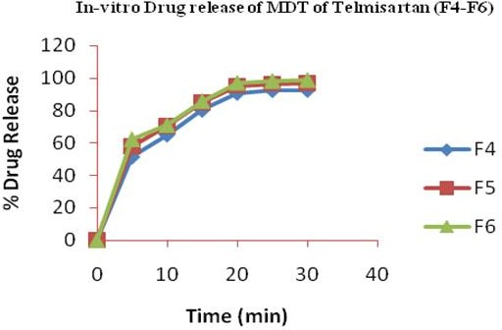

### Fig. No. 07: In-vitro drug release study of Mouth dissolving tablets of Telmisartan prepared by using Sodium Starch Glycolate as a Superdisintegrant (F4-F6)

Wasiq A khan. et al., Int. J. Pharm & Ind. Res., Vol.–03 (02) 2013 [206 - 216]

215

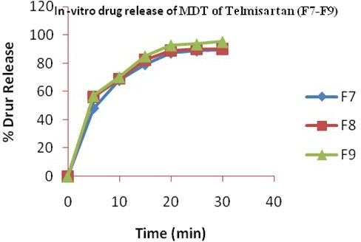

**Fig. No. 08: In-vitro drug release study of Mouth dissolving tablets of Telmisartan prepared by using Crosspovidone as a Superdisintegrant (F7-F9)**

**Conclusion**

From the above studies, it was concluded that the solid Dispersions of the drug (Telmisartan) formulated with the use of various water soluble carriers like (PEG 3350 and Poloxamer 407) in their different ratios prepared with different techniques like Physical mixing and Kneading method showed enhanced solubility and dissolution characteristics in one or many factors. Solubility studies showed increase in solubility of drug in the various carriers used in the study. All the solid Dispersions showed enhanced dissolution as compared to the pure drug, however, Poloxamer

407 came out as the most promising carrier. Fasted

1. Howard C. Ansel., Nichollas G. Popvich., Loyd V. Allen., “Pharmaceutical Dosage forms and Drug Delivery System”, First edition. 1995: 78.
2. Tejvir K., Bhawandeep G., Sandeep K., Gupta G.D., “Mouth Dissolving Tablets: A Novel Approach to Drug Delivery”, International Journal of Current Pharmaceutical Research, Vol- 3, Issue 1, 2011:1-7.
3. Rakesh K.R., “Orally disintegrating tablets: Novel Approach to Drug Delivery”, The Pharma Review 2004; 2(12): 34-36.
4. Tripathi K.D., “Essentials of medical pharmacol

th

ogy”., 6 edition, Jaypee publishers: 489.

drug release was obtained from the solid Dispersions containing TEL: PXM 407 of 1:3 wt/wt ratios prepared by Kneading method. Various compatibility tests like FTIR studies showed no evidence of any chemical interactions between drug and the carrier and DSC studies further provided useful information about the drug and carrier compatibility studies. Formulation of MDT by using Solid Dispersions of TEL is unique technique by which solubility of the drug can be enhanced which is most challenging aspects of the drug delivery. The technique adopted was found to be economical and industrially feasible. Thus, it can be concluded that combination of Solid Dispersions and Superdisintegrants is a promising approach to prepare efficient Mouth Dissolving Tablets of poorly water soluble drug i.e. Telmisartan.

## References

1. Brahmankar D. M., Jaiswal S.B., “Biopharmaceutics & Pharmaceutics”, First Edition, 1995: 335.

1. British Pharmacopoeia., “Medicine and Healthcare Product Regulatory Agency (MHRA)”, 2009: 5872-5877.
2. Rowe R.C., Sheskey P.J., Oven S.C., “Handbook of Pharmaceutical Excipients”, 5th edition, 2006, Pharmaceutical Press, London:506-509, 517-522, 48-50, 663-666.
3. Lachman L., Lieberman H.A., Kanig J., “The theory and practice of Industrial pharmacy”, 2nd edition, 4th Indian reprint, Verghese publishing house, Mumbai, (1991): 293-340.
4. Aulton M.E., “Pharmaceutics, The science of dosage form design”, 2nd edition, Churchill Livingstone, (2007): 197-211.
5. The United State of Pharmacopoeia., (USP 30/NF 25), “the official compendia of standards”, Asian edition, (2007): 643.
6. Indian Pharmacopoeia., 5th edition, vol-1, controller of publication, Ghaziabad, (2007): 177-190.
7. Vijay T., Dhana J., Krishna P., Gokulan P.D.,

“Preparation and Evaluation of Fast Dissolving

# 216

Wasiq A khan. et al., Int. J. Pharm & Ind. Res., Vol.–03 (02) 2013 [206 - 216]

Tablets of Celecoxib”, Journal of Current Pharmaceutical Research 04 (2010): 4-10.

1. Ganji A.R, Balajia., Naveen K.J., Rajesh B.S., Yedla A.C., “Formulation and evaluation of oral fast disintegrating tablets by using Amlodipine besylate solid Dispersions by direct compression method”, Scholars Research Library Der Pharmacia Lettre, 2012, 4 (2):683-694.
2. Raghavendra R., Tarun P., Upendra K., “formulation and evaluation of fast dissolving tablets of Carbamazepine by solid Dispersions method”, IJPT, 2010, Vol.1, (2): 23-37.
3. Vishal D., Gaurav J., Vaibhav J., Sheorey R.V., “Formulation and In-Vitro evaluation of fast dissolving tablets of Telmisartan”,

International Journal Of Pharmacy & Life Sciences, Vol-3, Issue-11, (2012): 2159-2164.

1. Kaushal P., Ashwini R., “Design and Evaluation of Mouth Dissolving Tablets of Anti Hypertensive Drug Telmisartan”, International Journal of PharmTech Research, Vol.4, (2012): 715-724.
2. Sucheta B., Dyandevi M., Mithun V.K., Rajendra D.P., “Solubility enhancement of antihypertensive agent by solid Dispersions technique,” International Journal of Pharmacy & Life Sciences, Vol. 2, Issue 8, 2011: 970- 975.