***Research Article***

**Available Online at:** [**www.ijpir.com**](http://www.ijpir.com/)



International Journal of Pharmacy and Industrial Research

**ISSN**

**Print 2231 – 3648**

**Online 2231 – 3656**

**FORMULATION AND CHARACTERIZATION OF**

**ORO-DISPERSIBLE TABLET OF IRON CHELATING AGENT**

*Pranitha T, Jeyabaskaran M, Dhanalakshmi B, Suresh Kumar P Browns college of pharmacy, Khammam, Ammapalem (Thanikella), Khammam, A.P, India - 507305.

# Abstract

Oral drug delivery remains the preferred route for administration of various drugs. Recent developments in technology, led to the development of Oro-dispersible tablets (ODT’s) with improved patient compliance and convenience. ODT’s are solid unit dosage forms, which disintegrate or dissolve rapidly in the mouth without chewing and water. Dispersible tablets disperse in water within three minutes.The faster the drug into solution, quickly will be the absorption and onset of clinical effects. Deferasirox an oral iron chelator is used in patients suffering from chronic iron over load and treatment of patients with anaemia. Deferasirox is a poorly soluble drug so, ODT’s is prepared to increase the release rate. The present work is carried out by using super disintegrants such as cross povidine, cross carmellose sodium and sodium starch glycolate(SSG). All these formulations are compressed by wet granulation technique. The developed tablets are evaluated for hardness, weight variation, friability, dispersion time, disintegration time and *in -vitro* dissolution studies. Before compression of the granules into tablets, the granules are evaluated for angle of repose, compressibility and hausner’s ratio. It is concluded that dispersible tablets of deferasirox (400mg) with the superdisintegrant crosspovidone, (total weight of tablet-900mg) showed rapid release rate and enhance dissolution. The developed deferasirox ODT’s has better patient compliance and effective therapy.

**Keywords:** Deferasirox, Wet Granulation, Super disintegrant, Dispersible tablet.

# Introduction

Tablet is the most widely used dosage form because of its convenience in terms of administration, compactness and ease of manufacturing. Solid oral dosage forms are most convenient from patient as well as from manufacturing chemist's perspective. They ensure uniformity of dosage, are more robust, have less microbiological issues compared to liquid dosage forms. However immediate release tablets cannot

act as a substitute for suspension. Thus, there is a need for a formulation, which overcomes the problems associated with the swallowing of solid dosage forms and act as a viable substitute for suspensions. One such dosage form is dispersible tablet. Dispersible tablets as defined in Ph. Eur. are uncoated or film coated tablets intended to be dispersed in water before administration giving a homogeneous dispersion. Typically a dispersible

**Author for Correspondence:**

Pranitha T,

Browns college of pharmacy, Khammam, Ammapalem (Thanikella), Khammam, A.P, India - 507305.

E-mail: [jeyabaskar2000@gmail.com](mailto:jeyabaskar2000@gmail.com)

Pranitha T. et al., Int. J. Pharm & Ind. Res., Vol.–03 (02) 2013 [168 - 171]

tablet is dispersed in about 5-15 ml of water (e.g. in a tablespoonful or a glass of water) and the resulting dispersion is administered to the patient. Deferasirox was used as model drug in present study because it is an iron chelator that has been widely used to treat ongoing high levels of iron in the body caused by multiple blood transfusions in certain types of blood diseases (e.g. Thalassemia, Sickle cell disease, Anemia).it is absorbed from the gastrointestinal tract and has a mean elimination half-life (t½) ranged from (8-16 hours).Since the drug is practically insoluble in water, it gives difficulties in formulation of dosage forms to variable dissolution rates. The objective of present study is to formulate Deferasirox dispersible tablets

to deliver with optimum concentration of drug at desired site at specific time for better stability, Rapid onset, achieve better patient compliance.

# Materials and methods

Deferasirox was obtained as a gift sample from NatcoPharma ltd., Hyderabad. Methyl cellulose PH 101,Povidone K30, Magnesium stearate, Talc was supplied by Signet Chemical Corporation, (Mumbai).Sodium starch glycolate, Starch 1500,Sucralose was supplied by KMV Enterprises, Hyderabad. Cross povidoneXL, Aerosol was supplied by Ansul Agencies, Mumbai. All chemicals and solvents were of analytical grade.

**Table No. 01: Various formulations of Oro-dispersible tablet**

|  |  |  |  |  |  |  |  |  |  |
| --- | --- | --- | --- | --- | --- | --- | --- | --- | --- |
| **S.No** | **Ingredient** | **F-1** | **F-2** | **F-3** | **F-4** | **F-5** | **F-6** | **F-7** | **F-8** |
| 1 | Deferasirox | 400 | 400 | 400 | 400 | 400 | 400 | 400 | 400 |
| 2 | Lactose monohydrate | 100 | 100 | 100 | 50 | 50 | 25 | - | - |
| 3 | Cross povidoneXL | 25 | 25 | 50 | 50 | 50 | 100 | 100 | 100 |
| 4 | MCC PH101 | 324.5 | 304.5 | 264.5 | 304.5 | 299.5 | 269.5 | 289.5 | 284.5 |
| 5 | Starch 1500 | - | 20 | 20 | 25 | 25 | 30 | 30 | 30 |
| 6 | Povidone K30 | 25 | 25 | 30 | 35 | 40 | 40 | 45 | 50 |
| 7 | SLS | 6 | 6 | 6 | 6 | 6 | 6 | 6 | 6 |
| 8 | Sucralose | - | - | - | 10 | 10 | 10 | 10 | 10 |
| 9 | Water | q.s | q.s | q.s | q.s | q.s | q.s | q.s | q.s |
| 10 | Color | 0.5 | 0.5 | 0.5 | 0.5 | 0.5 | 0.5 | 0.5 | 0.5 |
| 11 | Aerosil | 9 | 9 | 9 | 9 | 9 | 9 | 9 | 9 |
| 12 | Flavour | 5 | 5 | 5 | 5 | 5 | 5 | 5 | 5 |
| 13 | Magnesium stearate | 5 | 5 | 5 | 5 | 5 | 5 | 5 | 5 |

**Preparation of tablets by Wet Granulation method**

Oro-dispersible tablets were prepared using super disintegrants with deferasirox as model drug. All the excipients with drug were passed through sieve #40 to get same particles of excipients. above mixture was granulated using binder solution (Povidone K30 and water).The wet mass was passed through #12mesh.The sieved mixture was dried using FBD and temperature was maintained at 60°C until the moisture content in the blend comes to 1.0 to 2.0 %.The dried blend was passed through #18mesh and then pre lubricated using Aerosil for 5mins and then lubricated with Magnesium stearate in blender for 2 mins. Then finally the lubricated blend was compressed using 15mm round flat punches to produce tablets weighing 900 mg each with thickness of 4.43mm.A minimum of 50 tablets were prepared for each batch.

**Evaluation of Tablets and granules**

The quality of tablet is generally depending n the quality of physicochemical properties of powder and granules. There are many formulations variables and process variable involve d in the mixing step, and all these can affect the characteristics of tablet. The blended mixture was characterized for flow properties such as bulk density, tapped density, hausner’s ratio, compressibility index and angle of repose.

**Evaluation of Tablets**

Prepared tablets were evaluated for weight variation, hardness (Schluenzier’shardness tester),friability (Roche friabilator)*, Invitro* disintegration time, dispersion time and drug content. *In-vitro* dissolution study was carried out in the USP type II apparatus as specified at 10rpm; and phosphate buffer(pH 6.8) containing 0.5% Tween-20, 900 ml was used as dissolution medium. Temperature of dissolution medium was maintained at 37°C ± 0.5°C to maintain sink

170

Pranitha T. et al., Int. J. Pharm & Ind. Res., Vol.–03 (02) 2013 [168 - 171]

condition. Aliquot of dissolution medium was withdrawn at different time interval and was filtered. Absorption of the filtered solution was determined by with a suitable UV

spectrophotometer 245 nm (Shimadzu 1800, Japan). Dissolution Rate was studied for all designed formulations and conventional tablet.

**Table No. 02: Various evaluation parameters of Oro-dispersible tablets**

|  |  |  |  |  |  |  |  |  |
| --- | --- | --- | --- | --- | --- | --- | --- | --- |
| **Formulation parameters** | **F-1** | **F-2** | **F-3** | **F-4** | **F-5** | **F-6** | **F-7** | **F-8** |
| Weight(mg) | 908 | 904 | 897 | 901 | 905 | 903 | 902 | 903 |
| Bulk Density | 0.512 | 0.526 | 0.516 | 0.523 | 0.519 | 0.498 | 0.501 | 0.511 |
| Hausner’s Ratio | 1.36 | 1.33 | 1.22 | 1.30 | 1.25 | 1.21 | 1.15 | 1.14 |
| Compressibility index | 26.40 | 25.26 | 24.74 | 23.20 | 18.23 | 17.50 | 13.00 | 12.26 |
| Angle of repose | 45.80 | 30.32 | 25.70 | 28.28 | 32.16 | 30.34 | 26.59 | 25.26 |
| Hardness | 4.1 | 4.1 | 5.4 | 5.5 | 5.4 | 5.7 | 5.8 | 5.8 |
| Friability | 1.92 | 1.99 | 0.62 | 0.39 | 0.50 | 0.31 | 0.29 | 0.23 |
| Disintegration Time(sec) | 36 | 40 | 62 | 58 | 67 | 49 | 32 | 35 |
| Dispersion Time(sec) | 71 | 63 | 118 | 109 | 125 | 92 | 65 | 72 |
| % Drug release | 88.8 | 87.9 | 86.4 | 89.3 | 73.6 | 91.4 | 98.2 | 94.3 |

**Result and discussion**

The use of super disintegrants for preparation of Oro-dispersible tablet is highly effective and commercially feasible. These superdisintegrants affected disintegration of tablets because of their ability to absorb a large amount of water when exposed to an aqueous medium. The absorption of water results in breaking of tablets and therefore faster disintegration. Prepared Oro dispersible

tablet gets dispersed in the mouth quickly and releases the drug with wet granulation method. In this present study F-7 formulation was shown best disintegration time dispersion time and also percentage drug release than other formulations. In this total studies F-1, F-2 and F-8 formulations were also shown better disintegration time, dispersion time and percentage drug release other than F-1 formulation.

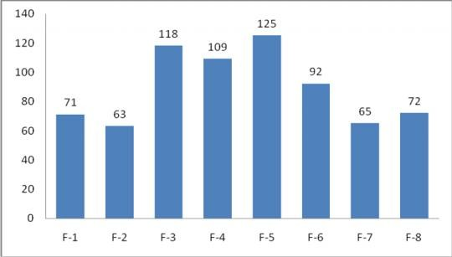**Fig. No. 01: Comparison of disintegration time of different formulations**

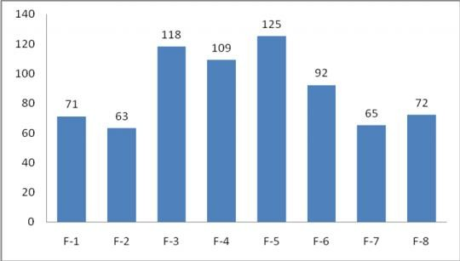**Fig. No. 02: Comparison of dispersion time of different formulations**

Pranitha T. et al., Int. J. Pharm & Ind. Res., Vol.–03 (02) 2013 [168 - 171]

171

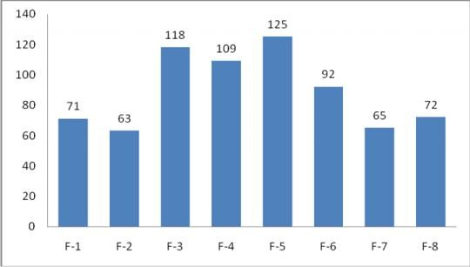**Fig. No. 03: Comparison of percentage drug release of different formulations**

# References

1. Lachman L, Liberman H, Kanig J, The Theory and Practice of Industrial Pharmacy, 3rd ed.293-345, 346-373.
2. Aulton M, Pharmaceutics: The Science of Dosage Form Design, International Student Edition.304-321, 347-668
3. Tricta, Chris berrie, Deferiprone and Deferasirox Equally Effective in Patients With Thalassemia Major, Euro.J of Hematol,19, 2006
4. V.P.Choudhry, Rahul Naithani ,Current Status of Iron Overload and Chelation with Deferasirox. Indian J Pediatr. 2007, 759-764.
5. Alfonso R Gennaro, Remington: The Science and Practice of Pharmacy, 20th ed. Vol 1. 889- 894
6. Pathare A, Taher A, Daar SDeferasirox (Exjade) significantly improves cardiacT2* in heavily iron-overloaded patients with beta- thalassemia major,AnnHematol. 2010 ; 89(4):405-9. Epub 2009 2.
7. Li J, Tao L, Dali M, Buckley D, Gao J, Hubert M,The effect of the physical stateof binders on high-shear wet granulation and granule properties: a mechanisticapproach toward understanding high-shear wet granulation process. Part II.Granulation and granule properties. 48. J Pharm Sci. 2011 294-310.
8. Milind P Wagh, Chetan P Yewale, Santosh U Zate, Paresh I Kothawade, Ganesh H Mahale, Formulation and Evaluation of fast dispersible tablets of aceclofenac using different superdisintegrant. Int J. of Pharm.PharmSci . 2010; Suppl 4, 2:154-157.
9. United States Pharmacopoeia, 2002; Vol 1 and 2, Pg. no. 242,643,731.
10. Maria DomenicaCappellini, Alan Cohen, Antonia Piga, Mohamed Bejaoui, SilverioPerrotta, LeylaAgaoglu , A phase 3 study of Deferasirox (ICL670), a once-daily oral iron chelator, in patients with β- thalassemia.J. of Am. Soc of Hematol. May 1 2006; 107(9):3455-3462.
11. Reddy LH, Ghosh B, Rajneesh, Fast dissolving drug delivery systems: A Brief Overview. Indian J Pharm Sci. 2002; 64(4):331-336
12. Brown D, Orally disintegrating tablets-taste over speed. Drug Delivery technol. 2001; 3(6):58-61.
13. H. Seager, Drug Delivery Products and the Zydis Fast-Dissolving Dosage Form. Journal Pharm.Pharmcol.1998;50:375–385.
14. http://www.pharmpedia.com/Tablet:Manufactur ing_methods/Granulation
15. http://www.pharmpedia.com/Tablet:Manufactur ing_methods/Granulation
16. kuchekar BS,Arumngam V. Fast dissolving tablets. Ind J Pharm Edu. 2001, 35:150.