# 144

***Review Article***

**Available Online at:** [**www.ijpir.com**](http://www.ijpir.com/)



International Journal of Pharmacy and Industrial Research

**ISSN**

**Print 2231 – 3648**

**Online 2231 – 3656**

**ANALYSIS AND COMPARISON OF PARACETAMOL TABLETS DISPENSED IN LEGAL DISPENSARIES AND NON PHARMACEUTICAL SHOPS IN GONDAR TOWN, NORTH WEST ETHIOPIA**

# *1Gashaw Binega, 2Dawit Wondimsigegn, 1Bayew Tsega

*,1University of Gondar, School of Pharmacy, Dept. of Clinical Pharmacy, Gondar, Ethiopia.

2University of Gondar, School of Pharmacy, Dept. of Pharmaceutics, Gondar, Ethiopia.

**Abstract**

Quality control is a step taken to make sure that a company’s products or services are of sufficiently high quality in accordance with established acceptable limits. Generally, the term quality applied to drug and drugs products including all factors which are contributing directly or indirectly to the safety, efficacy, purity and reliability of the pharmaceutical products or services. This research was conducted with the aim of analyzing and comparing the quality and physicochemical properties of three different brands of paracetamol tablets produced by company A, B and C which are dispensed in legal and illegal dispensaries in Gondar town, North West Ethiopia. The tablets were evaluated and compared experimentally by measuring hardness, friability, weight variation, disintegration time, dissolution time and assay (percent label claim) for active ingredient content. The study showed that tablet manufactured in company B which is dispensed in both legal and illegal dispensaries failed to pass the friability test. The tablet manufactured from company A which is dispensed in both legal and illegal dispensaries did not meet the British Pharmacopeia (BP) specification for assay of active ingredient content, disintegration and dissolution tests. Except the hardness test, where paracetamol tablets failed to be crushed, company C paracetamol dispensed in legal dispensaries meet the specification set by USP and BP. Generally illegally dispensed paracetamol tablets failed to comply with friability specification unlike the legally dispensed paracetamol tablets indicating the impact of storage condition on the quality indicators of paracetamol.

**Keywords:** Paracetamol, Quality control, Quality indicators.

## Introduction

Quality control is a step taken to make sure that a company’s products or services are of sufficiently high quality in accordance with established acceptable limits. Quality control of drug and drug products covers all measures taken, including the setting of specification sampling, testing and

analytical clearance to ensure that starting material, intermediate, packing material and finished pharmaceutical product indentify, strength, purity and other characteristics. Generally, the term quality applied to drug and drugs products including all factors which are contributing directly

### Author for Correspondence:

Bayew Tsega,

University of Gondar, School of Pharmacy, Dept. of Clinical Pharmacy,

Post box: 196, Gondar, Ethiopia.

E-mail: [bayewtsega14@gmail.com](mailto:bayewtsega14@gmail.com)

Gashaw Binega. et al., Int. J. Pharm & Ind. Res., Vol.–03 (02) 2013 [144 - 151]

145

or indirectly to the safety, efficacy, purity and reliability of the pharmaceutical products or services 1.

To render good quality product and /or service to the customer, sampling and different test should be done on the starting material, intermediate, packing and finished products. Some of the tests which may be run to ascertain the quality or purity of pharmaceutical dosage forms or products’ include color, odor and taste, determination of physico- chemical constants, specific optical rotation, analytical techniques like titrimetric techniques, separation techniques (chromatography method: TLC, HPLC, GC etc) and hyphenated techniques (GC/MS, HPLC/MS etc), spectroscopic techniques (UV/VISIBLE, NMR, IR, MS etc) 2.

The quality of pharmaceutical tablets are evaluated by a various method among them the quantitative evaluation and assessment of a tablet’s chemical, physical and bioavailability properties are important in the design of tablets and to monitor product quality. These properties are important since chemical break down or interaction between tablet components may alter the physical tablet properties and greatly affect the bioavailability of the tablet system. There are various standards that have been set in the various pharmacopeias regarding the quality of pharmaceutical tablets. These include the diameter, size, shape, thickness, weight variation, friability, hardness, disintegration, dissolution character, and assay of active ingredient 2.

Paracetamol is used as an analgesic-antipyretic in the presence of aspirin allergy, patients with blood coagulation disorders who are being treated with oral anticoagulants, bleeding disorders (e.g. hemophilia), and gouty arthritis; a variety of arthritic and rheumatic conditions involves musculoskeletal pain as well as other painful disorder, headache, pain associated with earache, teething, tonsillectomy, menstruation, toothache, disease cold “flu” and other bacterial and viral infection3. The presence of substandard pharmaceuticals products in the drug distribution chain may produce a danger to public health. Drug quality reports by the United States of Pharmacopeia drug quality and information program in different countries (China, Ghana, Nigeria, Benin, Bangladesh, and Colombia)

revealed that a large number of drugs failed quality testing. Some of these drugs were found to contain active ingredients outside the appropriate limits and most of them below the limits. Such drug products have therapeutic as well as social and economic implications 4, 5.

The production, storage and distribution of the drug in each country need to be regulated by the drug regulatory authority. Challenges to these drug regulatory authorities are the flourishing of many pharmaceuticals industries and distribution channels during the past few years in the world, leading to an increased the number of products circulating in national and international drug market. In the same manner, the presence of counterfeit and substandard drug in those markets has increased substantially as a result ineffective regulation of manufacturer and trading of pharmaceutical products by both exporting and importing countries.

Marketing of poor quality drugs is high in developing countries especially of Africa and Asia because of weak drug regulatory system. Ethiopia is at risk of being supplied with substandard, counterfeit drugs due to weak drug regulatory mechanism, unregulated market and distribution chain and the number of illegal and unauthorized outlets is much more than pharmaceutical shops. And the storage condition of the drug in illegal and legal dispensaries does not fulfill the general guidelines of good storage condition explained by WHO 6, 7.

The quality of drugs reaching to the patients is being compromised because of inappropriate storage condition of drug and presence of substandard and counterfeit drug in the market. It has a blow for poor economy. Even though researches have been conducted on storage condition and quality of paracetamol tablet, no research has been done on the analysis and comparison of paracetamol tablet that is dispensed in legal dispensaries and non pharmaceutical shops in Gondar town. Therefore, it was very important to stud the quality of paracetamol tablet dispensed in legal dispensaries and non pharmaceutical shops. Thus the objective of this study was to compare and assure quality of paracetamol tablet dispensed in legal dispensaries and non pharmaceutical shops in Gondar town, North West Ethiopia.

# 146

## Method

Gashaw Binega. et al., Int. J. Pharm & Ind. Res., Vol.–03 (02) 2013 [144 - 151]

research. Three selected brands of unexpired

This study was conducted in Gondar town, North West Ethiopia, from November 30, 2011 -May 30, 2012. According to the 2007 national censes, Gondar town has a total population of 285, 000. Experiment was used as a study design in this

## Tablets, chemicals, reagents and equipments used

### Tablets

* Three brand of paracetamol tablets, each with a label claim 500 mg

### Chemicals and reagents

* Di sodium mono hydrogen phosphate
* Sodium hydroxide
* Potassium Di hydrogen mono phosphate
* Hydrochloric acid

### Instrument

* Disintegration apparatus (PHARMA PTZ-E TEST, D-63512 HAINBURG)
* Electrical balance (SNR1121342483 NOE 11140 SWIZERLAND)
* Roche type friability tester (PHARMA PTZ TEST, D-63512 HAINBURG)
* UV/Visible Spectrometer (GALLENKAMP.UK...SANYO.SP 75 SP0204031 SPR 655, UVLK)
* pH meter (JANWAY LTD.FELSTED.DUNWOM.ESSEX CM 63LB.UK)
* Dissolution apparatus
* Monsanto hardness tester

For ethical and legal purposes the samples of paracetamol were coded with A, B, and C so that the identity of the owner of the paracetamol would not be identified by anyone except the study team. Secrecy of drug distributing shops was maintained only within the study team. The required samples of paracetamol 500 mg tablet were collected and the following tests were done.

### Weight variation test

20 tablets of each brand from both the legal dispensaries and non-pharmaceutical shops were weighed individually using an electronic balance. Then mean and relative standard deviation of the weights was determined 8.

paracetamol tablet (with label claim 500 mg) which were dispensed in both legal pharmacies and non- pharmaceutical shops were taken as a stud population.

### Hardness test

The hardness test was performed on 10 tablets for each brand from the legal dispensaries and non- pharmaceutical shops using a Monsanto hardness tester 8.

### Friability test

20 tablets, from brands of the legal dispensaries as well as the non-pharmaceutical shops, were weighed, placed in a Roche type friabilator and revolved at a speed of 25 rpm for 4 minutes. The tablets were removed, dusts removed and reweighed. The percentage weight loss or friability percentage was calculated 8.

### Disintegration test

The mean disintegration time of 6 tablets for the three brands from the non-pharmaceutical shops and the legal dispensaries was determined using disintegration apparatus. The disintegrating media from all the products comprised of distilled water maintained at 37+10C 8.

### Dissolution test

Dissolution test of the three brands from the two sample sources (legal dispensaries and non pharmaceutical shops) was conducted for 8 hour using 6-flask bath dissolution apparatus (basket method). The dissolution media used for all test consist of 900 ml of 0.1 N HCl (pH 1.0) during the first hour and then phosphate buffer (pH 7.4) during the next 7 hour. Rotational speed of the apparatus was hold constant at 100 revolutions per minute and the temperature of the dissolution media has been always maintained at 37+ 0.50C. Sample of 10 ml was withdrawn from the dissolution media at predetermined time intervals (every 15 minute for the first hour and then every 1 hour for the rest of the dissolution time). Each sample filtered and after the necessary dilution, the sample solution was analyzed for paracetamol by measuring their absorbance by UV/Visible spectrophotometer at 243 nm 8.

Gashaw Binega. et al., Int. J. Pharm & Ind. Res., Vol.–03 (02) 2013 [144 - 151]

147

### Percent label claim

Twenty tablets were weighed, powdered, and an accurately weighed amount of the powder equivalent to 0.15 g of paracetamol was assayed in the manner described in the BP 2, 9. The specific absorbance value (A1%1cm) of 715 at 257 nm was used to determine the amount of paracetamol in a tablet of average weight.

Data was cleaned, summarized, analyzed and presented as tables and figures.

## Result

The results of analysis of physicochemical properties including weight variation, hardness, friability, disintegration, dissolution and percent label claim of the three different brands of paracetamol tablets taken from legal and illegal dispensaries in Gondar town, North West Ethiopia, are presented in table 2 and 3. Totally 984 tablets of paracetamol had been collected between January and February, 2012. In the table 2 only quality control test results are tabulated while in table 3 the weight variation test is presented.

The results of disintegration time of paracetamol tablets obtained from company A were 16.07+0.18 and 18.58+0.17 minutes for paracetamol dispensed in legal and illegal shops, respectively. The disintegration time for paracetamol tablets produced from company B available in legal and illegal dispensaries were 8.81+1.77 and 10.14+1.078 minutes, respectively where as for those paracetamol tablets manufactured by company C and dispensed in legal and illegal dispensaries were 1.72+0.057 and 2.193+0.004 minutes, respectively (table 2). The result of analysis of the three different brands of paracetamol tablets obtained from legal and illegal dispensaries analyzed according to the BP specification. The assay of paracetamol tablets obtained from company B that were in the same batch number in legal and illegal dispensaries registered a value of 98.56+0.32% and 98.4+0.54%, respectively. Similarly, the tablet from company C in legal and illegal dispensaries registered a value of 101.63+0.5% and 97.21+0.18%, respectively (table 2).

|  |  |  |  |  |
| --- | --- | --- | --- | --- |
| **Table No. 01: Quantity of paracetamol tablet used to perform the quality control tests** | | | | |
| **Type of test Quantity required for one brand from** | | **Quantity required for one brand from non** | **Number of Total** | |
| **legal dispensaries** | | **pharmaceutical shops** | **brands** | |
| Weight 20 | | 20 | 3 120 | |
| variation |  |  |  |  |
| Hardness | 10 | 10 | 3 | 60 |
| Friability | 20 | 20 | 3 | 120 |
| Disintegration | 6 | 6 | 3 | 36 |
| Dissolution | 6 | 6 | 3 | 36 |
| % label claim | 20 | 20 | 3 | 120 |
| Total | 82 | 82 | 3 | 492 |

For the reliability of the result the experiment was done twice. Hence a total of 984 tablets were used for the study. The legal dispensaries as well as non pharmaceutical shops from which the three brands of paracetamol tablets taken were selected randomly. Moreover, the required quantity of the three brands from both the legal dispensaries and non pharmaceutical shops was randomly taken.

### Table No. 02: Quality control test of paracetamol 500 mg tablet of three brands from legal dispensaries and non-pharmaceutical shops

**Standard Legal dispensary Non pharmaceutical shop**

(n=10)

|  |  |  |  |  |  |  |
| --- | --- | --- | --- | --- | --- | --- |
| **Variable Source literature**  **value** | **A** | **B** | **C** | **A** | **B** | **C** |
| Hardness USP >50 | 114.66+3.5 | - | - | 110.45+7.10 | - | - |

Friability (% loss)

|  |  |  |  |  |  |  |  |
| --- | --- | --- | --- | --- | --- | --- | --- |
| USP | <1% | 0.437 | 1 tablet crushed | 0.69 | 0.829 | 1 tablet crushed | 1.50 |
| USP | <15min | 16.07+0.18 | 8.81+1.77 | 1.72+0.06 | 18.58+0.17 | 10.14+1.01 | 2.19+0.04 |

Disintegration time (min), n=6 Dissolution efficiency (50%)

|  |  |  |  |  |  |  |  |
| --- | --- | --- | --- | --- | --- | --- | --- |
| USP |  | | | | | | |
|  |  | >60 | 5.5 | 5.1 | >60 | 6.1 | 5.9 |
| BP | 95-105% | 110.26+0.32 | 98.56+0.32 | 101.63+0.55 | 107.74+0.39 | 98.42+0.54 | 97.21+0.18 |

T50%

Drug release in minute

%Label claim

# 148

Gashaw Binega. et al., Int. J. Pharm & Ind. Res., Vol.–03 (02) 2013 [144 - 151]

### Table No. 03: Weight variation test for three brands of paracetamol from legal dispensaries and non pharmaceutical shops

**Source and brand**

**Weight variation (mean weight and RSD)**

**Number of tablets with**

**weight variation greater than 5%**

**Number of tablets with**

**weight variation greater than 10%**

|  |  |  |  |  |
| --- | --- | --- | --- | --- |
| Legal-dispensaries | A | 0.57+0.01 | 0 | 0 |
|  | B | 0.59+0.04 | 0 | 0 |
|  | C | 0.60+0.02 | 0 | 0 |
| Non-pharmaceutical | A | 0.58+0.01 | 0 | 0 |
| shops | B | 0.62+0.04 | 0 | 0 |
|  | C | 0.61+0.01 | 0 | 0 |

The dissolution profile of the three brands of paracetamol tablets from legal and illegal dispensaries is depicted in figure 1 and figure 2, respectively. The t50% and t90% of the different

brands of pharmaceutical tablets which were available in legal and illegal dispensaries were analyzed using SPSS version 20.0.

p e r c e n t

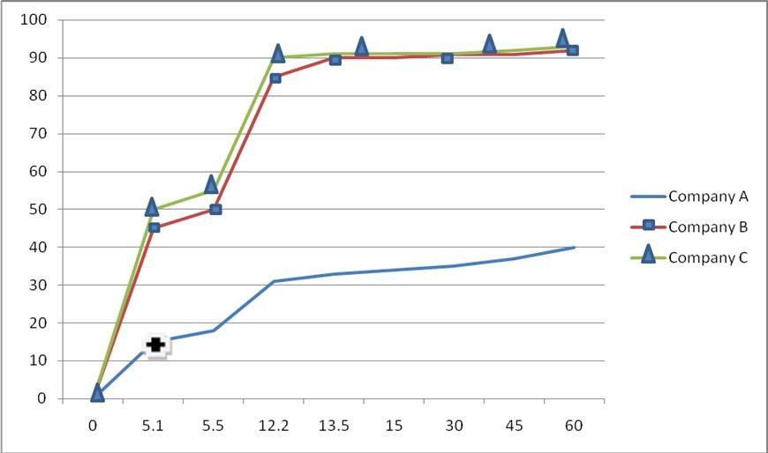

Times in minutes

### Fig. 01: Dissolution profile of three brands of paracetamol tablet in legal dispensaries

The result showed that tablets manufactured from company B and C release 50% of the tablet with in

5.5 and 5.1 minutes in legal dispensaries and 6.10 and 5.9 minutes in illegal shops, respectively. With respect to t90%, paracetamol tablets manufactured from company B and C release 90% of the tablet with in 13.5 and 12.2 minutes in legal dispensaries and 14.32 and 13.55 minutes in illegal shops, respectively. However, the tablet obtained in company A released 50% and 90% of the drug in

>60 minutes for both legal and illegal dispensaries.

**Discussion**

The compendia specification of weight variation is the weight of each of the tablet analyzed and it

should not be deviated from the average value by more than 5% 8. Accordingly all samples of paracetamol tablet passed the weight uniformity test set by USP. The present result on weight variation test is in agreement with the research done on different brand of paracetamol tablets in different retail outlet in Addis Ababa 10. However slight variation weight among the different brands and between legally and illegally dispensed paracetamol in the present study could be accounted to the use of varying proportion of excipient by manufacturer and inappropriate storage condition to the tablet, especially in illegal shops respectively.

Gashaw Binega. et al., Int. J. Pharm & Ind. Res., Vol.–03 (02) 2013 [144 - 151]

149

P

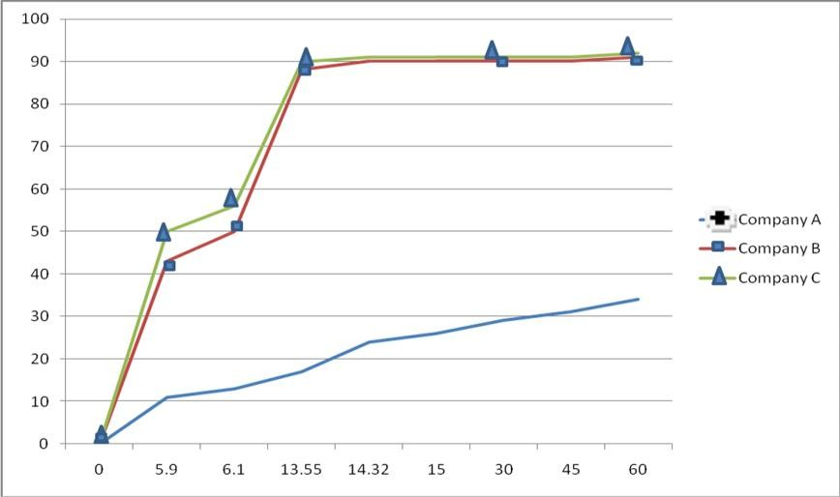

e r c e n t

Times in minutes

### Fig. 02: Dissolution profile of three brands of paracetamol tablet in illegal dispensaries

For compressed tablets, hardness of 50 N is the minimum requirement for satisfactory tablet product8. Paracetamol tablet manufactured from company A which is available in both legal and illegal dispensaries passed the hardness test with mean hardness value of 114.11+0.345 and 110.45+5.102N respectively. However, tablets manufactured from company B and C that were available in legal and illegal dispensaries were not crushed by Monsanto hardness tester. This might be due to the fact that the company might have utilized different type of excipient or compression techniques. Whereas the variation of the result in company A which was dispensed in legal and illegal dispensaries might be due to improper storage of conditions of illegal dispensaries. Similar to this study, a research done on different brands of paracetamol tablets in different retail outlet in Addis Ababa 10 reported a higher value of hardness test for paracetamol tablets produced in company C.

Compressed tablets should not loss more than 1% of its weight after friability test and should not be crushed during the test8. The percent friability test of company A tablets obtained from legal and illegal shops was 0.44% and 0.83%, respectively where as for company C were 0.50% and 1.58%, respectively. Unlike the tablets of company A obtained from both legal and illegal shops and

company C tablets obtained from legal shops, paracetamol tablets obtained from company B and dispensed in both legal and illegal shops failed to pass the friability test. The research done on different brands of paracetamol tablets in different retail outlet in Addis Ababa 10 had reported a friability test value of 0.49 for paracetamol tablets of company C which was in agreement to the present study.

The official requirement in the USP pharmacopeia disintegration test is that uncoated tablet should disintegrate in less than 15 minutes 8. This study revealed that among the three investigated brands of paracetamol tablets, paracetamol tablets manufactured by company A dispensed in both legal and illegal dispensaries did not comply with the USP specification. Although the disintegration time of company B is higher than company C, paracetamol tablets manufactured from both company B and C which is available in legal and illegal dispensaries passed the test. The greater variation of the disintegration time between legal and illegal shops of the different brands of paracetamol tablet might be due to inappropriate storage conditions especially in illegal shops.

The t50% and t90% are the dissolution parameters that can be utilized to analyze dissolution profile of different pharmaceutical products 8. In this study

# 150

Gashaw Binega. et al., Int. J. Pharm & Ind. Res., Vol.–03 (02) 2013 [144 - 151]

out of the three investigated brands of paracetamol tablet, tablets manufactured in company A and dispensed in both legal and illegal shops did not comply with the USP specification. The greater variation of the dissolution time between legal and illegal dispensaries manufactured from company A, B and C might be due to improper storage conditions specifically in illegal shops.

Assay of the active ingredient in pharmaceutical products is determined using different instrumental methods. In this study the method described in BP 2011 9 have been used. The British pharmacopeia stated that paracetamol tablet must contain 95- 105% of paracetamol 9. Accordingly, except tablets manufactured in company A and dispensed from both legal and illegal dispensaries with a value of 110. 26+3.2% and 107.74+0.39%, respectively, tablets from other companies of both legal and illegal dispensaries comply with BP specification. The variation of the assay of active ingredients between legal and illegal dispensaries might by due to improper storage condition of the tablets especially in illegal shops that might led to breakdown of the active ingredient and affected the assay. Higher value of active ingredient in paracetamol tablets from company A which is beyond the BP specification may lead to toxicity.

### Limitation of the study

As the study design was experimental there might be errors related to instrumental constraints or technical problems.

**Conclusion and recommendation**

Paracetamol tablets manufactured in company A and were available in legal and illegal shops complied with the specification with regard to hardness, weight variation and friability. But the disintegration, dissolution and assay of active ingredient content did not comply with the specification.

In company B, the tablets available in legal and illegal dispensaries complied with the specification in terms of weight variation, disintegration, dissolution and assay of active ingredient content but the hardness and friability test result did not comply with the specification. In company C the tablets available in legal and illegal dispensaries complied with the specification in terms of weight variation, friability (only in the legal dispensaries),

disintegration, dissolution and assay of active ingredient content.

Although paracetamol tablets manufactured in company B failed to meet some physicochemical parameters, it is the paracetamol tablets produced in company A failed in almost all the parameters indicating that the tablets manufactured by company A might be substandard or counterfeit.

In addition to variation in physico-chemical properties of paracetamol tablets produced in the three companies, variation in the physico-chemical properties were noted in paracetamol tablets dispensed between legal and illegal dispensaries. Generally illegally dispensed paracetamol tablets exhibited physicochemical characteristic values that fell slightly within the range set by the USP and BP specifications and failed to comply with friability specification unlike the legally dispensed paracetamol tablets indicating the impact of storage condition on the quality indicators of paracetamol. Based on the above conclusion the following recommendations are forwarded:

1. Food, Medicine and Health Care Administration and Control Authority of Ethiopia (FMHACA) and regional health bureau should control the quality of the tablets at various levels particularly before the tablets being distributed to the different dispensaries and follow up the factories.
2. FMHACA and other health organizations at various levels have to control the sale of paracetamol tablet in illegal shops.
3. Pharmacy professionals and academicians in the field should give due attention in conducting quality control research and assuring the quality of paracetamol and in general in all drugs at Gondar town or regional and national level.

## Acknowledgment

The researchers would like to thank the pharmaceutical analysis laboratory, School of Pharmacy, University of Gondar for laboratory facilities, without it the conduction of this study would be a dream.

## Refernces

1. Winfield A.J, R.M.E Richards. The principle of quality assurance in : chapman D.G, eds. Leith Walk, Edinburgh, Harcout, 1998; 29: 305-308.

Gashaw Binega. et al., Int. J. Pharm & Ind. Res., Vol.–03 (02) 2013 [144 - 151]

151

1. British pharmacopoeia. HMSO, 2011.
2. Odeku O.A and Itiola O.A. Advances in dissolution test. In pharmaceutical analysis. 2005 accessed via. <http://www.Pharmpedia.com/tabletevaluationtest>
3. World Health Organizaiton. Couonterfeit products in: WHO. Quality assurance of pharmaceutical a compendium of guidelines material. Vol.1. Geneva: WHO Library, 1997; 8: 220-221.
4. World health organization. Counterfeit and substandard drugs in Mayanmar and Vietnam, report a study carried out in cooperation with the governments of Mayenmar and Vietnam. Mayenmar and Vietnam, world health organiziton, 1999 (WHO/EDM/QSM 99.3).
5. Reidberg MM, Connors BA. Counterfeit and substandard drugs. Clin Pharmaco Ther, 2001; 69: 189-193.
6. Workalemahu M, Ayanew A, and Negussu M., etal. Comparative evaluation of the in vitro and in vivo characteristics of different brands of paracetamol tablet. Ethio.Pharm. J.2000, 18: 43-53.
7. The United States Pharmacopeia 27, National formulary 22. The united states pharmacopeia convention. Inc, Rockville, MD, USA, USP, 2009.
8. Hundie K., Aseres K. and Mohammed AIM etal. Comparative quality evaluation of some brands of paracetamol tablets, suppositories and syrups. Ethio.Pharm.J.2003; 26: 59-63.
9. The British pharmacopeia, her Majesties stationary office, London, 1999.