***Research Article***

**Available Online at:** [**www.ijpir.com**](http://www.ijpir.com/)



International Journal of Pharmacy and Industrial Research

**ISSN**

**Print 2231 – 3648**

**Online 2231 – 3656**

**DEVELOPMENT AND VALIDATION OF AN ASSAY METHOD FOR LAMIVUDINE AND ABACAVIR COMBINED**

**TABLET FORMULATION BY RP-HPLC**

# *Narasimha Rao V Bathula, Gayathri Devi Ketineni

Victoria College of Pharmacy, Challavaripalem (village), Nallapadu (via), Guntur (District), Andhra Pradesh, India - 522 005.

## Abstract

The aim of the present analytical research is to develop a simple, precise, accurate, rapid and economic RP- HPLC method for the assay of Lamivudine and Abacavir in combined tablet formulation. Till to date no accurate and precise RP-HPLC method is developed for the combined estimation of Lamivudine and Abacavir in combined tablet formulation. The main objective of this study is to validate the developed method by using parameters Specificity, Linearity, Precision, and Accuracy.

**Keywords:** Abacavir, Lamivudine, RP-HPLC.

## Introduction

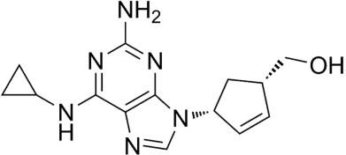

### Lamivudine

Chemically lamivudine is 4-amino-1-((2R, 5S)-2- (hydroxyl methyl)-1,3-oxathiolan-5-yl) pyrimidin- 2(1H)-one. Lamivudine is a synthetic nucleoside analogue with potent activity against HIV virus (Type-I) and hepatitis-B.

### Abacavir

Chemically abacavir sulphate is [(1S,4R)-4-[2- amino-6-(cyclopropylamino)-9H-purin-9yl] cyclo pent-2-en-1-yl] methanol sulphate. Abacavir is a carboxylic synthetic nucleoside analogue with activity against HIV virus (type-I). These both drugs act by inhibiting reverse transcriptase enzyme1-4. In the recent past Lamivudine and Abacavir combined formulations are designed as they exhibit synergistic effect in activity against

### Author for Correspondence:

Narasimha Rao V Bathula,

C/o K. Anjaneyulu, Door No: 16-295,

Opp: Jaya nursing home, Kalamandhir center, Chilakaluri pet, Guntur (dist), Andhra pradesh, India. E-mail: [gayathridevi.ketineni4@gmail.com](mailto:gayathridevi.ketineni4@gmail.com)

HIV-virus. For the analysis of Lamivudine and Abacavir individually UV, RP-HPLC and HPTLC methods are reported. Analytical methods such as UV and HPTLC are available for the combined estimation of Lamivudine and Abacavir5-6.

## Materials and method

Potassium dihydrogen ortho phosphate, triethylamine, methanol, acetonitrile, water, lamivudine WRS (99.8%), abacavir sulphate WRS (99.7%), ABEC-L (labell claim 300 mg of lamivudine and 600mg of abacavir). HPLC empower software, aliance 2695, detector 2487 model. UV spectrophotometer UV win 5 software, UV-3000+ model.

### Chromatographic Conditions

Column : Hypersil BDS C18 (100 X 4.6 mm) 5

Pump mode : Isocratic

Flow rate : 0.6 mL/min

Detection : UV, 278 nm

Injection volume : 20 L Column oven temperature : Ambient Run time : 9 minutes

### Standard Stock Solution

Accurately 50.04 mg of Lamivudine and 117.21 mg of Abacavir sulphate (equivalent to 100.0 mg of Abacavir) working standards were weighed and transferred into a 50 mL clean dry volumetric flask and about 10 mL of diluent was added, sonicated for 10min to dissolve completely and volume was made up to the mark with the diluent and filtered through 0.45 µ Millipore Nylon filter.

### Standard Solution

4 mL of standard stock solution was pipetted into a 100 mL volumetric flask and diluted up to the mark with diluent.

### Sample Stock Solution

20 tablets were weighed and average weight of tablet was determined. The tablets were crushed into a fine powder. Accurately weighed and transferred 232.12 gm of powder equivalent to 50 mg of Lamivudine into a 50 mL clean dry volumetric flask added about 10 mL of diluent and sonicated for 20 minutes. Volume was made up to the mark with the diluent and centrifuged at 5000 RPM for 10 minutes.

### Sample Solution

4 mL of supernatant sample stock solution solution was pipetted into a 100 mL volumetric flask and diluted up to the mark with diluent and filtered through 0.45 µ Millipore Nylon filter.

### Chromatographic Procedure of Assay System Suitability

20 L of the standard solution was injected into the chromatographic system and chromatogram was recorded.

### Assay

20 L of the standard solution was injected five times into the chromatographic system, chromatograms were recorded and peak areas were measured.

20 L of the sample solution was injected in duplicate into the chromatographic system, chromatograms were recorded and peak areas were measured.

### Acceptance Criteria

1. RSD for the peak areas of responses of five replicate injections of the standard solution is not more than 2.0%.
2. The number of theoretical plates (N) for the Lamivudine and Abacavir peaks is NLT 2000.
3. The Tailing factor (T) for the Lamivudine and Abacavir peaks is NMT 2.0

### Calculation for Lamivudine

AT1 DS1 P 1

Amount present = ---------- X ---------- X X AW

AS1 DT1 100

Where,

AT1 = Average area counts of Lamivudine peak in chromatogram of sample solution AS1 = Average area counts of Lamivudine peak in chromatogram of standard solution DS1 = Dilution factor for the standard solution

DT1 = Dilution factor for the sample solution

P 1 = Percentage potency of Lamivudine working standard used (as is basis) AW = Average weight of tablet

Amount of Lamivudine

% Labeled Amount = ------------------------------------ X 100

Label claim of Lamivudine

### Calculation for Abacavir

AT2 DS2 P2

Amount present = ------------ X ----------- X X M. F X AW

AS2 DT2 100

Where,

AT2 = Average area counts of Abacavir peak in chromatogram of sample solution. AS2 = Average area counts of Abacavir peak in chromatogram of standard solution

DS2 = Dilution factor for the standard solution DT2 = Dilution factor for the sample solution

P 2 = Percentage potency of Abacavir working standard used (as is basis)

M.F = Molecular factor

AW = Average weight of tablet

Amount of Abacavir

% Labeled Amount = 100

Label claim of Abacavir

### Method of Validation

**Specificity**

The retention times obtained from working standard and test samples were compared for identification.

### Linearity

A series of solutions of drug substance standard were prepared in the concentration range from 50% to 300% of test concentration to demonstrate linearity for assay by using single plot and injected in to the chromatographic system. A calibration graph is plotted between amount of drug (µg/mL) and chromatographic peak area (mV).

### Precision System Precision

The system precision was established by injecting six replicate injections of standard solution in to the chromatographic system by maintaining the optimized chromatographic conditions.

### Method Precision

Six assay samples of drug product at 100% of the working sample concentration were prepared and injected into the chromatographic system (Set-I).

### Accuracy

Sample solutions prepared separately by addition of standard stock at 50%, 100% and 150% of working sample concentration were injected three times into the chromatographic system.

## Results

### Table No. 01: Data of system suitability

**S.no Name**

|  |  |  |  |  |  |  |  |  |
| --- | --- | --- | --- | --- | --- | --- | --- | --- |
|  | | | | | | **count** |  | **values)** |
| 1 | lamivudine | 2.128 | 3628811 | 242040.4 |  | 3439 | 1.5 | 99.4%-100.2% |
| 2 | Abacavir  sulphate | 3.214 | 6910890 | 389805.7 | 3.01 | 3787 | 1.6 | 99.8%-100.4% |

**Retention time(min)**

**Area (μV*sec)**

**Height (μV)**

**USP**

**Resolution**

**USP**

**plate**

**USP**

**Tailing**

**accuracy (recovery**

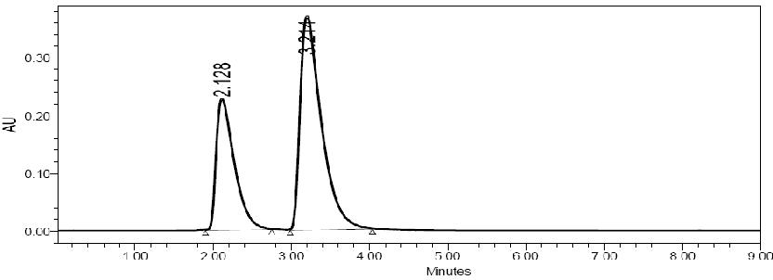

### Fig. No. 01: Chromatogram of system suitability

**Table No. 02: Data of standard chromatograms**

|  |  |  |  |  |
| --- | --- | --- | --- | --- |
|  | **Lamivudine** | **Abacavir sulphate** | **Lamivudine** | **Abacavir sulphate** |
| 1 | 2.130 | 3.216 | 3612114 | 6906784 |
| 2 | 2.124 | 3.208 | 3613316 | 6910847 |
| 3 | 2.132 | 3.216 | 3612124 | 6907887 |
| 4 | 2.128 | 3.214 | 3620116 | 6876906 |
| 5 | 2.126 | 3.215 | 3621411 | 6912548 |
| Mean |  |  | 3615816 | 6902994 |
| SD |  |  | 4565.6 | 14763.4 |
| % RSD |  |  | 0.12 | 0.21 |

**Injection Retention Time Peak Area**

### Chromtograms of standard

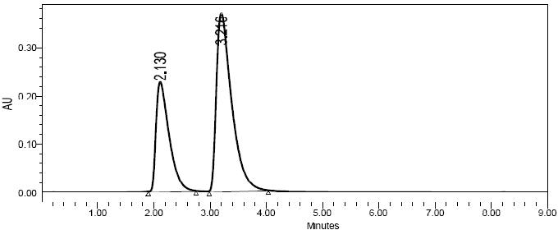

**Fig. No. 02: Chromatogram No: 1**

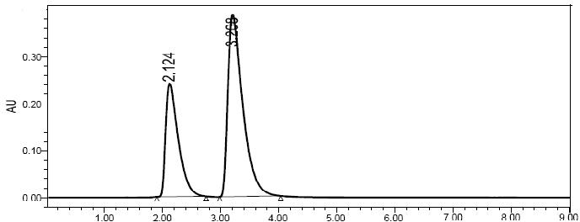

### Fig. No. 03: Chromatogram No: 2

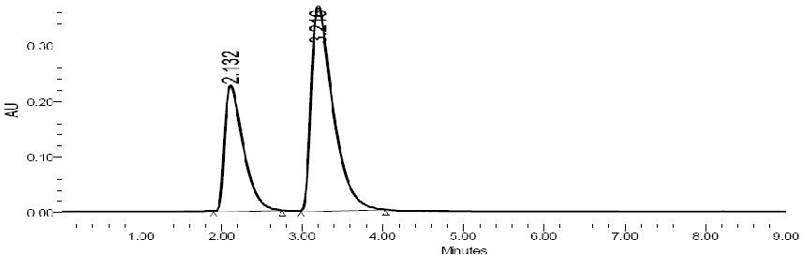

**Fig. No. 04: Chromatogram No: 3**



### Fig. No. 05: Chromatogram No: 4

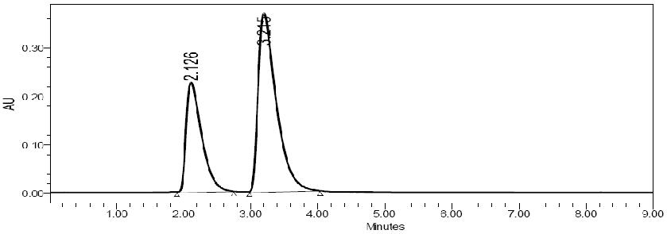

**Fig. No. 06: Chromatogram No: 5**

### Sample chromatograms

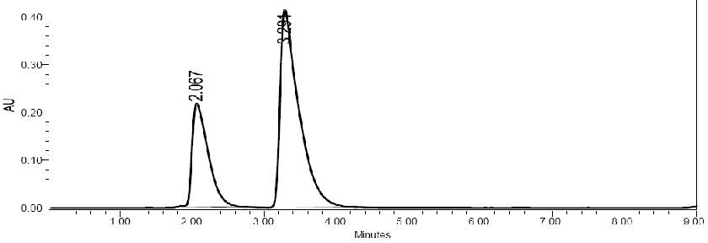

**Fig. No. 07: Chromatogram No: 1**

### Fig. No. 08: Chromatogram No: 2 Table No. 03: Data of sample chromatograms

**Injection Retention Time Peak Area Lamivudine Abacavir sulphate Lamivudine Abacavir sulphate**

|  |  |  |  |  |
| --- | --- | --- | --- | --- |
| 1 | 2.067 | 3.291 | 3581677 | 6883814 |
| 2 | 2.071 | 3.290 | 3576624 | 6878314 |
| Mean |  |  | 3579150 | 6881064 |
| SD |  |  | 3573 | 3889 |
| % RSD |  |  | 0.09 | 0.05 |

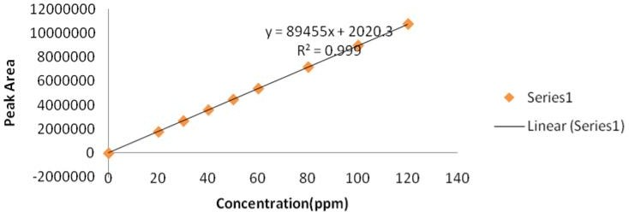

### Fig. No. 09: Calibration curve of Lamivudine

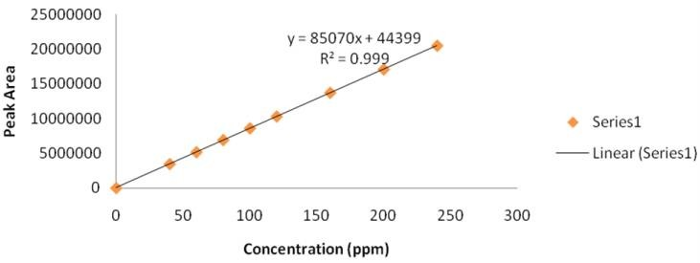

**Fig. No. 10: Calibration curve of Abacavir**

### Table No. 04: Validation parameters

**S.No Parameter**

**Lamivudine**

**Result**

**Abacavir**

1. Linearity 20-120 µg/mL Correlation coefficient = 0.999

40-240 µg/mL Correlation coefficient = 0.999

1. System precision %RSD = 0.30 %RSD = 0.17
2. Method precision %RSD = 0.21 %RSD = 0.21
3. Accuracy Recovery values = 99.4%-100.2% Recovery values = 99.8%-100.4%

## Discussion

A simple, sensitive, rapid and economic RP-HPLC method was developed and validated for the assay of Lamivudine and Abacavir in combined tablet formulation. This method yielded high recoveries with good linearity and precision. It can be concluded that the proposed method is a good approach for obtaining reliable results and found to be suitable for the routine analysis of Lamivudine and Abacavir in combined tablet formulation.

## References

1. [www.rxlist.com/lamivudine/html](http://www.rxlist.com/lamivudine/html) referred date

: 23-11-2010

1. [www.rxlist.com/abacavir/html](http://www.rxlist.com/abacavir/html) referred date:23-11-2010
2. [www.drugbank.com/lamivudine](http://www.drugbank.com/lamivudine) referred date:12-11-2010
3. [www.drugbank.com/abacavir](http://www.drugbank.com/abacavir) referred date

:12-11-2010

1. V.P. Devmurari, “Simultaneous Spectro - photometric determination of Lamivudine and Abacavir in the mixture” by International Journal of Pharmaceutical Sciences and Research, 2010, 1(7):82-86.
2. T. Sudha, V. R. Ravikumar and P. V. Hemalatha, “Validated HPTLC method for simultaneous determination of Lamivudine and Abacavir Sulphate in tablet dosage form” International Journal of Pharmaceutical Sciences and Research, 2010 ,1 (11): 107-111.