***Research Article***

**Available Online at:** [**www.ijpir.com**](http://www.ijpir.com/)



International Journal of Pharmacy and Industrial Research

**ISSN**

**Print 2231 – 3648**

**Online 2231 – 3656**

**A NOVEL VALIDATED RP-HPLC METHOD FOR THE DETERMINATION OF BALOFLOXACIN IN BULK AND PHARMACEUTICAL DOSAGE FORMS**

# *1,2Ravisankar P, 3Devala Rao G, 1Devadasu Ch, 1Gopalareddy P,

1Srinivasa Babu P, 1Afzal Basha SK, 1Sricharitha P

*1Department of Pharmaceutical Analysis and Quality Assurance, Vignan Pharmacy College, Vadlamudi, Guntur, A.P, India - 522 213.

2Faculty of Science, Sri Chandrasekharendra Saraswathi Viswa Mahavidyalaya (SCSVMV University), Enathur, Kanchipuram, T.N, India – 631 561.

3KVSR Siddhartha College of Pharmaceutical Sciences, Vijayawada, A.P, India - 520 010.

## Abstract

A simple, specific, accurate, selective isocratic reversed phase-high performance liquid chromatography (RP- HPLC) method was developed for the quantitative estimation of balofloxacin in pharmaceutical formulations. RP-HPLC method was developed by using WELCHROM C18 Column (4.6 X 250mm, 5µm), SHIMADZU LC- 20AT prominence liquid chromatograph. The mobile phase composed of phosphate buffer: acetonitrile (70:30%, v/v), pH-3.1 adjusted with triethylamine. The responses are measured at 293nm using SHIMADZU SPD-20A prominence UV-Vis detector. The retention time of balofloxacin was found to be 6.253 min. Linearity was established for balofloxacin in the range of 1-10 µg/ml with correlation coefficient 0.999. The accuracy and reliability of the proposed method was ascertained by evaluating various validation parameters like linearity, precision and specificity according to ICH guidelines. This method can be successfully employed for quantitative analysis of balofloxacin in bulk drugs and formulations.

**Keywords:** Balofloxacin, Isocratic RP-HPLC, UV-Vis detector, Method Validation.

## Introduction

The new fluoroquinolone balofloxacin1-4 (BLFX) is1-cyclopropyl-6-fluoro-8-methoxy-7-(-3-methyl aminonopiperidin-1-yl)-4-oxoquinoline-3-carb - oxylic acid (fig. 1), is a broad spectrum fluorinated a quinolone antibiotic, prescribed for infective ophthalmitis and sinusitis, chronic bronchitis, acute exacerbation, community-acquired pneumonia, skin infections, urinary tract infection5. It exhibits

excellent antibacterial activity against gram- positive bacteria such as multiple-drug-resistant staphylococci and pneumococci. The quinolones6 and BLFX compounds are bactericidal in nature. They act by inhibiting DNA gyrase7 in Gram negative and topoisomerase IV in Gram positive organisms which are vital bacterial enzymes responsible for DNA replication8 and transcription.

### Author for Correspondence:

Ravisankar Panchumarthy,

Vignan Pharmacy College, Vadlamudi, Guntur, AP, India - 522 213.

E-mail: [banuman35@gmail.com](mailto:banuman35@gmail.com)

Literature survey revealed that very few methods have been reported for the analysis of BLFX which include luminescence spectroscopy9, Reverse Phase High Pressure liquid Chromatography10-12, LC-MS, HPLC with fluorescent spectroscopy13, RP-HPLC with fluorescence detection14, HPLC-Electro spray ionization mass spectroscopy15, and few UVspectrophotometric methods16. The present study illustrates development and validation of simple, sensitive, precise and accurate RP-HPLC method for the determination of new antibacterial fluoroquinolone BLFX17-19 in bulk samples and pharmaceutical tablet dosage forms. The method was validated in compliance with ICH guidelines20. The goal of this investigation is to develop rapid HPLC methods for the analysis of BLFX in bulk drug samples and tablet formulations using the most commonly employed column (C18) with UV detection at appropriate wavelength.

## Materials and methods

Quantitative HPLC was performed on a high pressure gradient high performance liquid chromatography (SHIMADZU LC-20AT prominence liquid chromatography) with two LC- 20AT VP pumps, manual injector with loop volume of 20 µl (Rheodyne), programmable variable wavelength SHIMADZU SPD-20A prominence UV-Vis detector and WELCHROM C18 Column (4.6 X 250mm, 5µm particle size). The HPLC system was equipped with “Spinchrome” software. In addition an electronic balance (Shimadhu TX223L), digital PH meter (Systronics model 802), a sonicator (spectra lab, model UCB 40), UV- Visible Spectrophotometer (Systronics model- 2203) were used in this study.

### Standards and chemicals used

BLFX pharmaceutical grade was kindly supplied as gift sample by Hetero Drugs Limited, Hyderabad and Andhra Pradesh, India. All the chemicals were analytical grade. Potassium dihydrogen orthophosphate and phosphoric acid from S.D Fine-Chem. Ltd., Mumbai, India, while acetonitrile (HPLC grade) and triethylamine (HPLC grade) from Merck Pharmaceuticals Private Limited (Mumbai, India). Commercial tablets of BLFX was procured from local market and used for analysis of marketed formulation. Balowin-100(intra lab), Balox-100mg tablets manufactured by Lupin Ltd., B-Cin-100mg tablets are manufactured by Hetero

labs Ltd., and marketed by Lupin Ltd., Mumbai, India.

### Preparation of mobile phase

A 10 mM phosphate buffer was prepared by dissolving 6.056 g of potassium dihydrogen orthophosphate in 445 ml of HPLC grade water. To this 55ml of 0.1M phosphoric acid was added and pH was adjusted to 3.1 with triethylamine. The above prepared buffer and acetonitrile were mixed in the proportion of 70: 30 v/v and was filtered through 0.45 µm nylon membrane filter and degassed by sonication.

### Preparation of calibration standards

About 100 mg of pure BLFX was accurately weighed and dissolved in 100 ml of mobile phase to get 1 mg/ml stock solution. Working standard solution of BLFX was prepared with mobile phase. To a series of 10ml volumetric flasks, standard solutions of BLFX in the concentration range of 2, 4, 6, 8, 10 µg/ml were transferred. The final volume was made with the mobile phase.

### System suitability

System suitability tests are an integral part of chromatographic method which was used to verify reproducibility of the chromatographic system. To ascertain its effectiveness, certain system suitability test parameters were checked by repetitively injecting the drug solution at the concentration level 10µg/ml for BLFX to check the reproducibility of the system. At first the HPLC system was stabilized for forty min. One blank followed by six replicates of a single calibration standard solution of BLFX was injected to check the system suitability. To ascertain the systems suitability for the proposed method a number of parameters such as theoretical plates, peak asymmetry, retention time and parameters were taken and results were presented in table Table 1.

### Recommended procedure Calibration curve for balofloxacin

Replicates of each calibration standard solutions ( 2, 4, 6, 8, 10 µg/ml ) were injected using a 20µl fixed loop system and the chromatograms were recorded. Calibration curves were constructed by plotting by taking concentration of BLFX on X- axis and ratio of peak areas of standard BLFX on Y-axis and regression equations were computed for BLFX (Table 2).

### Analysis of Marketed Formulations

The content of twenty tablets were accurately weighed and transferred into a mortar and ground to a fine powder. From this, tablet powder which is equivalent to 100 mg of BLFX was taken and the drug was extracted in 100 ml of mobile phase. The resulting solution was filtered using Whatman Grade No. 1 filter paper and degassed by sonication. This solution was further suitably diluted for chromatography. The test solutions were injected into the system by filling a 20 µl fixed volume loop manual injector. The chromatographic run time of 10 min. was maintained for the elution of the drug from the column. The elutes were monitored with UV detector at 293 nm. A 20µl volume of standard and sample solutions were separately injected on HPLC system. From the peak area of BLFX the amount of drug in the sample were computed. The content was calculated as an average of six determinations and experimental results were presented in Table 3. The representative standard and sample chromatograms of BLFX were shown in Fig. 2 and 3.

### Validation study of Balofloxacin

The developed method of analysis was validated as per the ICH21 and USP22 for the parameters like specificity, precision, accuracy, linearity, robustness, system suitability, limit of detection (LOD) and limit of quantification (LOQ).

### Specificity

The effect of wide range of excipients and other additives usually present in the formulations of BLFX in the determinations under optimum conditions was investigated. The specificity of the RP-HPLC method was established by injecting the mobile phase and placebo solution in triplicate and recording the chromatograms. The common excipients such as lactose anhydrous, microcrystalline cellulose and magnesium stearate have been added to the sample solution and injected and tested.

### Precision

Intraday and interday precision study of BLFX was carried out by estimating corresponding responses 3 times on the same day and on 3 different days for the concentration of 10μg. The percent relative standard deviation (% RSD) was calculated which is within the acceptable criteria of not more than 2.0.

### Linearity

The linearity graphs for the proposed assay methods were obtained over the concentration range of 1-10 µg/ml BLFX. Method of least square analysis was carried out for getting the slope, intercept and correlation coefficient, regression data values and the results were presented in Table

2. The representative chromatograms indicating the BLFX were shown in Fig. 4 to 8. A calibration curve was plotted between concentration and area response and statistical analysis of the calibration curve is shown in (Fig. 9).

### Accuracy (Recovery studies)

The accuracy of the method was determined by calculating recovery of BLFX by the method of addition. Known amount of BLFX at 50%, 100%, and 150% was added to a pre quantified sample solution. The recovery studies were carried out in the tablet in triplicate each in the presence of placebo. The mean percentage recovery of BLFX at each level was not less than 99% and not more than 101%.

### Robustness

The Robustness was evaluated by the analysis of BLFX under different experimental conditions such as making small changes in flow rate (± 0.2 ml/min), temperature (± 5oC), Mobile phase composition (±5%), and pH of the buffer solution.

### Ruggedness

Ruggedness is the degree of reproducibility of results obtain by the analysis of the same sample under a variety of normal test conditions i.e., different analysts, laboratories, instruments and columns. RSD was always found to be < 2%, which indicates the method is rugged.

### LOD and LOQ

This is the lowest concentration in a sample that can be detected, but not necessarily quantitated under the stated experimental conditions. The limit of quantitation is the lowest concentration of analyte in a sample that can be determined with acceptable precision and accuracy. Limit of detection and limit of quantitation were calculated using following formula LOD= 3.3(SD)/S and LOQ= 10 (SD)/S, where SD=standard deviation of response (peak area) and S= average of the slope of the calibration curve.

## Results and discussion

The mobile phase consisting of phosphate buffer (pH-3.1): acetonitrile (70:30% v/v) at1ml/min flow rate was optimized which gave sharp peak, minimum tailing factor with short runtime for BLFX. The retention time for BLFX was 6.253 min. UV spectra of BLFX showed that the drug absorbed maximum at 293 nm, so this wavelength was selected as the detection wavelength. System suitability parameters & optimized chromatographic conditions are shown in Table no

1. The calibration curve for BLFX was found to be linear over the range of 1-10 µg/ml. The data of regression analysis of the calibration curve is shown in Table 2.

The developed method was applied to the assay of BLFX tablets. The experimental results are given in Table 3. The results were very close to labeled value of commercial tablets. The representative standard and sample chromatograms of BLFX are shown in Fig. 2 and 3 respectively. The regression equation was found to be Y=61.11x + 0.872 with correlation coefficient is r2 =0.999 which indicates this method has good linearity. The representative chromatograms indicating the BLFX are shown in Fig. 4 to 8. The linearity of the graph is shown in (Fig. 9). The specificity was studied for the examination of the presence of interfering components, while the comparison of chromatograms there was no interference from placebo with sample peak. They do not disturb the elution or quantification of BLFX, furthermore the well-shaped peaks also indicate the specificity of the method. Therefore, it was concluded that the method is specific. The specificity results are summarized in Table 4. Precision was studied to find out intra and inter day variations in the test

methods of BLFX for the three times on the same day and different day. The intra-day and inter-day precision obtained was % RSD (< 2) indicates that the proposed method is quite precise and reproducible and results are shown in Table 5. Recovery studies of the drug were carried out for the accuracy parameter at three different concentrations levels i.e. multiple level recovery studies. A known amount of BLFX standard was added into pre-analyzed sample and subjected them to the proposed HPLC method. The % recovery was found to be within the limits as listed in Table

6. Generally the mean percentage recovery of BLFX at each level was not less than 99% and not more than 101%. In this case percentage recovery of BLFX was found to be in the range of 99.46 to 99.49%. The method precision was done and the low %RSD (0.081) values indicates that the proposed method which was in good agreement with precision. Robustness was done by small changes in the chromatographic conditions like mobile phase flow rate, temperature, mobile phase composition etc., It was observed that there were no marked changes in the chromatograms. Infact the parameters are within the limit which indicates that the method has robustness and suitable for routine use. The Robustness results are presented in Table 7. The limit of detection (LOD) and limit of quantitation (LOQ) was calculated based on the standard deviation (SD) of the response and the slope (S) of the calibration curve at levels approximating the LOD and LOQ. The limit of detection (LOD) was 0.089 μg/ml and the limit of quantitation (LOQ) was 0.271 μg/ml which shows that this method is very sensitive. The results are presented in Table 8.

**Table No. 01: Optimized chromatographic conditions and system suitability parameters for proposed method Parameter Chromatographic conditions**

Instrument SHIMADZU LC-20AT prominence liquid chromatograph

Column WELCHROM C18 Column (4.6 X 250mm, 5µm)

Detector SHIMADZU SPD-20A prominence UV-Vis detector

Diluents Buffer: Acetonitrile (70:30 v/v)

Mobile phase Buffer: ACN (70 : 30 v/v)

Flow rate 1ml/min.

Detection wave length By UV at 293nm.

Run time 10 minutes

Column back pressure 118-119(kg/cm2)

Temperature Ambient temperature(25oC)

Volume of injection loop 20(µl)

Retention time 6.253 min

Theoretical plates[th.pl] (Efficiency) 15,916 Theoretical plates per meter[t.p/m] 318324

Tailing factor (asymmetry factor) 1.063

### Table No. 02: Linear regression data of the proposed method of balofloxacin

|  |  |
| --- | --- |
| **Parameter** | **Method** |
| Detection wavelength( λ max) | By UV at 293nm |
| Linearity range (µg/ml) | 1-10µg/ml |
| Regression equation (Y=a+bc) | Y=61.11X+0.872 |
| Slope(b) | 61.11 |
| Intercept(a) | 0.872 |
| Standard deviation of slope (Sb) | 0.43003001 |
| Standard deviation of intercept (Sa) | 0.721161 |
| Standard error of estimation (Se) | 1.923152 |
| Correlation coefficient (r) | 0.999 |
| % Relative standard deviation* i.e., | 0.08132 |
| Coefficient of variation(CV) |  |
| Percentage range of errors* |  |
| (Confidence limits) |  |
| 0.005significance level | 0.0853636 |
| 0.001 significance level | 0.1338725 |

*Average of six determinations

### Table No. 03: Assay results of balofloxacin formulations

|  |  |  |  |
| --- | --- | --- | --- |
|  | | | **±RSD\*** |
| 1 Balowin (intra lab) | 100 | 99.68 | 99.68±0.09 |
| 2 Balox ( Lupin) | 100 | 99.65 | 99.65±0.08 |

**S.No Formulations Labeled amount Amount found % Assay**

**\*** Average of 6 determinations.

### Table No. 04: Specificity study

**Name of the solution Retention time in min.**

Blank No peaks

Balofloxacin 6.253min.

### Table No. 05: Results of Intraday and interday precision study

**Sample Injection number Intraday precision Interday precision**

**Peak area Peak area**

|  |  |  |
| --- | --- | --- |
| 1 | 609.9 | 608.59 |
| 2 | 609.88 | 607.68 |
| 3 | 608.76 | 609.98 |
| 4 | 609.79 | 608.99 |
| Balofloxacin 5 | 609.68 | 609.69 |
| 6 | 608.99 | 609.96 |
| Mean | 609.5 | 609.148 |
| Standard deviation | 0.495701523 | 0.90958 |

% RSD acceptance criteria 2.0)

0.081329208 0.14932

### Table No. 06: Recovery data of the proposed balofloxacin RP-HPLC method.

**S. No Concentration**

|  |  |  |  |  |  |
| --- | --- | --- | --- | --- | --- |
|  | **level** | **(µg/ml)** | **(µg/ml)** | **Recovery ± SD\*** |  |
|  |  | 5 | 4.94 |  |  |
| 1 | 50% | 5 | 5 | 99.46±0.61 | 0.61 |
|  |  | 5 | 4.98 |  |  |
|  |  | 10 | 9.85 |  |  |
| 2 | 100% | 10 | 9.99 | 99.47±0.83 | 0.84 |
|  |  | 10 | 10 |  |  |
|  |  | 15 | 14.82 |  |  |
| 3 | 150% | 15 | 15 | 99.49±0.61 | 0.62 |
|  |  | 15 | 14.95 |  |  |

**Amount added**

**Amount found**

**Mean %**

**%RSD #**

*SD is standard deviation, # % RSD is percentage of relative standard deviation.

### Table No. 07: Robustness results of balofloxacin

**Table No. 08: Limit of Detection (LOD) and Limit of Quantitation (LOQ)**

Limit of Detection(LOD) 0.089 μg/ml Limit of Quantitation(LOQ) 0.271 μg/ml

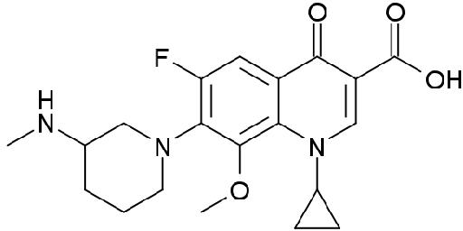

### Fig. No. 01: structure of Balofloxacin (BLFX)

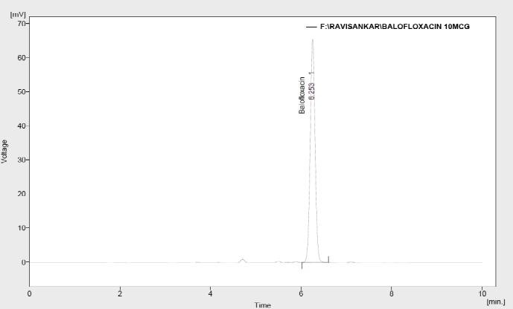

**Fig. No. 02: A typical chromatogram of balofloxacin standard**

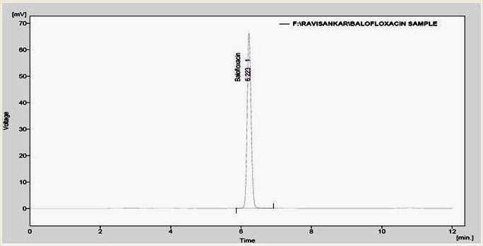

### Fig. No. 03: Chromatogram of market formulation (Tablets) of balofloxacin.

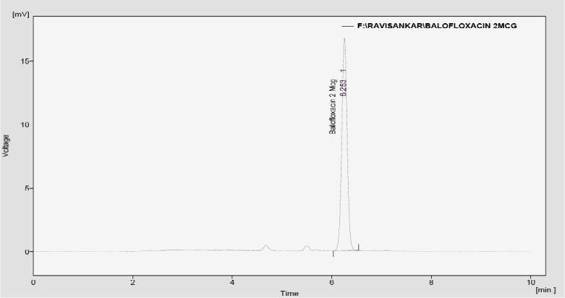

**Fig. No. 04: Standard chromatogram of balofloxacin (2 µg/mL)**

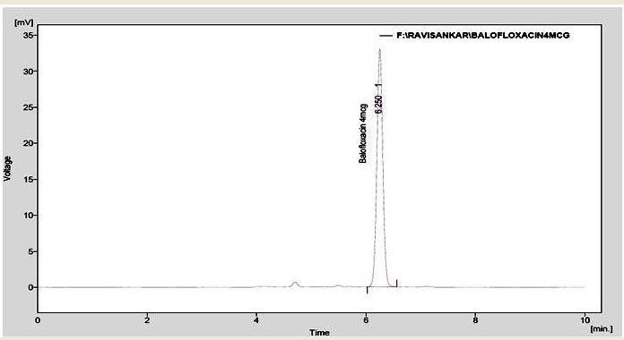

### Fig. No. 05: Standard chromatogram of balofloxacin (4µg/mL)

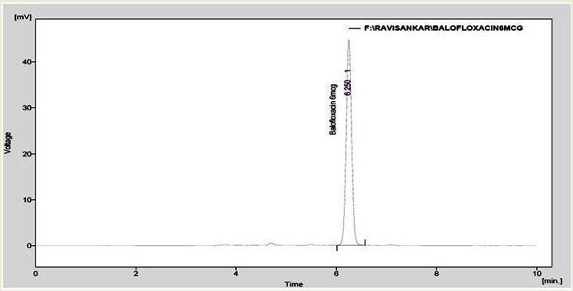

**Fig. No. 06: Standard chromatogram of balofloxacin (6 µg/mL)**

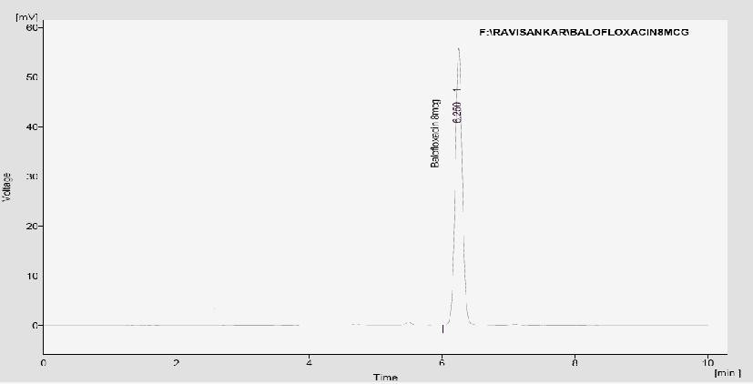

### Fig. No. 07: Standard chromatogram of balofloxacin (8 µg/mL)

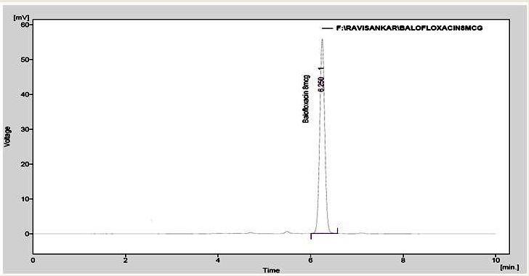

**Fig. No. 08: Standard chromatogram of balofloxacin (10µg/mL)**

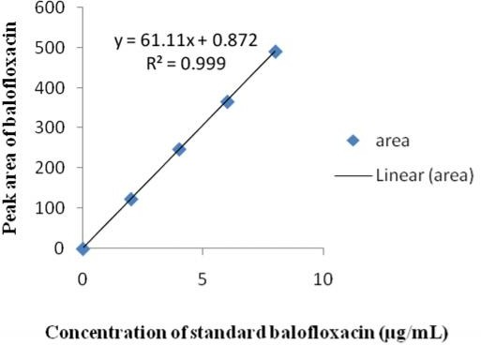

**Fig. No. 09: Calibration plot of balofloxacin**

## Conclusion

A New validated RP-HPLC method has been developed for the quantitative determination of BLFX in tablet dosage forms in bulk and pharmaceutical dosage forms was established. Statistical analysis of the results shows that the proposed procedure has good precision and accuracy. The method was completely validated shows satisfactory results for all the method validation parameters tested and method was free from interference of the other active ingredients and additives used in the formulation. Infact results of the study indicate that the developed method was found to be simple, reliable, accurate, linear, sensitive, economical, and reproducible and have short run time which makes the method rapid. Hence it can be concluded that this method may be employed for the routine quality control analysis of BLFX in active pharmaceutical ingredient (API) and pharmaceutical preparations.

## Acknowledgement

The authors thank to Hetero Labs Limited, jeedimetla, Hyderabad for providing balofloxacin as gift sample for this work. They also thank chairman Dr.L. Rathaiah, Vignan Pharmacy College for providing necessary facilities to carry out this research work.

## References

1. Drug today medical journal, October- December 2012.
2. [http://en.wikipedia.org/wiki/Balofloxacin.](http://en.wikipedia.org/wiki/Balofloxacin)
3. Merck and Co.Inc., The Merck Index, an Encyclopedia of Chemicals, Drugs and Biologicals,14th Edn.,white house station,Newjeresy, 2006, 941.
4. Sean C. Sweetman., Martindale: The complete drug reference, 37th Edn, Pharmaceutical Press, London, 2011, 229.
5. Alksne L. Balofloxacin Choongwae. Curr Opin Investing Drugs 4(2), 2003, 224-229.
6. Andriole, V.T (ed.) (1998) the quinolones, 2nd edn.academic press, New York.
7. Saunders, j.(2000) Quinolones as anti-bacteral DNA gyrase inhibitors. Chapter 10 in: Top drugs: top synthetic routes.Oxford university press, Oxford.
8. Ross DL, Elkinton S, Riley CM. Physicochemical Properties of the Fluoroquinolone antimicrobials IV 1- octanol/Water Partition Coefficients and Their Relationships to Structure. Int. J. Pharm. 88, 1992, 379-389.
9. Chu Z, Wang L, Guo C, Jiang W. Luminescence enhancement effect for the determination of balofloxacin with balofloxacin europium (III) sodium dodecyl benzenesulfonate system.Journal of Luminescence 2009; 129:90-4.
10. Nakagawa T, Ishigai M, Hiramatsu Y, Kinoshita H, Ishitani Y, Ohkubo K, Okazaki A, Determination of the new fluoroquinolone balofloxacin and its metabolites in biological fluids by high performance liquid chromatography, *Arzneimittelforschung*, 1995, *45*, 716–718.
11. Mi Yaxian, Wu Yan, Li Hualong, Li Lijian. Study on determination of related substances in balofloxacin by RP-HPLC, Available from: [http://eng.hi138.com,](http://eng.hi138.com/) Updated 2010 March 29.
12. Lunn, George. HPLC methods for recently approved pharmaceuticals Published by John Wiley & Sons, Inc., Hoboken, New Jersey. Published simultaneously in Canada; 67.
13. Marutani K ,Matsumoto M, Otabe Y, Nagamuta M, Tanaka K,Miyoshi A, et al. Reduced photo toxicity of a fluoroquinolone antibacterial agent with a methoxy group at the

8 position in mice irradiated with long- wavelength UV light. Antimicrobial Agents Chemother.1993; 37:2217–2223.

1. Qi X.J, Wang J.X, Liu Z.R. Fluorescent spectroscopy of Balofloxacin. Chinease Journal of Analytical chemistry 2006; 34:1047.
2. Bian Z, Tian Y, Zhang Z, Xu F, Li J, Cao X. High performance liquid chromatography electro spray ionization mass spectrometric determination of balofloxacin in human plasma and its pharmacokinetics. J Chromatogr B Analyt Technol Biomed Life Sci. May- 2007; 850(1-2):68-73.
3. Punan M,Tumar,Vandana B, Patel International journal of Pharm Tech Research vol.3,No.4,pp 1938-1941,Oct-Dec 2011.
4. Marutani K, Matsumoto M, Otabe Y Nagamuta M, Tanaka K, Miyoshi A,

Hasegawa T, Nagano H, Matsubara S, Kamide R, Yokota T, Matsumoto F, Ueda Y. Reduced photo toxicity of a fluoroquinolone antibacterial agent with a methoxy group at the

8 position in mice irradiated with long- wavelength UV light, *Antimicrob.Agents Chemother.*, 1993, *37*, 2217–23.

1. Kozawa, O, Uematsu T, Matsuno H, Niwa M, Nagashima S, Kanamaru M. comparative study of pharmacokinetics of two new fluoroquinolones, balofloxacin and grepafloxacin, in elderly subjects, *Antimicrob. Agents Chemother.*, 1996, *40*, 2824–2828.
2. Uematsu T, Ohsawa Y, Mizuno A, Nakashima

M. Analysis of a new fluoroquinolone derivative (Q- 35) in human scalp hair as an index of drug exposure and as a time marker in hair, *Int.J.Legal Med.*, 1994, *106*, 237–243.

1. The International Conference on Harmonization, Q2 (R1), Validation of Analytical Procedure: Text and methodology.2005.
2. ICH Guidance on Analytical Method Validation, in Proceedings of the International Convention on Quality for the Pharmaceutical Industry, Toronto, Canada, and September, 2002.
3. United States Pharmacopoeia /National Formulary, 24th ed. Rockville, MD: Pharmacopeial Convention; 2000. P. 2149.