# 114

***Research Article***

**Available Online at:** [**www.ijpir.com**](http://www.ijpir.com/)



International Journal of Pharmacy and Industrial Research

**ISSN**

**Print 2231 – 3648**

**Online 2231 – 3656**

**RP-HPLC METHOD DEVELOPMENT AND VALIDATION FOR SIMULTANEOUS ESTIMATION OF SITAGLIPTIN PHOSPHATE AND METFORMIN HYDROCHLORIDE IN TABLET DOSAGE FORM**

# *Kurra Neelesh

Vagdevi College of Pharmacy, Gurajala, Guntur, A.P, India - 522415.

## Abstract

A simple, rapid, precise, accurate RP-HPLC method has been developed and validated for the simultaneous estimation of Sitagliptin and Metformin in combined dosage forms. Chromatographic separation was achieved with mobile phase consisting of Acetonitrile: Phosphate Buffer pH 3.0 in the ratio of 40:60 v/v with Supercil C18 (250 × 4.6 mm × 5 µm), column at a flow rate of 1 mL/min and detection wavelength was 236 nm. The retention times of Sitagliptin Phosphate and Metformin Hydrochloride was found to be 4.813 min and

2.390 min respectively. The method was validated in terms of Linearity, Range, Accuracy, Precision, Specificity, LOD, LOQ, Robustness and system suitability according to ICH guidelines. Commercial tablet formulation was successfully analyzed using the developed method and the proposed method is applicable to routine analysis for determination of Sitagliptin Phosphate and Metformin Hydrochloride in tablet dosage form.

**Keywords:** Sitagliptin, Metformin, RP-HPLC, Development, Validation, Simultaneous estimation.

## Introduction

Sitagliptin Phosphate (STG) is chemically 1,2,4- triazolo[4,3-a]pyrazine,7-[(3R)-3-amino-1-oxo-4- (2,4,5-trifluorophenyl)butyl]-5,6,7,8-tetrahydro-3- (trifluoromethyl). It is used in the treatment of diabetes. It is an oral anti hyperglycemic (anti- diabetic) drug of the dipeptidyl peptidase-4 (DPP- 4) inhibitor class. Sitagliptin phosphate competitively inhibits dipeptidyl peptidase-4, an enzyme involved in the breakdown of incretins such as glucagon-like particle-1 (GLP-1) which potentiate insulin. Secretion in vivo. Inhibit ion of DPP-4 reduces the breakdown of GLP-1 and increases insulin secretion; this suppresses the release of glucagon from the pancreas and drives down blood sugar levels.**1**

Metformin Hydrochloride (MET) is chemically 3- (diaminomethylidene)-1,1 dimethylguanidine. It is an oral anti-diabetic drug which is the first line drug of choice for the treatment of type 2 diabetes, particularly in overweight or obese peoples and those with normal kidney function. Metformin improves hyperglycemia, primarily through its suppressive action on production of hepatic glucose (hepatic gluconeogenesis).**2**

A literature survey shows that a number of Derivative spectrophometry**3**, ion pair chromatography**4**, UV-spectroscopy**5**, Spectro - flourimetri**6**, Liquid chromatography tandem mass spectrometry**7,8,9**, UPLC**10**, HPLC**11,12,13,14** methods

### Author for Correspondence:

Kurra Neelesh**,**

Vagdevi College of Pharmacy, Gurajala, Guntur, A.P, India - 522415. E-mail: [neelesh.kurra4u@gmail.com](mailto:neelesh.kurra4u@gmail.com)

Kurra Neelesh., Int. J. Pharm & Ind. Res., Vol.–03 (02) 2013 [114 - 120]

115

have been reported for the simultaneous estimation of STG and MET in pharmaceutical dosage forms in combination or combinations with other drugs.

So my aim to develop new method with optimum pH and less run time for simultaneous estimation of STG and MET in tablet dosage form.

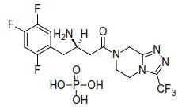 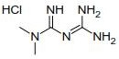

**Fig. No. 01: Chemical structure of STG Fig. No. 02: Chemical structure of MET**

## Materials and methods

### Chemicals and reagents

Drug samples were obtained from Getz Pharmaceuticals Research Pvt. Ltd., India. Tablets (Janumet, MSD Pharmaceuticals Pvt Ltd) Potassium Dihydrogen orthophosphate (Rankem

/AR Grade) Dipotassium hydrogen orthophosphate (Rankem/AR Grade) Acetonitrile (Merck/HPLC Grade) Water (Merck/HPLC Grade) Methanol (Merck/HPLC Grade) O-phosphoric acid (Rankem/ Reagent Grade).

### Instrumentation

Shimadzu HPLC system equipped with pump (LC- 10ATVP), UV detector (SPD-10ADVP), column Supersil C18 (250×4.6 mm I.D) 5 µm particle size, Rheodyne injector fitted with 20µL loop and data read out by using spinchrom software.

### Chromatographic conditions

Analysis was carried out at ambient temperature. Compounds were separated isocratically with a mobile phase consisting of Acetonitrile: phosphate buffer having pH 3.0 ± 0.2 in the ratio of 40:60 v/v at a flow rate of 1 mL/ min. The detection of the compounds was carried out at 236 nm. The mobile phase was filtered by using 0.45 µm membrane filter (Millipore, Bradford, MA), and sonicated in ultrasonicator for 15 minutes.

**Preparation of phosphate buffer pH 3.0±0.2** Accurately weigh 1.625 gm of potassium dihydrogen orthophosphate and 0.39 gm of Dipotassium hydrogen orthophosphate in 550 mL of HPLC grade water and pH is adjusted to 3.0±0.2 with O-Phosphoric acid.

### Preparation of standard stock solution

Stock solution was prepared by dissolving 125 mg of MET and 12.5 mg of STG in few mL of mobile phase in a 100 mLvolumetric flask. It sonicated and the volume was made to the mark with the mobile phase and filtered.

### Working standard solution

From above stock solution 125µg/mL of MET and

12.5 µg/mL of STG working solution was prepared, pipette out 1 mL in 10 mL volumetric flask and the volume up to the mark was made with the mobile phase. The above solution is used for precision, specificity, robustness

### Sample stock preparation

Twenty tablets were weighed accurately and powdered. A quantity of powder equivalent to 125 mg of MET and 12.5 mg of STG in 100 mL volumetric flask and make up mark with mobile phase. The above solution was sonicated and filtered.

### Working sample solution

From above stock solution 125 µg/mL of MET and 12.5 µg/mL of STG working solution was prepared by pipette out 1 mL in 10mL volumetric flask and the volume up to the mark was made with the mobile phase. The above solution is used for assay.

### Calibration and linearity

The calibration curves were constructed in the range of 75-175 µg/mL for MET and 7.5-17.5 µg/mL for STG. the solution were prepared by diluting 0.6, 0.8, 1.0, 1.2, 1.4 mL of standard stock solution to 10 mL with mobile phase.

# 116

Kurra Neelesh., Int. J. Pharm & Ind. Res., Vol.–03 (02) 2013 [114 - 120]

## Results and discussions

Optimization of chromatographic conditions by using different mobile phase compositions. The optimum chromatographic conditions found with acetonitrile and phosphate buffer pH 3 in the ratio of 40:60 v/v on Supercil column C18 (250×4.6 mm I.D) 5µm particle size with a flow rate of 1 mL/min and detection wavelength was selected as

236 nm. STG was eluted at 4.813 min with theoretical plates 4441, tailing factor 1.359 and resolution 9.428. MET was eluted at 2.390 min with theoretical plates 2000, tailing factor 1.912. So this condition was used for assay and the assay results were shown in Table 1.

### Method validation

Method validation done according to the ICH guidelines for validation of analytical procedures.

### System suitability

System suitability of method was carried out to verify that the resolution and reproducibility of the system are satisfactory for the analysis to be performed. Theoretical plates, tailing factor, Resolution parameters were determined and compared against the specifications and are presented in Table 2.

### Precision System Precision

System precision was carried out by using standard preparation for six times and the result was calculated. The %RSD was found to be less than 2%. This proves the method was precise. The result was shown in Table 3.

### Method Precision

Method precision was carried out by using sample preparation for six times and the result was calculated. The %RSD was found to be less than 2%, which proves the method was precise. The result was shown in Table 4.

### Linearity

The linearity of method was studied by preparing different concentration levels of standard solutions. The linearity range for MET and STG were found to be 75-175 µg/mL and 7.5-17.5 µg/mL, respectively. The regression equation for MET and STG were found to be y = 30.92x – 985.1 and y = 9.889x –32.36 with coefficient of correlation, (*R2*)

0.999 and 0.999, respectively. The linearity graph of MET and STG was shown in Fig 3 and Fig 4.

***LOD and LOQ***

LOD and LOQ is calculated from standard deviation of response from precision and slope from linearity

LOQ = 10 σ / S LOD = 3.3 σ / S

Where,

σ is standard deviation from response S is slope from calibration curve

The LOD for this method was found to be 0.072 µg/mL for MET and 0.0.307 µg/mL for STG respectively. The LOQ for this method was found to be 0.0.219 µg/mL for MET and 0.930 µg/mL for STG respectively.

### Specificity

Specificity of the method was determined by comparing the retention times of MET and STG of standard solution with the retention times of MET and STG of sample solutions. Good correlation was obtained between the retention times of standard with sample shows that there is no interference of excipients from tablet dosage form. Specificity chromatograms given in Fig 5 and Fig 6.

### Accuracy

The degree of accuracy of the method was determined by recovery studies in triplicate by standard addition method at 80%, 100% and 120%. Known amounts of standard MET and STG were added to pre-analyzed samples and were analysed in proposed HPLC method. Results of recovery studies were shown in Table 5 and Table 6.

### Robustness

Robustness of the method was performed by small deliberate variation in operating conditions like wave length (±2 nm) and flow rate (±0.1mL/min). The results were shown in Table 7.

From linearity the correlation coefficient *R2* values were found to be 0.999 for both drugs which shows that linear relationship between concentrations versus response. The proposed HPLC method was also validated for system suitability, system precision and method precision. The % RSD in the peak area of drug was found to be less than 2%. The number of theoretical plates was found to be more than 2000, which indicates efficient

Kurra Neelesh., Int. J. Pharm & Ind. Res., Vol.–03 (02) 2013 [114 - 120]

117

performance of the column. The LOD of MET and STG were found to be 0.072 μg/mL and 0.307 μg/mL and LOQ of MET and STG were found to be 0.219 μg/mL and 0.930 μg/mL respectively,

indicates the sensitivity of the method. The percentage of recovery of MET and STG were found to be 99.71 and 100.03 respectively shows that the proposed method is highly accurate.

|  |  |  |  |
| --- | --- | --- | --- |
| **Table No. 01: Results for assay** | | | |
| **Drug** | **Label claim(mg)** | **Amount found(mg)** | **% Assay** |
| STG | 50 | 49.90 | 99.79 |
| MET | 500 | 498.17 | 99.63 |
| **Table No. 02: Results for system suitability parameters** | | | |

|  |  |  |
| --- | --- | --- |
| **Parameters** | **STG** | **MET** |
| Retention times(min) | 4.820 | 2.380 |
| Theoretical plates | 4533 | 2230 |
| Tailing factor | 1.220 | 1.92 |
| Resolution | 9.679 | - |

### Table No. 03: Results for system precision

|  |  |  |  |  |
| --- | --- | --- | --- | --- |
|  | **Retention times** | **Area** | **Retention times** | **Area** |
| 1 | 4.81 | 85.421 | 2.36 | 2811.265 |
| 2 | 4.81 | 85.452 | 2.36 | 2822.991 |
| 3 | 4.817 | 86.603 | 2.37 | 2810.69 |
| 4 | 4.813 | 87.213 | 2.37 | 2806.346 |
| 5 | 4.817 | 86.969 | 2.373 | 2807.444 |
| 6 | 4.783 | 86.926 | 2.337 | 2767.662 |
| Average | 4.808 | 86.43067 | 2.3617 | 2804.40 |
| SD | 0.013 | 0.794 | 0.0133 | 18.948 |
| %RSD | 0.27 | 0.92 | 0.56 | 0.68 |

**Injection STG MET**

### Table No. 04: Results for method precision

|  |  |  |  |  |
| --- | --- | --- | --- | --- |
|  | **Retention times** | **Area** | **Retention times** | **Area** |
| 1 | 4.82 | 85.431 | 2.38 | 2818.265 |
| 2 | 4.82 | 85.462 | 2.38 | 2822.991 |
| 3 | 4.827 | 86.613 | 2.38 | 2811.69 |
| 4 | 4.823 | 87.203 | 2.38 | 2806.346 |
| 5 | 4.817 | 86.969 | 2.373 | 2807.444 |
| 6 | 4.783 | 86.926 | 2.337 | 2769.662 |
| Average | 4.815 | 86.434 | 2.3717 | 2806.07 |
| SD | 0.016 | 0.788 | 0.0172 | 18.943 |
| %RSD | 0.33 | 0.91 | 0.73 | 0.68 |

**Injection STG MET**

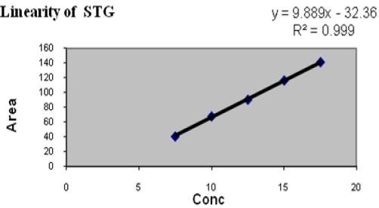

**Fig. No. 03: Linearity graph of STG**

# 118

Kurra Neelesh., Int. J. Pharm & Ind. Res., Vol.–03 (02) 2013 [114 - 120]

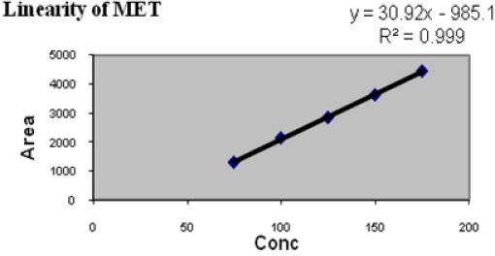

### Fig. No. 04: Linearity graph of MET

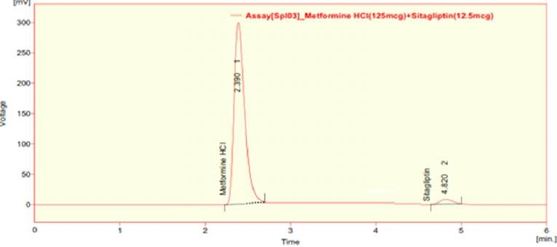

**Fig. No. 05: Chromatogram of sample**

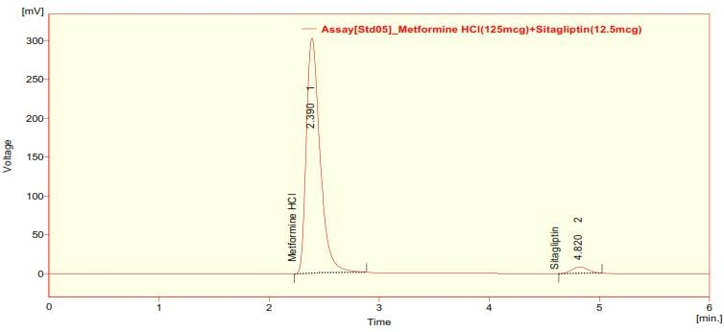

### Fig. No. 06: Chromatogram of standard

**Table No. 05: Results for Recovery of STG.**

**Conc Amount**

|  |  |  |  |  |
| --- | --- | --- | --- | --- |
|  | **present (µg/mL)** | **added (µg/mL)** | **(µg/mL)\*** | **Recovery * Recovery** |
| 80% | 10 | 0.5 | 9.89 | 98.91 |
| 100% | 13 | 0.5 | 13.13 | 101.01 100.03 |
| 120% | 15 | 0.5 | 15.11 | 100.76 |

**Amount**

**Amount found**

**Percentage**

**% Mean**

**\*** Mean of three observations

Kurra Neelesh., Int. J. Pharm & Ind. Res., Vol.–03 (02) 2013 [114 - 120]

119

### Table No. 06: Results for Recovery of MET.

**Conc Amount**

|  |  |  |  |  |
| --- | --- | --- | --- | --- |
|  | **present (µg/mL)** | **added (µg/mL)** | **(µg/mL)\*** | **Recovery * Recovery** |
| 80% | 100 | 0.5 | 105.16 | 100.15 |
| 100% | 125 | 0.5 | 129.05 | 99.27 99.71 |
| 120% | 150 | 0.5 | 154.54 | 99.70 |

**Amount**

**Amount found**

**Percentage**

**% Mean**

**\*** Mean of three observations

### Table No. 07: Results for Robustness

|  |  |  |  |  |
| --- | --- | --- | --- | --- |
|  | **STG** | **MET** | **STG** | **MET** |
| Flow rate 0.8 | 5.970 | 2.970 | 1.120 | 1.98 |
| (mL/min) 1 | 4.817 | 2.373 | 1.317 | 1.98 |
| 1.2 | 4.050 | 1.997 | 1.237 | 1.97 |
| 234 | 4.823 | 2.390 | 1.275 | 1.98 |
| Wavelength (nm) 236 | 4.817 | 2.373 | 1.317 | 1.98 |
| 238 | 4.820 | 2.390 | 1.200 | 1.97 |

**Chromatographic changes Retention time(min) Tailing factor**

**Conclusion**

The develop RP-HPLC method was proves to be precise, rapid, accurate, linear, specific. It can be effectively applied for routine analysis in research institutions, quality control department in industries, approved testing laboratories in near future.

## Acknowledgement

The author wish to thank the management of Vagdevi College of Pharmacy for providing facilities during the work.

## References

|  |  |  |  |
| --- | --- | --- | --- |
| 1. Sitagliptin | Phosphate | Drug | Profile- |
| <http://www.drugbank.ca/drugs/DB01261> | | | |
| 2. Metformin | Hydrochloride | Drug | Profile- |
| <http://www.drugbank.ca/drugs/DB00331> | | | |

1. Shankar M B, Modi V D, Shah D A, Bhatt K K , Mehta R S, Geetha M and Patel B J; Estimation of Pioglitazone Hydrochloride and Metformin Hydrochloride in Tablets by Derivative Spectrophotometry and Liquid Chromatographic Methods. Journal of AOAC International. 2005; 88(4):1167-1172.
2. Vasudevan M, Ravi J, Ravisankar S, Suresh B. Ion-pair liquid chromatography technique for the estimation of metformin in its multicomponent dosage forms. J Pharm Biomed Anal. 2001 Apr; 25(1):77-84.
3. Ajithdas A, Nancy K. Simultaneous estimation of metformin hydrochloride and glipizide solid dosage forms by ultraviolet spectrophotometry. Indian Drugs. 2000; 37: 533–536.
4. Ramzia IE, Ehab FE, Bassam MA. Spectroflourometric and Spectrophotometric Methods for Determination of Sitagliptin in Binary Mixture with Metformin and Ternary Mixture with Metformin and Sitagliptin alkaline Degradation product. Int J Biomed Sci. 2011; 7: 62–69.
5. John G. Swale, Richard T. Gallagher, Mark Denn, Raimund M. Peter, Simultaneous quantitation of Metformin and Sitagliptin from mouse and human dried blood spots using laser diode thermal desorption tandem mass spectrometry, Journal of Pharmaceutical and Biomedical Analysis, Volume 55, Issue 3, 1 June 2011, Pages 544-551.
6. Zeng W, Musson DG, Fisher AL, Chen L, Schwartz MS, Woolf EJ, Wang AQ. Determination of Sitagliptin in human urine and hemodialysate using turbulent flow online extraction and tandem mass spectrometry. J Pharm Biomed Anal. 2008; 46: 534–542.
7. Ramakrishna N, Vishwottam K, Koteshwara M, Prashanth K, Raghupathi A, Rajeshkumar

B. Sensitive liquid chromatography tandem mass spectrometry method for the quantification of sitagliptin, a DPP-4 inhibitor, in human plasma using liquid liquid extraction. Biomed Chromatogr. 2008; 22: 214–222.

1. Malleswararao Chellu S. N., Mulukutla V. Suryanarayana, Khagga mukkanti. Simultaneous Determination of Sitagliptin Phosphate Monohydrate and Metformin Hydrochloride in Tablets by a Validated UPLC Method. Sci Pharm. 2012; 80: 139–152.

# 120

Kurra Neelesh., Int. J. Pharm & Ind. Res., Vol.–03 (02) 2013 [114 - 120]

1. Shyamala.M, Mohideen.S, Satyanarayana .T, Ch. Narasimha Raju, Suresh Kumar.P, Swetha.K.Validated RP-HPLC for simultaneous estimation of sitagliptin phosphate and metformin hydrochloride in tablet dosage form. AJPTR. 2011; 1(2): 93- 101.
2. Charles BG, Jascoben NW, Ravenscroft PJ. Rapid liquid chromatographic determination of metformin in plasma and urine. Clin Chem. 1981; 27: 434–436.
3. Lad NR, Bhoir SI, Bhoir IC, Sundaresan M. Concurrent assay of metformin and glimepiride in tablet using RP-HPLC with wavelength Programming. Indian J Pharm Sci. 2003; 65: 650–653.
4. Yuen KH, Peh KK. Simple HPLC method for the determination of metformin in human plasma. J Chromator B. 1998; 710: 243–246.