Research Article

Available Online at: www.ijpir.com

International Journal of Pharmacy and Industrial Research

ISSN
Print 2231 – 3648
Online 2231 – 3656

FORMULATION AND EVALUATION OF ORODISPERSIBLE TABLET OF NISOLDIPINE

^{*1}Mohan P, ¹Raja N, ²Shravan N, ²Sandeep G, ¹Raghunandan N
^{*1}Balaji Institute of Pharmaceutical Sciences, Narsampet (M), Warangal (D), AP, India – 506 331.
²Balaji Institute of Pharmacy, Narsampet (M), Warangal (D), AP, India – 506 331.

Abstract
Nisoldipine is an antihypertensive agent. It has low absolute bioavailability (5%) is due to poorly solubility, and high hepatic metabolism in the gut wall. In this investigation of the study was to improve the oral bioavailability, superior therapeutic efficacy and improve the onset of action via Formulation and evaluation of orodispersible tablets of Nisoldipine. ODTs were prepared by direct compression method by using superdisintegrant such as Ac-di-sol, Crospovidone, sodium starch glycolate. The prepared ODTs Powder blend was evaluated for angle of repose, bulk density, tapped density, compressibility index, Hausner's ratio. The prepared tablets were evaluated for weight variation, thickness, drug content, friability, hardness, wetting time, invitro disintegration time, and invitro dissolution study. The optimized formulation was found to be good hardness, wetting time, fast disintegration, and improved dissolution profile .The drug release from ODTs containing superdisintegrant was more as compared to ODTs containing without superdisintegrant and it was found to be highest (53.86±2.06% drug release after 45 min) with formulation batch containing crospovidone (F6) so it can be concluded as promising formulation.

Keywords: Nisoldipine, Orodispersible tablets (ODTs), Ac-di-sol, Crospovidone, Sodium Starch Glycolate.

Introduction
Whenever a new Pharmaceutical active molecule has been identified, oral conventional tablet will be the first choice of formulation approach because of its greatest advantages in convenience in manufacturing and also in administration by patients. Many of the Pharmaceutical drugs falling under BCS class-II drugs have poor bioavailability owing to their low aqueous solubility. For such drugs rate of dissolution is the rate limiting step for the bioavailability^{1,} ². To overcome the solubility issue of the drug various research approaches like addition of surfactants³, complexation with

cyclodextrins⁴, solid dispersions with water soluble agents such as poloxamer⁵, polyethylene glycol⁶, polyvinylpyrollidone⁷ and novel approaches like Nanosuspension, Nanoemulsion and Self emulsifying formulation were directed. Among those orally Disintegrating tablet (ODT) has primary importance because of its scale up applicability to large scale manufacturing.

Additionally, children and the elderly population and many patients suffering by Dysphagia find it inconvenient to ingest conventional solid dosage

Author for Correspondence:
Mohan P,
Balaji Institute of Pharmaceutical Sciences, Narsampet (M), Warangal (D), AP, India – 506 331. E-mail: mpharmmohan@yahoo.com

forms such as tablets and capsules due to an impaired ability to swallow⁸. This leads to patient non-compliance and potentially prolonged duration of treatment. This issue can also be resolved through the development of orally disintegrating dosage forms that disperse or dissolve in the saliva within a few seconds and are swallowed without the need of water. This can be achieved by incorporation of optimized quantity of superdisintegrants such as Cross Cormellose, Cross Povidone, Sodium Starch Glycolate and etc.,

Nisoldipine is 9-3-isobutyl-5-methyl-1,4-dihydro- 2,6- dimethyl-4- (2-nitrophenyl)- pyridine-3,5- dicarboxylate, Pharmacologically a calcium channel blocking agent included in dihydropyridine family⁹. It is mainly indicated for hypertension, angina pectoris and heart failure ¹⁰. Nisoldipine is classified as BCS Class-II drug based on its poor water solubility with very low bioavailability⁹. This makes Nisoldipine a potential drug of choice for Orally Disintegrating Tablet formulation which will result in improved solubility, dissolution and ultimately bioavailability.

Materials and method

Materials
Nisoldipine (NSD) was generously gifted by Orchid chemicals and Pharmaceutical Ltd., Chennai (India). Sodium starch glycolate (Micro labs, Bengaloru), Crospovidone, Ac-Di-Sol, Avicel PH 102 (Hetero labs, Hyderabad), Talc, Magnesium stearate, Mannitol (Himedia, Hyderbad). All other materials and reagents used were of analytical grade of purity.

Formulation of orodispersible tablets
Tablet containing 10 mg Nisoldipine were prepared as per composition given in table 1. Tablet formulations were prepared by mixing the excipients except magnesium stearate passed through sieve no 80 to ensure uniform mixing. After addition of magnesium stearate, mixing was continued for 2 min. The mixed blend was then compressed with 8 mm flat face surface punches using hydraulic press rotary compression machine. A minimum of 60 tablets was prepared for each batch before tablet preparation the blend mixture of each formulation was subjected to evaluation of pre-compression parameters.

Evaluation of pre compression parameters Angle of repose¹¹
The fixed funnel method was used to determine the angle of repose. The blend was poured through funnel until the apex of the conical pile just touches the tip of the funnel. The angle of repose can be mathematically calculated by using formula
Tan θ =H/R
Where,
H =height of the pile R=radius of conical pile

Bulk density¹¹
An accurately weighed quantity of sample was poured through a 100 ml cylinder with aid of funnel. The initial volume and weight of power was noted .The bulk density was calculated using the following formula. The result are expressed in (gm/ml).

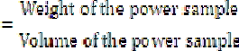

Tapped density¹¹
The cylinder was tapped from a height of 2.5 cm 50 times on a wooden bench top to attain a constant volume reading from the cylinder, The Tapped density was calculated using the following formula results are expressed in (gm/ml).

Carr’s compressibility index¹¹
An accurate weight of formulation blend was poured into a volumetric cylinder to occupy a volume (V0) and then subjected to a standard tapping procedure onto a solid surface until a constant volume was achieved (Vt). Carr’s “percent compressibility” was calculated using the equation.

Hausner’s ratio¹¹
Hausner ratio is an indirect index of ease of power flow. It is calculated by the following formula,
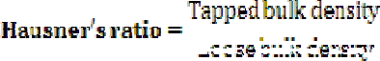

Hausner’s ratio less than 1.25 indicates better flow greater than 1.25 indicates poor flow.

Evaluation of post compression parameters Thickness^{12,13}
The thickness of tablet was measured by using thickness screw gauge. Five tablets from each batch were used and average value was calculated.

Hardness test or crushing strength
The crushing strength of ten tablets was measured using Monsanto hardness tester. It is expressed in kg/cm^{2.}Data are reported as an average of 10 measurements

Friability^{12,13}
The friability was determined using roche friabilator. 20 tablets was previously weighed to falling shocks for 4 min in a friabilator, set at 25 rev/min. After 4 min, the tablets were reweighed and the percentage friability was calculated. The percentage friability (f) is given by the formula.


Weight variation test^{12,13}
Twenty tablets were collected from each batch and weighed individually. And individual weight was compared with an average weight.

Drug content uniformity^{12,13}
Twenty tablets from each batch were powdered and weight equivalent to 10 mg of drug was placed in 100 ml volumetric flask and dissolved in methanol and make up volume with 0.2M phosphate buffer solution (pH 6.8). 5 ml of the filtrate was diluted to 100 ml with same buffer solution and drug content was estimated spectrophotometrically at 238nm
Wetting time^{14,} ¹⁵
The simplest method was used to determine wetting time. The prepared tablets were placed in a petridish of 5.5 cm in diameter containing 10 ml of water at room temperature and the time for complete wetting was recorded.

In vitro dispersion time
One tablet of the selected formulation was placed in a 50 ml of water (see Figure 1) and the dispersion process was recorded without agitation and kinetic digital images were taken with a 7.2 mega pixel camera (Sony- DSC-W55, Japan).

In vitro Disintegration time¹⁶
The disintegration time for all tablets was carried out using tablet disintegration test apparatus The tablet was carefully placed in the tube of disintegration test apparatus and disc were placed . The water was maintained thermostated at 37⁰C ± 0.5.and the time for tablet complete disintegration into fine particles was measured.

In vitro dissolution studies¹⁷
The in-vitro dissolution study was performed in USP II dissolution test apparatus (Lab India DS 8000) in 500 ml 0.2M phosphate buffer solution with pH 6.8 with 1% SLS as dissolution medium the temperature was maintained at 37±0.5ºC and rotation speed was 50 rpm . Aliquots of 5ml were withdrawn at predetermined time intervals at 5, 10, 15, 20, 25, 30 and 45 mins and replace with fresh medium. The samples were filtered through
0.2 μm whatmann filter paper and analyzed spectrophotometrically at 238nm. All experiments were carried out in triplicate.

Table No. 01: Formulation design of orodispersible tablets
Ingredients (mg) | F1 | F2 | F3 | F4 | F5 | F6 | F7 | F8 | F9 | F10
Nisoldipine | 10 | 10 | 10 | 10 | 10 | 10 | 10 | 10 | 10 | 10
Mannitol | 128 | 124 | 120 | 128 | 124 | 120 | 128 | 124 | 120 | 130
Sodium starch glycolate | 4 | 8 | 12 | - | - | - | - | - | - | -
Crospovidone | - | - | - | 4 | 8 | 12 | - | - | - | -
Croscarmelose sodium | - | - | - | - | - | - | 4 | 8 | 12 | -
Microcrystalline cellulose | 50 | 50 | 50 | 50 | 50 | 50 | 50 | 50 | 50 | 50
Aspartame | 2 | 2 | 2 | 2 | 2 | 2 | 2 | 2 | 2 | 2
Talc | 4 | 4 | 4 | 4 | 4 | 4 | 4 | 4 | 4 | 4
Magnesium stearate | 2 | 2 | 2 | 2 | 2 | 2 | 2 | 2 | 2 | 2
Total | 200 | 200 | 200 | 200 | 200 | 200 | 200 | 200 | 200 | 200

TableNo. 02: Evaluation parameters of powdered blend
Formulation Angle of Bulk density |  |  | Tapped density | Percentage | Hausner’s
 | repose (θ) | (gm/ml) | (gm/ml) | compressibility (%) | ratio
F1 | 20.61 | 0.55 | 0.62 | 11.11 | 0.88
F2 | 21.12 | 0.55 | 0.61 | 10.00 | 0.90
F3 | 21.22 | 0.54 | 0.62 | 13.33 | 0.87
F4 | 22.45 | 0.58 | 0.66 | 11.76 | 1.13
F5 | 22.35 | 0.58 | 0.66 | 11.11 | 1.13
F6 | 22.48 | 0.58 | 0.67 | 11.17 | 1.15
F7 | 22.68 | 0.54 | 0.57 | 10.81 | 1.05
F8 | 22.58 | 0.55 | 0.62 | 11.11 | 1.13
F9 | 22.68 | 0.54 | 0.57 | 10.92 | 1.05
F10 | 22.58 | 0.55 | 0.61 | 10.00 | 0.90

Table No. 03: Evaluation parameters of orodispersible tablet

* ₍ Thickness
** Friability*
** Disintegration

Formulation | Weight Variation mg) (mm )** |  | Hardness | (%) Wetting time (sec) |  | time (sec)**
F1 | 198.26±0.59 | 4.74±0.08 | 3.2±0.16 | 0.29±0.03 | 34±1.35 | 25±1.03
F2 | 201.06±0.32 | 4.45±0.11 | 3.4±0.06 | 0.30±0.04 | 32±1.25 | 21±1.02
F3 | 196.79±0.78 | 4.40±0.06 | 3.5±0.16 | 0.27±0.06 | 29±1.19 | 19±1.22
F4 | 198.52±0.96 | 4.46±0.14 | 3.4±0.17 | 0.31±0.14 | 19±1.10 | 16±1.12
F5 | 199.27±1.06 | 4.55±0.10 | 3.3±0.12 | 0.34±0.16 | 14±1.14 | 11±1.04
F6 | 198.84±0.92 | 4.55±0.12 | 3.3±0.14 | 0.36±0.13 | 12±1.13 | 08±1.07
F7 | 197.32±1.12 | 4.54±0.06 | 3.4±0.07 | 0.39±0.09 | 38±1.20 | 26±1.05
F8 | 196.46±0.85 | 4.74±0.12 | 3.2±0.17 | 0.38±0.08 | 36±1.15 | 22±1.12
F9 | 199.82±0.74 | 4.30±0.08 | 3.4±0.18 | 0.40±0.07 | 30±1.25 | 18±1.15
F10 | 198.75±0.44 | 4.78±0.10 | 3.2±0.16 | 0.36±0.11 | 41±1.82 | 38±1.73
*all values are expressed as mean±SD, n=20
**all values are expressed as mean±SD, n=6

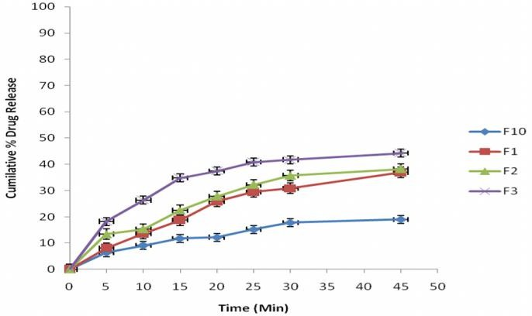
Fig. No. 01: In vitro Dissolution profile of F1, F2,F3 sodium starch glycolate formulation and direct compression nisoldipine tablet (F10)

Fig. No. 02: In vitro Dissolution profile of F4,F5,F6 Crospovidone formulation and direct compression Nisoldipine tablet (F10)
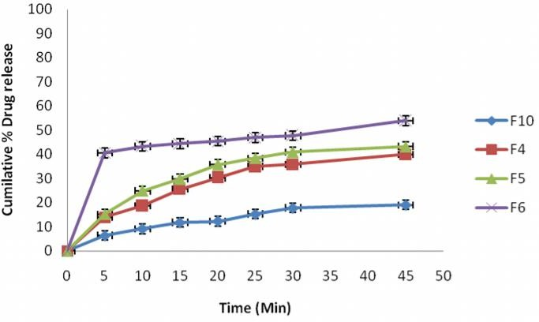

Fig. No. 03: In vitro Dissolution profile of F7,F8,F9 Croscarmelose sodium formulation and direct compression nisoldipine tablet (F10)
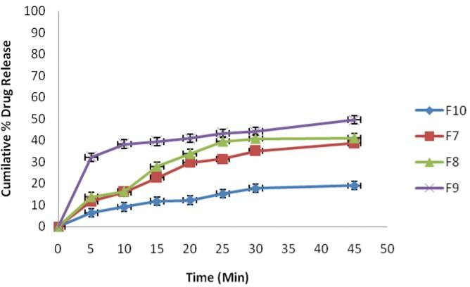

Fig. No. 04: Photographs of the disintegration process of the water dispersible tablet. The chronological sequence is given by the disintegration time in seconds.
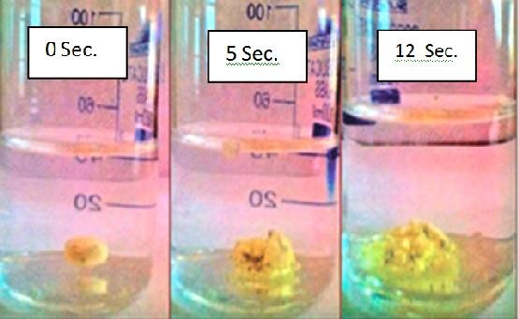

Result and discussion
Nisoldipine orodispersible tablets tablets were prepared by direct compression method. Ten formulations were prepared by using various concentrations (2%, 4% and 6%) of superdisintegrant such as Sodium Starch Glycolate, Crospovidone, and Ac-di-sol. All batches of formulations were evaluated for pre compression and post compression parameters. Pre compression parameters like angle of repose, bulk density, tapped density, Percentage compressibility, and Hausner’s ratio are shown in Table no-2. Pre compression parameters for all formulations were within the Indian pharmacopoeial limit. The angle of repose of the powder blend is ranging from 20.61⁰ to 22.68⁰ and the Hausner’s ratio ranging from 0.88 to 1.15 which confirms the good flow nature of powders. Post compression parameters like weight variation, thickness, hardness, friability, wetting time, and in vitro disintegration time, are shown in table no-3. The hardness was found to be in the range of 3.2-3.6 kg/cm². The maximum friability was found to be less than 0.40±0.07% for F9 formulation. This indicated the prepared tablet have sufficient mechanical strength to withstand the loss of surface powders while handling of tablets. The percentage drug content in fast disintegrating tablet formulations ranging from 98.15±1.42% to 101.05±32%, States that tablet have highly content uniformity. All the batch of formulated tablets passes the weight variation test with in prescribed pharmacopoeial limit.

As the disintegration of the tablet is depends on the wetting of the disintegrant, Wetting time is an important parameter for the fast disintegrating tablet. All the formulations show faster wetting time than compared to the directly compressed formulation 41±1.82 sec. The slowest wetting time 38±1.20 sec. and fastest wetting time 12±1.13 sec. and was resulted for the formulation F7 and F6 respectively. The Disintegration time is the critical parameter for the fast disintegrating tablet due to the faster rate of release of drug primarily depends on rate of disintegration followed by dissolution of drug. The addition of superdisintegrants shows significant effect on faster rate of disintegration than the directly compressed tablet (F10) and it was observed concentration dependant reduction of disintegration time.

Though all the superdisintegrant influences faster disintegration, among them crosspovidone has the superior disintegrating ability followed by Ac-di- sol and Sodium Starch Glycolate. The Formulation F6 shows complete disintegration of tablet in 08±1.07 sec. due to the faster rate of wicking action of the Crosspovidone. Also the other agents Ac-di- sol influenced the disintegration in 18±1.15 sec. and Sodium Starch Glycolate shows 20±1.22 sec. at its highest concentration level in the formulation.

The comparative cumulative invitro dissolution study results of directly compressed tablet of Nissoldipine with Fast disintegrating tablet containing SSG, Crosspovidone and Ac-di-sol have been described in Fig-2, 3, 4 respectively. The formulations added with superdisintegrant shows better dissolution than the directly compressed tablet. This may be due to faster disintegration followed by increased wetting of drug with the dissolution medium. Among the drug release result the quickest drug dissolution in 5 min have been seen as 40.61±1.75% and the maximum dissolution of Nissoldipine resulted as 53.86±2.06% in 45 min for the formulation F6. Also Ac-di-sol and SSG shows 49.53±1.22% and 44.28±1.69% respectively increased dissolution significantly than 19.03±1.96% resulted for the directly compressed tablet.

Conclusion
Fast disintegrating tablet of Nissoldipine has been done using various superdisintegrants in various ratios by direct compression technique. The prepared tablets were evaluated for Pre compression and post compression parameters. The rate of dissolution of Nissoldipine has been increased through the fast disintegrating tablet. Hence this is the useful method to enhance the bioavilability of Nissoldipine.

Acknowledgement
The authors are thankful to orchid chemicals and pharmaceuticals, Chennai for providing the gift sample of Nisoldipine; we wish to thank the, Dr.Rajendraprasad reddy, Chairman, Balaji Institute of Pharmaceutical Sciences, Warangal -
A.P. for providing facilities to carry out and publish the research work.

Reference
- Amidon, G.L., Lennernas, H., Shah, V.P., Crison, J.R., 1995. A theoretical basis for biopharmaceutic drug classification: the correlation of in vitro drug product dissolution and in vivo bioavailability. Pharm. Res. 12, 413–420.
- Mathot, F., van Beijsterveldt, L., Preat, V., Brewster, M., Arien, A., 2006. Intestinal uptake and biodistribution of novel polymeric micelles after oral administration. J. Control. Release 111, 47–55.
- Liu, C., Zhu, S.J., Zhou, Y., Wei, Y.P., Pei, Y.Y., 2006. Enhancement of dissolution of cyclosporine A using solid dispersions with polyoxyethylene (40) stearate. Pharmazie 61, 681–684.
- Wang, S., Ding, Y., Yao, Y., 2009. Inclusion complexes of fluorofenidone with betacyclodextrin and hydroxypropyl-beta- cyclodextrin. Drug Dev. Ind. Pharm. 31, 1–6.
- Kanagale, P., Patel, V., Venkatesan, N., Jain, M., Patel, P., Misra, A., 2008. Pharmaceutical development of solid dispersion based osmotic drug delivery system for nifedipine. Curr. Drug Deliv. 5, 306–311.
- Rahman, Z., Zidan, A.S., Habib, M.J., Khan, M.A., 2010b. Non-destructive methods of characterization of risperidone solid lipid nanoparticles. Eur. J. Pharm. Biopharm. (May 12 Epub).
- Rahamathulla, M., Hv, G., Rathod, N., 2008. Solubility and dissolution improvement of rofecoxib using solid dispersion technique. Pak. J. Pharm. Sci. 21, 350–355.
- Yourong Fu, Shicheng Yang, Seong Hoon Jeong, Susumu Kimura, & Kinam Park, 2004, Orally Fast Disintegrating Tablets: Developments, Technologies,Taste-Masking and Clinical Studies, Critical Reviews™ in Th erapeutic Drug Carrier Systems, 21(6):433– 475.

- Fakhar ul Hassnain, Sajid Bashir, Muhammad Asad, Imran Nazir, Sumbul Qamar, 2012, Formulation and characterization of Solid dispersion of Nisoldipine by Solvent Evaporation Method, Journal of Pharmacy and Alternative Medicine, 2, 21-28.
- Vogt, A. and Kreuzer, H. (1983). Arzneim.- Forsc./Drug Res; 33:877.
- Martin A, Micromeretics, In: martin A ,ed. Physical Pharmacy, Baltimores, MD: Lippincott Williams and Wilkins :2001.p.423- 454.
- Indian Pharmacopoeia, 4th ed, Ministry of Health and Family Welfare, Govt. of India. The controller of publications, New Delhi.1996: A-54.
- Liberman H. Lachman L,The Thery and Practice of Industrial Pharmacy 3 rd ed. Bombay:Varghese publication house
;1991.p171-193.
- Kuchekar B.S., Badhan A.C. and Mahajan H.S., Mouth dissolving tablets of salbutamol sulphate: A novel drug delivery system, Indian Drugs, 2004, 41,10, 592-598.
- Mishra D.N., Rapidly disintegrating oral tablets of meloxicam by direct compression method, Indian Drugs, 2006, 43, 117-121.
- Sudarshan Singh and Dhaval Shah* Development and Characterization of Mouth Dissolving Tablet of Zolmitriptan Asian Pacific Journal of Tropical Disease (2012) S457-S464.
- Amit G, Ram S.G, S.Ganga, Development of discriminating dissolution method for an Insoluble drug Nisoldipine. International Journal of Pharma Tech Research 2010;2: no.1, 931- 939.

